Medical Care Collections Fund (MCCF) ePayments

Electronic Data Interchange (EDI)

Transactions Applications Suite (TAS)

Interface Control Document

ASC X12N/005010 835 Health Care Claim Payment and Remittance Advice

Logo for the Department of Veterans Affairs, Office of Information and Technology, Product Development, including the official seal of the Department of Veterans Affairs


Department of Veterans Affairs

March 2018

Version 1

Revision History

|  |  |  |  |
| --- | --- | --- | --- |
| Date | Version | Description | Author |
| 2/22/18 | 0.0.1 | Initial creation of document | Steffen Maerdian - Halfaker |
| 2/26/18 | 0.0.2 | Formatting | Steffen Maerdian - Halfaker |
| 3/1/18 | 1 | Finalizing draft | Steffen Maerdian - Halfaker |
|  |  |  |  |
|  |  |  |  |
|  |  |  |  |
|  |  |  |  |
|  |  |  |  |
|  |  |  |  |
|  |  |  |  |
|  |  |  |  |
|  |  |  |  |
|  |  |  |  |
|  |  |  |  |
|  |  |  |  |
|  |  |  |  |
|  |  |  |  |
|  |  |  |  |
|  |  |  |  |
|  |  |  |  |
|  |  |  |  |

Table of Contents

1 Introduction 1

1.1 Purpose 1

1.2 Scope 1

1.3 System Identification 1

1.3.1 MCCF EDI TAS ePayments 1

1.3.2 FSC 2

1.4 Operational Agreement 2

2 Interface Definition 2

2.1 System Overview 2

2.1.1 Overview Diagram 3

2.2 Interface Overview 4

2.2.1 Connectivity between the systems 5

2.3 Operations 5

2.3.1 Data Extraction 5

2.3.2 Data Transformation 5

2.3.3 Sending/Receiving 5

2.4 Data Transfer 6

2.5 Transaction Types 6

2.6 Data Exchanges 6

2.6.1 FHIR Based Resources 6

2.6.2 JSON Format 7

2.6.3 Bundle Definition 7

2.7 Communications Methods 9

2.7.1 Ports and Protocols 9

2.7.2 ESB Configuration(s) 9

2.7.3 System Configuration 10

2.8 Performance Requirements 10

2.9 Security 10

2.9.1 Is within the VA firewall 10

2.10 Testing Requirements 10

2.10.1 Comparison of Data 10

2.10.2 Completeness 10

2.11 Policies and Constraints 10

2.11.1 HIPAA Compliance 10

3 Appendix A 1

3.1 Data Elements 1

3.2 Bundle 1

3.3 Resource Sections 1..N 2

3.3.1 835 MRA and ERA FHIR Bundle Resources 2

3.3.2 835 EFT FHIR Bundle Resources 16

3.3.3 Embedded following comlumns: 16

4 Appendix B - TASCore Mapping Rules 16

5 Appendix C – TASCore Default Values 16

6 Appendix D – FSC Mapping Rules 16

7 Appendix E – FSC Default Values 16

# Introduction

This document describes the interface between the MCCF EDI TAS ePayments application and the VA Financial Services Center in Austin, TX (FSC) for ASC X12N/005010 835 Health Care Claim Payment and Remittance Advice messages.

## Purpose

The purpose of this Interface Control Document (ICD) is to define the message structure and protocols which govern the interchange of data between ePayments within MCCF EDI TAS and the FSC related to the electronic processing of ASC X12N/005010 835 Health Care Claim Payment and Remittance Advice (835) messages.

## Scope

This ICD specifies the interface between MCCF EDI TAS ePayments and FSC. This document provides details on the functional, performance, operational and design requirements for the interface. This document defines the layouts for the data that the FSC sends to MCCF EDI TAS ePayments. This document is intended for all parties requiring such information, including business stakeholders, end-users, software developers, system designers, testers and anyone else responsible for implementing this interface.

## System Identification

This ICD describes a generalized interface between the MCCDF EDI TAS Platform and the system(s) at the FSC.

### MCCF EDI TAS ePayments

The MCCF EDI TAS Platform will modernize and automate the business processes used currently as part of the VA revenue cycle. This includes insurance verification, billing, and claims processing, payment, and remittance. These processes are tied to other processes that are out of scope, including documenting the care provided, coding treatment and encounters, and sending claims and receiving remittance to and from the clearinghouse.

This interface supports the electronic third party billing process which involves the electronic transmission 835 messages for MRAs, ERAs, and EFTs between FSC and MCCF EDI TAS ePayments.

|  |  |
| --- | --- |
| System | Details |
| Title |  |
| Abbreviation |  |
| Version number |  |
| Release number |  |
| Point of Contact |  |
| Vendor [optional] |  |

### FSC

The system(s) at FSC receive(s) 835 messages from Emdeon and forward(s) them to the MCCF EDI TAS Platform.

|  |  |
| --- | --- |
| System | Details |
| Title |  |
| Abbreviation |  |
| Version number |  |
| Point of Contact |  |
| Vendor [optional] |  |

## Operational Agreement

This ICD provides the specification for an interface between MCCF EDI TAS ePayments and FSC regarding Health Care Claim Payment and Remittance Advice data. The Chief Business Office (CBO) is responsible for notifying FSC personnel of any potential or planned changes to data feeds once these changes are known in order to minimize adverse impacts.

# Interface Definition

Health Care Claim Payment and Remittance Advice data is transmitted between the FSC and MCCF EDI TAS ePayments in FHIR bundles.

## System Overview

The MCCF EDI TAS ePayments is designed to facilitate transmission of Health Care Claim Payment and Remittance Advice data from the FSC.

FSC is designed to receive Health Care Claim Payment and Remittance Advice (835) data from payers, to translate that data into a FHIR resources and to bundle and send it to MCCF EDI TAS ePayments.

### Overview Diagram

Interim solution

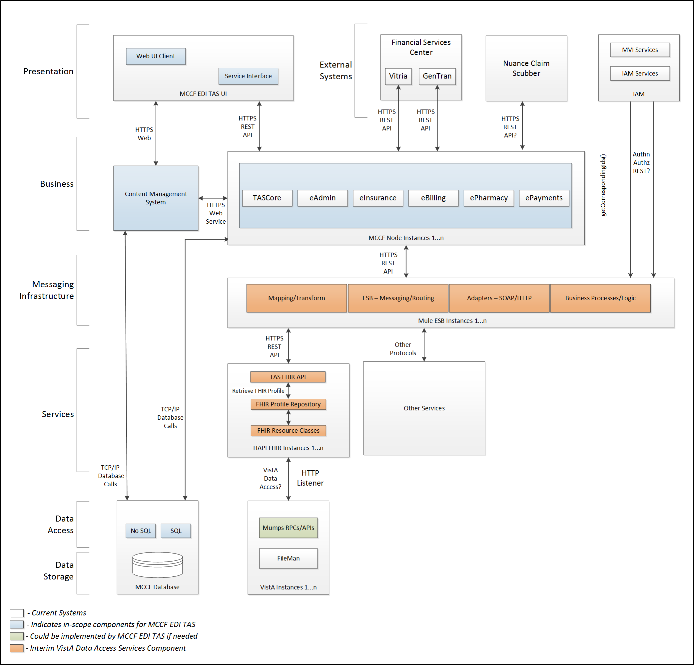

To be solution

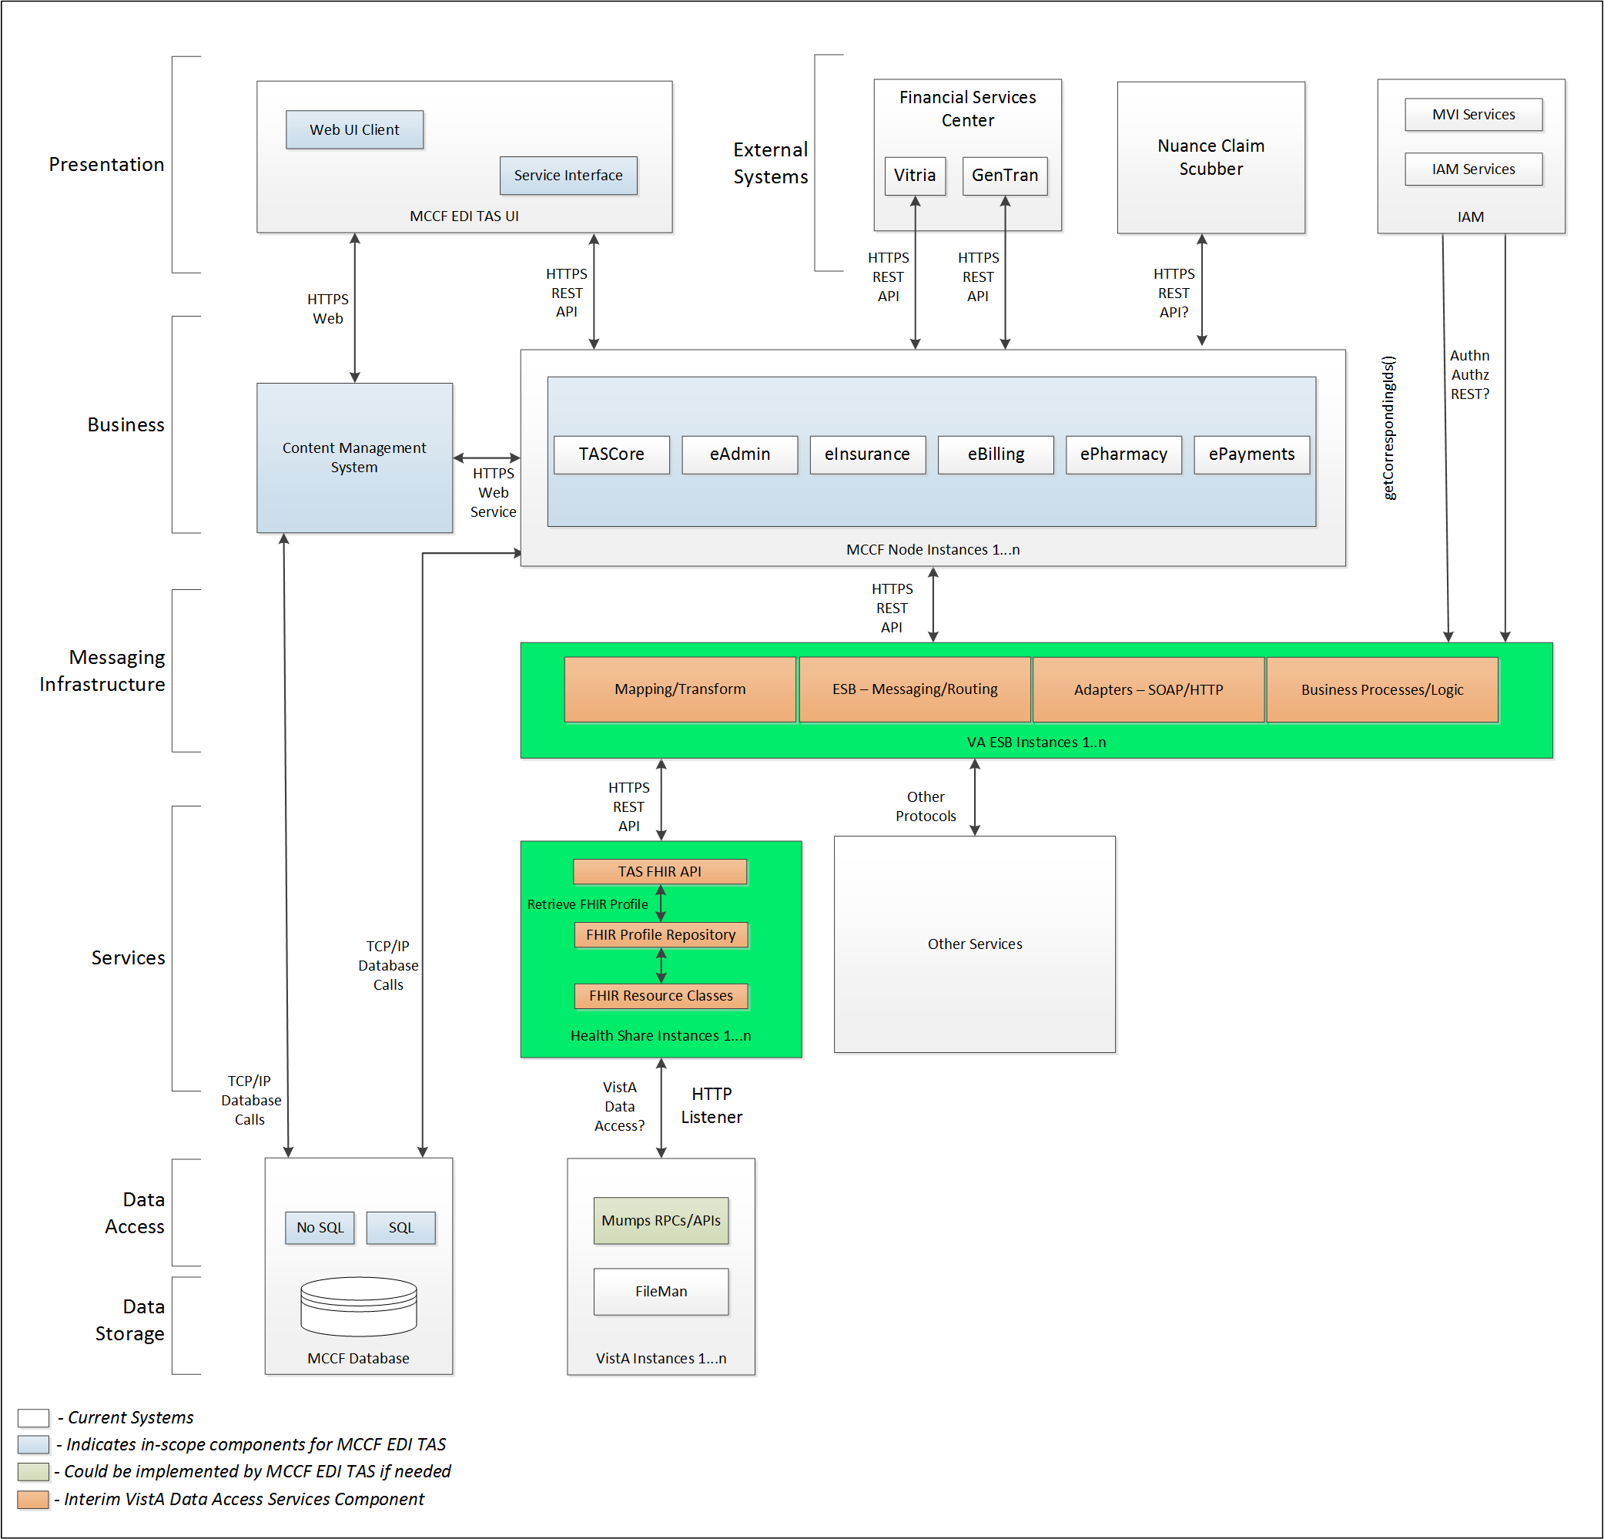

## Interface Overview

Exchanging messages between MCCF EDI TAS ePayments and FSC can be done in real time or via message queuing.

### Connectivity between the systems

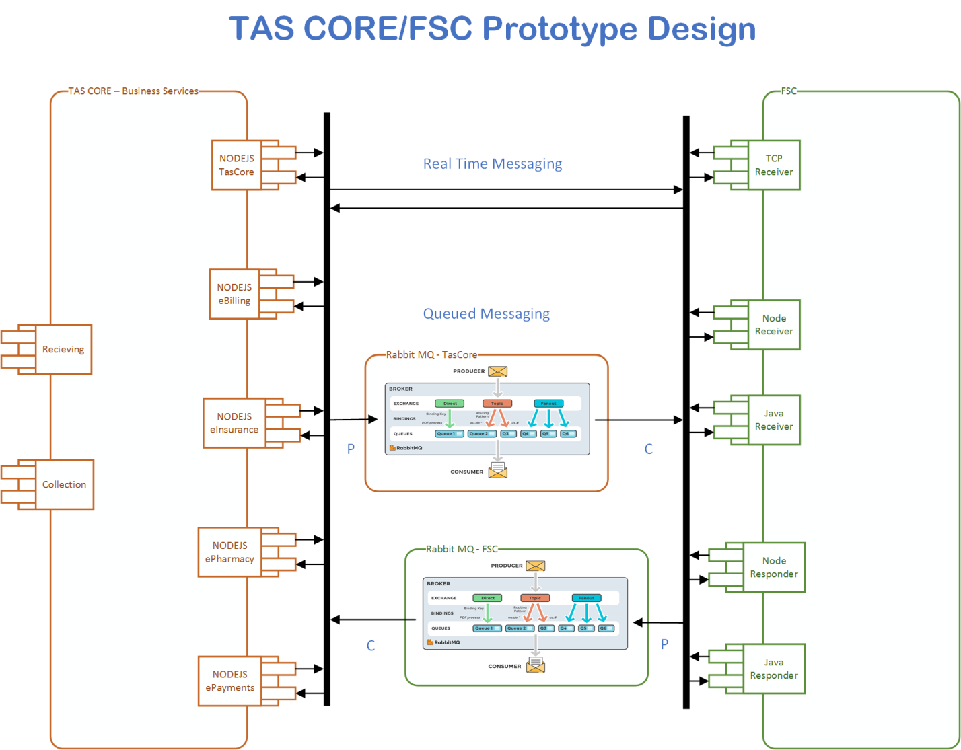

## Operations

Tbd

### Data Extraction

n/a

### Data Transformation

Tbd

### Sending/Receiving

MCCF EDI TAS ePayments receives 835 messages from FSC.

## Data Transfer

Data is transferred between the FSC and the TASCore Application Stack.

## Transaction Types

FSC receives Health Care Claim Payment and Remittance Advice (835) messages from payers and transmits that data in FHIR resources inside FHIR bundles to MCCF EDI TAS ePayments.

## Data Exchanges

FSC sends a FHIR Bundle to MCCF EDI TAS ePayments.

Refer to Appendix A.

### FHIR Based Resources

#### ERA and MRA

The following FHIR resources are needed to assemble a 835 MRA and ERA Message FHIR bundle

* Basic
* Claim
* ClaimResponse
* CodeableConcept
* Coverage
* Message Header
* MessageDefinition
* Organization
* Patient
* PaymentReconciliation
* Practitioner
* Procedure

#### EFT

The following FHIR resources are needed to assemble a 835 EFT Message FHIR bundle

Tbd

### JSON Format

Messages are formatted using the JSON format and implement a Bundle FHIR Resource.

Refer to <https://www.hl7.org/fhir/json.html> for JSON representation of FHIR Resources.

#### 835 ERA and MRA FHIR bundle

A bundle implementing a 835 message sent from FSC MCCF EDI TAS ePayments will have the following structure:

See Appendix A.

#### 835 EFT FHIR bundle

Tbd

### Bundle Definition

A Bundle is a top level container in FHIR that contains all the FHIR resources desired for a transaction between MCCF EDI TAS and FSC.

A Bundle is a container for resources, enabling one to group and transmit resources altogether at once. Resources such as Claim, Patient, etc. will be transmitted inside multiple entries (see entry list inside Bundle) as a resource type.

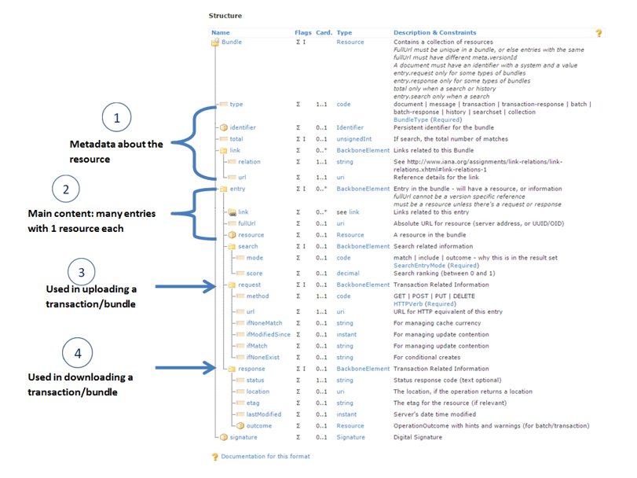

Figure - Source https://fhir-drills.github.io/bundle.html

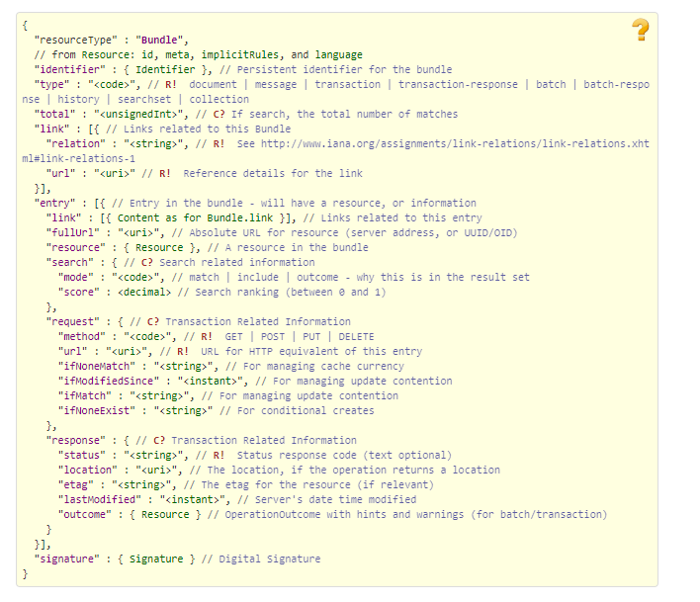

Figure - Source <https://www.hl7.org/fhir/bundle.html>

## Communications Methods

### Ports and Protocols

#### HTTP(S)

Can be used for real time communication.

#### AMQP

AMQP offers reliable messaging via queues.

### ESB Configuration(s)

Tbd

### System Configuration

Tbd

## Performance Requirements

System Design Document (SDD); Medical Care Collection Fund (MCCF) - Electronic Data Interchange Transaction Application Suite (EDI TAS).

## Security

System Design Document (SDD); Medical Care Collection Fund (MCCF) - Electronic Data Interchange Transaction Application Suite (EDI TAS).

### Is within the VA firewall

Tbd

## Testing Requirements

System Design Document (SDD); Medical Care Collection Fund (MCCF) - Electronic Data Interchange Transaction Application Suite (EDI TAS).

### Comparison of Data

Tbd

### Completeness

Tbd

## Policies and Constraints

Tbd

### HIPAA Compliance

FSC receives 835 data from payers.

# Appendix A

## Data Elements

## Bundle

Repeating fields within a segment need context definition so they can be differentiated within a segment.

Also, repeating fields across multiple segments need to be differentiated. Following steps have been used to assign context to fields.

1. Identify the segment where the resource is located (Bundle.entry.extension.url="segment" and Bundle.entry.extension.valueString="278-EVN") [MessageType-Segment]

2. Where elements repeat within a segment use extension.valueString to identify field (Basic.extension.url="sequence" and Basic.extension.valueString="278-MSH-16" or Location.identifier.extension.url="sequence" and Location.identifier.extension.valueString="278-MSH-3") [MessageType-Segment-Field]

3. Repeating segments will include an incrementing id (MSA1, MSA2, ...)

## Resource Sections 1..N

### 835 MRA and ERA FHIR Bundle Resources

#### Basic

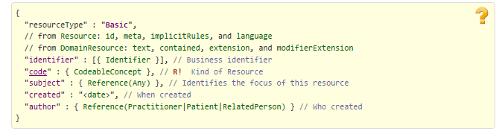

Figure - https://www.hl7.org/fhir/basic.html

#### Claim

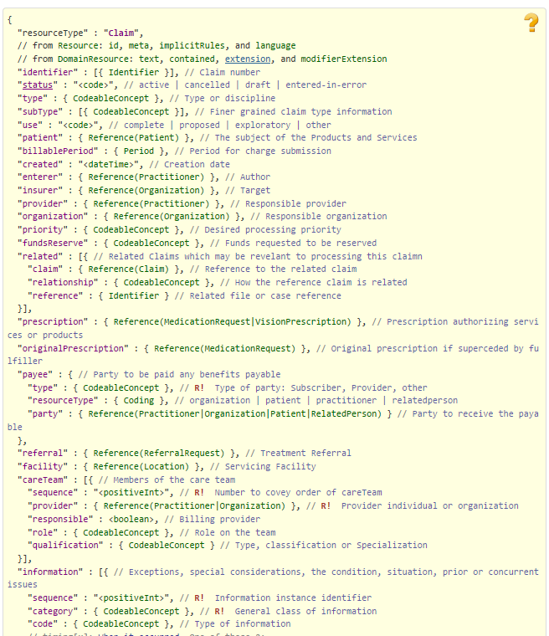

Figure - https://www.hl7.org/fhir/claim.html Part 1

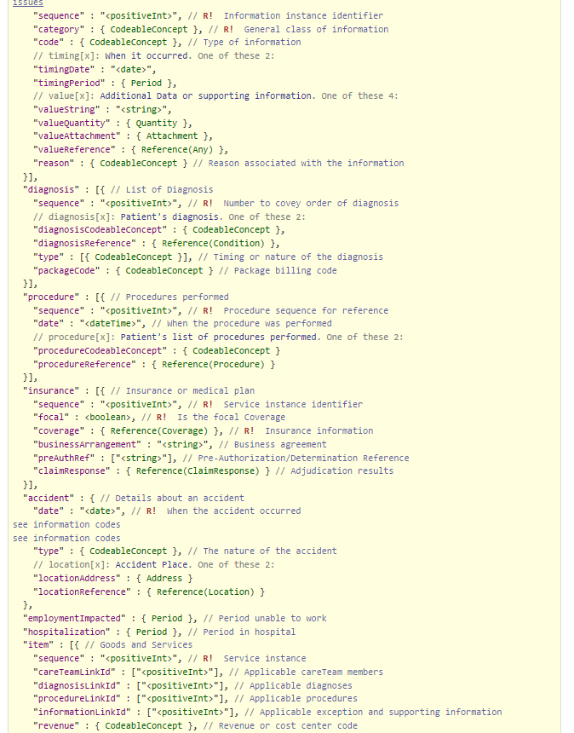

Figure - https://www.hl7.org/fhir/claim.html Part 2

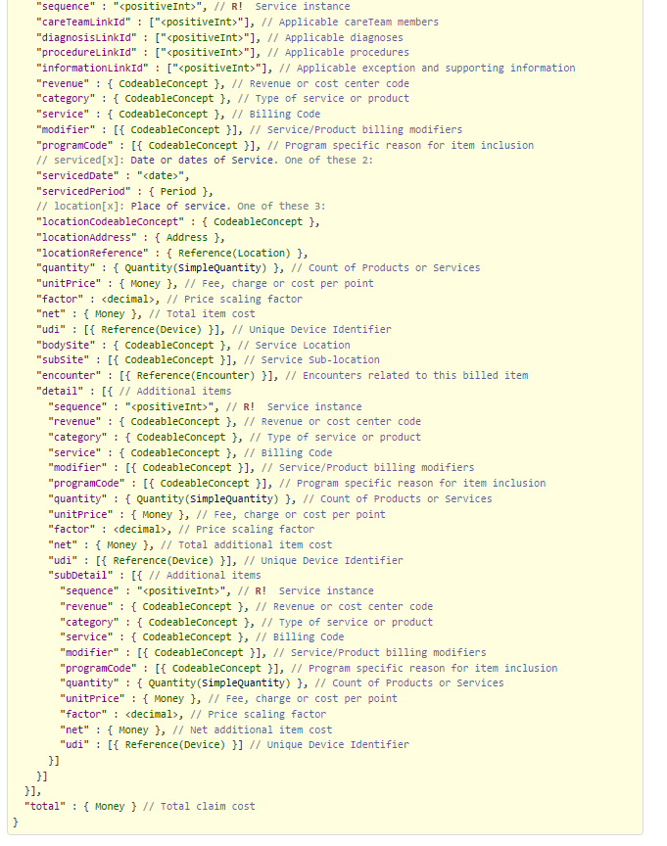

Figure - https://www.hl7.org/fhir/claim.html Part 3

#### ClaimResponse

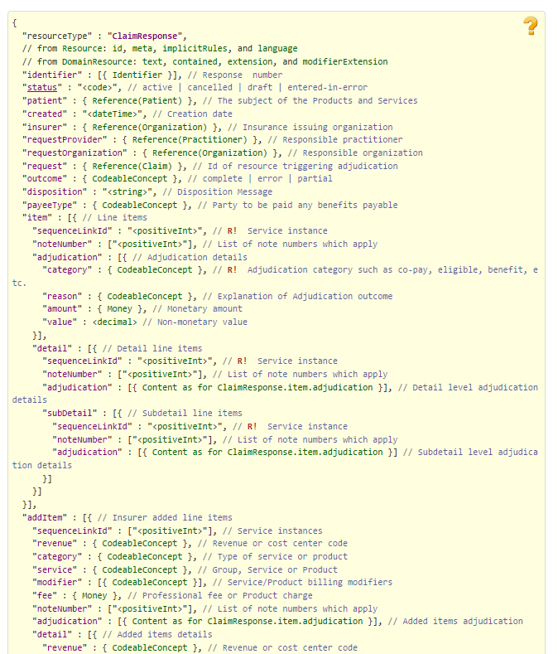

Figure - https://www.hl7.org/fhir/claimresponse.html Part 1

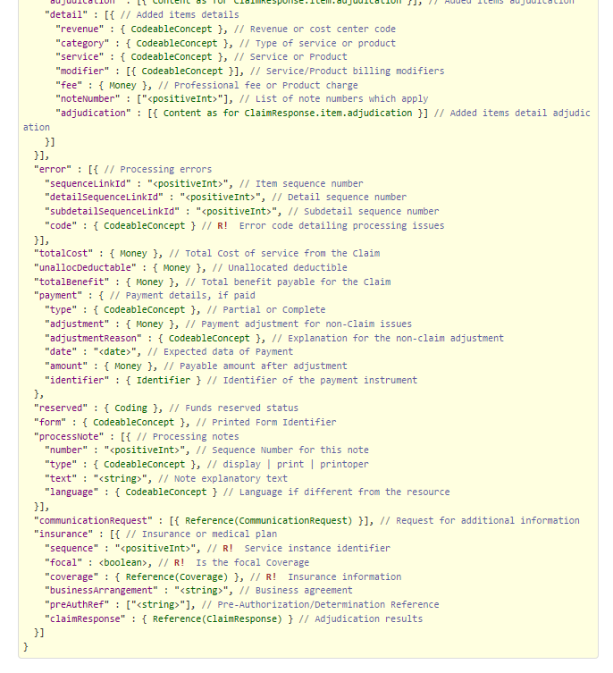

Figure - https://www.hl7.org/fhir/claimresponse.html Part 2

#### Coverage

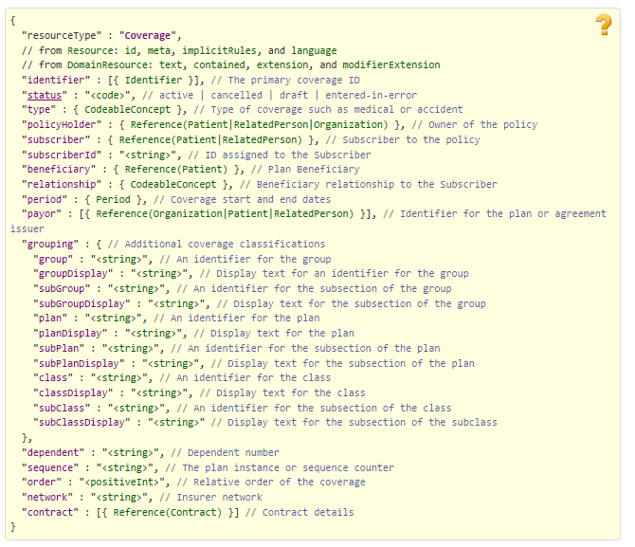

Figure - https://www.hl7.org/fhir/coverage.html

#### Message Header

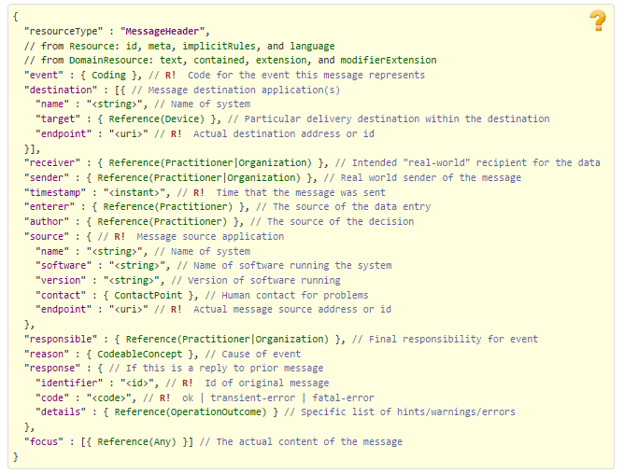

Figure - https://www.hl7.org/fhir/messageheader.html

#### MessageDefinition

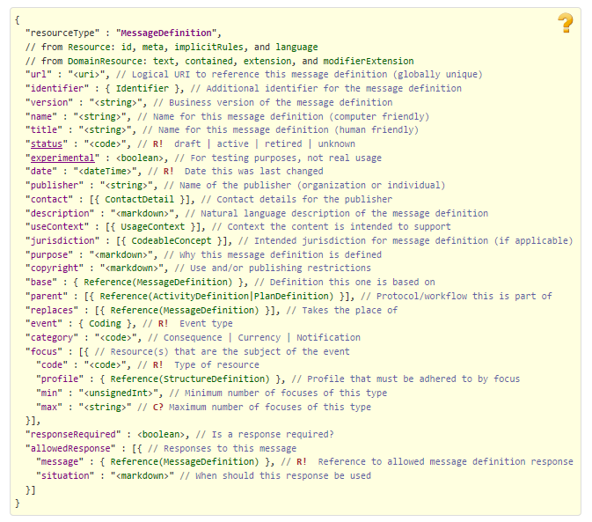

Figure - https://www.hl7.org/fhir/messagedefinition.html

#### Organization

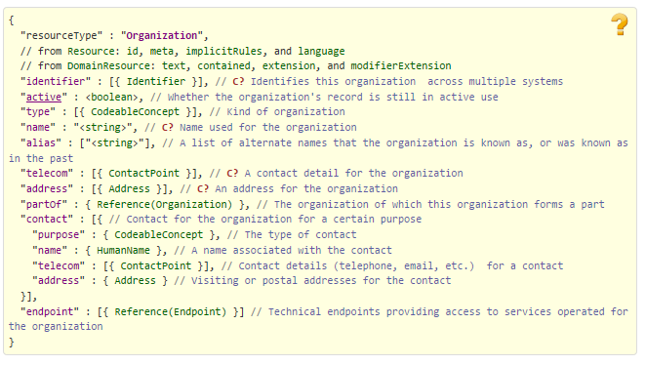

Figure - https://www.hl7.org/fhir/organization.html

#### Patient

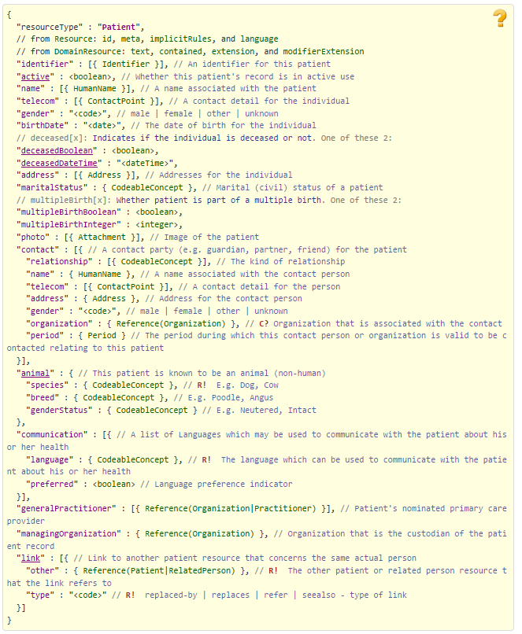

Figure - https://www.hl7.org/fhir/patient.html

#### PaymentReconciliation

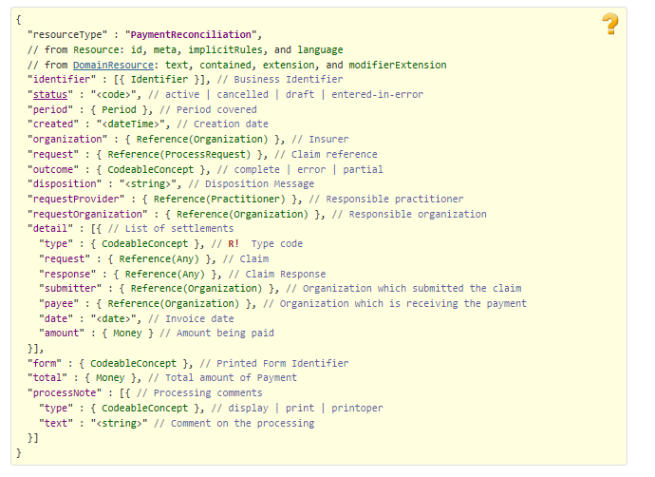

Figure - https://www.hl7.org/fhir/paymentreconciliation.html

#### Practitioner

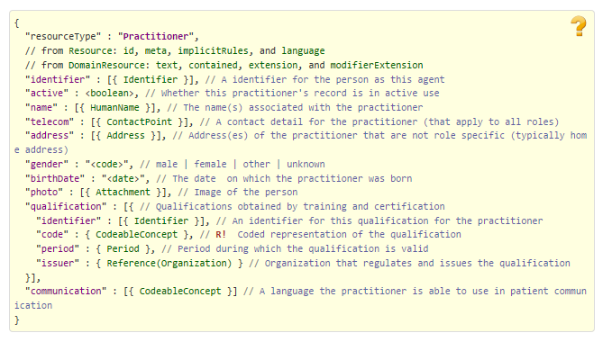

Figure - https://www.hl7.org/fhir/practitioner.html

#### Procedure

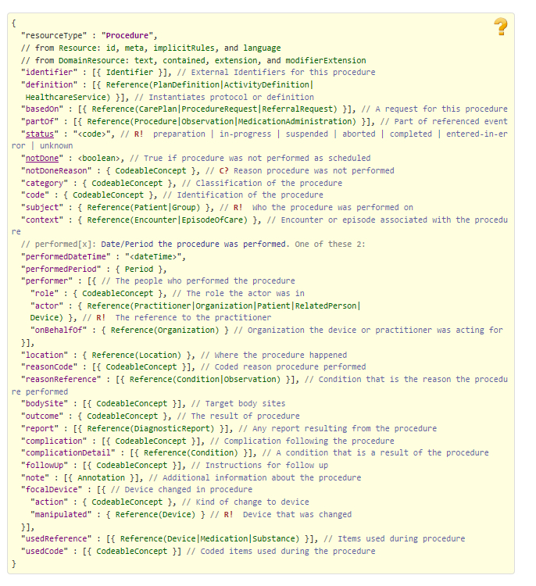

Figure - https://www.hl7.org/fhir/procedure.html

### 835 EFT FHIR Bundle Resources

### Embedded following columns:

#### Element #

#### Max Length

#### FSC Transaction Location

* FSC Comments
* FHIR Resource
* TASCore Comments

# Appendix B - TASCore Mapping Rules

# Appendix C – TASCore Default Values

# Appendix D – FSC Mapping Rules

# Appendix E – FSC Default Values