Medical Care Collections Fund (MCCF) ePayments

Electronic Data Interchange (EDI)

Transactions Applications Suite (TAS)

Interface Control Document

ASC X12N/005010 835 Health Care Claim Payment

and Remittance Advice

Logo for the Department of Veterans Affairs, Office of Information and Technology, Product Development, including the official seal of the Department of Veterans Affairs


Department of Veterans Affairs

May 2018

Version 3.0

Revision History

|  |  |  |  |
| --- | --- | --- | --- |
| Date | Version | Description | Author |
| 2/22/18 | 0.0.1 | Initial creation of document | Steffen Maerdian - Halfaker |
| 2/26/18 | 0.0.2 | Formatting | Steffen Maerdian - Halfaker |
| 3/1/18 | 1 | Finalizing draft | Steffen Maerdian - Halfaker |
| 3/19/18 | 1.1 | Incorporation of review remarks from technical writer, FSC team, and product team. | Steffen Maerdian - Halfaker |
| 3/20/18 | 1.2 | Including EFT section. | Steffen Maerdian - Halfaker |
| 3/26/18 | 2.0 | Final Draft Review | Keith Oulson – Halfaker & Associates |
| 4/19/18 | 2.1 | Adding latest mapping sheet | Steffen Maerdian - Halfaker |
| 4/30/2018 | 2.11 | Corrected signature page according to Frank Annecchini | Keith Oulson – Halfaker & Associates |
| 5/2/2018 | 3.0 | Carve out MRA | Keith Oulson – Halfaker & Associates |
| 5/8/2018 | 3.1 | Added corrected ERA and EFT JSON files | Steffen Maerdian - Halfaker |
|  |  |  |  |
|  |  |  |  |
|  |  |  |  |
|  |  |  |  |
|  |  |  |  |
|  |  |  |  |
|  |  |  |  |
|  |  |  |  |
|  |  |  |  |
|  |  |  |  |
|  |  |  |  |
|  |  |  |  |

Table of Contents

1 Introduction 1

1.1 Purpose 1

1.2 Scope 1

1.3 System Identification 1

1.3.1 MCCF EDI TAS ePayments 1

1.3.2 FSC 2

1.4 Operational Agreement 2

2 Interface Definition 2

2.1 System Overview 2

2.1.1 Overview Diagram 3

2.2 Interface Overview 5

2.2.1 Connectivity between the systems 5

2.3 Operations 5

2.3.1 Data Extraction 5

2.3.2 Data Transformation 6

2.3.3 Sending/Receiving 6

2.4 Data Transfer 6

2.5 Transaction Types 6

2.6 Data Exchanges 6

2.6.1 FHIR Based Resources 6

2.6.2 Bundle Definition 7

2.7 Communications Methods 10

2.7.1 Ports and Protocols 10

2.7.2 ESB Configuration(s) 10

2.7.3 System Configuration 10

2.8 Performance Requirements 10

2.9 Security 10

2.10 Testing Requirements 10

2.10.1 Comparison of Data 10

2.10.2 Completeness 10

2.10.3 Load Testing 11

2.11 Policies and Constraints 11

2.11.1 HIPAA Compliance 11

3 Appendix A 12

3.1 Data Elements 12

3.2 Bundle 12

3.2.1 ERA Bundle 12

3.2.2 EFT Bundle 12

3.3 Resource Sections 13

3.3.1 835 ERA FHIR Bundle Resources 13

3.3.2 835 EFT FHIR Bundle Resources 13

3.4 Mapping Sheet 15

4 Appendix B - TASCore Mapping Rules 15

5 Appendix C – TASCore Default Values 15

6 Appendix D – FSC Mapping Rules 15

7 Appendix E – FSC Default Values 15

8 Glossary 15

9 Attachment A – Approval Signatures 16

Table of Figures

Figure 1 - Interim Solution 3

Figure 2 - To Be Solution 4

Figure 3 - Connectivity 5

Figure 4 - FHIR Bundle 8

Figure 5 - FHIR Bundle JSON 9

# Introduction

This document describes the interface between the MCCF EDI TAS ePayments application and the VA Financial Services Center in Austin, TX (FSC) for ASC X12N/005010 835 Health Care Claim Payment and Remittance Advice messages.

## Purpose

The purpose of this Interface Control Document (ICD) is to define the message structure and protocols which govern the interchange of data between the FSC and ePayments within MCCF EDI TAS related to the electronic processing of ASC X12N/005010 835 Health Care Claim Payment and Remittance Advice (835) messages.

## Scope

This ICD specifies the interface between FSC and MCCF EDI TAS ePayments. This document provides details on the functional, performance, operational, and design requirements for the interface. This document defines the layouts for the data that the FSC sends to MCCF EDI TAS ePayments. This document is intended for all parties requiring such information, including business stakeholders, end-users, software developers, system designers, testers, and anyone else responsible for implementing this interface.

## System Identification

This ICD describes a generalized interface between the MCCDF EDI TAS Platform and the system(s) at the FSC.

### MCCF EDI TAS ePayments

The MCCF EDI TAS Platform will modernize and automate the business processes used currently as part of the VA revenue cycle. This includes insurance verification, billing and claims processing, payment, and remittance. These processes are tied to other processes that are out of scope, including documenting the care provided, coding treatment and encounters, and sending claims and receiving remittance to and from the clearinghouse.

This interface supports the electronic third-party billing process which involves the electronic transmission of 835 messages for ERAs and EFTs between FSC and MCCF EDI TAS ePayments.

|  |  |
| --- | --- |
| System | Details |
| Title | tbd |
| Abbreviation | tbd |
| Version number | tbd |
| Release number | tbd |
| Point of Contact | tbd |
| Vendor [optional] | tbd |

### FSC

The system(s) at FSC receive(s) 835 messages from financial or banking institutions and forward(s) them to the MCCF EDI TAS Platform.

|  |  |
| --- | --- |
| System | Details |
| Title | tbd |
| Abbreviation | tbd |
| Version number | tbd |
| Point of Contact | tbd |
| Vendor [optional] | tbd |

## Operational Agreement

This ICD provides the specification for an interface between MCCF EDI TAS ePayments and FSC regarding Health Care Claim Payment and Remittance Advice data. The Chief Business Office (CBO) is responsible for notifying FSC personnel of any potential or planned changes to data feeds once these changes are known to minimize adverse impacts.

# Interface Definition

Health Care Claim Payment and Remittance Advice data is transmitted between the FSC and MCCF EDI TAS ePayments in FHIR bundles.

## System Overview

The MCCF EDI TAS ePayments module is designed to facilitate reception of Health Care Claim Payment and Remittance Advice data from the FSC.

FSC is designed to receive Health Care Claim Payment and Remittance Advice (835) data from payers, to translate that data into FHIR resources in a FHIR bundle and send it to MCCF EDI TAS ePayments.

### Overview Diagram

Interim solution

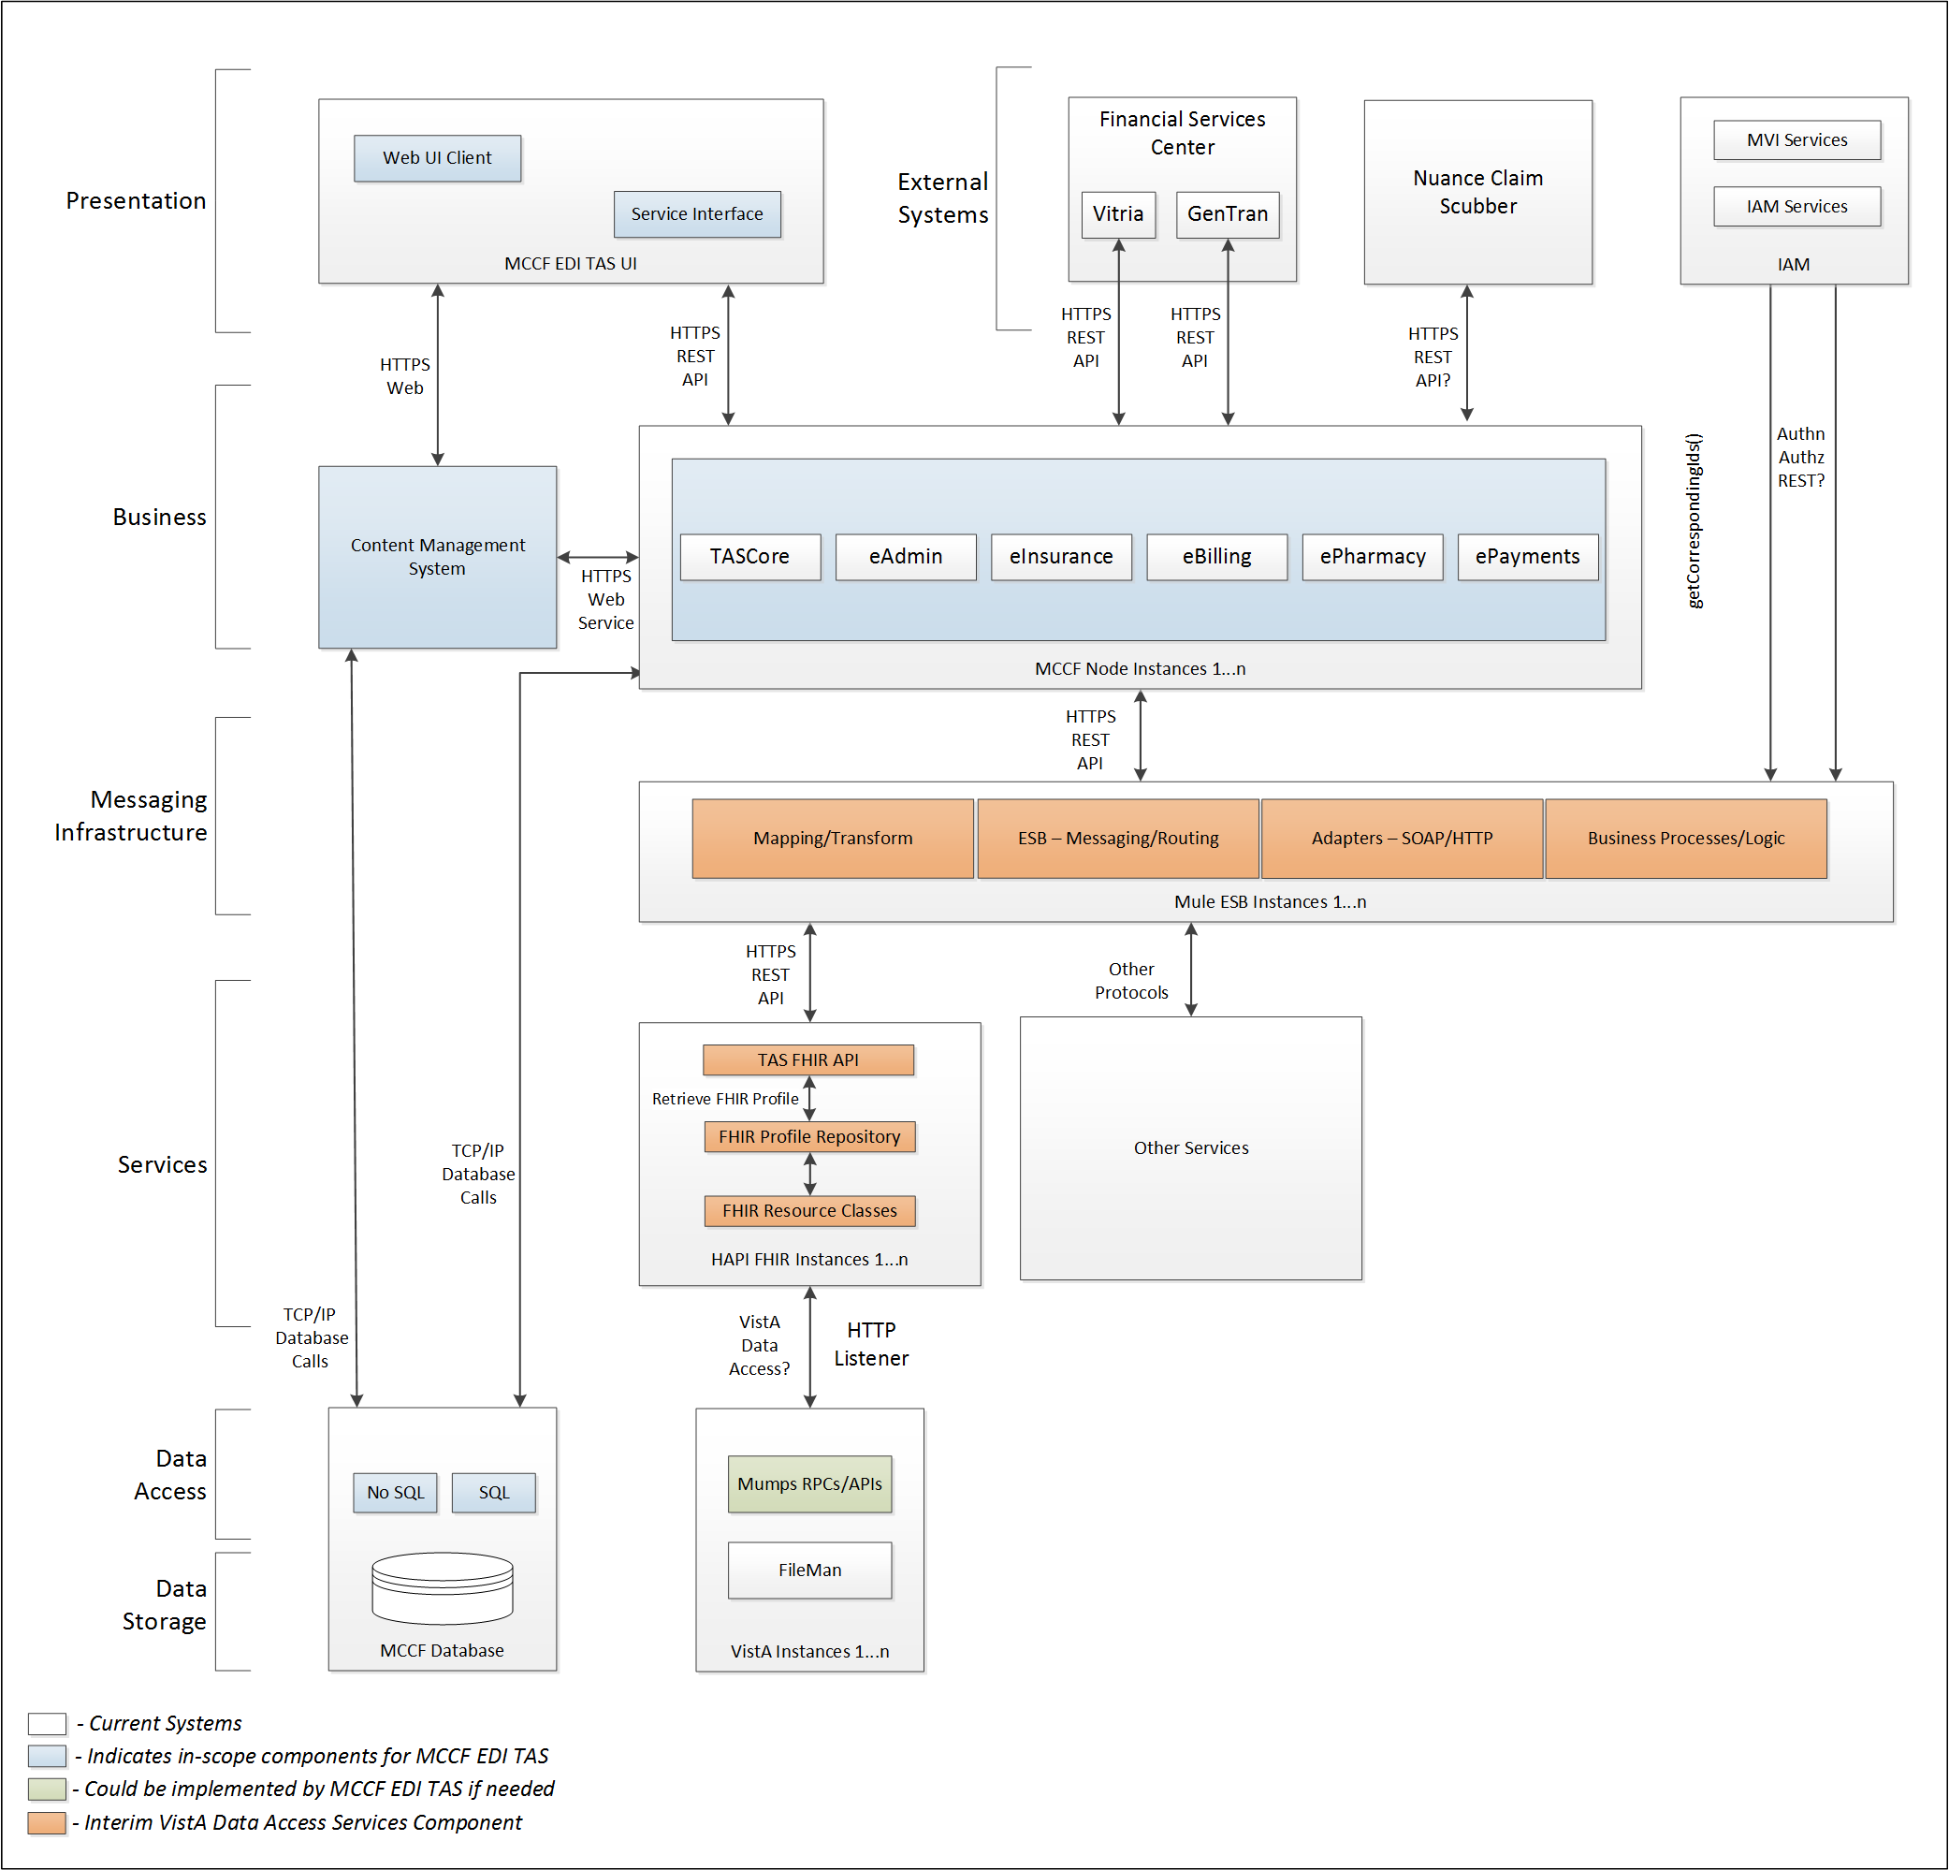

Figure - Interim Solution

To be solution

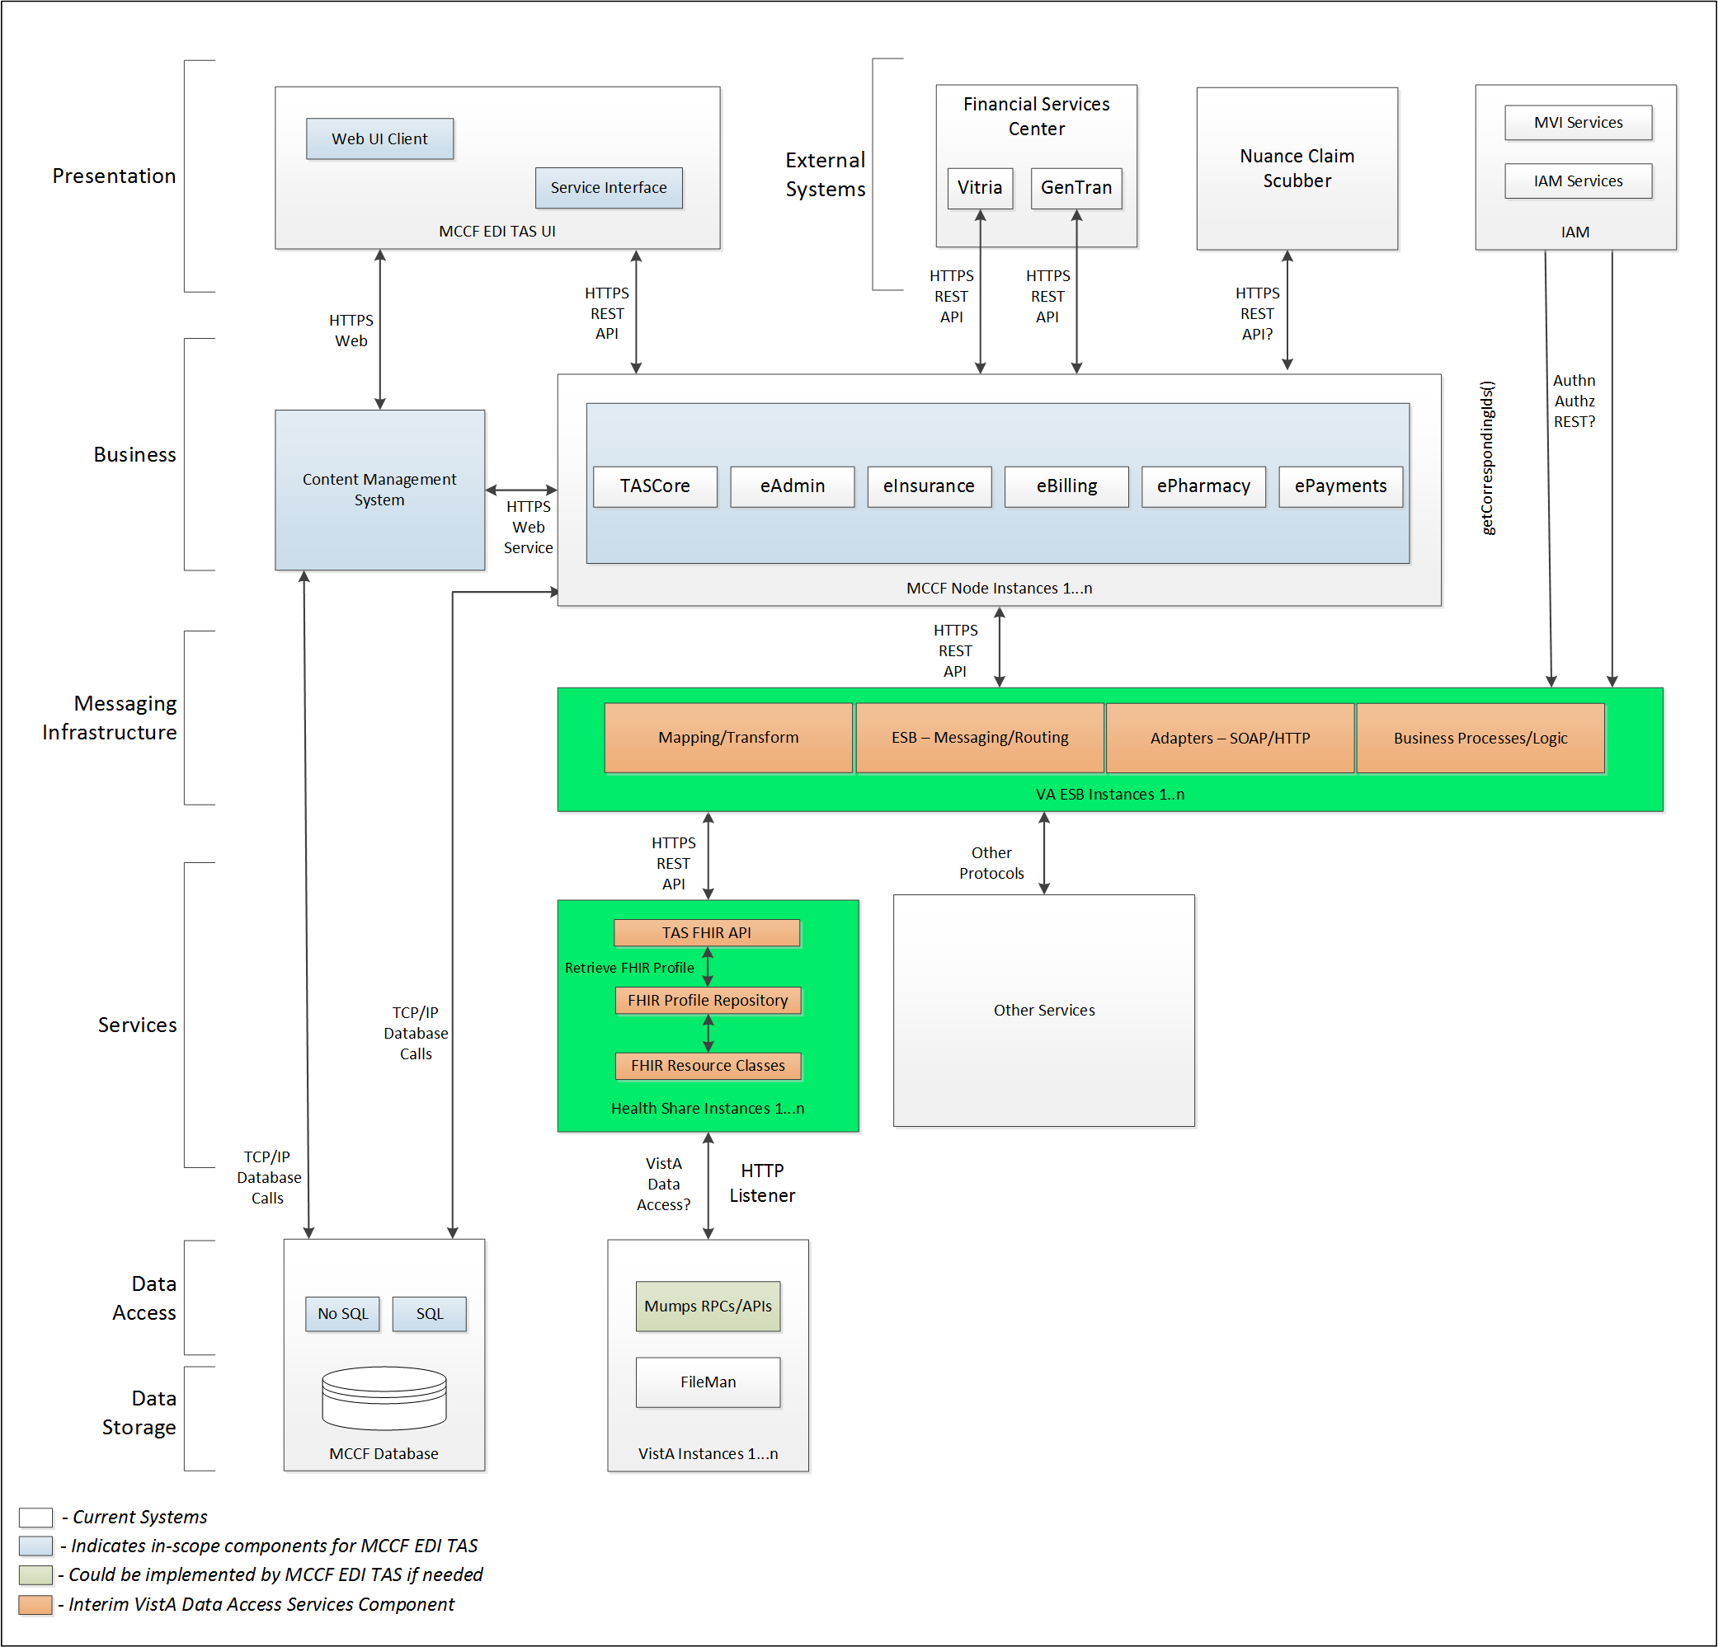

Figure - To Be Solution

## Interface Overview

Exchanging messages between FSC and MCCF EDI TAS ePayments can be done in real time or via message queuing.

### Connectivity between the systems

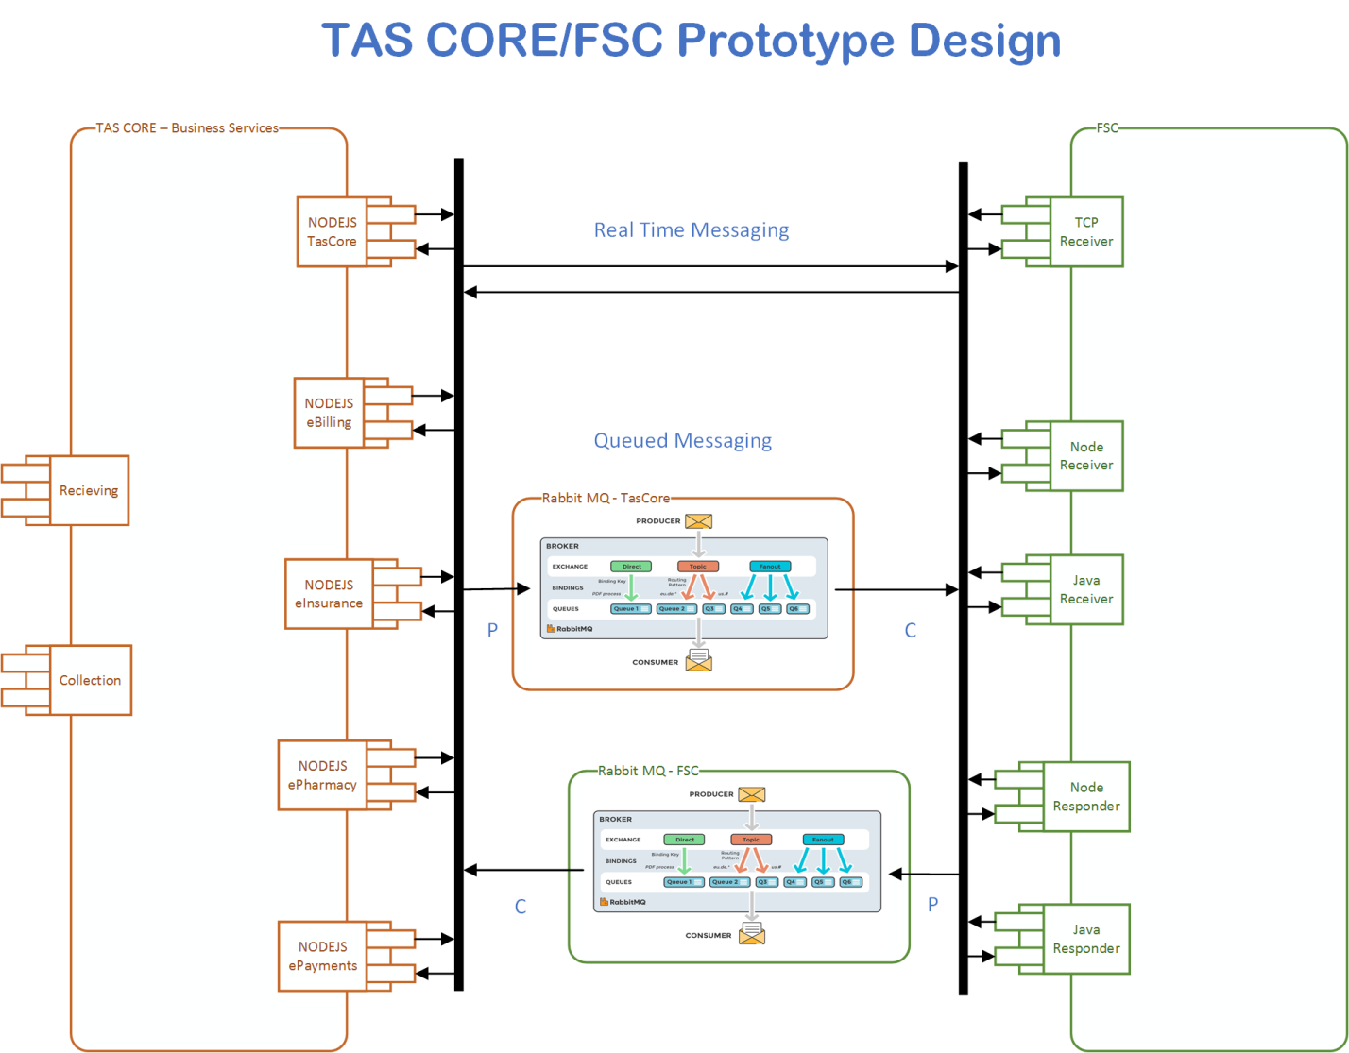

Figure - Connectivity

## Operations

Tbd

### Data Extraction

Tbd

### Data Transformation

Tbd

### Sending/Receiving

MCCF EDI TAS ePayments receives 835 messages from FSC.

## Data Transfer

Data is transferred between the FSC and the TASCore Application Stack.

## Transaction Types

FSC receives Health Care Claim Payment and Remittance Advice (835) messages from payers and transmits that data in FHIR resources inside FHIR bundles to MCCF EDI TAS ePayments.

## Data Exchanges

FSC sends a FHIR Bundle to MCCF EDI TAS ePayments.

Refer to Appendix A.

### FHIR Based Resources

#### ERA

The following FHIR resources are needed to assemble an 835 ERA Message FHIR bundle

* Basic
* Claim
* ClaimResponse
* Coverage
* MessageDefinition
* MessageHeader
* Observation
* Organization
* Patient
* PaymentReconciliation
* Practitioner
* Procedure

#### EFT

The following FHIR resources are needed to assemble an 835 EFT message FHIR bundle. Since the TAS team did not receive further information in time (Mapping from trading partners to FSC) regarding the actual X12 fields that are being used for an 835 EFT, the TAS team went ahead and used the format of the mailman message and mapped that to X12 segments and fields to their best knowledge. Those were then used and mapped to FHIR resources. This will have to be reviewed by the product and FSC team and updated later (once the needed information becomes available).

* Basic
* Claim
* ClaimResponse
* MessageHeader
* Organization
* Person

#### JSON Format

Messages are formatted using the JSON format and implement a Bundle FHIR Resource.

Refer to <https://www.hl7.org/fhir/json.html> for JSON representation of FHIR Resources.

#### 835 ERA FHIR bundle

A bundle implementing an 835 ERA message sent from FSC to MCCF EDI TAS ePayments will have the following structure:

See Appendix A.

#### 835 EFT FHIR bundle

A bundle implementing an 835 EFT message sent from FSC to MCCF EDI TAS ePayments will have the following structure:

See Appendix A.

### Bundle Definition

A Bundle is a top-level container in FHIR that contains all the FHIR resources desired for a transaction between MCCF EDI TAS and FSC.

A Bundle is a container for resources, enabling one to group and transmit resources altogether at once. Resources such as Claim, Patient, etc., will be transmitted inside multiple entries (see entry list inside Bundle) as a resource type.

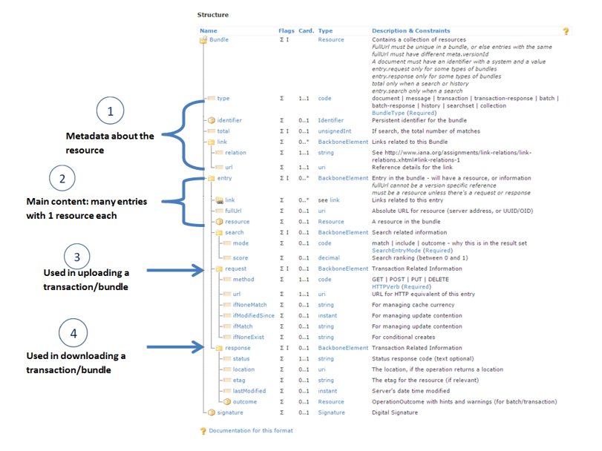

Figure - FHIR Bundle

Source https://fhir-drills.github.io/bundle.html

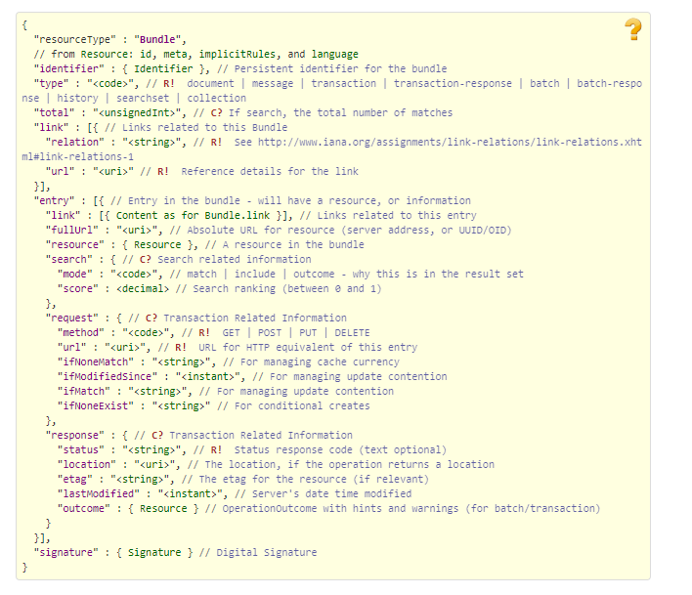

Figure - FHIR Bundle JSON

Source https://www.hl7.org/fhir/bundle.html

## Communications Methods

### Ports and Protocols

#### HTTP(S)

Can be used for real time communication.

#### Advanced Message Queuing Protocol (AMQP)

AMQP offers reliable messaging via queues.

### ESB Configuration(s)

Tbd

### System Configuration

Tbd

## Performance Requirements

Refer to MCCF EDI TAS SDD <https://vaww.oed.portal.va.gov/pm/hape/ipt_5010/EDI_Portfolio/TASCore/MCCF_EDI_TAS_System_Design_Document_v0.7.pdf>

## Security

Refer to MCCF EDI TAS SDD <https://vaww.oed.portal.va.gov/pm/hape/ipt_5010/EDI_Portfolio/TASCore/MCCF_EDI_TAS_System_Design_Document_v0.7.pdf>

## Testing Requirements

### Comparison of Data

Testing the FHIR conformance will be based on <https://www.hl7.org/fhir/validation.html>.

Business Rules will have to be specifically defined in user stories by the product team.

* Which fields are mandatory from a business perspective?
* Data integrity.

### Completeness

Tests defined in section 2.10.1 must cover all the FHIR resources that are defined in section 2.6.1 in consideration of any functional user story.

### Load Testing

Bench mark tests must be performed based on individual use case requirements.

## Policies and Constraints

### HIPAA Compliance

FSC receives 835 data from financial or banking institutions.

# Appendix A

## Data Elements

Data being exchanged between TAS and FSC will be formatted in FHIR using the JSON notation. Data elements are mapped into fields in FHIR resources. FHIR resources will be located inside a FHIR bundle.

## Bundle

Repeating fields within a segment need context definition so they can be differentiated within a segment.

Also, repeating fields across multiple segments need to be differentiated. Following steps have been used to assign context to fields.

1. Identify the segment where the resource is located (Bundle.entry.extension.url="segment" and Bundle.entry.extension.valueString=" 835-Header") [MessageType-Segment]
2. Where elements repeat within a segment use extension.valueString to identify field (MessageHeader.extension.url="sequence", MessageHeader.extension.valueString="835-Header-01") [MessageType-Segment-Field]
3. Repeating segments will include an incrementing id (835-PayerAdjustmentRecordGroup2, 835-PayerAdjustmentRecordGroup3, ...)

Following JSON files describe the 835 bundles.

### ERA Bundle



### EFT Bundle



## Resource Sections

### 835 ERA FHIR Bundle Resources

#### Basic

See Basic resource in Bundle included in section 3.2.1

#### Claim

See Claim resource in Bundle included in section 3.2.1

#### ClaimResponse

See ClaimResponse resource in Bundle included in section 3.2.1

#### Coverage

See Coverage resource in Bundle included in section 3.2.1

#### MessageHeader

See MessageHeader resource in Bundle included in section 3.2.1

#### MessageDefinition

See MessageDefinition resource in Bundle included in in section 3.2.1

#### Organization

See Organization resource in Bundle included in section 3.2.1

#### Patient

See Patient resource in Bundle included in section 3.2.1

#### PaymentReconciliation

See PaymentReconciliation in Bundle resource included in section 3.2.1

#### Practitioner

See Practitioner resource in Bundle included in section 3.2.1

#### Procedure

See Procedure resource in Bundle included in section 3.2.1

### 835 EFT FHIR Bundle Resources

#### Basic

See Basic resource in Bundle included in section 3.2.2

#### Claim

See Claim resource in Bundle included in section 3.2.2

#### ClaimResponse

See ClaimResponse resource in Bundle included in section 3.2.2

#### MessageHeader

See MessageHeader resource in Bundle included in section 3.2.2

#### Organization

See Organization resource in Bundle included in section 3.2.2

#### Person

See Person resource in Bundle included in section 3.2.2

## Mapping Sheet

The following mapping sheets includes three tabs. One for ERA and two for EFT (one based on information from Peter Hartley and one based on information from Aaris Epps):



# Appendix B - TASCore Mapping Rules

Tbd

# Appendix C – TASCore Default Values

Tbd

# Appendix D – FSC Mapping Rules

Tbd

# Appendix E – FSC Default Values

See mapping sheet section 3.4

# Glossary

| **Term** | **Meaning** |
| --- | --- |
| AMQP - Advanced Message Queuing Protocol | The *Advanced Message Queuing Protocol* (*AMQP*) is an open standard for passing business messages between applications or organizations using queues. |
| HCCH | Health Care Clearing House |
| REST - REpresentational State Transfer | REpresentational State Transfer, or RESTful web services provide interoperability between computer systems on the Internet or other network. Sometimes spelled ReST. |

# Attachment A – Approval Signatures

This section is used to document the approval of the ICD. The review should be conducted face to face where signatures can be obtained ‘live’ during the review. If unable to conduct a face-to-face meeting then it should be held via Lync and concurrence captured during the meeting. The Scribe should add /es/name by each position cited.

By signing below, I agree that I have reviewed and agree the document is approved.

