Medical Care Collections Fund (MCCF) ePharmacy

Electronic Data Interchange (EDI)

Transactions Applications Suite (TAS)

Interface Control Document

National Council for Prescription Drug Programs (NCPDP)

Claim Billing Reversal Request (B2)



Department of Veterans Affairs

March 2018

Version 1

Revision History

|  |  |  |  |
| --- | --- | --- | --- |
| Date | Version | Description | Author |
| 2/23/18 | 0.0.1 | Initial creation of document | Steffen Maerdian - Halfaker |
| 2/26/2018 | 0.0.2 | Formatting and content updates for initial draft | Keith Oulson – Halfaker and Associates |
| 3/2/2018 | 1 | Finalization of the draft | Keith Oulson – Halfaker & Associates |
|  |  |  |  |
|  |  |  |  |
|  |  |  |  |
|  |  |  |  |
|  |  |  |  |
|  |  |  |  |
|  |  |  |  |
|  |  |  |  |
|  |  |  |  |
|  |  |  |  |
|  |  |  |  |
|  |  |  |  |
|  |  |  |  |
|  |  |  |  |
|  |  |  |  |
|  |  |  |  |
|  |  |  |  |

Table of Contents

1 Introduction 1

1.1 Purpose 1

1.2 Scope 1

1.3 System Identification 1

1.3.1 MCCF EDI TAS ePharmcy 1

1.3.2 FSC 2

1.4 Operational Agreement 2

2 Interface Definition 2

2.1 System Overview 3

2.1.1 Overview Diagram 3

2.2 Interface Overview 4

2.2.1 Connectivity between the systems 5

2.3 Operations 5

2.3.1 Data Extraction 5

2.3.2 Data Transformation 5

2.3.3 Sending/Receiving 6

2.4 Data Transfer 6

2.5 Transaction Types 6

2.6 Data Exchanges 6

2.6.1 FHIR Based Resources 6

2.6.2 JSON Format 10

2.6.3 Bundle Definition 10

2.7 Communications Methods 12

2.7.1 Ports and Protocols 12

2.7.2 ESB Configuration(s) 12

2.7.3 System Configuration 13

2.8 Performance Requirements 13

2.9 Security 13

2.9.1 Is within the VA firewall 13

2.10 Testing Requirements 13

2.10.1 Comparison of Data 13

2.10.2 Completeness 13

2.11 Policies and Constraints 13

2.11.1 HIPAA Compliance 13

3 Appendix A 14

3.1 Data Elements 14

3.2 Bundle 14

3.3 Resource Sections 1..N 14

3.3.1 Claim Billing Reversal Request (B2) request bundle 14

3.3.2 Request (B2)request inside the Communication resource 39

3.3.3 Claim Billing Reversal Request (B2) response bundles 40

For TRANSMISSION ACCEPTED/TRANSACTION APPROVED responses 40

3.3.4 For TRANSMISSION ACCEPTED/TRANSACTION CAPTURED responses 50

3.3.5 For TRANSMISSION ACCEPTED/TRANSACTION REJECTED responses 51

3.3.6 For TRANSMISSION REJECTED/TRANSACTION REJECTED repsonses 51

3.3.7 Embedded following comlumns: 52

3.4 Appendix B - TASCore Mapping Rules 52

3.5 Appendix C – TASCore Default Values 52

3.6 Appendix D – FSC Mapping Rules 52

3.7 Appendix E – FSC Default Values 52

# Introduction

This document describes the interface between a MCCF EDI TAS ePharmacy application and the VA Financial Services Center in Austin, TX (FSC) for National Council for Prescription Drug Programs (NCPDP) Claim Billing Reversal Request (B2) messages.

## Purpose

The purpose of this Interface Control Document (ICD) is to define the message structure and protocols which govern the interchange of data between ePharmacy within MCCF EDI TAS and the FSC related to the electronic processing of NCPDP Claim Billing Reversal Request (B2) messages.

## Scope

This Interface Control Document describes a generalized interface between TAS Platform and the system(s) at the FSC. specifies the interface between MCCF EDI TAS ePharmacy and FSC. This document provides details on the functional, performance, operational and design requirements for the interface. This document defines the layouts for the data that the FSC sends to MCCF EDI TAS ePharmacy. This document is intended for all parties requiring such information, including business stakeholders, end-users, software developers, system designers, testers and anyone else responsible for implementing this interface.

## System Identification

MCCF EDI TAS ePharmacy is a software designed to support the requests and responses related to Claim Billing information sent to and received from the FSC. This interface supports the electronic transmission of Claim Billing Reversal Request (B2) between FSC and MCCF EDI TAS ePharmacy.

### MCCF EDI TAS ePharmacy

The TAS Platform will modernize and automate the business processes used currently as part of the VA revenue cycle. This includes insurance verification, billing, and claims processing, payment, and remittance. These processes are tied to other processes that are out of scope, including documenting the care provided, coding treatment and encounters, and sending claims and receiving remittance to and from the clearinghouse.

This interface supports the electronic third-party billing process which involves the electronic transmission of Claim Billing Reversal Request (B2) to Emdeon, the VA’s clearinghouse, where claims are either transmitted to the insurance company or sent to a printing facility.

|  |  |
| --- | --- |
| System | Details |
| Title |  |
| Abbreviation |  |
| Version number |  |
| Release number |  |
| Point of Contact |  |
| Vendor [optional] |  |
|  |  |

### FSC

The system(s) at FSC, receives the data from the TAS Platform, translates the data into a standard NCPDP B2 transmission, validates the data complies with HIPAA standards and then forwards the claim data to Emdeon.

|  |  |
| --- | --- |
| System | Details |
| Title |  |
| Abbreviation |  |
| Version number |  |
| Point of Contact |  |
| Vendor [optional] |  |

## Operational Agreement

This ICD provides the specification for an interface between MCCF EDI TAS ePharmacy and FSC regarding Claim Billing data. The Chief Business Office (CBO) is responsible for notifying FSC personnel of any potential or planned changes to data feeds once these changes are known to minimize adverse impacts.

# Interface Definition

Claim Billing Reversal Request (B2) data is transmitted between the FSC and MCCF EDI TAS ePharmacy in FHIR bundles or inside a Communication FHIR resource.

## System Overview

The MCCF EDI TAS ePharmacy is designed to facilitate transmission of Claim Billing Reversal Request (B2) data to and from the FSC. MCCF EDI TAS sends the data necessary as FHIR resources for FSC to format a B2 message.

FSC is designed to receive Claim Billing Reversal Request (B2) from MCCF EDI TAS ePharmacy and send them to payers. It is also designed to receive Claim Billing Reversal Request (B2) responses from payers and send them to MCCF EDI TAS ePharmacy as FHIR data.

### Overview Diagram

Interim solution

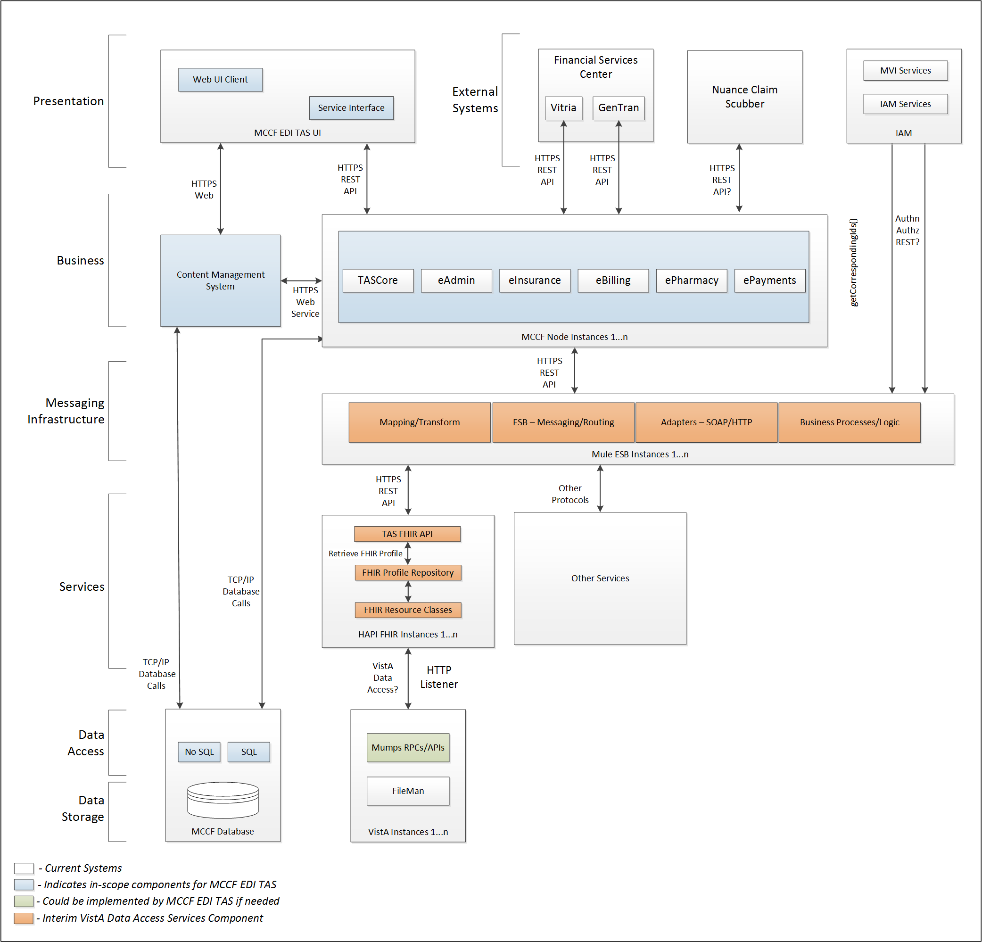

To be solution

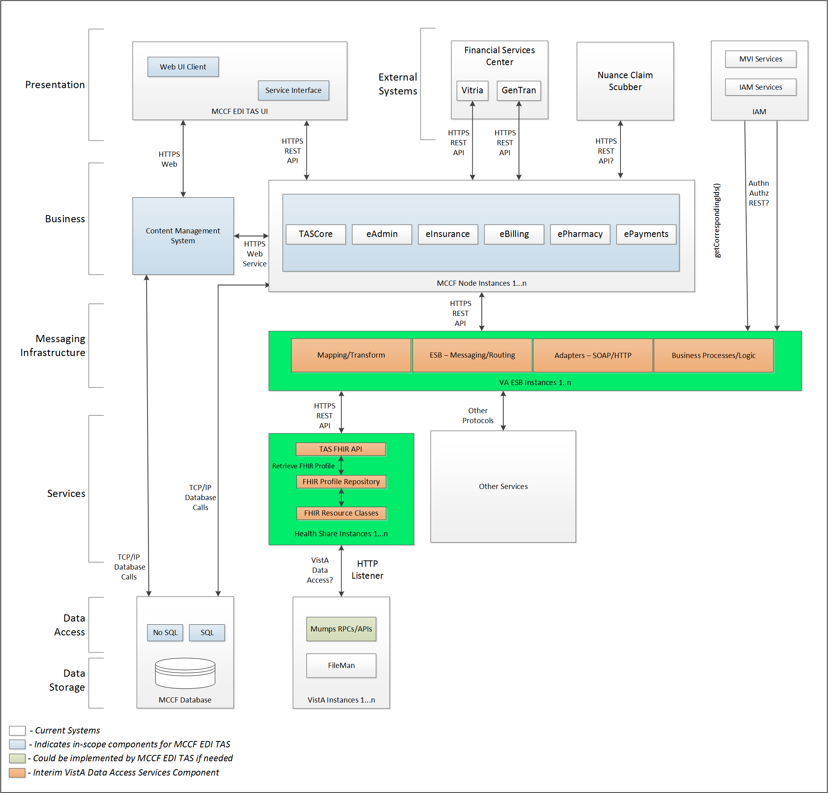

## Interface Overview

Exchanging messages between MCCF EDI TAS ePharmacy and FSC can be done in real time or via message queuing.

### Connectivity between the systems

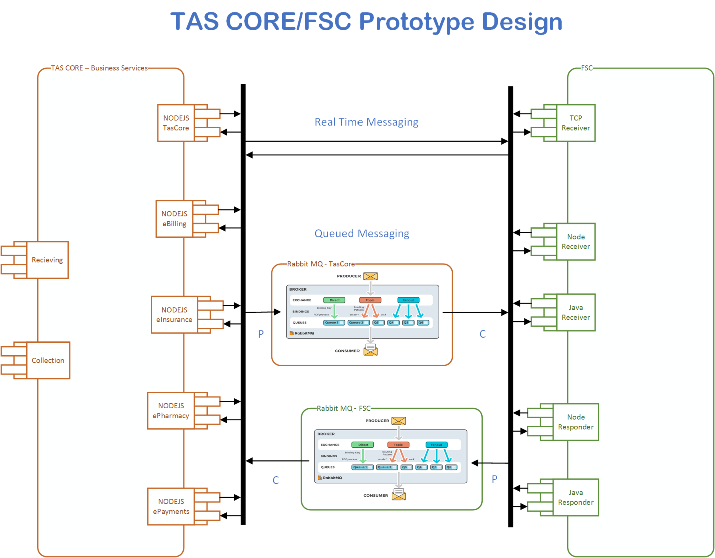

## Operations

Tbd

### Data Extraction

Data being sent to FSC will be extracted from the VistA databases using a FHIR server.

### Data Transformation

Tbd

### Sending/Receiving

MCCF EDI TAS ePharmacy sends and receives B2 messages to and from FSC.

## Data Transfer

Data is transferred between the FSC and the TASCore Application Stack.

## Transaction Types

MCCF EDI TAS ePharmacy sends messages (either FHIR bundles of FHIR resources or as a FHIR bundle containing a single Communication FHIR resource) to the FSC that are needed by the FSC so FSC can properly format and send a Claim Billing Reversal Request (B2) requests (transaction) to payers.

FSC receives Claim Billing Reversal Response (B2) from payers and transmits that data in FHIR resources inside FHIR bundles (or inside a single bundle with a FHIR Communication resource) to MCCF EDI TAS.

## Data Exchanges

MCCF EDI TAS ePharmacy either sends a Claim Billing Reversal Request (B2) FHIR bundle or a Communication FHIR resource containing Claim Billing Reversal Request (B2) in NCPDP format to FSC and receives either a Claim Billing Reversal Request (B2) response FHIR bundle or a Communication FHIR resource containing a Claim Billing Reversal Request (B2) response in NCPDP format from FSC. Refer to Section Appendix A.

There are four different types of Claim Billing Reversal Request (B2) responses the FSC can send to MCCF EDI TAS ePharmacy:

* TRANSMISSION ACCEPTED/TRANSACTION APPROVED
* TRANSMISSION ACCEPTED/TRANSACTION CAPTURED
* TRANSMISSION ACCEPTED/TRANSACTION REJECTED
* TRANSMISSION REJECTED/TRANSACTION REJECTED

### FHIR Based Resources

The following FHIR resources are needed to assemble a Claim Billing Reversal Request (B2) request bundle

* Basic
* Claim
* ClaimResponse
* Condition
* Coverage
* EligibilityRequest
* Encounter
* ExplanationOfBenefit
* HealthcareService
* Medication
* MedicationAdministration
* MedicationDispense
* MedicationRequest
* MessageHeader
* Organization
* Patient
* Procedure
* RelatedPerson

The following FHIR resources are needed to send a Claim Billing Reversal Request (B2) request inside the Communication resource

* Communication

The following FHIR resources are needed to assemble a Claim Billing Reversal Request (B2) response bundle

* For TRANSMISSION ACCEPTED/TRANSACTION APPROVED responses
  + Basic
  + CarePlan
  + ChargeItem
  + Claim
  + ClaimResponse
  + Communication
  + EligibilityResponse
  + Encounter
  + ExplanationOfBenefit
  + Medication
  + MedicationAdministration
  + MedicationDispense
  + MedicationRequest
  + MessageHeader
  + Organization
  + PaymentReconciliation
  + ProcessRequest
  + ProcessResponse
  + Substance
* For TRANSMISSION ACCEPTED/TRANSACTION CAPTURED responses
  + Basic
  + CarePlan
  + ChargeItem
  + ClaimResponse
  + Communication
  + Coverage
  + EligibilityResponse
  + Encounter
  + ExplanationOfBenefit
  + Medication
  + MedicationAdministration
  + MedicationDispense
  + MessageHeader
  + Organization
  + ProcessRequest
  + ProcessResponse
  + Substance
* For TRANSMISSION ACCEPTED/TRANSACTION REJECTED responses
  + Basic
  + CarePlan
  + ChargeItem
  + ClaimResponse
  + Communication
  + EligibilityResponse
  + Encounter
  + ExplanationOfBenefit
  + Medication
  + MedicationAdministration
  + MedicationDispense
  + MedicationRequest
  + MessageHeader
  + Organization
  + ProcessRequest
  + ProcessResponse
  + Substance
* For TRANSMISSION REJECTED/TRANSACTION REJECTED responses
  + Basic
  + ClaimResponse
  + Communication
  + EligibilityResponse
  + Encounter
  + MedicationAdministration
  + MessageHeader
  + Organization
  + ProcessRequest
  + ProcessResponse

### JSON Format

Messages are formatted using the JSON format.

Refer to <https://www.hl7.org/fhir/json.html> for JSON representation of FHIR Resources.

#### B2 Request FHIR bundle

A bundle implementing a B2 request sent to FSC will have the following structure:

See appendix A.

#### B2 Request using the Communication FHIR resource

See appendix A.

#### B2 Response FHIR bundle

A bundle implementing a B2 responses sent from FSC will have the following structure:

* TRANSMISSION ACCEPTED/TRANSACTION APPROVED
  + See appendix A
* TRANSMISSION ACCEPTED / TRANSACTION CAPTURED
  + See appendix A
* TRANSMISSION ACCEPTED/TRANSACTION REJECTED
  + See appendix A
* TRANSMISSION REJECTED/TRANSACTION REJECTED
  + See appendix A

#### B2 Response using the Communication FHIR Resource

See appendix A.

### Bundle Definition

A Bundle is a top-level container in FHIR that contains all the FHIR resources desired for a transaction between MCCF EDI TAS and FSC.

A Bundle is a container for resources, enabling grouping and transmitting resources altogether at once. Resources such as Claim, Patient, etc. will be transmitted inside multiple entries (see entry list inside Bundle) as a resource type.

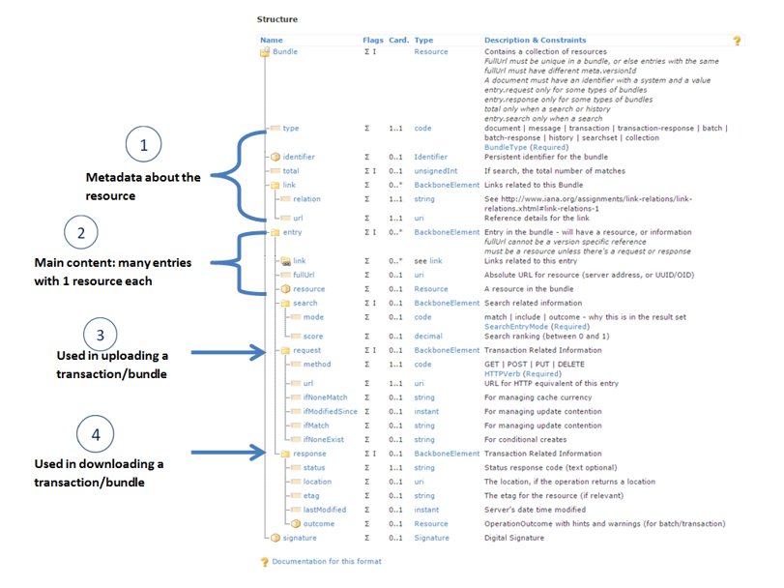

Figure - Source https://fhir-drills.github.io/bundle.html

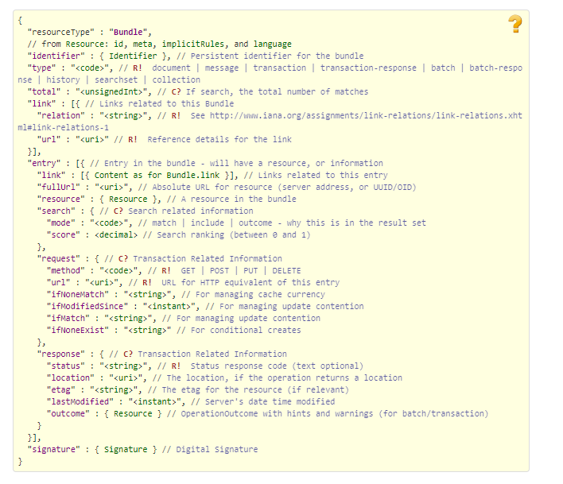

Figure - Source <https://www.hl7.org/fhir/bundle.html>

## Communications Methods

### Ports and Protocols

#### HTTP(S)

Can be used for real time communication.

#### AMQP

AMQP offers reliable messaging via queues.

### ESB Configuration(s)

Tbd

### System Configuration

Tbd

## Performance Requirements

System Design Document (SDD); Medical Care Collection Fund (MCCF) - Electronic Data Interchange Transaction Application Suite (EDI TAS).

## Security

System Design Document (SDD); Medical Care Collection Fund (MCCF) - Electronic Data Interchange Transaction Application Suite (EDI TAS).

### Is within the VA firewall

Tbd

## Testing Requirements

System Design Document (SDD); Medical Care Collection Fund (MCCF) - Electronic Data Interchange Transaction Application Suite (EDI TAS).

### Comparison of Data

Tbd

### Completeness

Tbd

## Policies and Constraints

Tbd

### HIPAA Compliance

FSC receives transactions and then translates them into standard NCPDP Claim Billing Reversal Request (B2), validates whether the data complies with HIPAA standards and then forwards the claim data to the VA Healthcare Clearing House (HCCH).

# Appendix A

## Data Elements

## Bundle

Repeating fields within a segment need context definition so they can be differentiated within a segment.

Also, repeating fields across multiple segments need to be differentiated. Following steps have been used to assign context to fields.

1. Identify the segment where the resource is located (Bundle.entry.extension.url="segment" and Bundle.entry.extension.valueString="278-EVN") [MessageType-Segment]

2. Where elements repeat within a segment use extension.valueString to identify field (Basic.extension.url="sequence" and Basic.extension.valueString="278-MSH-16" or Location.identifier.extension.url="sequence" and Location.identifier.extension.valueString="278-MSH-3") [MessageType-Segment-Field]

3. Repeating segments will include an incrementing id (MSA1, MSA2, ...)

## Resource Sections 1..N

### Claim Billing Reversal Request (B2) request bundle

#### Basic

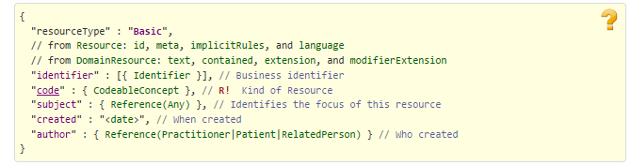

Figure Source https://www.hl7.org/fhir/basic.html

#### Claim

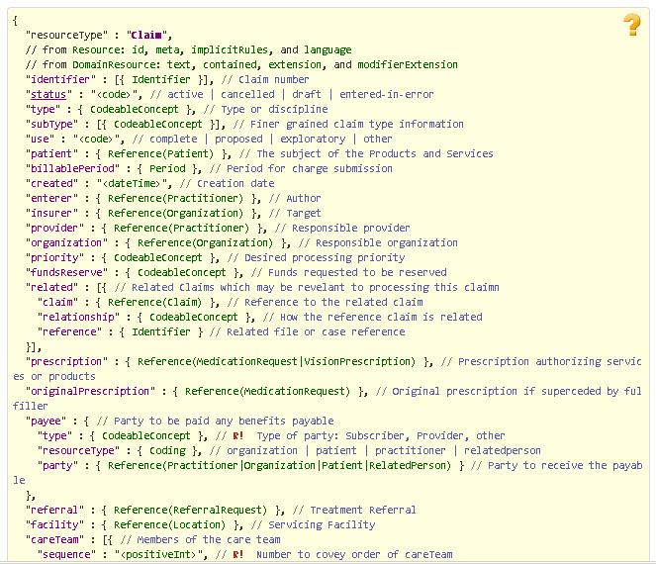

Figure Source http://www.hl7.org/fhir/claim.html Part 1

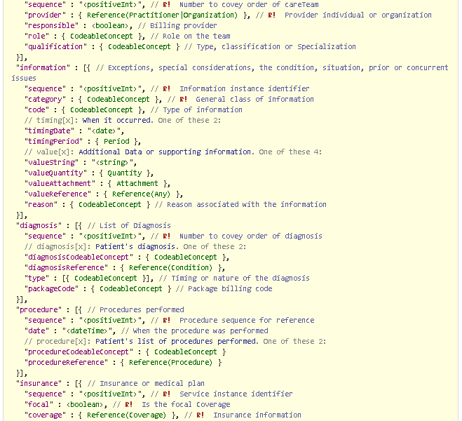

Figure Source http://www.hl7.org/fhir/claim.html Part 2

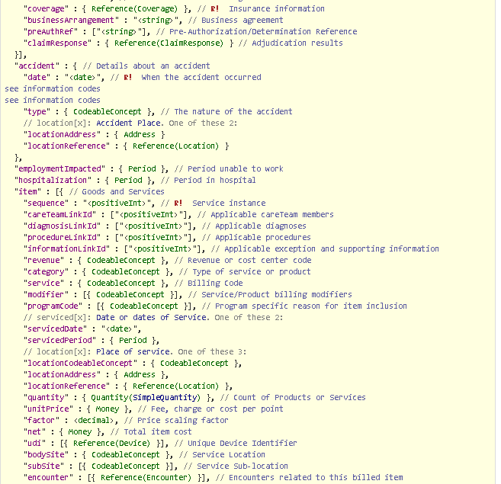

Figure Source http://www.hl7.org/fhir/claim.html Part 3

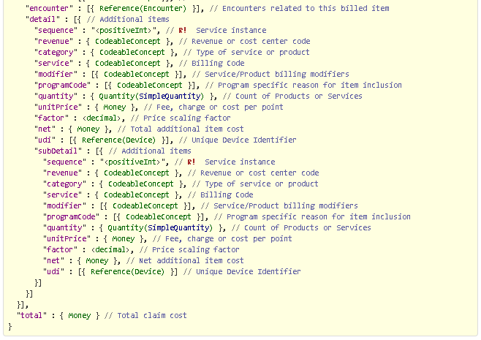

Figure Source <http://www.hl7.org/fhir/claim.html> Part 4

#### ClaimResponse

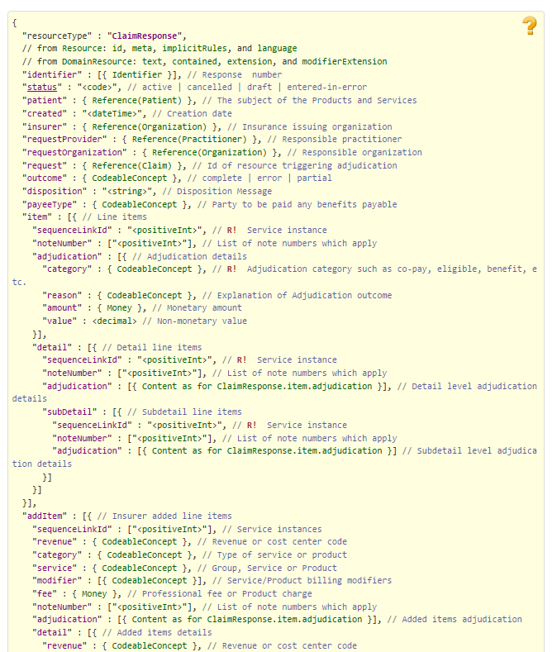

Figure Source https://www.hl7.org/fhir/claimresponse.html - Part 1

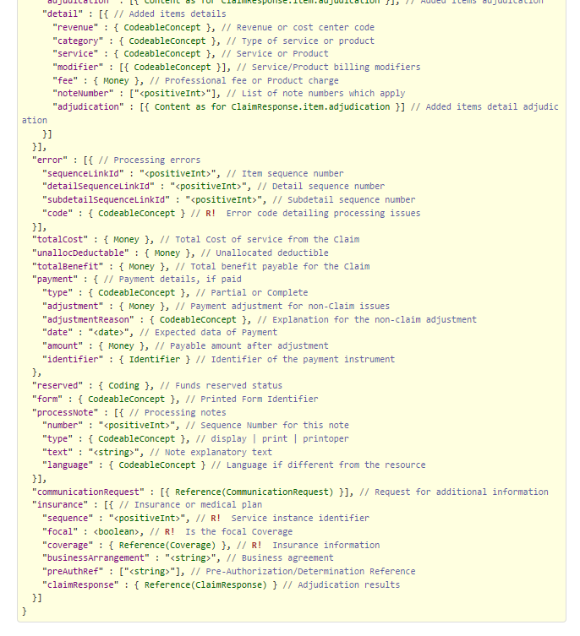

Figure Source https://www.hl7.org/fhir/claimresponse.html - Part 2

#### Condition

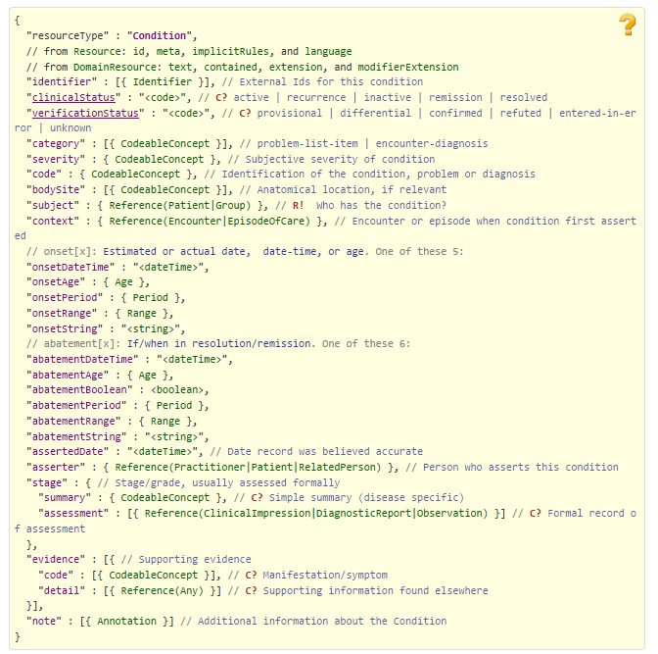

Figure Source https://www.hl7.org/fhir/condition.html

#### Coverage

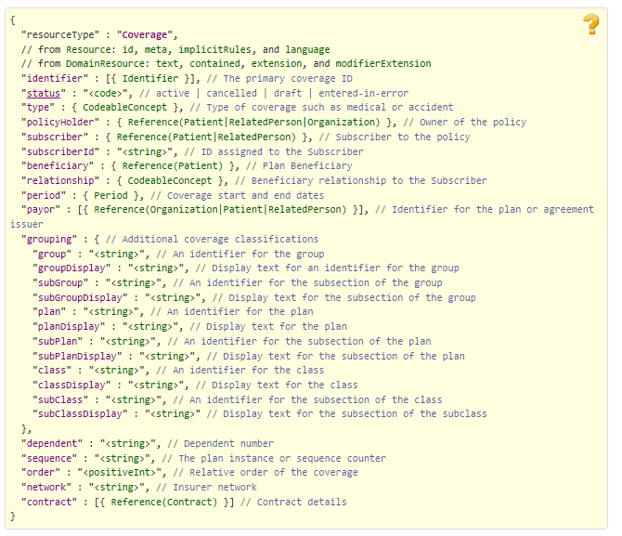

Figure Source https://www.hl7.org/fhir/coverage.html

#### EligibilityRequest

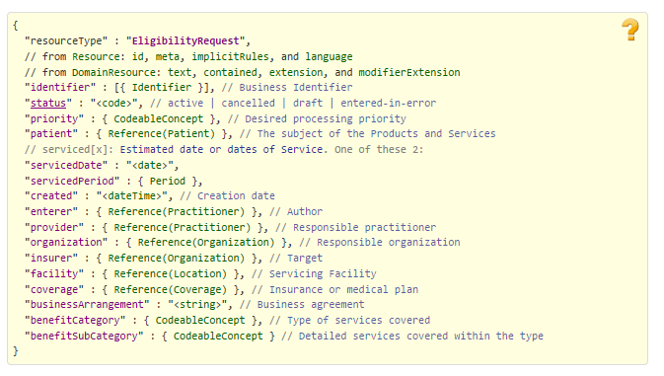

Figure Source https://www.hl7.org/fhir/eligibilityrequest.html

#### Encounter

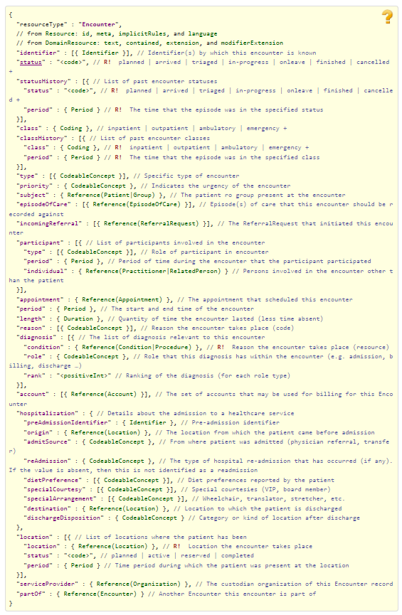

Figure Source https://www.hl7.org/fhir/encounter.html

#### ExplanationOfBenefit

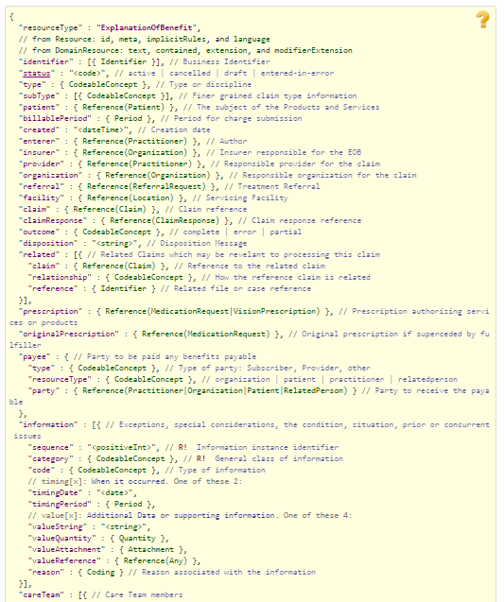

Figure Source http://www.hl7.org/fhir/explanationofbenefit.html Part 1

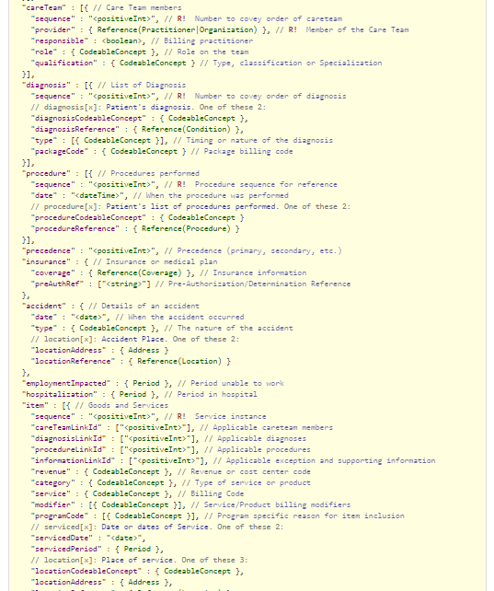

Figure Source http://www.hl7.org/fhir/explanationofbenefit.html Part 2

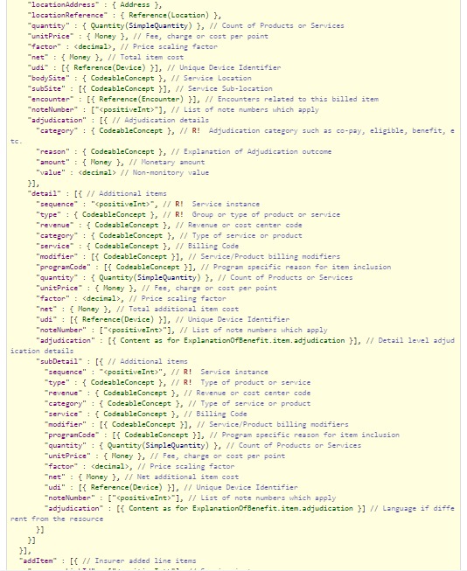

Figure Source http://www.hl7.org/fhir/explanationofbenefit.html Part 3

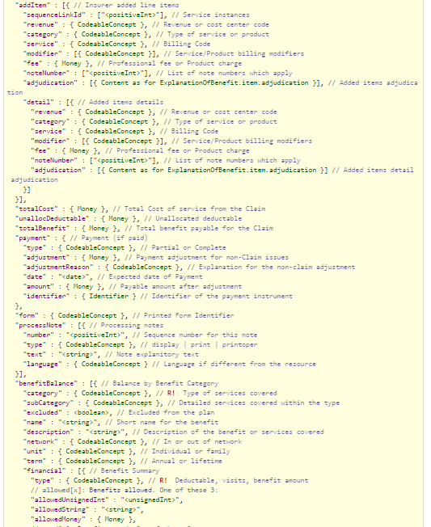

Figure Source http://www.hl7.org/fhir/explanationofbenefit.html Part 4

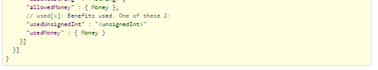

Figure Source http://www.hl7.org/fhir/explanationofbenefit.html Part 5

#### HealthcareService

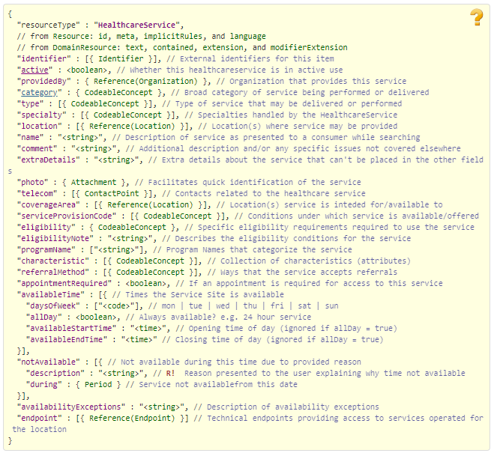

Figure Source http://www.hl7.org/fhir/healthcareservice.html

#### Medication

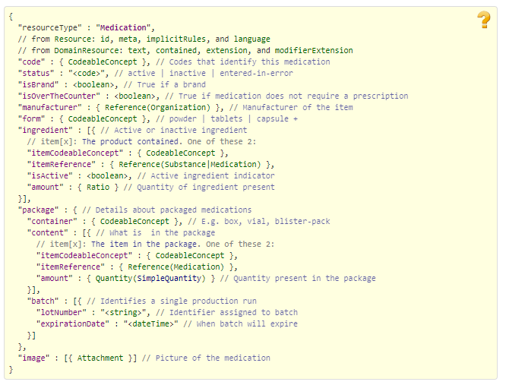

Figure Sourcehttp://www.hl7.org/fhir/medication.html

#### MedicationAdministration

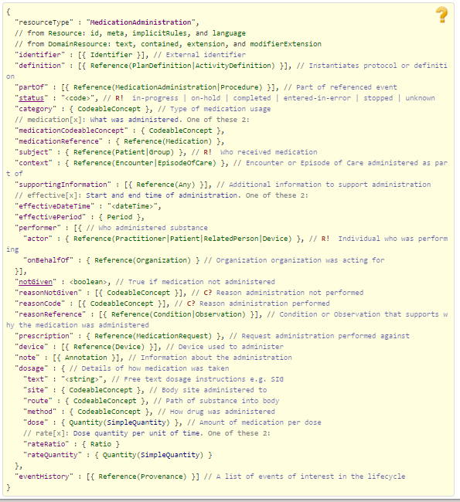

Figure Source http://www.hl7.org/fhir/medicationadministration.html

#### MedicationDispense

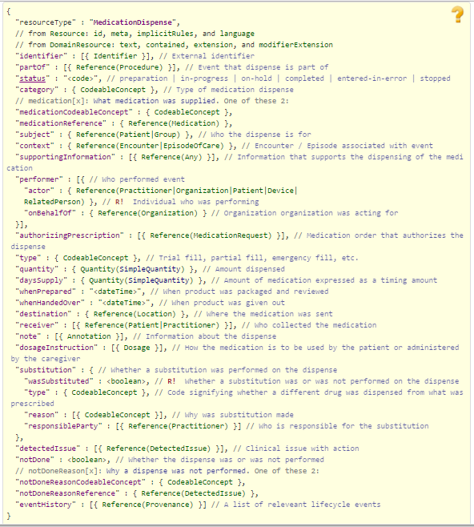

Figure Source http://www.hl7.org/fhir/medicationdispense.html

#### MedicationRequest

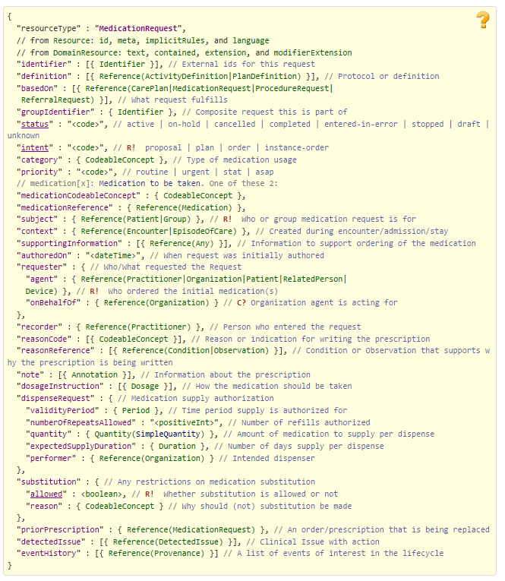

Figure Source https://www.hl7.org/fhir/medicationrequest.html

#### MessageHeader

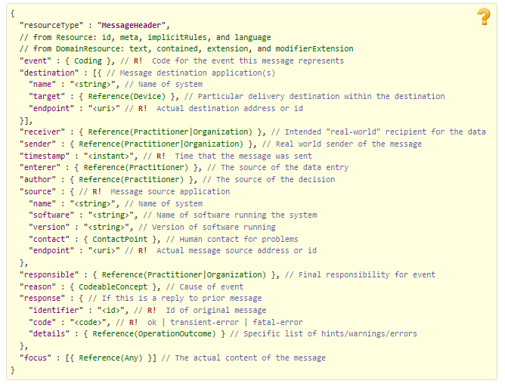

Figure Source https://www.hl7.org/fhir/messageheader.html

#### Organization

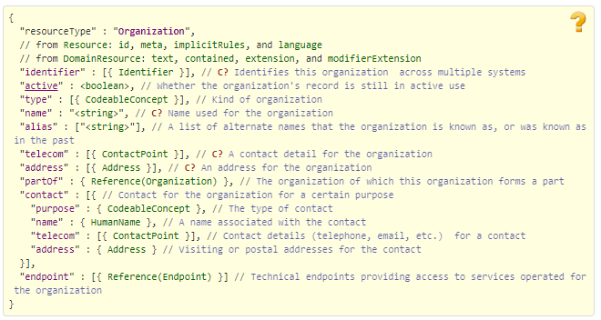

Figure Source http://www.hl7.org/fhir/organization.html

#### Patient

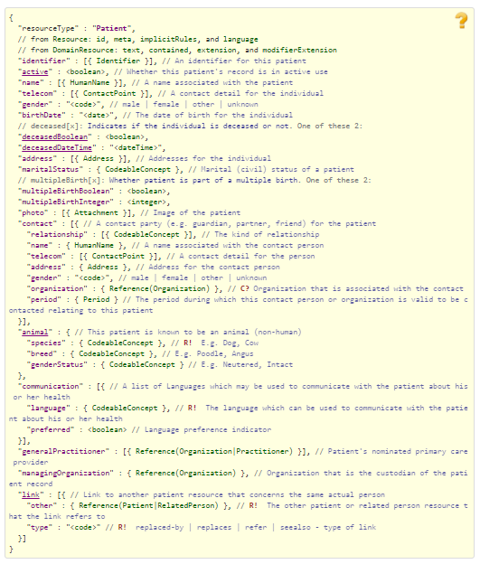

Figure Source http://www.hl7.org/fhir/patient.html

#### Procedure

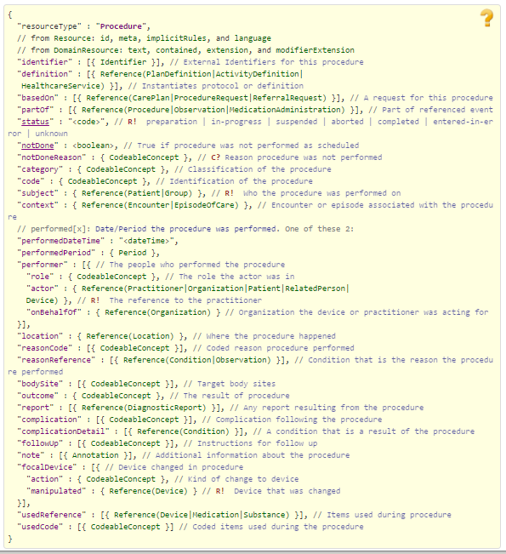

Figure Source http://www.hl7.org/fhir/procedure.html

#### RelatedPerson

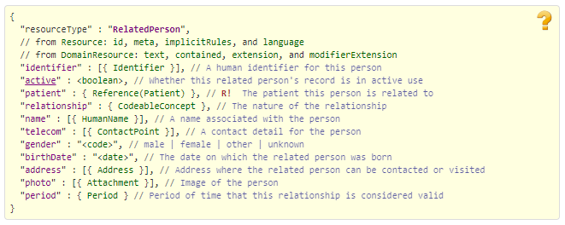

Figure Source http://www.hl7.org/fhir/relatedperson.html

### Request (B2) request inside the Communication resource

#### Communication

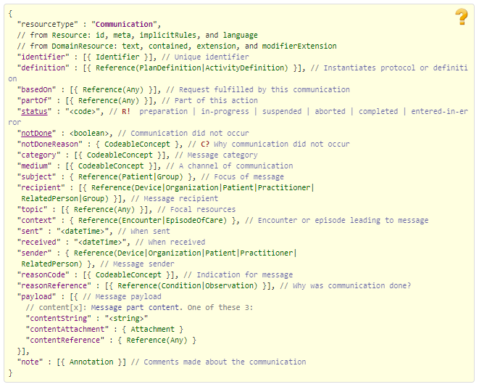

Figure Source http://www.hl7.org/fhir/communication.html

### Claim Billing Reversal Request (B2) response bundles

### For TRANSMISSION ACCEPTED/TRANSACTION APPROVED responses

#### Basic

See above.

#### CarePlan

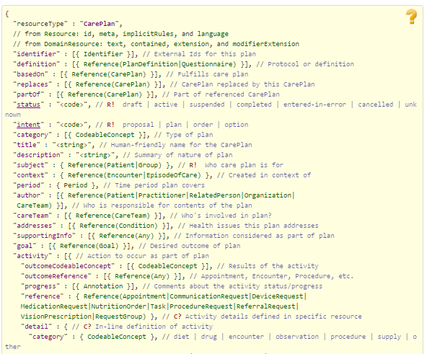

Figure Source [http://www.hl7.org/fhir/careplan.html Part 1](http://www.hl7.org/fhir/careplan.html%20Part%201)

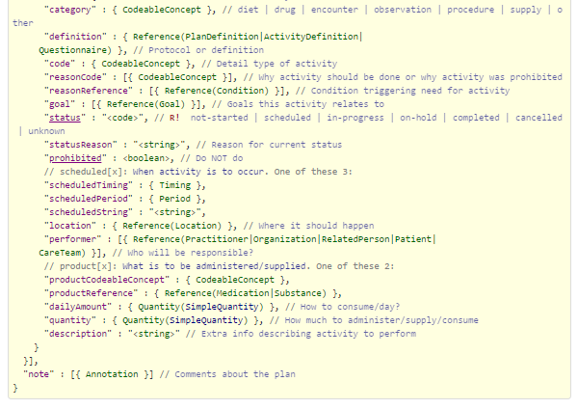

Figure Source http://www.hl7.org/fhir/careplan.html Part 2

#### ChargeItem

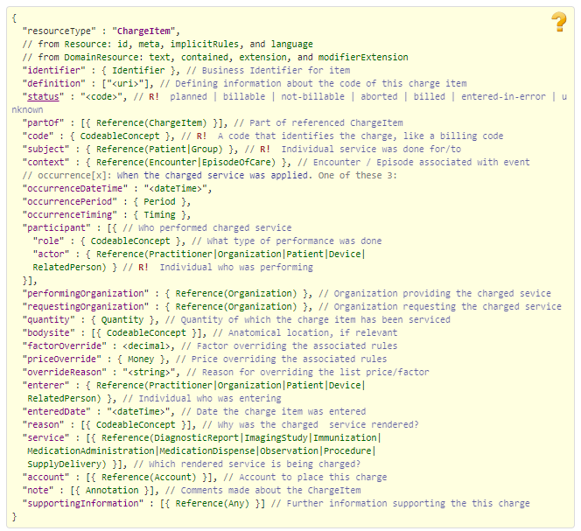

Figure Source http://www.hl7.org/fhir/chargeitem.html

#### Claim See above

#### ClaimResponse See above

#### Communication See above

#### EligibilityResponse

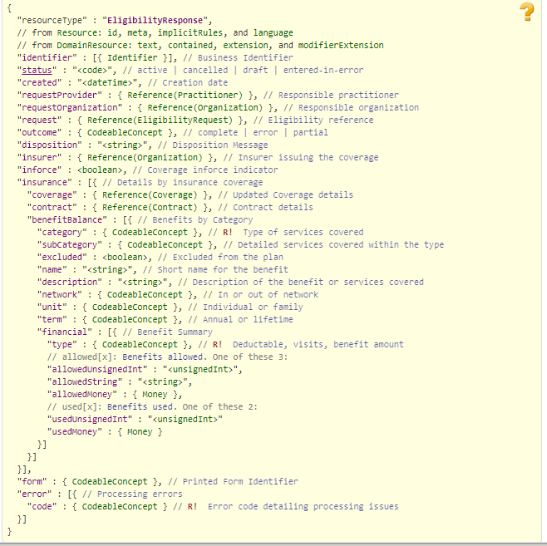

Figure Source http://www.hl7.org/fhir/eligibilityresponse.html

#### Encounter See above

#### ExplanationOfBenefit See above

#### Medication See above

#### MedicationAdministration See above

#### MedicationDispense See above

#### MedicationRequest See above

#### MessageHeader See above

#### Organization See above

#### PaymentReconciliation

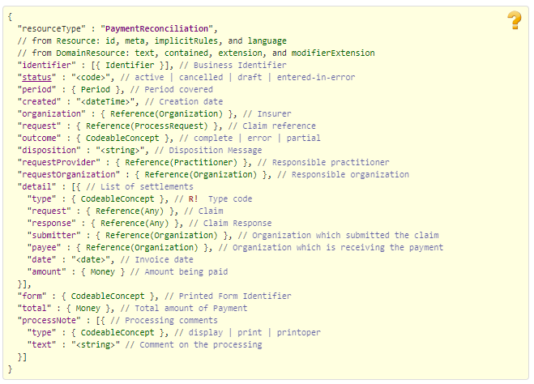

Figure Source http://www.hl7.org/fhir/paymentreconciliation.html

#### ProcessRequest

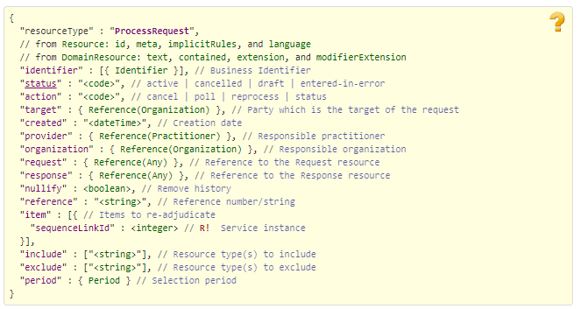

Figure Source http://www.hl7.org/fhir/processrequest.html

#### ProcessResponse

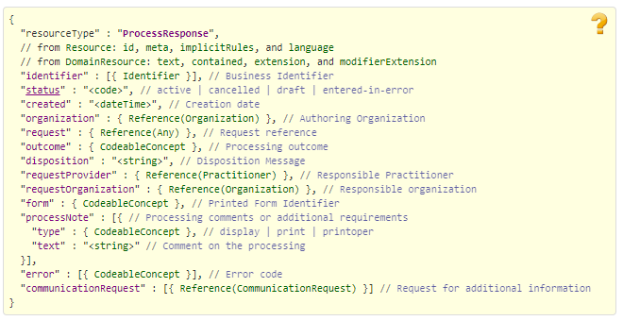

Figure Source http://www.hl7.org/fhir/processresponse.html

#### Substance

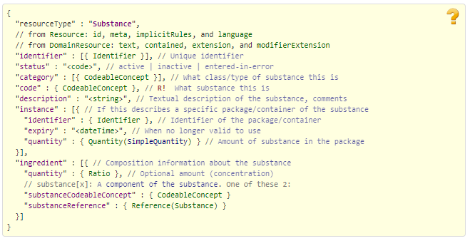

Figure Source http://www.hl7.org/fhir/substance.html

### For TRANSMISSION ACCEPTED/TRANSACTION CAPTURED responses

#### Basic

See above.

#### CarePlan

See above.

#### ChargeItem

See above.

#### ClaimResponse

See above.

#### Communication

See above.

#### Coverage

See above.

#### EligibilityResponse

See above.

#### Encounter

See above.

#### ExplanationOfBenefit

See above.

#### Medication

See above.

#### MedicationAdministration

See above.

#### MedicationDispense

See above.

#### MessageHeader

See above.

#### Organization

See above.

#### ProcessRequest

See above.

#### ProcessResponse

See above.

#### Substance

See above.

### For TRANSMISSION ACCEPTED/TRANSACTION REJECTED responses

#### Basic

See above.

#### CarePlan

See above.

#### ChargeItem

See above.

#### ClaimResponse

See above.

#### 

#### Communication

See above.

#### EligibilityResponse

See above.

#### Encounter

See above.

#### ExplanationOfBenefit

See above.

#### Medication

See above.

#### MedicationAdministration

See above.

#### MedicationDispense

See above.

#### MedicationRequest

See above.

#### MessageHeader

See above.

#### Organization

See above.

#### ProcessRequest

See above.

#### ProcessResponse

See above.

#### Substance

See above.

### For TRANSMISSION REJECTED/TRANSACTION REJECTED responses

#### Basic

See above.

#### ClaimResponse

See above.

#### Communication

See above.

#### EligibilityResponse

See above.

#### Encounter

See above.

#### MedicationAdministration

See above.

#### MessageHeader

See above.

#### Organization

See above.

#### ProcessRequest

See above.

#### ProcessResponse

See above.

### Embedded following columns:

#### Element #

#### Max Length

#### FSC Transaction Location

#### FSC Comments

#### FHIR Resource

#### TASCore Comments

## Appendix B - TASCore Mapping Rules

## Appendix C – TASCore Default Values

## Appendix D – FSC Mapping Rules

## Appendix E – FSC Default Values