Medical Care Collections Fund (MCCF) ePharmacy

Electronic Data Interchange (EDI)

Transactions Applications Suite (TAS)

Interface Control Document

National Council for Prescription Drug Programs (NCPDP)

Claim Billing Rebill (B3)

Logo for the Department of Veterans Affairs, Office of Information and Technology, Product Development, including the official seal of the Department of Veterans Affairs


Department of Veterans Affairs

March 2018

Version 1

Revision History

|  |  |  |  |
| --- | --- | --- | --- |
| Date | Version | Description | Author |
| 2/23/18 | 0.0.1 | Initial creation of document | Steffen Maerdian - Halfaker |
| 2/26/18 | 0.0.2 | Formatting and content updates for initial draft | Keith Oulson – Halfaker and Associates |
| 3/2/18 | 0.9 | Finalization of the draft | Keith Oulson – Halfaker & Associates |
| 3/5/18 | 1 | Review | Steffen Maerdian - Halfaker |
|  |  |  |  |
|  |  |  |  |
|  |  |  |  |
|  |  |  |  |
|  |  |  |  |
|  |  |  |  |
|  |  |  |  |
|  |  |  |  |
|  |  |  |  |
|  |  |  |  |
|  |  |  |  |
|  |  |  |  |
|  |  |  |  |
|  |  |  |  |
|  |  |  |  |
|  |  |  |  |

Table of Contents

1 Introduction 1

1.1 Purpose 1

1.2 Scope 1

1.3 System Identification 1

1.3.1 MCCF EDI TAS ePharmacy 1

1.3.2 FSC 2

1.4 Operational Agreement 2

2 Interface Definition 2

2.1 System Overview 2

2.1.1 Overview Diagram 3

2.2 Interface Overview 4

2.2.1 Connectivity between the systems 5

2.3 Operations 5

2.3.1 Data Extraction 5

2.3.2 Data Transformation 5

2.3.3 Sending/Receiving 6

2.4 Data Transfer 6

2.5 Transaction Types 6

2.6 Data Exchanges 6

2.6.1 FHIR Based Resources 6

2.6.2 JSON Format 10

2.6.3 Bundle Definition 11

2.7 Communications Methods 13

2.7.1 Ports and Protocols 13

2.7.2 ESB Configuration(s) 13

2.7.3 System Configuration 14

2.8 Performance Requirements 14

2.9 Security 14

2.9.1 Is within the VA firewall 14

2.10 Testing Requirements 14

2.10.1 Comparison of Data 14

2.10.2 Completeness 14

2.11 Policies and Constraints 14

2.11.1 HIPAA Compliance 14

3 Appendix A 15

3.1 Data Elements 15

3.2 Bundle 15

3.3 Resource Sections 1..N 15

3.3.1 Claim Billing Rebill (B3) request bundle 15

3.3.2 Claim Billing Rebill (B3) request bundle inside the Communication resource 45

3.3.3 Claim Billing Rebill (B3) response bundle For TRANSMISSION ACCEPTED/TRANSACTION PAID responses 46

3.3.4 For TRANSMISSION ACCEPTED/TRANSACTION CAPTURED responses 55

3.3.5 For TRANSMISSION ACCEPTED/TRANSACTION REJECTED responses 56

3.3.6 For TRANSMISSION REJECTED/TRANSACTION REJECTED responses 57

3.3.7 Embedded following columns: 57

3.4 Appendix B - TASCore Mapping Rules 57

3.5 Appendix C – TASCore Default Values 57

3.6 Appendix D – FSC Mapping Rules 57

3.7 Appendix E – FSC Default Values 57

# Introduction

This document describes the interface between a MCCF EDI TAS ePharmacy application and the VA Financial Services Center in Austin, TX (FSC) for National Council for Prescription Drug Programs (NCPDP) Claim Billing (B3) messages.

## Purpose

The purpose of this Interface Control Document (ICD) is to define the message structure and protocols which govern the interchange of data between ePharmacy within MCCF EDI TAS and the FSC related to the electronic processing of NCPDP Claim Billing Rebill (B3) messages.

## Scope

This Interface Control Document describes a generalized interface between TAS Platform and the system(s) at the FSC. specifies the interface between MCCF EDI TAS ePharmacy and FSC. This document provides details on the functional, performance, operational and design requirements for the interface. This document defines the layouts for the data that the FSC sends to MCCF EDI TAS ePharmacy. This document is intended for all parties requiring such information, including business stakeholders, end-users, software developers, system designers, testers and anyone else responsible for implementing this interface.

## System Identification

MCCF EDI TAS ePharmacy is a software designed to support the requests and responses related to Claim Billing information sent to and received from the FSC. This interface supports the electronic transmission of Claim Billing Rebill (B3) between FSC and MCCF EDI TAS ePharmacy.

### MCCF EDI TAS ePharmacy

The TAS Platform will modernize and automate the business processes used currently as part of the VA revenue cycle. This includes insurance verification, billing, and claims processing, payment, and remittance. These processes are tied to other processes that are out of scope, including documenting the care provided, coding treatment and encounters, and sending claims and receiving remittance to and from the clearinghouse.

This interface supports the electronic third-party billing process which involves the electronic transmission of Claim Billing Rebill Requests (B3) to Emdeon, the VA’s clearinghouse, where claims are either transmitted to the insurance company or sent to a printing facility.

|  |  |
| --- | --- |
| System | Details |
| Title |  |
| Abbreviation |  |
| Version number |  |
| Release number |  |
| Point of Contact |  |
| Vendor [optional] |  |
|  |  |

### FSC

The system(s) at FSC, receive(s) the data from the TAS Platform, translate(s) the data into a standard NCPDP Claim Billing Rebill Requests (B3) transmission, validate(s) the data complies with HIPAA standards and then forward(s) the claim data to Emdeon.

|  |  |
| --- | --- |
| System | Details |
| Title |  |
| Abbreviation |  |
| Version number |  |
| Point of Contact |  |
| Vendor [optional] |  |

## Operational Agreement

This ICD provides the specification for an interface between MCCF EDI TAS ePharmacy and FSC regarding Claim Billing data. The Chief Business Office (CBO) is responsible for notifying FSC personnel of any potential or planned changes to data feeds once these changes are known to minimize adverse impacts.

# Interface Definition

Claim Billing Rebill (B3) data is transmitted between the FSC and MCCF EDI TAS ePharmacy in FHIR bundles or inside a Communication FHIR resource.

## System Overview

The MCCF EDI TAS ePharmacy is software designed to facilitate transmission of Claim Billing Rebill (B3) requests and responses to and from the FSC. MCCF EDI TAS sends the data necessary as FHIR resources for FSC to format a B3 message.

FSC is designed to receive Claim Billing Rebill (B3) requests from MCCF EDI TAS ePharmacy and send them to payers. It is also designed to receive Claim Billing Rebill (B3) responses from payers and send them to MCCF EDI TAS ePharmacy as FHIR data.

### Overview Diagram

Interim solution

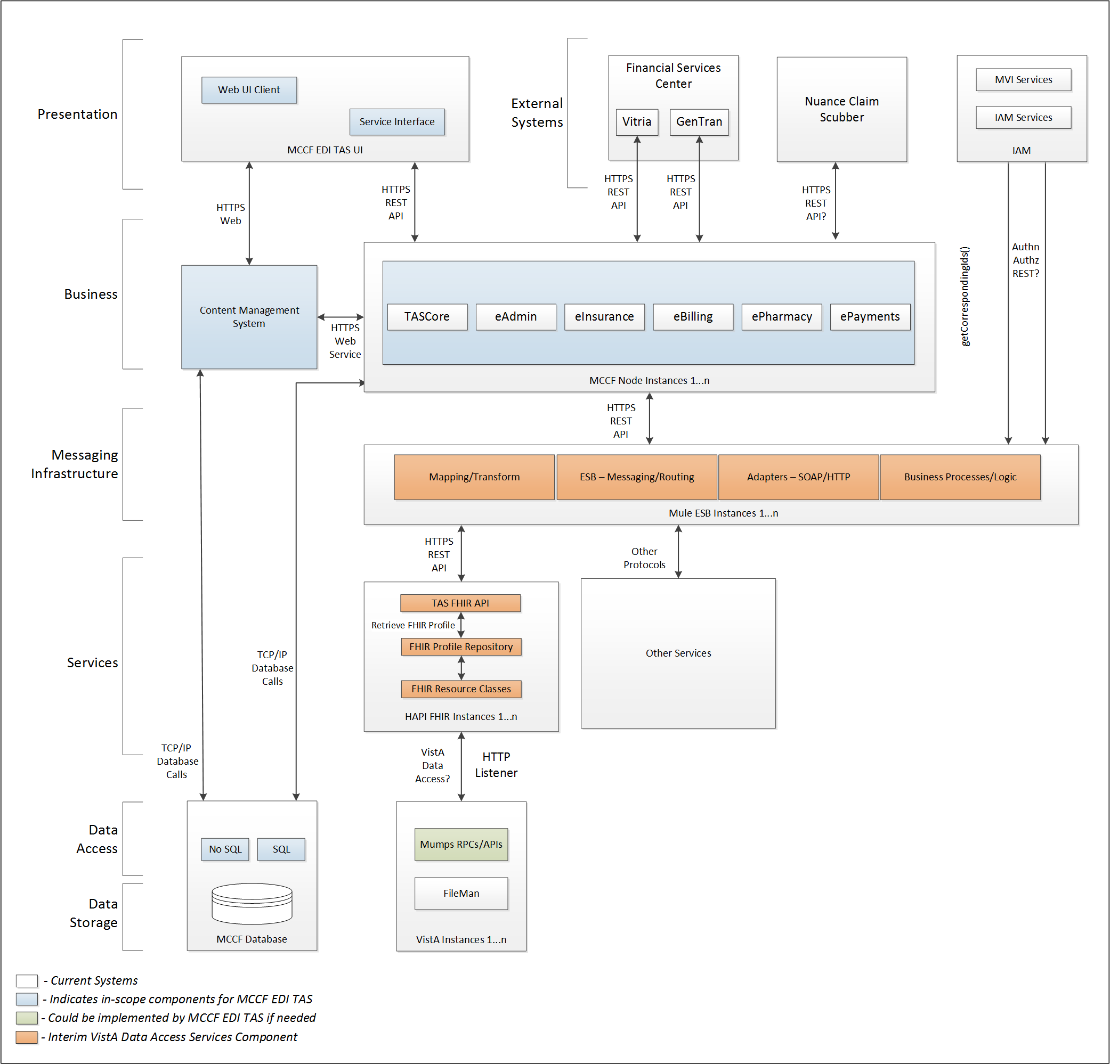

To be solution

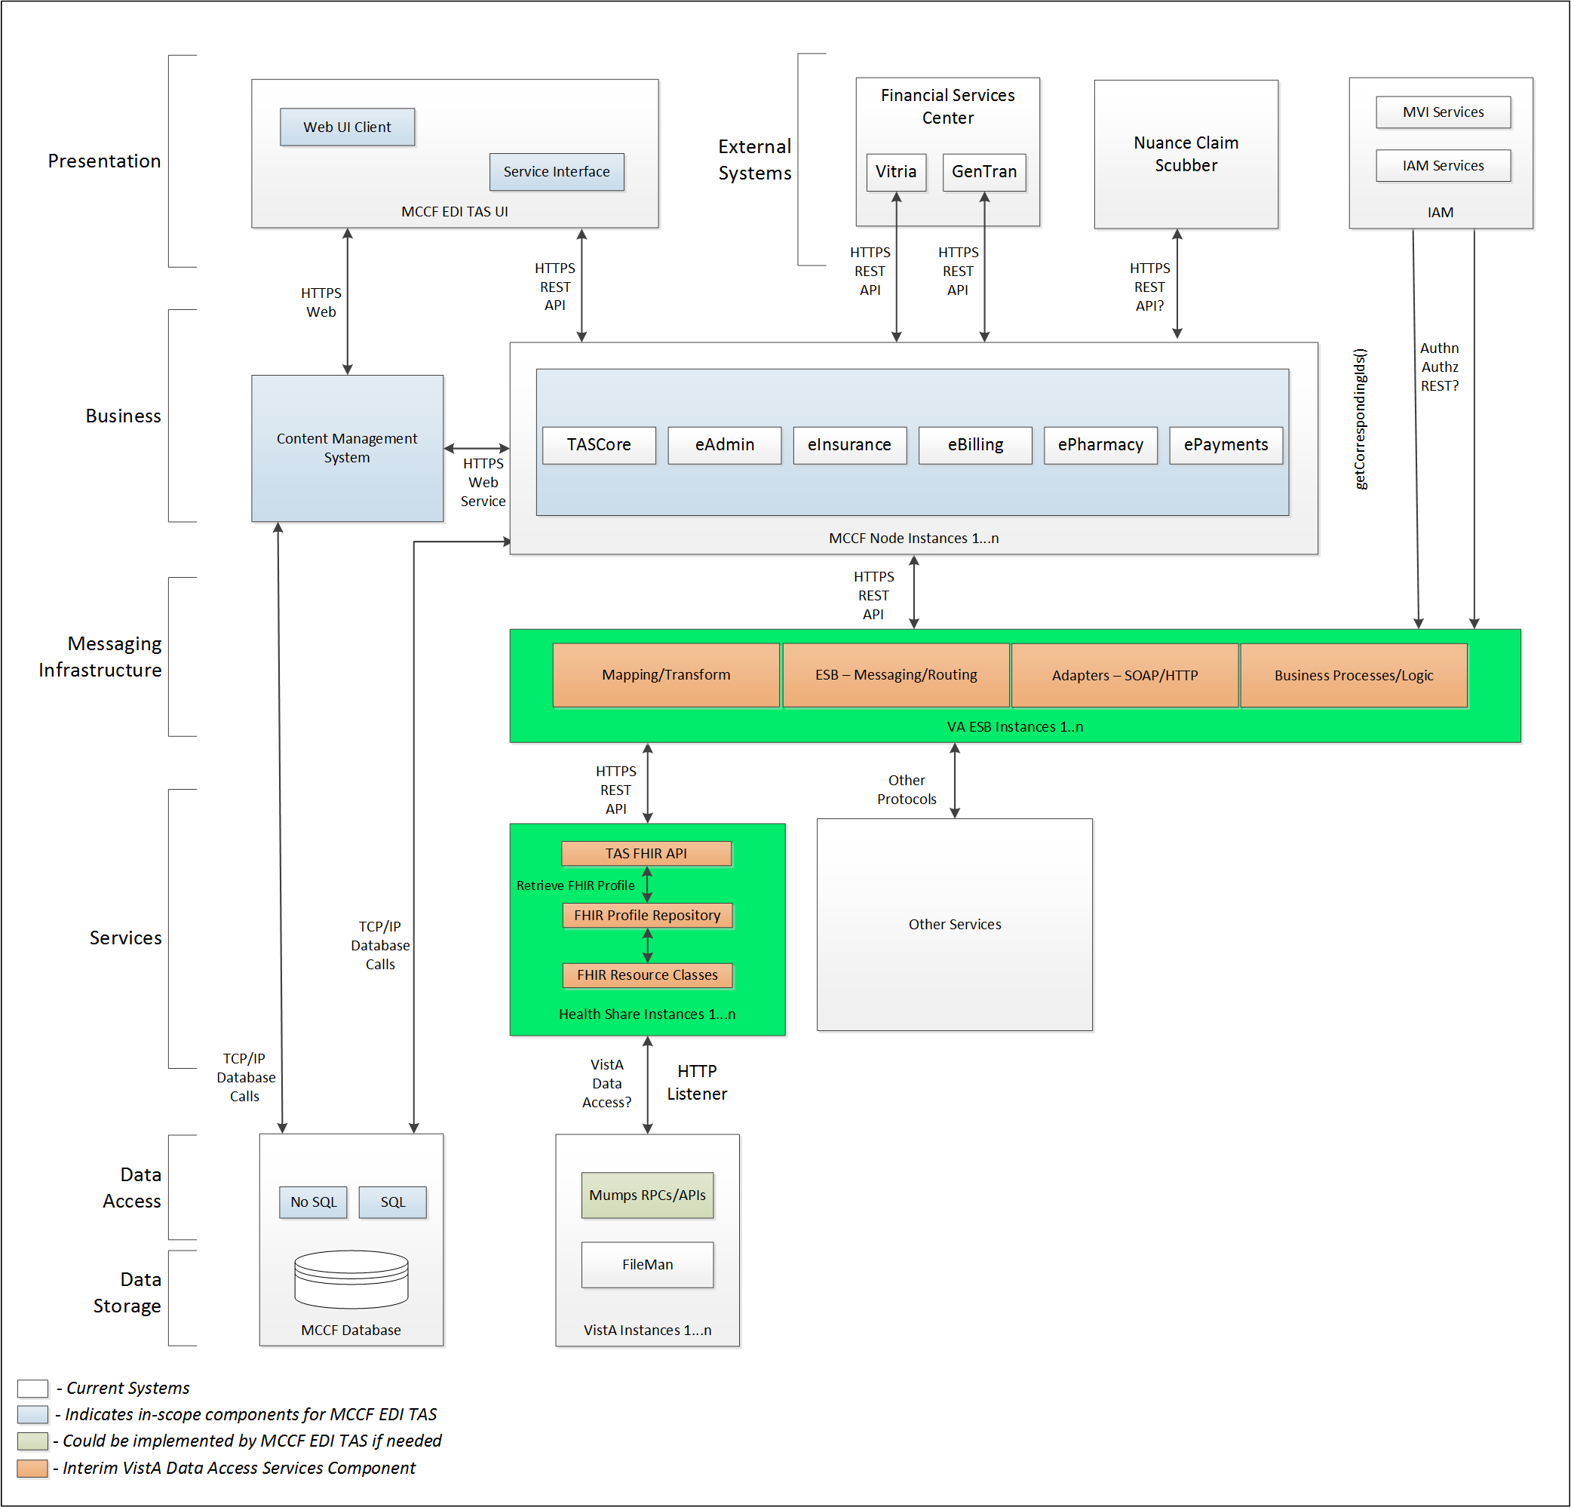

## Interface Overview

Exchanging messages between MCCF EDI TAS ePharmacy and FSC can be done in real time or via message queuing.

### Connectivity between the systems

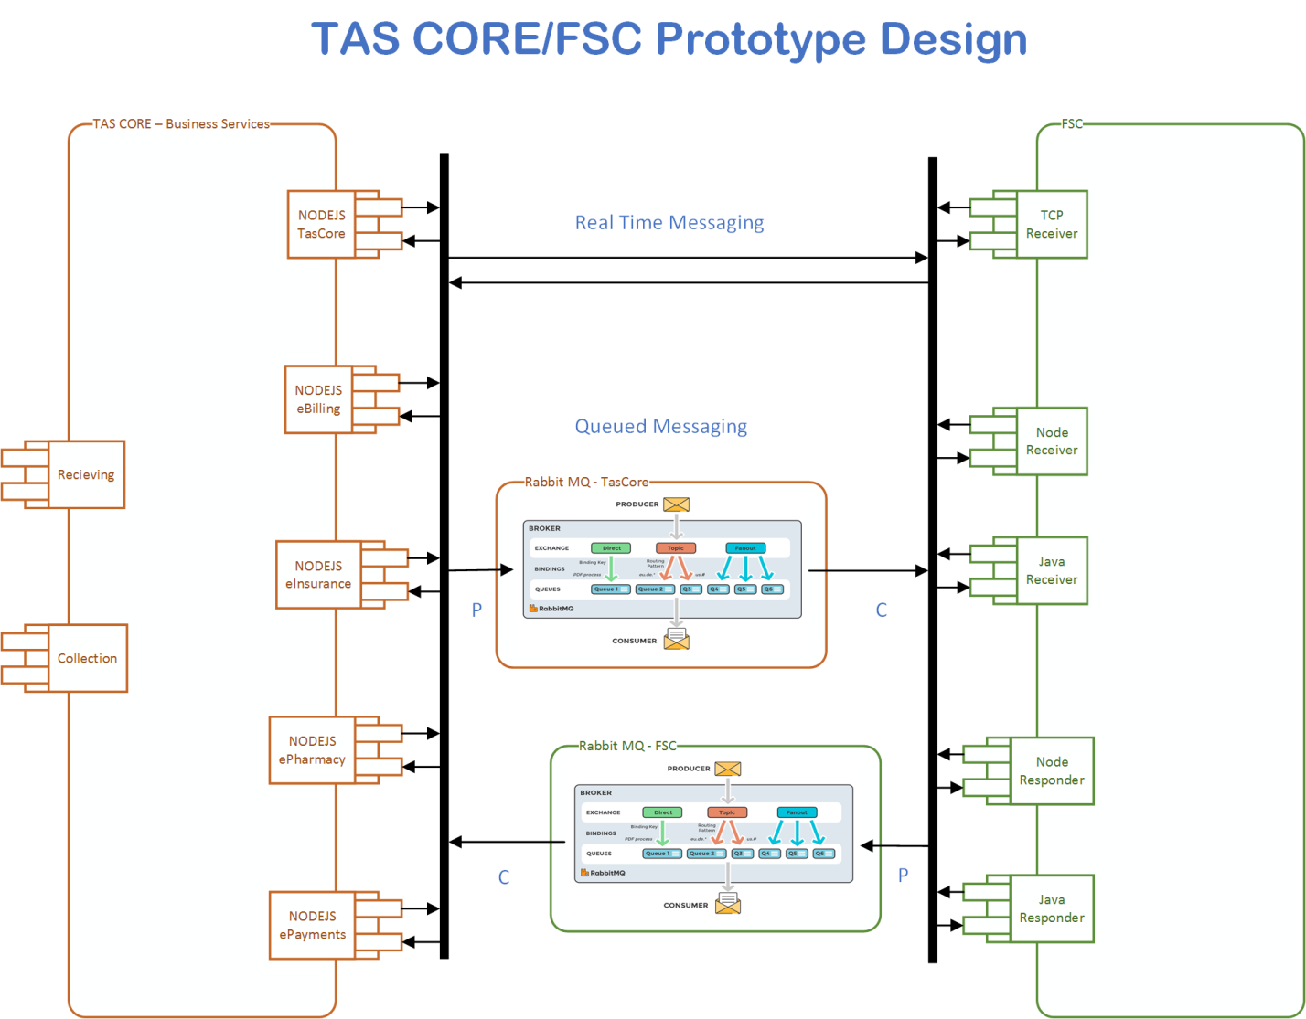

## Operations

Tbd

### Data Extraction

Data being sent to FSC will be extracted from the VistA databases using a FHIR server.

### Data Transformation

Tbd

### Sending/Receiving

MCCF EDI TAS ePharmacy sends and receives B3 messages to and from FSC.

## Data Transfer

Data is transferred between the FSC and the TASCore Application Stack.

## Transaction Types

MCCF EDI TAS ePharmacy sends messages (either FHIR bundle of FHIR resources or an NCPDP stream inside a Communication FHIR resource) to the FSC that are needed by the FSC so FSC can properly format and send a Claim Billing Rebill (B3) requests (transaction) to payers.

FSC receives Claim Billing Rebill (B3) responses from payers and transmits that data in FHIR resources inside a FHIR bundle (or as an NCPDP stream inside a FHIR Communication resource) to MCCF EDI TAS.

## Data Exchanges

MCCF EDI TAS ePharmacy either sends a Claim Billing Rebill (B3) request FHIR bundle or a Communication FHIR resource containing Claim Billing Rebill (B3) in NCPDP format to FSC and receives either a Claim Billing Rebill (B3) response FHIR bundle or a Communication FHIR resource containing a Claim Billing Rebill (B3) response in NCPDP format from FSC. Refer to Section Appendix A.

There are four different types of Claim Billing Rebill (B3) responses the FSC can send to MCCF EDI TAS ePharmacy:

* TRANSMISSION ACCEPTED/TRANSACTION PAID
* TRANSMISSION ACCEPTED/TRANSACTION CAPTURED
* TRANSMISSION ACCEPTED/TRANSACTION REJECTED
* TRANSMISSION REJECTED/TRANSACTION REJECTED

### FHIR Based Resources

The following FHIR resources are needed to assemble a Claim Billing Rebill (B3) request bundle

* Basic
* Claim
* ClaimResponse
* Communication
* Condition
* Coverage
* DocumentReference
* EligibilityRequest
* Encounter
* ExplanationOfBenefit
* HealthcareService
* Medication
* MedicationAdministration
* MedicationDispense
* MedicationRequest
* MessageHeader
* Observation
* Organization
* Patient
* Practitioner
* Procedure
* RelatedPerson
* Substance

The following FHIR resources are needed to send a Claim Billing Rebill (B3) request inside the Communication resource

* Communication

The following FHIR resources are needed to assemble a Claim Billing Rebill (B3) response bundle

* For TRANSMISSION ACCEPTED/TRANSACTION PAID responses
  + Basic
  + CarePlan
  + ChargeItem
  + Claim
  + ClaimResponse
  + Communication
  + Coverage
  + EligibilityResponse
  + Encounter
  + Medication
  + MedicationAdministration
  + MedicationDispense
  + MedicationRequest
  + MessageHeader
  + Organization
  + Patient
  + PaymentNotice
  + PaymentReconciliation
  + Person
  + Practitioner
  + ProcessRequest
  + ProcessResponse
  + Substance
* For TRANSMISSION ACCEPTED/TRANSACTION CAPTURED responses
  + Basic
  + CarePlan
  + ChargeItem
  + Claim
  + ClaimResponse
  + Communication
  + Coverage
  + EligibilityResponse
  + Encounter
  + ExplanationOfBenefit
  + Medication
  + MedicationAdministration
  + MedicationDispense
  + MessageHeader
  + Organization
  + Patient
  + PaymentNotice
  + PaymentReconciliation
  + Practitioner
  + ProcessRequest
  + ProcessResponse
  + Substance
* For TRANSMISSION ACCEPTED/TRANSACTION REJECTED responses
  + Basic
  + CarePlan
  + ChargeItem
  + ClaimResponse
  + Communication
  + Coverage
  + EligibilityResponse
  + Encounter
  + ExplanationOfBenefit
  + Medication
  + MedicationAdministration
  + MedicationDispense
  + MedicationRequest
  + MessageHeader
  + Organization
  + Patient
  + PaymentNotice
  + Person
  + Practitioner
  + ProcessRequest
  + ProcessResponse
  + Substance
* For TRANSMISSION REJECTED/TRANSACTION REJECTED responses
  + Basic
  + ClaimResponse
  + Communication
  + EligibilityResponse
  + Encounter
  + MedicationAdministration
  + MessageHeader
  + Organization
  + ProcessRequest
  + ProcessResponse

### JSON Format

Messages are formatted using the JSON format.

Refer to <https://www.hl7.org/fhir/json.html> for JSON representation of FHIR Resources.

#### B3 Request FHIR bundle

A bundle implementing a B3 request sent to FSC will have the following structure:

See Appendix A.

#### B3 Request using the Communication FHIR resource

See Appendix A.

#### B3 Response FHIR bundle

A bundle implementing a B3 responses sent from FSC will have the following structure:

* TRANSMISSION ACCEPTED/TRANSACTION PAID
  + See Appendix A.
* TRANSMISSION ACCEPTED / TRANSACTION CAPTURED
  + See Appendix A.
* TRANSMISSION ACCEPTED/TRANSACTION REJECTED
  + See Appendix A.
* TRANSMISSION REJECTED/TRANSACTION REJECTED
  + See Appendix A.

#### B3 Response using the Communication FHIR Resource

See Appendix A.

### Bundle Definition

A Bundle is a top-level container in FHIR that contains all the FHIR resources desired for a transaction between MCCF EDI TAS and FSC.

A Bundle is a container for resources, enabling grouping and transmitting resources altogether at once. Resources such as Claim, Patient, etc. will be transmitted inside multiple entries (see entry list inside Bundle) as a resource type.

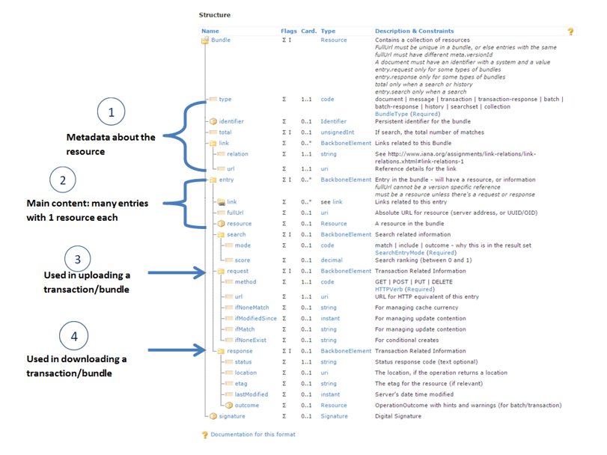

Figure 1 - Source https://fhir-drills.github.io/bundle.html

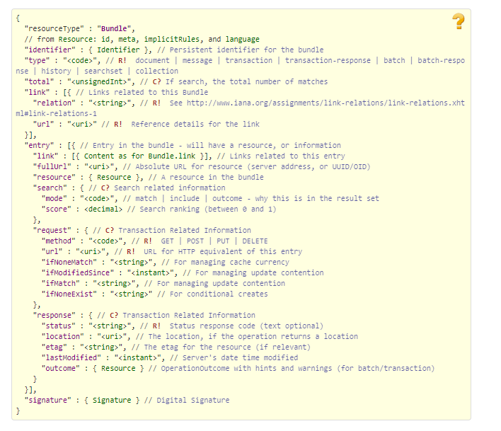

Figure 2 - Source <https://www.hl7.org/fhir/bundle.html>

## Communications Methods

### Ports and Protocols

#### HTTP(S)

Can be used for real time communication.

#### AMQP

AMQP offers reliable messaging via queues.

### ESB Configuration(s)

Tbd

### System Configuration

Tbd

## Performance Requirements

System Design Document (SDD); Medical Care Collection Fund (MCCF) - Electronic Data Interchange Transaction Application Suite (EDI TAS).

## Security

System Design Document (SDD); Medical Care Collection Fund (MCCF) - Electronic Data Interchange Transaction Application Suite (EDI TAS).

### Is within the VA firewall

Tbd

## Testing Requirements

System Design Document (SDD); Medical Care Collection Fund (MCCF) - Electronic Data Interchange Transaction Application Suite (EDI TAS).

### Comparison of Data

Tbd

### Completeness

Tbd

## Policies and Constraints

Tbd

### HIPAA Compliance

FSC receives transactions and then translates them into standard NCPDP Claim Billing Rebill (B3), validates whether the data complies with HIPAA standards and then forwards the claim data to the VA Healthcare Clearing House (HCCH).

# Appendix A

## Data Elements

## Bundle

Repeating fields within a segment need context definition so they can be differentiated within a segment.

Also, repeating fields across multiple segments need to be differentiated. Following steps have been used to assign context to fields.

1. Identify the segment where the resource is located (Bundle.entry.extension.url="segment" and Bundle.entry.extension.valueString="278-EVN") [MessageType-Segment]

2. Where elements repeat within a segment use extension.valueString to identify field (Basic.extension.url="sequence" and Basic.extension.valueString="278-MSH-16" or Location.identifier.extension.url="sequence" and Location.identifier.extension.valueString="278-MSH-3") [MessageType-Segment-Field]

3. Repeating segments will include an incrementing id (MSA1, MSA2, ...)

## Resource Sections 1..N

### Claim Billing Rebill (B3) request bundle

#### Basic

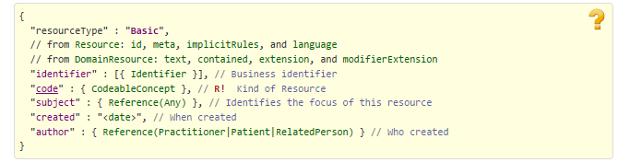

Figure 3 Source https://www.hl7.org/fhir/basic.html

#### Claim

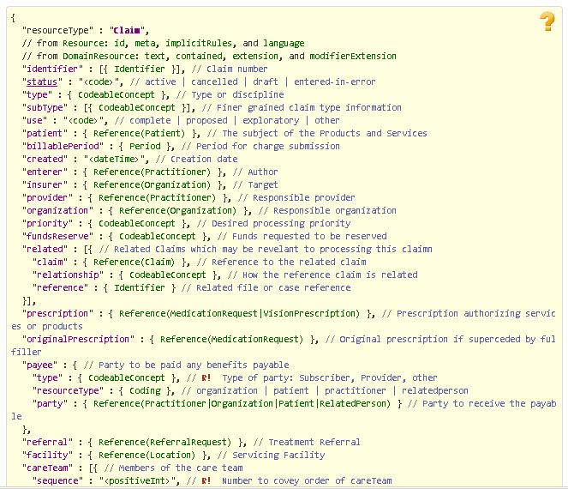

Figure 4 Source http://www.hl7.org/fhir/claim.html

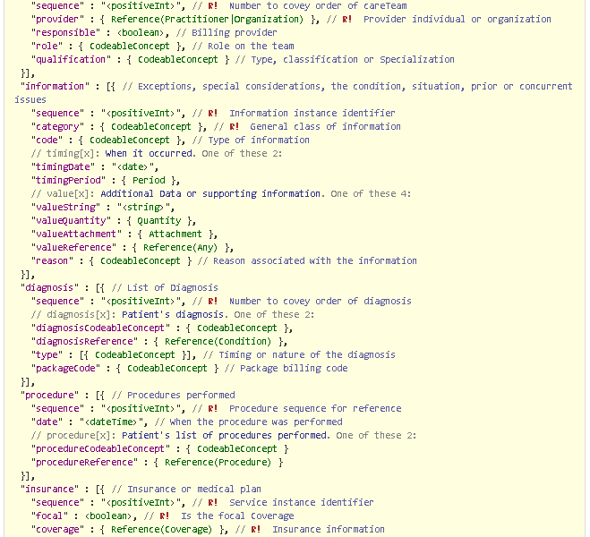

Figure 5 Source http://www.hl7.org/fhir/claim.html

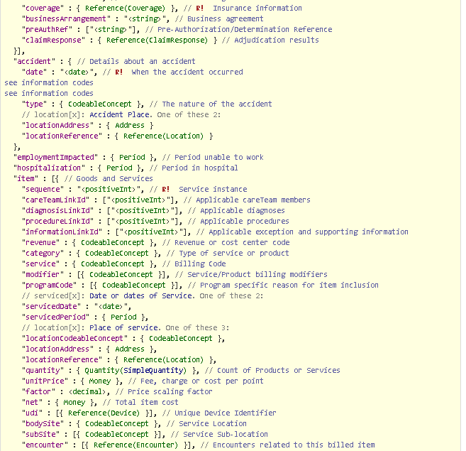

Figure 6 Source http://www.hl7.org/fhir/claim.html

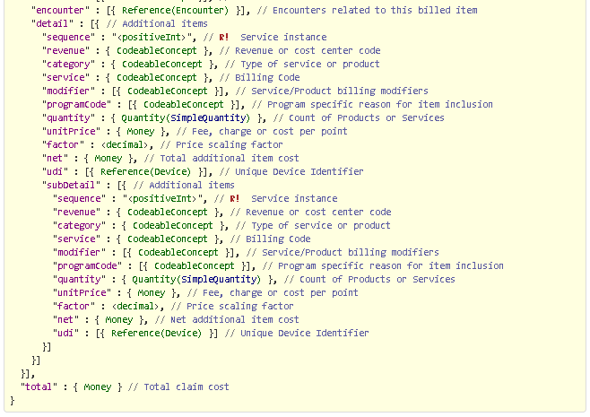

Figure 7 Source http://www.hl7.org/fhir/claim.html

#### ClaimResponse

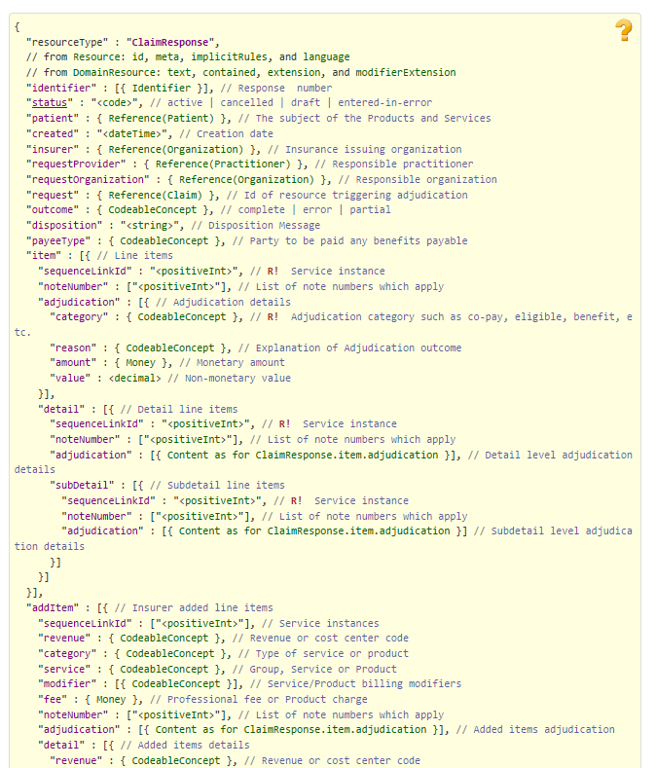

Figure 8 Source https://www.hl7.org/fhir/claimresponse.html - Part 1

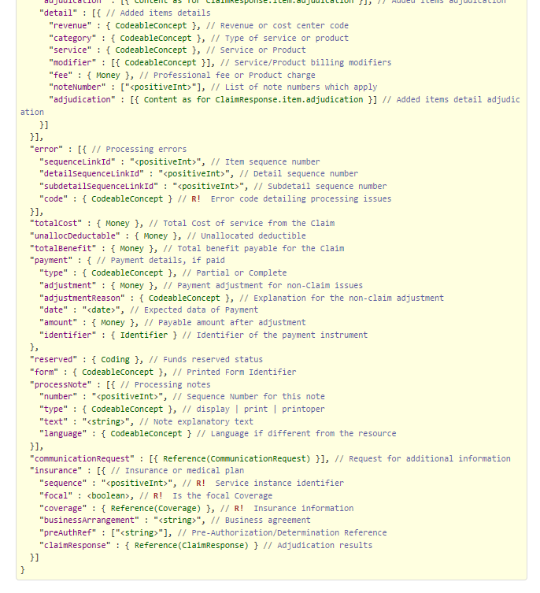

Figure 9 Source https://www.hl7.org/fhir/claimresponse.html - Part 2

#### Communication

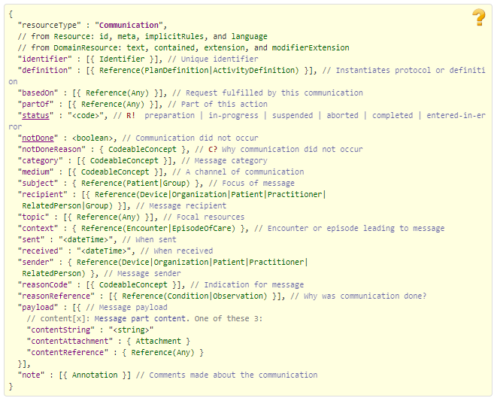

Figure 10 Source http://www.hl7.org/fhir/communication.html

#### Condition

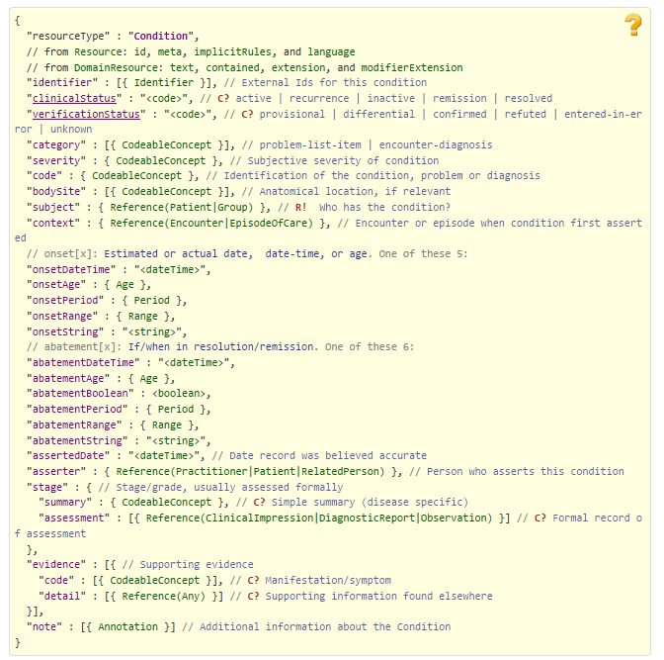

Figure 11 Source https://www.hl7.org/fhir/condition.html

#### Coverage

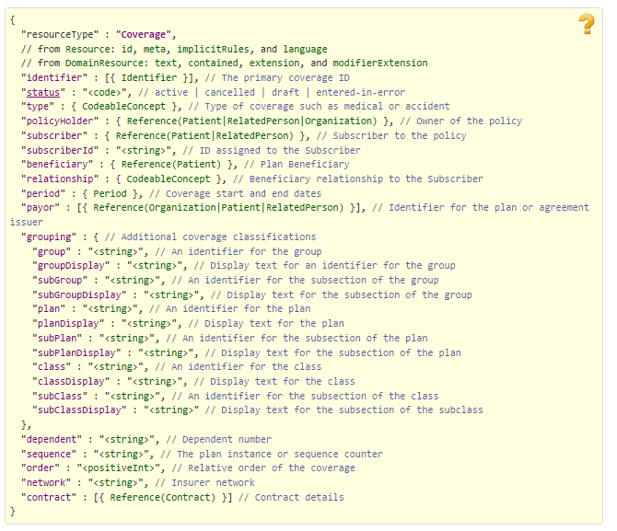

Figure 12 Source https://www.hl7.org/fhir/coverage.html

#### DocumentReference

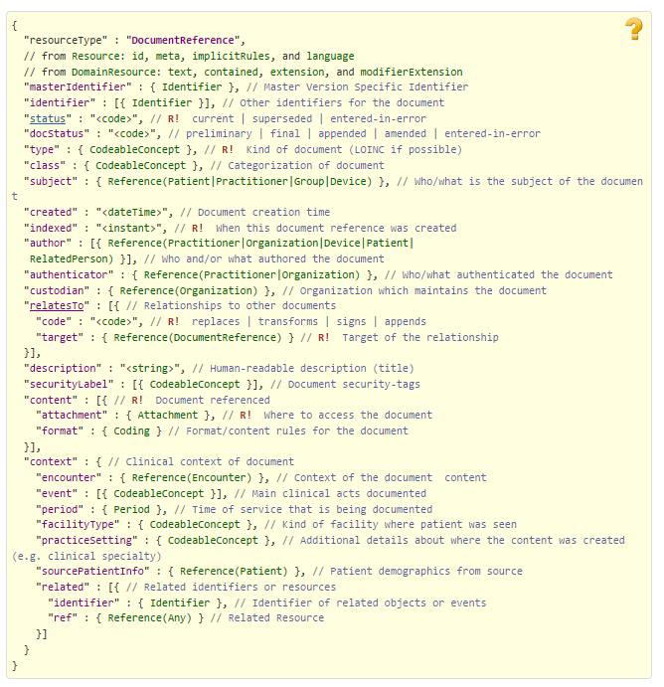

Figure 13 Source https://www.hl7.org/fhir/documentreference.html

#### EligibilityRequest

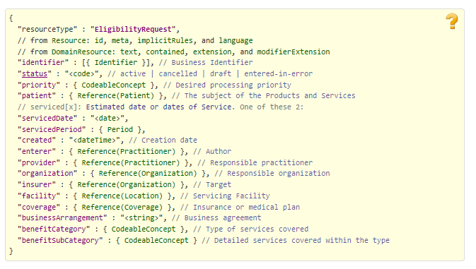

Figure 14 Source https://www.hl7.org/fhir/eligibilityrequest.html

#### Encounter

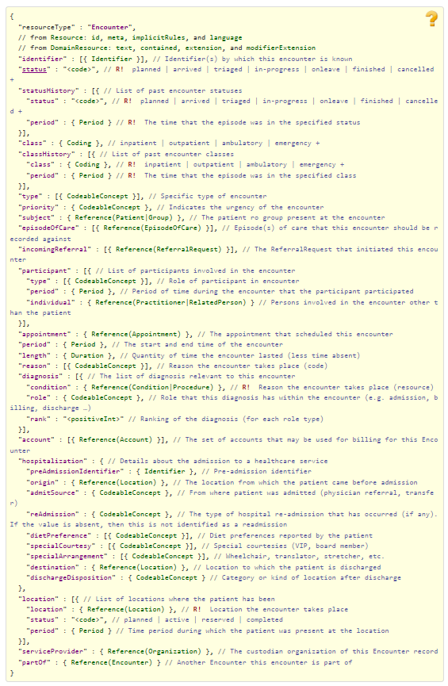

Figure 15 Source https://www.hl7.org/fhir/encounter.html

#### ExplanationOfBenefit

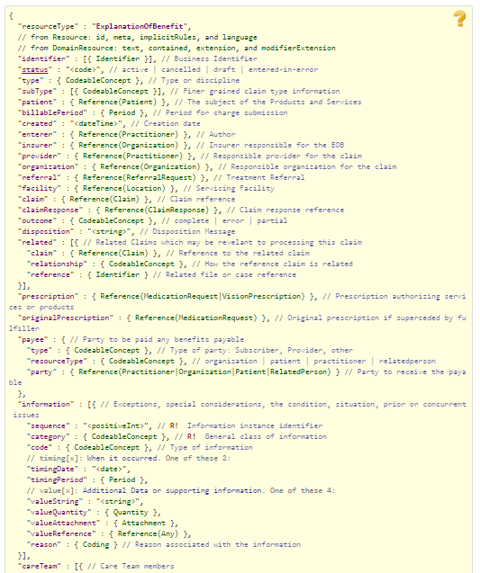

Figure 16 Source <http://www.hl7.org/fhir/explanationofbenefit.html> Part 1

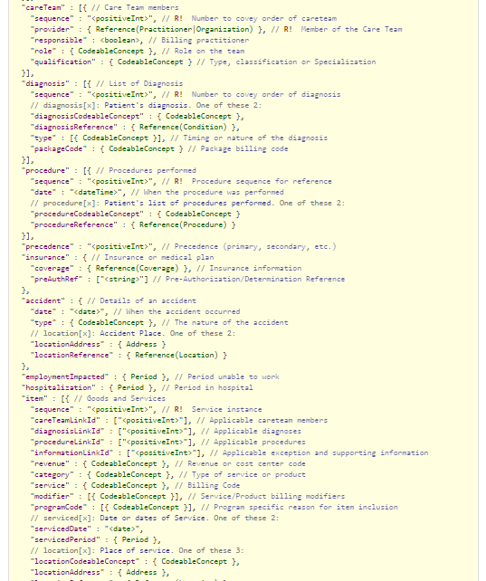

Figure 17 Source http://www.hl7.org/fhir/explanationofbenefit.html Part 2

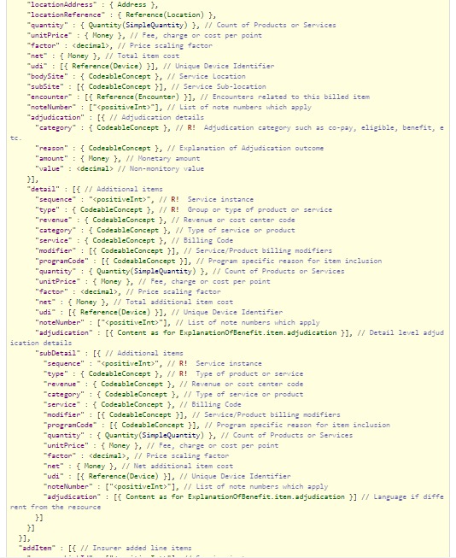

Figure 18 Source http://www.hl7.org/fhir/explanationofbenefit.html Part 3

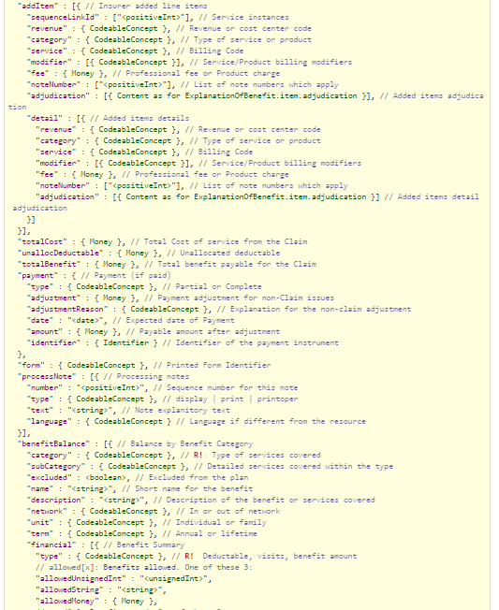

Figure 19 Source http://www.hl7.org/fhir/explanationofbenefit.html Part 4

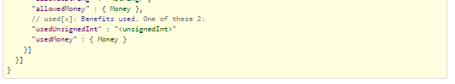

Figure 20 Source http://www.hl7.org/fhir/explanationofbenefit.html Part 5

#### HealthcareService

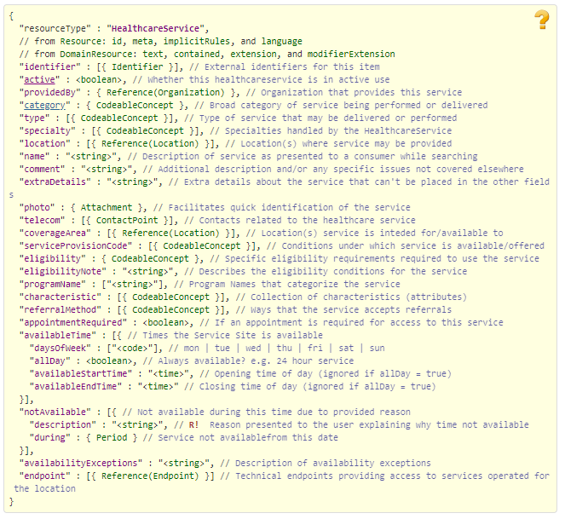

Figure 21 Source http://www.hl7.org/fhir/healthcareservice.html

#### Medication

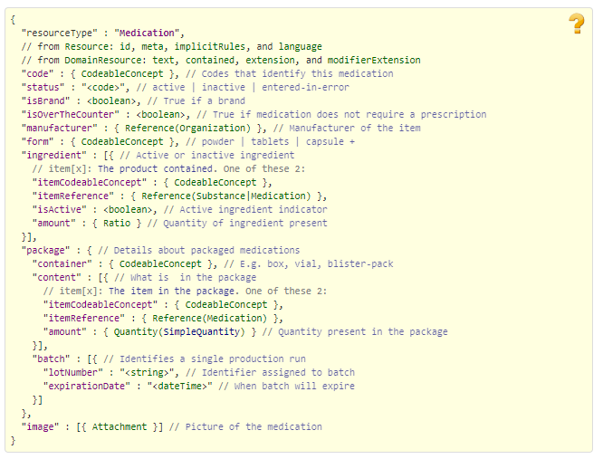

Figure 22 Sourcehttp://www.hl7.org/fhir/medication.html

#### MedicationAdministration

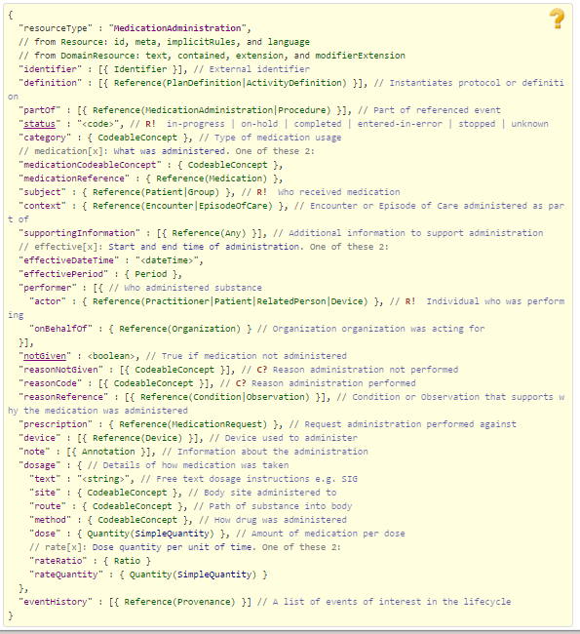

Figure 23 Source http://www.hl7.org/fhir/medicationadministration.html

#### MedicationDispense

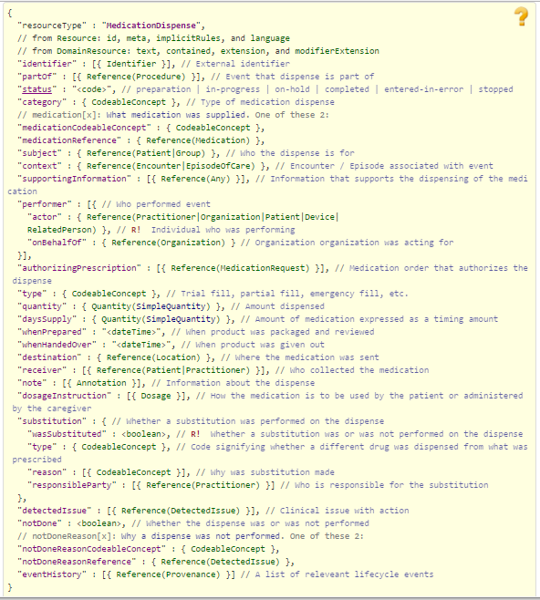

Figure 24 Source http://www.hl7.org/fhir/medicationdispense.html

#### MedicationRequest

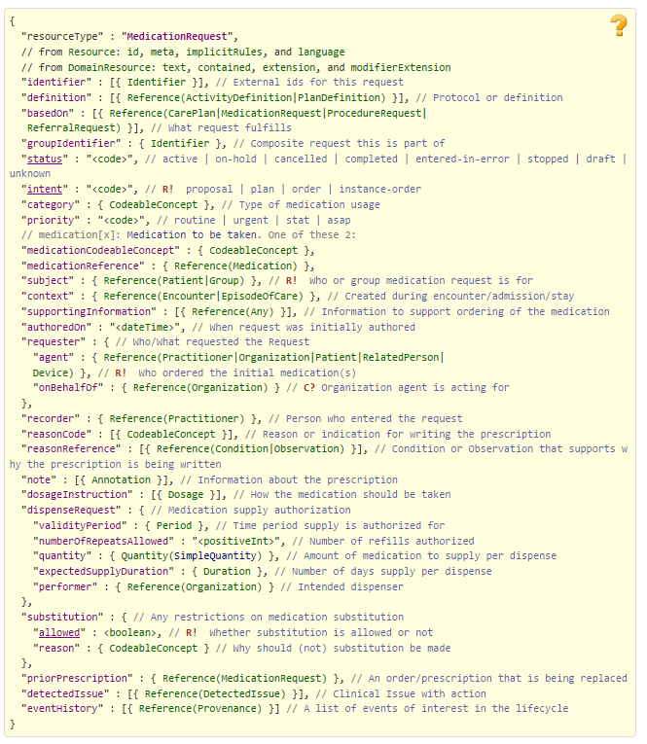

Figure 25 Source https://www.hl7.org/fhir/medicationrequest.html

#### MessageHeader

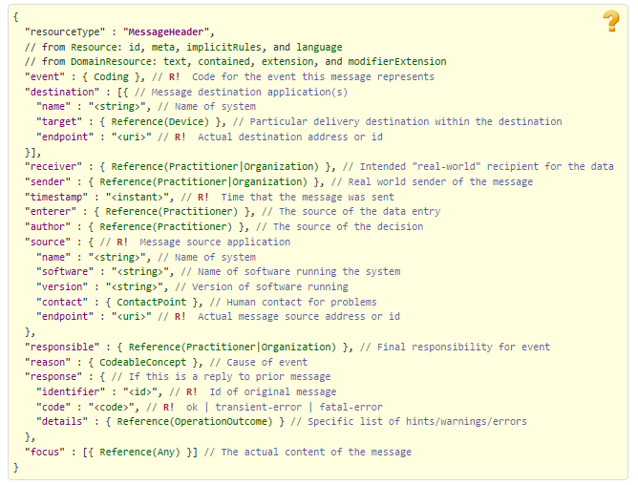

Figure 26 Source https://www.hl7.org/fhir/messageheader.html

#### Observation

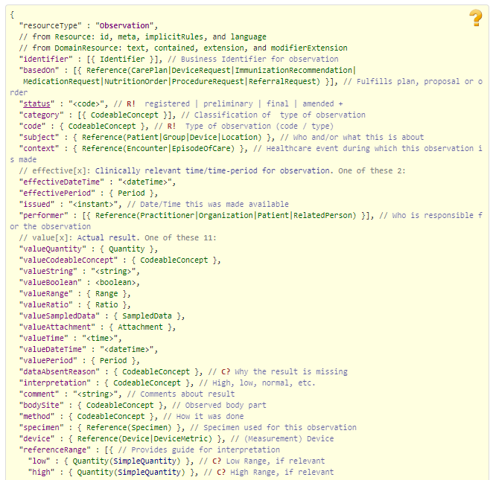

Figure 27 Source <http://www.hl7.org/fhir/observation.html> Part 1

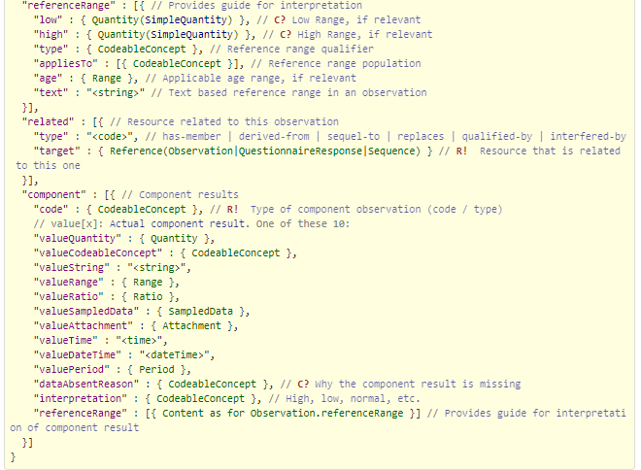

Figure 28 Source http://www.hl7.org/fhir/observation.html Part 2

#### Organization

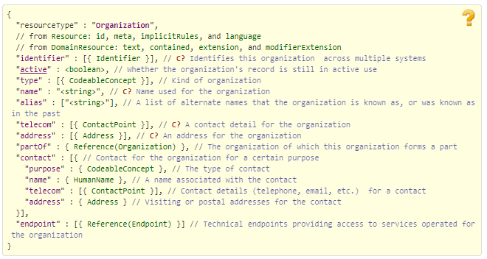

Figure 29 Source http://www.hl7.org/fhir/organization.html

#### Patient

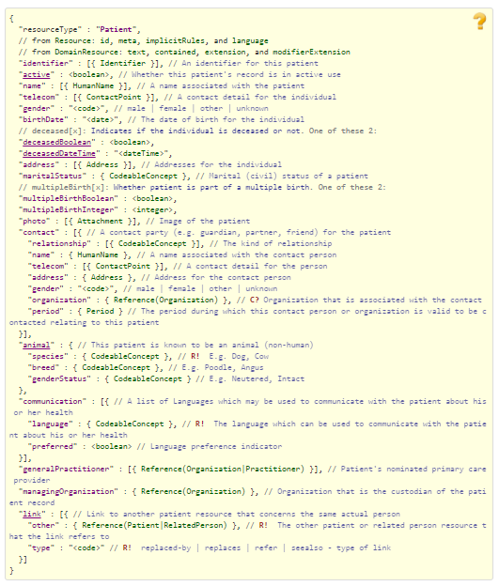

Figure 30 Source http://www.hl7.org/fhir/patient.html

#### Practitioner

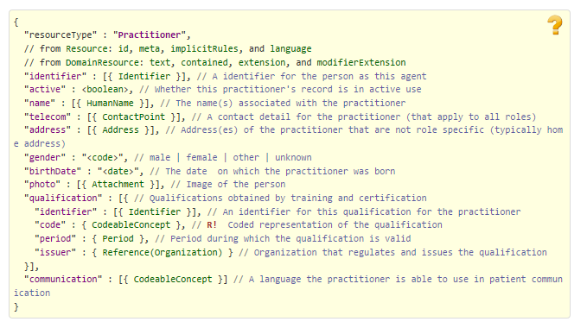

Figure 31 Source https://www.hl7.org/fhir/practitioner.html

#### Procedure

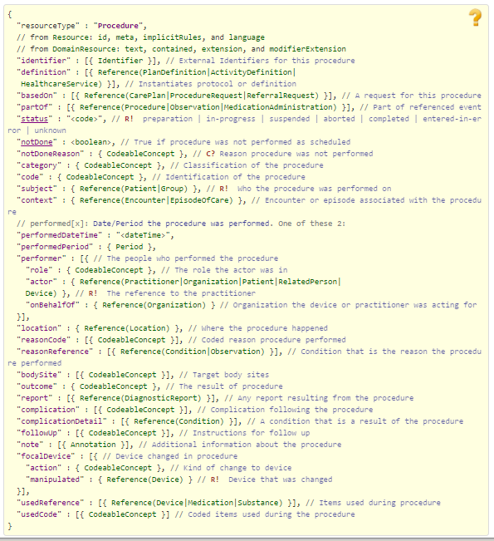

Figure 32 Source http://www.hl7.org/fhir/procedure.html

#### RelatedPerson

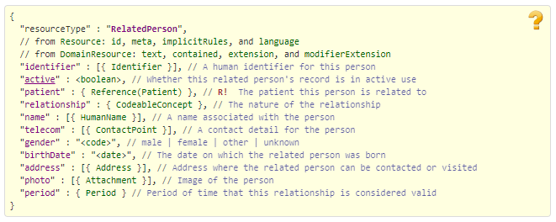

Figure 33 Source http://www.hl7.org/fhir/relatedperson.html

#### Substance

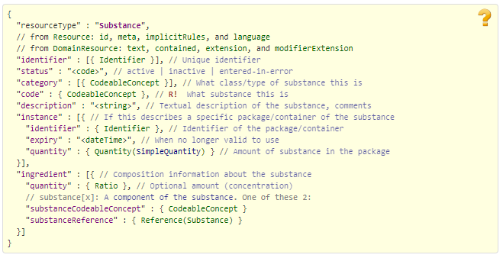

Figure 34 Source http://www.hl7.org/fhir/substance.html

### Claim Billing Rebill (B3) request bundle inside the Communication resource

#### Communication See above

### Claim Billing Rebill (B3) response bundle For TRANSMISSION ACCEPTED/TRANSACTION PAID responses

#### Basic See above

#### CarePlan

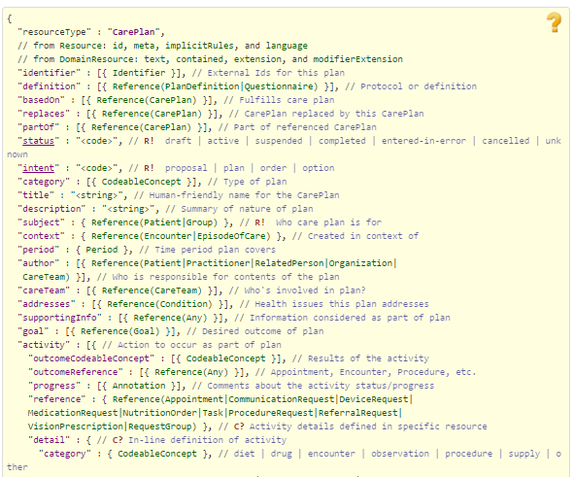

Figure 35 Source http://www.hl7.org/fhir/careplan.html Part 1

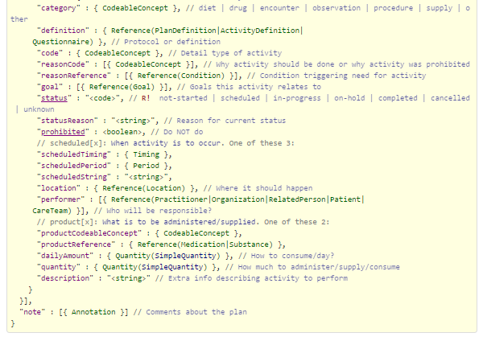

Figure 36 http://www.hl7.org/fhir/careplan.html Part 2

#### ChargeItem

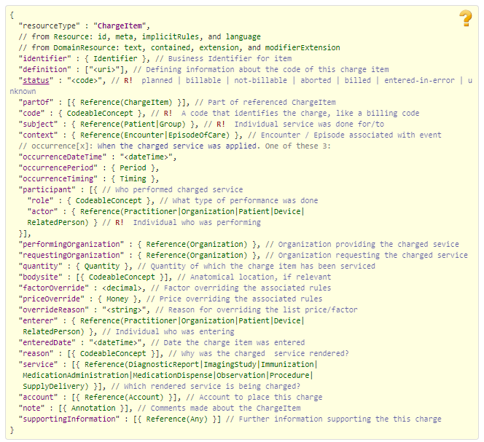

Figure 37Source http://www.hl7.org/fhir/chargeitem.html

#### Claim See above

#### ClaimResponse See above

#### Communication See above

#### Coverage See above

#### EligibilityResponse

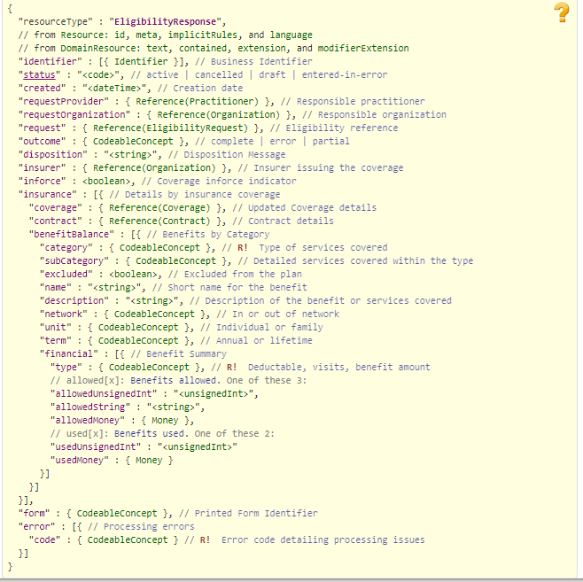

Figure 38 Source http://www.hl7.org/fhir/eligibilityresponse.html

#### Encounter See above

#### ExplanationOfBenefit See above

#### Medication See above

#### MedicationAdministration See above

#### MedicationDispense See above

#### MedicationRequest See above

#### MessageHeader See above

#### Organization See above

#### Patient See above

#### PaymentReconciliation

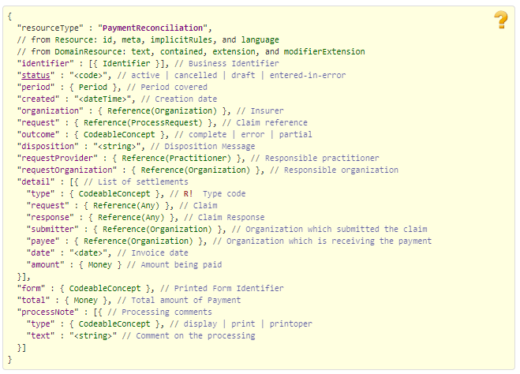

Figure 40 Source http://www.hl7.org/fhir/paymentreconciliation.html

#### 

#### Practitioner See above

#### ProcessRequest

#### 

Figure 42 Source http://www.hl7.org/fhir/processrequest.html

#### 

#### ProcessResponse

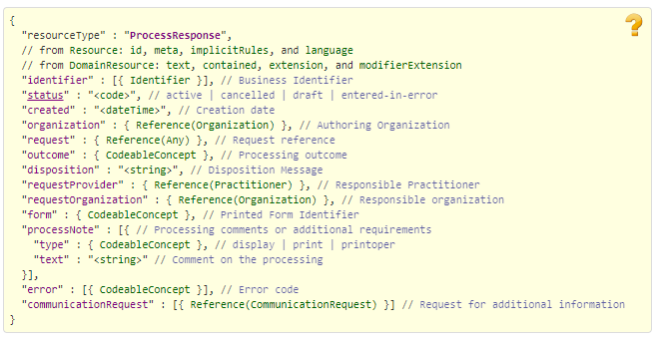

Figure 43 Source http://www.hl7.org/fhir/processresponse.html

#### Substance See above

### For TRANSMISSION ACCEPTED/TRANSACTION CAPTURED responses

#### Basic See above

#### CarePlan See above

#### ChargeItem See above

#### Claim See above

#### ClaimResponse See above

#### Communication See above

#### Coverage See above

#### EligibilityResponse See above

#### Encounter See above

#### ExplanationOfBenefit See above

#### Medication See above

#### MedicationAdministration See above

#### MedicationDispense See above

#### MedicationRequest See above

#### MessageHeader See above

#### Organization See above

#### Patient See above

#### PaymentReconciliation See above

#### ProcessRequest See above

#### ProcessResponse See above

#### Substance See above

### For TRANSMISSION ACCEPTED/TRANSACTION REJECTED responses

#### Basic See above

#### CarePlan See above

#### ChargeItem See above

#### ClaimResponse See above

#### Communication See above

#### Coverage See above

#### EligibilityResponse See above

#### Encounter See above

#### ExplanationOfBenefit See above

#### Medication See above

#### MedicationAdministration See above

#### MedicationDispense See above

#### MedicationRequest See above

#### MessageHeader See above

#### Organization See above

#### Patient See above

#### Practitioner See above

#### ProcessRequest See above

#### ProcessResponse See above

#### Substance See above

### For TRANSMISSION REJECTED/TRANSACTION REJECTED responses

#### Basic See above

#### ClaimResponse See above

#### Communication See above

#### Encounter See above

#### MedicationAdministration See above

#### MessageHeader See above

#### Organization See above

#### ProcessRequest See above

#### ProcessResponse See above

### Embedded following columns:

#### Element #

#### Max Length

#### FSC Transaction Location

* FSC Comments
* FHIR Resource
* TASCore Comments

## Appendix B - TASCore Mapping Rules

## Appendix C – TASCore Default Values

## Appendix D – FSC Mapping Rules

## Appendix E – FSC Default Values