Medical Care Collections Fund (MCCF) ePharmacy

Electronic Data Interchange (EDI)

Transactions Applications Suite (TAS)

Interface Control Document

National Council for Prescription Drug Programs (NCPDP)

Eligibility Verification Information (E1)

Logo for the Department of Veterans Affairs, Office of Information and Technology, Product Development, including the official seal of the Department of Veterans Affairs


Department of Veterans Affairs

March 2018

Version 1

Revision History

|  |  |  |  |
| --- | --- | --- | --- |
| Date | Version | Description | Author |
| 2/23/18 | 0.0.1 | Initial creation of document | Steffen Maerdian - Halfaker |
| 2/26/2018 | 0.0.2 | Formatting and content updates for initial draft | Keith Oulson – Halfaker and Associates |
| 3/1/18 | 1.0 | Finalization of draft | Steffen Maerdian - Halfaker |
|  |  |  |  |
|  |  |  |  |
|  |  |  |  |
|  |  |  |  |
|  |  |  |  |
|  |  |  |  |
|  |  |  |  |
|  |  |  |  |
|  |  |  |  |
|  |  |  |  |
|  |  |  |  |
|  |  |  |  |
|  |  |  |  |
|  |  |  |  |
|  |  |  |  |
|  |  |  |  |
|  |  |  |  |
|  |  |  |  |

Table of Contents

1 Introduction 1

1.1 Purpose 1

1.2 Scope 1

1.3 System Identification 1

1.3.1 MCCF EDI TAS ePharmcy 1

1.3.2 FSC 2

1.4 Operational Agreement 2

2 Interface Definition 2

2.1 System Overview 3

2.1.1 Overview Diagram 4

2.2 Interface Overview 5

2.2.1 Connectivity between the systems 6

2.3 Operations 6

2.3.1 Data Extraction 6

2.3.2 Data Transformation 6

2.3.3 Sending/Receiving 7

2.4 Data Transfer 7

2.5 Transaction Types 7

2.6 Data Exchanges 7

2.6.1 FHIR Based Resources 7

2.6.2 JSON Format 10

2.6.3 Bundle Definition 11

2.7 Communications Methods 12

2.7.1 Ports and Protocols 12

2.7.2 ESB Configuration(s) 12

2.7.3 System Configuration 13

2.8 Performance Requirements 13

2.9 Security 13

2.9.1 Is within the VA firewall 13

2.10 Testing Requirements 13

2.10.1 Comparison of Data 13

2.10.2 Completeness 13

2.11 Policies and Constraints 13

2.11.1 HIPAA Compliance 13

3 Appendix A 14

3.1 Data Elements 14

3.2 Bundle 14

3.3 Resource Sections 1..N 14

3.3.1 Eligibility Verification (E1) request Bundle 14

3.3.2 Embedded following comlumns: 27

4 Appendix B - TASCore Mapping Rules 27

5 Appendix C – TASCore Default Values 27

6 Appendix D – FSC Mapping Rules 27

7 Appendix E – FSC Default Values 27

# Introduction

This document describes the interface between the MCCF EDI TAS ePharmacy application and the VA Financial Services Center in Austin, TX (FSC) for National Council for Prescription Drug Programs (NCPDP) Eligibility Verification Information (E1) messages.

## Purpose

The purpose of this Interface Control Document (ICD) is to define the message structure and protocols which govern the interchange of data between ePharmacy within MCCF EDI TAS and the FSC related to the electronic processing of NCPDP Eligibility Verification Information (E1) messages.

## Scope

This Interface Control Document describes a generalized interface between TAS Platform and the system(s) at the FSC. It specifies the interface between MCCF EDI TAS ePharmacy and FSC. This document provides details on the functional, performance, operational and design requirements for the interface. This document defines the layouts for the data that the FSC sends to MCCF EDI TAS ePharmacy . This document is intended for all parties requiring such information, including business stakeholders, end-users, software developers, system designers, testers and anyone else responsible for implementing this interface.

## System Identification

MCCF EDI TAS ePharmacy is a software designed to support the requests and responses related to Eligibility Verification information sent to and received from the FSC. This interface supports the electronic transmission of Elegibility Verification (E1) transactions between FSC and MCCF EDI TAS ePharmacy.

### MCCF EDI TAS ePharmacy

The TAS Platform will modernize and automate the business processes used currently as part of the VA revenue cycle. This includes insurance verification, billing, and claims processing, payment, and remittance. These processes are tied to other processes that are out of scope, including documenting the care provided, coding treatment and encounters, and sending claims and receiving remittance to and from the clearinghouse.

This interface supports the electronic third party billing process which involves the electronic transmission of Eligibility Verification Information (E1) to Emdeon, the VA’s clearinghouse, where claims are either transmitted to the insurance company or sent to a printing facility.

|  |  |
| --- | --- |
| System | Details |
| Title |  |
| Abbreviation |  |
| Version number |  |
| Release number |  |
| Point of Contact |  |
| Vendor [optional] |  |
|  |  |

### FSC

The system(s) at FSC, receive(s) the data from the TAS Platform, translate(s) the data into a standard National Council for Prescription Drug Programs (NCPDP) Eligibility Verification Information (E1) transmission, validate(s) the data complies with HIPAA standards and then forward(s) the data to Emdeon.

|  |  |
| --- | --- |
| System | Details |
| Title |  |
| Abbreviation |  |
| Version number |  |
| Point of Contact |  |
| Vendor [optional] |  |

## Operational Agreement

This ICD provides the specification for an interface between MCCF EDI TAS ePharmacy and FSC regarding Eligibility Verification Information data. The Chief Business Office (CBO) is responsible for notifying FSC personnel of any potential or planned changes to data feeds once these changes are known in order to minimize adverse impacts.

# Interface Definition

Eligibility Verification Information data is transmitted between the FSC and MCCF EDI TAS ePharmacy in FHIR bundles or inside a Communication FHIR resource.

## System Overview

MCCF EDI TAS ePharmacy is a software designed to support the requests and responses related to Eligibility Verification Information sent to and received from the FSC. This interface supports the electronic transmission of Eligibility Verification Information (E1) between FSC and MCCF EDI TAS ePharmacy.

FSC is designed to receive Eligibility Verification Information (E1) requests from MCCF EDI TAS ePharmacy and send them to payers. It is also designed to receive Eligibility Verification Information (E1) responses from payers and to send that information to MCCF EDI TAS ePharmacy.

### Overview Diagram

Interim solution

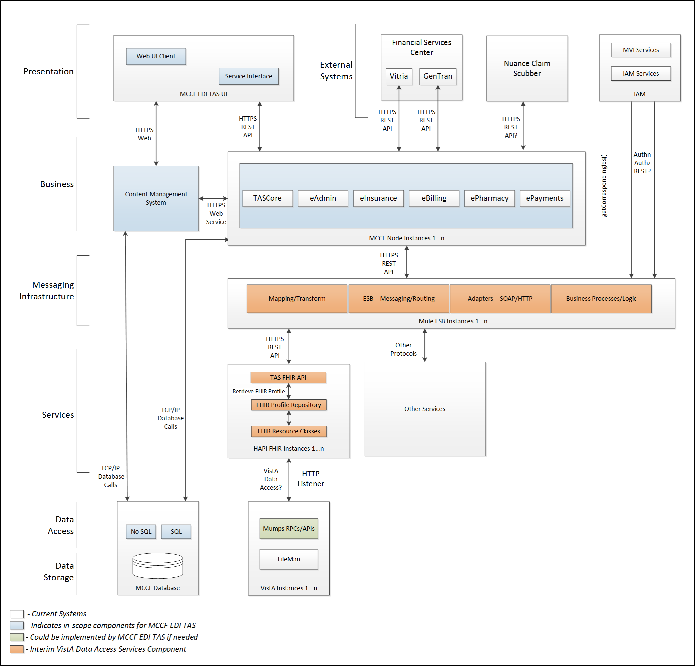

To be solution

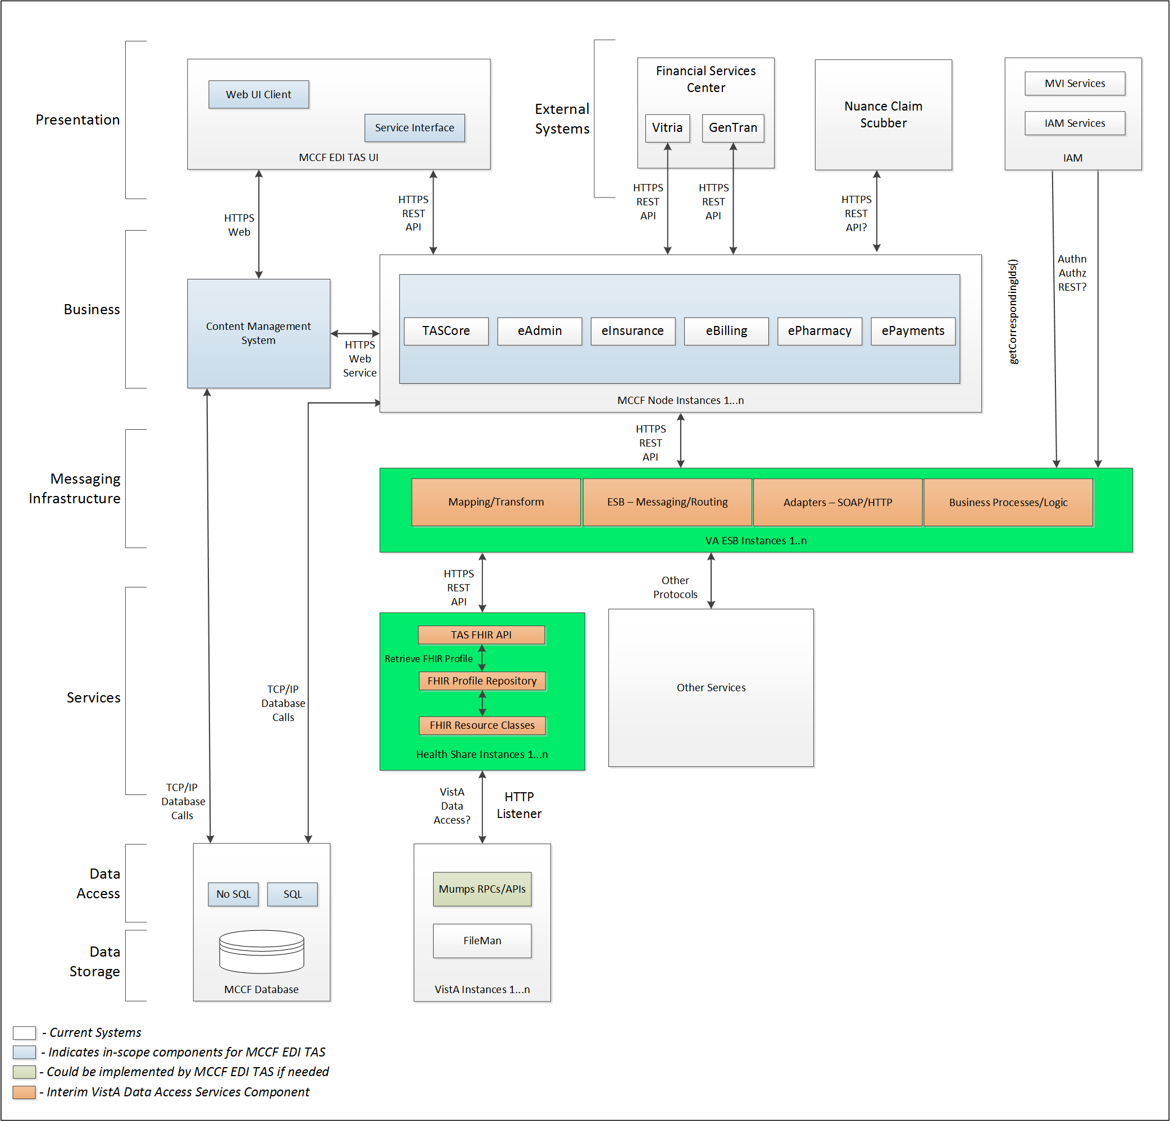

## Interface Overview

Exchanging messages between MCCF EDI TAS ePharmacy and FSC can be done in real time or via message queuing.

### Connectivity between the systems

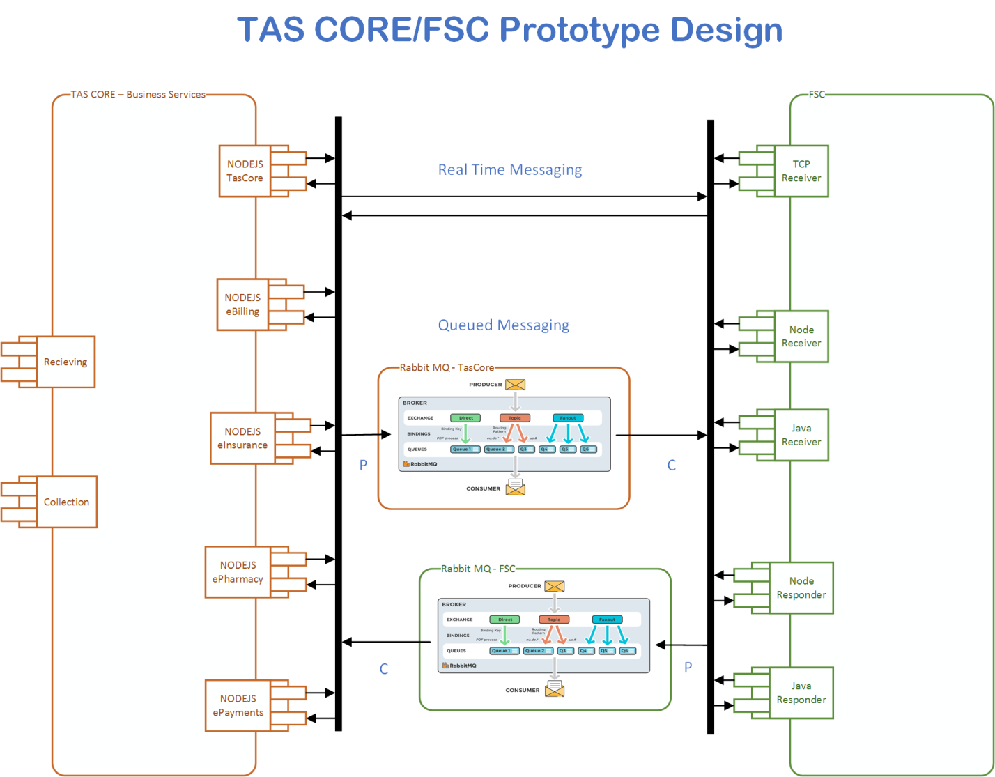

## Operations

Tbd

### Data Extraction

Data being sent to FSC will be extracted from the VistA databases using a FHIR server.

### Data Transformation

Tbd

### Sending/Receiving

MCCF EDI TAS ePharmacy sends and receives E1 messages to and from FSC.

## Data Transfer

Data is transferred between the FSC and the TASCore Application Stack**.**

## Transaction Types

MCCF EDI TAS ePharmacy sends the data (either as FHIR Resources in a FHIR Bundle or an NCPDP stream inside a Communication FHIR resource) to the FSC that is needed by the FSC so FSC can properly format and send an Eligibility Verification (E1) requests to payers.

FSC receives Eligibility Verification Information (E1) responses from payers and transmits that data in FHIR resources inside FHIR bundles (or as an NCPDP stream inside a FHIR Communication resource) to MCCF EDI TAS.

## Data Exchanges

MCCF EDI TAS ePharmacy either sends an Eligibility Verification (E1) request FHIR Bundle or a Communication FHIR resource containing Eligibility Verification (E1) in NCPDP to FSC and receives either a Eligibility Verification (E1) response FHIR bundle or a Communication FHIR resource containing an Eligibility Verification (E1) response in NCPDP from FSC. Refer to Section Appendix A.

There are three different types of Eligibility Verification (E1) responses the FSC can send to MCCF EDI TAS ePharmacy:

* TRANSMISSION ACCEPTED/TRANSACTION APPROVED
* TRANSMISSION ACCEPTED/TRANSACTION REJECTED
* TRANSMISSION REJECTED/TRANSACTION REJECTED

### FHIR Based Resources

The following FHIR resources are needed to assemble an Eligibility Verification (E1) request Bundle

* Basic
* ClaimResponse
* Condition
* Coverage
* DocumentReference
* EligibilityRequest
* Encounter
* MedicationRequest
* MessageHeader
* Organization
* Patient
* Practitioner
* RelatedPerson

The following FHIR resources are needed to send an Eligibility Verification (E1) request inside a Communication resource

* Communication

The following FHIR resources are needed to assemble an Eligibility Verification (E1) response bundle

* For TRANSMISSION ACCEPTED/TRANSACTION APPROVED responses
  + Basic
  + CarePlan
  + ClaimResponse
  + Communication
  + Condition
  + Coverage
  + EligibilityResponse
  + Encounter
  + Medication
  + MedicationAdministration
  + MessageHeader
  + Organization
  + Patient
  + PaymentNotice
  + Practitioner
  + ProcessRequest
  + ProcessResponse
* For TRANSMISSION ACCEPTED/TRANSACTION REJECTED responses
  + Basic
  + CarePlan
  + ClaimResponse
  + Communication
  + Coverage
  + EligibilityResponse
  + Encounter
  + Medication
  + MedicationAdministration
  + MessageHeader
  + Organization
  + Patient
  + ProcessRequest
  + ProcessResponse
* For TRANSMISSION REJECTED/TRANSACTION REJECTED responses
  + Basic
  + ClaimResponse
  + Communication
  + EligibilityResponse
  + Encounter
  + MedicationAdministration
  + MessageHeader
  + Organization
  + ProcessRequest
  + ProcessResponse
* The following FHIR resources are needed to send a Eligibility Verification (E1) response inside a Communication resource
  + Communication

### JSON Format

Messages are formatted using the JSON format.

Refer to <https://www.hl7.org/fhir/json.html> for JSON representation of FHIR Resources.

#### E1 Request FHIR Bundle

A Bundle implementing a E1 request sent to FSC will have the following structure:

See Appendix A.

#### E1 Request using the Communication FHIR resource

See Appendix A.

#### E1 Response FHIR Bundle

A bundle implementing a E1 responses sent from FSC will have the following structure:

* TRANSMISSION ACCEPTED/TRANSACTION APPROVED
  + See Appendix A.
* TRANSMISSION ACCEPTED/TRANSACTION REJECTED
  + See Appendix A.
* TRANSMISSION REJECTED/TRANSACTION REJECTED
  + See Appendix A.

#### E1 Response using the Communication FHIR Resource

See Appendix A.

### Bundle Definition

A Bundle is a container for resources, enabling grouping and transmitting resources altogether at once. Resources such as Claim, Patient, etc. will be transmitted inside multiple entries (see entry list inside Bundle) as a resource type.

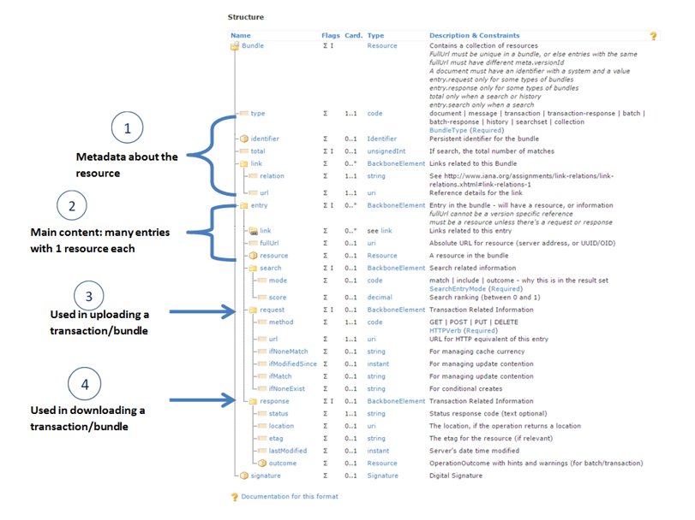

Figure 1 - Source https://fhir-drills.github.io/bundle.html

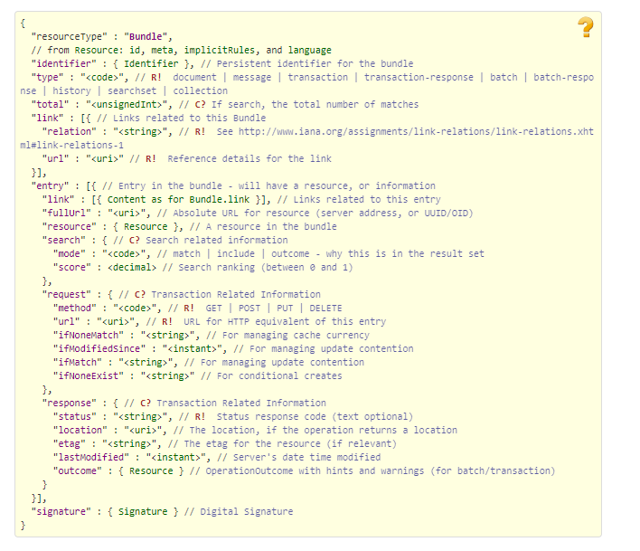

Figure 2 - Source <https://www.hl7.org/fhir/bundle.html>

## Communications Methods

### Ports and Protocols

#### HTTP(S)

Can be used for real time communication.

#### AMQP

AMQP offers reliable messaging via queues.

### ESB Configuration(s)

Tbd

### System Configuration

Tbd

## Performance Requirements

System Design Document (SDD); Medical Care Collection Fund (MCCF) - Electronic Data Interchange Transaction Application Suite (EDI TAS) Section and Page or Paragraph if Needed.

## Security

System Design Document (SDD); Medical Care Collection Fund (MCCF) - Electronic Data Interchange Transaction Application Suite (EDI TAS) Section and Page or Paragraph if Needed.

### Is within the VA firewall

Tbd

## Testing Requirements

System Design Document (SDD); Medical Care Collection Fund (MCCF) - Electronic Data Interchange Transaction Application Suite (EDI TAS) Section and Page or Paragraph if Needed.

### Comparison of Data

Tbd

### Completeness

Tbd

## Policies and Constraints

Tbd

### HIPAA Compliance

FSC receives transactions and then translates them into standard National Council for Prescription Drug Programs (NCPDP) Eligibility Verification Information (E1), validates whether or not the data complies with HIPAA standards and then forwards the claim data to the VA Healthcare Clearing House (HCCH).

# Appendix A

## Data Elements

## Bundle

Repeating fields within a segment need context definition so they can be differentiated within a segment.

Also, repeating fields across multiple segments need to be differentiated. Following steps have been used to assign context to fields.

1. Identify the segment where the resource is located (Bundle.entry.extension.url="segment" and Bundle.entry.extension.valueString="278-EVN") [MessageType-Segment]

2. Where elements repeat within a segment use extension.valueString to identify field (Basic.extension.url="sequence" and Basic.extension.valueString="278-MSH-16" or Location.identifier.extension.url="sequence" and Location.identifier.extension.valueString="278-MSH-3") [MessageType-Segment-Field]

3. Repeating segments will include an incrementing id (MSA1, MSA2, ...)

## Resource Sections 1..N

### Eligibility Verification (E1) request Bundle

#### Basic

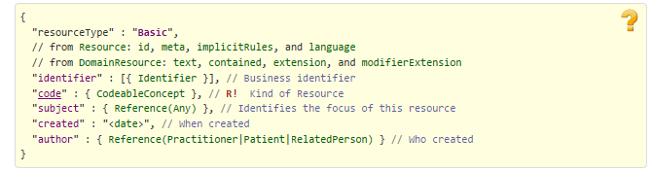

Figure 3 - https://www.hl7.org/fhir/basic.html

#### ClaimResponse

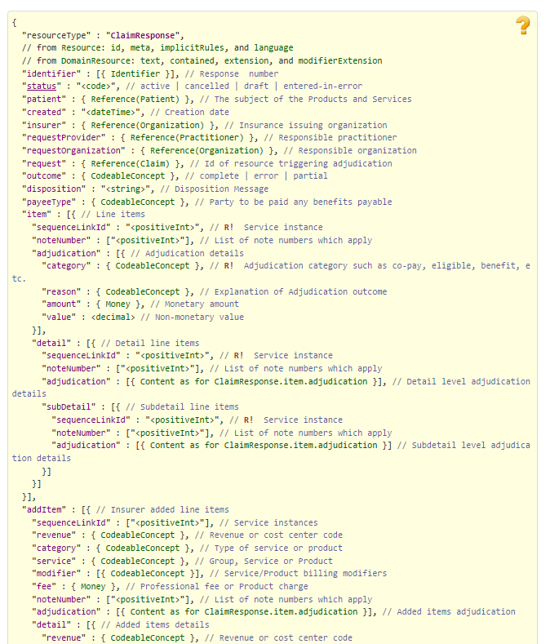

Figure 4 - https://www.hl7.org/fhir/claimresponse.html Part 1

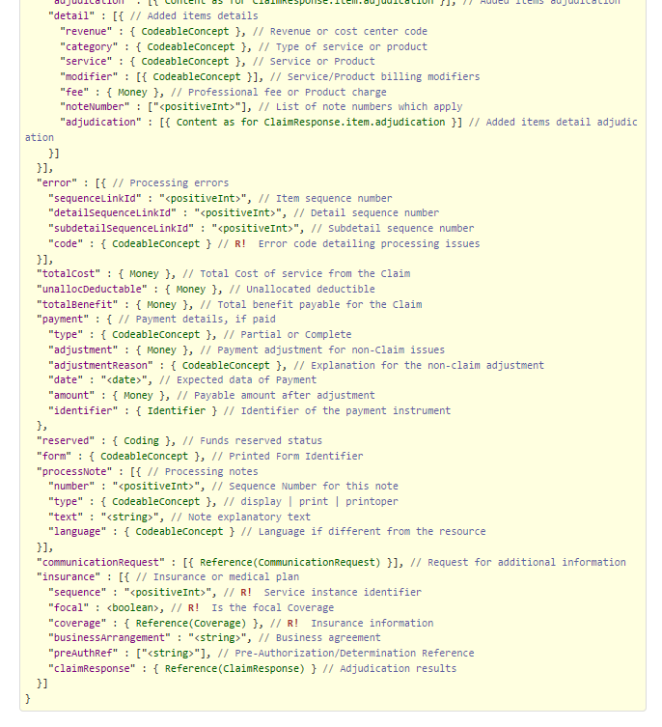

Figure 5 - https://www.hl7.org/fhir/claimresponse.html Part 2

#### Condition

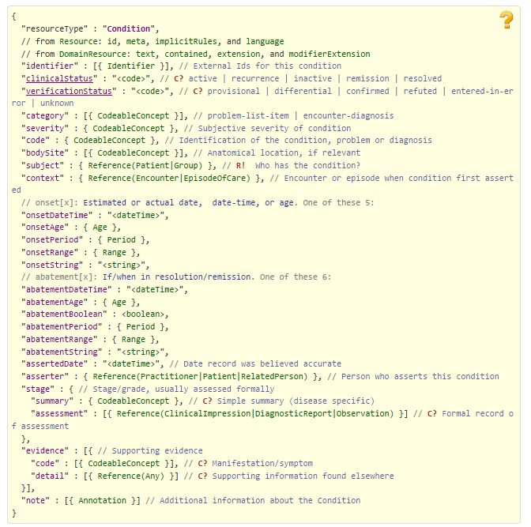

Figure 6 - https://www.hl7.org/fhir/condition.html

#### Coverage

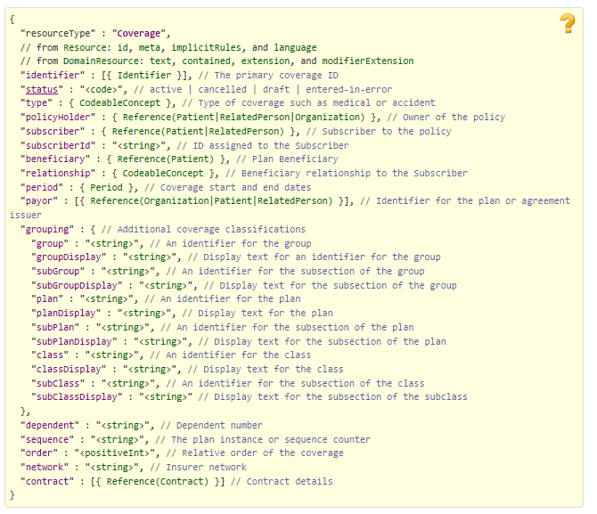

Figure 7 - https://www.hl7.org/fhir/coverage.html

#### DocumentReference

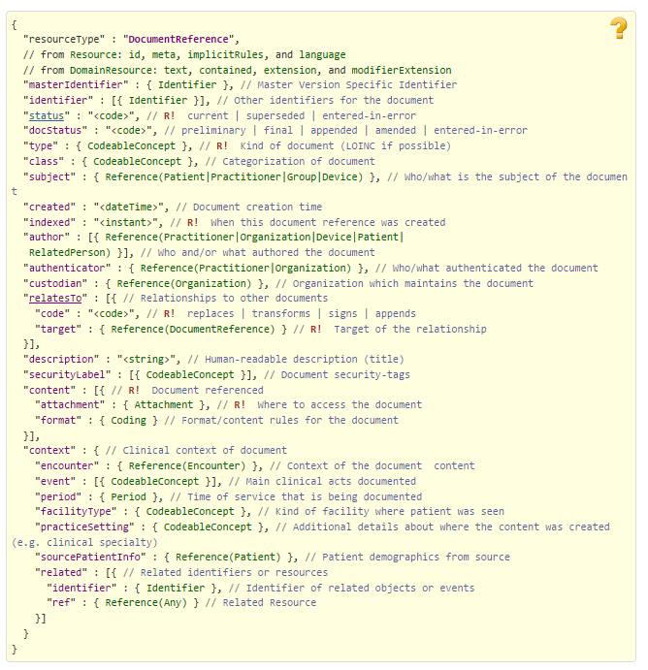

Figure 8 - https://www.hl7.org/fhir/documentreference.html

#### EligibilityRequest

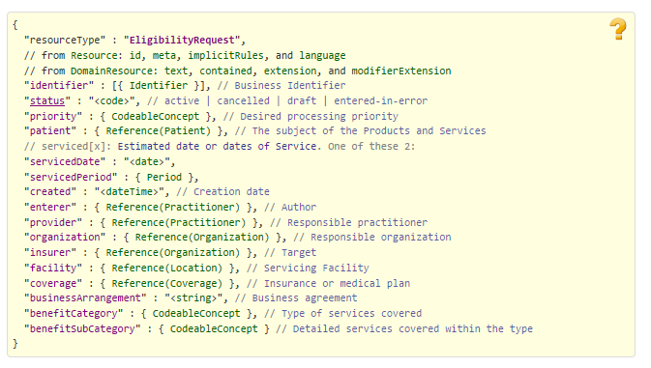

Figure 9 - https://www.hl7.org/fhir/eligibilityrequest.html

#### Encounter

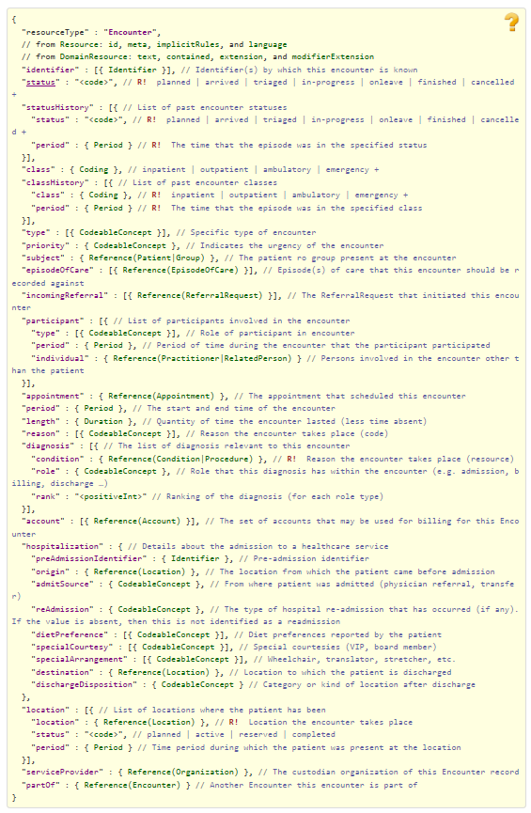

Figure 10 - https://www.hl7.org/fhir/encounter.html

#### MedicationRequest

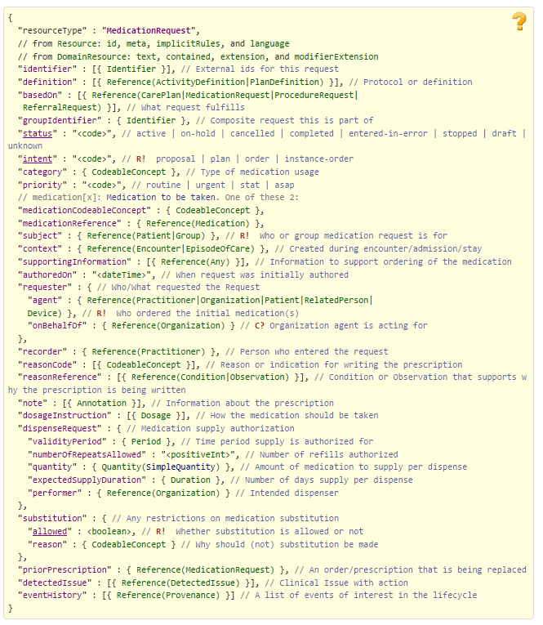

Figure 11 - https://www.hl7.org/fhir/medicationrequest.html

#### MessageHeader

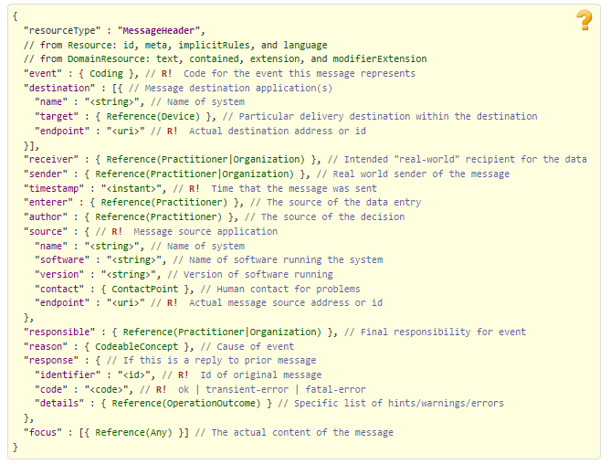

Figure 12 - https://www.hl7.org/fhir/messageheader.html

#### Organization

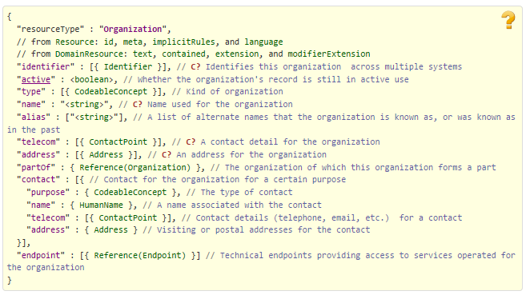

Figure 13 - https://www.hl7.org/fhir/organization.html

#### Patient

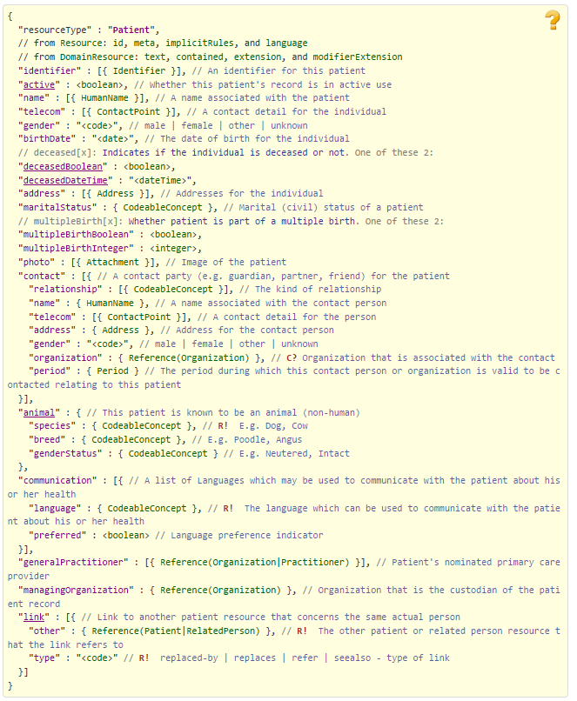

Figure 14 - https://www.hl7.org/fhir/patient.html

#### Practitioner

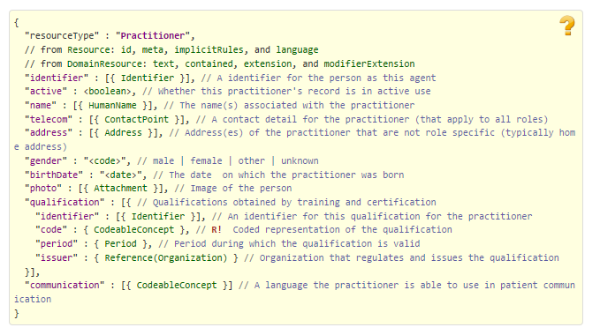

Figure 15 - https://www.hl7.org/fhir/practitioner.html

#### RelatedPerson

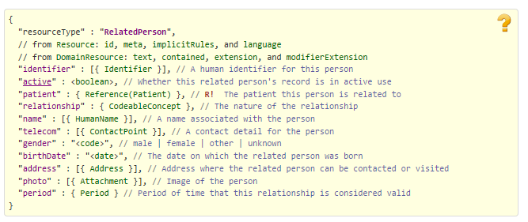

Figure 16 - <https://www.hl7.org/fhir/relatedperson.html>

### Eligibility Verification (E1) request inside the Communication resource

#### Communication

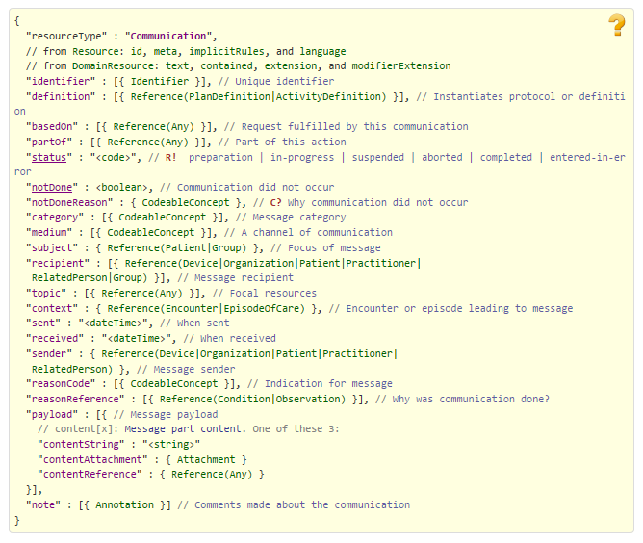

Figure 18 - https://www.hl7.org/fhir/communication.html

### E1 Response in FHIR Bundle

#### TRANSMISSION ACCEPTED/TRANSACTION APPROVED

##### Basic



Figure 19 - https://www.hl7.org/fhir/basic.html

##### CarePlan

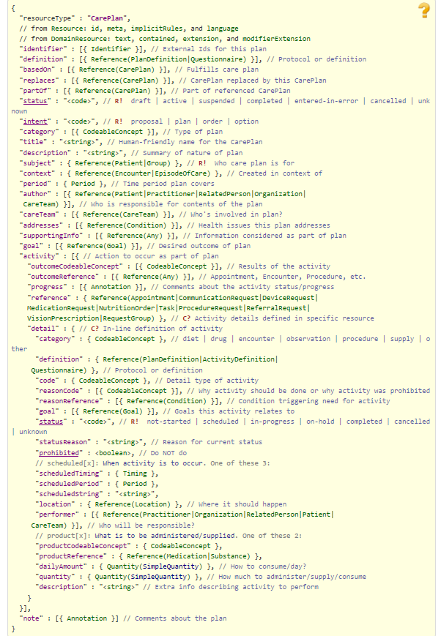

Figure 20 - https://www.hl7.org/fhir/careplan.html

##### ClaimResponse



Figure 21 - https://www.hl7.org/fhir/claimresponse.html Part 1



Figure 22 - https://www.hl7.org/fhir/claimresponse.html Part 2

##### Communication

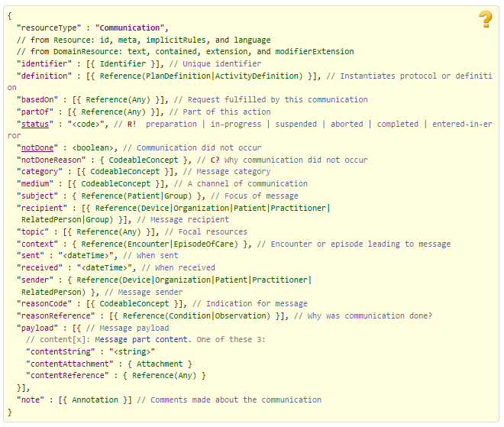

Figure 23 - https://www.hl7.org/fhir/communication.html

##### Condition

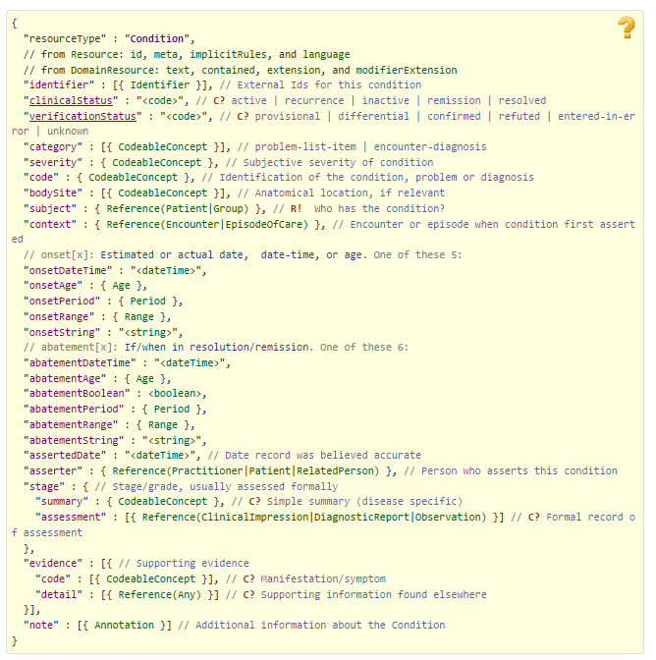

Figure 24 - https://www.hl7.org/fhir/condition.html

##### Coverage

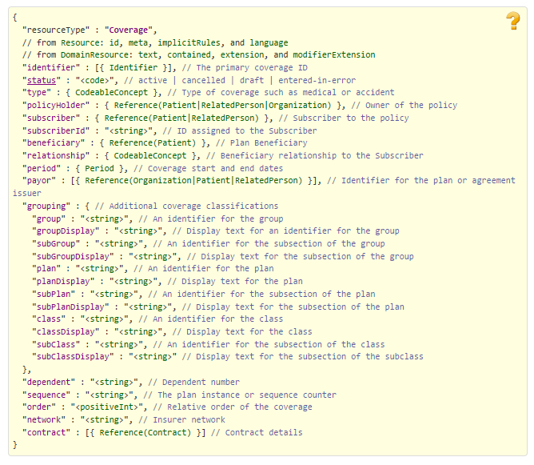

Figure 25 - https://www.hl7.org/fhir/coverage.html

##### EligibilityResponse

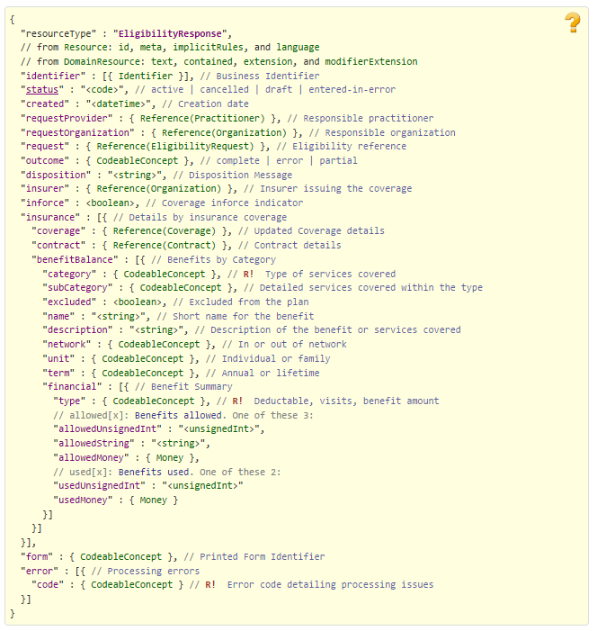

Figure 26 - https://www.hl7.org/fhir/eligibilityresponse.html

##### Encounter



Figure 27 - https://www.hl7.org/fhir/encounter.html

##### Medication

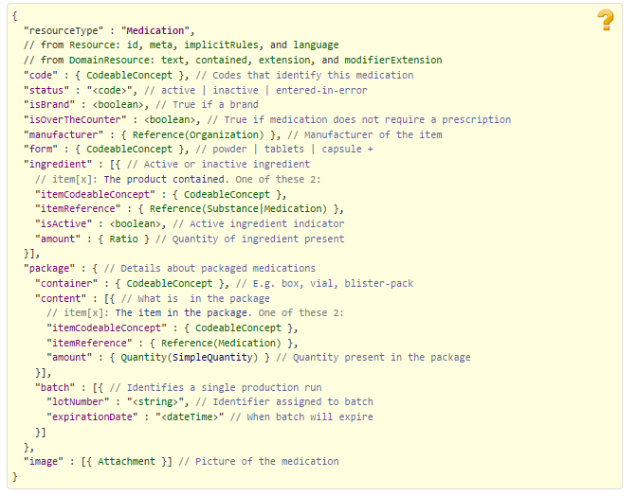

Figure 28 - https://www.hl7.org/fhir/medication.html

##### MedicationAdministration

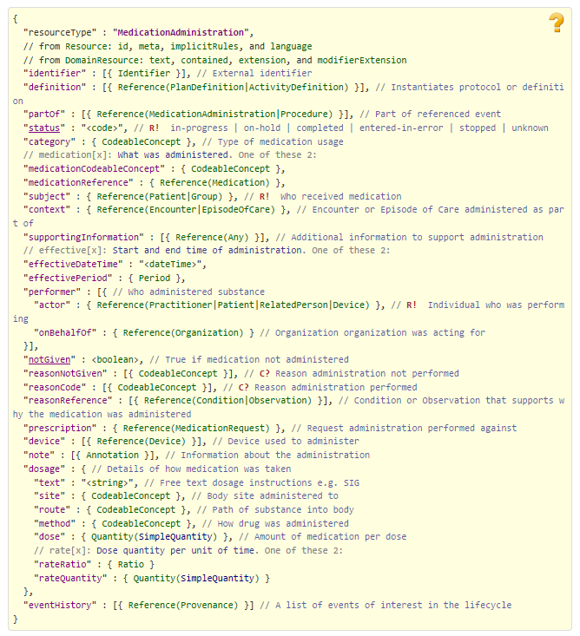

Figure 29 - https://www.hl7.org/fhir/medicationadministration.html

##### MessageHeader



Figure 30 - https://www.hl7.org/fhir/messageheader.html

##### Organization



Figure 31 - https://www.hl7.org/fhir/organization.html

##### Patient



Figure 32 - https://www.hl7.org/fhir/patient.html

##### PaymentNotice

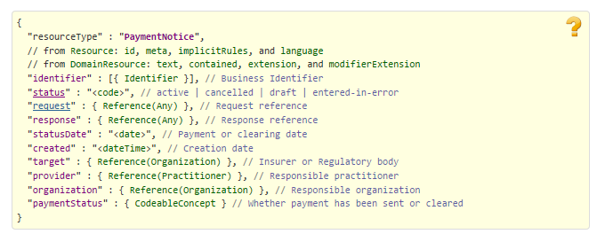

Figure 33 - https://www.hl7.org/fhir/paymentnotice.html

##### Practitioner

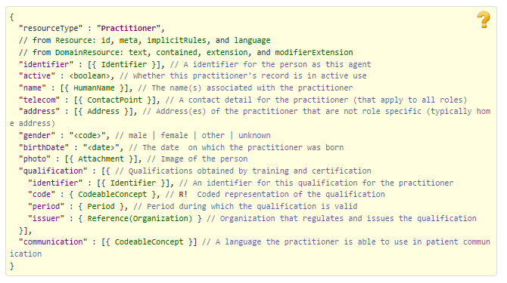

Figure 34 - https://www.hl7.org/fhir/practitioner.html

##### ProcessRequest

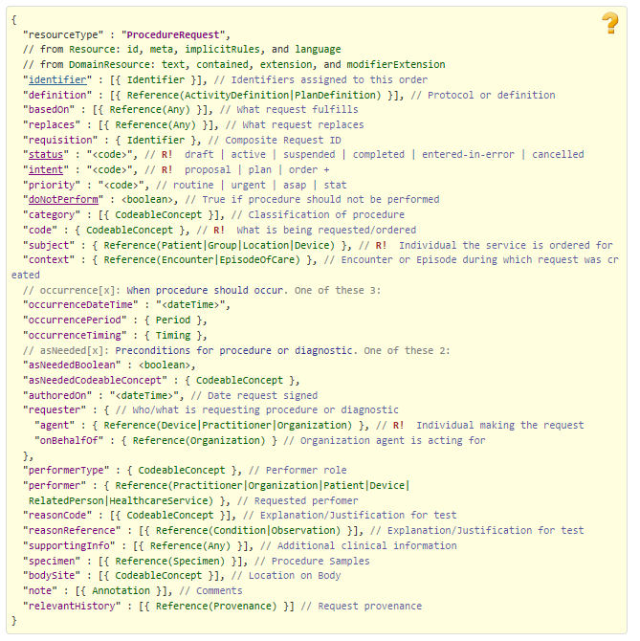

Figure 35 - https://www.hl7.org/fhir/procedurerequest.html

##### ProcessResponse

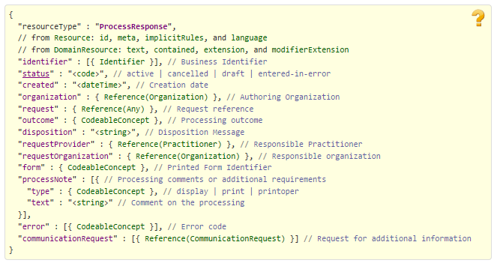

Figure 36 - https://www.hl7.org/fhir/processresponse.html

#### TRANSMISSION ACCEPTED/TRANSACTION REJECTED

##### Basic

See TRANSMISSION ACCEPTED/TRANSACTION APPROVED

##### CarePlan

See TRANSMISSION ACCEPTED/TRANSACTION APPROVED

##### ClaimResponse

See TRANSMISSION ACCEPTED/TRANSACTION APPROVED

##### Communication

See TRANSMISSION ACCEPTED/TRANSACTION APPROVED

##### Coverage

See TRANSMISSION ACCEPTED/TRANSACTION APPROVED

##### EligibilityResponse

See TRANSMISSION ACCEPTED/TRANSACTION APPROVED

##### Encounter

See TRANSMISSION ACCEPTED/TRANSACTION APPROVED

##### Medication

See TRANSMISSION ACCEPTED/TRANSACTION APPROVED

##### MedicationAdministration

See TRANSMISSION ACCEPTED/TRANSACTION APPROVED

##### MessageHeader

See TRANSMISSION ACCEPTED/TRANSACTION APPROVED

##### Organization

See TRANSMISSION ACCEPTED/TRANSACTION APPROVED

##### Patient

See TRANSMISSION ACCEPTED/TRANSACTION APPROVED

##### ProcessRequest

See TRANSMISSION ACCEPTED/TRANSACTION APPROVED

##### ProcessResponse

See TRANSMISSION ACCEPTED/TRANSACTION APPROVED

#### TRANSMISSION REJECTED/TRANSACTION REJECTED

##### Basic

See TRANSMISSION ACCEPTED/TRANSACTION APPROVED

##### ClaimResponse

See TRANSMISSION ACCEPTED/TRANSACTION APPROVED

##### Communication

See TRANSMISSION ACCEPTED/TRANSACTION APPROVED

##### EligibilityResponse

See TRANSMISSION ACCEPTED/TRANSACTION APPROVED

##### Encounter

See TRANSMISSION ACCEPTED/TRANSACTION APPROVED

##### MedicationAdministration

See TRANSMISSION ACCEPTED/TRANSACTION APPROVED

##### MessageHeader

See TRANSMISSION ACCEPTED/TRANSACTION APPROVED

##### Organization

See TRANSMISSION ACCEPTED/TRANSACTION APPROVED

##### ProcessRequest

See TRANSMISSION ACCEPTED/TRANSACTION APPROVED

##### ProcessResponse

See TRANSMISSION ACCEPTED/TRANSACTION APPROVED

### Eligibility Verification (E1) response inside a Communication resource

#### Communication



Figure 18 - https://www.hl7.org/fhir/communication.html

### Embedded following columns:

#### Element #

#### Max Length

#### FSC Transaction Location

* FSC Comments
* FHIR Resource
* TASCore Comments

# Appendix B - TASCore Mapping Rules

# Appendix C – TASCore Default Values

# Appendix D – FSC Mapping Rules

# Appendix E – FSC Default Values