Medical Care Collections Fund (MCCF) ePharmacy

Electronic Data Interchange (EDI)

Transactions Applications Suite (TAS)

Interface Control Document

for the interface between MCCF EDI TAS and

the Financial Service Center (FSC)

National Council for Prescription Drug Programs (NCPDP)

Claim Billing (B1)

Claim Billing Reversal (B2)

Claim Billing ReBill (B3)

Eligibility Verification (E1)

With additional transactions (to be added)

Logo for the Department of Veterans Affairs, Office of Information and Technology, Product Development, including the official seal of the Department of Veterans Affairs


Department of Veterans Affairs

March 2018

Version 2.0

Revision History

|  |  |  |  |
| --- | --- | --- | --- |
| Date | Version | Description | Author |
| 2/23/18 | 0.0.1 | Initial creation of document | Steffen Maerdian - Halfaker and Associates |
| 2/26/18 | 0.0.2 | Formatting and content updates for initial draft | Keith Oulson – Halfaker and Associates |
| 3/2/18 | 0.9 | Finalization of the draft | Keith Oulson – Halfaker & Associates |
| 3/5/18 | 1.0 | Review | Steffen Maerdian - Halfaker and Associates |
| 3/21/18 | 1.5 | Incorporation of review comments from ePharmacy team, FSC and Technical Writer | Keith Oulson – Halfaker & Associates |
| 3/26/18 | 2.0 | Review | Steffen Maerdian - Halfaker and Associates |
|  |  |  |  |
|  |  |  |  |
|  |  |  |  |
|  |  |  |  |
|  |  |  |  |
|  |  |  |  |
|  |  |  |  |
|  |  |  |  |
|  |  |  |  |
|  |  |  |  |
|  |  |  |  |
|  |  |  |  |
|  |  |  |  |
|  |  |  |  |

Table of Contents

1 Introduction 1

1.1 Purpose 1

1.2 Scope 1

1.3 System Identification 1

1.3.1 MCCF EDI TAS 1

1.3.2 FSC 2

1.4 Operational Agreement 2

2 Interface Definition 2

2.1 System Overview 3

2.1.1 Overview Diagram 4

2.2 Interface Overview 5

2.2.1 Connectivity between the systems 6

2.3 Operations 6

2.3.1 Data Extraction 6

2.3.2 Data Transformation 6

2.3.3 Sending/Receiving 7

2.4 Data Transfer 7

2.5 Transaction Types 7

2.6 Data Exchanges 7

2.6.1 FHIR Based Resources 8

2.6.2 JSON Format 9

2.6.3 Bundle Definition 9

2.7 Communications Methods 11

2.7.1 Ports and Protocols 11

2.7.2 ESB Configuration(s) 12

2.7.3 System Configuration 12

2.8 Performance Requirements 12

2.9 Security 12

2.10 Testing Requirements 12

2.10.1 Comparison of Data 12

2.10.2 Completeness 12

2.10.3 Load Testing 12

2.11 Policies and Constraints 13

2.11.1 HIPAA Compliance 13

3 Appendix A 14

3.1 Data Elements 14

3.2 Bundle ePharmacy Transactions 14

3.2.1 ePharmacy transaction Communication resource inside a bundle 14

3.3 Resource Sections 14

3.3.2 Mapping Sheet 14

4 Appendix B - TASCore Mapping Rules 14

5 Appendix C – TASCore Default Values 14

6 Appendix D – FSC Mapping Rules 14

7 Appendix E – FSC Default Values 14

8 Glossary 15

9 Attachment A – Approval Signatures 16

9.1 Signature page continued 17

Table of Figures

Figure 1 - Interim Solution 4

Figure 2 - Future (To Be) Solution 5

Figure 3 - TASCore / FSC Connectivity 6

Figure 4 – Content of a FHIR Bundle Resource 10

Figure 5 - Example Bundle FHIR Resource 11

# Introduction

This document describes the interface between an MCCF EDI TAS ePharmacy application and the VA Financial Services Center in Austin, TX (FSC) for National Council for Prescription Drug Programs (NCPDP) Claim Billing (B1), Claim Billing Reversal (B2), Claim Billing ReBill (B3) and Eligibility Verification (E1) messages (ePharmacy transactions). It also covers additional transaction types exchanged between VistA and FSC which will occur via the TAS platform including Table Updates and Registration messages in the future.

## Purpose

The purpose of this Interface Control Document (ICD) is to define the message structure and protocols which govern the interchange of data between ePharmacy within MCCF EDI TAS and the FSC related to the electronic processing of NCPDP ePharmacy transaction messages.

## Scope

This ICD describes a generalized interface between TAS Platform and the system(s) at the FSC. It specifies the interface between the FSC and MCCF EDI TAS ePharmacy. This document provides details on the functional, performance, operational, and design requirements for the interface. This document defines the layouts for the data exchanged between the FSC and MCCF EDI TAS ePharmacy. This document is intended for all parties requiring such information, including business stakeholders, software developers, system designers, testers and anyone else responsible for implementing this interface.

## System Identification

MCCF EDI TAS ePharmacy is software designed to support the requests and responses related to ePharmacy Claim Billing information sent to and received from the FSC. This interface supports the electronic transmission of ePharmacy transactions between FSC and MCCF EDI TAS ePharmacy.

### MCCF EDI TAS

The TAS Platform will modernize and automate the business processes used currently as part of the VA revenue cycle. This includes insurance verification, billing and claims processing, payment, and remittance.

This interface supports the electronic third-party billing process which involves the electronic transmission of NCPDP ePharmacy transactions to VA’s clearinghouse, Health Care Clearing House (HCCH),where claims are either transmitted to the insurance company or sent to a printing facility.

|  |  |
| --- | --- |
| System | Details |
| Title | TDB |
| Abbreviation | TBD |
| Version number | TBD |
| Release number | TBD |
| Point of Contact | TBD |
| Vendor [optional] | TBD |
|  |  |

### FSC

The system(s) at FSC receive(s) the data from the TAS Platform, extract(s) standard NCPDP ePharmacy transactions from FHIR wrapper, partially validate(s) the data and then forward(s) the ePharmacy transaction data to HCCH.

|  |  |
| --- | --- |
| System | Details |
| Title | TBD |
| Abbreviation | TBD |
| Version number | TBD |
| Point of Contact | TBD |
| Vendor [optional] | TBD |

## Operational Agreement

This ICD provides the specification for an interface between FSC and MCCF EDI TAS ePharmacy regarding ePharmacy transaction data. The eBusiness Solutions is responsible for notifying FSC personnel of any potential or planned changes to data feeds once these changes are known to minimize adverse impacts.

# Interface Definition

ePharmacy transaction data is transmitted between the FSC and MCCF EDI TAS ePharmacy inside a Communication FHIR resource.

## System Overview

The MCCF EDI TAS ePharmacy is software designed to facilitate transmission of NCPDP transaction ePharmacy transaction requests to and responses from the FSC. MCCF EDI TAS sends the data as NCPDP-formatted transactions inside a Communication FHIR resource.

FSC is designed to receive ePharmacy transaction requests from MCCF EDI TAS ePharmacy and send them to payers. FSC is also designed to receive ePharmacy transaction responses from HCCH and send them to MCCF EDI TAS ePharmacy inside a Communication FHIR resource.

### Overview Diagram

Interim solution – for all eBusiness

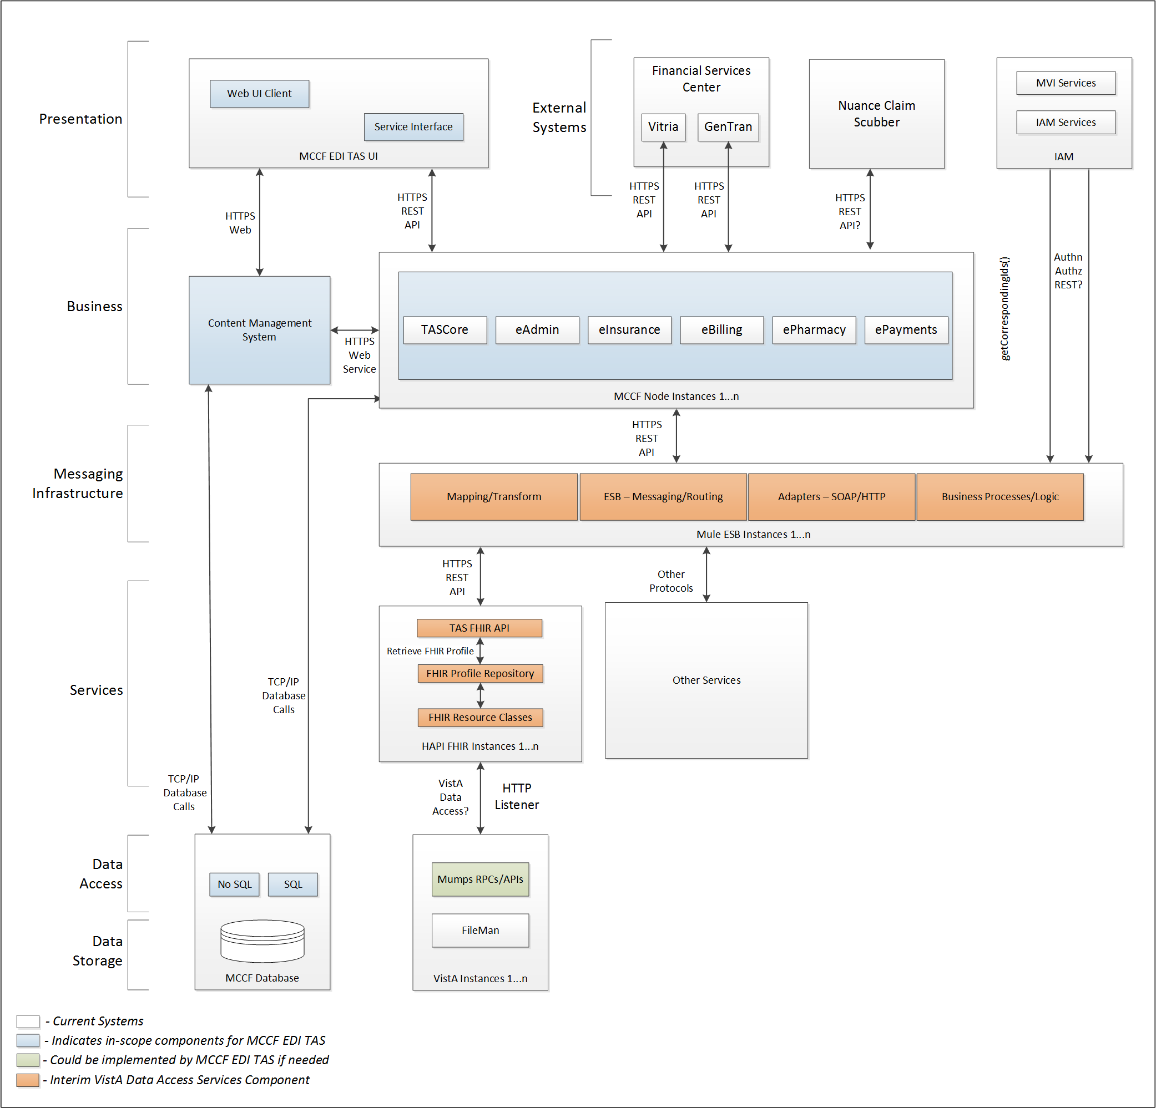

Figure 1 - Interim Solution

To be solution proposed for all eBusiness

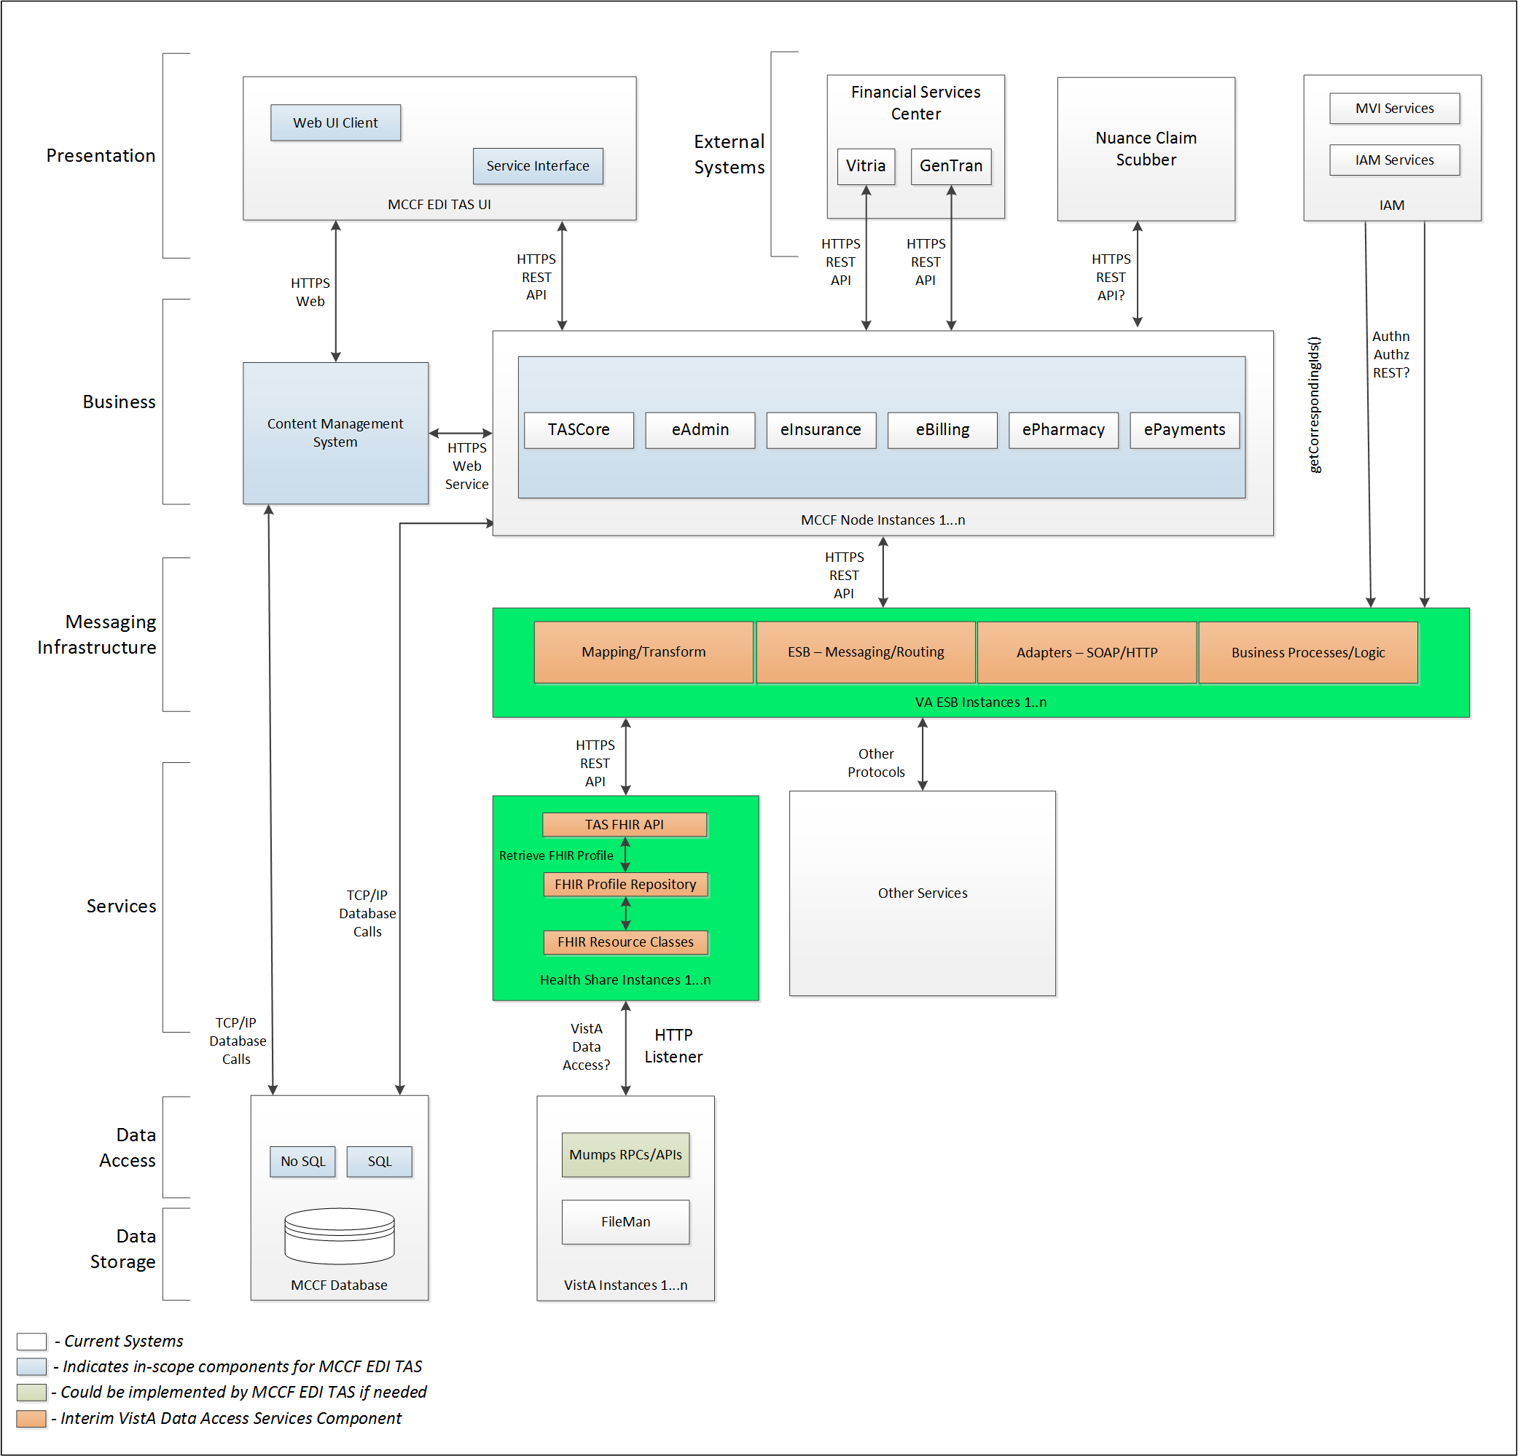

Figure 2 - Future (To Be) Solution

## Interface Overview

Exchanging messages between FSC and MCCF EDI TAS ePharmacy will be done in synchronous real time.

### Connectivity between the systems

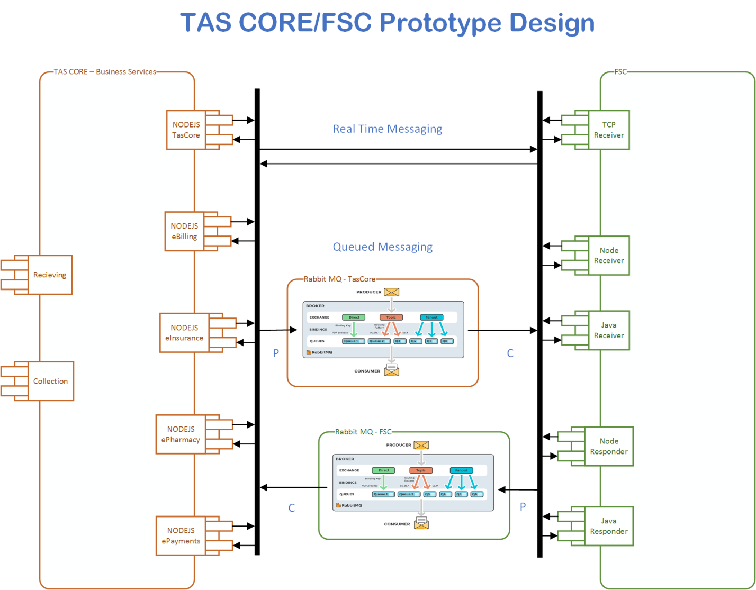

Figure 3 - TASCore / FSC Connectivity

## Operations

### Data Extraction

Data being sent to FSC will be extracted from the VistA databases using a FHIR server.

### Data Transformation

TBD

### Sending/Receiving

MCCF EDI TAS ePharmacy sends and receives ePharmacy transaction messages to and from FSC.

## Data Transfer

Data is transferred between the FSC and the TASCore Application Stack.

## Transaction Types

MCCF EDI TAS ePharmacy sends messages as an NCPDP stream inside a Communication FHIR resource to the FSC that are needed by the FSC so FSC can extract and send ePharmacy transaction requests (transaction) to HCCH.

FSC receives ePharmacy transaction responses from HCCH and transmits that data as an NCPDP stream inside a FHIR Communication resource to MCCF EDI TAS.

## Data Exchanges

MCCF EDI TAS ePharmacy sends a Claim Billing (B1) or a Claim Billing ReBill (B3) request in a Communication FHIR resource containing (B1) or (B3) in NCPDP format to FSC and receives a Claim Billing (B1) or (B3) response FHIR bundle or a Communication FHIR resource containing a Claim Billing (B1) or (B3) response in NCPDP format from FSC. Refer to Section Appendix A [Claim Billing Communication resource](#_Claim_Billing_(B1)_1).

There are four different types of Claim Billing (B1) and Claim Billing ReBill (B3) responses the FSC can send to MCCF EDI TAS ePharmacy:

* TRANSMISSION ACCEPTED/TRANSACTION PAID
* TRANSMISSION ACCEPTED/TRANSACTION CAPTURED
* TRANSMISSION ACCEPTED/TRANSACTION REJECTED
* TRANSMISSION REJECTED/TRANSACTION REJECTED

MCCF EDI TAS ePharmacy sends a Claim Billing Reversal (B2) request in a Communication FHIR resource containing (B2) in NCPDP format to FSC and receives a (B2) response in a Communication FHIR resource from FSC. Refer to Appendix A.

There are four different types of Claim Billing Reversal (B2) responses the FSC can send to MCCF EDI TAS ePharmacy:

* TRANSMISSION ACCEPTED/TRANSACTION APPROVED
* TRANSMISSION ACCEPTED / TRANSACTION CAPTURED
* TRANSMISSION ACCEPTED/TRANSACTION REJECTED
* TRANSMISSION REJECTED/TRANSACTION REJECTED

MCCF EDI TAS ePharmacy sends an Eligibility Verification (E1) request in a Communication FHIR resource containing Eligibility Verification (E1) in NCPDP to FSC and receives an Eligibility Verification (E1) response in a Communication FHIR resource containing an Eligibility Verification (E1) response in NCPDP from FSC. Refer to Section Appendix A.

There are three different types of Eligibility Verification (E1) responses the FSC can send to MCCF EDI TAS ePharmacy:

* TRANSMISSION ACCEPTED/TRANSACTION APPROVED
* TRANSMISSION ACCEPTED/TRANSACTION REJECTED
* TRANSMISSION REJECTED/TRANSACTION REJECTED

### FHIR Based Resources

The following FHIR resources are needed to send an ePharmacy transaction request inside the Communication resource:

* Communication

The following FHIR resources are needed to assemble a Claim Billing (B1) or Claim Billing ReBill (B3) response bundle:

* For TRANSMISSION ACCEPTED/TRANSACTION PAID responses:
  + Communication
* For TRANSMISSION ACCEPTED/TRANSACTION CAPTURED responses:
  + Communication
* For TRANSMISSION ACCEPTED/TRANSACTION REJECTED responses:
  + Communication
* For TRANSMISSION REJECTED/TRANSACTION REJECTED responses:
  + Communication

The following FHIR resources are needed to send any ePharmacy transaction request inside the Communication resource:

* Communication

The following FHIR resources are needed to assemble any Claim Billing (B1), (B2), (B3) or Eligibility (E1) response:

* Communication

### JSON Format

Messages are formatted using the JSON format.

Refer to <https://www.hl7.org/fhir/json.html> for JSON representation of FHIR Resources.

#### ePharmacy transaction Request using the Communication FHIR resource

See Appendix A Communication FHIR resource.

#### ePharmacy transaction Response Using the Communication FHIR Resource

See 2.6.2.1

### Bundle Definition

A Bundle is a top-level container in FHIR that contains all the FHIR resources desired for a transaction between MCCF EDI TAS and FSC.

A Bundle is a container for resources, enabling grouping and transmitting resources altogether at once. Resources such as Claim, Patient, Communication etc., will be transmitted inside multiple entries (see entry list inside Bundle) as a resource type.

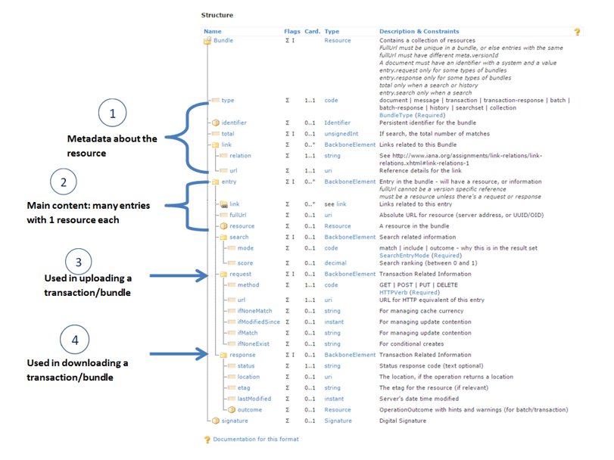

Figure 4 – Content of a FHIR Bundle Resource

Source https://fhir-drills.github.io/bundle.html

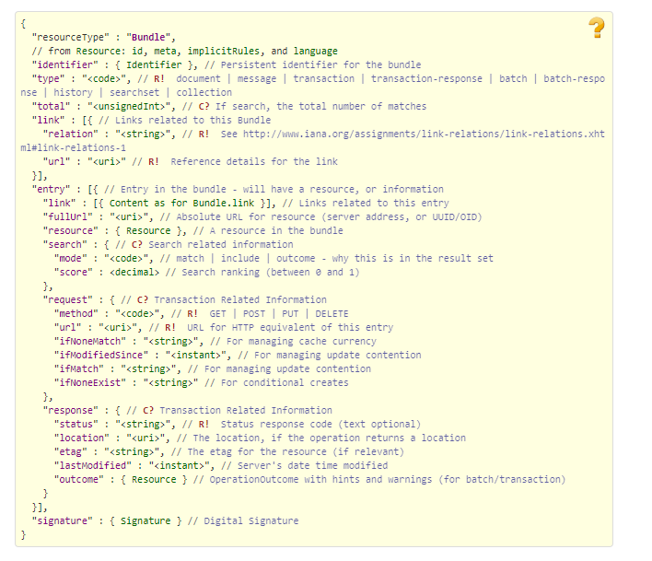

Figure 5 - Example Bundle FHIR Resource

Source https://www.hl7.org/fhir/bundle.html

## Communications Methods

### Ports and Protocols

#### HTTP(S)

Can be used for real time communication.

#### Advanced Message Queuing Protocol (AMQP)

AMQP offers reliable messaging via queues.

### ESB Configuration(s)

TBD

### System Configuration

TBD

## Performance Requirements

System Design Document (SDD); Medical Care Collections Fund (MCCF) - Electronic Data Interchange Transaction Application Suite (EDI TAS). <https://vaww.oed.portal.va.gov/pm/hape/ipt_5010/EDI_Portfolio/TASCore/MCCF_EDI_TAS_System_Design_Document_v0.7.pdf>

## Security

System Design Document (SDD); Medical Care Collections Fund (MCCF) - Electronic Data Interchange Transaction Application Suite (EDI TAS). <https://vaww.oed.portal.va.gov/pm/hape/ipt_5010/EDI_Portfolio/TASCore/MCCF_EDI_TAS_System_Design_Document_v0.7.pdf>

## Testing Requirements

### Comparison of Data

Testing the FHIR conformance will be based on HTTPS://www.hl7.org/fhir/validation.html.

Business Rules will have to be specifically defined in user stories by the ePharmacy team.

* Which fields are mandatory from a business perspective?
* Data integrity

### Completeness

Tests defined in section 2.10.1 must cover all the FHIR resources that are defined in section 2.6.1 in consideration of any functional user story.

### Load Testing

Bench mark tests must be performed based on individual use case requirements.

## Policies and Constraints

### HIPAA Compliance

FSC receives transactions, strips the communication FHIR resource, and then forwards the claim data or eligibility request as NCPDP-formatted transactions to the HCCH.

# Appendix A

## Data Elements

Data being exchanged between TAS and FSC will be formatted in FHIR using the JSON notation. The NCPDP Data stream will be located inside the payload element of the Communication FHIR resource. The first element in the payload will be the NCPDP header and the second element the NCPDP message text. The Communication resource will be wrapped inside a FHIR bundle.

## Bundle ePharmacy Transactions

NOTE: The embedded JSON illustrates a general message being sent to the FSC and being received from the FSC using a B1 NCPDP request payload example and is for illustration purposes only and the NCPDP streams inside the payload element are unmasked.

### ePharmacy transaction Communication resource inside a bundle



## Resource Sections

#### Communication

See Communication resource inside FHIR bundle in section 3.2.1

### Mapping Sheet

ePharmacy transactions use a Communication resource to wrap the NCPDP stream and therefore there is no mapping to and from FHIR.

# Appendix B - TASCore Mapping Rules

TBD

# Appendix C – TASCore Default Values

TBD

# Appendix D – FSC Mapping Rules

TBD

# Appendix E – FSC Default Values

TBD

# Glossary

|  |  |
| --- | --- |
| AMQP - Advanced Message Queuing Protocol | The **Advanced Message Queuing Protocol** (**AMQP**) is an open standard for passing business messages between applications or organizations using queues. |
|  |  |
| HCCH | Health Care Clearing House |
|  |  |
| REST ReSt | REpresentational State Transfer |
|  |  |

# 

# Attachment A – Approval Signatures

This section is used to document the approval of the ICD. The review should be conducted face to face where signatures can be obtained ‘live’ during the review. If unable to conduct a face-to-face meeting then it should be held via Lync and concurrence captured during the meeting. The Scribe should add /es/name by each position cited.

By signing below, I agree that I have reviewed and agree the document is approved.



## Signature page continued

