**memory_match** - game aka "Concentration" or "Card Match". Flip 2 cards at a time and see if the card fronts match. If no match, then the cards are returned to the card back. Proceed until all 9 pairs of cards are matched.

**Link to live demo:** TBI

Source code: <https://github.com/vernonlouie/v_memory_match/tree/v2.1>

**Features:**

a) My Little Pony theme

b) Statistics of game play (matches, attempts, match %)

c) Lift Cards (for those who wish to cheat)

d) Various sound effects (card flip, getting a match, lifting cards, winning a game, resetting game)

e) User can click on various cards and not disrupt play

**Planned or Possible Additions**

1) user option to switch themes

a) Pokemon

b) Star Wars

2) replace general sounds effects with theme-specific sound effects

3) a timer so people can try to beat their best time

4) database to record game scores

**What I Learned**

- how to implement a downloadable font.

- how to fill background with an image.

- how to use jQuery to dynamically add elements to the DOM.

- how to use jQuery methods and chaining

- how to implement sound files.

- how to affect css dynamically

- how to position elements, using HTML, CSS, Javascript, and jQuery.

- how to use GIMP to crop and save files

- responsiveness using bootstrap (hidden columns)

**Screenshots**

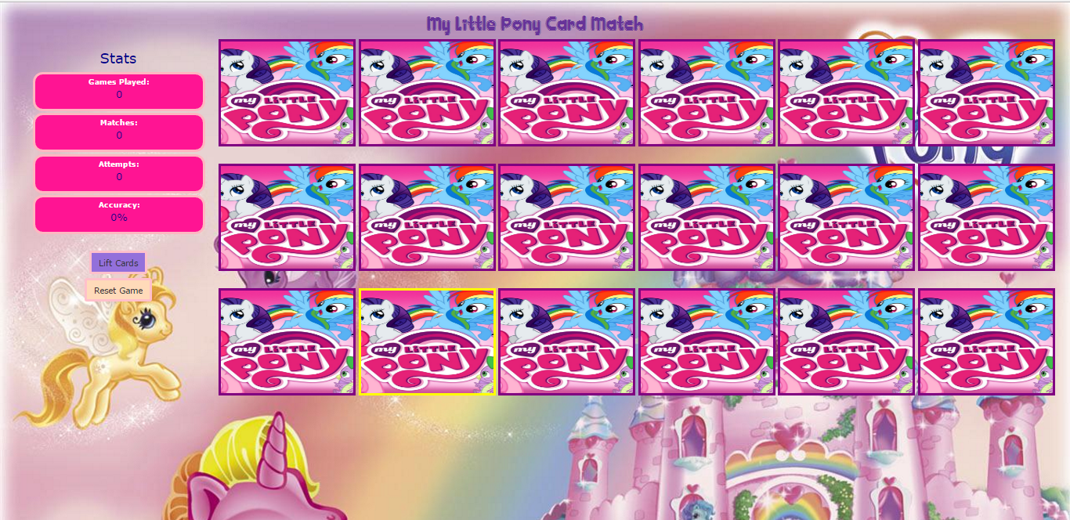

responsive

