The Infinite We

# A Hypothesis of Universal Interconnection

© 2019 Vernon Miles Kerr, vernonmileskerr.com

Living in a black box, as we do, that which happens before birth and after death is a mystery, to most of us. Other than musty religious texts and orally communicated myths, we haven’t a clue. I’m not knocking the religious; at least those who put absolute faith in these traditions have peace of mind — to the degree of depth in their belief, that is. The rest of us are left to ponder, to hypothesize. The current hypothesis came to me in my customary caffeine-induced morning meditations. It usually takes two cups to reach this level of meditative bliss. Here is a tweet I posted moments after receiving this “revelation.”

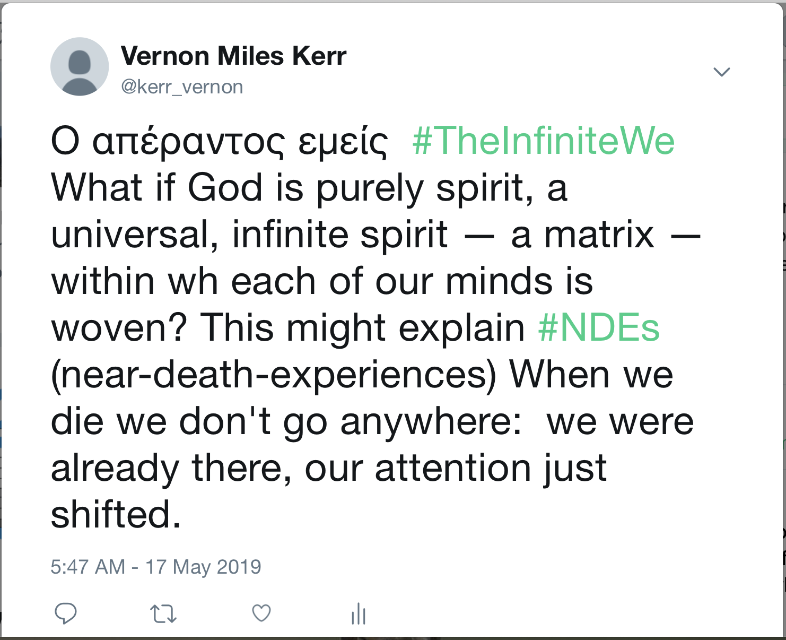

In addition to explaining near-death-experiences, “The Infinite We”, might also explain examples of apparent mental-telepathy. This would be another instance of averting our attention to another part of the spiritual matrix — from our own local part of the spiritual-web to someone else’s. The transitory and infrequent nature of these experiences would seem to indicate that we either do not have control over these experiences or we are not sufficiently evolved to use them at will. If we were, there would definitely be “privacy” issues to deal with.

Moving on to other ramifications of an “Infinite We,” the concept might also explain mysterious answers to prayer, where someone — apparently a normal human —shows up out of the blue to render physical aid or some other kind of solution to a dire problem or quandary.

An Infinite We, might also explain flashes of god-like insight so common in the autobiographies of renowned scientists, artists and musicians. Many of these instant-revelations have moved human civilization forward in “quantum leaps,” over the centuries.

The Infinite We concept would also have to include members of other civilizations spread throughout physical existence, many of which may be far more advanced than we “earthly” creatures. After all, in geologic terms, our own “super-intelligence.” compared to other earthly creatures, has only sprung up in *very* recent times. This raises a big “why.” Why did our level of intelligence and creativity spring up “all of a sudden” as it did? Is there some active agency that selects and initiates prospective members into the Infinite We? I invite you to meditate on that question with me, and to share your thoughts.