EOFY Giveaway
EOFY 4 picture giveaway
www.peterbrandt.com.au
EOFY 4 picture giveaway
www.peterbrandt.com.au
EOFY 4 picture giveaway
www.peterbrandt.com.au
EOFY 4 picture giveaway
www.peterbrandt.com.au
EOFY 4 picture giveaway
www.peterbrandt.com.au
EOFY 4 picture giveaway
www.peterbrandt.com.au
EOFY 4 picture giveaway
www.peterbrandt.com.au
EOFY 4 picture giveaway
www.peterbrandt.com.au
EOFY 4 picture giveaway
www.peterbrandt.com.au
EOFY 4 picture giveaway
www.peterbrandt.com.au
EOFY 4 picture giveaway
www.peterbrandt.com.au
EOFY 4 picture giveaway
www.peterbrandt.com.au
EOFY 4 picture giveaway
www.peterbrandt.com.au
EOFY 4 picture giveaway
www.peterbrandt.com.au

2015
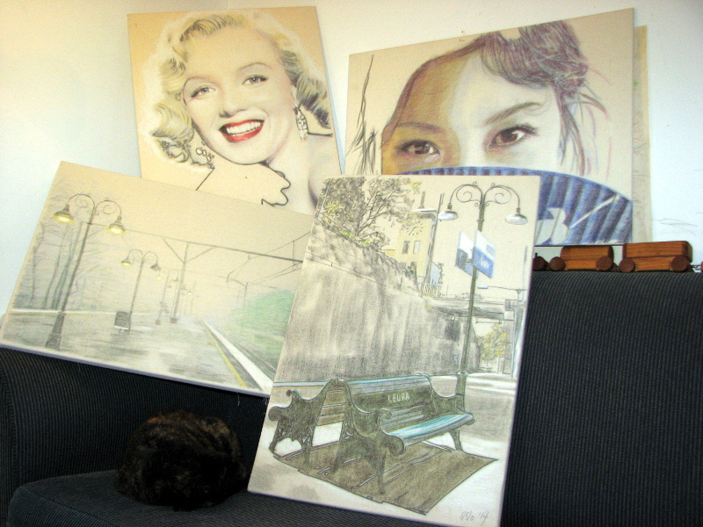
Choose one of four framed portraits

Marilyn Fan girl
Monroe

Leura Leura
Station Station
Autumn take a
Morning seat

enter at
www.peterbrandt.com.au

winners chosen 1st July 2015

