I.

Invitation.

Invitatio.
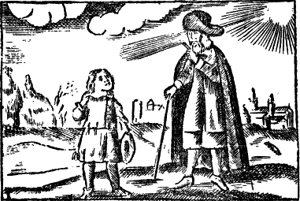
The Master and the Boy. | Magister & Puer.
M. Come, Boy, learn to be wise. | M. Veni, Puer, disce sapere.
P. What doth this mean, to be wise? | P. Quid hoc est, Sapere?
M. To understand rightly,  to do rightly,  and to speak out rightly  all that are necessary. | M. Intelligere recte,  agere recte,  et eloqui recte  omnia necessaria.
P. Who will teach me this? | P. Quis docebit me hoc?
M. I, by God’s help. | M. Ego, cum DEO.
P. How? | P. Quomodo?
M. I will guide thee thorow all. | M. Ducam te per omnia.
I will shew thee all. | Ostendam tibi omnia.
I will name thee all. | Nominabo tibi omnia.
P. See, here I am;  lead me in the name of God. | P. En, adsum;  duc me in nomine DEI.
M. Before all things,  thou oughtest to learn  the plain sounds,  of which man’s speech  consisteth;  which living creatures  know how to make,  and thy Tongue knoweth how  to imitate, and thy hand  can picture out. | M. Ante omnia,  debes discere  simplices Sonos  ex quibus Sermo humanus  constat;  quos Animalia  sciunt formare,  & tua Lingua scit  imitari, & tua Manus  potest pingere.
Afterwards we will go  into the World,  and we will view all things. | Postea ibimus  Mundum,  & spectabimus omnia.
Here thou hast a lively  and Vocal Alphabet. | Hic habes vivum  et vocale Alphabetum.

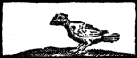 | Cornix cornicatur, à à  The Crow crieth. | A a
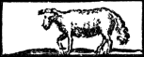 | Agnus balat, b è è è  The Lamb blaiteth. | B b
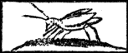 | Cicàda stridet, cì cì  The Grasshopper chirpeth. | C c
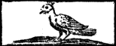 | Upupa dicit, du du  The Whooppoo saith. | D d
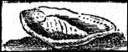 | Infans ejulat, è è è  The Infant crieth. | E e
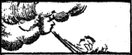 | Ventus flat, fi fi  The Wind bloweth. | F f
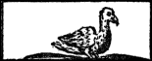 | Anser gingrit, ga ga  The Goose gagleth. | G g
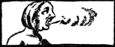 | Os halat, hà’h hà’h  The Mouth breatheth. | H h
 | Mus mintrit, ì ì ì  The Mouse chirpeth. | I i
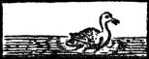 | Anas tetrinnit, kha, kha  The Duck quaketh. | K k
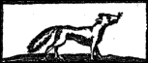 | Lupus ululat, lu ulu  The Wolf howleth. | L
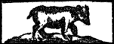 | Ursus murmurat, mum mum  The Bear grumbleth. | M m
4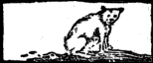 | Felis clamat, nau nau  The Cat crieth. | N n
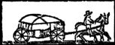 | Auriga clamat, ò ò ò  The Carter crieth. | O o
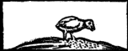 | Pullus pipit, pi pi  The Chicken peepeth. | P p
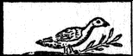 | Cúculus cuculat, kuk ku  The cuckow singeth. | Q q
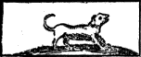 | Canis ringitur, err  The dog grinneth. | R r
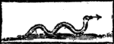 | Serpens sibilat, si  The Serpent hisseth. | S s
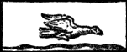 | Graculus clamat, tac tac  The Jay crieth. | T t
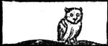 | Bubo ululat, ù ù  The Owl hooteth. | U u
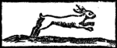 | Lepus vagit, va  The Hare squeaketh. | W w
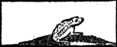 | Rana coaxat, coax  The Frog croaketh. | X x
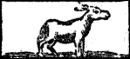 | Asinus rudit, y y y  The Asse brayeth. | Y y
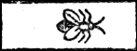 | Tabanus dicit, ds ds  The Breeze or Horse-flie saith. | Z z

II.

God.

Deus.

God is of himself  from everlasting to everlasting. | Deus est ex seipso,  ab æterno in æternum.
A most perfect  and a most blessed Being. | Perfectissimum  & beatissimum Ens.
In his Essence Spiritual,  and One. | Essentiâ Spiritualis  & unus.
In his Personality, Three. | Hypostasi Trinus.
In his Will, Holy, Just,  Merciful and True. | Voluntate, Sanctus, Justus,  Clemens, Verax.
In his Power very great. | Potentiâ maximus.
In his Goodness, very good. | Bonitate Optimus.
In his Wisdom, unmeasurable. | Sapientiâ, immensus.
A Light inaccessible;  and yet all in all. | Lux inaccessa;  & tamen omnia in omnibus.
Every where, and no where. | Ubique & nullibi.
The chiefest Good, and  the only and inexhausted  Fountain of all good things. | Summum Bonum, et  solus et inexhaustus  Fons omnium Bonorum.
As the Creator, so the  Governour and Preserver  of all things, which we call  the World. | Ut Creator, ita  Gubernator et Conservator  omnium rerum, quas vocamus  Mundum.

III.

The World.

Mundus.
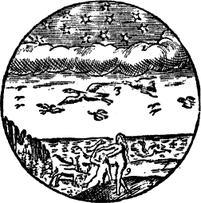
The Heaven, 1.  hath Fire, and Stars. | Cœlum, 1.  habet Ignem & Stellas.
The Clouds, 2.  hang in the Air. | Nubes, 2.  pendent in Aere.
Birds, 3.  fly under the Clouds. | Aves, 3.  volant sub nubibus.
Fishes, 4.  swim in the Water. | Pisces, 4.  natant in Aqua.
The Earth hath Hills, 5.  Woods, 6. Fields, 7.  Beasts, 8. and Men, 9. | Terra habet Montes, 5.  Sylvas, 6. Campos, 7.  Animalia, 8. Homines, 9.
Thus the greatest Bodies  of the World,  the four Elements,  are full of  their own Inhabitants. | Ita maxima Corpora  Mundi,  quatuor Elementa,  sunt plena  Habitatoribus suis.

IV.

The Heaven.

Cœlum.
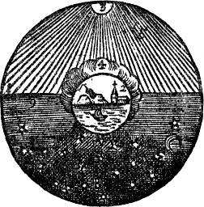
The Heaven, 1.  is wheeled about, and  encompasseth the Earth, 2.  standing in the middle. | Cœlum, 1.  rotatur, &  ambit Terram, 2.  stantem in medio.
The Sun, 3.  wheresoever it is,  shineth perpetually,  howsoever dark Clouds, 4.  may take it from us;  and causeth by his Rays, 5.  Light, and the Light, Day. | Sol, 3.  ubi ubi est,  fulget perpetuo,  ut ut densa Nubila, 4.  eripiant eum a nobis;  facitque suis Radiis, 5.  Lucem, Lux Diem.
On the other side,  over against it,  is Darkness, 6.  and thence Night. | Ex opposito,  sunt Tenebræ, 6.  inde Nox.
In the Night  shineth the Moon, 7.  and the Stars, 8.  glister and twinkle. | Nocte  splendet Luna, 7.  & Stellæ, 8.  micant, scintillant.
In the Evening, 9.  is Twilight: | Vesperi, 9.  est Crepusculum:
In the Morning, 10.  the breaking,  and dawning of the Day. | Manè  Aurora, 10.  & Diluculum.

