IV.

The Heaven.

Cœlum.
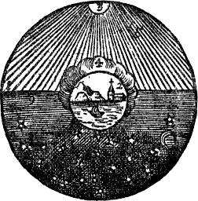
The Heaven, 1.  is wheeled about, and  encompasseth the Earth, 2.  standing in the middle. | Cœlum, 1.  rotatur, &  ambit Terram, 2.  stantem in medio.
The Sun, 3.  wheresoever it is,  shineth perpetually,  howsoever dark Clouds, 4.  may take it from us;  and causeth by his Rays, 5.  Light, and the Light, Day. | Sol, 3.  ubi ubi est,  fulget perpetuo,  ut ut densa Nubila, 4.  eripiant eum a nobis;  facitque suis Radiis, 5.  Lucem, Lux Diem.
On the other side,  over against it,  is Darkness, 6.  and thence Night. | Ex opposito,  sunt Tenebræ, 6.  inde Nox.
In the Night  shineth the Moon, 7.  and the Stars, 8.  glister and twinkle. | Nocte  splendet Luna, 7.  & Stellæ, 8.  micant, scintillant.
In the Evening, 9.  is Twilight: | Vesperi, 9.  est Crepusculum:
In the Morning, 10.  the breaking,  and dawning of the Day. | Manè  Aurora, 10.  & Diluculum.

