The Air. VI. Aër.
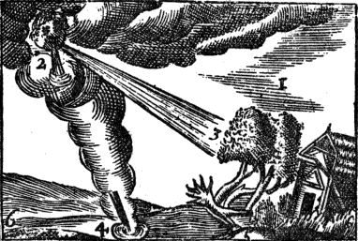
A cool Air, 1.  breatheth gently. | Aura, 1.  spirat leniter.
The Wind, 2.  bloweth strongly. | Ventus, 2.  flat valide.
A Storm, 3.  throweth down Trees. | Procella, 3.  sternit Arbores.
A Whirl-wind, 4.  turneth it self  in a round compass. | Turbo, 4.  agit se  in gyrum.
A Wind under Ground, 5.  causeth an Earthquake. | Ventus subterraneus, 5.  excitat Terræ motum.
An Earthquake causeth  gapings of the Earth,  (and falls of Houses.) 6. | Terræ motus facit  Labes (& ruinas.) 6.

