III.

The World.

Mundus.
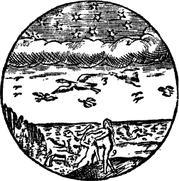
The Heaven, 1.  hath Fire, and Stars. | Cœlum, 1.  habet Ignem & Stellas.
The Clouds, 2.  hang in the Air. | Nubes, 2.  pendent in Aere.
Birds, 3.  fly under the Clouds. | Aves, 3.  volant sub nubibus.
Fishes, 4.  swim in the Water. | Pisces, 4.  natant in Aqua.
The Earth hath Hills, 5.  Woods, 6. Fields, 7.  Beasts, 8. and Men, 9. | Terra habet Montes, 5.  Sylvas, 6. Campos, 7.  Animalia, 8. Homines, 9.
Thus the greatest Bodies  of the World,  the four Elements,  are full of  their own Inhabitants. | Ita maxima Corpora  Mundi,  quatuor Elementa,  sunt plena  Habitatoribus suis.

