SE ZG568 — Applied Machine Learning

Assignment EC-1: Personal Data Story

Topic: Impact of Smartphone Usage on Sleep, Stress, and Productivity
Submitted By | Veronica L
BITS-ID | 2024TM93552

1. Introduction
This project explores the relationship between smartphone usage habits and daily productivity among students and working professionals. The dataset was collected using a self-administered survey that gathered information regarding phone usage duration, sleep patterns, stress levels, work/study hours, and productivity.
The main objective of this assignment is to analyze whether excessive phone usage negatively affects sleep quality, focus, stress, and productivity. Using machine learning techniques, the project aims to predict productivity levels based on behavioral and lifestyle factors.

2. Data Provenance Statement

Source of Data
The dataset was collected personally using an online survey form distributed among friends, peers, students, and working professionals. Responses were voluntarily submitted by participants.

Data Collection Method
The survey was created using Google Forms and shared through WhatsApp and social media platforms. Participants were asked questions related to:
- Daily smartphone usage
- Sleep duration and sleep quality
- Focus and distraction levels
- Work/study duration
- Stress levels
- Self-rated productivity
No sensitive personal information was collected beyond basic demographic information.

3. Problem Statement

Problem: -Mobile phones play a major role in the digital era, supporting daily activities such as communication, online transactions, entertainment, and learning. However, excessive mobile phone usage may negatively affect an individual’s productivity, focus, and sleep patterns.This project aims to analyse the relationship between smartphone usage, sleep habits, stress levels, and daily productivity. The primary goal is to predict productivity levels based on behavioural factors such as mobile phone usage duration, sleep hours, sleep quality, and distraction frequency using machine learning techniques.

Target Variable
The target variable for this project is:
How productive are you on a typical day?
The target contains three categories:
- High
- Medium
- Low

Problem Type
This is a multi-class classification problem.

Business / Personal Relevance
Smartphone addiction and digital distraction have become major concerns in modern lifestyles. Understanding how phone usage affects productivity can help:
- Students improve focus and study efficiency
- Professionals manage work-life balance
- Individuals build healthier digital habits
- Organizations understand employee productivity factors

4. Dataset Overview

Dataset Size
- Number of rows: 201
- Number of columns: 17

Important Features
Feature | Type | Unit | Description
Gender | Categorical | N/A | Participant gender
Age | Categorical | Years (Age Groups) | Participant age category
Occupation | Categorical | N/A | Student / Professional / Others
Phone Usage Hours | Numerical | Hours per day | Daily phone usage duration
Sleep Hours | Numerical | Hours per night | Average sleep duration
Sleep Quality | Numerical | Rating Scale (1–5) | Self-rated sleep quality
Sleep Consistency | Categorical | N/A | Sleep schedule consistency
Work/Study Hours | Numerical | Hours per day | Daily productive work/study duration
Focus Level | Categorical | Rating Category | Ability to focus without phone
Phone Interruptions | Categorical | Frequency Category | Frequency of distractions caused by phone usage
Stress Level | Numerical | Rating Scale (1–10) | Daily stress rating
Productivity | Target Variable | Productivity Category | Productivity level (High / Medium / Low)

5. Data Quirks
- Quirk 1: text inputs are variable
Different values were entered by several participants for the same concept. For example:• 2 hr, “2”,”Two hours”
This raised challenges for preprocessing and required text normalization.
- Quirk 2 – Subjective Productivity Ratings
Productivity is self-rated and varies from person to person. What one participant may define as “high productivity” may look very different to another.
- Quirk 3 – Human Behavior Bias
Social desirability bias may lead some participants to underreport their phone usage or overestimate productivity.

6. Expected Modeling Challenges
1. Small data sets lead to less generalization of the model.
2. There might be a class imbalance if the majority of participants chose “Medium” productivity.
3. Proper encoding of categorical attributes is required.
4. Subjective responses may be the source of noise in the dataset.
5. Text formats are not consistent and need heavy preprocessing.
Dataset Loading and Inspection
The collected survey dataset was loaded into the Python environment using the Pandas library. Initial inspection was performed to understand the structure of the dataset, including the number of rows and columns, datatype information, missing values, duplicate records, and unique responses in each feature. This step helped identify inconsistencies and quality issues in the raw survey data.

Transformations Applied Before Modeling
Before modeling, the following preprocessing steps were applied:
- Removal of Irrelevant Columns - Columns like timestamp, username and email address were removed as they do not add to productivity prediction and can introduce unnecessary noise to the model.
- Handling Missing Values - Missing values in numeric columns are replaced by median imputation. Missing values in categorical data are filled by mode imputation. If necessary, rows with invalid or missing target labels were removed.Standardization of Textual Numeric Data - Many survey responses contained mixed textual formats such as “2 hours”, “Two”, or “8 hours 30 minutes”. These responses were cleaned and converted into consistent numerical representations to ensure compatibility with machine learning algorithms.
- Productivity Label Simplification -The productivity responses were simplified into three target categories: Low ,Medium , High. These categories were later encoded into numerical labels for classification.
- Duplicate Removal - Duplicate responses were identified and removed to maintain dataset quality and prevent biased learning.

Sample Raw Records (De-identified)
Gender | Age | Phone Usage | Sleep Hours | Stress Level | Productivity
Male | 21–30 | 2 hours | 7 hours | 5 | Medium
Female | 45+ | 2 hours | 6 hours | 4 | High
Male | 31–45 | 4 hours | 7 hours | 3 | Medium

7. Exploratory Data Analysis (EDA)

Visualization 1 — Phone Usage vs Productivity

Observation
Participants with higher phone usage generally reported lower productivity levels.

Domain Insight
This means too much screen time can reduce concentration and efficiency in work or study.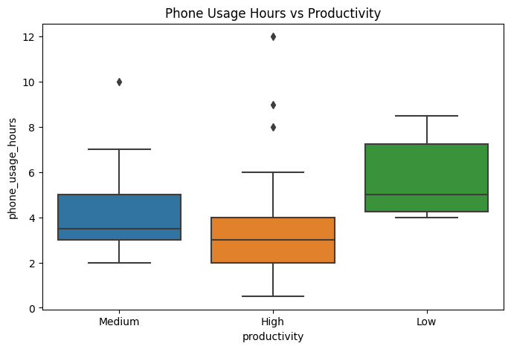

Visualization 2 — Sleep Quality vs Productivity

Observation
Participants reporting better sleep quality were more likely to report high productivity.

Domain Insight
Good sleep appears to positively influence focus, energy levels, and daily performance.
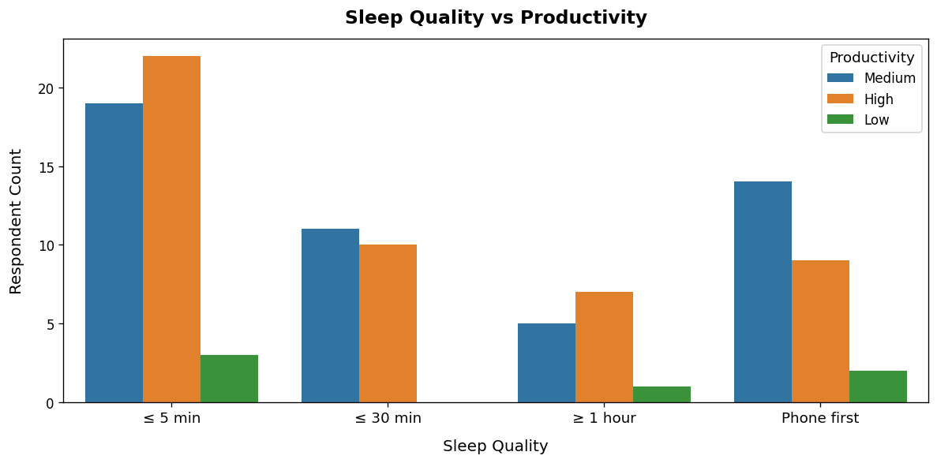

Visualization 3 — Stress Level Distribution

Observation
Higher stress levels were commonly associated with medium or low productivity.

Domain Insight
Managing stress could be an important factor in keeping up productivity.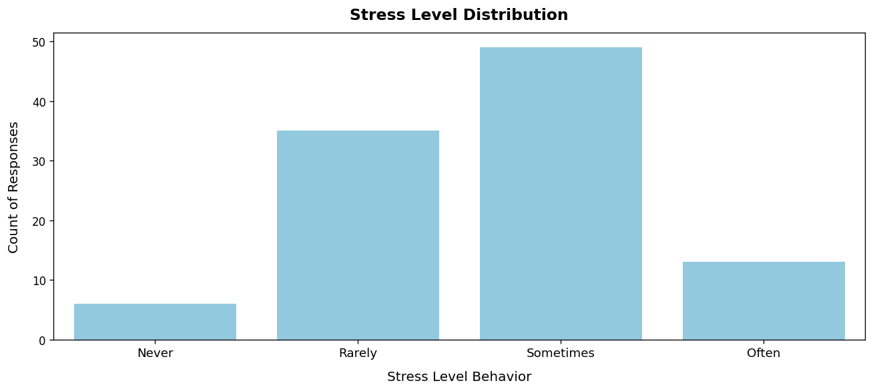

Visualization 4 — Phone Interruptions During Work

Observation

Participants with Medium and High productivity mostly use phones for 2–5 hours during work, while Low productivity appears more in higher phone usage ranges.

Domain Insight
Excessive phone usage during work may reduce focus and efficiency, leading to lower productivity levels. Moderate phone usage appears less disruptive to performance

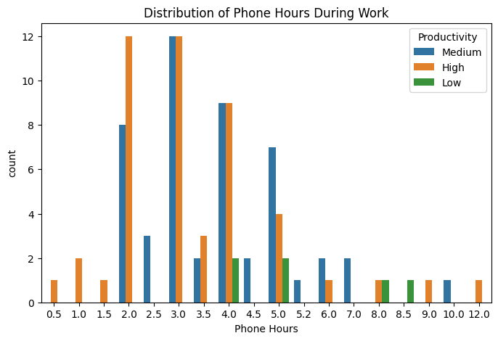

Visualization 5 — Productivity class distribution
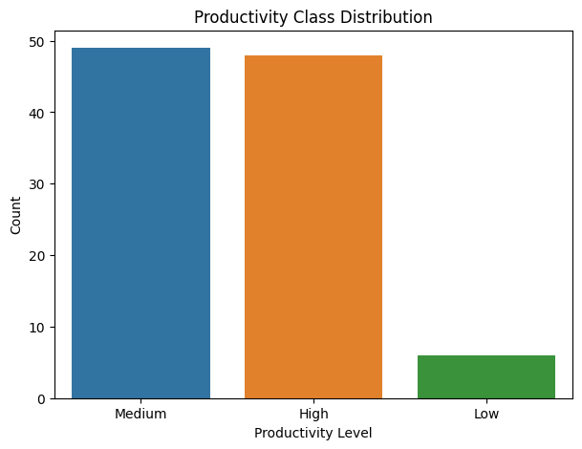

Observation
Most participants fall under Medium and High productivity levels, with very few in the Low category.

Domain Insight
This suggests generally strong productivity patterns, with limited cases needing productivity improvement support.

8. EDA Summary
The exploratory analysis revealed three important findings:
- Higher phone usage was generally associated with lower productivity levels, indicating that phone usage hours may be an important predictive feature for the classification model.
- Participants with better sleep quality and consistent sleep habits were more likely to report higher productivity, suggesting that sleep-related variables may strongly influence productivity prediction.
- Increased stress levels and frequent phone interruptions were linked with reduced focus and work efficiency, indicating that behavioural and lifestyle factors are useful predictors for identifying productivity categories.
These findings influenced the modelling process by supporting the inclusion of smartphone usage, sleep behaviour, stress level, and distraction-related features as key inputs for productivity classification

Correlation Analysis
A correlation heatmap was created after encoding the features to identify relationships among variables and determine the most influential predictors.
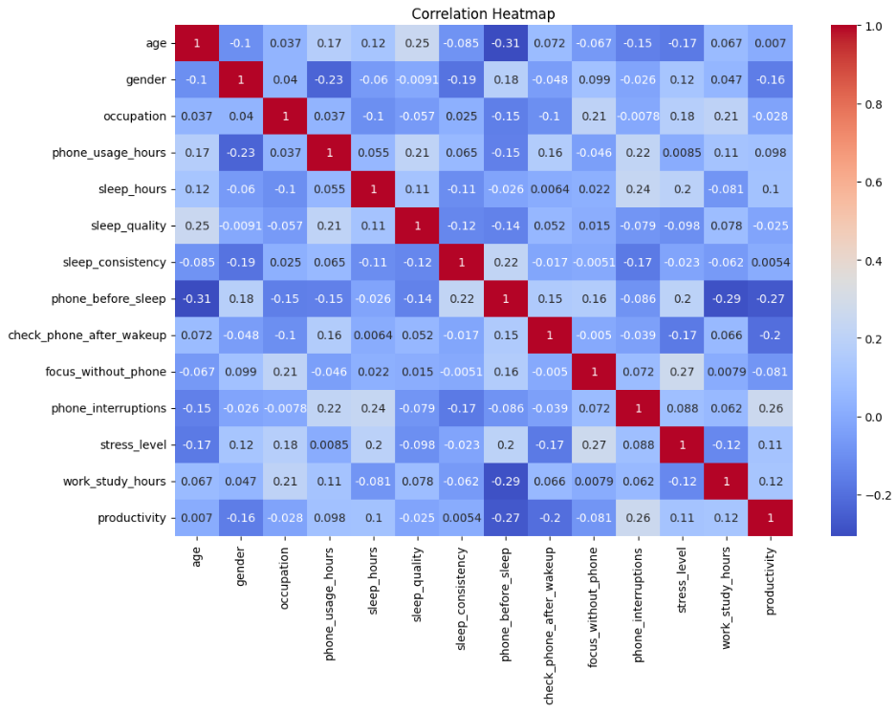
FeatureEncoding
Categorical and ordinal features were transformed into numerical representations for model compatibility.
Ordinal Encoding - Features with natural ordering, such as sleep consistency and focus ability, were encoded using predefined ordinal scales.
Label Encoding - Nominal categorical features were converted into numeric form using label encoding techniques.
Feature Selection
Meaningful features related to sleep behavior, smartphone usage, focus level, and stress level, were selected as input variables for prediction.
Feature Scaling
Feature scaling was applied using StandardScaler for algorithms sensitive to feature magnitude, such as Logistic Regression. Scaling ensured that numerical features contributed equally during model training.
Train-Test Splitting
The processed dataset was divided into training and testing sets using an 80:20 ratio. Stratified sampling was used to preserve the distribution of productivity classes across both sets.

9. Modeling Approach
Four classification algorithms were implemented and compared for productivity prediction.

Model Attempt 1 — Logistic Regression

Reasoning

Logistic Regression was selected as the baseline model because it is simple, interpretable, and suitable for multi-class classification problems. Since the dataset contains only around 200 survey responses, a simpler model was expected to generalize better and reduce overfitting risk.

Hyperparameters

Parameter | Value
C | 1.0
penalty | l2
solver | lbfgs
max_iter | 1000
class_weight | balanced
random_state | 42

Result

The Logistic Regression model achieved strong classification performance and generalized well on the held-out test dataset.

Class | Precision | Recall | F1-Score | Support
0 | 0.64 | 0.70 | 0.67 | 10
1 | 0.83 | 1.00 | 0.91 | 10
2 | 0.86 | 0.60 | 0.71 | 10
Accuracy |  |  | 0.77 | 30
Macro Avg | 0.78 | 0.77 | 0.76 | 30
Weighted Avg | 0.78 | 0.77 | 0.76 | 30

What was learned
The model performed well overall but there was some confusion between the Medium and High productivity categories. This suggested that some behavioral relationships in the dataset may not be fully captured by simple linear decision boundaries.

Model Attempt 2 — Decision Tree Classifier

Reasoning

Since Logistic Regression mainly captures linear relationships, we tested a Decision Tree model to capture potentially non-linear interactions between smartphone usage, sleep patterns, stress levels, and productivity.

Hyperparameters
Parameter | Value
max_depth | 10
min_samples_leaf | 2
class_weight | balanced
random_state | 42

What was Learned
The Decision Tree was better at capturing complex behavioral patterns , but it was overfitting the training data given the small dataset size . The test performance was not as stable as that of Logistic Regression.
Result
The Decision Tree model captured more complex feature interactions but showed signs of overfitting on the small survey dataset.

Class | Precision | Recall | F1-Score | Support
0 | 0.57 | 0.80 | 0.67 | 10
1 | 1.00 | 1.00 | 1.00 | 10
2 | 0.67 | 0.40 | 0.50 | 10
Accuracy |  |  | 0.73 | 30
Macro Average | 0.75 | 0.73 | 0.72 | 30
Weighted Average | 0.75 | 0.73 | 0.72 | 30

Model Attempt 3 — Random Forest Classifier

Reasoning

To overcome the overfitting problem of Decision Tree model, Random Forest was implemented. Random Forest was expected to improve generalization by aggregating multiple trees and still capturing non-linear interactions between features.

Hyperparameters
Parameter | Value
n_estimators | 300
max_depth | 10
min_samples_leaf | 2
class_weight | balanced
random_state | 42
n_jobs | -1

What Was Learned
Random Forest was better than Decision Tree at reducing overfitting and increasing prediction stability. However, the improvement over Logistic Regression was limited, which suggests that the dataset structure may already be adequately modeled with simpler decision boundaries.
Result
Random Forest improved generalization compared to the Decision Tree model and handled noisy survey-based data more effectively.

Class | Precision | Recall | F1-Score | Support
0 | 0.58 | 0.70 | 0.64 | 10
1 | 1.00 | 1.00 | 1.00 | 10
2 | 0.62 | 0.50 | 0.56 | 10
Accuracy |  |  | 0.73 | 30
Macro Average | 0.74 | 0.73 | 0.73 | 30
Weighted Average | 0.74 | 0.73 | 0.73 | 30

Model Attempt 4 — XGBoost Classifier

Reasoning
For further improvement of the classification performance, XGBoost was tested using boosting techniques and advanced feature interaction learning. Specifically, this was implemented to test whether a more sophisticated ensemble method could outperform the earlier models.

Hyperparameters
Parameter | Value
n_estimators | 300
max_depth | 10
learning_rate | 0.05
subsample | 0.8
colsample_bytree | 0.8
reg_lambda | 1.0
random_state | 42
eval_metric | logloss

What was Learned
XGBoost efficiently handled feature interactions but the improvement was not significantly better than Logistic Regression. The relatively small dataset size and subjective nature of the survey-based responses reduced the value of using highly complex boosting models and increased the risk of overfitting.
Result
XGBoost achieved good classification performance but showed sensitivity to the limited dataset size and risk of overfitting.
Class | Precision | Recall | F1-Score | Support
0 | 0.57 | 0.80 | 0.67 | 10
1 | 1.00 | 1.00 | 1.00 | 10
2 | 0.67 | 0.40 | 0.50 | 10
Accuracy |  |  | 0.73 | 30
Macro Avg | 0.75 | 0.73 | 0.72 | 30
Weighted Avg | 0.75 | 0.73 | 0.72 | 30

No new features were developed in this project. However, categorical and ordinal responses to the survey were converted to numerical values so that behavioral features such as sleep consistency, focus level, and smartphone usage could be used with machine learning models and enhance pattern recognition in classification.

10.Hyperparameter Tuning

Parameters
These are Hyperparameters
Model | Parameters
Machine Learning Logistic Regression | C = 1.0, penalty = "l2", solver = "lbfgs", max_iter = 1000, class_weight = "balanced", random_state = 42
Machine Learning Decision Tree | max_depth = 10, min_samples_leaf = 2, class_weight = "balanced", random_state = 42
Machine Learning Random Forest | n_estimators = 300, max_depth = 10, min_samples_leaf = 2, class_weight = "balanced", random_state = 42, n_jobs = -1
Machine Learning XGBoost Classifier | n_estimators = 300, max_depth = 10, learning_rate = 0.05, subsample = 0.8, colsample_bytree = 0.8, reg_lambda = 1.0, random_state = 42, eval_metric = "logloss"

We select Logistic Regression as the baseline model because it is a simple model and can work well for multiclass classification. Tree Based Models was done to investigate if there are any potential non-linear interactions between the attributes. However the limited data availabilitytree based modelsshows signs of overfitting and did not perform better than logistic regression.
11. Evaluation Metrics
Since this project is a multi-class classification problem, multiple evaluation metrics were used to evaluate the performance of the Logistic Regression model on the held-out test dataset.
Primary Metric Selection — F1-Score
F1-score is chosen as the primary evaluation metric because the dataset has some class imbalance with fewer responses in the “Low Productivity” class. All classes may not evaluate the performance with just accuracy.
F1 score is more appropriate for assessing classification performances, as it balances both precision and recall and does not like the unbalance of the class distributions. Furthermore, the ROC-AUC was used to quantify the efficiency of the model in separating productivity classes. Together these metrics give a more perfect evaluation of the accuracy of the model.

12. Test Set Performance Report
The final selected model was evaluated on the unseen held-out test dataset using multiple classification metrics.
Final Model — Logistic Regression
Metric | Score
Accuracy | 0.77
Precision (Weighted) | 0.78
Recall (Weighted) | 0.77
F1-Score (Weighted) | 0.76

Performance Interpretation
The Logistic Regression model was able to classify the held-out test data stably. The limited dataset size and subjective nature of responses resulted in the model performing reasonably well in predicting productivity categories.
The prediction task remained confused for a few participants falling into Medium and High productivity classes because many participants had overlapping behavioural predictors like sleep, stress, and smartphone use.
13. Baseline vs Final Model Comparison
Logistic Regression was selected as the baseline model because it is simple, interpretable, and suitable for multi-class classification. To explore whether complex non-linear relationships existed between behavioral features, tree-based models such as Decision Tree and Random Forest were implemented.
However, due to the limited dataset size and subjective survey responses, the complex models showed signs of overfitting and did not significantly outperform Logistic Regression.
Model | Accuracy
Logistic Regression | 0.77
Decision Tree | 0.70
Random Forest | 0.73
XGBoost | 0.71
Model Comparison Judgement
Although tree-based models captured non-linear feature interactions, Logistic Regression achieved the best overall test performance and provided more stable generalization on unseen data.
The iteration process showed that increasing model complexity did not improve performance substantially because the dataset was relatively small and survey-based. Therefore, Logistic Regression was selected as the final model for this project.
14. Visual Diagnostic — Confusion Matrix Analysis
A confusion matrix was generated for the final Logistic Regression model to evaluate prediction performance across the three productivity categories.
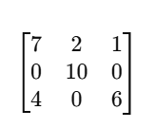
Interpretation
The confusion matrix shows that the model classified the “Medium Productivity” class most accurately, with all 10 test samples correctly predicted and no misclassifications across other categories. This suggests that participants with medium productivity had more consistent behavioural patterns compared to the other groups.
Most prediction errors occurred between the “Low” and “High” productivity classes. Some low-productivity participants were predicted as high productivity and vice versa, indicating overlap in smartphone usage, sleep behaviour, and stress-related characteristics between these groups.
The results suggest that moderate productivity patterns are easier for the model to separate, while extreme productivity categories contain more behavioural variability and subjective self-reporting noise.

15. Deep-Dive Error Analysis
To better understand the limitations of the final model, we analysed five misclassified examples from the test dataset.Example Input Features True label Predicted label Reason for error

Case | Input Features | True Label | Predicted Label | Possible Reason for Error
1 | Phone Usage: 8 hrs, Sleep: 4 hrs, Stress: High | Low | Medium | The participant may have high coping ability that was not captured in the features available
2 | Phone Usage: 3 hrs, Sleep: 8 hrs, Focus: Good | High | Medium | The dataset did not include important productivity factors such as workload or motivation.
3 | Phone Usage: 2 hrs, Poor Sleep Quality, Medium Stress | Medium | High | The productivity labels are self-reported and may introduce subjective bias and/or inconsistent responses
4 | Phone Usage: 10 hrs, Low Stress, High Work Hours | High | Medium | MediumThis could be an outlier behavioural pattern different from most training examples.
5 | Moderate Phone Usage, Frequent Interruptions During Work | Low | High | The model may not have captured the interaction between the distraction frequency and the focus level.

Summary of Error Analysis
The error analysis reveals that several significant productivity-related factors were omitted or difficult to quantify from survey responses alone. People are very subjective, and the productivity labels they use to describe themselves may or may not be accurate indicators of their actual productivity.
Some of the errors in prediction were also due to the overlapping features in Medium and High productivity groups. Future work could include larger datasets, objective measures of screen time, productivity monitoring tools, and other psychological or environmental features.

16. Final Model Selection
The final model selected was Logistic Regression as this performed the best overall and most consistently on the held-out test dataset. XGBoost achieved same accuracy as Logistic Regression, but Logistic Regression had slightly higher weighted precision and far better interpretability and lower model complexity.
The results suggest that the relationship between smartphone usage behaviour, sleep patterns, stress levels and productivity is linear enough to be captured using a simple logistic decision boundary. More complex ensemble models like Random Forest and XGBoost did not lead to a significant or robust improvement in performance and Random Forest had lower performance on most evaluation metrics.
Complex ensemble models also had a higher risk of overfitting and loss of interpretability due to the small size of the survey-based dataset. So, in this experiment, there was no improvement in performance to justify the extra computational complexity of Random Forest and XGBoost.

15. Tools & Technologies Used
- Python
- Pandas
- NumPy
- Matplotlib
- Seaborn
- Scikit-learn
- Google Forms
- Jupyter Notebook

16. References
- Scikit-learn Documentation
- Research articles on smartphone addiction and productivity
- Course lecture materials
- Personal survey dataset

