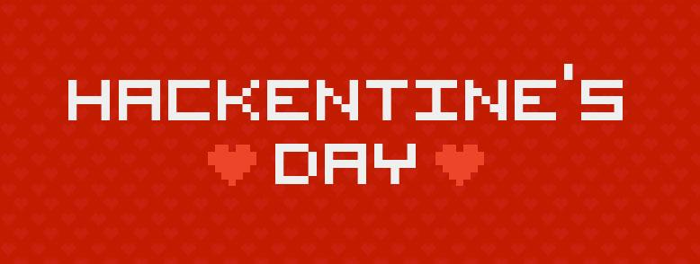

♥ ♥ ♥ ♥ ♥ ♥ ♥ ♥ ♥ ♥ ♥ ♥ ♥ ♥ ♥ ♥ ♥ ♥ ♥ ♥ ♥ ♥ ♥ ♥ ♥ ♥ ♥ ♥ ♥ ♥ ♥ ♥ ♥ ♥ ♥

Welcome to Hackentine’s Day! We are so happy you are here. Today you will learn the basic building blocks of HTML, CSS and JavaScript by building a Valentine’s Day e-card of your very own!

# Checklist:

1. Make sure you have [Textmate](http://macromates.com/download) or [Sublime](http://www.sublimetext.com/download) (or equivalent text editor) downloaded on your computer. Ask for help if you need it!
2. Make sure you have access to a browser. We prefer [Chrome](https://www.google.com/intl/en/chrome/browser/).
3. If you like, jam out to [this rdio playlist](http://www.rdio.com/people/marthakelly/playlists/8116379/Hackentine%27s_Day/) we made for you! Feel free to add new songs. Tip: It’s more fun on shuffle.
4. Download the source files for the project [here](http://bit.ly/hackentines-day-project)

# Let’s get started!

First we will go over what HTML, CSS and JavaScript are. Then you can dive in to the project and customize it for yourself! If you prefer, you can skip over the teaching material and go straight to the tutorial.

# What is HTML?

HTML stands for “Hyper Text Markup Language.” HTML defines the **structure** of your web page. By **structure** we mean sections, columns, headlines, and paragraphs (among [many other elements](http://www.w3schools.com/tags/)).

Your browser can tell the difference between a paragraph and a headline because each element has its own HTML tag. HTML tags look like this:

<h1>Happy Hackentine’s Day!</h2>

<p>You are the CSS to my HTML</p>

You will see a lot of HTML tags in the index.html file in the hackentines day folder. Don’t worry about all of them yet! Just focus on the elements inside the tag that looks like this:

<div class=”hackentines-day-card-container”>

<!-- Lots of cool stuff can happen inside here! -->

</div>

**Note:** anything inside the <!-- and --> characters is a **comment**. Anything between those characters does not show up in the browser. Comments are a way for you to make notes to yourself or to other developers.

A <div></div> is an HTML tag that specifies a **section**, technically called a **division**, in your code. We have two <div></div> to care about, the front of our card and the back of our card.

Any HTML tag can have a name. The name of an HTML tag is set in the class attribute on the tag. For example, the name of the <div> above is “hackentines-day-card-container”

Note: every HTML tag can have more than one name! For example, if you’d like to have an HTML tag with **\*two* or more** class names, just separate them with a space.

<div class=”hackentines-day-card-container hearts”>

You can style HTML tags by having a separate CSS file. To connect the files you create a link in your HTML to the CSS file like this:

<link rel="stylesheet" type="text/css" href="css/main.css">

(But you don’t have to worry about that, we put that in the source file for you!)

# What is CSS?

CSS stands for “Cascading Style Sheet” but don’t let the name confuse you! CSS is the way you tell the browser what size, color, or font you want your HTML tags to be.

If HTML is the structure of your webpage, CSS is the decoration!

CSS is written differently than HTML. It is made of **declarations** and they look like this:

.hackentines-day-card-container {

color: red;

background-color: pink;

}

p {

color: black;

font-family: “Times New Roman”;

}

These declarations mean, “Hey Browser, everytime you see a div with a class name of ‘hackentines-day-card-container’, make the text inside of it red! Oh, and also make the background color of that tag pink. And, every time you see a <p> tag, make the text inside of it pink with the font Times New Roman!”

You can write CSS declarations for **all HTML tags of a certain kind** (like we are with the <p> tag above), or you can write them for **all HTML tags with a certain name** (like we are with the “.hackentines-day-card-container declaration” above).

**Note:** in CSS you apply styles to a div’s class name by writing the name with a period in front of it

.hackentines-day-card-container {

/* style properties go here! */

}

In our example we are applying the CSS styles to **only** the divs with the name ‘hackentines-day-card-container’, but we’re applying CSS styles to **any** <p> tag on the page.

CSS is usually stored in a different file than the HTML. If you look inside the hackentines day project folder, you’ll find a folder named **css**. Inside that folder is a file named “main.css” that contains the CSS styles for this project.

# What is JavaScript?

If HTML is the structure of your web page and CSS is the decoration, JavaScript is the action! JavaScript performs actions based on user input. In our project, JavaScript will flip the card when a person clicks on it.

JavaScript is a **scripting language** and it’s available in 98% of browsers worldwide. A **scripting language** is used to write programs that give step by step instructions to a computer. In our case, we’re giving step by step instructions to the Browser to flip the card when a user clicks on it. JavaScript is an excellent place to learn the basics of programming!

JavaScript looks like this:

alert(“hello kitty!”);

In that example we’re calling a function named alert. A function is a piece of JavaScript that performs a specific task. In this case, the function named alert takes text (inside the parenthesis) and launches a dialog box that displays that text.

Try it out [here](http://jsfiddle.net/Mj5WB/)! You’ll see that when the page loads an alert pops up with the text “Hello Kitty”. You can click “Run” in the top left corner of the page, and see this happen again.

Try changing the text inside the quotations and hit “Run” again. Remember to make sure the text is inside quotes! “”. By changing what you give to the alert() function as input, you can change how it behaves!

For this project we are going to use a library that sits on top of JavaScript and makes it much easier to write. This library is called [jQuery](http://jquery.com/) and it’s very popular in modern web development.

Today we’re going to focus on one function in jQuery that will **listen** for a click on the “hackentines-day-card-container” <div>, and then flip the page once that happens.

Remember the alert() function we played with earlier? jQuery is a function too! You use the jQuery library by calling a function named **$.** Yes, that’s right! jQuery is called the “$” sign in your page! This is because it’s short and easy to type. **The jQuery function takes the name of your <div> as input, and then performs actions on that HTML tag**. Just like in CSS, in jQuery you call a div by its class name with a period in front of the name.

Here’s an example:

$(“.hackentines-day-card-container”).on(“click”, function() {

/* Do cool things on “click” here!! */

});

This snippet of code waits and listens for a “click” to happen on the <div> with a class name of “hackentines-day-card-container”. Once it detects a “click” it will execute the function highlighted in red as a task.

If this is confusing or hard, don’t worry! Just look through the code in the project files and read the comments. Don’t be afraid to ask questions, try things, and make mistakes.

# How to build your e-card

Now that we’re getting more familiar with HTML, CSS and JavaScript (or more specifically jQuery in our case), we can start building our e-card!

Make sure you have downloaded the project files from [here](http://bit.ly/hackentines-day-project). Double click on hackentines-day.zip to unzip the file. Inside the Hackentine’s Day folder you will see several files and several folders. This is an entire web-project, just for you!

Here’s what’s inside that folder:

**index.html** (this is your HTML file)

**css/** (this is a folder)

main.css (this is your CSS file)

**javascripts/** (this is a folder)

card-flip.js (this is our custom jQuery)

jquery.js (we need to include the library in the project so we can use it!)

**images/** (this is a folder)

heart.jpg (these are the images you can use in your project)



**styleguide.html** (this is the HTML file for the styleguide)

To begin, open index.html in your browser. The easiest way to do this is to drag and drop the index.html file into Chrome. What do you see? This is your blank Valentine’s Day E-Card! Right now your card will look very blank and very boring.

Now, open index.html in your text editor. It should look something like this:

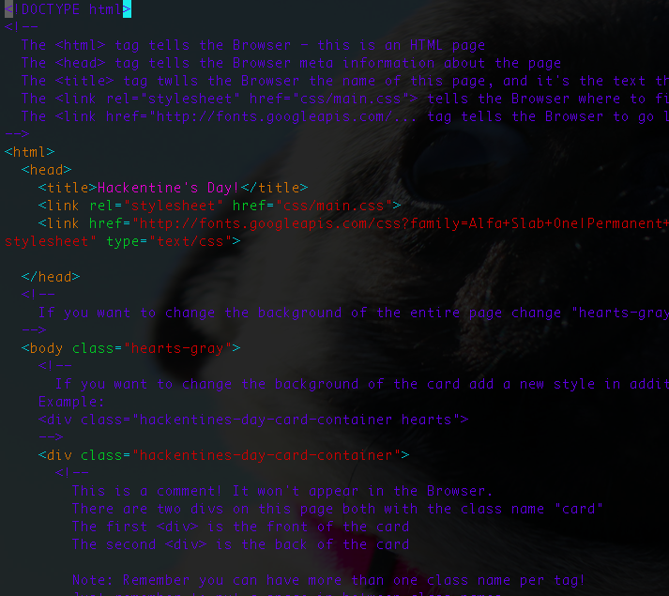

Don’t worry if the colors look different on your screen. This is the HTML you will edit to create your e-card! You will make changes to this file, save the index.html file, and then refresh the index.html file in your Browser to see the changes.

Next, open styleguide.html in a new tab or a new window in your browser. It should look like this:

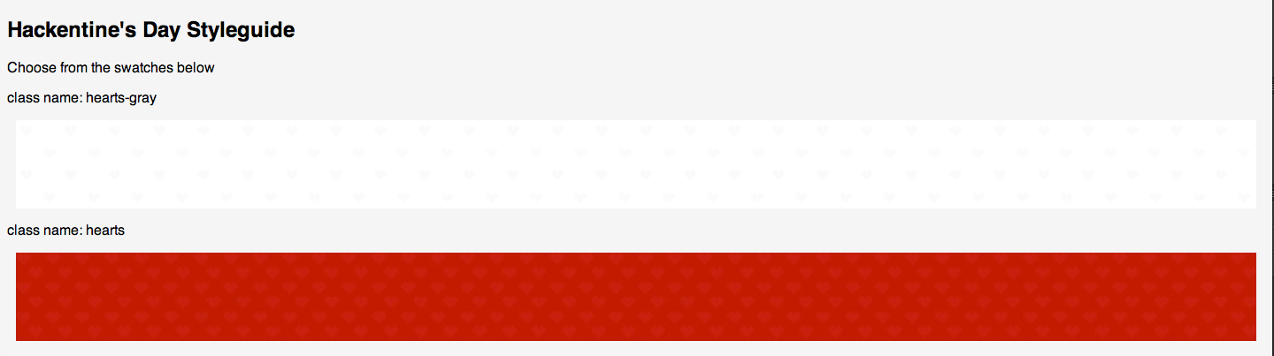

This is your palette of styles to choose from!

How this works is you will copy the name of the swatch in the styleguide and apply it to the class of the HTML tag you want to apply it to.

For example, if I wanted to change the background of the page from gray hearts to red hearts, I would find the HTML tag in index.html that looks like this:

<body class="hearts-gray">

and change it to:

<body class="hearts">

You can style any HTML tag this way, or add more of your own!

If you’re feeling extra adventurous, try searching online for more styles and write some CSS. Please ask someone for help if you want to try this, but aren’t sure how.

Here are a few more examples for you to look at for reference:

|  |  |
| --- | --- |
| HTML | CSS |
| <p>You are the CSS to my HTML</p> | p {  color: black;  font-family: “Times New Roman”;  } |

List of things you can do:

|  |  |
| --- | --- |
| HTML |  |
| Add more text | <h2> I learn to make this card at Hackentines’s Day 2014</h2> |

|  |  |
| --- | --- |
| CSS |  |
| Change the font colors | color: red; |
| Change the background color | background-color: red; |
|  |  |

**Note:** Anytime you change your HTML file hit save, and then refresh the browser! That way you can see your latest changes.

If you want to play around with jQuery, find the file named “card-flip.js” in the folder named “javascripts” and read the comments! It will show you a few ways you can customize the card flip effect for your e-card.

Good luck, have fun, and don’t be afraid to make mistakes!! We are here to help.

If you want to share your card, zip up the final product (the entire Hackentine’s Day folder) and email it to [martha@uber.com](mailto:martha@uber.com). We’ll email you back a link you can share in time for V-Day!

Keep Calm and Hack On,

Martha ([@marthakelly](https://twitter.com/marthakelly))

**Share the awesomeness of what you are doing on the interwebs:**

Tweet: [This Hackentine's day I'm learning HTML, CSS and JavaScript with @marthakelly at @Hackbright #hackentinesday http://ctt.ec/r17IW+](http://ctt.ec/r17IW+)