psql -U postgres -h localhost -W
psql -U postgres -h localhost musicdb1

CREATE DATABASE musicdb WITH OWNER admin_user

tablas
psql -U operator_user -h localhost musicdb
alter role operator_user with superuser;

create table Artist(ArtistId int primary key, Name varchar(150) );

CREATE TABLE Album(AlbumId INT PRIMARY KEY, title VARCHAR(150) , ArtisId int references Artist(ArtistId));

create table PlayList(PlayListId int primary key, Name varchar(150));

create table Genre(GenreId int primary key, Name varchar(150));

create table MediaType(MediaTypeId int primary key, Name varchar(150));

create table Track(TrackId int primary key, Name varchar(150),AlbumId int references Album(AlbumId), MediaTypeId int references MediaType(MediaTypeId), GenreId int references Genre(GenreId), Composer varchar(150), MilliSeconds int, Bytes varchar(50), UnitPrice float );

create table PlayListTrack (PlayListId int references PlayList(PlayListId), TrackId int references Track(TrackId), primary key(PlayListId,TrackId));

create table Customer (CustomerId int primary key, firstName varchar(70), LastName varchar(70), Company varchar(50), Addres varchar(80), City varchar(80), State varchar(2), Country varchar(50), PostalCode varchar(50), Phone varchar(50), Fax varchar(50), Email varchar(50), SupportRepId int);

create table Invoice (InvoiceId int primary key, CustomerId int references Customer(CustomerId), InvoiceData date, BillingAddress varchar(50), BillingCity varchar(50), BillingState varchar(10),BillingCountry varchar(50), BillingPostal varchar(50), Total float );

create table InvoiceLine(InvoiceLineId int primary key references Invoice(InvoiceId), InvoiceId int,
TrakId int references Track(TrackId),
UnitPrice float,
Quantity int);

create table Employee (EmployeeId int primary key, LastName varchar(70), FirstName varchar(70), Title varchar(50), ReportsTo int, BirthDate date, HireDate date, Address varchar(50), City varchar(50), State varchar(5), Country varchar(50), PostalCode varchar(50), Phone varchar(50), Fax varchar(50), Email varchar(80));

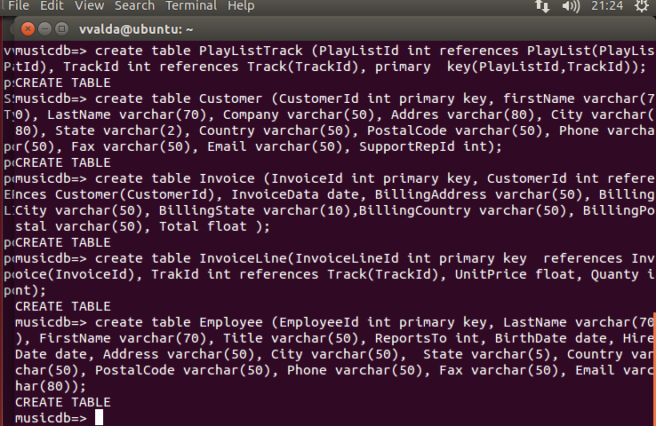

psql -U operator_user -h localhost musicdb
alter role operator_user with superuser;
Para importar datos
Para artist
COPY Artist FROM '/home/vvalda/tablas/artist_data.txt' WITH (DELIMITER ';' );
insert into Artist values (273, '"C. Monteverdi, Nigel Rogers - Chiaroscuro; London Baroque; London Cornett & Sackbu" ')
;
Para album
COPY Album FROM '/home/vvalda/tablas/album_data.txt' WITH (DELIMITER ';' );

Para PlayList
COPY PlayList FROM '/home/vvalda/tablas/playlist_data.txt' WITH (DELIMITER ';' );
Para Genre
COPY Genre FROM '/home/vvalda/tablas/genre_data.txt' WITH (DELIMITER ';' );
Para MediaType
COPY MediaType FROM '/home/vvalda/tablas/mediatype_data.txt' WITH (DELIMITER ';' );
Para Track
COPY Track FROM '/home/vvalda/tablas/track_data.txt' WITH (DELIMITER ';' );

asi sucesivamente para las siguientes tablas
Consultas
select distinct(t.trackid), t.name as cancion ,count(*) from invoiceline as i
inner join track as t
on t.trackid=i.trackid
group by t.trackid
order by count(*)desc
limit 5
select distinct(c.customerid),count(iv.invoiceid),c.firstname,c.lastname
from invoiceline as i
inner join track as t
on t.trackid=i.trackid
inner join invoice as iv on iv.invoiceid=i.invoiceid
inner join customer as c on c.customerid=iv.customerid
group by (c.customerid)
limit 3
generar bakups

Formato plano | Formato postgre
pg_dump -i -h localhost -p 5432 -U postgres -F p -b -v -f "/home/vvalda/backups/bk_musicdb_usergithub.backup" musicdb; | pg_dump -i -h localhost -p 5432 -U postgres -F c -b -v -f "/home/vvalda/backups/bk_musicdb_usergithubA.backup" musicdb;
pg_dump -i -h localhost -p 5432 -U postgres -F p -b -a -f "/home/vvalda/backups/bk_musicdb_usergithubA.backup" musicdb; | pg_dump -i -h localhost -p 5432 -U postgres -F c -b -a -f "/home/vvalda/backups/bk_musicdb_usergithubV.backup" musicdb;

