**Web Development Interview: Practical Test**

|  |  |
| --- | --- |
| **Project:** Develop a match countdown asset using HTML, CSS, JavaScript.  **Timescales:** All files should be zipped and returned to Perform via your agent at least 2 working days before interview.  **What will be assessed:** We will be looking at the validity of your code as well as how clean, semantic and accessible it is. Use of HTML5 , CSS3 and/or JavaScript libraries is permitted but is not a requirement. A clear separation of content, presentation and behavior is essential. The end result will be tested on the latest version of Chrome and Firefox. Be prepared to talk about your code and how you approached this task during your interview.  **Files provided:** The archive provided contains two folders. Within the folder “designs” are the two states of the asset. Within the folder “cutups” are the images required to build the asset.  **Requirements:** From the archive open the file countdownBefore.jpg and create the layout using HTML and CSS.  **countdown.jpg**  Figure : countdownBefore.jpg |  |

The countdown feature should be incorporated using JavaScript. This should count down to a date and time in the future that can be specified within the HTML. When the time is reached the layout should change to appear as in countdownAfter.jpg

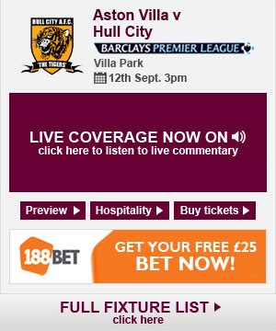

Figure : countdownAfter.jpg