National Technical University of Ukraine
"Kyiv Polytechnic Institute named after Igor Sikorsky"
Educational and Scientific Institute of Atomic and Thermal Energy
Department of Digital Technologies in Energy

Visualization of graphical and geometric information

Calculation and graphics work
Topic: «Operations on texture coordinates»

Performed by:
5th year student,
the TR-43mp group
Snigur V.V.
Variant-14

Inspected:
PhD Kaleniuk O. S.

Kyiv-2024

TASK Description
This assignment focuses on implementing operations on texture coordinates, specifically scaling and rotation of a texture around a user-defined point in the (u, v) coordinate space. The core of the task is to develop algorithms that apply either texture scaling or rotation based on user input. The task is divided into two distinct variants:
- Odd variants: Implement texture scaling around a user-specified point in the (u, v) coordinate space. The scaling operation will enlarge or shrink the texture according to the distance from the point.
- Even variants: Implement texture rotation around the same user-specified point in the (u, v) space. This operation will rotate the texture at a given angle, maintaining the center of rotation as the user-specified point.
The key feature of this assignment is the ability for the user to adjust the location of the reference point in the (u, v) space using the keyboard:
- The A and D keys allow the user to move the point along the u axis, adjusting the horizontal positioning.
- The W and S keys move the point along the v axis, adjusting the vertical positioning.
These operations enable real-time interaction with the texture, giving the user control over the texture’s transformation. The challenge lies not only in implementing the mathematical algorithms for scaling and rotation but also in ensuring smooth and intuitive user interaction. The task also requires efficient handling of texture coordinates to maintain visual integrity during the transformations.
In addition to the implementation of the texture operations, the project will emphasize user interaction and demonstrate how the transformations can be manipulated interactively to achieve various visual effects, making the experience dynamic and user-driven.
Theoretical information
Texture mapping is a fundamental technique in computer graphics that involves applying a 2D image (texture) onto a 3D object’s surface. This is achieved by mapping each point of the 3D object to a corresponding point on a 2D image. The mapping process uses texture coordinates, typically represented by (u, v) values, which define the horizontal and vertical positions on the texture. These coordinates allow the system to determine how the texture should be applied to the 3D surface.
In the context of 3D rendering, textures are mapped to objects using a coordinate system known as UV mapping. The u coordinate refers to the horizontal axis, while the v coordinate refers to the vertical axis of the texture. These coordinates range from 0 to 1, where (0, 0) represents the bottom-left corner of the texture, and (1, 1) represents the top-right corner. Each point on a 3D model is assigned a pair of (u, v) coordinates, which indicates where the corresponding point on the texture will be applied.
Texture scaling involves adjusting the size of a texture applied to a surface. When scaling a texture, the (u, v) coordinates are modified to either enlarge or shrink the texture on the 3D model. Scaling is typically achieved by multiplying the coordinates by a scale factor:
- Scaling Factor: a scale factor greater than 1 will increase the texture size, while a factor less than 1 will reduce the texture size.
- Scaling Formula: the new texture coordinates (u', v') after scaling are given by:
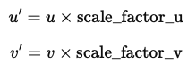
This operation effectively stretches or compresses the texture across the surface of the object. In this task, the scaling will be centered around a user-specified point, which means that the scaling operation will adjust the texture relative to the location of this point.
Texture rotation involves rotating the texture around a specific point (u, v) in the texture space. This operation is based on standard 2D rotation transformations, which involve rotating the texture coordinates by a certain angle.
The texture is rotated by shifting the coordinates relative to the center point, performing the rotation, and then shifting the coordinates back.
A unique feature of this task is the ability for the user to move the reference point (center of scaling or rotation) in the (u, v) space using the keyboard. The user can control the position of the reference point by adjusting the u and v coordinates with the following keys:
- A and D move the point along the u axis, changing its horizontal position.
- W and S move the point along the v axis, adjusting its vertical position.
This interaction allows for real-time adjustments to the texture transformation, enabling dynamic effects based on user input.

IMPLEMENTATION DETAILS
This system manipulates texture coordinates in WebGL, enabling texture scaling and rotation around a user-defined point. The process includes setting up the WebGL context, creating shaders, loading textures, generating the 3D surface, and handling user interaction through keyboard controls.
The WebGL context is initialized by creating a <canvas> element and obtaining the WebGL rendering context, enabling 3D graphics rendering directly on the web page. If WebGL is unsupported, a message is displayed to inform the user.
Key components of the system are the vertex and fragment shaders. The vertex shader processes 3D vertex positions and texture coordinates, while the fragment shader calculates the color of each pixel based on lighting and surface texture. The vertex shader transforms texture coordinates based on the user-defined point and rotation angle using a rotation matrix in the getUV function. This function shifts and rotates the texture's UV coordinates, returning the transformed coordinates for use by the fragment shader.
The vertex shader also calculates surface normals using the Tangent, Bitangent, Normal (TBN) matrix for accurate lighting. The transformed normal is used in the fragment shader to compute diffuse and specular lighting effects with the Phong reflection model.
The fragment shader computes the lighting at each pixel, blending ambient, diffuse, and specular contributions based on the surface normal and light direction. The final color is a combination of these lighting components.
The TextureHandler function handles texture loading and mapping to the 3D surface. The LoadTexture function initializes a texture object in WebGL, sets texture parameters such as wrapping and filtering modes, and updates the texture once the image is loaded. An event listener triggers the drawing process once the texture is ready, and the rendering loop continuously updates the model with the latest texture and transformation data.
User interaction is managed through keyboard controls via the TexCoord object. This object adjusts the rotation angle and point of texture manipulation based on user input. For example, arrow keys adjust the texture's center of rotation, while other keys modify the rotation angle, providing real-time control over the texture mapping.
The 3D model is generated using parametric equations that define points on the surface. Normals and tangents are calculated to ensure accurate lighting effects. The model is rendered with the updated normals and transformed texture coordinates, applying textures using the LoadTexture function.
The rendering process is driven by a continuous loop, updating the scene with each user input to ensure smooth interaction. The requestAnimationFrame function synchronizes the frame rendering with the browser's refresh rate, providing a fluid user experience. The rotation point and angle can be interactively adjusted, allowing for a customizable view of the 3D surface.
Through this setup, users can manipulate texture coordinates in real time, adjusting texture position and rotation. By combining keyboard controls, shaders, and dynamic texture loading, the system offers an interactive environment for working with 3D textures in WebGL.

user's instruction
This system allows users to manipulate texture coordinates in WebGL through operations like texture scaling and rotation around a user-defined point. Below are the instructions on how to interact with the system and control the texture.
1. Loading the WebGL Model
Step 1: Open the web page containing the WebGL canvas.
Step 2: The 3D model will be automatically loaded along with its default texture.
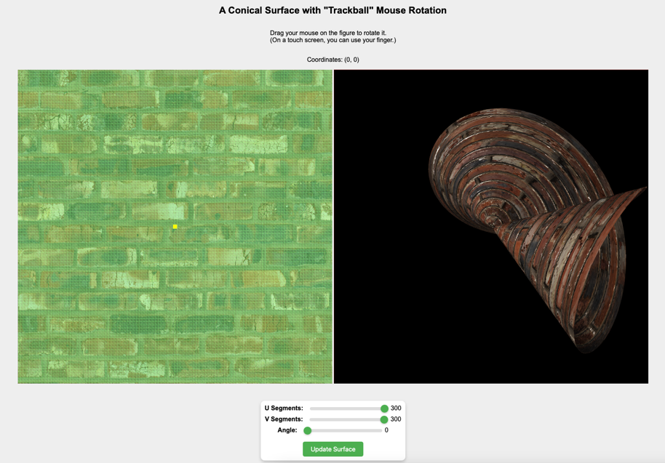
Figure 1. Model loaded with default texture
2. Changing the Rotation Angle of the Texture
Step 1: Locate the Angle slider below the U/V Segments sliders.
Step 2: Use the slider to adjust the rotation angle of the texture. Moving the slider to the left decreases the angle (counterclockwise rotation), while moving it to the right increases the angle (clockwise rotation).
Step 3: As you adjust the slider, the texture will rotate in real-time, updating the 3D model’s surface accordingly.
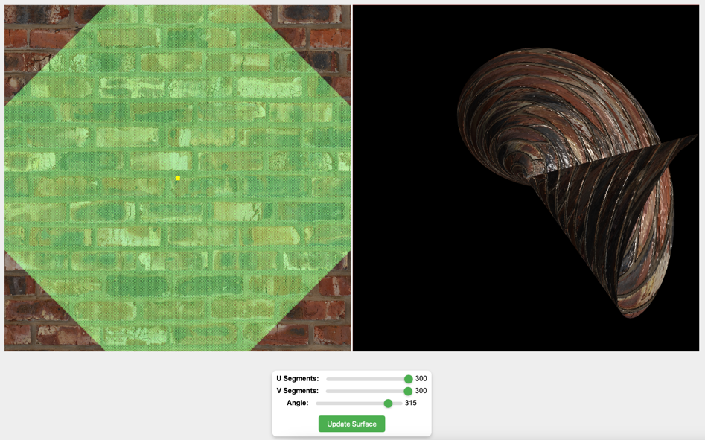
Figure 2. Angle slider (Placeholder)
3. Manipulating the Texture Rotation
Step 1: To rotate the texture, use the A/W/S/D keys on your keyboard (after angle adjustment):
A Arrow: Rotates the texture counterclockwise.
D Arrow: Rotates the texture clockwise.
Step 2: The texture will rotate around the point you defined.
Example: Press the D key to rotate the texture, and the model’s texture will update in real-time.
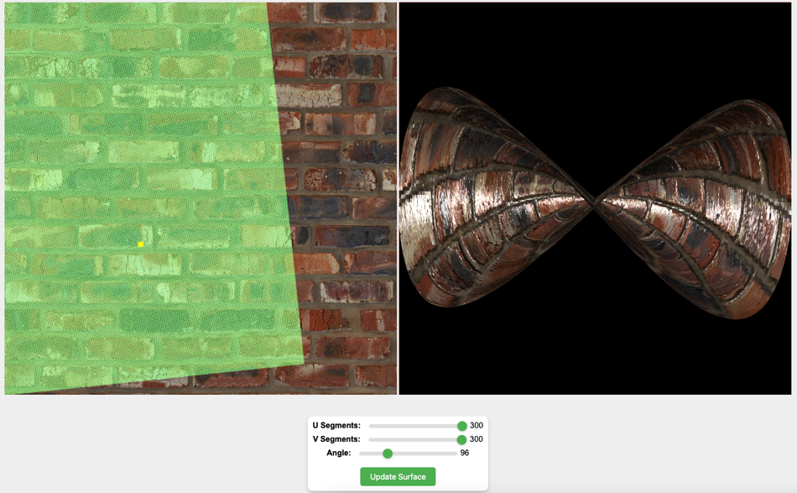
Figure 3. Texture rotated (Placeholder)
source code
This code defines a Model function that sets up a 3D object in WebGL, including creating buffers for vertices, normals, tangents, and UVs. It also handles texture loading and application using a diffuse, normal, and specular texture. The model is generated using parametric equations, and surface data is processed with functions to calculate normals and tangents. The model is rendered by binding the buffers and textures, applying transformations, and drawing the surface using WebGL's drawArrays function:

function normalizeUV(value, min, max) {
return (value - min) / (max - min);
}

The vertex shader calculates the transformation of 3D vertices using projection, model, and normal matrices. It also handles texture coordinate manipulation with rotation and computes the world space normal, which is modified using a normal map for lighting effects. The resulting color is calculated with ambient, diffuse, and specular lighting models.vec2 getUV():

{
vec2 uv = inUV - point;
float cosTheta = cos(angle);
float sinTheta = sin(angle);

uv = vec2(
uv.x * cosTheta - uv.y * sinTheta,
uv.x * sinTheta + uv.y * cosTheta
);

return uv + point;
}

The code listens for keypresses (w, a, s, d) to move a point in a 2D space. The point array is updated based on the pressed key, with movement constrained between 0.0 and 1.0 for both axes. The mesh object's point is updated with the new position after each movement:
document.addEventListener('keydown', (event) => {
let moveDir = [0, 0];
let speed = 0.01;
if(event.key == 'w') {
moveDir[1] += speed;
}

if(event.key == "s") {
moveDir[1] -= speed;
}

if(event.key == "d") {
moveDir[0] += speed;
}

if(event.key == "a") {
moveDir[0] -= speed;
}

point[0] += moveDir[0];
point[1] += moveDir[1];

point[0] = Math.max(Math.min(point[0], 1.0), 0.0);
point[1] = Math.max(Math.min(point[1], 1.0), 0.0);
mesh.point = point;
});

TexCoordDrawer is a function for rendering texture coordinates on a WebGL canvas with the ability to adjust the point using the mouse and keyboard. It uses shaders to render the texture, UV coordinates, and a point on the screen:

surface.addEventListener('mousedown', (event) => {
if (event.button == 0) {
point = calculatePoint(event);
mesh.point = point;
document.dispatchEvent(new Event('draw'));
}
});

LoadTexture is a function that loads a texture from a specified URL and prepares it for use in WebGL. It first sets default texture parameters, loads a temporary 1x1 blue pixel, and then loads the image from the given URL into the texture upon its successful load event:
var image = new Image();
image.crossOrigin = 'anonymous';
image.src = url;
image.addEventListener('load', () => {
// copy image to texture memory
gl.bindTexture(gl.TEXTURE_2D, texture);
gl.texImage2D(gl.TEXTURE_2D, 0, gl.RGBA, gl.RGBA,gl.UNSIGNED_BYTE, image);
document.dispatchEvent(new Event('draw'));
});

