PERSONAL INFORMATION Veronika Kuznetsova – **Front-end Developer**

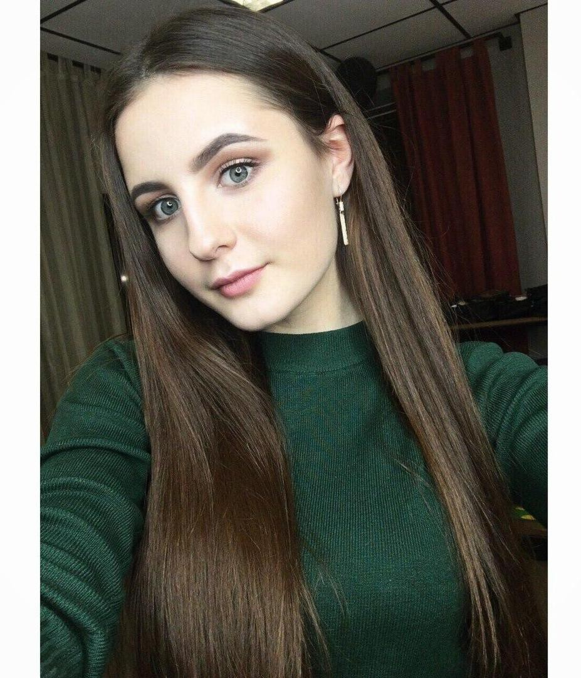 Pritytskogo str., 51-21, 220121 Minsk (Belarus)

 +375 296439757

 [veronichka.kuznetsova.1997@mail.ru](mailto:veronichka.kuznetsova.1997@mail.ru)

Sex Female | Date of birth 30 Oct 1997 | Nationality Belarusian

WORK EXPERIENCE

4 Apr 2019–To Present Logistics Specialist

Transconsult

https://www.transconsult.by/

1. Work with existing and new customers (complete cargo, import);

2. Organization of accepted for execution orders of Clients for the carriage of goods by road and cooperate quickly with a logistics specialist (for work with carriers);

3. Maintaining a CRM block;

4. Control of receivables.

Business or sector Logistics

EDUCATION AND TRAINING

1 Sep 2015–06.2019 Logistic-economist

School of Business and Management of Technologies of Belarusian State University Moscow str., 5, 220007 Minsk (Belarus)

<http://www.sbmt.bsu.by/>

General

* English language
* Physical education and sports Occupational
* Foundations of Management
* Foundations of Marketing
* Foundations of Logistics
* Knowledge of business and its economic and social context

Average: 8.5

PERSONAL SKILLS

Native language Russian, Belarusian

Other languages English language - A2

Polish - A1

Communication skills -Excellent communication skills;

-Responsibility, gained through my work experience as a service;

-Ability to organize work, plan, make decisions as a commercial agent.

Organisational / managerial skills - Huge experience in team management and resolve conflict situations (gained through my work experience as a commercial agent);

* Strategically and creatively to think through interesting studies at the university;

-Plan and optimally organize the work process (due to the combination of study and work).

Digital skills SELF-ASSESSMENT

|  |  |  |  |  |
| --- | --- | --- | --- | --- |
| Information processing | Communication | Content creation | Safety | Problem solving |
| Independent user | Independent user | Independent user | Independent user | Independent user |

[Digital skills - Self-assessment grid](http://europass.cedefop.europa.eu/en/resources/digital-competences)

* Excellent command of Microsoft Office™ tools (Word™, Excel™, Powerpoint™, Visio™, Access™, Project™);
* Basic knowledge of graphic design applications (Adobe Photoshop™);
* Good knowledge HTML, CSS;
* Basic knowledge Java Script;
* Work with Sublime Text.

Other skills - I lead a healthy lifestyle (I do not smoke, I do not drink, I eat right);

- Every day I do 20-minute physical activity in the morning;

- Daily I give 60 minutes during the day to watch informative videos on YouTube to expand my horizons;

- During my university years I wrote 3 scientific papers;

- Every day I set myself tasks and time that needs to be spent on a particular task;

- I can easily find a common language with people and tune in to their wave, resolve conflict situations, thanks to the work in the contact center;

- When shopping in stores I am looking for the most profitable products (value for money), I never buy the first one;

- I analyze my expenses every month;

- At school I loved math, loved to go to the tutor and solve complex problems;

- Studied HTML, CSS, JAVA on my own.

Driving licence AM, B

Изучила самостоятельно HTML, CSS, JAVA. Сделала свой сайт-резюме и на этом не останавливаюсь! :)

Владею Английским на уровне - B2 и польским – А1. Люблю честных и добрых людей. Имею опыт работы 2 года на должности «Специалист по организации международных грузоперевозок». Где я сделала выводы, что безвыходных ситуаций точно не бывает!)) И главное решать все возникающие вопросы мирным и интеллигентным способом. Люблю путешествовать и мечтаю о большой собаке и маленьком котенке. Хочу стать крутым специалистом-девушкой Full Stack Developer. Уверена в том, что каждый человек интересен по-своему и может принести какую-то особенную пользу нашему миру.

Studied HTML, CSS, JAVA on my own. I made my own resume website and I'm not stopping there! :)

I speak English at B2 level and Polish at A1. I love honest and kind people. I have 2 years of experience in the position of " International Logistics Manager". Where I draw the conclusion that there are definitely no hopeless situations!)) And the main thing is to solve all the emerging issues in a peaceful and intelligent way. I love to travel and dream of a big dog and a small kitten. I want to become a tough female Full Stack Developer. I am sure that each person is interesting in their own way and can bring some special benefit to our world.