2. Literature Review

2.1 E-Recruitment

On my research regarding e-recruitment, the e-recruitment has become the new technology to the world of recruiting as mentioned by **Yogita Gupta(2016).** E-Recruitment is stands for Online Recruitment which is a method of recruiting that used Internet based application as stated by **Maureen Sills (2014)**. E-recruiting, embracing the term web-based recruiting, can be described as any recruiting processes that a business organization Conducts via web-based tools, such as a firm’s public Internet site or its corporate intranet. (Shahila .D& Vijayalakshmi.R, 2013). E-recruitment technology helps the organization or company to centralized the information of the applicant, and make them easier to be evaluated by the company.

E-recruitment makes the recruiting process become easier for the candidates and the Human Resource Management. The World Wide Web, or Web 1.0, shortened the search time, costs and offered a transparent method of information for candidates (Salmen, 2012). It is e-recruitment that encourages organizations reviewing the processes of human resource management and applying information communication technologies. (Rasa Smaliukienė & Sergejus Trifonovas, 2012).

2.2 Recruitment Process

Human is the most important factor in the organization, because humans is the only thing that have ideas, wills, skills, and knowledge. Human Resources called them as the candidates, all candidates have the potential to make the company grows and lead the company to meet their vision. However, the candidates must be selected, evaluated, delegated, and developed appropriately so they can improve their experience, knowledge, and skills so they can make improvement for the company or organization.

In this era there are 2 ways to do the recruitment process, the first one is using the traditional method and the second is by using the technology of e-recruitment.

Anna Holm’s (2012) visualized the traditional recruitment process in the diagram (See Figure 1)

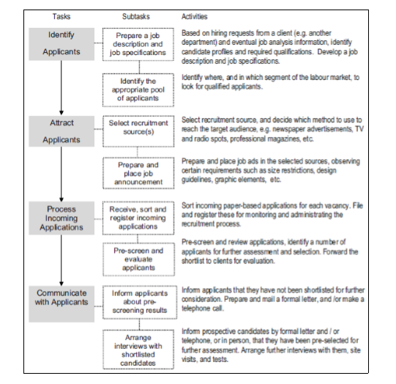

References

[1] Salmen, S. (2012). Einleitung - Die Suche von Top-Mitarbeitern im War for Talent! In B. Rath, & S. Salmen, Recruiting im Social Web (pp. 30-40). Göttingen: BusinessVillage GmbH. 17

[2] Shahila &. Vijayalakshmi (2013), E-Recruitment Challenges, International Journal of Social Science & Interdisciplinary Research (IJSSIR), Volume. 2 (5), MAY (2013) Pg.No.118-123. ISSN 2277 3630.

[3] Rasa Smaliukienė & Sergejus Trifonovas, (2012), “E-recruitment in the Military: Challenges and Opportunities for Development”, journal of Security and Sustainability Issues, Volume.1 (4): Pg.No:299–307. ISSN 2029-7017 print/ISSN 2029-7025 online. Robert W. Wendover (2008), “Smart Hiring at the Next Level”, Pg.No: 49 – 90.ISBN: 81-7722-785-8.

[4] Holm, Anna B. (2012) : E-recruitment: Towards an ubiquitous recruitment process and candidate relationship management, Zeitschrift für Personalforschung (ZfP), ISSN 1862-0000, Rainer Hampp Verlag, Mering, Vol. 26, Iss. 3, pp. 241-259, http://dx.doi.org/10.1688/1862-0000_ZfP_2012_03_Holm