VersariteViewer 1.1 — Architecture
Units, dependencies and how they work together (release 1.1, Day 30, 2026-10-19)

How to read this
Every unit in source\ starts with a header in the same layout:
Section | What it says
Purpose | what the unit is for, in the program’s terms
Owns | the objects, threads, timers and files it creates and frees
Knows | what it uses but does not own (handed in, global, callbacks)
Responsibilities | what it does
Does NOT | what it leaves to others, and to whom
Threads | which thread runs its code, and how shared data is protected
Uses (MView units) | generated from its uses clauses, plus the libraries (the headers keep the old name)
Used by | generated: which units use it
Extra sections (Rules, Notes, Flow, Delivery safety net, …) follow after these. The header is the first thing to read before changing a unit; this document is the map that ties them together.

What changed since 1.0
The program is now called VersariteViewer (formerly MView); its microscopy edition is Versarite Image Lab. The project files are VersariteViewer.lpi / .lpr (the edition: VersariteViewerLab.lpi / .lpr); the units keep their names (uMView, TMView …). The program is VersariteViewer.exe, its settings VersariteViewer.ini (an MView.ini is taken over at the first start).
Release 1.1 adds these units (marked 1.1 in the table further down) without changing the layering: no unit uses one in a higher layer, still no cycles.
- The editions (Day 25): uEdition (which program this is), uExtensions (the plug-in points) and uContainers (files that hold several images). They let the microscopy edition, a second program from the same source tree, plug itself in without the core naming it. uContainerThumbs makes a container’s thumbnails on a thread of its own.
- Copy and save (Day 25 / 26): uClipboardImage (Copy image), uImageFileScale (a TIFF / PNG keeps its scale).
- The testers’ requests (Day 27): uSlotMenuWindow (the sort panel’s folder menu as an own window), uPreviewStrip (the scan bar at the top) with uFolderThumbs (its thumbnails, on a thread of its own, through its own TMediaLoader). uSortFolders holds several folder lists and the Rapid sorting list; uMouseProfile holds single keys; uMouseEngine watches the top and bottom edges.
- Safe settings (Day 28): uSafeFile writes the ini in one step (a .tmp file, flushed, then replacing the old one); the end line is checked at the start, and the .bak copy restores a damaged ini.
- The second round (Day 30): uZipContainer (ZIP and CBZ archives as containers, in both editions), uDirPeek (counts a folder for the Total Commander dir preview, on threads of its own) and uExifRotate (lossless rotation: only the JPEG’s EXIF orientation tag changes). uSortFolders gained copy / cut / paste of entries between lists.

Picture 1 — unit dependencies
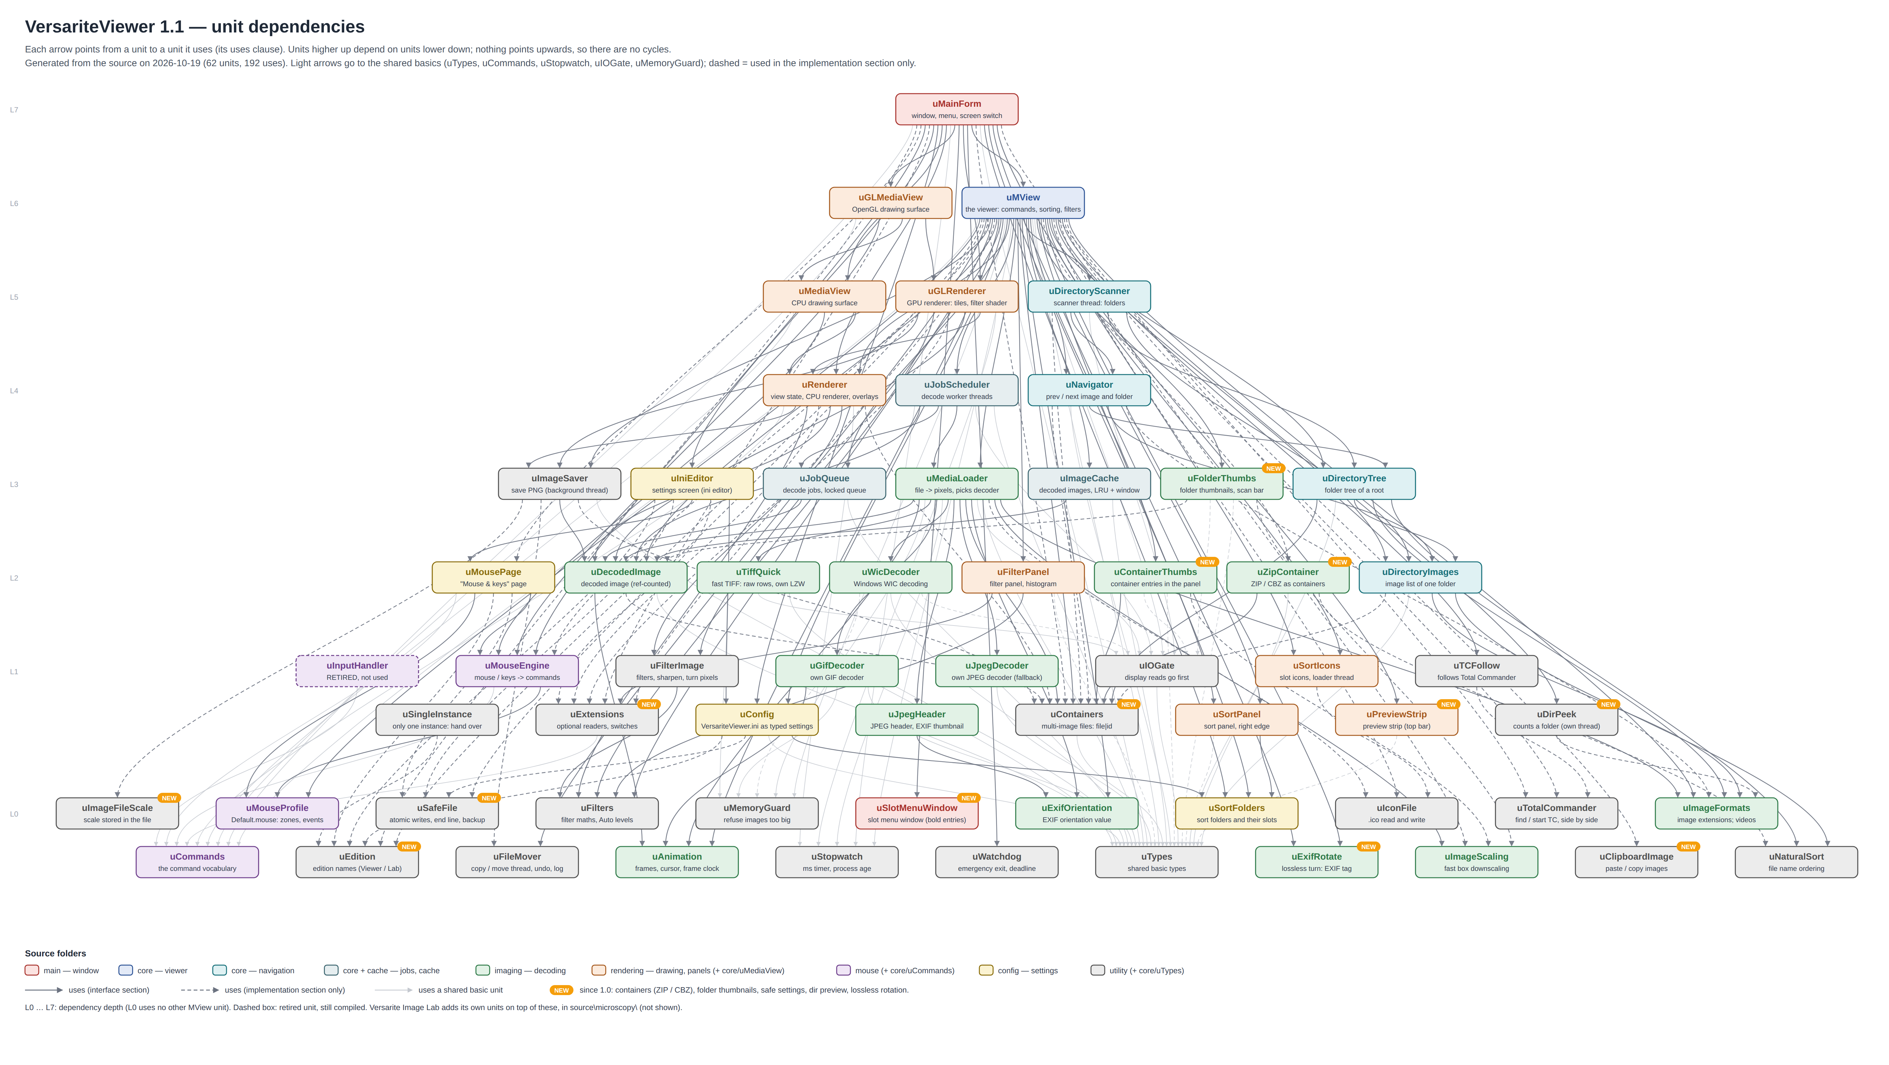
VersariteViewer unit dependencies
Arrows point from a unit to the units it uses. The layers (L0 at the bottom to L7 at the top) are the dependency depth: a unit only uses units in lower layers, so there are no cycles. uMainForm is the only unit that sees everything; the imaging units never see the window, and the utility units see nothing of the viewer at all. Layers with many units are drawn as two staggered rows. Units marked NEW came after 1.0 (the list above). Versarite Image Lab’s own units (source\microscopy\) sit on top of these and are not drawn.

Picture 2 — at run time
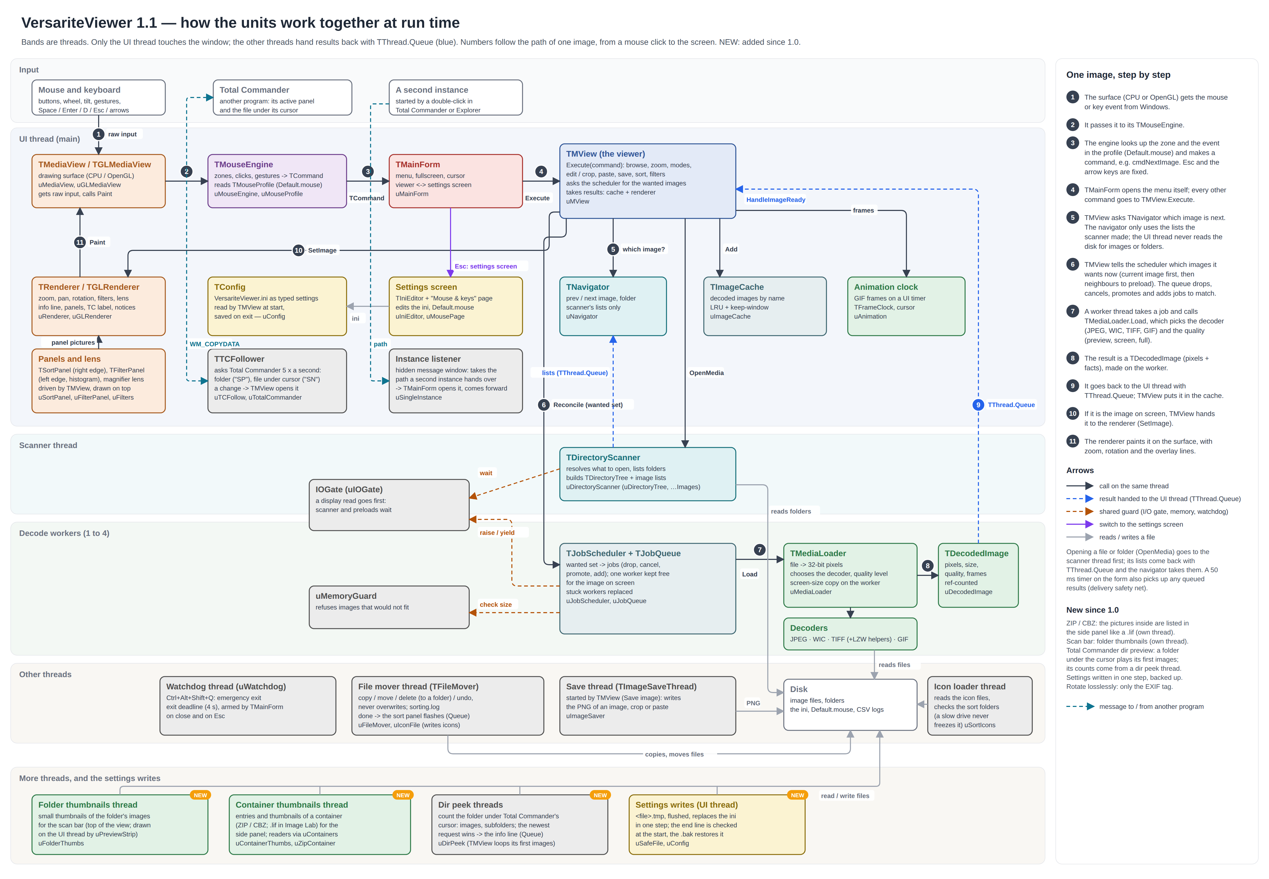
VersariteViewer runtime interactions
The bands are threads. Only the UI thread touches the window and the renderers. The scanner thread, the decode workers and the save thread never call into the UI; they hand their results back with TThread.Queue (blue in the picture), and a 50 ms timer on the form picks up anything a lost wake-up left in the queue (the delivery safety net in uMView). The I/O gate lets the image on screen read the disk first; the memory guard refuses images that would not fit; the watchdog ends the program if a shutdown hangs.
The sort and filter panels and the magnifier lens live on the UI thread and are drawn by the renderers on top of the image; copies and moves run on the file mover thread, icon files are read on a loader thread of their own; the Total Commander follower asks Total Commander five times a second through window messages; a second instance hands its path to the running one through a hidden message window and ends.
New since 1.0 (the bottom band, NEW): the scan bar’s thumbnails, a container’s entries and thumbnails (ZIP / CBZ; .lif in Image Lab) and the dir peek each run on threads of their own and hand their results back with TThread.Queue; the settings are written on the UI thread through uSafeFile.

The units in one line each
Folder | Unit | Purpose | Runs on
main | uMainForm | The window: creates the viewer or the settings screen, the menu, fullscreen, cursor hiding; switches viewer ↔ settings (Esc). | UI
main | uSlotMenuWindow | 1.1 The sort panel’s folder menu as an own window: stays open while moving, Move up / down repeat while held. | UI
core | uMView | The viewer: carries out every command, browsing, modes, edit / crop / paste / save; asks for images and takes the results. | UI
core | uCommands | The command vocabulary (TCommand) that every input source produces. | any
core | uTypes | Small shared types and their names in the ini. | any
core | uNavigator | Which folder and image are current; what next / previous mean. | UI
core | uDirectoryTree | The folders under the root as a tree, in visiting order. | scanner, then UI
core | uDirectoryImages | The image list of one folder, sorted. | scanner, then UI
core | uJobQueue | Decode jobs in a locked queue. | UI + workers
core | uJobScheduler | The decode worker threads; wanted set → jobs; results back to the UI. | UI + workers
core | uMediaView | The CPU drawing surface; passes input to its mouse engine. | UI
navigation | uDirectoryScanner | The scanner thread: resolves what to open, lists folders, builds the tree. | scanner
cache | uImageCache | Decoded images kept by name (LRU plus keep-window). | UI
imaging | uMediaLoader | File → pixels: picks the decoder and the quality level, makes the screen copy. | workers
imaging | uDecodedImage | A decoded image, read-only and reference-counted. | any
imaging | uJpegDecoder | Own JPEG decoder (fallback after WIC; cancellable). | workers
imaging | uJpegHeader | JPEG header and EXIF thumbnail without reading the whole file. | workers
imaging | uExifOrientation | The EXIF orientation value. | workers
imaging | uTiffQuick | Fast TIFF: only the needed rows of raw TIFFs, own parallel LZW. | workers (+ helpers)
imaging | uWicDecoder | Decoding through Windows WIC, in bands for huge PNG / TIFF / BMP. | workers
imaging | uGifDecoder | Own GIF decoder: first frame fast, all frames on demand. | workers
imaging | uAnimation | Animation frames, the frame cursor and the frame clock. | workers, then UI
imaging | uImageScaling | Fast box downscaling for screen copies. | workers
imaging | uImageFormats | The one list of image file extensions (1.1: also the formats only Windows’ codecs read, and which codec is missing). | any
imaging | uContainerThumbs | 1.1 A container’s entries and their thumbnails, on a thread of its own (ZIP / CBZ; .lif in Image Lab). | own thread
imaging | uFolderThumbs | 1.1 Thumbnails for the scan bar, on a thread of its own: the image under the mouse first. | own thread
imaging | uExifRotate | 1.1 Lossless rotation: sets a JPEG’s EXIF orientation tag (patched, inserted into IFD0, or a new APP1); the pixels stay untouched. | UI
imaging | uZipContainer | 1.1 ZIP and CBZ archives as containers: the pictures inside listed in natural order, one unpacked into memory and decoded. | any (re-entrant)
rendering | uRenderer | View state (fit, zoom, pan, rotation, overlays) and the CPU renderer. | UI
rendering | uGLRenderer | The GPU renderer: textures, tiles, mipmaps, overlay text. | UI
rendering | uGLMediaView | The OpenGL drawing surface. | UI
rendering | uSortPanel | The sort panel at the right edge: buttons, pin, flash, icon preview; drawn as one picture. | UI
rendering | uSortIcons | The slot icons: files read on a loader thread, pictures scaled on the UI thread. | UI + loader
rendering | uFilterPanel | The filter panel at the left edge: histogram, rows, Auto, Reset; drawn as one picture. | UI
rendering | uPreviewStrip | 1.1 The scan bar at the top: the folder’s images 1 … n, the one under the mouse shown under the bar. | UI
mouse | uMouseEngine | Mouse and key input → commands, following the profile (zones, clicks, gestures). | UI
mouse | uMouseProfile | Default.mouse: zones, events, commands; read, check, save. | UI
mouse | uInputHandler | Retired (replaced by uMouseEngine + uMouseProfile); still compiled, used by nothing. | —
config | uConfig | VersariteViewer.ini as typed settings; takes over MView.ini at the first start. | UI
config | uSortFolders | The sort panel’s folders (slots: folder, name, colour, icon) and recent folders, in the ini; 1.1: several lists ([DirList1] …), the Rapid sorting list, copy / cut / paste of entries. | UI
config | uIniEditor | The settings screen: the ini in a text editor, with help per key. | UI
config | uMousePage | The “Mouse & keys” page, with “Try it here”. | UI
utility | uIOGate | Display reads go first; the scanner and preloads wait. | workers, scanner
utility | uMemoryGuard | Refuses decodes that cannot fit in memory. | workers
utility | uWatchdog | Emergency exit hotkey and exit deadline, on its own thread. | watchdog
utility | uStopwatch | Millisecond clock and process age for the timing logs. | any
utility | uImageSaver | Saves an image as PNG on a background thread. | save thread
utility | uNaturalSort | File name ordering as in Explorer (numbers by value). | any
utility | uFileMover | Copy / move / delete (into a folder) / undo on a thread of its own; never overwrites; sorting.log. | mover thread
utility | uIconFile | .ico files: read the directory and pictures, write multi-size icons. | any
utility | uFilters | The display filters’ maths: tone table, colour, Auto levels, names. | any
utility | uFilterImage | Filters, sharpening and turns applied to a bitmap; histograms. | UI
utility | uTCFollow | Follows Total Commander: asks for its folder and the file under its cursor. | UI
utility | uTotalCommander | Finds and starts Total Commander, side by side. | UI
utility | uSingleInstance | Only one instance: a second one hands its path over through a message window. | UI
utility | uClipboardImage | 1.1 Copy image: the picture on the clipboard as every program takes it (CF_DIB). | UI
utility | uImageFileScale | 1.1 A saved TIFF / PNG keeps its scale (ImageJ-style TIFF, a PNG text chunk). | any
utility | uEdition | 1.1 Which program this is (VersariteViewer or Versarite Image Lab): its settings file, names and version. | any
utility | uExtensions | 1.1 The plug-in points for an edition (menu entries, layers, panel rows, settings pages); empty in VersariteViewer. | UI
utility | uContainers | 1.1 Files holding several images, browsed as one-time folders (ZIP / CBZ in both editions; .lif in Image Lab). | any
utility | uSafeFile | 1.1 Settings files written in one step (.tmp, flush, replace), the end line, exact file times. | any
utility | uDirPeek | 1.1 Counts a folder’s images and subfolders for the Total Commander dir preview; the newest request wins. | own threads

Rules the structure follows
- Input only makes commands. The surfaces pass raw input to the mouse engine; the engine makes a TCommand; the form handles the menu and gives everything else to TMView.Execute.
- The UI thread never reads the disk for images or folders. The scanner lists folders, the workers read files; the UI thread only reads and writes the ini, Default.mouse and the CSV logs.
- Threads never touch the UI. Results come back with TThread.Queue, never Synchronize.
- Decoding knows nothing about the window, and rendering knows nothing about files.
- Shared data is locked in exactly four places: the job queue, the image cache, the directory scanner and the I/O gate — plus the file mover’s and the icon loader’s request queues and the state the thumbnail threads and the dir peek share with their owners.
- Panels are pictures. The sort and filter panels draw themselves into a bitmap; the renderers only put that bitmap on top (a texture on the GPU), so both renderers show them the same way.

Housekeeping noticed while documenting (not changed)
- uInputHandler is retired but still in VersariteViewer.lpr’s uses and in the project, so it is compiled. It can be removed from both.
- Several settings in uConfig are never read from the ini and keep their built-in values (BackgroundColor, FitMode, Interpolation, UseMipMaps); TopMost, RememberZoom and RememberRotation are never set. To be decided when those features come up.
- VersariteViewer.lpr’s uses list does not name the newer units (uAnimation, uGifDecoder, uMouseEngine, uMouseProfile, uMousePage); they are compiled because other units use them. Harmless.

What comes next
Versarite Image Lab (metadata, calibration, measuring, scale bar, movies, image editing, Fiji through Fiji itself) is a second program built from this same source tree: its own project file (VersariteViewerLab.lpi), its units in source\microscopy\, plugged in through uEdition, uExtensions and uContainers. It is in development and not part of this repository. Planned there: RAR archives, Nikon .nd2 files. Planned for 1.2: a CBZ read as one continuous strip, a true lossless crop.

