**Earthquake Prediction Using Numpy**

**Principle:**

The probability of an earthquake increases as the solar magnetic activities increases.

**Goal:**

To investigate if the magnetic activity on the sun follows a definite cycle . One of the ways to quantify the magnetic activities is to measure the number of sunspots every year. Our task is to find out the frequency at solar magnetic activity attains a maximum and further predict ,in which upcoming years, it will be peak value.

**Dataset:**

The dataset which is used contains the historic data of the number of sunspots observed in the year 1700 to year 2019.

**FFT(Fast Fourier Transform) Function:**

The FFT refers to a way the discrete fourier transform (DFT) can be calculated efficiently, by using symmetries in the calculated terms . The symmetry is highest when n is a power of 2 , and the transform is therefore most efficient for those sizes.

Using this function we analyse the data and we predict the future upcoming earthquakes.

**Procedure:**

*Import the required libraries such as : Pandas , Numpy , Matplotlib.

*Perform the data pre-processing steps after loading the dataset.

*Find the frequency which is in cycles/year at which the number of sunspots or the solar magnetic activity attains a maximum, and by reciprocating this frequency we get years after which solar activity again reaches it’s maximum.

*Therefore to find the frequency first we transform our tabular data into a summation series of harmonic functions having different amplitudes and frequencies via fourier transform functions np.fft.fft, then the frequency of each harmonic function we have taken is represented by the np.fft.fftfreq .

*Plot the frequency v/s magnitude of fourier transform using matplotlib to visualize the frequencies at which the magnitude seems to be maximum and frequency would be the one in cycles/year at which the activity seems to be maximum.

**Observations:**

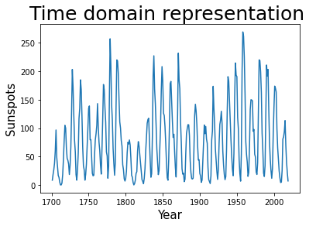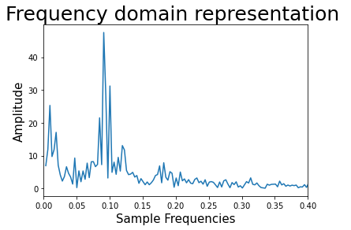

In this analysis the solar magnetic activity is maximum at nearby “0.1 cycles/year” . After every 10 years (1/0.1) each cycles will repeat it self and the magnetic activity increases.

**Conclusion:**

By our prediction we can conclude that after every 10 years there is a maximum chance of getting an earthquake.