TRIMS INSPECTION SYSTEM
User Guide

Version 1.0
Quality Control Department
Internal Use Only

Table of Contents
1. Introduction
2. System Access – User Login
3. Downloading Raw Data from GO+
4. Main Inspection Page
5. Dashboard Module
6. Inspection Report – By Date Range
7. Performance Summary / Brand
8. AI Assistant
9. Troubleshooting & Support

1. Introduction
The Trims Inspection System is an internal web-based quality control application designed to standardize and streamline the inspection of trims and accessories used in garment manufacturing. It provides a centralized digital platform where QC personnel can record inspection data, monitor supplier performance, and generate analytical reports.

By integrating directly with the GO+ production management system, the application automatically populates relevant order data per inspection session — reducing manual data entry, minimizing errors, and ensuring all records are consistent and traceable.

Who Should Use This Guide
- QC Inspectors – conducting daily trims inspections
- QC Supervisors – reviewing results and monitoring performance
- Administrators – managing system data and generating reports

Key Modules at a Glance
Module | Description
User Login | Secure access via internal network URL
GO+ Data Download | Retrieve and sync raw inspection data from GO+
Main Inspection Page | Perform trims inspections per IO Number and Supplier
Dashboard | Real-time visual summary of inspection KPIs and trends
Inspection Report | Filterable inspection records by date range; export to PDF/Excel
Performance Summary | Pass/fail analytics by Supplier and/or Brand; export to PDF/Excel
AI Assistant | Conversational AI tool for instant inspection insights and analytics

2. System Access – User Login

Overview
The User Login page is the secured entry point to the Trims Inspection System. It authenticates each user before granting access to any module. The system is hosted on the company's internal network and can only be accessed from within the office premises or via a company-approved VPN when working remotely.

Accessing the System
- Open a web browser (Google Chrome is recommended for best compatibility).
- In the address bar, type the following URL and press Enter:
http://172.16.28.108/trims/
- Enter your assigned Username and Password in the login fields.
- Click the Login button to access the system.

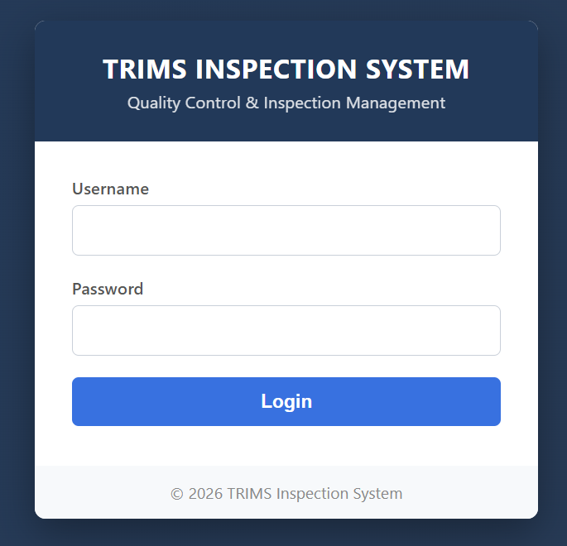
Figure 1 – Trims Inspection System Login Page

NOTE: This URL is only accessible within the company's internal network. If working remotely, connect to the company VPN before attempting to log in.

TIP: If you have forgotten your password or cannot log in, contact your system administrator to reset your credentials. Never share your login details with other users.

3. Downloading Raw Data from GO+

Overview
GO+ is the company's primary production management and order tracking system. Before conducting any inspection, users must first download the latest data from GO+ into the Trims Inspection System. This synchronization ensures that inspection records are aligned with the most current production orders, supplier assignments, and trim specifications.

Skipping this step may result in outdated or incomplete order data, which could lead to inaccurate inspection records.

How to Download Raw Data
- Log in to the Trims Inspection System (see Section 2).
- From the left navigation panel, click on Download Raw Data.
- On the Raw Data Feed screen, click the Refresh Raw Data button (highlighted in the screenshot below).
- Wait for the system to load the latest records. The Raw Data Records table will populate with current data from GO+.
- Verify that records are up to date before proceeding to the Inspection page.

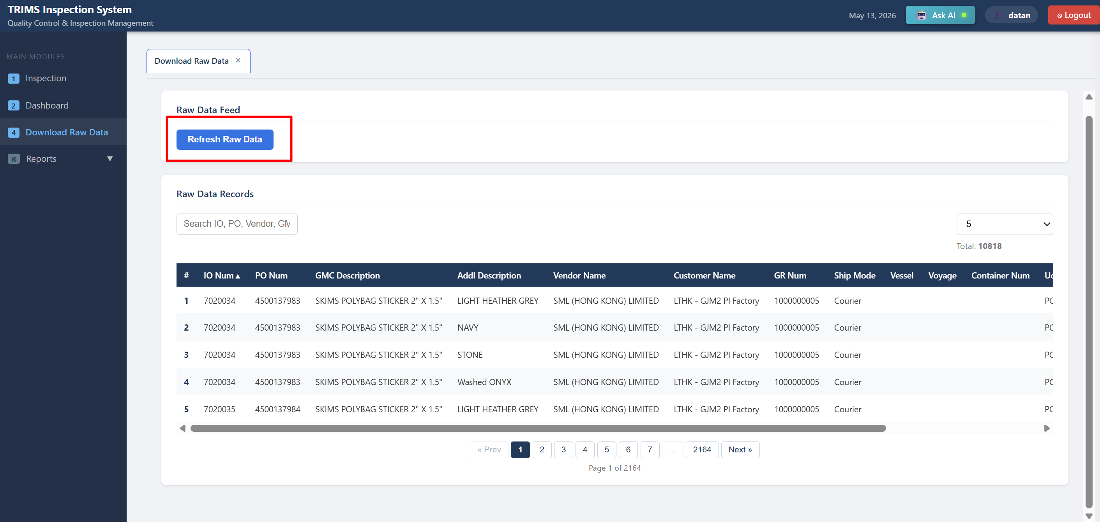
Figure 2 – Download Raw Data screen showing the Refresh Raw Data button and the populated Raw Data Records table

IMPORTANT: Always perform this step at the start of each inspection session, or whenever new production orders have been issued, to ensure you are working with current data.

What Data Is Retrieved from GO+
- IO (Inspection Order) Numbers and associated production details
- PO Numbers and GMC / Additional trim descriptions
- Vendor (Supplier) names and Customer names
- GR Numbers, Ship Mode, Vessel, Voyage, and Container information

4. Main Inspection Page

Overview
The Main Inspection Page is the core working screen of the Trims Inspection System. This is where QC inspectors conduct the actual trims inspection for a given production order. The page guides the inspector through selecting the IO Number, choosing the relevant supplier and trim, and entering quality findings. Data pre-populated from GO+ minimizes manual input and ensures consistency.

Step-by-Step: Conducting an Inspection
- From the left navigation panel, click on Inspection.
- In the Search by IO Number field, type the IO Number and click Search.
- The system confirms the match and displays the IO Number, PO Number, and Customer name.
- In the Inspection Details section, click the Supplier / Trim dropdown and select the appropriate trim item. Each entry shows the Supplier, PO Number, trim description, color, GR Number, and HBL.

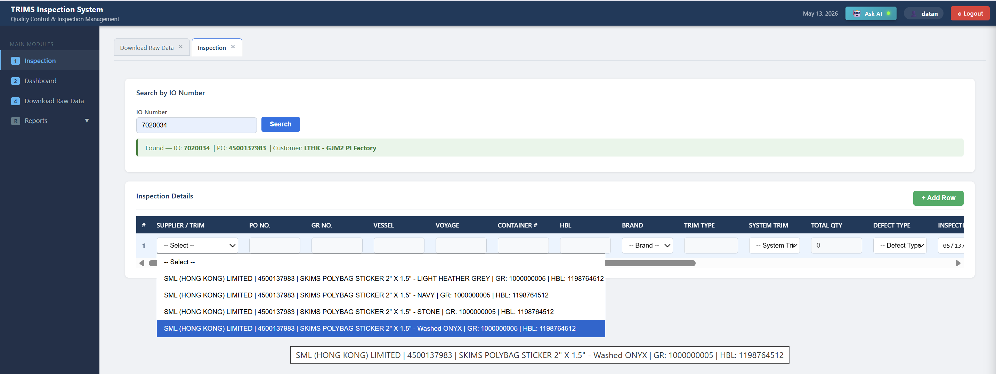
Figure 3 – IO Number search result and Supplier / Trim dropdown with available trim selections

- Once a trim is selected, the row auto-populates with data from GO+, including PO No., GR No., Brand, Trim Type, System Trim, and Total Qty.
- Complete the remaining fields: Defect Type, Inspection Date, Month, Week, Qty Inspected, Qty Defects, and Result (PASSED / FAILED).
- To inspect additional trims on the same IO, click the + Add Row button and repeat the process.
- Review all entries for accuracy, then save the inspection record.

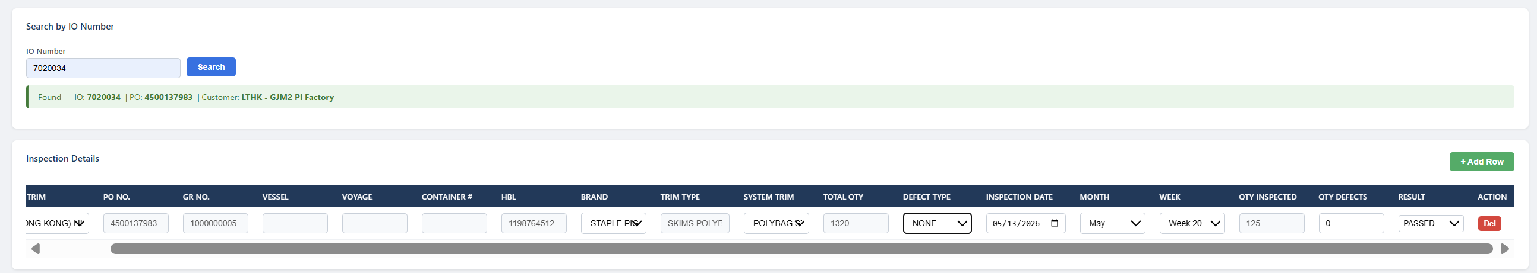
Figure 4 – Completed inspection row with all fields populated and result set to PASSED

Key Fields on the Inspection Page
Field | Description
IO Number | Unique Inspection Order identifier, searched and sourced from GO+
Supplier / Trim | Dropdown listing all trims for the selected IO, grouped by supplier
PO No. | Purchase Order number – auto-populated from GO+
GR No. | Goods Receipt number – auto-populated from GO+
Brand | Brand associated with the trim – auto-populated
Trim Type / System Trim | Classification of the trim item (e.g., Polybag, Label, Zipper)
Total Qty | Total quantity ordered – auto-populated from GO+
Defect Type | Type of defect found (e.g., None, Multiple, Wrong Color, Wrong Size)
Qty Inspected | Number of units physically examined during the inspection
Qty Defects | Number of defective units identified
Result | Final inspection outcome: PASSED or FAILED

NOTE: If the Supplier / Trim dropdown is empty after searching an IO Number, ensure the GO+ data has been refreshed (see Section 3).

5. Dashboard Module

Overview
The Dashboard provides a real-time visual summary of inspection activity and quality performance across all active production orders. It gives QC supervisors and managers an at-a-glance view of KPIs, defect trends, and supplier performance — without needing to generate individual reports.

The Dashboard can be filtered by date range, supplier, brand, and IO Number, and refreshed on demand using the Refresh Dashboard button.

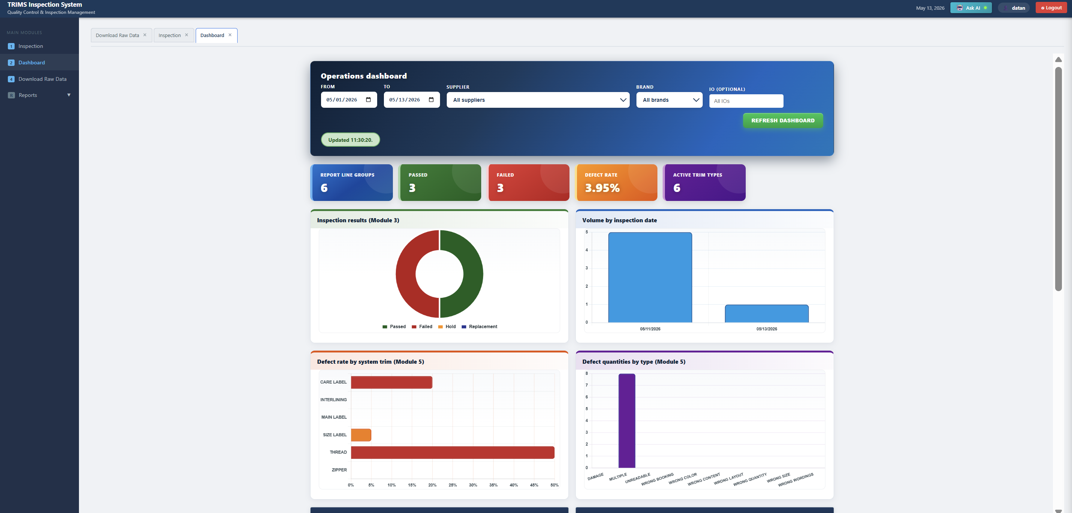
Figure 5 – Operations Dashboard showing KPI summary tiles, Inspection Results chart, Volume by Inspection Date, Defect Rate by System Trim, and Defect Quantities by Type

Purpose
- Monitor total inspection counts and pass/fail outcomes within a selected period.
- Track the overall defect rate across all active trim types.
- Identify which trim types have the highest defect rates (Defect rate by system trim chart).
- Understand the breakdown of defect categories (Defect quantities by type chart).
- Monitor inspection volume trends over time (Volume by inspection date chart).

Dashboard Filter Options
Filter | Description
From / To (Date Range) | Defines the period for which inspection data is displayed
Supplier | Filter dashboard data to a specific supplier or view all suppliers
Brand | Filter by a specific brand or view all brands
IO (Optional) | Narrow the view to a single Inspection Order
Refresh Dashboard | Reloads all charts and KPIs with the latest submitted inspection data

Key KPI Tiles
Tile | What It Shows
Report Line Groups | Total number of distinct inspection line groups recorded
Passed | Total inspection lines with a PASSED result
Failed | Total inspection lines with a FAILED result
Defect Rate | Overall percentage of defective units across all inspected trim lines
Active Trim Types | Number of distinct trim types present in the current data set

TIP: Review the Dashboard at the start of each working day to spot quality concerns early. Click Refresh Dashboard after new inspections are submitted to see the latest figures.

6. Inspection Report – By Date Range

Overview
The Inspection Report module (Module 3 – TRIMS INSPECTION REPORT) allows users to retrieve a detailed line-by-line record of all inspection transactions within a specified date range. It is the primary tool for auditing inspection activity, verifying compliance, and producing documentation for internal quality reviews or external buyer requirements.

Reports can be exported to PDF for formal documentation or to Excel for further data analysis and record-keeping.

How to Generate an Inspection Report
- From the left navigation panel, expand Reports and click Inspection Report.
- Set the Date From and Date To fields to define the reporting period.
- Click Generate Report to retrieve all matching records.
- A summary row above the table will display total Records, Total Qty, Qty Inspected, Qty Defects, and counts of Passed and Failed lines.
- Review the detailed Report Result table.
- Click Export PDF for a formatted printable report, or Export Excel for a spreadsheet file.

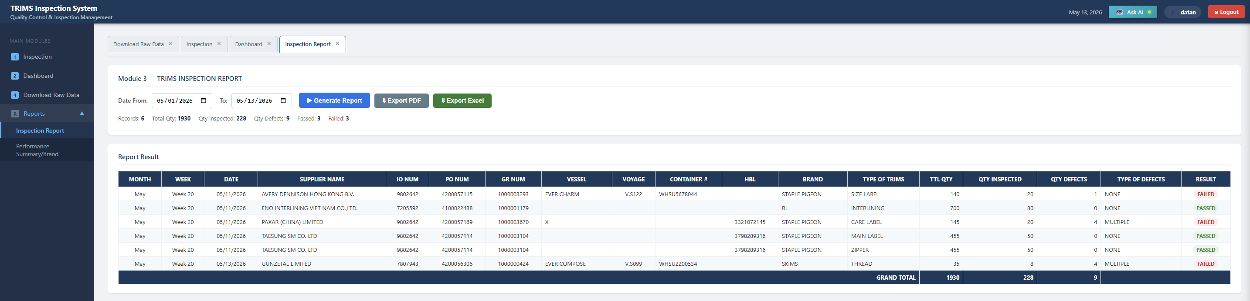
Figure 6 – Inspection Report showing date filters, summary statistics bar, Report Result table, and Export PDF / Export Excel buttons

Report Columns
Column | Description
Month / Week | The month and week number the inspection was conducted
Date | The specific date of the inspection
Supplier Name | The supplier whose trims were inspected
IO Num / PO Num | Inspection Order and Purchase Order numbers
GR Num | Goods Receipt number for shipment traceability
Vessel / Voyage / Container | Shipping details for the inspected consignment
HBL | House Bill of Lading reference number
Brand | The brand associated with the trim item
Type of Trims | The trim category (e.g., Size Label, Zipper, Care Label)
TTL Qty | Total ordered quantity for the trim line
Qty Inspected | Number of units physically checked
Qty Defects | Number of defective units identified
Type of Defects | Category of defect found (e.g., None, Multiple, Wrong Color)
Result | Final inspection outcome: PASSED or FAILED

NOTE: The Grand Total row at the bottom of the report summarizes Total Qty, Qty Inspected, and Qty Defects across all records in the selected date range.

7. Performance Summary / Brand

Overview
The Performance Summary module (Module 5 – TRIMS PERFORMANCE MONITORING SUMMARY) provides an aggregated analytical view of inspection quality performance broken down by trim type, with defect data categorized by defect type. It can be filtered by Supplier, Brand, or both simultaneously.

Unlike the Inspection Report, which lists individual records, this module aggregates data across all inspections to reveal overall quality trends — making it a key tool for supplier evaluation, management reporting, and sourcing decisions.

How to Generate a Performance Summary
- From the left navigation panel, expand Reports and click Performance Summary/Brand.
- Set the Date From and To fields to define the analysis period.
- In the Supplier dropdown, select a specific supplier or leave as All Suppliers.
- In the Brand dropdown, select a specific brand or leave as All Brands.
- Click Generate to load the aggregated summary data.
- Review the summary statistics above the table: Trim types with data, Total Qty, Total Inspected, Total Defects, and Overall Defect Rate.
- Click Export PDF or Export Excel to save or share the report.

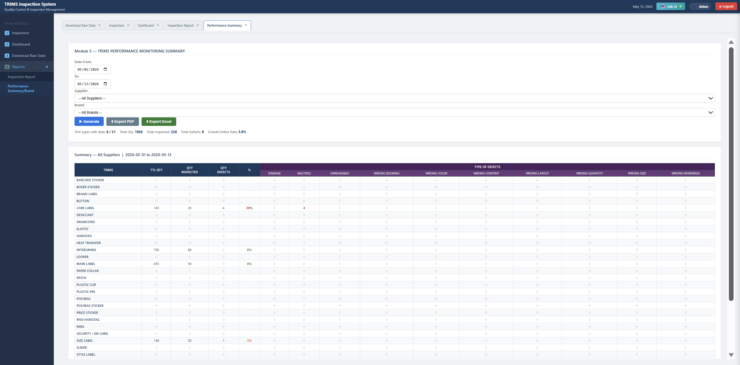
Figure 7 – Performance Summary / Brand showing filter options, summary statistics, and the trim-by-trim defect breakdown table with defect type columns

Filter Options
Filter | Description
By Supplier | View performance data for one or more selected suppliers
By Brand | View performance data grouped by brand or product line
Mixed Selection | Combine Supplier and Brand filters to cross-reference performance
Date Range | Limit the summary to a specific time period for targeted analysis

Summary Table Columns
Column | Description
Trims | Name of the trim type (e.g., Care Label, Zipper, Size Label)
TTL Qty | Total ordered quantity for that trim type in the selected period
Qty Inspected | Total units inspected for that trim type
Qty Defects | Total defective units found for that trim type
% (Defect Rate) | Defect percentage; highlighted when above threshold
Defect Type Columns | Individual columns per defect category: Damage, Multiple, Unreadable, Wrong Booking, Wrong Color, Wrong Content, Wrong Layout, Wrong Quantity, Wrong Size, Wrong Wordings

TIP: Use the mixed Supplier + Brand filter to evaluate how a specific supplier performs for a particular brand — especially useful when a supplier provides trims for multiple clients or product lines.

8. AI Assistant

Overview
The AI Assistant is a built-in conversational analytics tool that allows users to instantly query inspection data using plain language — without navigating to specific report modules or setting manual filters. It is powered by an AI model with direct access to the system's inspection data and is designed to help QC teams quickly surface insights, identify issues, and understand performance trends.

The AI Assistant is accessible from any page in the system via the Ask AI button located in the top navigation bar.

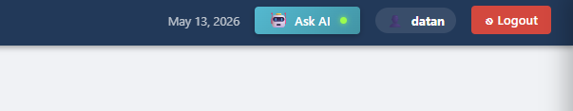
Figure 8 – The Ask AI button in the top navigation bar, available from any screen in the system

Purpose
- Get instant inspection summaries without manually generating reports.
- Ask questions in plain language (e.g., "Summary this month" or "Top 5 suppliers by defect rate").
- Quickly identify which suppliers or trim types are underperforming.
- Compare performance across time periods (e.g., this month vs last month).
- Access KPI snapshots — Lines, Total Qty, Inspected, Defect Rate, Pass Rate, Failed Lines — on demand.

How to Use the AI Assistant
- Click the Ask AI button in the top navigation bar. A chat panel will open on the right side of the screen.
- The assistant will greet you by name and display a set of suggested quick-action prompts.
- Click any suggested prompt to run it immediately, or type your own question in the text box at the bottom and press Send.
- The assistant will respond with a structured summary, table, or analysis based on your query.
- Use the suggested follow-up prompts ("Try Next") to continue the analysis or drill deeper into the data.

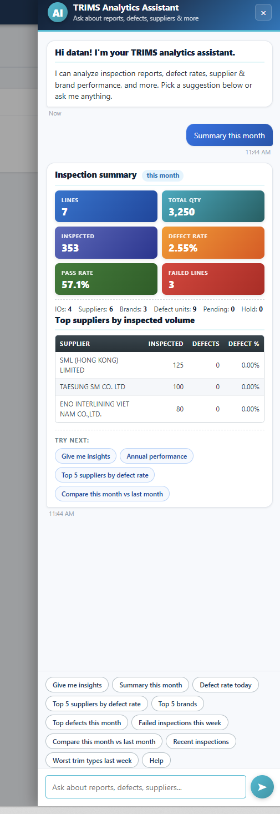
Figure 9 – AI Assistant chat panel showing a monthly inspection summary with KPI tiles, top suppliers table, and suggested follow-up prompts

Example Prompts
Prompt | What the Assistant Returns
Summary this month | KPI summary tiles: Lines, Total Qty, Inspected, Defect Rate, Pass Rate, Failed Lines, plus top suppliers by inspected volume
Defect rate today | Current day defect rate with a breakdown of affected trim types and suppliers
Top 5 suppliers by defect rate | Ranked list of suppliers with the highest defect percentages for the current period
Top 5 brands | Performance summary ranked by brand, showing inspection volumes and defect rates
Top defects this month | List of the most frequent defect types recorded in the current month
Failed inspections this week | All inspection lines marked as FAILED during the current week
Compare this month vs last month | Side-by-side comparison of key metrics between the two periods
Recent inspections | List of the most recently submitted inspection records
Worst trim types last week | Trim types with the highest defect rates recorded in the previous week
Annual performance | Year-to-date summary of inspection volumes, pass rates, and defect trends
Give me insights | AI-generated observations and recommendations based on current inspection data

TIP: You are not limited to the suggested prompts. You can type any question related to inspections, defects, suppliers, or brands in plain language and the assistant will interpret and respond accordingly.

NOTE: The AI Assistant's responses are based on the inspection data currently in the system. Ensure GO+ data has been refreshed and recent inspections have been submitted for the most accurate results.

9. Troubleshooting & Support

Common Issues and Solutions
Issue | Suggested Solution
Cannot access the login page | Verify you are connected to the company network or VPN. Confirm the URL: http://172.16.28.108/trims/
Login credentials not working | Ensure Caps Lock is off. If the issue persists, contact your system administrator to reset your password.
IO Number not found in search | Refresh the raw data from GO+ (Section 3). The order may not yet be synced into the system.
Supplier / Trim dropdown is empty | Confirm the GO+ data download completed successfully. Re-run the Refresh Raw Data step.
Export button not responding | Ensure your browser allows pop-ups and downloads from the system. Google Chrome is recommended.
Dashboard data not refreshing | Click the Refresh Dashboard button. If data remains stale, log out and log back in.
Performance Summary shows no data | Check that the selected date range contains completed inspections. Adjust filters and click Generate again.
AI Assistant not responding | Refresh the page and try again. If the issue persists, log out and log back in. Contact IT if the problem continues.

Contacting Support
For issues not covered in this guide, contact your IT Department or System Administrator. Please provide the following when reporting a problem:
- Your username and department
- The module or page where the issue occurred
- A brief description of the problem and any error messages displayed
- The date and time the issue was first observed

REMINDER: Do not share your login credentials with other users. Each user must have their own account to maintain accountability and a proper audit trail.

