Vertel Quality Incitament
2022-09-20

These steps will help the developer to ship software people can use. To start, do a ”git pull” to ensure your local copy is up to date.

1. grep -sR "'name':" */*__.py
2. grep -sR "'version':" */*__.py
3. grep -sR "'category':" */*__.py
4. grep -sR "'summary':" */*__.py
5. grep -sR "'description':" */*__.py

1. Name should be something clever and end with a colon.
2. Version shall be the same for every module in the project
3. Category shall be relevant and consistant. Not creative!
4. Summary shall be… something.
5. Description shall be empty (multiline) and end with ”””

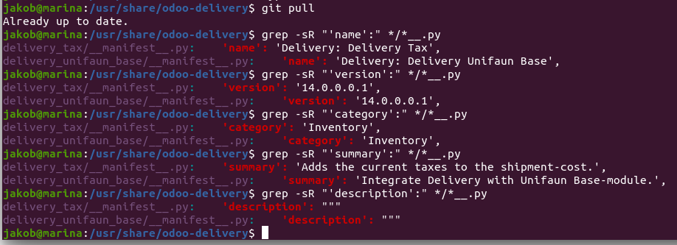
Go to Apps, select all modules from this project (1.) Mark the list view (2.) select all moduels (3.) and press Install Modules (4.).

