API Eniro, Odoo 12 compatible
2019-08-20

The module crm_eniro depends on kthe module partner_eniro.

Instructions, get started
Create a free account at https://api.eniro.com/

This account will give you some thousands of free requests each month.

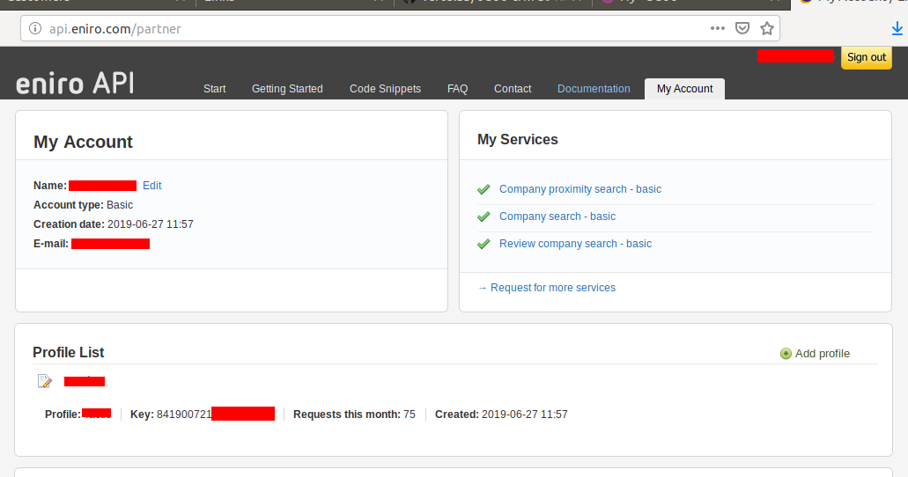

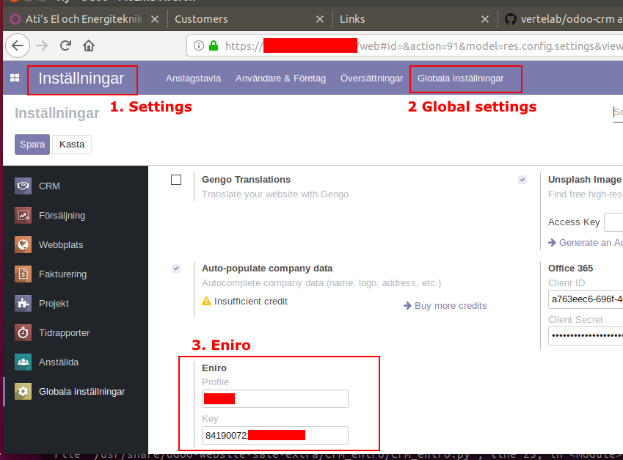
You will need to enter the key inside Odoo.

From module CRM.

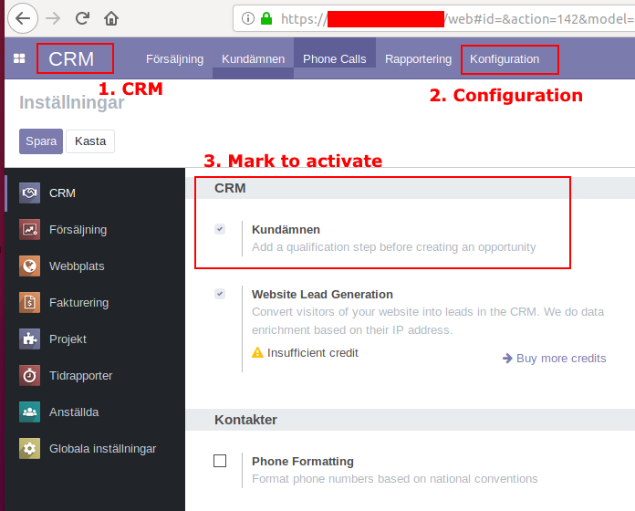
You can manually insert the API Key and the API Profile.
Settings >> Technical >> System Parameters.

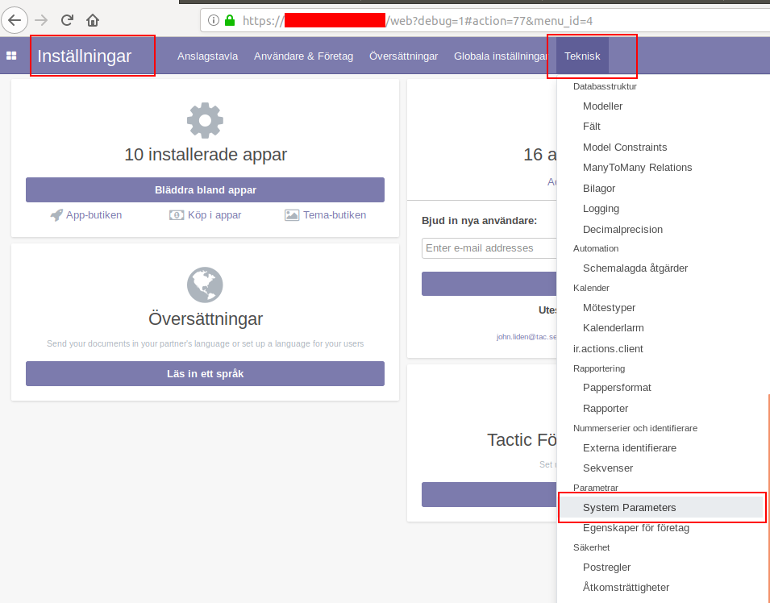
Here you can create your key and profile settings.

