Odootools // odoolangexport
Instructions guide
2019-08-06

https://github.com/vertelab/odootools

1. Uning the Terminal, go to the actual project.
$ /usr/share/odoo-website-client/webshop_client

2. Look for a folder named i18n
$ /usr/share/odoo-website-client/webshop_client/i18n/

Export translation
”This gives you a file called yourmodule.pot which should be moved to the yourmodule/i18n/ directory.”
https://www.odoo.com/documentation/11.0/reference/translations.html

Odoo 12
https://www.odoo.com/documentation/12.0/reference/translations.html

3. Change priviledges in this folder by typing...
$ sudo chmod a+w . -R

4. Follow the instructions from github: ”export po/pot file for a module, -m -d -l ”

$ odoolangexport -m [module] -d [name_of_database] -l [language]

$ odoolangexport -m webshop_client -d database_name -l sv_SE

5. Logout from Terminal
$ logout

6. Log on again using capital X
$ ssh [server_name] X

7. Go back to folder:
$ /usr/share/odoo-website-client/webshop_client/i18n/

8. Use Poedit to edit translations.
$ poedit sv_SE.po

Install in Odoo 8.

Log on to your server.

Go to Settings > Import / Export > Import translations.

See image below.

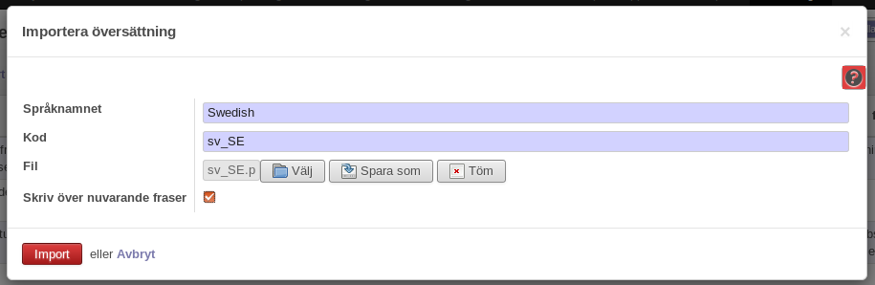

Empty cashe for changes to take effect!

