Crop Analysis Q3 2013

John Smith

May 3rd, 2014

# output: html_document  
# output: pdf_document  
# output: word_document

# Homework 12 - Web scraping and APIs

Dean Attali Nov 29 2014

Last updated: 2018-08-03 15:37:59

## Overview

I wanted to see if there’s any relationship between the amount of money a country spends on research and development (R&D) and the number of Nobel Prize laureates produed by the country. I expect that there is such a relationship to some extent. While money spent on R&D does not necessarily mean the money is going towards science-based R&D for example, it can

# try.dev.off()  
MyGauss = rnorm(1000)  
hist(MyGauss, col = "gold1")

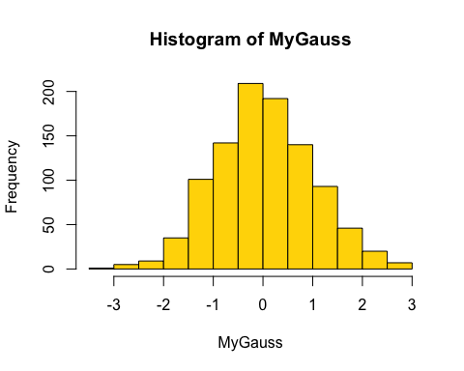

MyPoiss = rpois(1000, lambda = 7)  
hist(MyPoiss, col = "gold1")

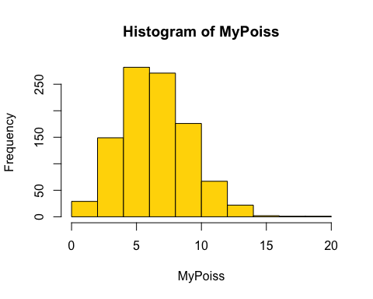

plot(cars)

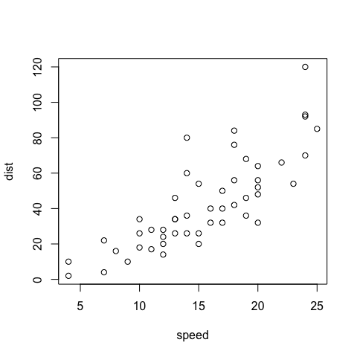

plot(1)

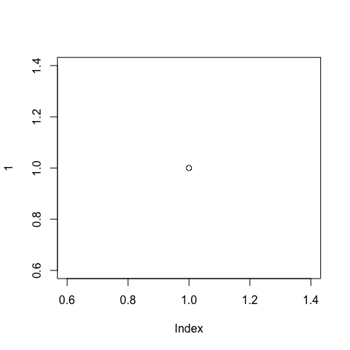

asas sasa sa s