**VertexGraph AI Skill – Microsoft Teams**

**Setup Microsoft App Permission:**

1. Go to <https://entra.microsoft.com>
2. Login with your Microsoft account credentials.
3. Go to **Applications > App registrations.**

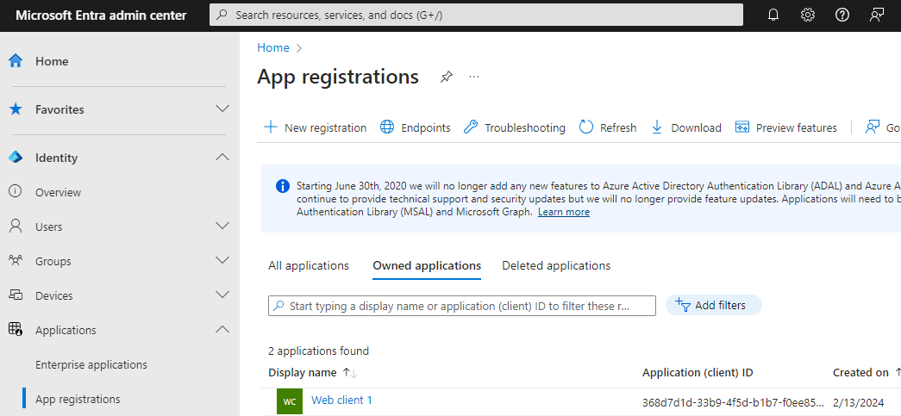

1. Select **New registrations**. Fill out the desired name for the registration and then choose second or third option in **Supported account types.** You can leave Redirect URI empty.

1. Select **Register** to create a new app registration.
2. After that is done, navigate back to App registrations in step 3 and click on your newly create application.
3. Now navigate to **API Permissions** and click **Add a permission**

1. Select **Microsoft Graph > Delegated permissions** and then select all necessary permissions in the application (*offline_access, User.Read, User.ReadBasic.All, Chat.ReadWrite, ChatMember.ReadWrite, Group.ReadWrite.All, TeamMember.ReadWrite.All, Team.ReadBasic.All*). Then click **Add permissions** to complete.

(*) Note: Some permissions need admin consent so unless you are granted permission by the admin or the account is the admin itself, some permissions will not work.

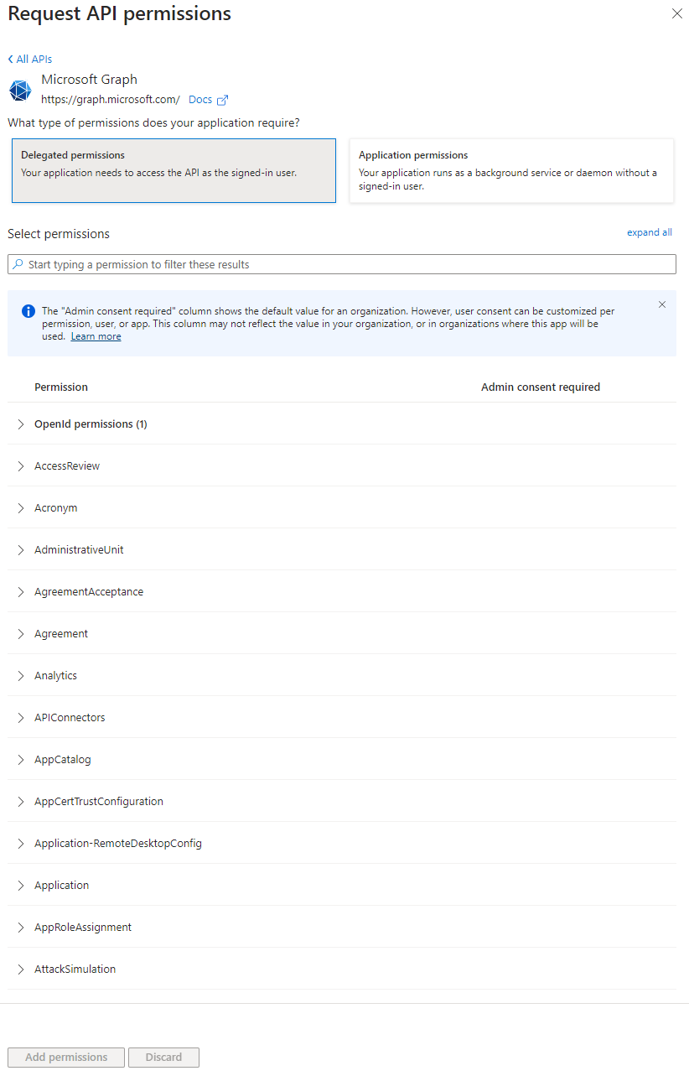

1. After adding the permissions, navigate to **Authentication** and click **Add a platform**.

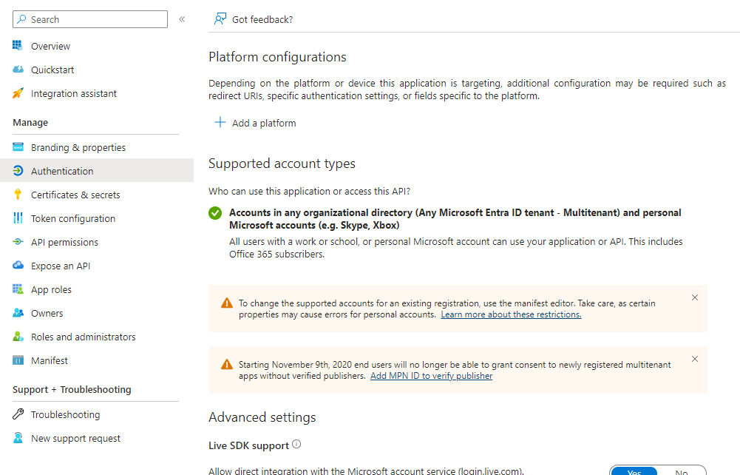

1. In **Configure platforms**, select **Web.**

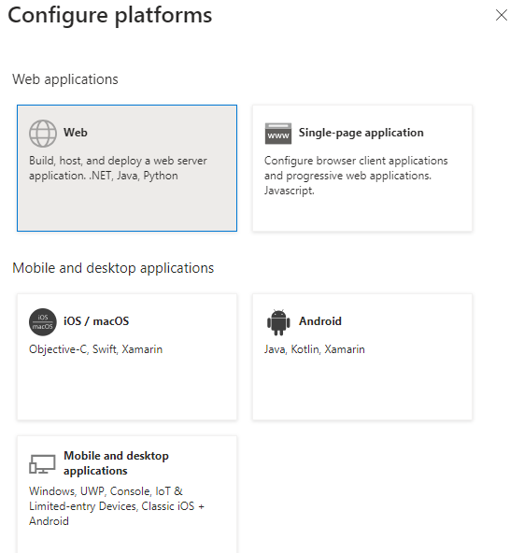

1. Add <https://api.vertexgraph.com/adminapi/assets/oauthcode> in Redirect URIs in Configure Web. Then select Configure to create the platform.

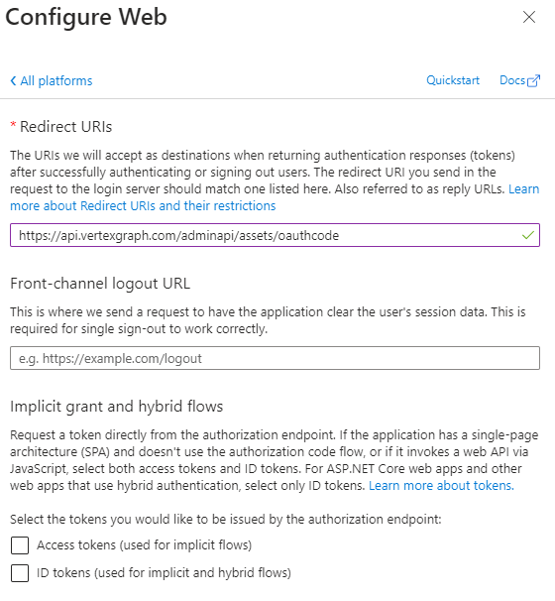

1. Then a window for Web platform will be created. Add the following URL’s below the first one.

<https://api.vertexgraph.com/adminapi/assets/oauthcode>

<https://login.microsoftonline.com/common/oauth2/v2.0/token>

<http://localhost/msteams/auth>

<http://localhost/msteams/token>

1. Once that is done, navigate **Overview** and click on **Add a certificate or secret** on the right corner.

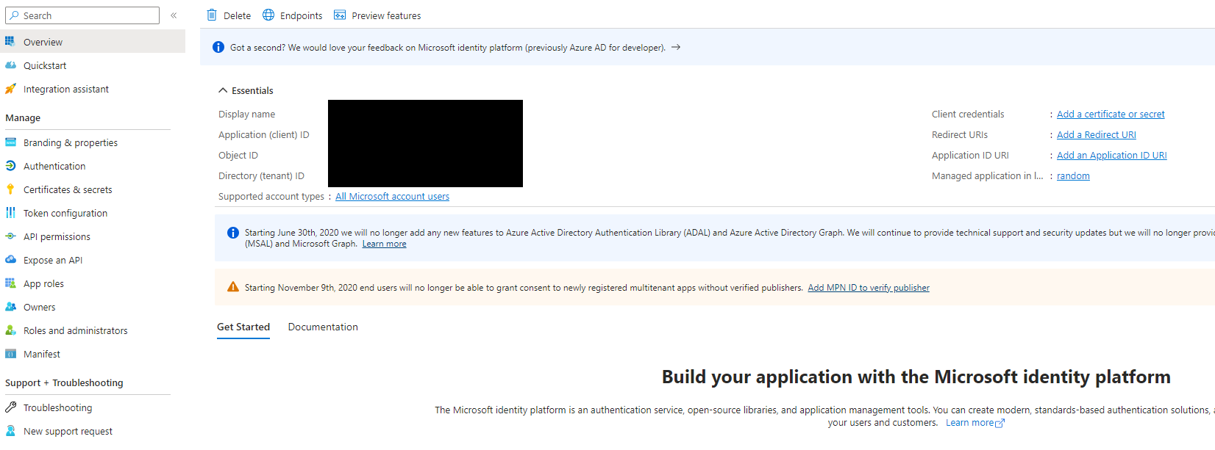

1. Click on **New client secret**, add a description to the client secret and then click **Add.**

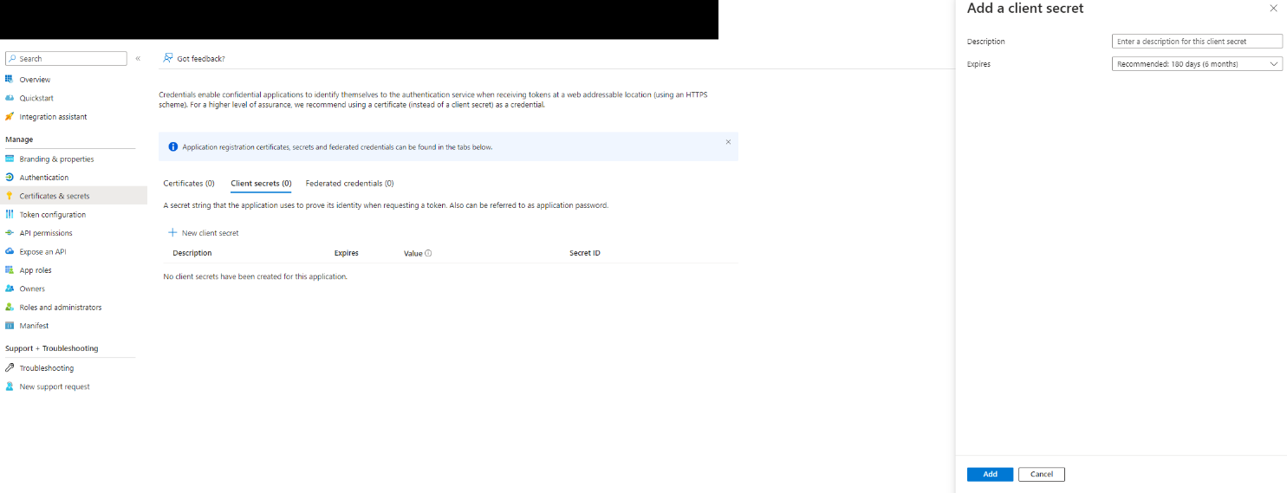

1. Scroll down and you will see your App Credentials, you want to copy your **Client ID** (or Application ID) and **Client Secret** (Client Secret Value)

Note: *Multiple applications can use the same app registrations, what matters is that permissions are added and redirect URLs and secrets are known*

**Setting up Skill in VertexGraph**

1. Navigate to <https://vertexgraph.ai/portal/>
2. On the left side tool bar select the second option “AI”
3. Now select the custom skills icon on the top right corner

1. Once on the skills section Press “New Custom Skill”
2. Follow the setup until you reach the section where you must enter the OAuth Client ID and Secret
3. Copy and paste the client ID and secret from the MSTeams AI Skill information
4. Get the authorization code and authorize VertexGraph to access your Microsoft account
5. Once completed assign the new skill to any of your assistants to start using it

**Test Prompts:**

* Get chats for the past week.
* Create a chat with example@example.com in my MS teams.
* Update my most recent chat's topic to "chat with friend”.
* Add testing1@vertexgraph.com to my chats within last 2 days in my MS teams.
* Remove example@example.com from my chats within last 2 days in my MS teams.
* Get chat messages for the past week from my MS teams.
* Send a message with content "test message from ai chat" to chats within past week from my MS teams.
* Update chat messages to "new update message" from my MS teams in the chat with topic containing 'test1'.
* Remove chat messages from my MS teams with topic containing "chat".
* Get teams with example@example.com.
* Create a team with example@example.com.
* Update most recently created team display name to "update team display name”.
* Remove most recently created team.
* Get team members who are the owner of the teams.
* Add example@example.com to all teams.
* Remove testing1@vertexgraph.com from most recent team.