Tribhuvan University
Institute of Information Technology (IIT)
Kirtipur, Kathmandu, Nepal

IIT LAB REPORT
Computer Fundamentals & Office Applications

Submitted By:
Mohan Shahi

Roll No. | IIT-078-056
Semester | First Semester
Academic Year | 2080/081
Faculty | Mr. Rajesh Paudel

Submitted To:
Department of Computer Science and IT
IIT, Tribhuvan University

ACKNOWLEDGEMENT

I would like to express my heartfelt gratitude to all those who helped me complete this IIT Lab Report. First and foremost, I am very thankful to my lab teacher Mr. Rajesh Paudel for guiding me throughout the practical sessions and giving clear instructions about each lab exercise.

I am also grateful to the management and faculty members of the Institute of Information Technology (IIT), Tribhuvan University, Kirtipur for providing us with a well-equipped computer lab and the necessary resources to complete our practical work.

I would also like to thank my classmates and friends — especially Rajan Thapa, Sita Karki and Priya Bhandari — for their support and help during the lab sessions. There were times when we sat together after class to finish the practicals and I am grateful for that.

Finally, I want to thank my family for their continuous encouragement and support. Without all of these people, this report would not have been possible.

— Mohan Shahi
IIT, Roll No: IIT-078-056
Date: 2081/04/15

INDEX

S.N. | Lab Title | Page No.
1 | Lab 1: Word Processor (MS Word) — Bio-Data / CV | 4
2 | Lab 2: MS Word Functions — Page Layout, Pictures, Charts, Shapes | 8
3 | Lab 3: MS Excel — Student Mark Sheet | 12
4 | Lab 4: MS Excel — Salary Sheet | 16
5 | Lab 5: MS DOS Commands | 19
6 | Lab 6: MS PowerPoint — IT Presentation (Cyber Security) | 22
7 | Lab 7: Gmail Account Creation | 25

LAB 1: WORD PROCESSOR (MS WORD)
Objective:
To develop a Bio-Data / Curriculum Vitae (CV) using Microsoft Word including table for qualification profile, header, footer and page number.

1.1 Introduction to MS Word
MS Word or Microsoft Word is a graphical user interface (GUI) based word processing software developed by Microsoft Corporation. It is one of the most widely used software applications for creating, editing and formatting documents. It allows users to make professional documents like letters, reports, memos, resumes, etc. MS Word has many helpful tools such as grammar checker, word count, speech recognition, tables, templates, and so on.

1.2 Features of MS Word
- Home: Contains text formatting options such as font, font size, bold, italic, underline, paragraph alignment, bulleting and numbering.
- Insert: Used to insert tables, images, shapes, SmartArt, charts, headers, footers, page numbers etc.
- Design: Provides document themes, styles, watermarks, page color and borders.
- Layout: Controls page margins, orientation, size, columns and line spacing.
- References: For table of contents, footnotes, citations, bibliography and index.
- Mailings: For mail merge, envelopes and labels.
- Review: For spell check, grammar check, word count and track changes.
- View: For different document views like Read Mode, Print Layout, Web Layout.

1.3 Steps to Open MS Word
- Click on the Start button (Windows logo) on the bottom left of the screen.
- Scroll down the application list and find 'Microsoft Office' folder.
- Click on 'Word' to launch the application.
- A splash screen will appear and then the Word home interface opens.
- Select 'Blank Document' to open a new empty document.

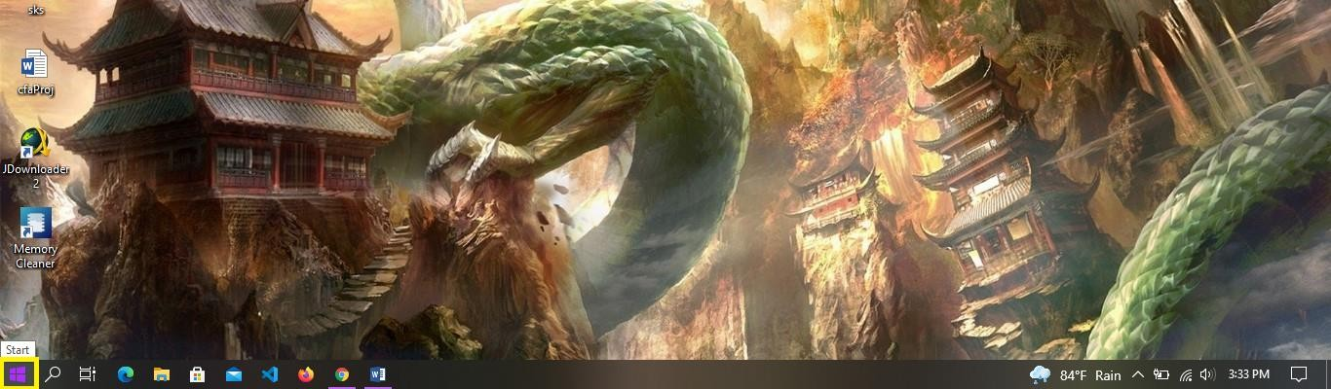
✏ Word 2016 opened successfully on my laptop

1.4 Common Shortcuts in MS Word
Ctrl + B | Bold selected text
Ctrl + I | Italic selected text
Ctrl + U | Underline selected text
Ctrl + S | Save the document
Ctrl + Z | Undo last action
Ctrl + Y | Redo last action
Ctrl + C | Copy selected text
Ctrl + V | Paste copied text
Ctrl + A | Select all content

1.5 Bio-Data / Curriculum Vitae of Mohan Shahi

CURRICULUM VITAE

━━━━━━━━━━━━━━━━━━━━━━━━━━━━━━━━━━━

Personal Details
Full Name | Mohan Shahi
Date of Birth | 2058/05/22 (B.S.)
Gender | Male
Nationality | Nepali
Religion | Hindu
Address | Butwal-10, Rupandehi, Lumbini Province
Phone | 9847XXXXXX
Email | mohan.shahi@gmail.com

Education / Qualification
Year | Institution | Board/University | Faculty | Grade/CGPA
2080–Present | IIT, Tribhuvan University | T.U. | B.Sc. CSIT | Running
2077–2079 | Janata Higher Secondary School, Butwal | NEB | Science (+2) | B+
2076 | Shree Rastriya Secondary School | DEO Rupandehi | S.L.C. / SEE | A

Skills
- Microsoft Office Package (Word, Excel, PowerPoint)
- Basic C Programming
- HTML and CSS basics
- Typing Speed: 35+ WPM
- Team work and communication skills

Languages Known
- Nepali — Mother Tongue
- English — Intermediate
- Hindi — Basic

Reference
Mr. Rajesh Paudel, Lab Instructor, Department of CS & IT, IIT, T.U., Kirtipur

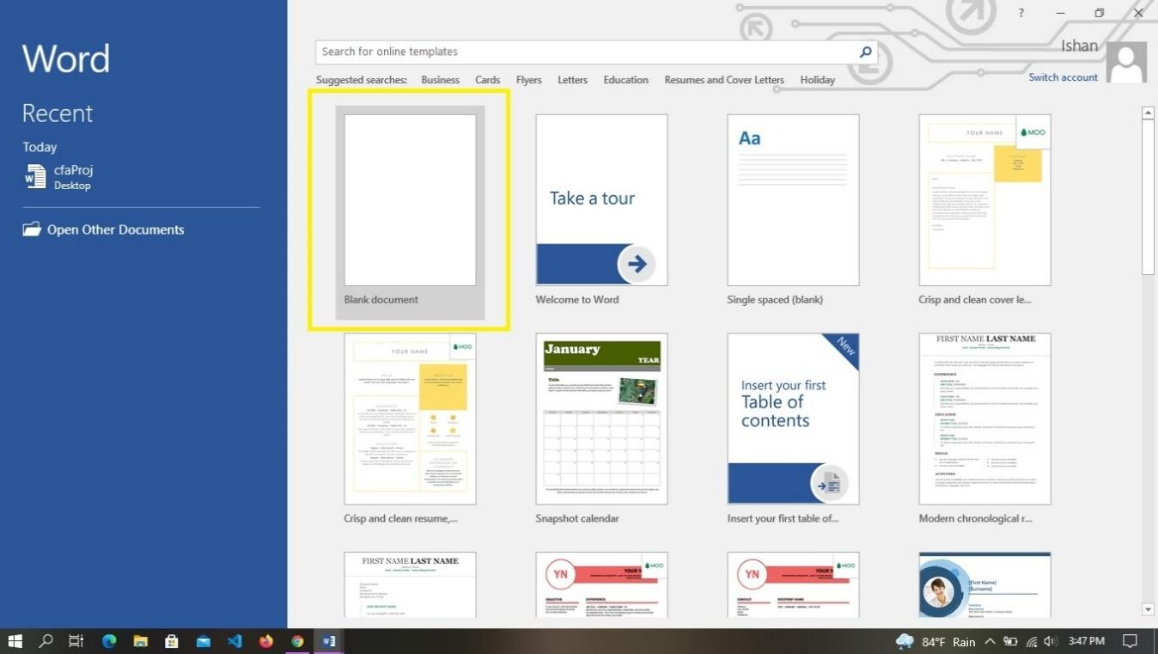
✏ Header added: 'IIT Lab Report' | Footer: 'Mohan Shahi — Roll No IIT-078-056' | Page no. shown at bottom

Result:
A professional Curriculum Vitae / Bio-Data of Mohan Shahi was successfully created using Microsoft Word. The document includes a personal information section, education table, skills, languages, and proper header, footer and page number formatting.
Conclusion:
MS Word is a powerful word processing tool. Through this lab we learned how to create and format a professional document including tables, headers, footers and page numbers.

LAB 2: MS WORD FUNCTIONS
Objective:
To create a document in MS Word demonstrating Page Layout, Page Break, Insert Picture, Clip Art, Shapes, and Chart features.

2.1 Page Layout
Page Layout is found under the 'Layout' tab in MS Word ribbon. It allows the user to control how the page looks and how content is arranged. Important options in page layout are:
- Margins: Set top, bottom, left, right margins (default is 1 inch on all sides).
- Orientation: Switch between Portrait (vertical) and Landscape (horizontal).
- Size: Change paper size — A4, Letter, Legal etc.
- Columns: Divide the page content into one, two or three columns.
- Indentation and Spacing: Adjust line spacing and paragraph spacing.

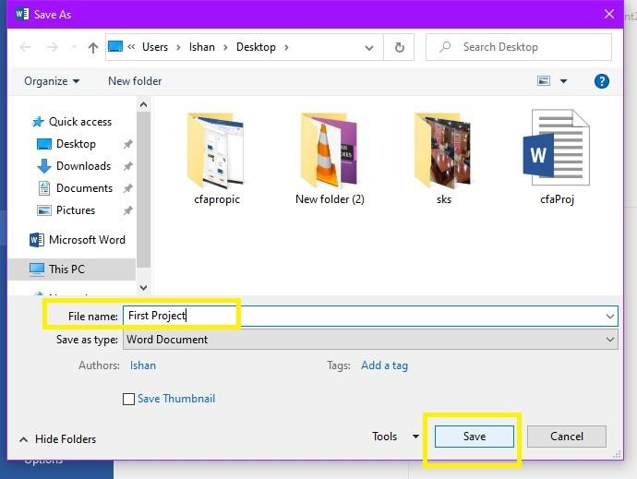
✏ Selected A4 paper size, Portrait mode, 1 inch margins on all sides

2.2 Page Break
A page break forces the remaining content to move to the next page. To insert a Page Break:
- Place the cursor where you want the break.
- Go to Insert tab and click on 'Page Break' option.
- Or simply press Ctrl + Enter from the keyboard.
- The content after the cursor will now begin on a new page.

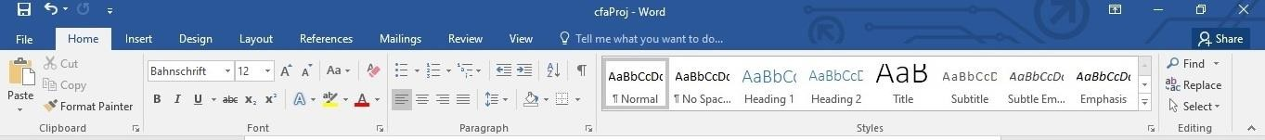
✏ Used Ctrl+Enter to insert page break before Lab 2 section

2.3 Insert Picture
To insert a picture from the computer into the Word document:
- Go to 'Insert' tab from the ribbon.
- Click on 'Pictures' button.
- Browse and select the image from your computer files.
- Click Insert. The image will appear on the document.
- Resize or reposition the image using the drag handles.

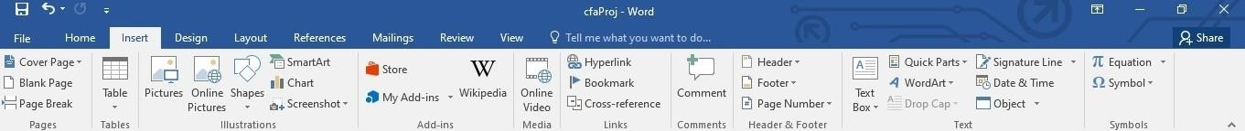
✏ Inserted image from Downloads folder — resized to 8x5 cm

2.4 Clip Art / Online Pictures
Clip art is pre-made artwork stored in a library. In MS Word 2016 and later, Clip Art was replaced with Online Pictures. To insert:
- Go to Insert tab.
- Click 'Online Pictures'.
- Search for a keyword like 'computer' or 'student'.
- Select the desired image and click Insert.

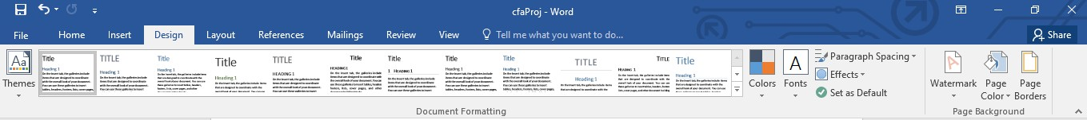
✏ Searched 'laptop' and selected a vector image from Bing

2.5 Shapes
MS Word provides many built-in shapes like rectangles, circles, arrows, lines, and flowchart symbols. To insert a shape:
- Click on Insert tab.
- Click on 'Shapes' dropdown button.
- Select any shape from the gallery.
- Click and drag on the document to draw the shape.
- Use Shape Format tab to change fill color, outline, and effects.

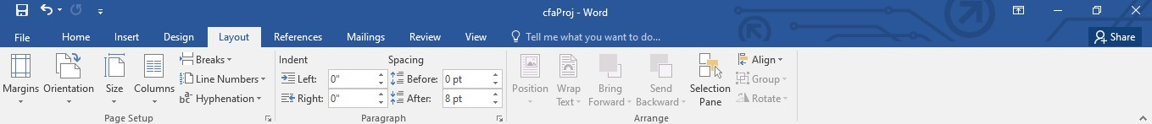
✏ Used arrow and rectangle shapes for diagram. Fill color changed to blue

2.6 Chart
Charts help visually represent data in a document. To insert a chart in MS Word:
- Click on Insert tab.
- Click on 'Chart' icon in the Illustrations group.
- Select chart type — Bar, Column, Pie, Line etc.
- Click OK. A small Excel spreadsheet will open to enter data.
- Enter your data in the spreadsheet. The chart will update in real time.
- Close the Excel pane. Format the chart using Chart Design tab.

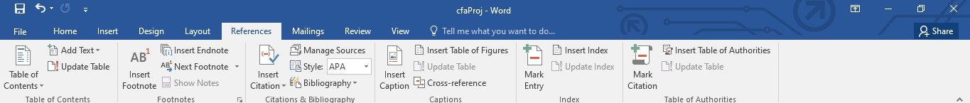
✏ This is chart output — Column chart with 5 subjects and marks

Result:
A Word document was successfully created demonstrating all the required features: page layout settings, page break, picture insertion, online clip art, shapes and chart. Each feature was practiced and the output was observed.
Conclusion:
MS Word provides a rich set of features for creating professional documents. Page layout controls the appearance while pictures, shapes, and charts make documents more visual and informative.

LAB 3: MS EXCEL — STUDENT MARK SHEET
Objective:
To develop a First Semester Mark Sheet using MS Excel with calculations for Sum, Average, Percentage, Pass/Fail result and Grade using Excel formulas.

3.1 Introduction to MS Excel
Microsoft Excel is a spreadsheet application developed by Microsoft. It is used to organize, analyze and present data in tabular form. Excel uses rows and columns to store data in cells. It provides powerful built-in functions for mathematical calculations, statistical analysis, logical operations, text manipulation and much more.

3.2 Formulas Used
Formula | Explanation
=SUM(B2:G2) | Adds all marks from column B to G for row 2
=AVERAGE(B2:G2) | Calculates average of marks from B2 to G2
=(H2/(100*6))*100 | Calculates percentage from total marks
=IF(MIN(B2:G2)>=40,"PASS","FAIL") | Shows PASS if all marks ≥ 40, else FAIL
=IF(I2>=90,"A+",IF(I2>=80,"A",IF(I2>=70,"B+","B"))) | Nested IF for grade calculation

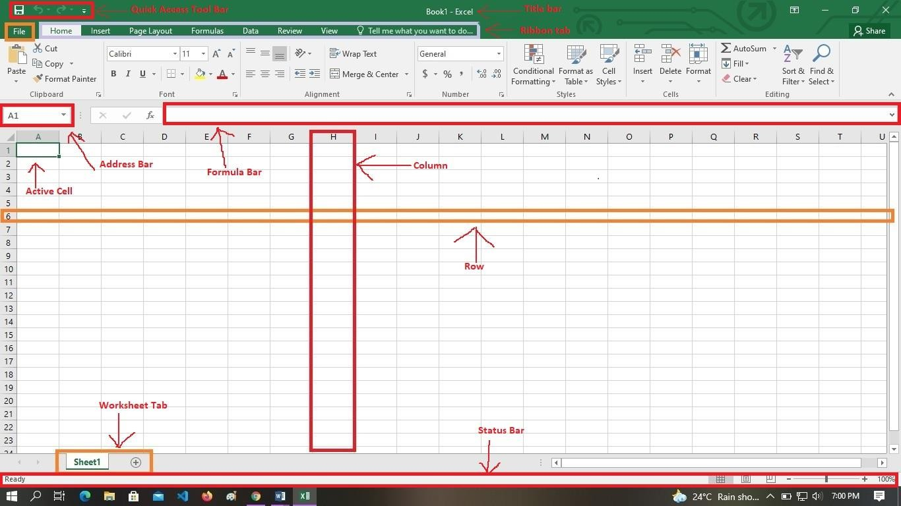
✏ =SUM(B2:G2) entered in Total column — calculates automatically

3.3 Output — First Semester Mark Sheet
FIRST SEMESTER MARK SHEET — 2080/081
IIT, Tribhuvan University | Full Marks: 100 per subject | Pass Marks: 40

Name | Comp. | Calculus | Physics | English | C | Digital | Total | Pct% | Grade | Division
Mohan Shahi | 78 | 65 | 72 | 80 | 85 | 70 | 450 | 75.0% | B+ | First
Sita Karki | 85 | 72 | 68 | 90 | 78 | 82 | 475 | 79.2% | B+ | First
Rajan Thapa | 60 | 55 | 63 | 70 | 72 | 65 | 385 | 64.2% | B | First
Priya Bhandari | 90 | 88 | 85 | 92 | 95 | 89 | 539 | 89.8% | A | First
Bikash Rana | 45 | 40 | 38 | 50 | 55 | 48 | 276 | 46.0% | D | FAIL
Anjali Shrestha | 70 | 68 | 74 | 76 | 80 | 72 | 440 | 73.3% | B+ | First

✏ Red marks = below 40 (fail). Percentage formula: (Total / 600) * 100
✏ Grade: A+ ≥ 90, A ≥ 80, B+ ≥ 70, B ≥ 60, C ≥ 50, D ≥ 40, F < 40

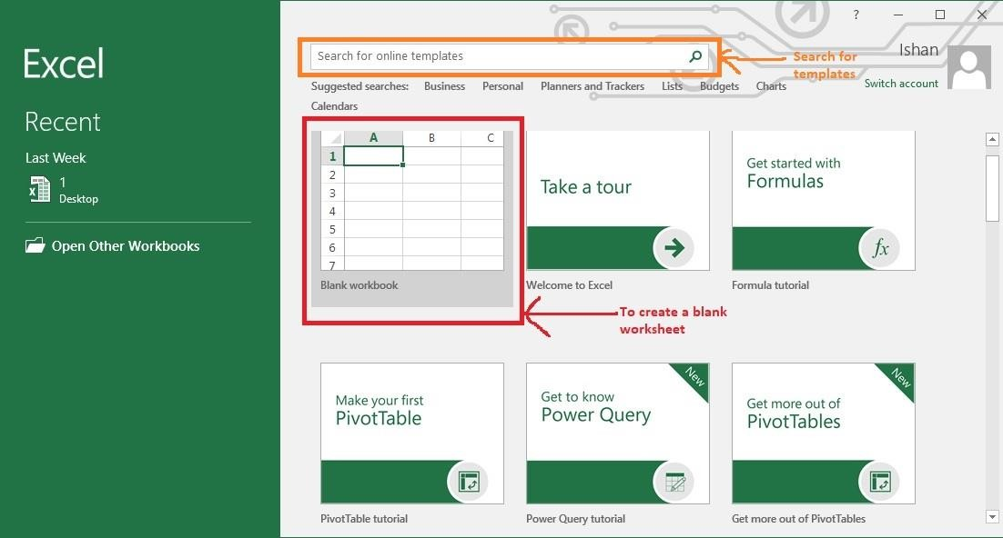

Result:
A First Semester Mark Sheet was successfully created in MS Excel for 6 students. Sum, Average, Percentage, Grade and Pass/Fail were calculated using Excel built-in formulas. Students scoring below 40 in any subject were marked FAIL.
Conclusion:
MS Excel is a very useful tool for handling numerical data and performing automatic calculations. Using formulas like SUM, IF and nested IF, we can automate complex calculations in just a few keystrokes.

LAB 4: MS EXCEL — SALARY SHEET
Objective:
To create a Salary Worksheet in MS Excel for at least 5 employees, calculating HRA, TA, Gross Pay, Tax and Net Pay using Excel formulas.

4.1 Introduction
A salary sheet is used by organizations to calculate the salary of employees. It includes details like basic salary, allowances, deductions and final net pay. MS Excel is widely used to create and manage salary sheets because of its formula and auto-calculation features.

4.2 Salary Calculation Rules
Component | Formula / Value
HRA (House Rent Allowance) | 50% of Basic Salary
TA (Travel Allowance) | 10% of Basic Salary
Deduction | Fixed: Rs. 500 per employee
Gross Pay | Basic + HRA + TA
Tax | 10% of Gross Pay
Net Pay | Gross Pay - Tax - Deduction

4.3 Formulas in Excel
The following formulas were used in the Excel salary sheet:
- =B2*0.5 (HRA — 50% of Basic in column B)
- =B2*0.1 (TA — 10% of Basic)
- =B2+C2+D2 (Gross Pay = Basic + HRA + TA)
- =F2*0.1 (Tax — 10% of Gross Pay)
- =F2-G2-E2 (Net Pay = Gross - Tax - Deduction)

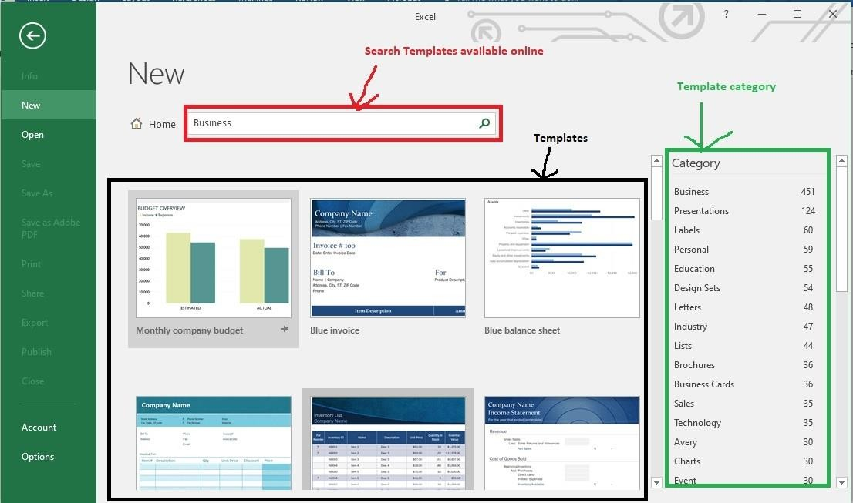
✏ All values calculated automatically using formulas — no manual typing needed

4.4 Salary Sheet Output
Name | Basic | HRA (50%) | TA (10%) | Deduction | Gross Pay | Tax (10%) | Net Pay
Mohan Shahi | Rs.25,000 | Rs.12,500 | Rs.2,500 | Rs.500 | Rs.40,000 | Rs.4,000 | Rs.35,500
Sita Rana | Rs.30,000 | Rs.15,000 | Rs.3,000 | Rs.500 | Rs.48,000 | Rs.4,800 | Rs.42,700
Bikash Adhikari | Rs.22,000 | Rs.11,000 | Rs.2,200 | Rs.500 | Rs.35,200 | Rs.3,520 | Rs.31,180
Priya Thapa | Rs.35,000 | Rs.17,500 | Rs.3,500 | Rs.500 | Rs.56,000 | Rs.5,600 | Rs.49,900
Rajesh Paudel | Rs.40,000 | Rs.20,000 | Rs.4,000 | Rs.500 | Rs.64,000 | Rs.6,400 | Rs.57,100
Anjali KC | Rs.28,000 | Rs.14,000 | Rs.2,800 | Rs.500 | Rs.44,800 | Rs.4,480 | Rs.39,820

✏ Calculated automatically — used formula =B2*0.5 for HRA
✏ Tax deducted at 10% of Gross Pay as per company policy

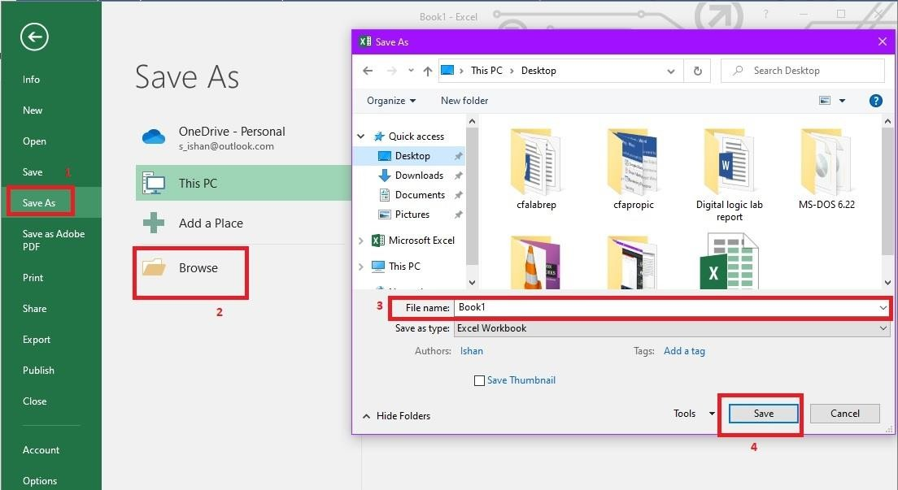

Result:
A Salary Sheet was successfully created in MS Excel for 6 employees. HRA (50% of Basic), TA (10% of Basic), Gross Pay, Tax (10% of Gross) and Net Pay were all calculated using Excel formulas automatically.
Conclusion:
MS Excel is an excellent tool for financial calculations. By using cell references and formulas, we can create a complete salary management system where changing one value automatically updates all related calculations.

LAB 5: MS DOS COMMANDS
Objective:
To demonstrate the use of MS DOS commands including directory management, file operations, date/time display, tree structure and help using Command Prompt.

5.1 Introduction to DOS
Disk Operating System (DOS) is one of the oldest type of operating systems. It is a Command Line Interface (CLI) type OS where users interact with the computer by typing commands. It was widely used in the 1980s on IBM PCs. MS-DOS (Microsoft Disk Operating System) was developed by Microsoft and became the standard OS for IBM-compatible personal computers.

In modern Windows systems, we can access DOS commands through the Command Prompt (cmd.exe), which is a CLI application that simulates the old DOS environment.

5.2 Types of DOS Commands
Internal Commands | External Commands
dir  cd  mkdir  rmdir  cls  copy  date  time  type  del  ren  ver  path  help  echo | format  chkdsk  diskcomp  diskcopy  tree  xcopy  edit  fdisk  label  backup

5.3 Opening Command Prompt
- Press Windows + R keys together. A Run dialog will open.
- Type 'cmd' in the text box and press Enter or click OK.
- The Command Prompt window will open with a black background.
- The default prompt looks like: C:\Users\Mohan>

5.4 Command Demonstrations

Command: DIR
Syntax: dir
Displays the contents (files and folders) of the current directory.
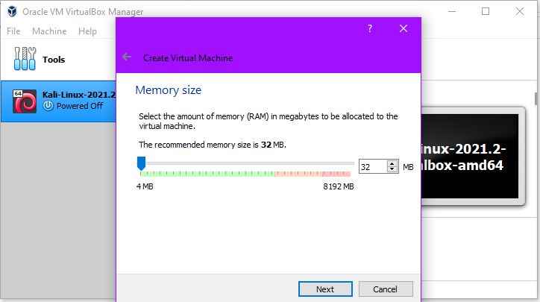
✏ Directory listed — shows files and folders

Command: MKDIR IIT_LAB
Syntax: mkdir IIT_LAB
Creates a new directory/folder named 'IIT_LAB' in the current location.
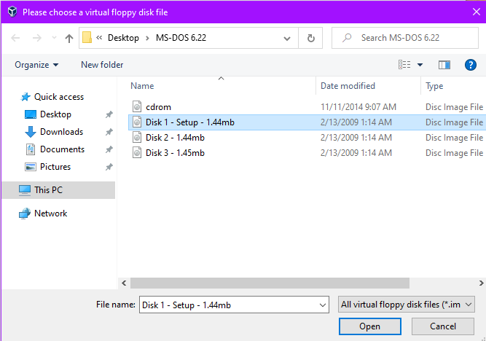
✏ Directory created successfully

Command: CD IIT_LAB
Syntax: cd IIT_LAB
Changes the current working directory to 'IIT_LAB'.
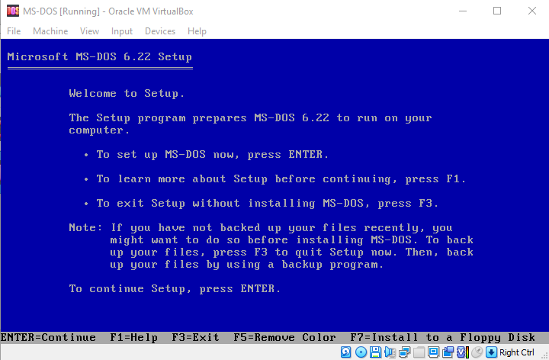
✏ Directory changed to IIT_LAB

Command: COPY NOTES.TXT IIT_LAB
Syntax: copy notes.txt IIT_LAB
Copies the file 'notes.txt' into the IIT_LAB folder.
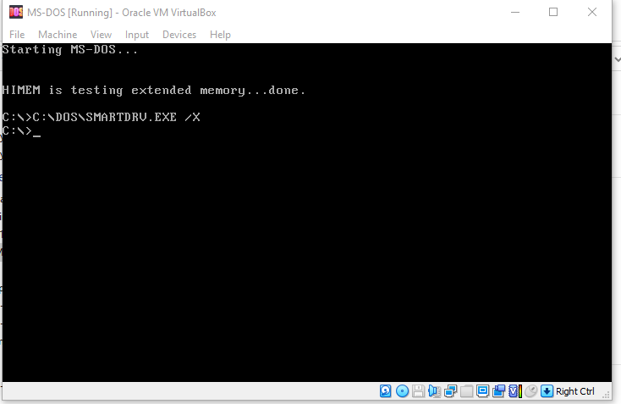
✏ File copied successfully to destination

Command: DATE
Syntax: date
Displays and allows setting the current system date.
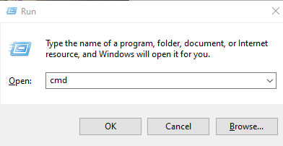
✏ System date displayed correctly

Command: TIME
Syntax: time
Displays and allows setting the current system time.
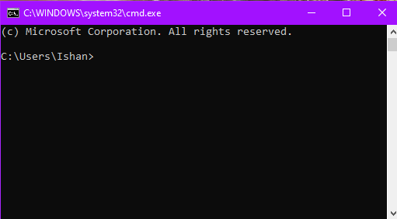
✏ System time displayed correctly

Command: TREE
Syntax: tree
Displays the directory structure of the current path in a tree format.
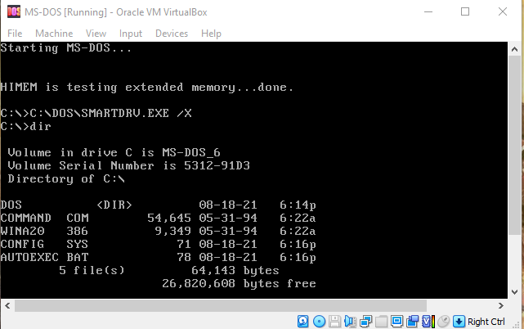
✏ Tree command output — shows folder structure

Command: CLS
Syntax: cls
Clears all text from the Command Prompt window and shows a fresh blank prompt.
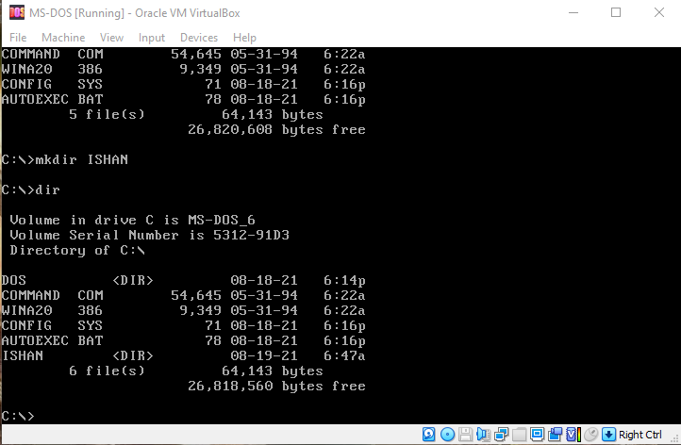
✏ Screen cleared — blank prompt shown

Command: HELP
Syntax: help
Lists all available internal DOS commands with brief descriptions.
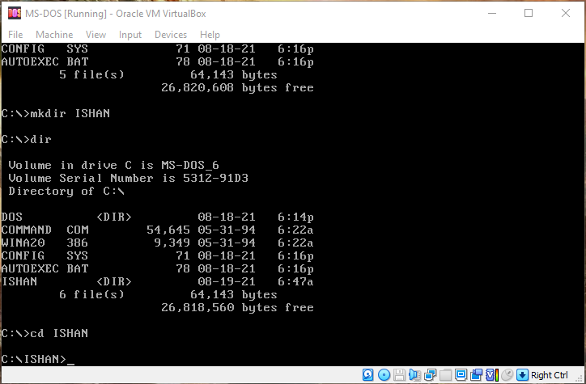
✏ Internal commands listed using help

Result:
All the required MS DOS commands were successfully demonstrated using Windows Command Prompt. Commands for directory operations (dir, mkdir, cd), file operations (copy), date/time display, tree structure, screen clearing and help listing were all executed and outputs were observed.
Conclusion:
MS DOS commands are still relevant in modern computing as Command Prompt. These commands allow fast file and folder management without using the graphical interface. Knowing DOS commands is an important skill for IT students.

LAB 6: MS POWERPOINT PRESENTATION
Objective:
To create a 5-slide IT-related PowerPoint presentation on Cyber Security with textured background, animations, transitions, table, clip art and color scheme changes.

6.1 Introduction to MS PowerPoint
Microsoft PowerPoint is a presentation software application developed by Microsoft Corporation. It allows users to create slide-based presentations that can include text, images, charts, tables, animations and transitions. PowerPoint presentations are widely used in education, business, conferences and seminars.

6.2 Steps to Create a Presentation
- Open Microsoft PowerPoint from Start menu.
- Select a blank presentation or choose a theme/template.
- Click on the first slide and add the title and subtitle.
- Use the Insert tab to add new slides, pictures, tables, clip art.
- Apply animations from the 'Animations' tab.
- Apply slide transitions from the 'Transitions' tab.
- Change color scheme from 'Design' tab > 'Variants'.
- Save the file as .pptx and run the slideshow using F5.

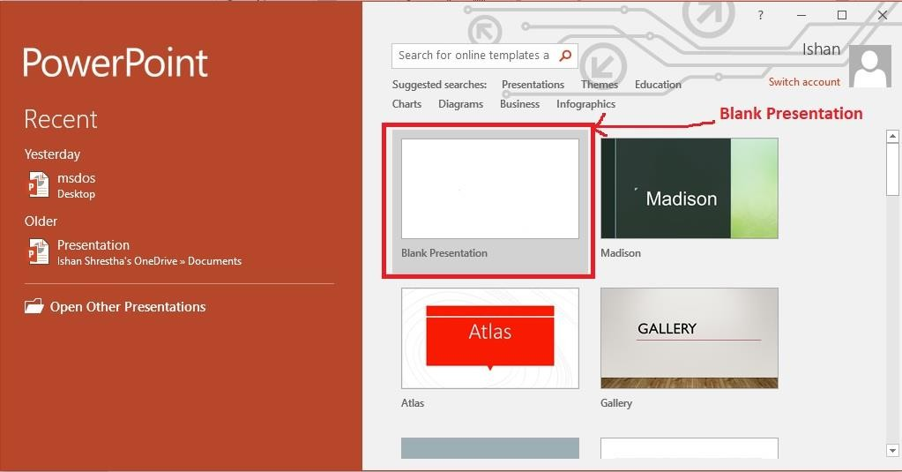
✏ Animation effect added — Fly In on title, Appear on bullets

6.3 Topic: CYBER SECURITY — Presentation Slides

Slide 1: Title Slide
CYBER SECURITY

Presented by: Mohan Shahi
IIT, Tribhuvan University
First Semester, 2080/081
✏ Title slide with textured background — used 'Circuit' theme

Slide 2: What is Cyber Security?
Definition & Importance

Cyber Security is the practice of protecting computers, servers, networks, and data from digital attacks, unauthorized access and damage.

Key Areas:
• Network Security
• Information Security
• Application Security
• Operational Security
✏ Bullet points added with Appear animation — title has Fly In effect

Slide 3: Common Cyber Threats
Types of Attacks

Phishing — Fake emails to steal information
Malware — Harmful software like virus, worms
Ransomware — Encrypts files and demands payment
DDoS — Overloads server with fake traffic
Man-in-Middle — Intercepts communications
Social Engineering — Tricks users psychologically
✏ Table inserted in this slide — 2 columns (Threat | Description)

Slide 4: How to Stay Safe Online
Best Practices

• Use strong and unique passwords
• Enable 2-Factor Authentication (2FA)
• Keep software and OS updated always
• Avoid clicking on suspicious links
• Use licensed antivirus software
• Back up your important data regularly
• Use HTTPS websites only
✏ Clip art of shield inserted — recolored to blue. Transition: Wipe

Slide 5: Conclusion & Summary
Summary & References

Cyber Security is very important in today's digital world. As more of our activities move online, the risks also increase.

By following basic security practices, we can protect ourselves and our data from cyber attacks.

References:
• www.cybersecurity.gov
• SANS Institute
• CERT Nepal
✏ Fade Out transition applied. Thank You message added at bottom

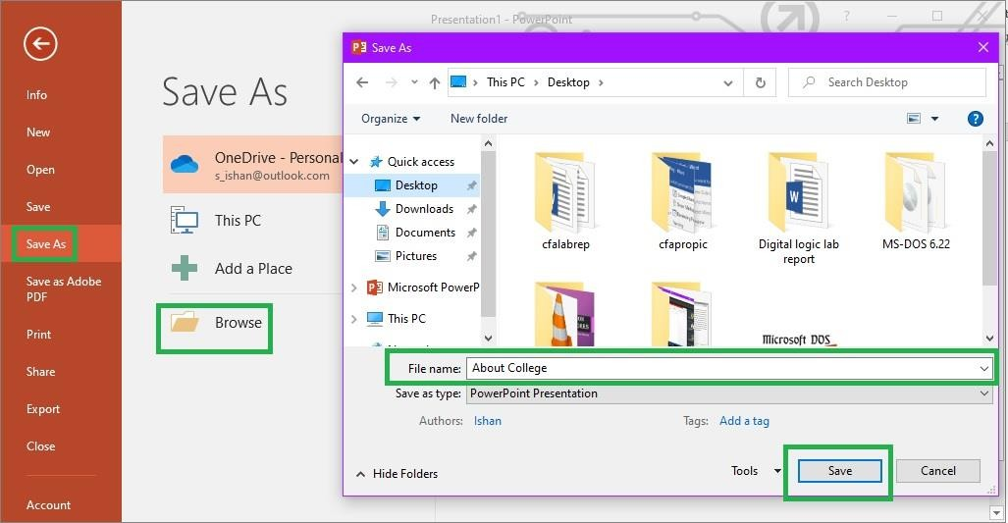
✏ Table inserted using Insert > Table > 2x7 rows — borders formatted in blue

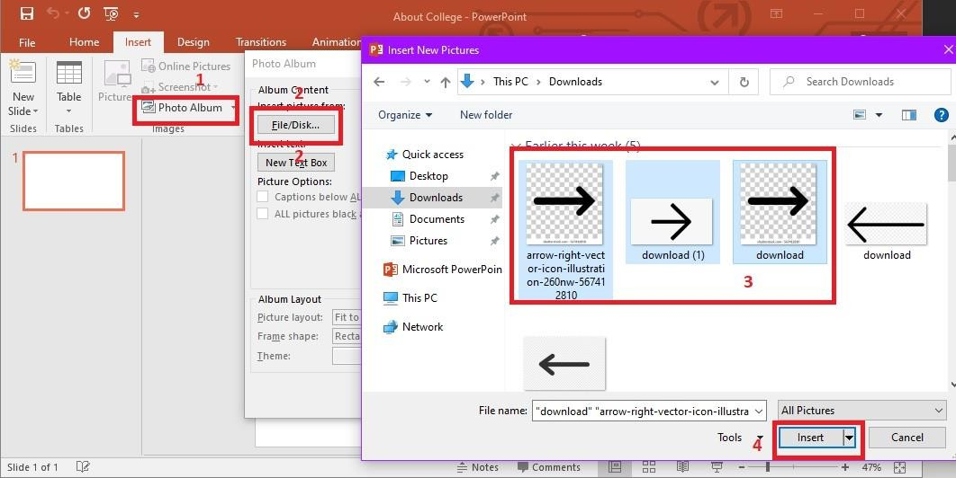
✏ Transition applied: Wipe from left on all slides. Color scheme: Dark Blue circuit

Result:
A 5-slide PowerPoint presentation on Cyber Security was successfully created. The presentation includes textured background (Circuit theme), animations (Fly In, Appear), transitions (Wipe, Fade), an inserted table, clip art with recoloring, and a consistent dark blue color scheme.
Conclusion:
MS PowerPoint is a very effective tool for creating visually appealing presentations. Through this lab we learned how to add slides, apply animations and transitions, insert tables and images, and customize the design for a professional look.

LAB 7: GMAIL ACCOUNT CREATION
Objective:
To understand the concept of electronic mail (email) and to create a Gmail account by following step-by-step procedure.

7.1 Introduction to Email
Electronic Mail (E-mail) is a method of exchanging digital messages over the internet. It allows users to send and receive messages, files, images and documents instantly to anyone in the world who has an email address. Email has largely replaced traditional postal letters for both personal and business communication.

An email address has the following format: username@domain.com
Example: mohanshahi056@gmail.com

7.2 What is Gmail?
Gmail is a free email service developed and provided by Google LLC. It was launched on April 1, 2004. Gmail offers 15 GB of free storage space. It is accessible via a web browser (gmail.com) and also through mobile apps on Android and iOS. Gmail integrates with other Google services like Google Drive, Google Meet, Google Calendar and more.

7.3 Importance of Gmail / Email
- Fast and instant communication with anyone worldwide.
- Free to use — no cost to send or receive emails.
- Can attach documents, images and files up to 25MB.
- Provides 15 GB of free cloud storage.
- Very important for professional and academic communication.
- Used for account registration and verification on other websites.
- Can organize emails using labels, folders and filters.

7.4 Requirements
- A working computer or smartphone.
- Internet connection.
- A mobile phone number for verification.
- A web browser (Chrome, Firefox, Edge, etc.)

7.5 Step-by-Step Procedure

Step 1: Open a web browser (Google Chrome / Mozilla Firefox) on your computer or laptop.
Step 2: Go to the address bar and type: www.gmail.com and press Enter.
Step 3: The Gmail login page will appear. Click on 'Create Account' button below the login form.
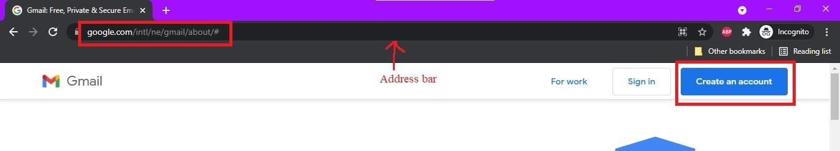
✏ Opened gmail.com in Chrome — clicked Create Account
Step 4: A new page opens. Select 'For myself' option from the dropdown menu.
Step 5: Enter your First Name: Demo and Last Name: User in the name fields.
Step 6: Choose a Gmail address. Type your desired username: mohanshahi056 (if available). Gmail will suggest alternatives if already taken.
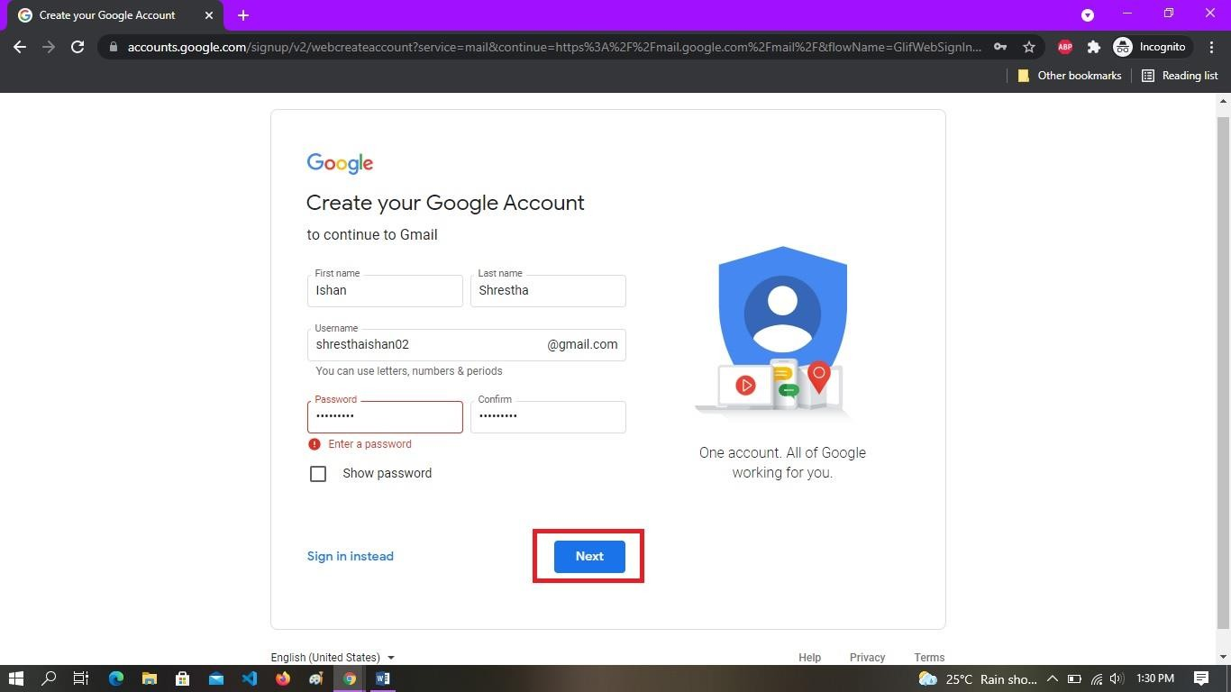
✏ Username entered — mohanshahi056 was available
Step 7: Create a strong password. Type: Demo@12345 in the password field. Confirm the password by typing it again in the next box.
Step 8: Click 'Next' to continue.
Step 9: Enter your Phone Number for verification (required for account recovery). Example: +977 9847000000. Click Next.
Step 10: Google will send a 6-digit OTP (One Time Password) to the phone number. Enter the OTP in the verification box and click Verify.
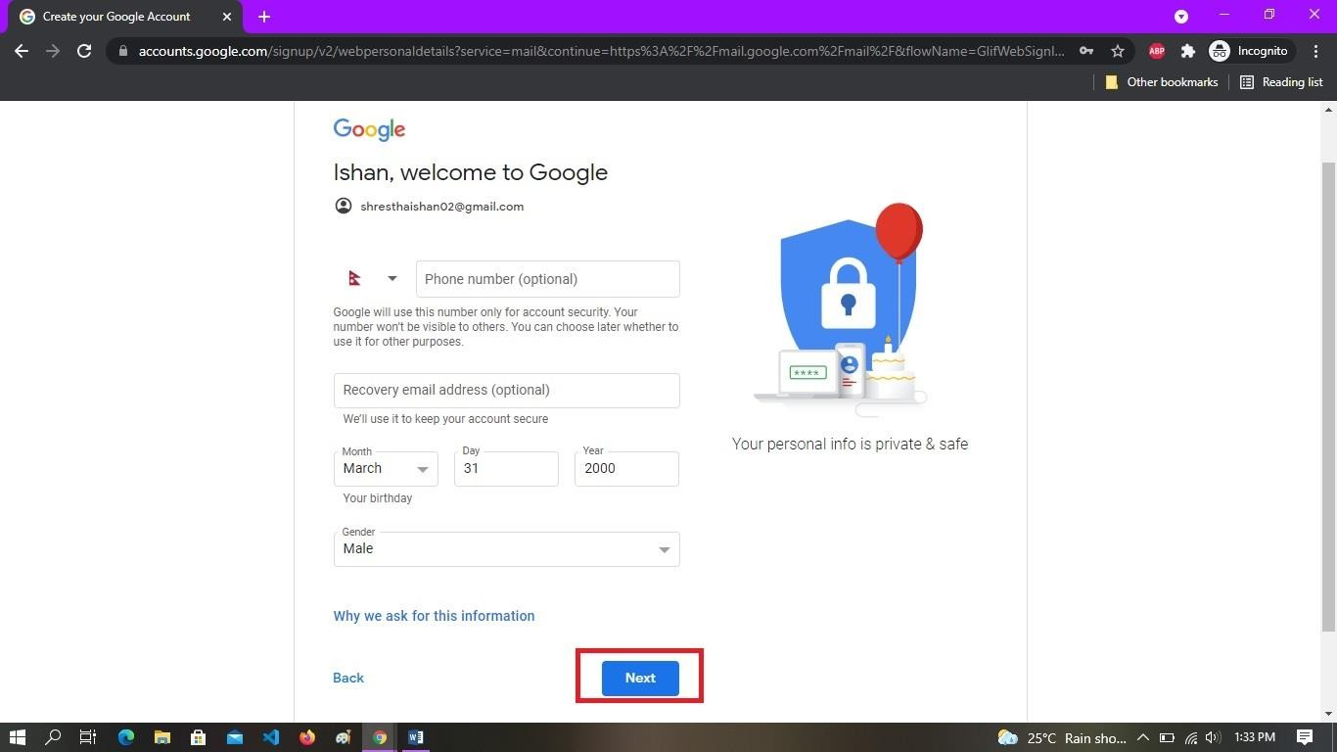
✏ OTP received on phone and verified successfully
Step 11: Enter additional information: Date of birth and Gender. Then click Next.
Step 12: Google will show you the Privacy Policy. Scroll down and click 'I agree' to accept the terms.
Step 13: Your Gmail account has been successfully created! You will be redirected to the Gmail inbox page.
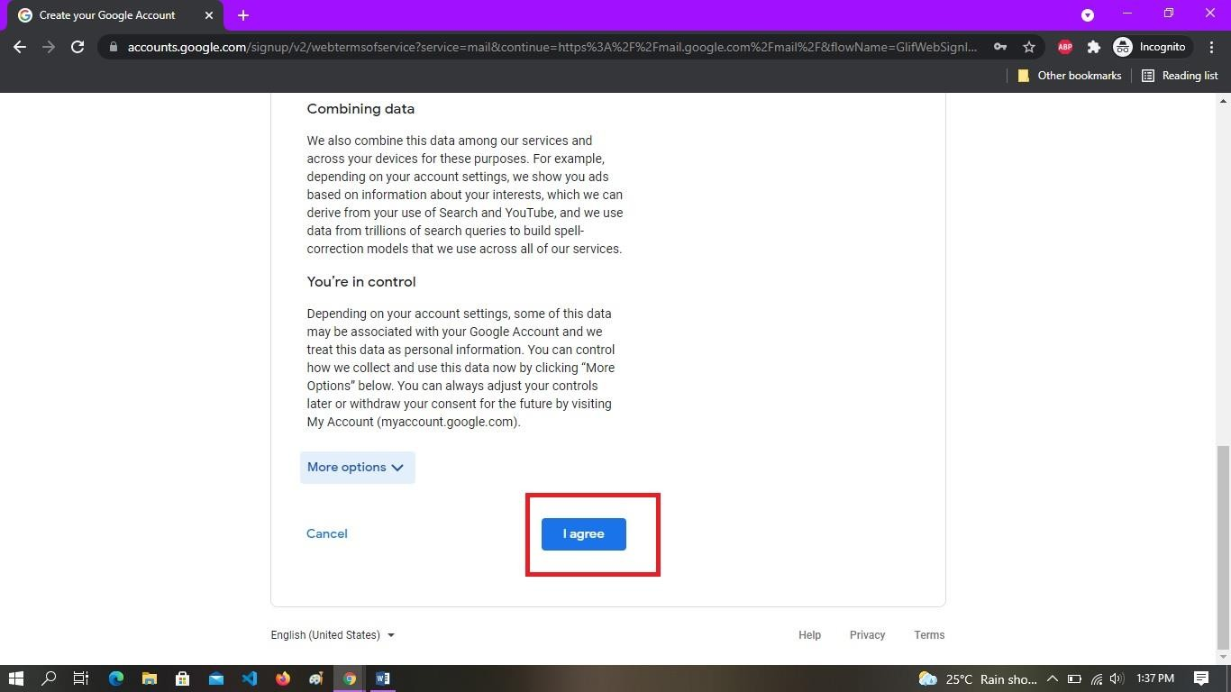
✏ Gmail inbox opened — account created successfully
Step 14: You can now compose and send emails by clicking the 'Compose' button on the left side.

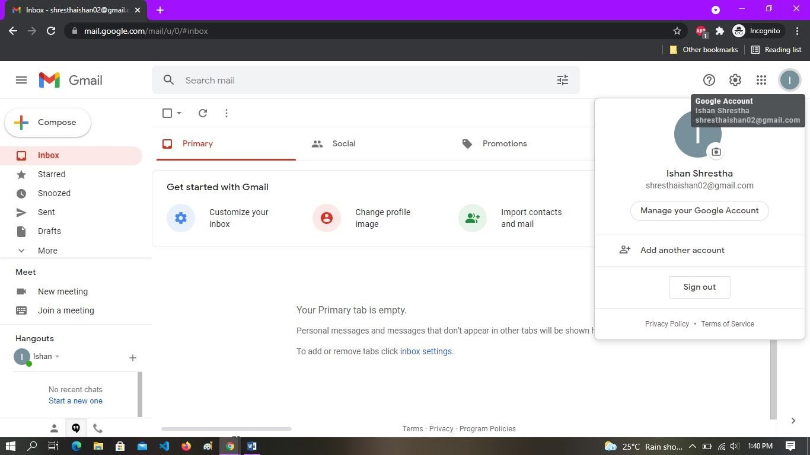
✏ Account successfully created — no. of emails: 0 (fresh inbox)

7.6 Parts of Gmail Interface
Part | Description
Compose | Button to write a new email
Inbox | Where received emails are shown
Sent | Shows emails you have sent
Drafts | Unfinished / saved emails
Spam | Suspicious or junk emails
Trash | Deleted emails (recoverable for 30 days)
Search Bar | Search for any email by keyword or sender

Result:
A Gmail account was successfully created by following the step-by-step procedure. The account mohanshahi056@gmail.com (demo) was registered with proper name, password, phone verification and privacy acceptance. The Gmail inbox was accessible after login.
Conclusion:
Gmail is an essential digital communication tool in today's world. Creating a Gmail account is simple and free. It gives access to email and also to the entire Google ecosystem of services. This lab helped us understand the process of email account creation and the features of Gmail interface.

— END OF IIT LAB REPORT —
Mohan Shahi | IIT-078-056 | IIT, Tribhuvan University | 2080/081

