LAB SHEET TWO (2)
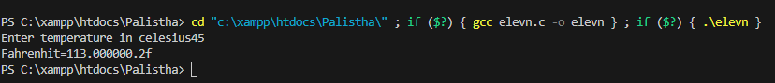
11
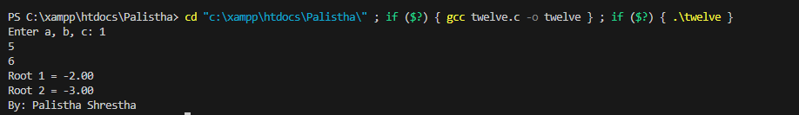
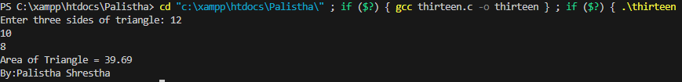
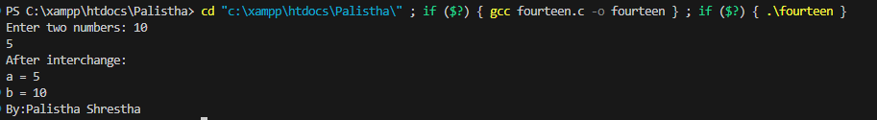

20
19
14
13
12

