IIT LAB
REPORT Reference

Cover Page

INDEX

LAB1: Word Processor

Introduction
MS Word or Microsoft Word is a graphical user software application. It is one of the best software for word processing and document creation. It allows user to make professional documents, letters, reports, memos, et cetera. It has many helpful tools available for users such as grammar checker, word count, speech recognition, tables, typefaces, templates, smart art and so on. It is highly compatible everywhere.

Opening Microsoft Word 2016
The steps for opening Microsoft word software package are as follows: -
Step 1: Click windows button on left side below your personal computer or laptop as shown in picture

Step 2: A new interface opens, scroll down and search for “Word 2016” and click it.
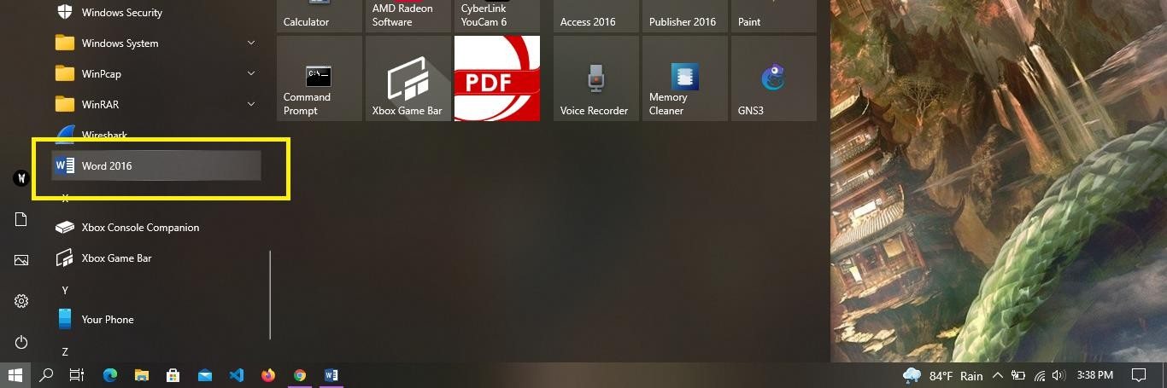

Create A document using MS Word
Step 1: Open Microsoft Word software package. We will find built-in templates. Select a blank Document as shown in figure.
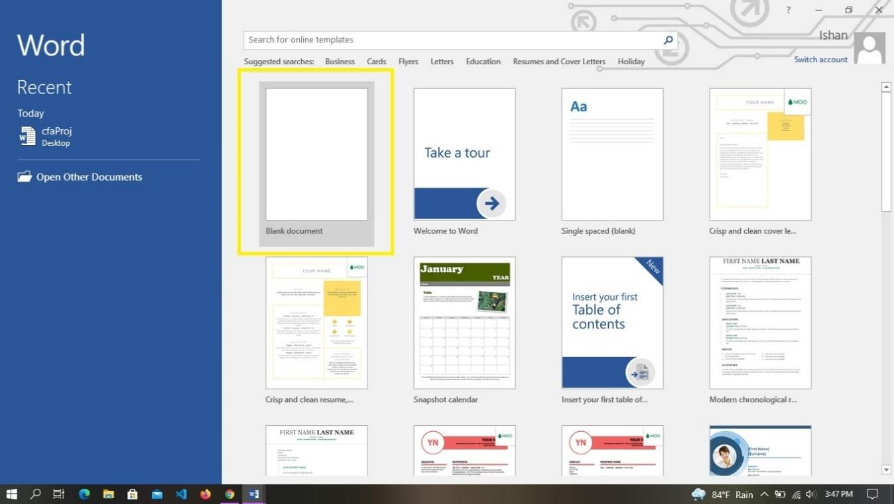
Step 2: Click the File tab.
Step 3: Click the save button. Locate the folder to save the file. Give the name to the document and save the file.

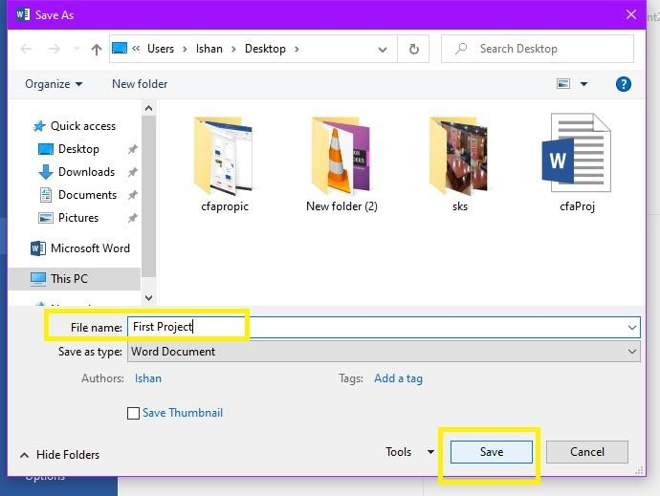
  - Features of MS Word
Talking about the features, MS word has given us many different elements and 7 categories.

- Home
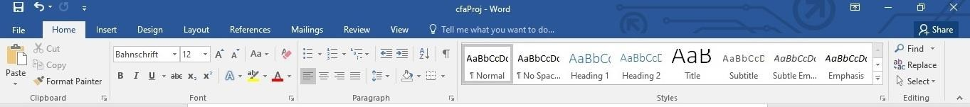
In this category, all the options for editing and formatting text are located. This category consists of options such as font style, font color, bold, italics, underline, highlight, bulleting, numbering, font size, font space, paragraph space, find, search, replace and so on.
- Insert
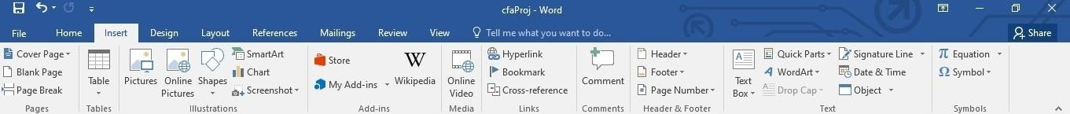
In this category, all the options that can be inserted in the page is located here. The options contained in this category are tables, shapes, pictures, smart art, chart, cross-reference, comments, header, footer, page number, word art, signature line, symbols, equations and so on.
- Design
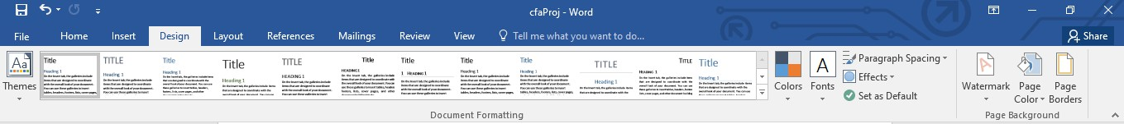
This category consists of templates or design which help to customize our documents. This tab also contains option such as paragraph spacing, effects, watermarks, page color and page borders.
- Layout
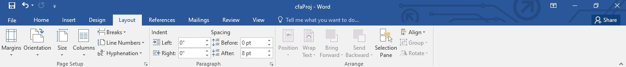
In this category, it consists of options that deals with the layout of the page. Some of the options are margins, page orientation, size, columns, breaks, line numbers, indent, spacing and so son.
- References
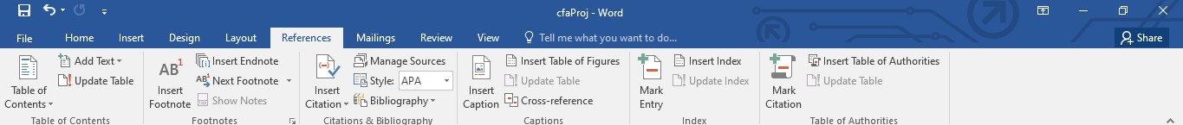
This category is useful for those group of people who are creating lengthy documents, thesis or writing a book. This tab consists of options such as footnote, table of content, endnote, citation, bibliography, caption, table of figures, mark entry and so on.

- Mailings
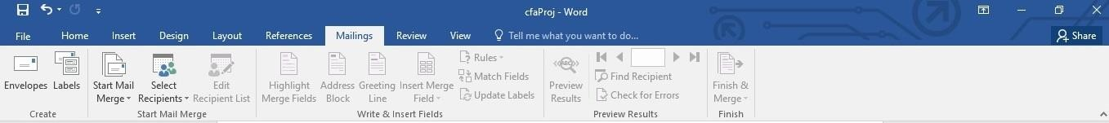
This category consists of all mailing options in an easier format such as envelops, labels, mail merge, select recipients, and so on.
- Review
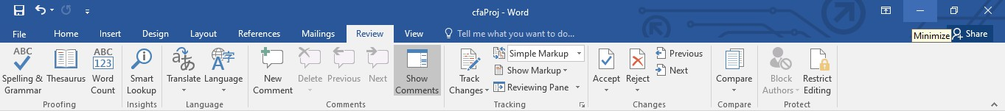
This category consists of options that are very useful and practical. This tab has options such as spelling check, grammar check, thesaurus, word count, smart lookup, language translate, comments, track changes, compare, restrict editing and son.
- View
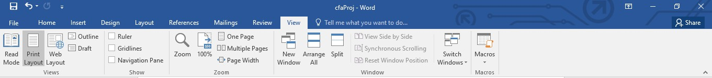
It is one of the most important category. It is used to view the document in different way. Some of the most used options are read mode, print layout, web layout, draft, ruler, guidelines, navigation pane, multiple page, macros and so on.
- Type of Files MS word create and use
Newer versions of MS word package mostly use .docx file extension. Most recent MS word can create, open and edit types of files such as
.doc, .docx, .docm
.dot, .dotx, .dotm
.htm, .html
.mht, .mhtml
.odt, .pdf, .rtf, .txt, .wps, .xps, .xml

Professional and Personal uses of MS Word

Business and Workplace
We can create all kinds of official documents in MS Word. We can use the built-in templates or download templates in Microsoft Word to download bills, receipts, letterhead samples, cash

memos, letters, and all various types of business or official work. We can also save the documents in other formats such as html format. It can help employee, subscribers or user to open attach files in web browser very easily on computer, laptop or smartphone. We can send an email by using a mail merge option in mailing category which helps us to send one document to thousands of people with names and addresses. Compared to other products, MS Word is easy and more productive than others. It as consists of in-built search function connected to the internet.

Education
Microsoft Word is one of the best tool for both students and teachers. Teachers can create lecture scripts, lesson plans, making test papers, reflective diaries, students worksheet, reports, attendance and so on. Students can create assignments, notes, dictionary, projects, thesis and so on. This software package also used in teaching learning process such as teacher can check student assignment, teachers can present their lesson here, can create visual charts to make lecture interesting, can share documents and so on. MS Word is also used in research fields for error free documents, effective work, citations, bibliography, publishing and so on.

Personal Use
Microsoft Word is one of the best tools for personal use. It provides almost every tools, options and features for creating any type of documents. We can create invitations, diary, daily to daily records, create job resumes, notes, assignments, create articles, write books, email newsletters and so on. Basic knowledge of Microsoft Word can play a big role to get jobs.

Common Used List of Shortcuts in MS Word
Ctrl+a | Select all content of the page
Ctrl+b | Bold Highlighted Section
Ctrl+i | Italic the selected text
Ctrl+u | Underline selected text
Ctrl+c | Copy selected text
Ctrl+v | Paste selected text
Ctrl+k | Insert hyperlink
Ctrl+m | Intent the paragraph
Ctrl+s | Save the document
Ctrl+w | Close the current document
Ctrl+y | Redo the last performed action
Ctrl+z | Undo last action
Ctrl+shift+> | Increase the font size of selected text by 1
Ctrl+shift+< | Decrease the font size of selected text by 1
F1 | Open help

  - Develop a Bio-Data using a Word Processor and it should include as given below.

CURRICULUM VITAE

Personal details
Name :
Date of birth :
Address :
Contact no :

EDUCATION

Year | Institution | Board | Grade | Faculty
2077 -  present |  | TU | _
2072 -  2074 | +2, Science | NEB | A | Computer science

WORK EXPERIENCE
2017-2019 : Working as network technician at OM Network PVT. LTD.

SKILLS
Team Working Skills CCNA
Python programming language with Networking Microsoft Office package skills
UNIX Bourne Shell scripting skills Linux System Administration LANGUAGE
English Nepali

OUTPUT

LAB : MS-DOS

Introduction
In 1960’s there is no hard drive which has the capacity to store large amount of data. At that time there is no high storage devices that stores graphical operating system like now. Disk Operating System (DOS) is an operating system that runs from the disk storage.
An operating system is a very important system software that run on a computer. We can also say that an operating system acts as an interface for interaction between a computer hardware and the end user. It controls and manages the system hardware and provides users an environment to the users in which they can run and execute programs efficiently.
Disk Operating System (DOS) is the oldest type of operating system. It is a command line interface (CUI) type of operating system. Users can only computer through commands. Commands are certain word of English language which are already stored in DOS.

MS-DOS
Microsoft Disk Operating System was the first Microsoft-marketed DOS version operating system which was widely installed on the personal computer. It is the same operating system developed by Bills Gate’s company for IBM as Personal Computer – Disk Operating System in 1981.
Microsoft Disk Operating System is 16-bit operating system. It is a single user and single tasking operating system. The role of MS-DOS is to intercept the commands that a user input through the keyboard. Commands in MS-DOS allows us to complete task such as file and folder management, disk upgrade, memory optimization, program execution and so on.
MS-DOS consist of three main important files and many command files. Three main important files are
- IO.SYS – Input Output System
- MS DOS, SYS – Microsoft Disk Operating System
- COMMAND.COM
    - Advantages of MS-DOS
      - MS-DOS supports all kinds of computer language.
      - It is a small sized operating system.
      - It is stored in different storage device. Operating system is loaded to the RAM on booting.
      - It supports different types of storages such as floppy disk, hard drive, CD and so on.
      - It helps make file management. Example creating, editing, moving and deleting files.
    - Disadvantages of MS-DOS
      - It is totally based on commands.
      - It has limited features compared to modern operating systems.
      - It is not user friendly and does not supports advance computer devices such as mouse.
      - It is single user and single tasking operating system.
      - Interrupt levels for hardware needs to managed by ourselves.

    - System Requirement for MS-DOS v6.22
      - Minimum RAM – 1 Mega Byte
      - Minimum Hard drive space – 5 Mega Byte Storage
      - Partition Type – FAT System File
      - CPU – x86 compatible only

Installing MS-DOS 6.22 in Virtual Box
Oracle Virtual Box is free and open source software that enables user to run more than one operating system in the computer. Following steps are for installing Microsoft Disk Operating System in Virtual Box.
- Step 1: Click on start button on left side below and search for virtual box. Open virtual box
and click new.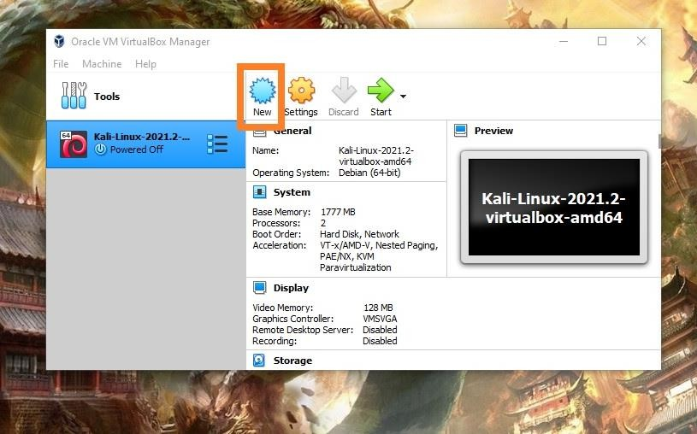
- Step 2: New window will open. For name write MS-DOS. Select others for type and DOS for version. After completing, click on Next button.
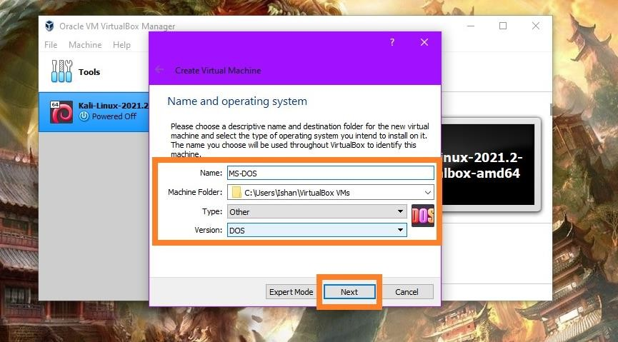

- Step 3: Select 32 MB RAM. Click Next
- Step 4: Check in Create a New Virtual Hard Drive and click Next
- Step 5: Select file location and hard drive size
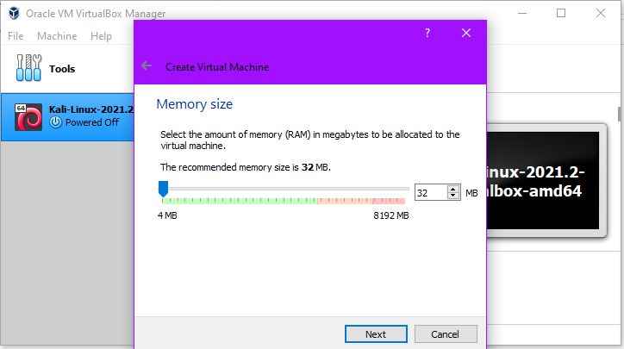
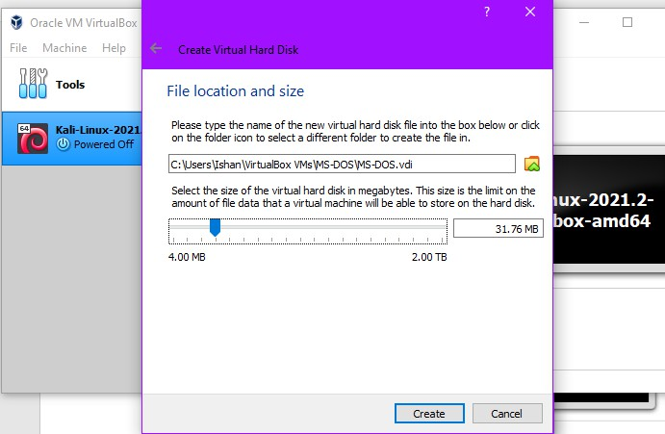
- ​

- ​

- ​

- Step 5: Go to Settings -> Storage ->Floppy->Empty->Choose a disk file
- 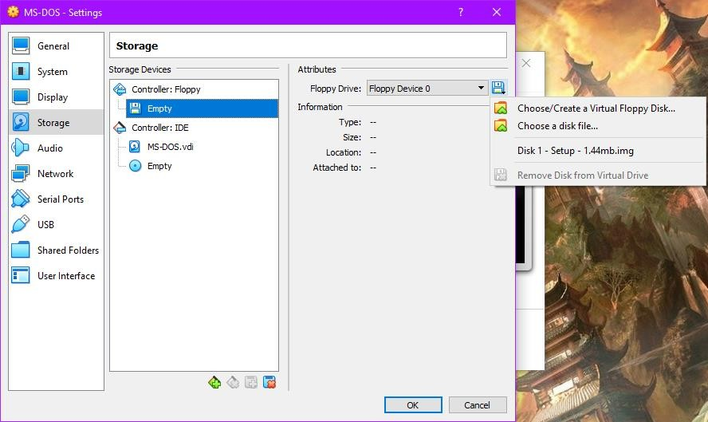
- Step 6: Go to folder where MS-DOS “img” file is stored. Select Disk 1 – setup – 1.44mb
->Click open -> Click Save.
- 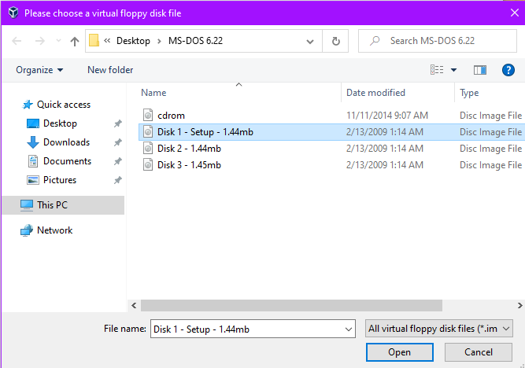
- ​

- Step 7: Click on Start. A new window will open.
- 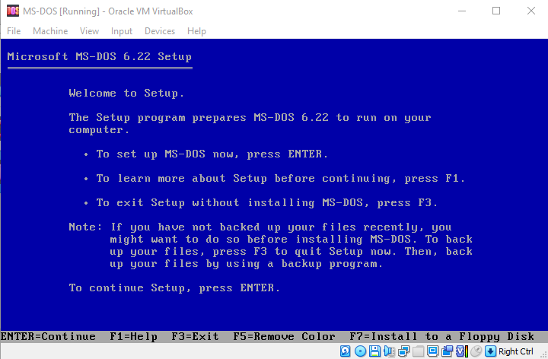
- Step 8: Press enter. Then It will ask “Disk 1.img” and “Disk 2.img”. Right Click on floppy
disk symbol and choose disc image from MS-DOS Folder. Then MS-DOS is successfully installed.
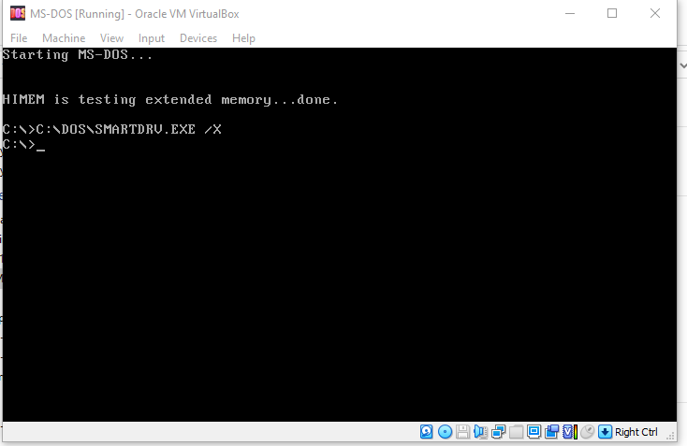

The Command Prompt
The command prompt is a program in GUI based operating systems where we give commands to the computer and output will produced. It is simply referred to DOS prompt, command line or MS- DOS prompt. Any newer versions of GUI operating system developed by Microsoft consist of MS-DOS prompt. To open MS-DOS prompt in windows 10, we have to follow following steps.
- Step 1: Press windows+R from keyboard.
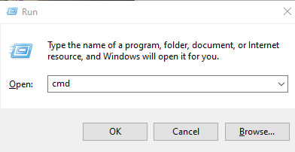
- Step 2: Type cmd and click on Run button. Then command prompt will open.
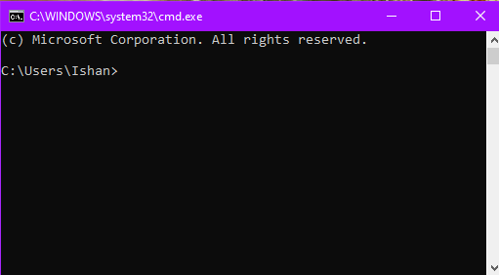

MS-DOS Commands
Since MS-DOS is command interface type, we have to use commands in order to interact with the computer. Instructions given to the computer are called commands. Commands are divided into two categories. They are
- Internal Commands
- External Commands
    - Internal Commands
COMMAND.COM file is one of the important files in MS-DOS as mentioned earlier. Internal commands are built-in commands in the COMMAND.COM file. It can be executed from any DOS prompt because these commands are already loaded to the memory when booting. Some of the internal commands are “dir”, “mkdir”, “cd”, “rmdir”, “cls”, “copy”, “date”, “time” and so on.
    - External Commands
Unlike internal commands, external commands are not present or built-in command interpreter. These commands are stored in other folders. These commands have the “.exe” or “.com” extension. Some of the example are “chkdsk”,”diskcopy”, “format”, “edit”, “tree” and so on.

Using MS-DOS Commands
    - To view directory
To view the directory, “dir” command is used.
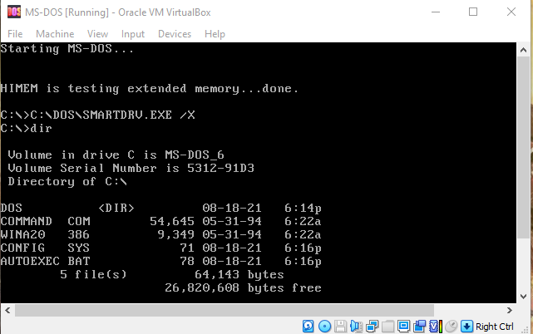

    - Make a directory
To make a new directory we will use “mkdir” command. Syntax for making directory named “ISHAN” is “mkdir ISHAN”.
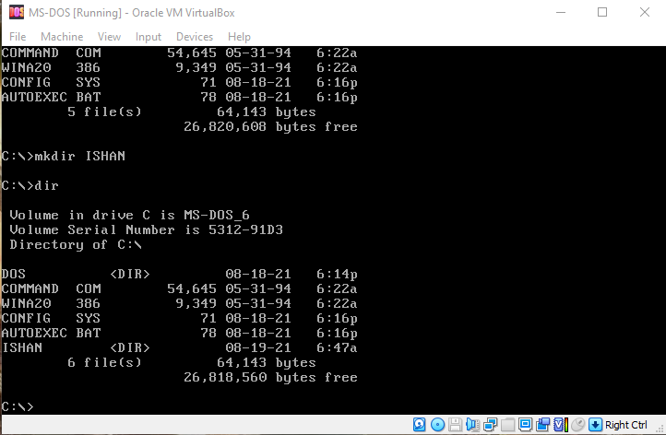
    - Change a directory
To change the directory, we will use command “cd”. To change to new directory “ISHAN”, we use the syntax “cd ISHAN”
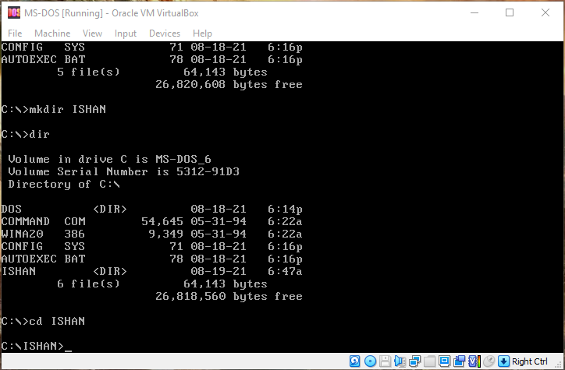

    - Create files
To create a new file, “edit” command is used. Example “edit SHRESHA.TXT”
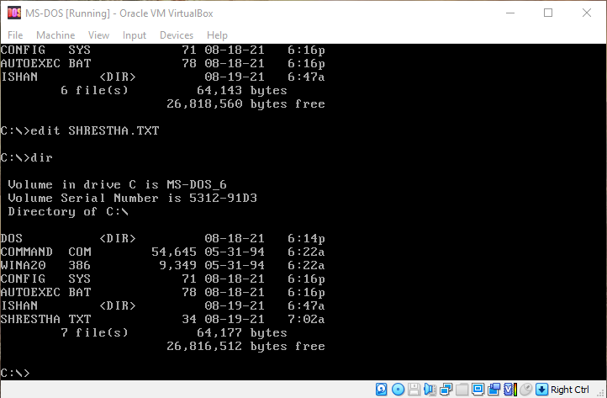
    - Copy a file
To copy a file, “copy” command is used. Syntax for copy command is “copy <source address>
<destination address>”. For example, “copy C:\SHRESTHA.TXT C:\ISHAN”. In this example, the file “SHRESTHA.TXT” is copied to folder “ISHAN”.
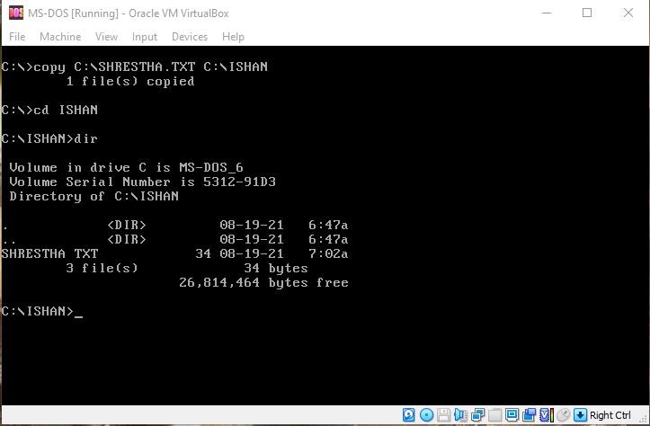

    - Remove a Directory
“rd” or “rmdir” command is used to delete a directory.
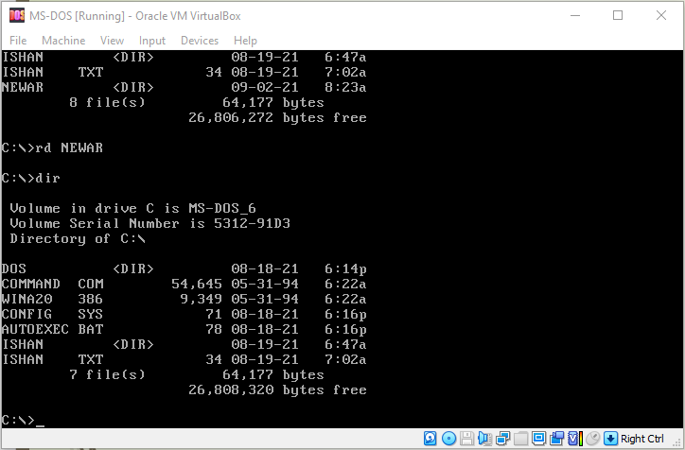
    - Check RAM status
“mem” command is used to display amount of free and used memory.
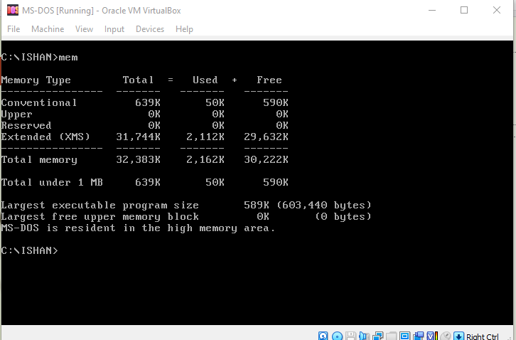

    - Show the list of command available
“help” command shows the list of commands available to us.
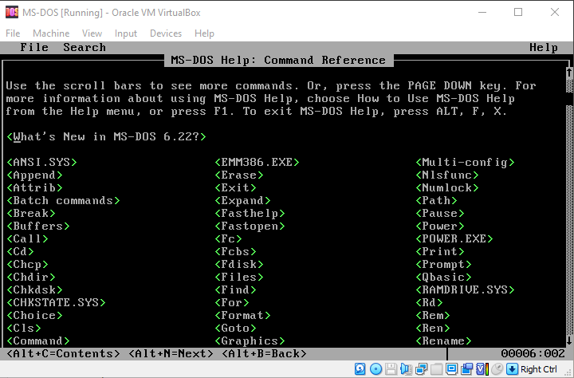

    - Display date and time
To display date, type “date” and press enter two times. To display time, type “time” and press enter two times.
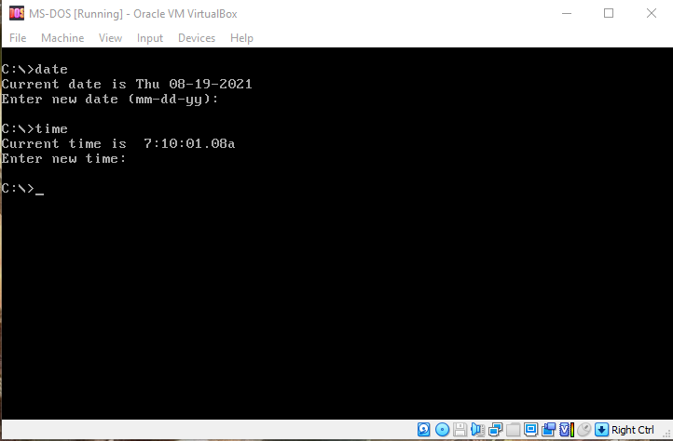

    - Show tree on your pc
To view tree, type command “tree” and press enter. This command shows the list of directories and sub directories.
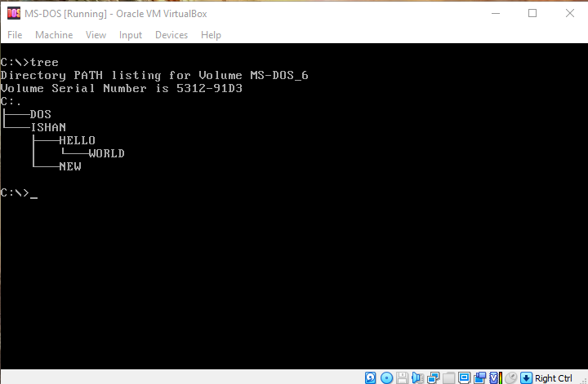
.

Lab: Spread Sheet

Introduction
Spreadsheet is a file which stores data in tabular form. It consists of cells in rows and columns where data are entered. It also helps to sort, organize and arrange data efficiently. Spreadsheet has a unique ability to calculate numerical values. It calculates values using mathematical formulas and data in the cells. Besides performing mathematical calculations, spreadsheets also provide built-in functions for the financial accounting and statistical operations. There are many spreadsheet software program available in the market. Microsoft Excel, produced by Microsoft Company is one the most popular and widely used spreadsheet software by the students, businessman, and officials and so on.

Microsoft Excel
MS-Excel is one of the most widely used spreadsheet program in past 30 years. It has been upgraded many times. Best features of MS-Excel are, it can apply many business task, statistics, finance, billing, data management, forecasting, analysis, and so on. There are three main components in excel. They are cell, worksheet and workbook.
    - Cell
Cell is the smallest, powerful and the most important component of the excel. We can enter the data in the cell by typing or copy-paste. Data that we enter in the cell can be either text, numbers, symbols or a date. We can also customize it by changing font size, font style, cell background, font color, cell outline, cell color and so on. Every cell is given a cell address. Cell address consist of column number and row number. If a cell is in 10th row and D column, then the cell address for this cell is D4.
    - Worksheet
Worksheet is made of number of cells arranged in row and column. It also holds images, charts and diagrams. Multiple worksheet is accessible in below left bottom side of the workbook.
    - Workbook
Workbook is a separate file. Every workbook has one or more worksheet depending upon the user. We can add, delete and change the order of the worksheet without deleting the workbook.
    - Uses of spreadsheet
There are many uses of spreadsheet almost in every fields. Some of the uses are
      - Forms
Using spreadsheets, we can make forms to handle quizzes, time sheet, patent information, surveys and so on.
      - Schools
In schools, colleges and universities, teachers can use spreadsheet to track attendance record, performance, identity data, high grades, low grades, missing tests, and so on.

      - Finance
Spreadsheet is one of the most used applications in finance department. They are used in financial data such as checking account information, budgets, taxes, billings, truncations, invoices, receipts, payment systems, forecast, calculating revenues and so on.
      - Creating Lists
Spreadsheet are used not only for numbers also for data that does not contain numbers. For examples, list of employee, telephone numbers, to-do list, student list, and so on.
      - Data storage
Spreadsheet stores all kind of data. They can include financial data, customer data, product data, and so on. Spreadsheet can support large number of rows and column. We will have many space to store large number of data. It will make easy for database creation.

MS-Excel Window
There are many components in MS-Excel 2016.
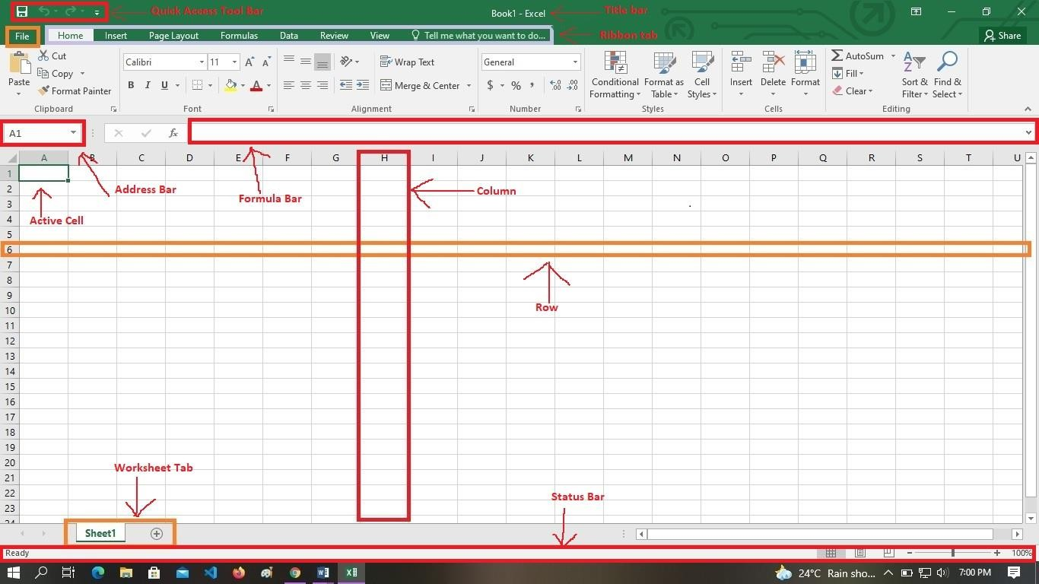
    - Active Cell
It is a cell that is currently being selected. It will be highlighted with the rectangular box and its address is shown in the address bar. In the above figure, the cell A1 is currently being selected and its address is shown in address bar.
    - Address Bar
Shows the address of current selected cell.

    - Column
Column are the vertical set of cells. There are 16384 number of columns present in a single worksheet. Every column has an alphabet Identity starting from A to XFD. A column is shown in above picture with an identity H. A column can be selected by clicking on the header, where identities of column are placed. If you click in D, then column D will be selected.
    - Row
Row are the horizontal set of cells. There are 1048576 number of rows present in a single worksheet. Every rows have a number for its identification, starting from 1 to 1048576. We can select rows by clicking the number placed in the left side of the window.
    - Formula Bar
It is an input bar located below the ribbon tab. It shows the content of active cells. We can edit the content of cell and also can use it to enter the formula in the cell.
    - Title Bar
It shows the name of the workbook along with the application name.
    - File menu
It consists of options like info, new, open, save, save as, print, share, export, close, account and option.
    - Quick Access Toolbar
It a toolbar where we will add options that are frequently being used.
3.4.9 Ribbon Tab
Starting from Microsoft Office 2007, all option menus are replaced with ribbon tabs.
3.3.10 Worksheet Tab
Shows all the worksheet present in the workbook. Sheet 1, Sheet 2, Sheet 3, et cetera are default name for the worksheet. We can also choose to rename the worksheet.

Create a MS-Excel 2016 Spreadsheet
Step 1: Click windows button on left side bottom and search for MS Excel 2016.
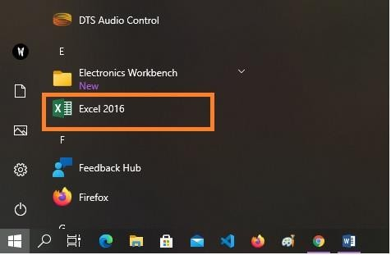
Step 2: Click on Excel 2016 and excel 2016 will open.
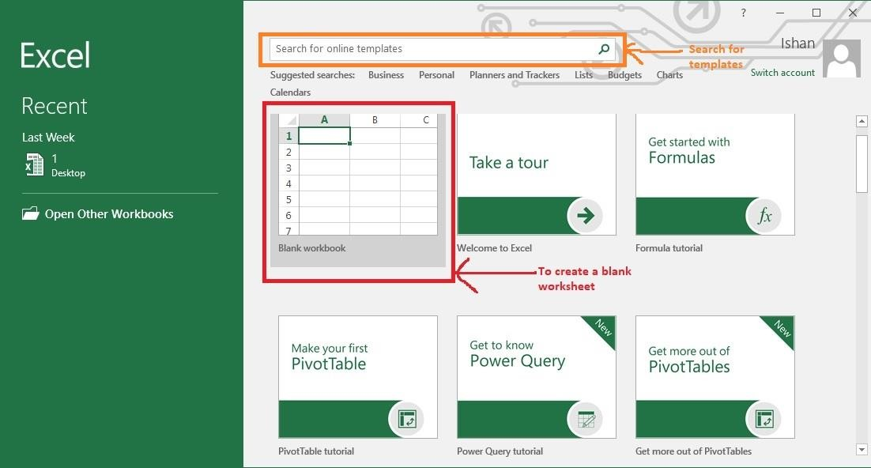

Step 3: To create a blank workbook, click on blank workbook. We can also use other templates than blank workbook. For example, we can search business templates in the search bar above blank workbook.
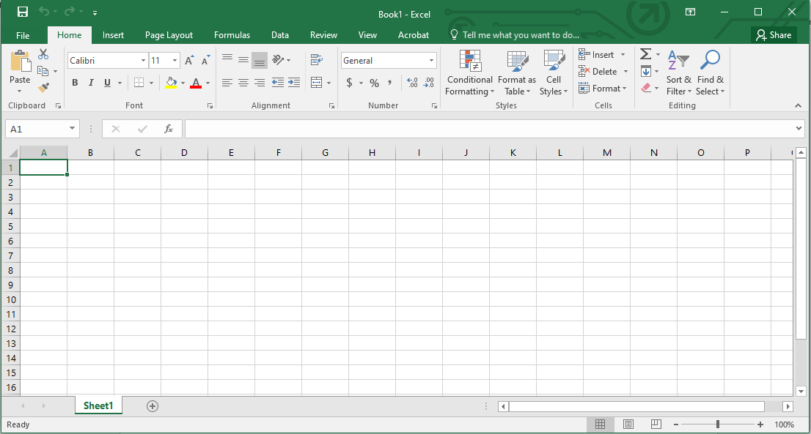
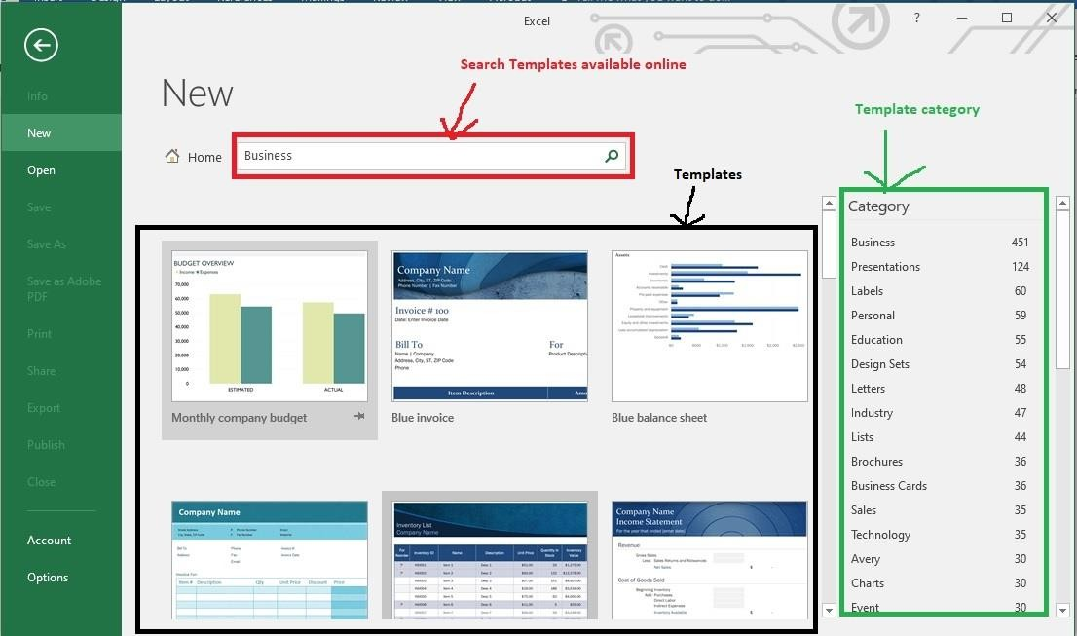

Step 4: After clicking blank workbook, to save the workbook, click on left top window of workbook. Or click on file tab and head to save as. Click on browse, a new window will pop. Name the workbook in file name field and click save button.
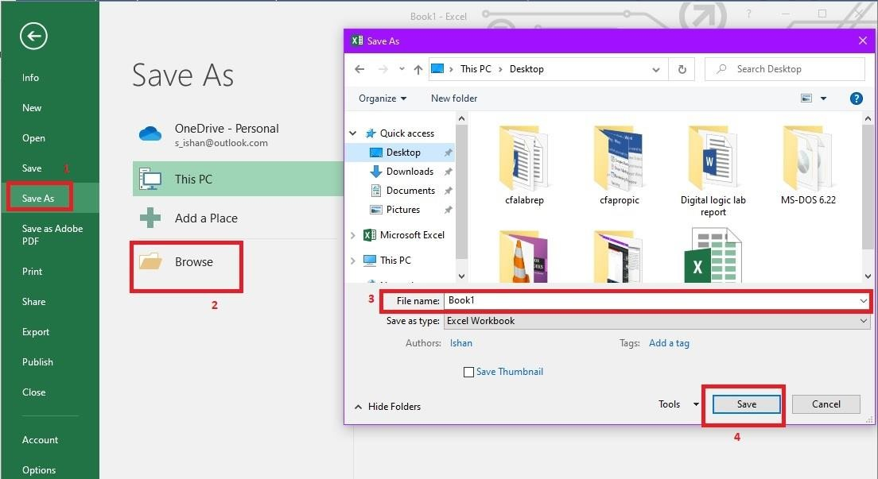

Managing Worksheet
1: To add worksheet, click in bottom left of workbook. Or press Shift+F11 key in key board to add work sheet.
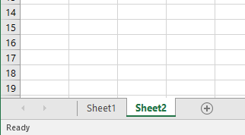

2: To delete a worksheet, right click on the worksheet and click to delete.
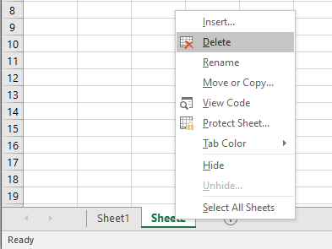
3: To rename worksheet, right click on the worksheet and click rename. Then type the new name for the worksheet and press enter.
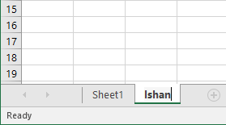

Entering data in cells
To enter data on cell we can directly select a cell and type data from keyboard. We can select the cell and go to formula bar and type data.
    - Formatting Cells
Excel has provided us with a lot of options for formatting cells. In Home ribbon tab, there are lots of options.

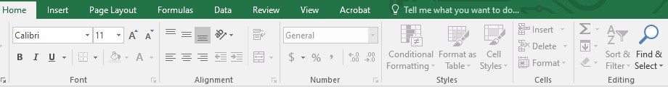
- Font group provides function changing font type, font size 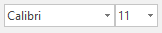, make data bold, italics and underline , change the color of the font and cell.
- From alignment group, we can define the alignment of the text, add indent , merge and wrap cell. With merge option, we can combine more than one cell into one.
- From number group, we can apply formatting to numerical values.
- From cells group, we can insert, delete and format cells. In format options, we can change the size of cells by changing cell height and column width.
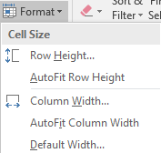
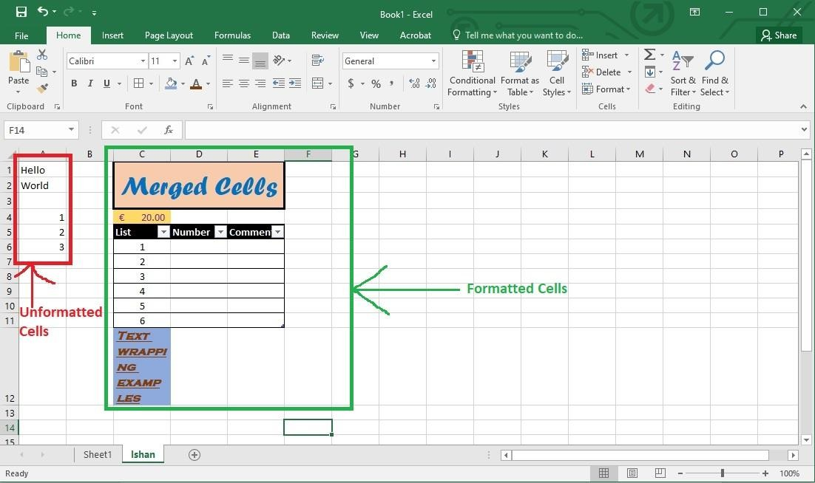

Performing Calculations
    - Using Formulas
Formulas are the expression that operates the values of cells or range of cells.
We can use formulas to calculate data. To find sum of cell A1 and A2, we can type “=A1+A2”
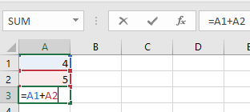
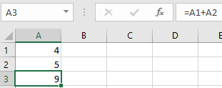
For multiplication between cells A1, A2, B1 and B2, we can type “=A1*A2*B1*B2”.
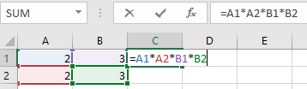
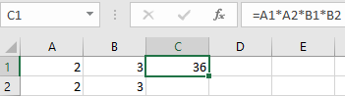
Like we can use subtraction, division and so on.
    - Functions
Functions are the predefined formulas in excel. For example “=Sum(A1,A2)” is the function for sum of cell A1 and A2.
      - Sum function
Perform addition operation of values of cells.
Syntax for Sum - =Sum(<number1>,<number2>,… )
Example of Sum
=Sum(A1:A4)
Performs the addition operations from cells A1 to A4.

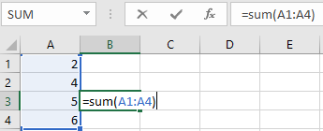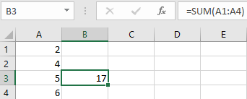
=Sum(A1:A4, B2:B4)
A sophisticated sum function which adds cells A1 to A4, skips B1 and adds B2 to B4
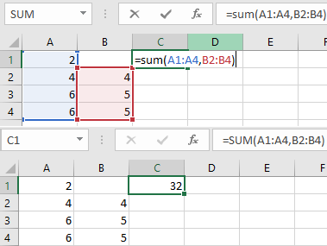
      - Average Function
Average function given the simple average of data. Syntax: =Average(<num1>, <num2>, )
Example: =Average(B2:B5)
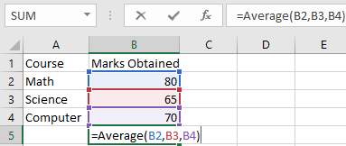

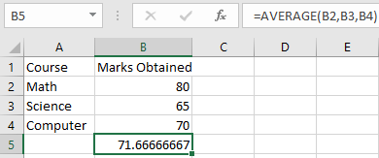
      - Count Function
Count function counts the cells which has only numerical values Syntax: =Count(<cell1> , <cell2> , )
Example: =Count(B1:B5)
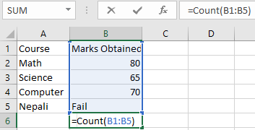
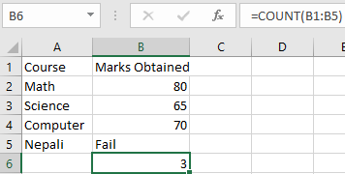

      - If function
If function is used to compare two cells and give result. Syntax: =if(<logic>, <if_logic_true>, <if_logic_false>) Example: =if(B2>C2, “Fail”, “Pass”)

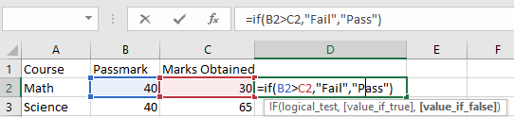
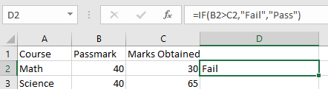
      - Max and Min
Max and Min function return highest and smallest value in the range of cells. Syntax: =Max(<cell1>,<cell2>,……….) or =Min(<cell1>,<cell2>,… )
Example: =Max(C2:C4)
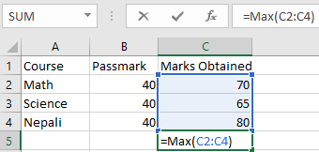
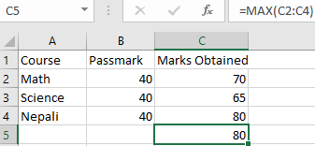
Example: =Min(C2:C4)
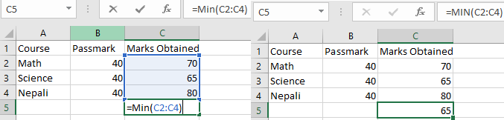

      - Trim Function
This function only removes unwanted or empty space in the cell. It only works in one cell.
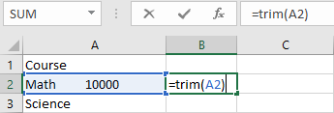
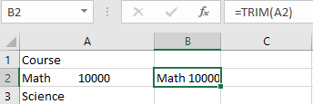

Develop a BCA first semester Mark Sheet using MS-Excel.

OUTPUT

Lab: Slide Presentation

Introduction
Presentation is a way to present yourself in creative way in a speech. It is a means in which we transfer our thoughts and ideas to the listeners or audiences. Presentation is adapted to various speaking situation, such as giving speech to people, business conference, briefing to a team, public conference, and so on. One sided presentation in which presenter only speak is boring. Advanced technologies have given us opportunity to make presentation interesting, curious and creative. Presentation software has allowed us to create presentation slides which can be the combination of text, images, videos and audios. These slide can be shown to the audience in bigger picture through the projector and computer hardware equipment. There is various presentation software available in the market. Some of them are Visme, Prezi, Google Slides, Keynote, Slides, Microsoft PowerPoint and so on.

Microsoft Power Point
Microsoft Power Point is a professional presentation software that allows us to create a powerful presentation slides. This application is part of Microsoft Office Package developed by Microsoft Company. It is one of the most widely used software by personals and business professionals. It allows user to create transitional slides consisting of text, images, audio and videos. MS Power Point uses the extension “.pptx”.

Starting MS Power Point
Step 1: Click on windows button on left side bottom of screen. Search PowerPoint 2016 and click it.
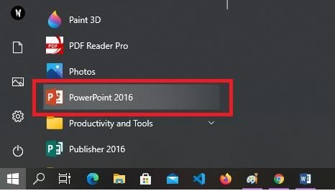
Step 2: Click on blank presentation. There are also other templates available. We can also search templates online through search bar above the black presentation as shown in figure.

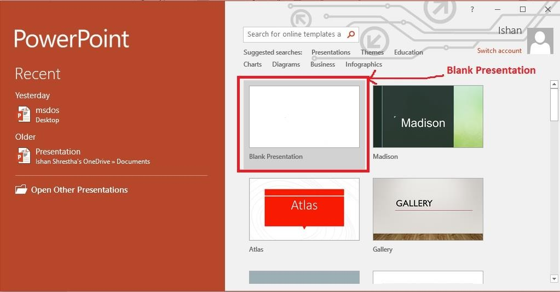
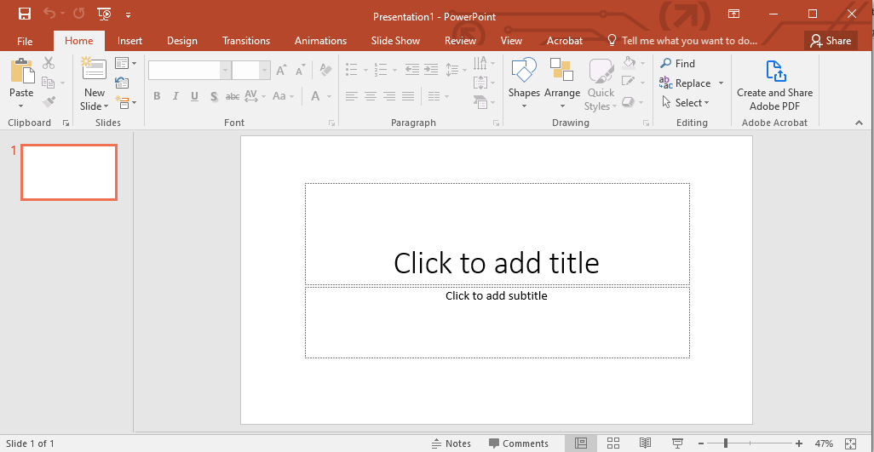

Step 4: Next step is to save the file. Click on file tab or click button. Select Browse button, a new window will pop up. Enter the name in file name bar and click on save button.

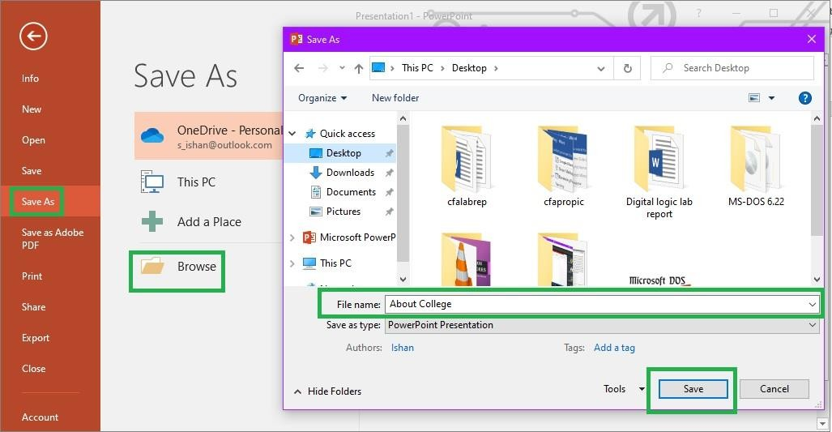

Features of Microsoft PowerPoint
Microsoft PowerPoint has 8 different ribbon tab in which features are divided.
    - Home Tab
It consists of many options such as adding new slide, changing layout of the slide, organizing the slides, text formatting, font type, font size, font color, making text bold, italics and underline, text shadow, paragraph indent, splitting the slides into columns, charts, shapes, font theme styles, find and replaces.
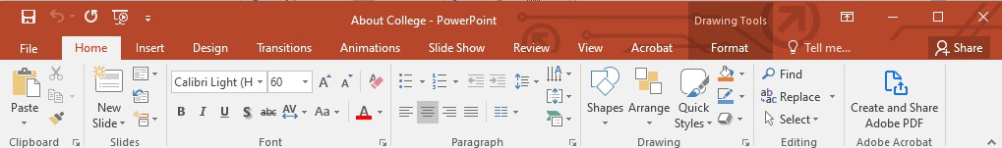
    - Insert Tab
It has options such as adding new slides, importing pictures from outside, inserting online pictures, screenshot, photo album, hyperlinks, comments, text box, header, footer, word art, date, time, symbols, videos, audios and screen recordings.
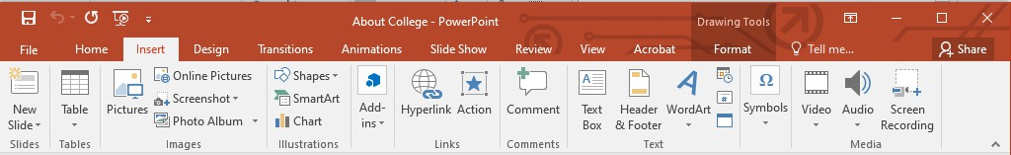

    - Design Tab
It has option mainly about designing the slides. It consists of options such as selecting slide design, slide size and formatting slide background.
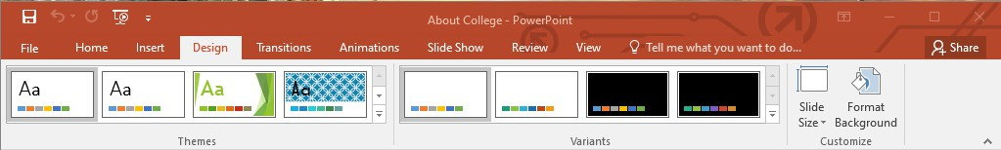
    - Transitions Tab
It has option specifically for when slide transit from one to others. It consists of options such as effects when transitioning slide, sound, duration, and automatic option.
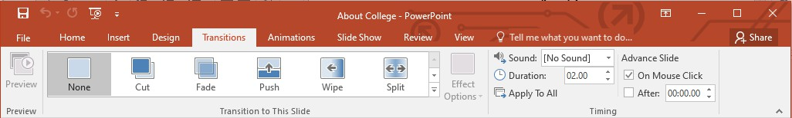
    - Animations Tab
In this tab, we have the options for animating text, images and videos. We can animate or draw movements to attract audience. There are several types of animations effect available. They are mostly divided into 4 categories. They are entrance, emphasis, exit and motion path.
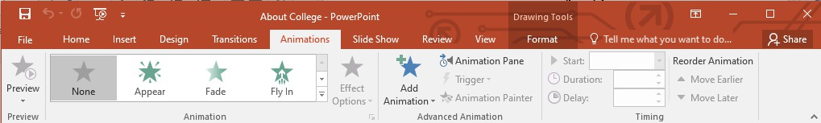
      - Entrance effect
These effect controls how the object enters the slide. Objects can be either text, images, or videos.
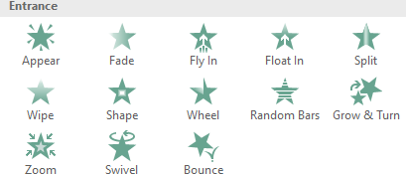

      - Emphasis effect

These effect control how to attract audience to a specific object. They are like highlighters.
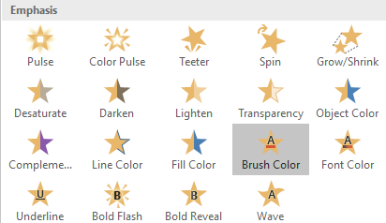
      - Exit effects
These effects controls how existing object in the slide disappear.
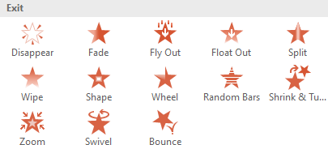
      - Motion Path
They are like emphasis but they move around a predefined path like straight line, circle, triangle and so on.
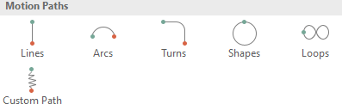
    - Slide Show Tab
In this tab, there option such as slide show from beginning, from current slide, present online, custom slide show, hide slide, record slide show and so on.
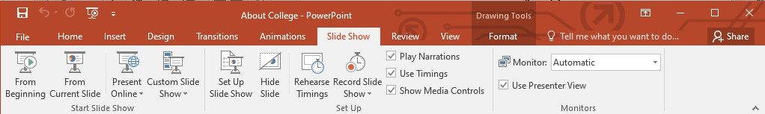
    - Review Tab

This tab has options that are used for reviewing such as spelling, thesaurus, smart lookup, translate, language, new comment, tracking changes and start inking.
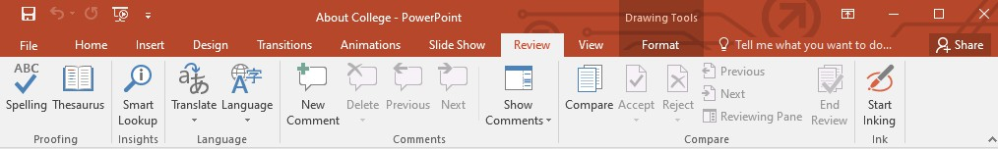
    - View Tab
In this tab, there are viewing type options such as normal, outline view, slider sorter, reading view, slide master, handout master, zoom, fit to windows, colors, grayscale, black and white, new windows and macros.
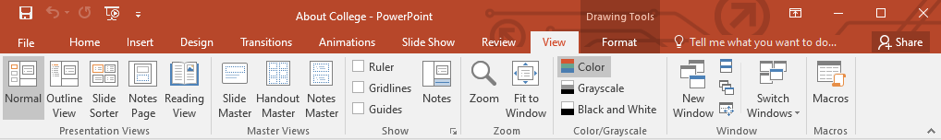

Changing layout of slide
Step 1: Go to home tab, click on layout button on left side of new slide option. Step 2: Choose a layout according to need.
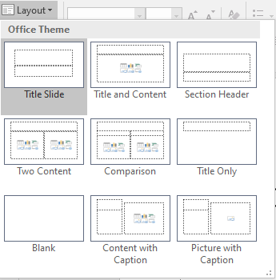
Adding a Photo Album Step 1: Go to Insert Tab
Step 2: Click on Photo album. New window will pop-up. Step 3: Click on file/disk. New window will pop-up
Step 4: Choose more than one photos for photo album

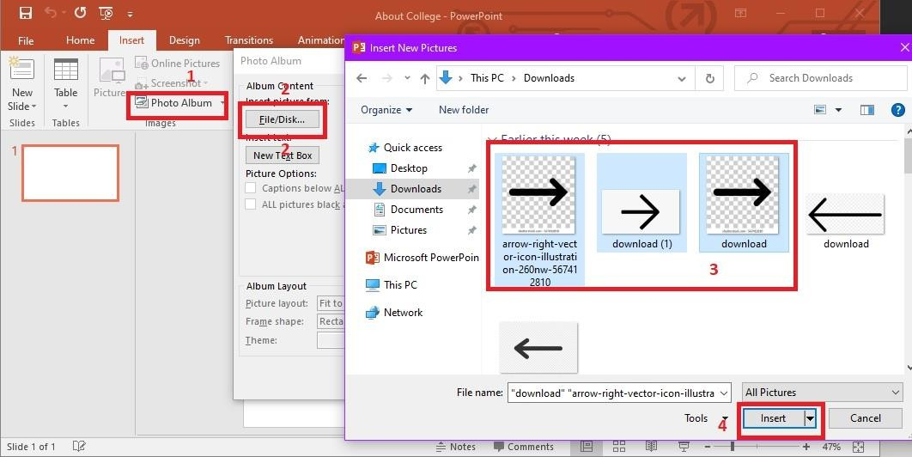

Adding a Video
Step 1: Go to Insert Tab
Step 2: Click video. Select online video if you want insert images from internet. Select video from my PC. Select a video. Select Insert.
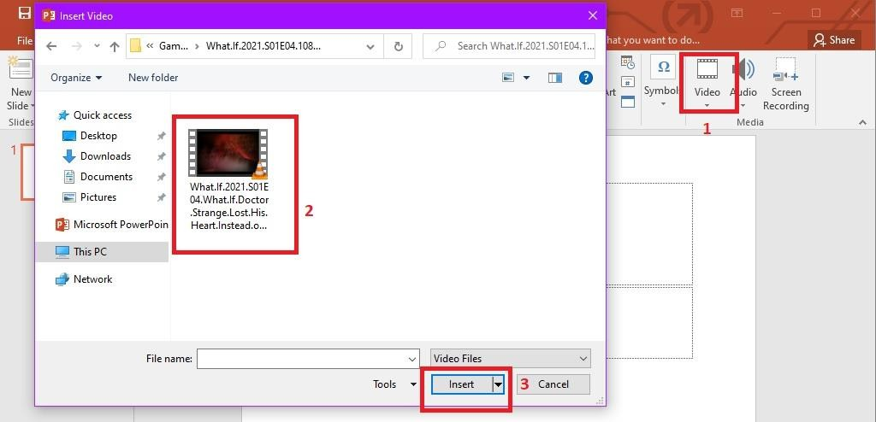

Adding an audio
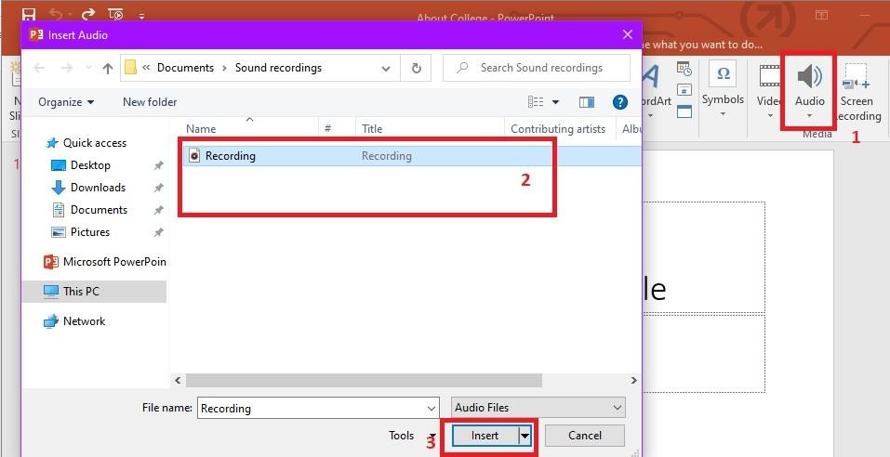
Step 1: Go to Insert Tab. Click on audio. Select audio form pc. Step 2: Select an audio file and click insert.

OUTPUT

Lab : Creating Gmail id

5.1Introduction
E-mail or Electronic Mail is way of transmission of message through the internet. It was invented in 1970s. It changed the way of communicating between people as it was faster than letters and telegrams. Ray Tomlinson is called the father of email. He established communication between computer systems called ARPANET.
E-mail can be defined as exchange or transmission of message from one system to another through a network. Email can be sent to one or more. To send an email we need a network i.e. internet, a computer system and recipient email address. Email uses many protocols from TCP/IP. Simple Mail Transfer Protocol (SMTP) is a protocol that is used for sending email message while IMAP or POP protocols are used for receiving messages. To this date there are many email clients. Among them most popular clients are Outlook, Yahoo, Thunderbird, Zoho, AOL, Gmail, and so on.

5.2Importance of Email
With the help of email in Business, communication can be done lot faster than other means. Contact can be easily stored. We can send same messages to many. Past message can also be checked. Email comes with subject. Through subject we can determine the type of the message. Those emails that does not have subjects are sent to spam folder. We can keep the record and details of message.

Google Mail (Gmail)
Gmail is a free email service provide by Google Company. Gmail is same type of email service like other. It provides services such as sending and receiving emails, saving contacts, block spams and perform other basic email services. By creating account in Gmail is equivalent to creating a google account. We can get access to other services through Gmail account such as Google Docs, Google Sheets, Google Forms, Google Classroom, YouTube and so on.

Features of Gmail
    - Gmail has advance methods for filtering spams. It separates spam from inbox. Spams are stored for only 30 days.
    - Gmail has given a conversation view for emails that we send back and forth with other person.
    - Gmail offers built-in chat features. We can send instant text message, voice and videos to each other.

Creating an E-mail with Google Mail (Gmail)
Steps 1: Open the browser. Go to address bar and type the link https://www.google.com/intl/ne/gmail/about/# and press enter. Then click on Create an account button.
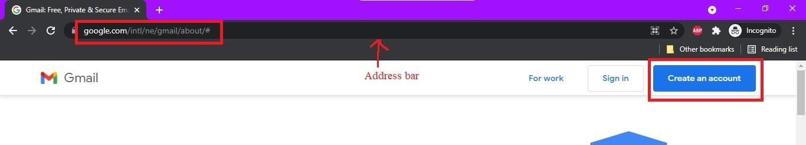
Step 2: Then it will ask your personal details such as first name, last name, new user name for email, password and conform password. When writing password, choose a strong one. For strong password, number of character must be greater than 8. These characters must be the combination of upper case, loser case, number and special characters. After filling the information click next button.

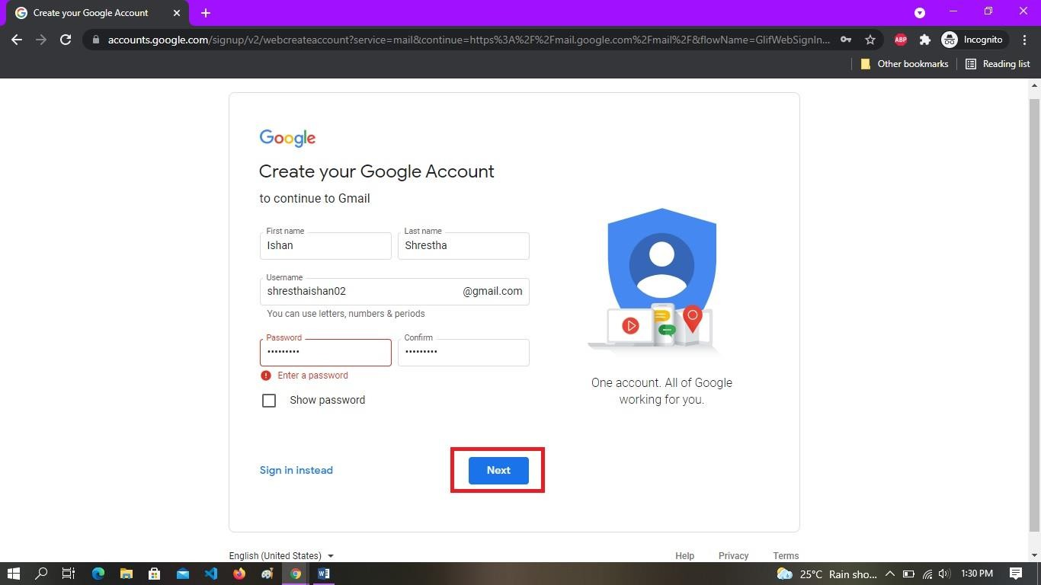
Step 3: It will ask phone number, recovery email address, birth day and gender. Phone number and recovery email address are optional. After filling the information click on next button.
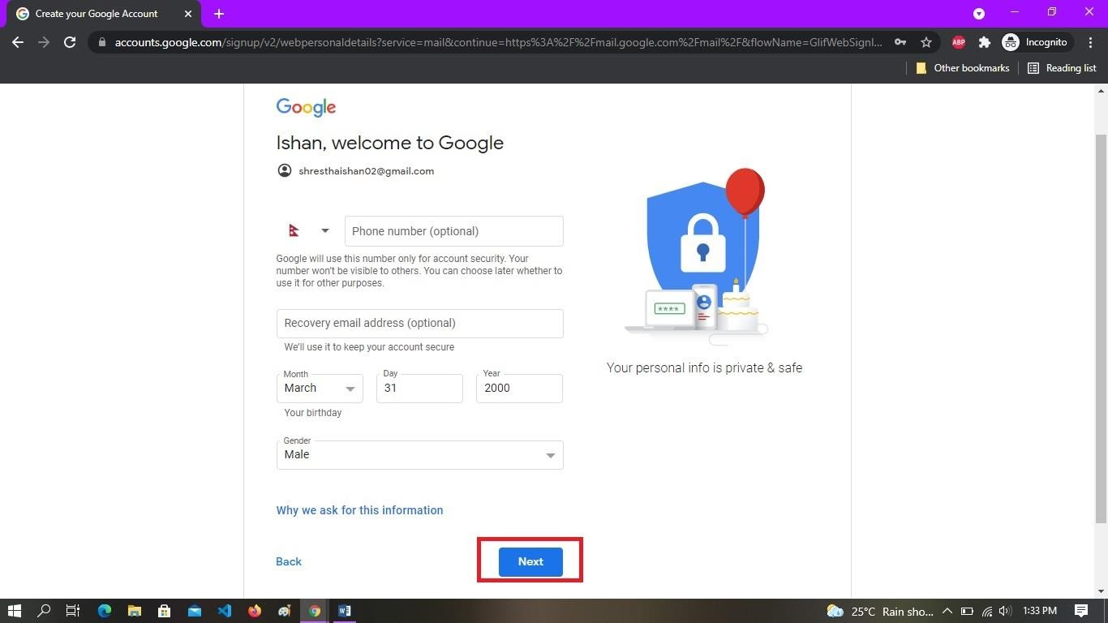

Step 4: It will show the details of privacy and terms. After reading it, click on I agree button.
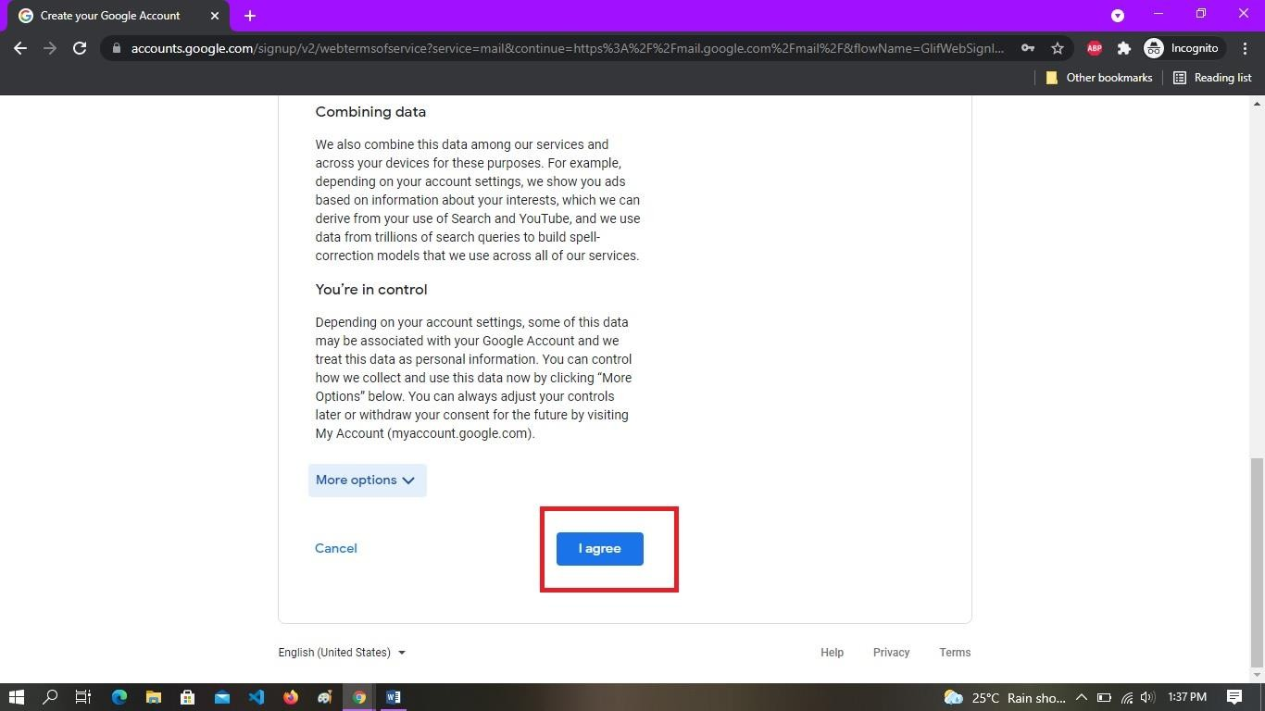
Step 5: After click on I agree button, our email account will be created and we will be redirected to our email a
ccount.
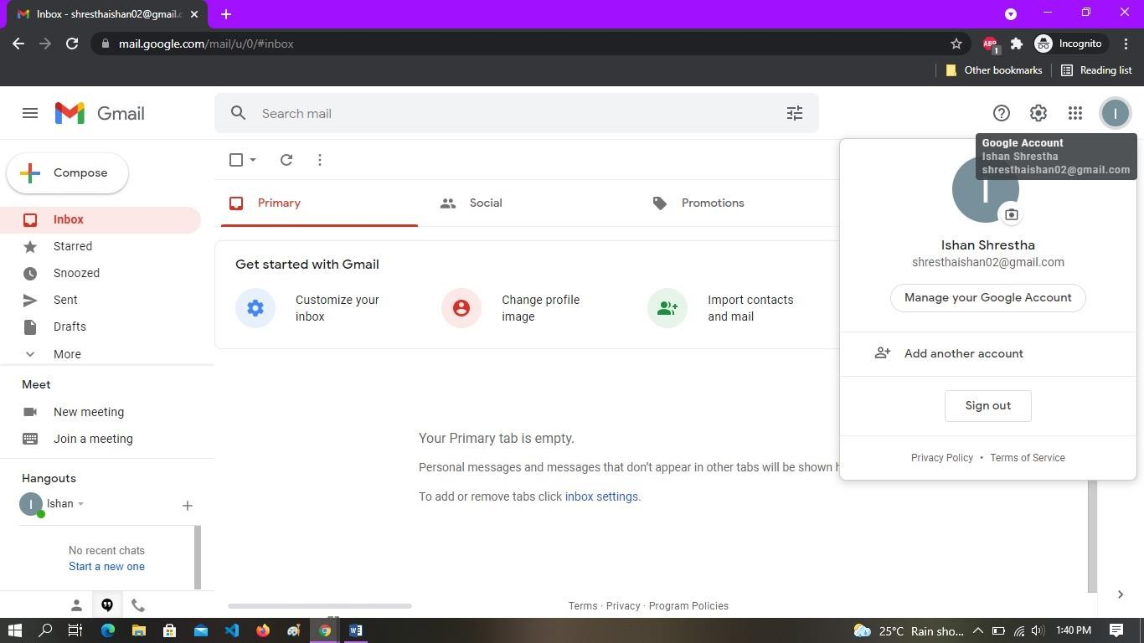

OUTPUT

