BSc CSIT – C Programming Lab Report
Student: Palistha Shrestha | Pascal College | Lab Sheet 1–8

Lab Sheet 1: Basic Constructs in C
1.1. Addition, Subtraction, Multiplication and Division of Two Numbers
1.2. Surface Area of Cube
1.3. Area and Circumference of Circle
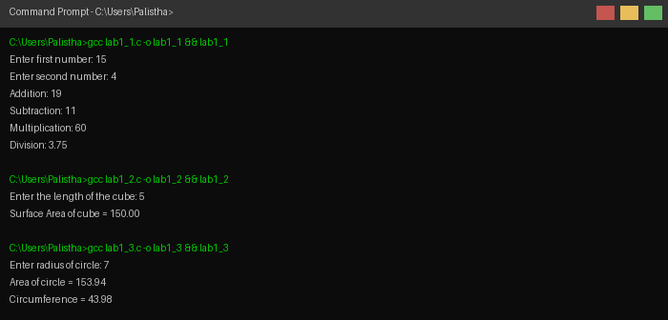
1.4. Area and Perimeter of Rectangle
1.5. Quotient and Remainder
1.6. Convert Seconds to Hours, Minutes and Seconds
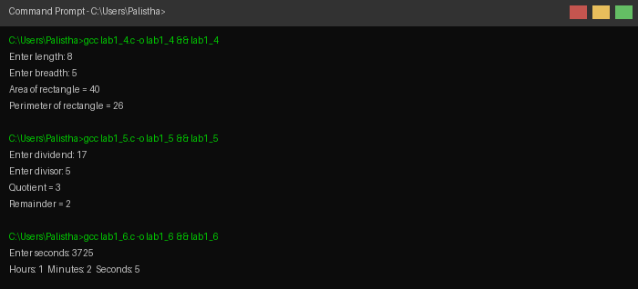
1.7. Convert Days to Years, Months and Days
1.8. Convert Length from mm to km, m, cm and mm
1.9. Reverse a Three-Digit Number
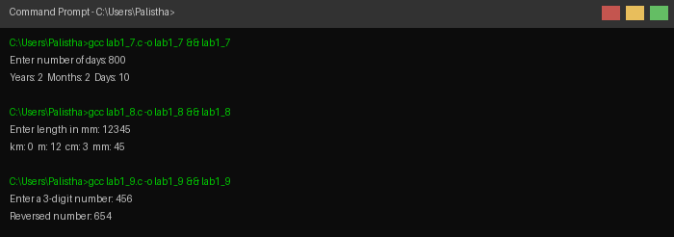
1.10. Aggregate Marks and Percentage of a Student
1.11. Temperature Conversion (Celsius to Fahrenheit)
1.12. Roots of a Quadratic Equation
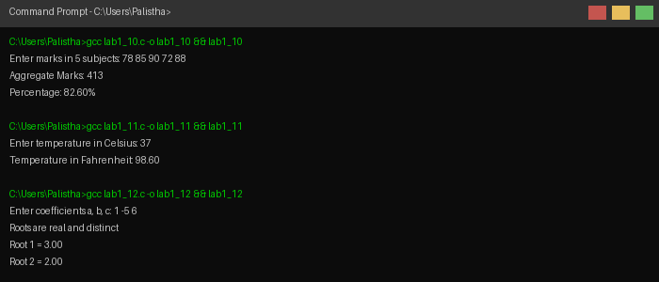
1.13. Area of Triangle Using Heron's Formula
1.14. Interchange Contents of Two Variables
1.15. Sum of Digits of a Five-Digit Number
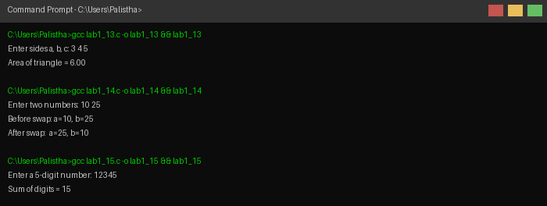
1.16. Sum/Difference Using Ternary Operator
1.17. Decimal to Octal and Hexadecimal
1.18. Volume of Sphere
1.19. Remainder After Dividing by 5
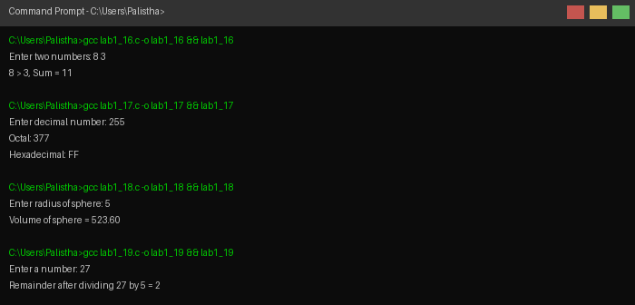

Lab Sheet 2: Decision Control and Looping
2.1. Generate Fibonacci Series
2.2. Print Armstrong Numbers Between 1 and 500
2.3. Numbers from 1 to 10 Using While Loop
2.4. Numbers from 9 to 0 Using While Loop
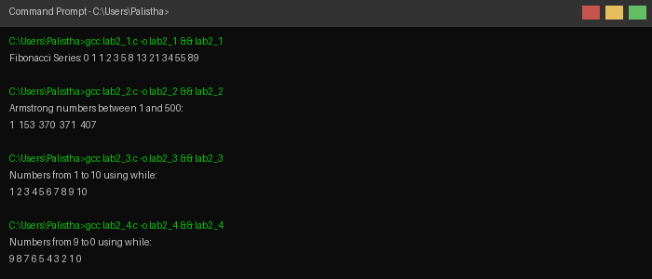
2.5. Print Numbers 10 to 1 and Their Sum
2.6. Factorial of a Given Number
2.7. Count of Positive, Negative and Zero Numbers
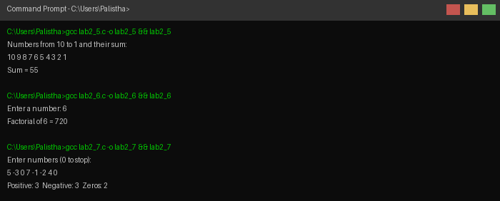
2.8. Star Pattern (**** to *)
2.9. Multiplication Table from 1 to 10
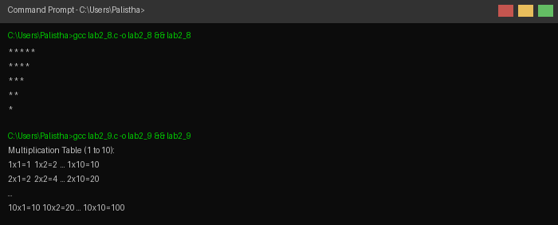
2.10. Square (Odd) / Cube (Even) of a Given Number
2.11. One Number Raised to Power of Another
2.12. Product of Digits of Any Number
2.13. Sum of Digits of Any Number
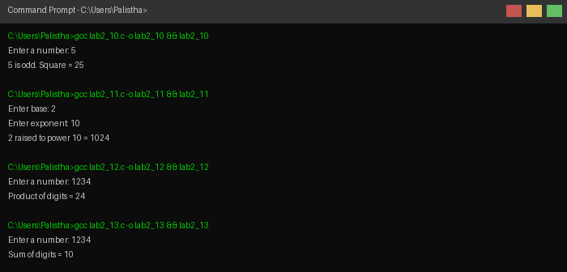

Lab Sheet 3: Arrays and Strings
3.1. Sum, Product, Average and Maximum of 10 Numbers
3.2. Display 10 Numbers with Array Variables and Addresses
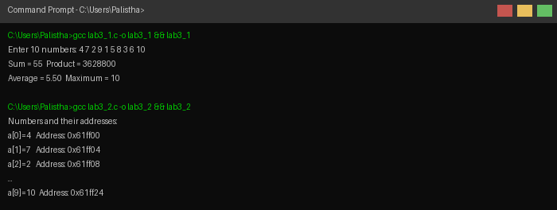
3.3. Largest and Smallest Among 10 Numbers
3.4. Sort 10 Numbers in Ascending Order
3.5. Sort 10 Numbers in Ascending Order Using Function
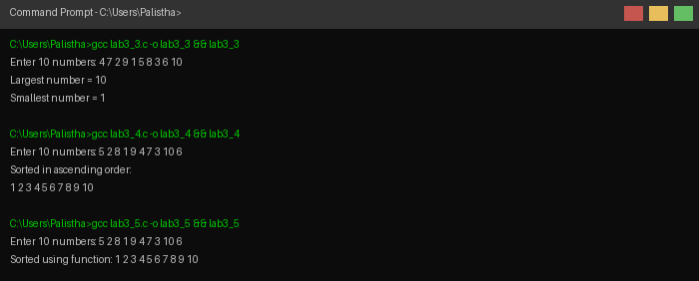
3.6. BScCSIT Marks in Descending Order with Max/Min
3.7. Count Positive, Negative, Even and Odd from 25 Numbers
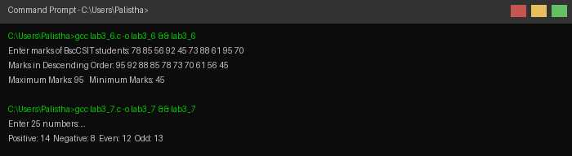
3.8. Sort 10 Numbers Using Array
3.9. Read and Display a 2×3 Matrix
3.10. Sum, Difference and Product of Two M×N Matrices
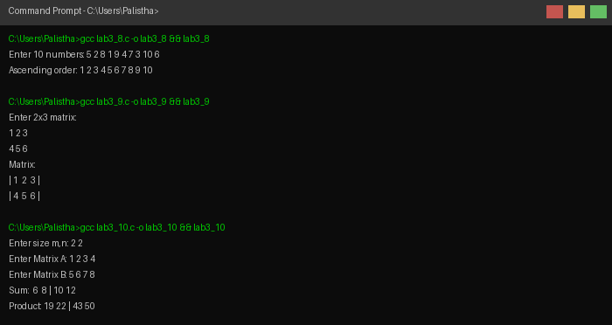
3.11. Display Prime Numbers Between 1 and 100
3.12. Marks of 10 Students – Print Top Five
3.13. Copy Contents of One Array into Another in Reverse
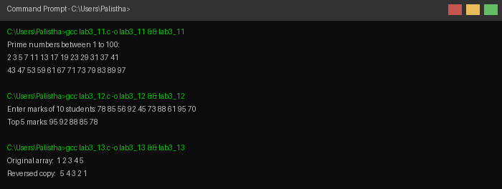
3.14. Length of String (With and Without strlen())
3.15. Display String in Uppercase
3.16. Display String in Lowercase
3.17. Toggle Case of Alphabets in a String
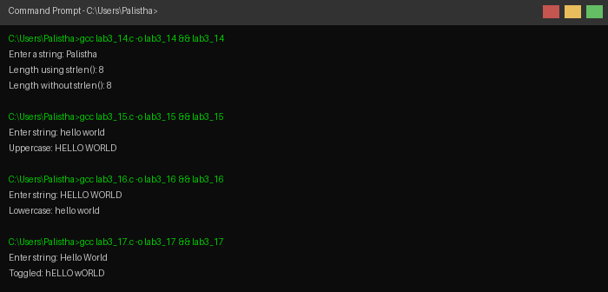
3.18. Check Palindrome String
3.19. Display String in Reverse (With and Without strrev())
3.20. Display ASCII Values of Characters
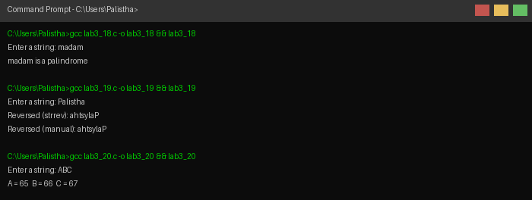
3.21. Count Lowercase, Uppercase and Spaces in String
3.22. Count Vowels in a String
3.23. Compare Two Strings and Display Larger One
3.24. Concatenate Two Strings Without Built-in Function
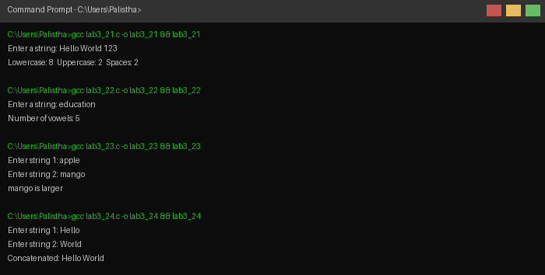
3.25. Sort Names of 10 Students Alphabetically
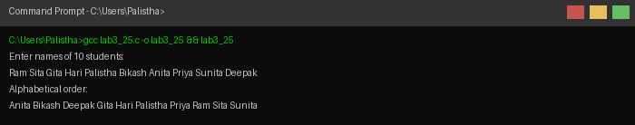

Lab Sheet 4: Functions
4.1. Arithmetic Operations Using User-Defined Functions
4.2. Largest Among Three Numbers Using Function
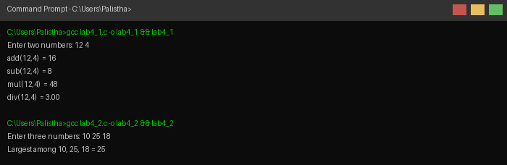
4.3. Product of Float and Int Using Function
4.4. Check Prime Number Using Function
4.5. Factorial Using Function long int factorial(int,int)
4.6. Power Function: int power(int,int)
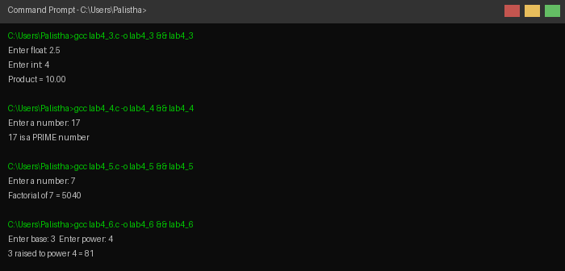
4.7. Factorial Using Recursive Function
4.8. Sum of Series 1+2+...+n Using Recursive Function
4.9. Fibonacci Series Using Recursive Function
4.10. a Raised to Power b Using Recursive Function
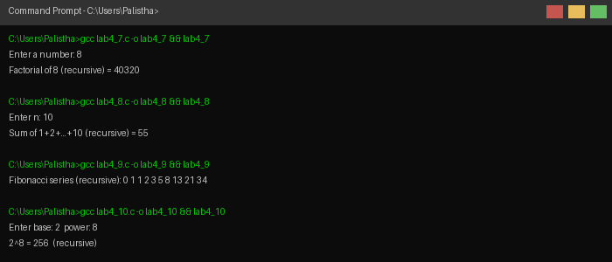
4.11. Sum of First Twenty Natural Numbers Using Function
4.12. Fibonacci Series Using Recursive Function
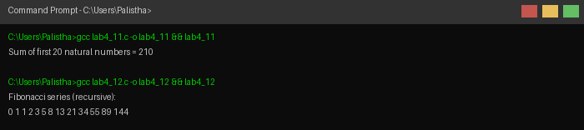

Lab Sheet 5: Structures and Union
5.1. Display Student Data Using Structure
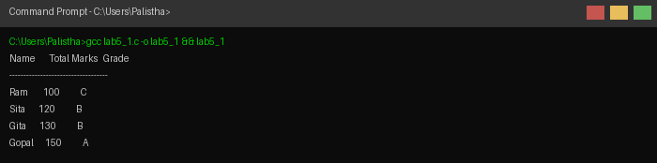
5.2. Read and Display Student Data Using Structure
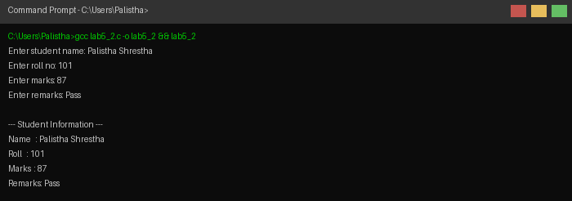
5.3. Display Students with Marks > 50 Using Array of Structure
5.4. Employee Data Sorted by Name Using Array of Structure
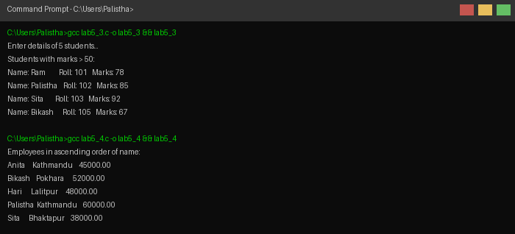
5.5. Sort Names Alphabetically Using Structures
5.6. Book Details Using Pointer to Structure
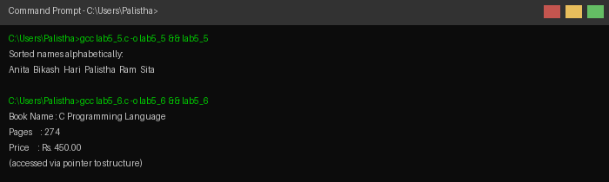
5.7. Most Expensive Book Using Array of Structure
5.8. Union with Roll and Marks Members
5.9. Initialize Structure Date to February 25, 1957
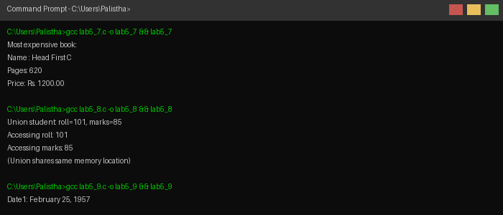
5.10. Enter and Display Date Using Structure
5.11. Student Registration System Using Structure
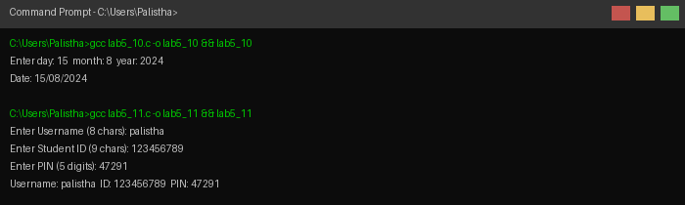
5.12. Difference Between Two Dates Using Structure
5.13. Airline Data Structure with Flight Information
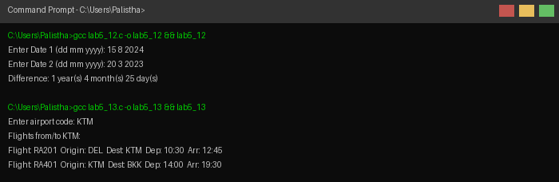
5.14. Employee Structure with Nested Date (Structure within Structure)
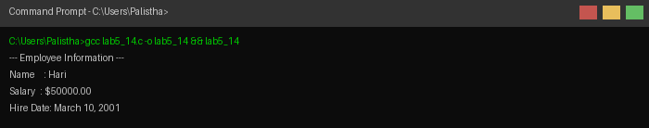

Lab Sheet 6: Pointers
6.1. Display Memory Addresses of char, float and int Variables
6.2. Sum of Array Elements Using Pointer
6.3. Top Five Marks of n Students Using Pointer
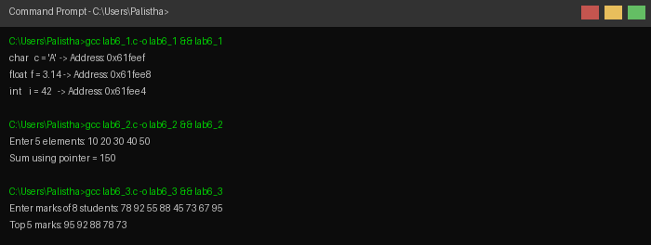
6.4. Size of Pointers for int, float and char
6.5. Exchange Two Values Using Pointer (Call by Address)
6.6. Add Two Matrices Using Pointers
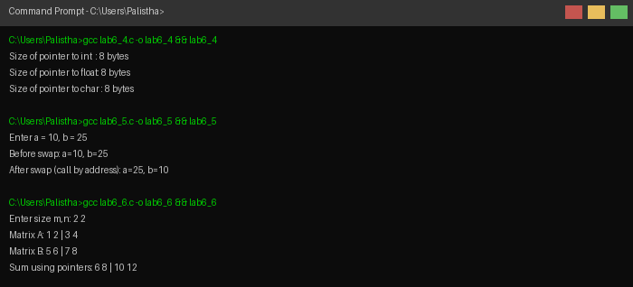
6.7. Sort 1D Array Using Dynamic Memory Allocation
6.8. Count Employees Above 80 Years Using malloc()
6.9. Read Matrix and Display Its Transpose Using Pointers
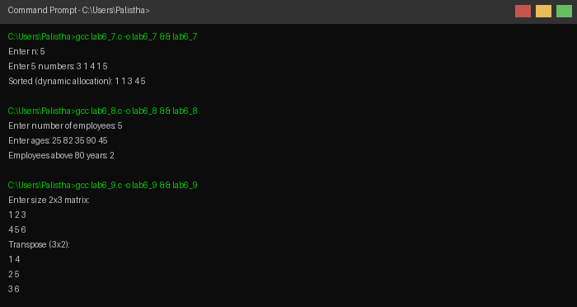

Lab Sheet 7: File Handling
7.1. Create test.txt and Write Text to File
7.2. Open test.txt and Display Its Content
7.3. Write and Read String Using Character I/O
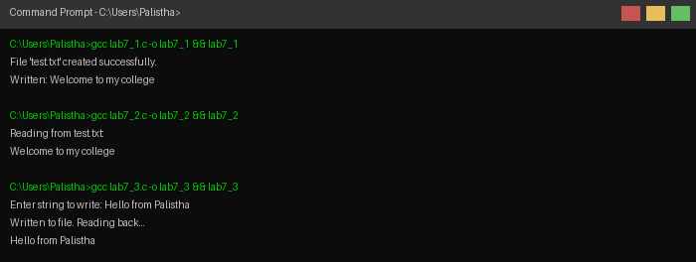
7.4. Append Text to a File
7.5. Write Student Data to D:\test\student.txt
7.6. Write Name, Address, Telephone to File and Display
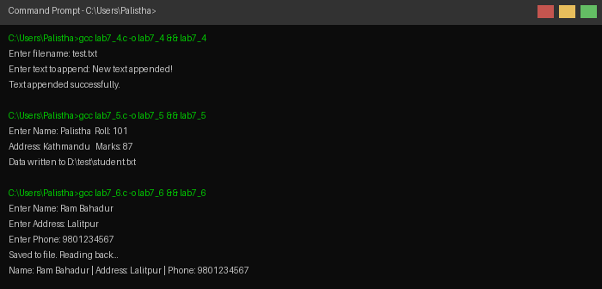
7.7. Store String in new1.dat and Read Back
7.8. Write and Read Even Numbers (10–50) to File
7.9. Write Natural Numbers 1–20 and Display Twice
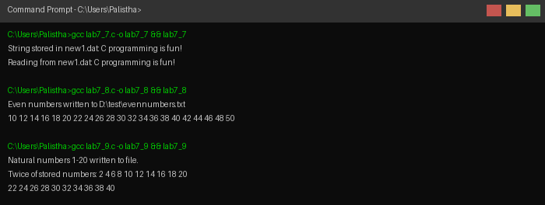
7.10. Store Array of 10 Numbers to File and Display
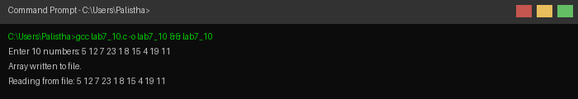

Lab Sheet 8: Graphics
8.1. Draw a Line
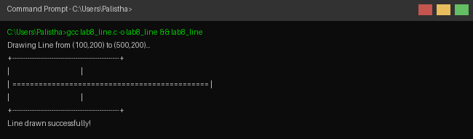
8.2. Draw a Rectangle
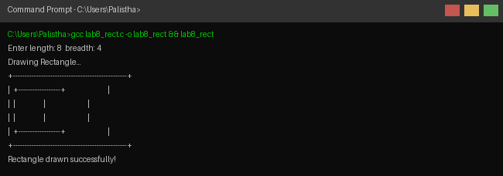
8.3. Draw a Circle
