🌐
Foundation of Web Development
HTML & CSS — A Beginner's Complete Guide
─────────────────────────────
Simple explanations • Practical examples • Hands-on projects

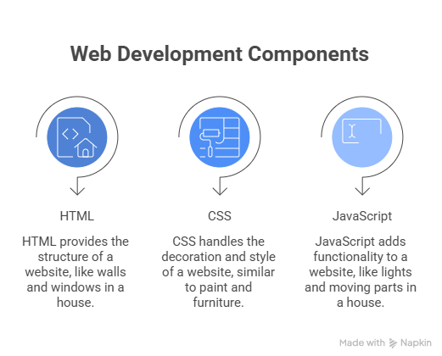

1. Introduction to Web Development

1.1 What is Web Development?
Web development is the process of building websites and web applications that run in a browser. When you open a website like Google or YouTube, everything you see — the layout, colors, buttons, and text — was created by web developers.
Think of it like building a house:
- HTML is the structure (walls, doors, windows)
- CSS is the decoration (paint, furniture, style)
- JavaScript is the functionality (lights, electricity, moving parts)

📖 Definition Web development = building things for the internet using code.

1.2 Frontend vs Backend
Web development is split into two main areas:

Frontend (Client-Side) | Backend (Server-Side)
What users see & interact with | Logic & data the user doesn't see
HTML, CSS, JavaScript | Python, PHP, Node.js, databases
Runs in the browser | Runs on a server
Example: Button, form, navbar | Example: Login system, database

💡 Tip This guide focuses on Frontend — specifically HTML and CSS, the two most important starting points for any web developer.

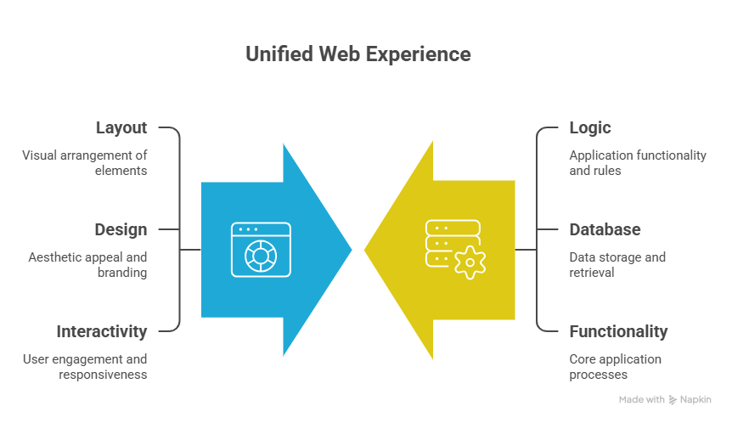

2. Introduction to HTML

2.1 What is HTML?
HTML stands for Hypertext Markup Language. It is the standard language used to create the structure of web pages. HTML tells the browser what content to show — headings, paragraphs, images, links, and more.
HTML uses tags to markup content. Tags are written inside angle brackets like <tag>. Most tags come in pairs: an opening tag and a closing tag.

📌 Remember HTML = Structure of the page. Every webpage on the internet is built with HTML.

2.2 Basic Structure of an HTML Document
Every HTML file follows the same basic structure. Here is the standard template:

<!DOCTYPE html>
<html lang="end">
<head>
<meta charset="UTF-8">
<meta name="viewport" content="width=device-width, initial-scale=1.0">
<title>My First Webpage</title>
</head>
<body>
<h1>Hello, World! </h1>
<p>Welcome to my website. </p>
</body>
</html>

What each part means:
Tag / Element | Purpose
<!DOCTYPE html> | Tells browser this is an HTML5 document
<html> | Root element — wraps all page content
<head> | Contains metadata (not visible to users)
<meta charset> | Supports all characters including Unicode
<title> | Text shown on the browser tab
<body> | All visible page content goes here

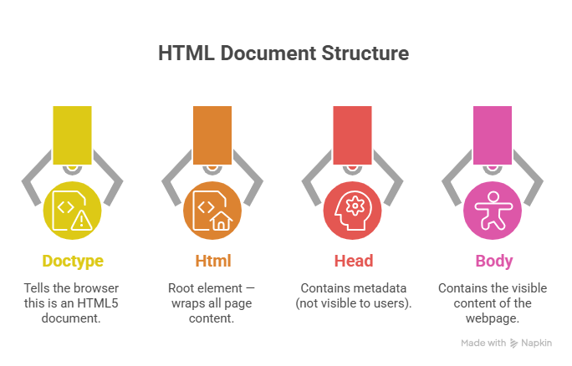

2.3 Common HTML Tags

Headings
HTML has 6 heading levels. h1 is the largest and most important. h6 is the smallest.

<h1>Main Heading (Biggest)</h1>
<h2>Sub Heading</h2>
<h3>Section Heading</h3>
<h4>Sub-section Heading</h4>
<h5>Minor Heading</h5>
<h6>Smallest Heading</h6>

💡 Tip Use only ONE <h1> per page for SEO. It should describe the main topic of the page.

Paragraphs & Text Formatting
Use <p> for paragraphs, and these tags to style text inline:

<p>This is a normal paragraph. </p>
<p>This is <strong>bold text</strong> in a paragraph. </p>
<p>This is <me>italic text</me> in a paragraph. </p>
<p>This is <u>underlined text</u>. </p>
<p>This is <mark>highlighted text</mark>. </p>
<p>Water formula: H<sub>2</sub>O</p>
<p>Area: 5<sup>2</sup> = 25</p>
<! -- This is a comment — not visible in the browser -->
<brr> <! -- Line break (no closing tag needed) -->
<hr.> <! -- Horizontal line -->

Links
Links let users navigate to other pages or websites. Use the <a> (anchor) tag:

<! -- Link to another website -->
<a her="https://www.google.com">Visit Google</a>
<! -- Link to another page in your site -->
<a her="about.html">About Us</a>
<! -- Open link in a new tab -->
<a her="https://www.google.com" target="_blank">Open in new tab</a>
<! -- Link to an email address -->
<a her="mailto:hello@example.com">Send Email</a>
<! -- Link to a phone number -->
<a her="tell: +9779812345678">Call Us</a>

Images
Use the <imp> tag to add images. It is a self-closing tag (no </imp> needed).

<! -- Basic image -->
<imp sac="photo.jpg" alt="A beautiful sunset">
<! -- Image with width and height -->
<imp sac="logo.png" alt="Company Logo" width="200" height="100">
<! -- Image from the internet -->
<imp sac="https://picsum.photos/400/200" alt="Random photo">
<! -- Image as a link -->
<a her="about.html">
<imp sac="logo.png" alt="Go to About Page">
</a>

⚠️ Important Always include the alt attribute! It describes the image for screen readers and shows if the image fails to load.

Lists
HTML has three types of lists:

<! -- Unordered List (bullet points) -->
<up>
<li>HTML</li>
<li>CSS</li>
<li>JavaScript</li>
</up>
<! -- Ordered List (numbered) -->
<old>
<li>Learn HTML</li>
<li>Learn CSS</li>
<li>Build a project</li>
</old>
<! -- Description List (term + definition) -->
<dl>
<dt>HTML</dt>
<dd>Structure of a webpage</dd>
<dt>CSS</dt>
<dd>Styling and design of a webpage</dd>
</dl>

Tables
Tables organize data into rows and columns. Use them for structured data — not for page layout.

<table border="1">
<thread>
<tr>
<the>Name</the>
<the>Age</the>
<the>City</the>
</tr>
</thread>
<body>
<tr>
<td>Aarav</td>
<td>22</td>
<td>Kathmandu</td>
</tr>
<tr>
<td>Priya</td>
<td>25</td>
<td>Pokhara</td>
</tr>
</body>
</table>

Tag | Meaning
<table> | Creates the table
<thread> | Table header section
<body> | Table body section
<tr> | Table row
<the> | Table header cell (bold by default)
<td> | Table data cell

Forms
Forms collect user input. They include fields for text, email, passwords, checkboxes, radio buttons, and more.

<form action="/submit" method="POST">
<! -- Text Input -->
<label for="name">Your Name:</label>
<input type="text" id="name" name="name" placeholder="Enter name">
<! -- Email Input -->
<label for="email">Email:</label>
<input type="email" id="email" name="email" required>
<! -- Password Input -->
<label for="pass">Password:</label>
<input type="password" id="pass" name="pass">
<! -- Dropdown -->
<label for="city">City:</label>
<select id="city" name="city">
<option value="kit">Kathmandu</option>
<option value="per">Pokhara</option>
</select>
<! -- Checkbox -->
<input type="checkbox" id="terms" name="terms">
<label for="terms">I agree to the terms</label>
<! -- Radio Buttons -->
<input type="radio" name="gender" value="male"> Male
<input type="radio" name="gender" value="female"> Female
<! -- Text area -->
<text area name="message" rows="4" cols="40"></text area>
<! -- Submit Button -->
<button type="submit">Send</button>
</form>

2.4 Semantic HTML Elements
Semantic elements describe what content they hold. They make your HTML more readable and help search engines understand your page.

📖 Definition Semantic = meaningful. A <header> clearly means 'page header'. A <div> means nothing by itself.

<!DOCTYPE html>
<html lang="end">
<body>
<header>
<nav>
<a her="/">Home</a>
<a her="/about">About</a>
</nav>
</header>
<main>
<article>
<h1>Blog Post Title</h1>
<section>
<h2>Introduction</h2>
<p>Welcome to the article...</p>
</section>
<section>
<h2>Main Content</h2>
<p>More content here...</p>
</section>
</article>
<aside>
<p>Related links or ads go here. </p>
</aside>
</main>
<footer>
<p>&copy; 2025 My Website</p>
</footer>
</body>
</html>

Semantic Tag | Purpose
<header> | Page or section header
<nav> | Navigation links
<main> | Main content of the page
<article> | Standalone content (blog post, news)
<section> | Thematic grouping within a page
<aside> | Side content (sidebar, ads)
<footer> | Page or section footer
<figure> | Image or diagram with caption
<fig caption> | Caption for a <figure>

2.5 HTML Attributes
Attributes provide extra information about an element. They go inside the opening tag.
Syntax: <tag name attribute="value">Content</tag name>

<! -- id: unique identifier for one element -->
<p id="intro">This paragraph has a unique ID.</p>
<! -- class: group multiple elements together -->
<p class="highlight">This is highlighted. </p>
<p class="highlight">This is also highlighted. </p>
<!-- style: inline CSS styling -->
<p style="color: red; font-size: 20px;">Red text</p>
<!-- title: shows a tooltip on hover -->
<p title="Tooltip text">Hover over me!</p>
<!-- href: link destination in <a> tags -->
<a href="https://example.com">Click here</a>
<!-- src: image source in <img> tags -->
<img src="photo.jpg" alt="My Photo">
<!-- required: makes form field mandatory -->
<input type="email" required>
<!-- disabled: disables an element -->
<button disabled>Can't click me</button>

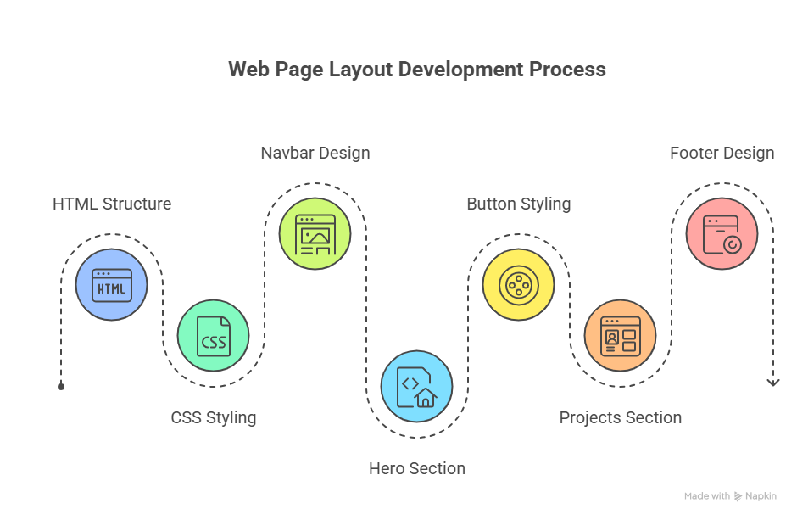

3. Introduction to CSS

3.1 What is CSS and Why is it Used?
CSS stands for Cascading Style Sheets. It controls the visual presentation of your HTML — colors, fonts, layout, spacing, and animations. Without CSS, every website would look the same: plain black text on a white background.

📌 Remember HTML = What is on the page. CSS = How it looks on the page.

3.2 Types of CSS

1. Inline CSS — Applied directly to one element
<p style="color: blue; font-size: 18px;">This text is blue.</p>
<h1 style="background-color: yellow;">Yellow background heading</h1>

2. Internal CSS — Written inside <style> tag in the <head>
<!DOCTYPE html>
<html>
<head>
<style>
p {
color: green;
font-size: 16px;
}
h1 {
text-align: center;
}
</style>
</head>
<body>
<h1>Centered Heading</h1>
<p>Green paragraph text</p>
</body>
</html>

3. External CSS — Written in a separate .css file (BEST PRACTICE)
<!-- In index.html <head> section: -->
<link rel="stylesheet" href="styles.css">
/* In styles.css file: */
body {
margin: 0;
font-family: Arial, sans-serif;
}
h1 {
color: navy;
text-align: center;
}
p {
color: #333;
line-height: 1.6;
}

Type | When to Use
Inline CSS | Quick testing only. Avoid in production.
Internal CSS | Small single-page projects.
External CSS | Always — best practice for real projects.

3.3 CSS Syntax
Every CSS rule has three parts:

selector {
property: value;
}
/* Example: */
h1 {
color: red;
font-size: 32px;
text-align: center;
}
/* Multiple selectors at once: */
h1, h2, h3 {
font-family: Arial, sans-serif;
}

Term | Meaning
Selector | Which HTML element to style (e.g. h1, p, .box)
Property | What to change (e.g. color, font-size, margin)
Value | The new setting (e.g. red, 16px, center)
Declaration | One property-value pair (color: red;)
Rule | The whole block: selector + declarations

3.4 CSS Selectors

Element, Class, and ID Selectors
/* Element Selector — targets all <p> tags */
p {
color: gray;
}
/* Class Selector — targets elements with class="btn" */
.btn {
background-color: blue;
color: white;
padding: 10px 20px;
}
/* ID Selector — targets element with id="header" */
#header {
background-color: navy;
height: 60px;
}
/* Descendant Selector — <p> inside <div> */
div p {
font-size: 14px;
}
/* Pseudo-class — styles on hover */
a:hover {
color: orange;
text-decoration: underline;
}
/* Pseudo-class — first child */
li:first-child {
font-weight: bold;
}

💡 Tip Use classes (.name) for styling multiple elements. Use IDs (#name) for unique elements only (like a navigation bar or a form).

3.5 Colors, Fonts & Text Styling
/* ── Colors ─────────────────────────── */
p { color: red; } /* named color */
p { color: #FF5733; } /* hex color */
p { color: rgb(255, 87, 51); } /* RGB */
p { color: rgba(255, 87, 51, 0.8);} /* RGB with opacity */
p { color: hsl(9, 100%, 60%); } /* HSL */
/* ── Background ─────────────────────── */
body { background-color: #f9f9f9; }
div { background-image: url('bg.jpg'); }
div { background-size: cover; }
/* ── Fonts ──────────────────────────── */
p {
font-family: 'Arial', sans-serif;
font-size: 16px; /* size */
font-weight: bold; /* bold / normal / 100–900 */
font-style: italic; /* normal / italic / oblique */
}
/* ── Text ───────────────────────────── */
h1 {
text-align: center; /* left, right, center, justify */
text-decoration: underline;/* none, underline, line-through */
text-transform: uppercase; /* uppercase, lowercase, capitalize */
letter-spacing: 2px;
line-height: 1.6;
text-shadow: 2px 2px 4px gray;
}

3.6 The CSS Box Model
Every HTML element is a box. The box model shows how space is calculated around each element.

📦 Box Model Layers (inside → outside) Content → Padding → Border → Margin

.box {
width: 300px; /* width of content area */
height: 150px; /* height of content area */
padding: 20px; /* space INSIDE the border */
padding-top: 10px; /* individual sides */
padding: 10px 20px; /* top/bottom left/right */
padding: 10px 20px 15px 5px; /* top right bottom left */
border: 2px solid black; /* size style color */
border-radius: 8px; /* rounded corners */
margin: 20px; /* space OUTSIDE the border */
margin: 0 auto; /* center element horizontally */
box-sizing: border-box; /* include padding & border in width */
}

Property | What it does
content | Where text and images appear
padding | Space between content and border
border | The line around the padding
margin | Space outside the border (between elements)
box-sizing: border-box | Makes width include padding + border (recommended)

3.7 Display & Positioning

Display Property
/* Block elements — take up full width, stack vertically */
div { display: block; }
/* Inline elements — sit side by side, no width/height */
span { display: inline; }
/* Inline-block — side by side but supports width/height */
button { display: inline-block; }
/* Flex — flexible layouts (see Flexbox section) */
.container { display: flex; }
/* Grid — grid layouts (see Grid section) */
.container { display: grid; }
/* Hide element completely */
.hidden { display: none; }

Position Property
/* Static — default, follows normal page flow */
.box { position: static; }
/* Relative — offset from its normal position */
.box {
position: relative;
top: 10px; /* move down 10px */
left: 20px; /* move right 20px */
}
/* Absolute — positioned relative to nearest positioned parent */
.badge {
position: absolute;
top: 0;
right: 0;
}
/* Fixed — stays in same spot when scrolling */
.navbar {
position: fixed;
top: 0;
width: 100%;
}
/* Sticky — sticks when you scroll to it */
.header {
position: sticky;
top: 0;
}

3.8 Flexbox Basics
Flexbox is a modern CSS layout system that makes it easy to align and distribute elements in a row or column.

/* ── Flex Container (parent) ────────── */
.container {
display: flex;
flex-direction: row; /* row (default) | column */
justify-content: center; /* align along main axis */
/* flex-start | flex-end | center | space-between | space-around */
align-items: center; /* align along cross axis */
/* flex-start | flex-end | center | stretch */
flex-wrap: wrap; /* wrap to next line if needed */
gap: 16px; /* space between items */
}
/* ── Flex Item (child) ──────────────── */
.item {
flex: 1; /* grow to fill available space */
flex: 0 0 200px; /* fixed 200px width */
}
/* ── Common Patterns ────────────────── */
/* Center anything horizontally and vertically */
.center-all {
display: flex;
justify-content: center;
align-items: center;
height: 100vh;
}
/* Navigation bar */
.navbar {
display: flex;
justify-content: space-between;
align-items: center;
padding: 0 24px;
}

3.9 CSS Grid Basics
CSS Grid is ideal for 2D layouts — rows AND columns at the same time.

/* ── Grid Container ─────────────────── */
.grid-container {
display: grid;
/* Define columns */
grid-template-columns: 200px 1fr 1fr; /* fixed + flexible */
grid-template-columns: repeat(3, 1fr); /* 3 equal columns */
grid-template-columns: repeat(auto-fit, minmax(200px, 1fr));
/* Define rows */
grid-template-rows: 80px auto 60px;
gap: 16px; /* space between all cells */
row-gap: 10px; /* space between rows */
column-gap: 20px; /* space between columns */
}
/* ── Grid Item ──────────────────────── */
.header {
grid-column: 1 / -1; /* span all columns */
}
.sidebar {
grid-column: 1 / 2; /* column 1 only */
grid-row: 1 / 3; /* span 2 rows */
}
/* ── Page Layout with Grid ───────────── */
.page {
display: grid;
grid-template-areas:
'header header'
'sidebar main'
'footer footer';
grid-template-columns: 250px 1fr;
grid-template-rows: 60px auto 60px;
}
.header { grid-area: header; }
.sidebar { grid-area: sidebar; }
.main { grid-area: main; }
.footer { grid-area: footer; }

3.10 Responsive Design Basics
Responsive design makes your website look good on all screen sizes — phones, tablets, and desktops.

Setting the Viewport
<!-- Always include this in <head> -->
<meta name="viewport" content="width=device-width, initial-scale=1.0">

Media Queries
/* Default styles (mobile first) */
body {
font-size: 16px;
}
.container {
width: 100%;
padding: 16px;
}
/* Tablet (768px and wider) */
@media (min-width: 768px) {
.container {
width: 90%;
margin: 0 auto;
}
.grid {
display: grid;
grid-template-columns: repeat(2, 1fr);
gap: 16px;
}
}
/* Desktop (1024px and wider) */
@media (min-width: 1024px) {
.container {
max-width: 1200px;
}
.grid {
grid-template-columns: repeat(3, 1fr);
}
}
/* Common breakpoints: */
/* Mobile: < 768px */
/* Tablet: 768px – 1023px */
/* Desktop: >= 1024px */

4. HTML + CSS Integration

4.1 Linking CSS to HTML
Always use external CSS for real projects. Here is how to link a CSS file to your HTML:

<!-- index.html -->
<!DOCTYPE html>
<html lang="en">
<head>
<meta charset="UTF-8">
<meta name="viewport" content="width=device-width, initial-scale=1.0">
<title>My Site</title>
<!-- Link to external CSS -->
<link rel="stylesheet" href="css/styles.css">
</head>
<body>
<h1>Hello World</h1>
</body>
</html>

File | Location
index.html | Root folder
css/styles.css | css/ subfolder
images/logo.png | images/ subfolder
js/script.js | js/ subfolder

4.2 Practical Layout Example
Here is a complete single-page layout combining HTML structure with CSS styling:

HTML (index.html)
<!DOCTYPE html>
<html lang="en">
<head>
<meta charset="UTF-8">
<meta name="viewport" content="width=device-width, initial-scale=1.0">
<title>My Portfolio</title>
<link rel="stylesheet" href="styles.css">
</head>
<body>
<header class="navbar">
<div class="logo">MyPortfolio</div>
<nav>
<a href="#about">About</a>
<a href="#projects">Projects</a>
<a href="#contact">Contact</a>
</nav>
</header>
<main>
<section class="hero">
<h1>Hi, I'm a Web Developer</h1>
<p>I build beautiful websites with HTML, CSS, and JavaScript.</p>
<a href="#projects" class="btn">View My Work</a>
</section>
<section id="projects" class="projects">
<h2>My Projects</h2>
<div class="cards">
<div class="card">Project One</div>
<div class="card">Project Two</div>
<div class="card">Project Three</div>
</div>
</section>
</main>
<footer>
<p>&copy; 2025 My Portfolio. All rights reserved.</p>
</footer>
</body>
</html>

CSS (styles.css)
/* Global Reset */
* { margin: 0; padding: 0; box-sizing: border-box; }
body { font-family: Arial, sans-serif; color: #333; }
/* Navbar */
.navbar {
display: flex;
justify-content: space-between;
align-items: center;
padding: 16px 32px;
background-color: #1a56db;
position: sticky; top: 0;
}
.logo { color: white; font-size: 24px; font-weight: bold; }
.navbar nav a {
color: white;
text-decoration: none;
margin-left: 24px;
font-size: 16px;
}
.navbar nav a:hover { text-decoration: underline; }
/* Hero Section */
.hero {
text-align: center;
padding: 80px 24px;
background: linear-gradient(135deg, #EFF6FF, #DBEAFE);
}
.hero h1 { font-size: 48px; margin-bottom: 16px; color: #1e40af; }
.hero p { font-size: 20px; color: #6b7280; margin-bottom: 32px; }
/* Button */
.btn {
background-color: #1a56db;
color: white;
padding: 12px 28px;
border-radius: 6px;
text-decoration: none;
font-size: 16px;
transition: background-color 0.3s;
}
.btn:hover { background-color: #1e40af; }
/* Projects Section */
.projects { padding: 64px 32px; }
.projects h2 { text-align: center; margin-bottom: 32px; font-size: 32px; }
.cards {
display: grid;
grid-template-columns: repeat(auto-fit, minmax(250px, 1fr));
gap: 24px;
max-width: 1100px;
margin: 0 auto;
}
.card {
background: white;
border: 1px solid #e5e7eb;
border-radius: 10px;
padding: 32px;
text-align: center;
box-shadow: 0 2px 8px rgba(0,0,0,0.08);
transition: transform 0.2s;
}
.card:hover { transform: translateY(-4px); }
/* Footer */
footer {
background: #111827;
color: #9ca3af;
text-align: center;
padding: 24px;
}

5. Best Practices

5.1 Clean Code Structure
- Always indent nested elements (2 or 4 spaces)
- Use lowercase for all tag names and attributes
- Always close your tags
- Use meaningful, descriptive names for classes and IDs
- Add comments to explain sections of your code
- Separate HTML, CSS, and JavaScript into different files

<!-- ✅ GOOD: Indented, lowercase, well-named -->
<header class="main-header">
<nav class="primary-nav">
<a href="/">Home</a>
</nav>
</header>
<!-- ❌ BAD: No indentation, uppercase, vague names -->
<HEADER class="x1">
<NAV class="nn"><A HREF="/">Home</A></NAV>
</HEADER>

5.2 Naming Conventions
Convention | Example
kebab-case (recommended for CSS) | main-header, card-title, btn-primary
camelCase (common in JavaScript) | mainHeader, cardTitle, btnPrimary
BEM (Block__Element--Modifier) | card__title, btn--primary, nav__link--active

/* ✅ Good class names — describe the content/purpose */
.hero-section { }
.product-card { }
.btn-primary { }
.nav-link { }
/* ❌ Bad class names — too vague or too specific */
.red-text { } /* what if you change the color? */
.box1 { } /* means nothing */
.x { } /* completely meaningless */

5.3 File Organization
my-project/
├── index.html ← Main page
├── about.html ← About page
├── contact.html ← Contact page
│
├── css/
│ ├── styles.css ← Main stylesheet
│ └── reset.css ← CSS reset/normalize
│
├── js/
│ └── script.js ← JavaScript
│
└── images/
├── logo.png
└── hero-bg.jpg

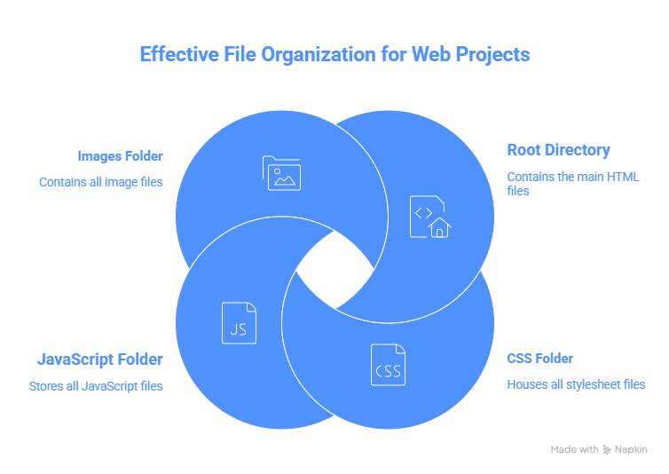

6. Practice Projects

Build these mini-projects to reinforce your learning. Each one focuses on a specific set of skills.

Project 1: Personal Profile Card

Skills: Box model, flexbox, styling
<!-- HTML -->
<div class="card">
<img src="avatar.jpg" alt="Profile Photo" class="avatar">
<h2>Aarav Sharma</h2>
<p class="title">Web Developer</p>
<p class="bio">Passionate about building beautiful websites.</p>
<div class="socials">
<a href="#">GitHub</a>
<a href="#">LinkedIn</a>
</div>
</div>
/* CSS */
.card {
width: 280px;
text-align: center;
padding: 32px;
border-radius: 12px;
box-shadow: 0 4px 20px rgba(0,0,0,0.12);
font-family: Arial, sans-serif;
margin: 40px auto;
}
.avatar {
width: 100px;
height: 100px;
border-radius: 50%;
margin-bottom: 16px;
}
.title { color: #6b7280; margin: 4px 0 12px; }
.bio { font-size: 14px; color: #374151; margin-bottom: 20px; }
.socials { display: flex; justify-content: center; gap: 12px; }
.socials a {
padding: 8px 16px;
background: #1a56db;
color: white;
border-radius: 6px;
text-decoration: none;
font-size: 14px;
}

Project 2: Responsive Navigation Bar

Skills: Flexbox, positioning, hover effects
<!-- HTML -->
<nav class="navbar">
<div class="logo">🌐 WebDev</div>
<ul class="nav-links">
<li><a href="#">Home</a></li>
<li><a href="#">About</a></li>
<li><a href="#">Portfolio</a></li>
<li><a href="#">Contact</a></li>
</ul>
<a href="#" class="nav-btn">Hire Me</a>
</nav>
/* CSS */
* { margin: 0; padding: 0; box-sizing: border-box; }
.navbar {
display: flex;
justify-content: space-between;
align-items: center;
padding: 16px 40px;
background: #0f172a;
position: sticky; top: 0;
}
.logo { color: white; font-size: 22px; font-weight: bold; }
.nav-links {
display: flex;
list-style: none;
gap: 32px;
}
.nav-links a {
color: #cbd5e1;
text-decoration: none;
font-size: 15px;
transition: color 0.2s;
}
.nav-links a:hover { color: #60a5fa; }
.nav-btn {
background: #2563eb;
color: white;
padding: 8px 20px;
border-radius: 6px;
text-decoration: none;
font-size: 14px;
}
.nav-btn:hover { background: #1d4ed8; }

Project 3: Contact Form

Skills: Forms, labels, input styling
<!-- HTML -->
<div class="form-container">
<h2>Get In Touch</h2>
<form>
<div class="form-group">
<label for="name">Full Name</label>
<input type="text" id="name" placeholder="Your name" required>
</div>
<div class="form-group">
<label for="email">Email Address</label>
<input type="email" id="email" placeholder="your@email.com" required>
</div>
<div class="form-group">
<label for="message">Message</label>
<textarea id="message" rows="5" placeholder="Write your message..."></textarea>
</div>
<button type="submit">Send Message</button>
</form>
</div>
/* CSS */
.form-container {
max-width: 480px;
margin: 40px auto;
padding: 40px;
border-radius: 12px;
box-shadow: 0 4px 24px rgba(0,0,0,0.1);
font-family: Arial, sans-serif;
}
h2 { margin-bottom: 24px; color: #1e40af; }
.form-group { margin-bottom: 20px; }
label { display: block; font-weight: bold; margin-bottom: 6px; color: #374151; }
input, textarea {
width: 100%;
padding: 10px 14px;
border: 1px solid #d1d5db;
border-radius: 6px;
font-size: 15px;
outline: none;
transition: border-color 0.2s;
}
input:focus, textarea:focus { border-color: #2563eb; }
button {
width: 100%;
padding: 12px;
background: #2563eb;
color: white;
border: none;
border-radius: 6px;
font-size: 16px;
cursor: pointer;
}
button:hover { background: #1d4ed8; }

Project 4: Product Card with Hover Effect

Skills: Card design, transitions, box-shadow
<!-- HTML -->
<div class="product-card">
<div class="product-badge">NEW</div>
<img src="product.jpg" alt="Product">
<div class="product-info">
<h3>Premium Headphones</h3>
<p>Noise-cancelling wireless headphones.</p>
<div class="price-row">
<span class="price">$99.00</span>
<button class="add-btn">Add to Cart</button>
</div>
</div>
</div>
/* CSS */
.product-card {
width: 300px;
border-radius: 12px;
overflow: hidden;
box-shadow: 0 2px 12px rgba(0,0,0,0.1);
transition: transform 0.3s, box-shadow 0.3s;
position: relative;
font-family: Arial, sans-serif;
}
.product-card:hover {
transform: translateY(-6px);
box-shadow: 0 8px 32px rgba(0,0,0,0.18);
}
.product-badge {
position: absolute; top: 12px; left: 12px;
background: #ef4444; color: white;
padding: 4px 10px; border-radius: 999px;
font-size: 12px; font-weight: bold;
}
.product-card img { width: 100%; height: 200px; object-fit: cover; }
.product-info { padding: 20px; }
.product-info h3 { margin-bottom: 8px; color: #111827; }
.product-info p { color: #6b7280; font-size: 14px; margin-bottom: 16px; }
.price-row { display: flex; justify-content: space-between; align-items: center; }
.price { font-size: 22px; font-weight: bold; color: #1a56db; }
.add-btn {
background: #1a56db; color: white;
border: none; padding: 8px 16px;
border-radius: 6px; cursor: pointer;
}

Project 5: Responsive Grid Photo Gallery

Skills: CSS Grid, responsive design, media queries
<!-- HTML -->
<section class="gallery">
<h2>Photo Gallery</h2>
<div class="gallery-grid">
<div class="photo-item"><img src="img1.jpg" alt="Photo 1"></div>
<div class="photo-item"><img src="img2.jpg" alt="Photo 2"></div>
<div class="photo-item"><img src="img3.jpg" alt="Photo 3"></div>
<div class="photo-item"><img src="img4.jpg" alt="Photo 4"></div>
<div class="photo-item"><img src="img5.jpg" alt="Photo 5"></div>
<div class="photo-item"><img src="img6.jpg" alt="Photo 6"></div>
</div>
</section>
/* CSS */
.gallery {
max-width: 1100px;
margin: 0 auto;
padding: 40px 16px;
font-family: Arial, sans-serif;
}
.gallery h2 {
text-align: center;
margin-bottom: 32px;
font-size: 32px;
color: #1e40af;
}
.gallery-grid {
display: grid;
grid-template-columns: repeat(auto-fit, minmax(280px, 1fr));
gap: 20px;
}
.photo-item {
border-radius: 10px;
overflow: hidden;
box-shadow: 0 2px 10px rgba(0,0,0,0.1);
transition: transform 0.3s;
}
.photo-item:hover { transform: scale(1.03); }
.photo-item img {
width: 100%;
height: 220px;
object-fit: cover;
display: block;
}

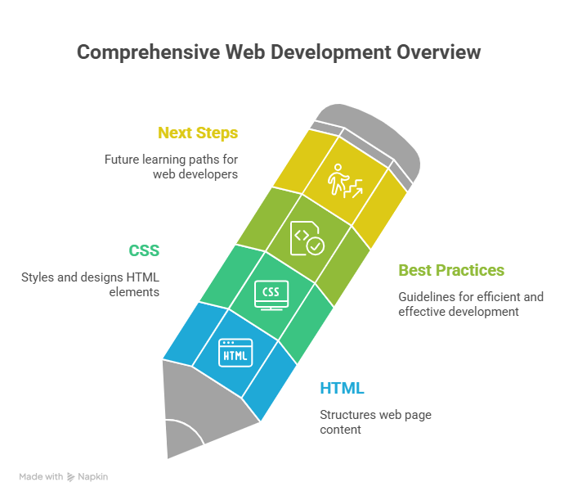

7. Summary

Congratulations! Here is a quick recap of everything covered in this guide:

HTML Summary
Concept | Key Takeaway
What is HTML | Markup language that structures web page content
Basic Structure | DOCTYPE → html → head + body
Headings | <h1> to <h6> — h1 most important, one per page
Text Elements | <p>, <strong>, <em>, <br>, <hr>
Links | <a href="..."> — use target="_blank" for new tab
Images | <img src="..." alt="..."> — alt is required
Lists | <ul> (bullets), <ol> (numbered), <dl> (definitions)
Tables | <table>, <thead>, <tbody>, <tr>, <th>, <td>
Forms | <form>, <input>, <label>, <select>, <textarea>, <button>
Semantic HTML | <header>, <nav>, <main>, <article>, <section>, <footer>
Attributes | id, class, href, src, alt, style, required, disabled

CSS Summary
Concept | Key Takeaway
What is CSS | Styles and designs HTML elements
Types of CSS | Inline / Internal / External (external is best)
Syntax | selector { property: value; }
Selectors | Element (p), Class (.name), ID (#name)
Box Model | Content → Padding → Border → Margin
Display | block, inline, inline-block, flex, grid, none
Position | static, relative, absolute, fixed, sticky
Flexbox | 1D layout — rows or columns, powerful alignment
Grid | 2D layout — rows AND columns, best for page layouts
Responsive | Viewport meta tag + Media queries (@media)

Best Practices Summary
- Use External CSS files — not inline styles
- Always use box-sizing: border-box on all elements
- Use semantic HTML elements, not just divs everywhere
- Mobile-first design — style for phones, then scale up
- Use meaningful class names in kebab-case
- Always include alt text on images
- Validate your HTML at validator.w3.org
- Use the browser DevTools to debug layout issues

🚀 Next Steps Once you're comfortable with HTML and CSS, start learning: JavaScript (interactivity), CSS frameworks (Tailwind CSS, Bootstrap), version control (Git & GitHub), and a frontend framework (React or Vue).

Happy Coding! 💻
Foundation of Web Development — HTML & CSS

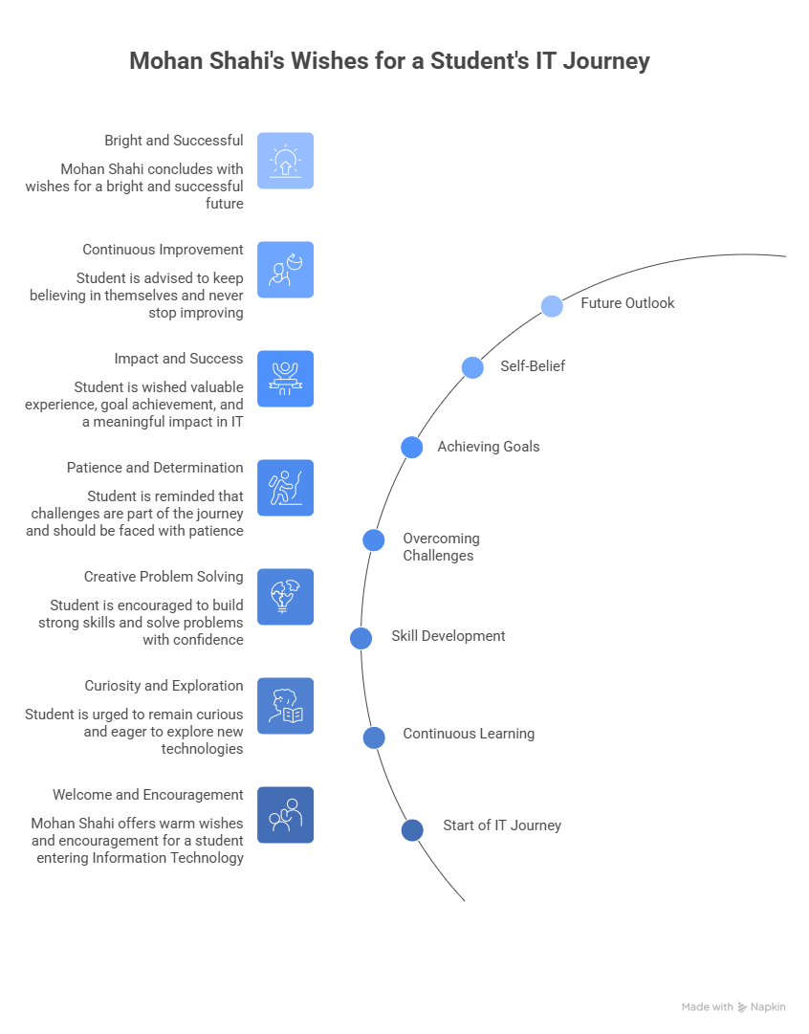

“Best Wishes for your IT Journey and Bright Future”
-Mohan Shahi

