Microsoft Office
Comprehensive Study Notes
Word · Excel · PowerPoint
Beginner to Advanced | Exam Preparation & Practical Use

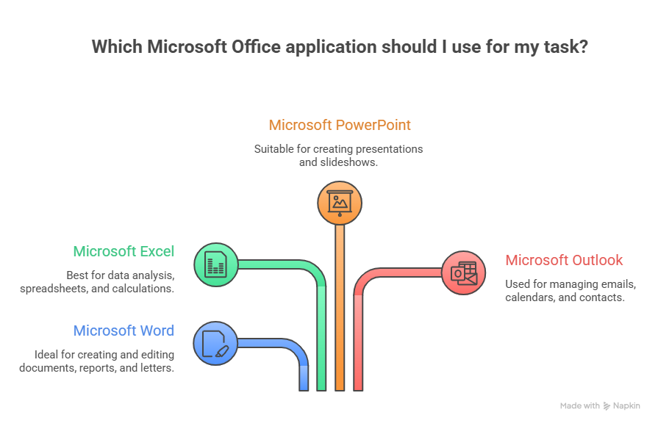
Prepared By: Mohan Shahi

Abstract
The Microsoft Office Comprehensive Study Notes is a carefully structured academic and practical guide designed to build a strong foundation in three essential productivity tools: Microsoft Word, Microsoft Excel, and Microsoft PowerPoint. In today’s digital era, proficiency in these applications is not just a technical skill but a fundamental requirement across education, business, administration, and professional communication.
This document adopts a progressive learning approach, starting from basic concepts and gradually advancing toward practical and exam-oriented applications. Each section is systematically organized to include interface understanding, core functionalities, step-by-step procedures, real-world examples, and keyboard shortcuts. This ensures that learners not only understand theoretical concepts but also develop hands-on operational skills.
The notes emphasize clarity, structured formatting, and practical relevance. Microsoft Word is presented as a powerful word processing tool for document creation and formatting; Microsoft Excel is explored as a data analysis and calculation engine; and Microsoft PowerPoint is introduced as a visual communication platform for effective presentations.
In addition, the inclusion of practical examples such as student result sheets, salary calculations, and slide design principles bridges the gap between learning and real-world application. The study material also aligns closely with examination requirements, highlighting frequently tested topics and essential commands.
Overall, this document serves as a complete learning resource for beginners, intermediate learners, and exam candidates, enabling them to develop both conceptual understanding and practical proficiency in Microsoft Office tools.

Happy learning and coding!

Table of Contents
Table of Contents 3
1. Microsoft Word 5
1.1 Introduction to MS Word 5
Key Features of MS Word 5
1.2 The MS Word Interface 5
Main Interface Components 6
Main Ribbon Tabs 7
1.3 Creating, Saving, and Opening Documents 7
1.4 Formatting Text 8
1.5 Paragraph Formatting 9
1.6 Page Setup 10
1.7 Inserting Elements 10
1.8 Headers, Footers & Page Numbers 10
1.11 Mail Merge — Step by Step 11
1.13 MS Word Keyboard Shortcuts 12
1.14 Section Summary — MS Word 12
2. Microsoft Excel 14
2.1 Introduction to MS Excel 14
2.2 The MS Excel Interface 14
2.3 Data Types in Excel 15
2.6 Formulas and Functions 15
Arithmetic Operators 15
Cell Reference Types 15
Common Functions 16
IF Function — Logic Diagram 16
VLOOKUP — How it Works 17
2.7 Sorting and Filtering 17
2.8 Creating Charts 17
2.9 Conditional Formatting 18
2.10 Practical Example: Student Result Sheet 19
2.11 Practical Example: Salary Calculation Sheet 19
2.12 MS Excel Keyboard Shortcuts 19
2.13 Section Summary — MS Excel 20
3. Microsoft PowerPoint 21
3.1 Introduction to MS PowerPoint 21
3.2 The PowerPoint Interface 21
PowerPoint Ribbon Tabs 22
3.4 Adding and Managing Slides 23
3.8 Animations 24
3.9 Transitions 25
3.10 Inserting Multimedia 25
3.11 Setting Up and Delivering the Slide Show 25
3.13 MS PowerPoint Keyboard Shortcuts 26
3.14 Section Summary — MS PowerPoint 26
Appendix: Comparison of Word, Excel & PowerPoint 28
Final Tips for Exam Success 29
General Study Tips 29
Most Tested Topics 29

SECTION 1: Microsoft Word — The Word Processor

1. Microsoft Word

1.1 Introduction to MS Word
Microsoft Word is a word processing software developed by Microsoft Corporation, first released in 1983. It is part of the Microsoft Office suite and is used for creating, editing, formatting, and printing text-based documents.

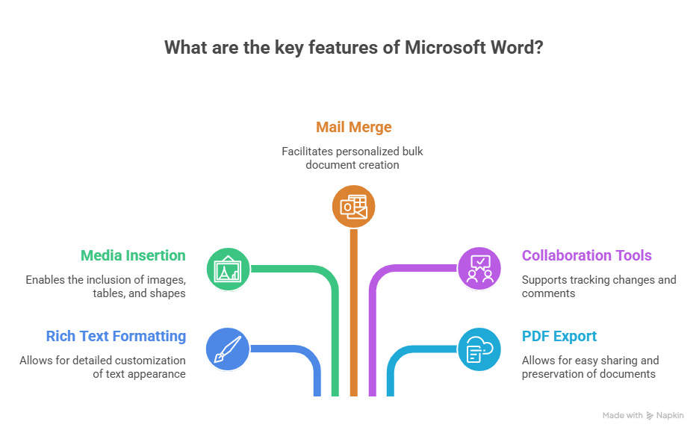

Key Features of MS Word
- Full-featured word processing with rich text formatting
- Tables, images, shapes, and SmartArt insertion
- Mail Merge for personalized bulk documents
- Spell check, grammar check, and thesaurus
- Page layout controls (margins, orientation, columns)
- Headers, footers, footnotes, and endnotes
- Track changes and comments for collaboration
- Export to PDF and other formats

1.2 The MS Word Interface
The diagram below shows all the major components of the MS Word interface:

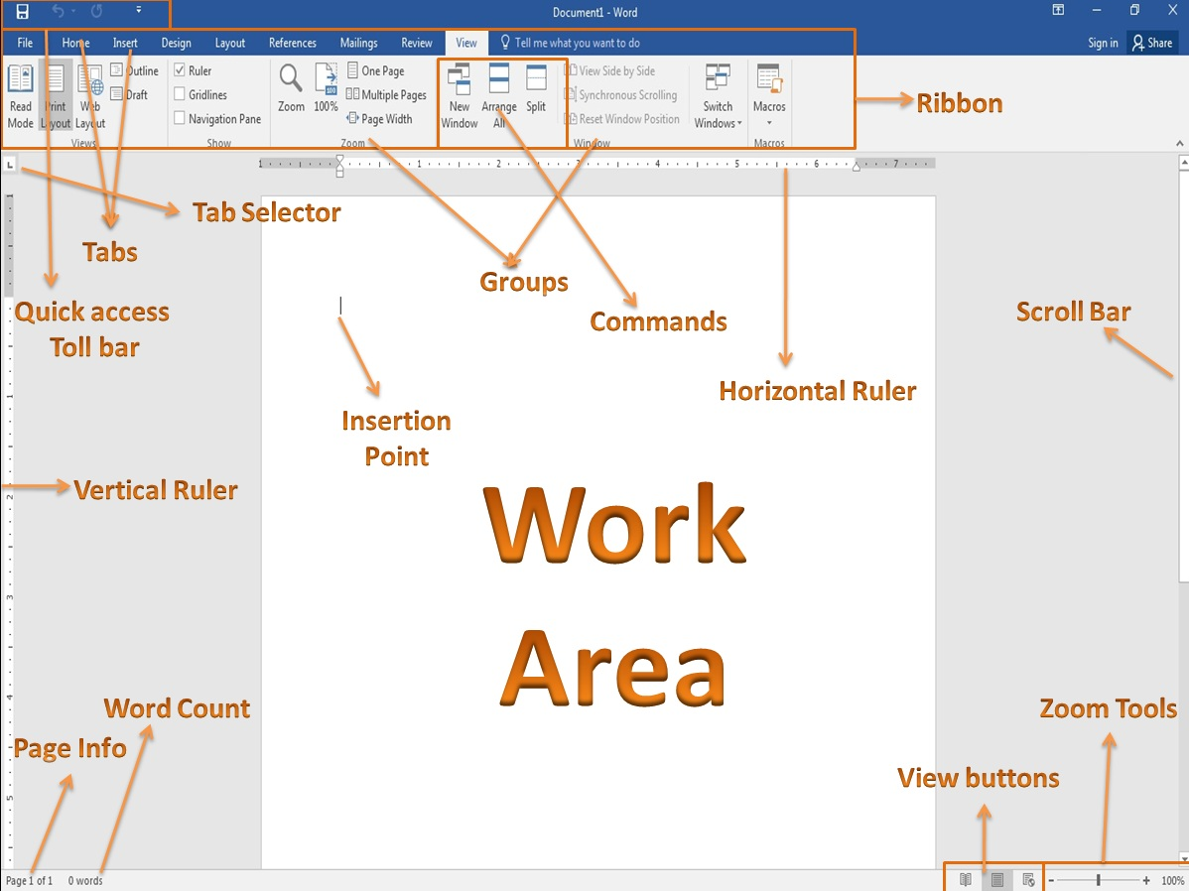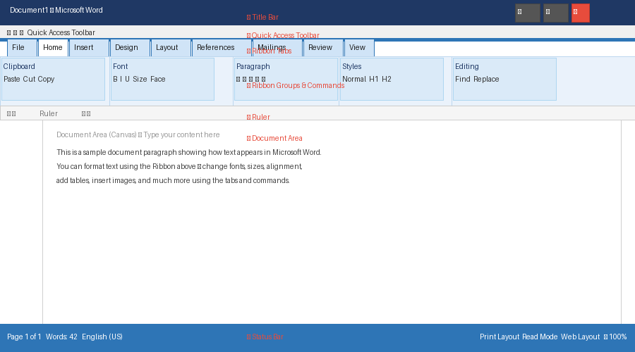
Figure 1.1 – Microsoft Word Interface Components

Main Interface Components
Component | Location | Purpose
Title Bar | Very top | Shows document name and app name. Has Minimize/Maximize/Close buttons.
Quick Access Toolbar | Above Ribbon | Customizable toolbar. Default: Save, Undo, Redo. Right-click to add commands.
Ribbon | Below Title Bar | Horizontal toolbar organized into Tabs → Groups → Commands.
Ruler | Below Ribbon | Set margins, tabs, and indentation. Horizontal + vertical.
Document Area | Center | White canvas where you type and edit your document.
Status Bar | Very bottom | Shows page number, word count, language, zoom, and view buttons.
Scroll Bars | Right & bottom edges | Navigate through the document vertically and horizontally.

💡 TIP
You can collapse the Ribbon by pressing Ctrl + F1 to get more screen space. Press again to restore.

Main Ribbon Tabs
Tab | Key Functions
File | New, Open, Save, Print, Export, Options (Backstage View)
Home | Clipboard, Font formatting, Paragraph formatting, Styles
Insert | Tables, Pictures, Shapes, SmartArt, Charts, Headers/Footers, Page Numbers
Design | Themes, Colors, Fonts, Page Borders
Layout | Margins, Orientation, Size, Columns, Indents, Spacing
References | Table of Contents, Footnotes, Citations, Index
Mailings | Mail Merge, Envelopes, Labels
Review | Spell Check, Comments, Track Changes, Compare
View | Print Layout, Web Layout, Zoom, Multiple Windows, Macros

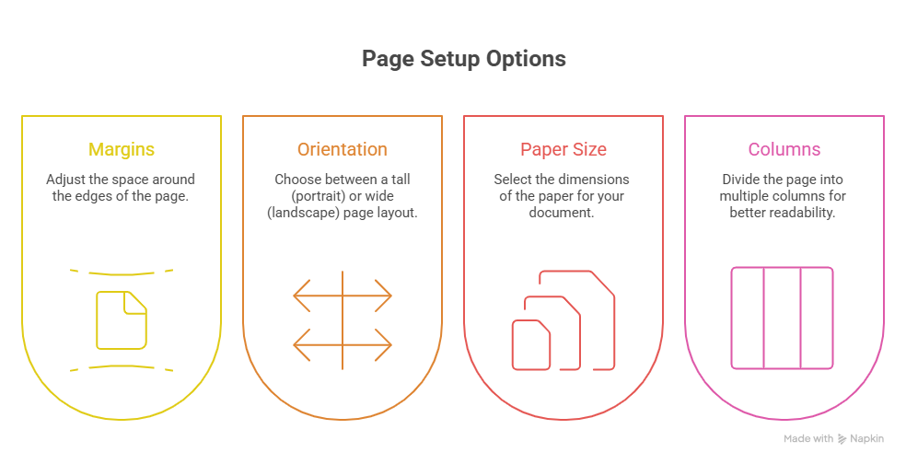

1.3 Creating, Saving, and Opening Documents
Action | Steps | Shortcut
New Document | Launch Word → Start Screen → Click 'Blank document' | Ctrl + N
Save As (First Save) | File → Save As → Choose location → Enter name → Choose format → Save | F12
Save (Subsequent) | Click Save icon (floppy disk) in Quick Access Toolbar | Ctrl + S
Open Document | File → Open → Choose location → Browse and double-click | Ctrl + O

💡 TIP
Enable AutoSave (toggle in top-left) when using OneDrive to automatically save every few seconds.

1.4 Formatting Text
Formatting makes your text more readable and visually appealing. The Home tab contains most text formatting tools.

Option | Description | Shortcut / Button
Bold | Makes text appear thicker/heavier | Ctrl + B
Italic | Makes text slant to the right | Ctrl + I
Underline | Adds a line below text | Ctrl + U
Strikethrough | Draws a line through text | ab button in Font group
Font Color | Changes the color of text | Font Color button (A with color)
Highlight Color | Adds background color behind text | Highlight Color button
Superscript | Raises text above the baseline (e.g. x²) | Ctrl + Shift + =
Subscript | Lowers text below the baseline (e.g. H₂O) | Ctrl + =
Change Case | Changes capitalization (UPPER, lower, Title Case) | Aa button → choose option
Clear Formatting | Removes all formatting from selected text | Eraser button

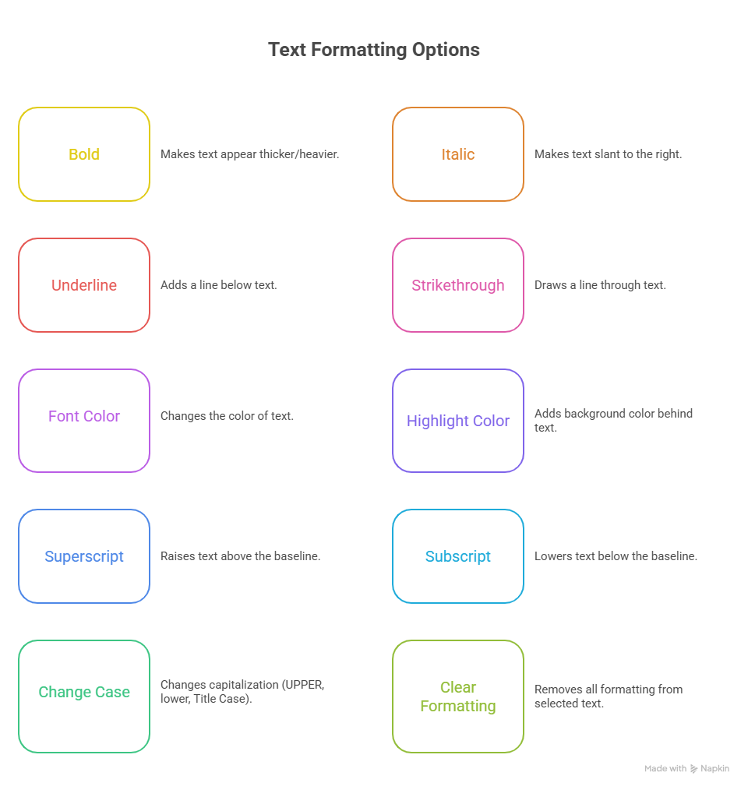

1.5 Paragraph Formatting
Alignment | Description | Shortcut
Left Align | Text lines up with the left margin (default) | Ctrl + L
Center Align | Text is centered between both margins | Ctrl + E
Right Align | Text lines up with the right margin | Ctrl + R
Justify | Text stretches to align with both left and right margins | Ctrl + J

📝 NOTE
Double spacing (2.0) is commonly required in academic papers and reports. Set via Home → Paragraph group → Line and Paragraph Spacing.

1.6 Page Setup
Setting | Options | How to Access
Margins | Normal (1"), Narrow (0.5"), Wide (2"), Custom | Layout → Margins
Orientation | Portrait (tall, default) / Landscape (wide) | Layout → Orientation
Paper Size | A4, Letter, Legal, A3, Custom | Layout → Size
Columns | 1, 2, 3, Left, Right, Custom | Layout → Columns

📝 NOTE
Standard margin is 1 inch (2.54 cm) on all sides. Narrow margin (0.5 inches) allows more content per page.

1.7 Inserting Elements
Element | Steps to Insert | Key Options
Table | Insert → Table → select rows/columns grid | Table Design & Layout tabs for formatting
Image | Insert → Pictures → This Device or Online Pictures | Picture Format tab: crop, wrap text, styles
Shape | Insert → Shapes → click a shape → draw on document | Shape Format tab: fill, outline, effects
SmartArt | Insert → SmartArt → choose category and layout | SmartArt Design tab: change colors and style
Chart | Insert → Chart → choose type → enter data | Chart Design and Format tabs

SmartArt Type | Best Used For | Example
List | Showing non-sequential items | Features of a product
Process | Step-by-step workflows | Hiring process steps
Cycle | Repeating / circular processes | Software development lifecycle
Hierarchy | Organizational structures | Company org chart
Relationship | Connections or overlapping concepts | Venn diagrams
Matrix | How parts relate to a whole | SWOT quadrant analysis
Pyramid | Proportional or hierarchical relationships | Maslow's Hierarchy of Needs

1.8 Headers, Footers & Page Numbers
Feature | Steps | Tip
Insert Header | Insert → Header & Footer → Header → choose style | Double-click header area to edit; press Esc to exit
Insert Footer | Insert → Header & Footer → Footer → choose style | Use different first-page option for title pages
Page Numbers | Insert → Page Number → choose position/style | Format Page Numbers to start at 0 or use Roman numerals

1.11 Mail Merge — Step by Step
Mail Merge combines a main document with a data source (e.g., Excel file) to produce personalized copies for multiple recipients.

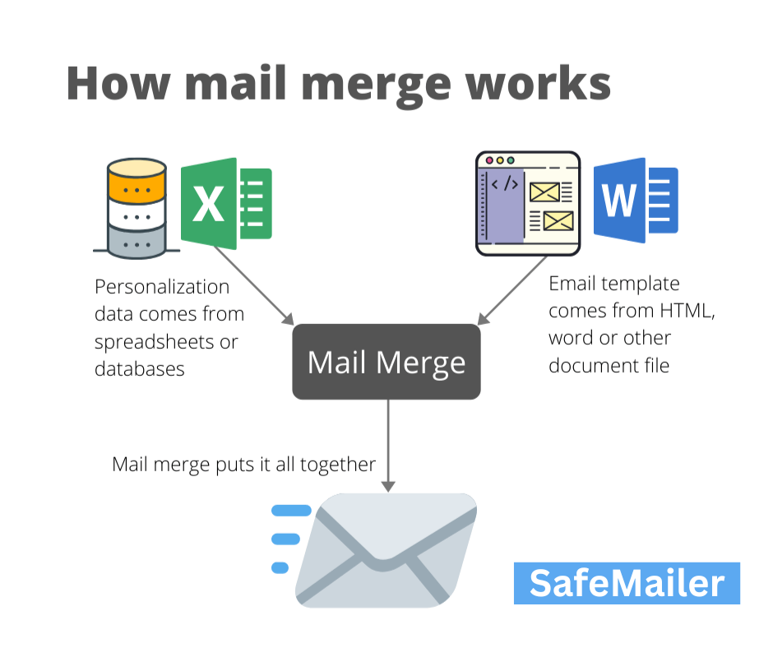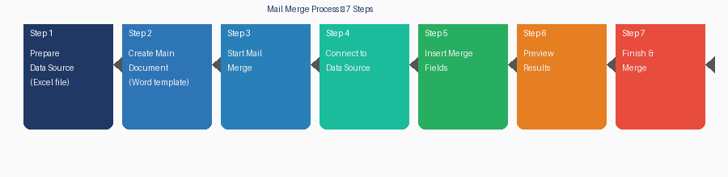
Figure 1.2 – Mail Merge Process Flow (7 Steps)

Step | Action | Details
1 | Prepare Data Source | Create Excel file with columns: First Name, Last Name, Address, City
2 | Create Main Document | Open Word, type letter template with spaces for merge fields
3 | Start Mail Merge | Mailings tab → Start Mail Merge → select document type (Letters)
4 | Connect Data Source | Mailings → Select Recipients → Use an Existing List → browse to Excel file
5 | Insert Merge Fields | Position cursor → Mailings → Insert Merge Field → select field (<<First Name>>)
6 | Preview Results | Mailings → Preview Results → use arrows to check each recipient
7 | Finish & Merge | Mailings → Finish & Merge → Edit Individual Documents / Print / Send Email

💡 TIP
Always preview before printing! Use 'Edit Individual Documents → All' to create one large document with all merged letters.

1.13 MS Word Keyboard Shortcuts
Shortcut | Action | Shortcut | Action
Ctrl + N | New document | Ctrl + Z | Undo last action
Ctrl + O | Open document | Ctrl + Y | Redo last action
Ctrl + S | Save document | Ctrl + B | Bold text
Ctrl + P | Print document | Ctrl + I | Italic text
Ctrl + A | Select all | Ctrl + U | Underline text
Ctrl + F | Find text | Ctrl + H | Find and replace
Ctrl + E | Center aligns | Ctrl + L | Left align
Ctrl + R | Right align | Ctrl + J | Justify
Ctrl + Home | Go to beginning | Ctrl + End | Go to end
F7 | Spell Check | Alt + F4 | Close Word

1.14 Section Summary — MS Word
Topic | Key Points to Remember
Interface | Ribbon has Tabs → Groups → Commands. Status Bar at bottom shows page/word count.
Saving | Use CTRLs often. First save = Save As. Choose .docx format for compatibility.
Formatting | Font group (Home tab) for text; Paragraph group for alignment, spacing, indentation.
Page Setup | Layout tab → Margins, Orientation, Size. Standard is 1-inch margins.
Tables | Insert → Table. Table Design and Layout tabs appear when cursor is inside.
Mail Merge | Requires: Main document + Data source. Mailings tab guides the full process.
Shortcuts | CTRL’s (Save), CTRL (Bold), CTRL (Find), CTRL (Replace), F7 (Spell Check)

SECTION 2: Microsoft Excel — The Spreadsheet Application

2. Microsoft Excel

2.1 Introduction to MS Excel
Microsoft Excel is a powerful spreadsheet program used for organizing, analyzing, and visualizing data through rows, columns, formulas, functions, charts, and automation. It is widely used in business, finance, education, science, and administration.

2.2 The MS Excel Interface
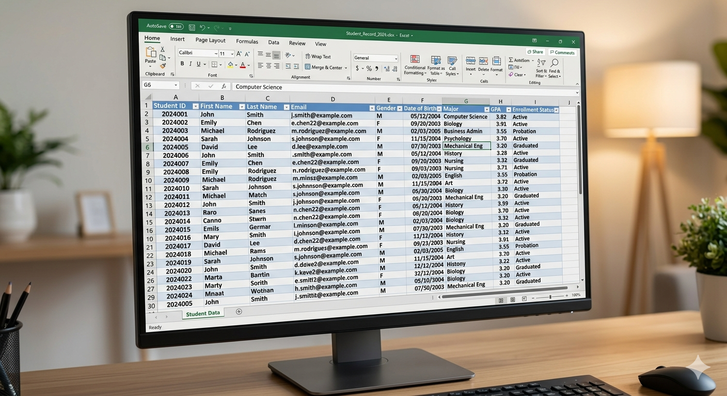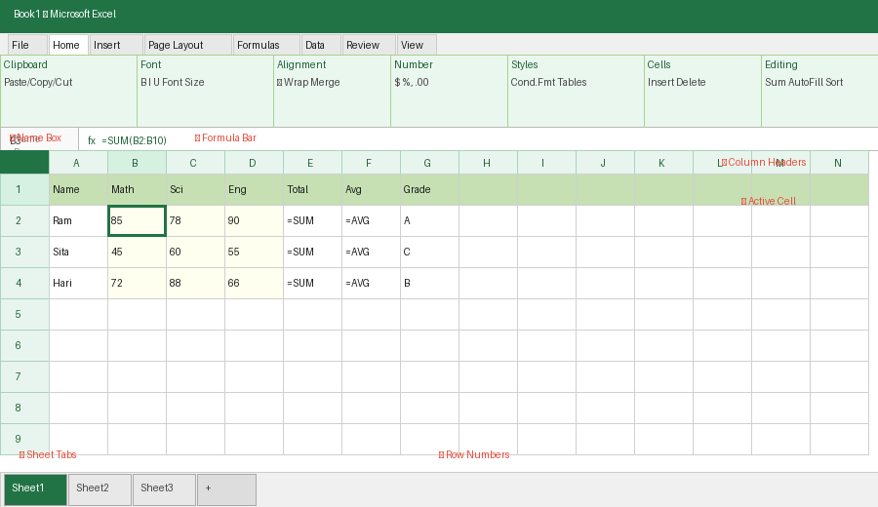
Figure 2.1 – Microsoft Excel Interface with Sample Student Data

Component | Description
Workbook | The Excel file (.xlsx). One file = one workbook. Think of it as a notebook.
Worksheet (Sheet) | A single grid of cells within a workbook. Default: Sheet1. Add more with + button.
Rows | Horizontal lines of cells, numbered 1, 2, 3… (up to 1,048,576 rows)
Columns | Vertical lines of cells, labeled A, B, C… Z, AA, AB… (up to 16,384 columns)
Cell | Intersection of a row and column. Each has a unique address (e.g., A1, B5).
Name Box | Top-left — shows active cell address. Type an address + Enter to jump there.
Formula Bar | Above grid — shows the content/formula of the active cell.
Sheet Tabs | Bottom of screen — one tab per worksheet. Right-click to rename/insert/delete.

2.3 Data Types in Excel
Data Type | Description | Examples | Default Alignment
Text (Labels) | Letters, words, any non-numeric data | Name, City, Product | Left
Numbers | Numeric values for calculation | 100, 3.14, -50 | Right
Dates & Times | Recognized date/time formats | 01/15/2025, 9:30 AM | Right
Formulas | Expressions that calculate values (start with =) | =A1+B1, =SUM (A1:A10) | Depends on result
Boolean | TRUE or FALSE logical values | TRUE, FALSE | Center

2.6 Formulas and Functions
Formulas are expressions that perform calculations. They always begin with an equal’s sign (=).

Arithmetic Operators
Operator | Meaning | Example | Result
+ | Addition | =A1+B1 | Sum of A1 and B1
- | Subtraction | =A1-B1 | A1 minus B1
* | Multiplication | =A1*B1 | A1 multiplied by B1
/ | Division | =A1/B1 | A1 divided by B1
^ | Exponentiation (Power) | =A1^2 | A1 squared
% | Percentage | =A1*10% | 10% of A1

Cell Reference Types
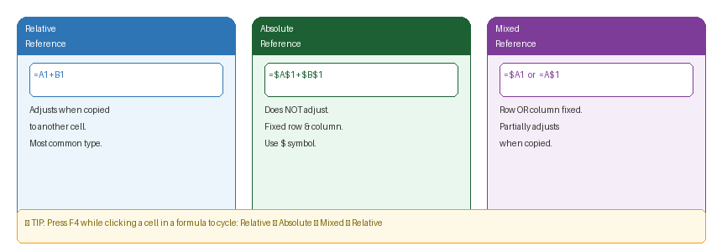
Figure 2.2 – Cell Reference Types: Relative, Absolute & Mixed

Reference Type | Example | Description
Relative | =A1+B1 | Adjusts when copied to another cell. Most common type.
Absolute | =$A$1+$B$1 | Does NOT adjust when copied. Fixed row and column. Use $ symbol.
Mixed | =$A1 or =A$1 | Row or column is fixed, but not both. Partially adjusts when copied.

💡 TIP
Press F4 while clicking a cell reference in a formula to cycle through: Relative → Absolute → Mixed → Relative.

Common Functions
Function | Syntax | Example | What it Does
SUM | =SUM (range) | =SUM (B2:B10) | Adds all numbers in the range
AVERAGE | =AVERAGE (range) | =AVERAGE (C2:C10) | Returns the arithmetic mean
COUNT | =COUNT (range) | =COUNT (D2:D20) | Counts cells with numeric values
MAX | =MAX (range) | =MAX (B2:B10) | Returns the largest value
MIN | =MIN (range) | =MIN (B2:B10) | Returns the smallest value
IF | =IF (test, true, false) | =IF(B2>=40,"Pass","Fail") | Conditional result based on test
COUNTA | =COUNTA (range) | =COUNTA (A1:A20) | Counts all non-empty cells
VLOOKUP | =VLOOKUP (val, range, col, false) | =VLOOKUP (A2, D2:F10,2, FALSE) | Searches and retrieves data

IF Function — Logic Diagram
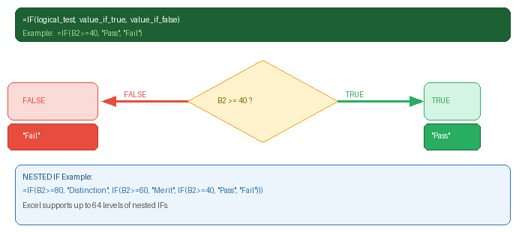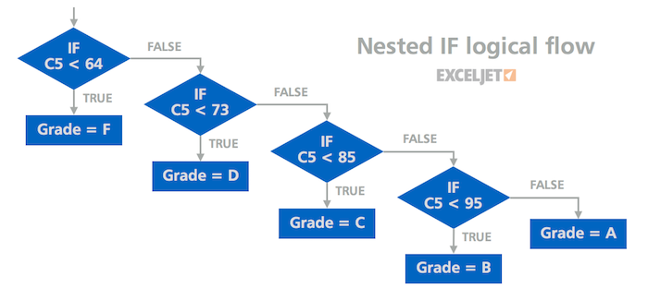
Figure 2.3 – IF Function Logic Flow with Nested IF Example

VLOOKUP — How it Works
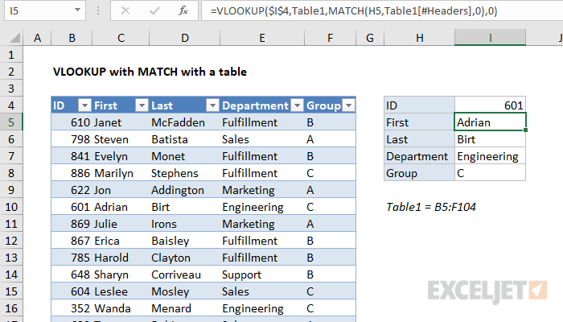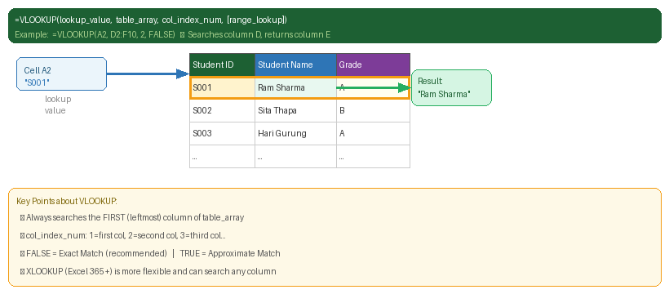
Figure 2.4 – VLOOKUP: Searching a Table and Returning a Value

2.7 Sorting and Filtering
Feature | Steps | Key Options
Sort | Data tab → Sort & Filter → Sort | Add Level for multi-column sort; always check 'My data has headers'
AutoFilter | Data tab → Sort & Filter → Filter | Drop-downs on each column. Use Number/Text Filters for conditions.
Clear Filter | Click filter arrow → 'Clear Filter from column' | Or Data → Filter to toggle off completely

2.8 Creating Charts
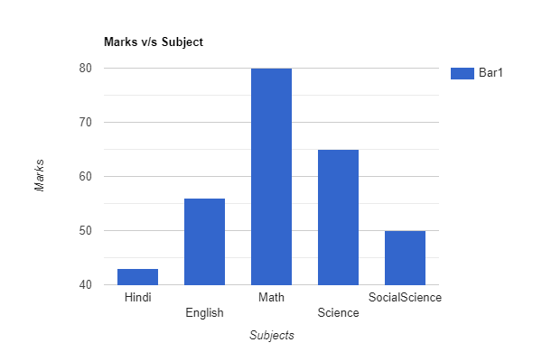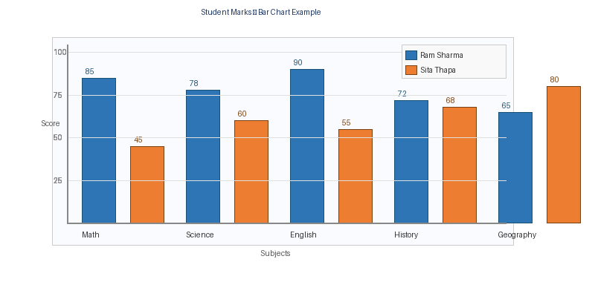
Figure 2.5 – Bar Chart Example: Student Marks by Subject

Chart Type | Best Used When | Example Use
Column / Bar Chart | Comparing values across categories | Sales by month, Marks by subject
Line Chart | Showing trends over time | Temperature over days, Stock price
Pie Chart | Showing proportions of a whole (<7 categories) | Market share, Budget allocation
Scatter Chart | Showing relationship between two numeric variables | Height vs. Weight correlation
Area Chart | Like line chart but with shaded area (shows volume) | Revenue over quarters

2.9 Conditional Formatting
Rule Type | Description | Best Use
Highlight Cell Rules | Greater Than, Less Than, Equal To, Duplicate Values | Highlight scores above/below threshold
Top/Bottom Rules | Top 10 items, Bottom 10%, Above/Below Average | Find top performers
Data Bars | Horizontal bars within cells proportional to values | Visual comparison within a column
Color Scales | Gradient colors (e.g. red → yellow → green) | Exam scores at a glance
Icon Sets | Arrows, traffic lights, stars indicating value levels | Quick status indicators

2.10 Practical Example: Student Result Sheet
Column | Formula | Purpose
Total | =SUM (B2:D2) | Adds Math + Science + English scores
Average | =AVERAGE (B2:D2) | Calculates the mean of all subjects
Grade | =IF(F2>=80,"A”, IF(F2>=60,"B”, IF(F2>=40,"C","D"))) | Assigns grade based on average
Result | =IF(F2>=40,"Pass","Fail") | Determines pass or fail

2.11 Practical Example: Salary Calculation Sheet
Column | Heading | Formula
A | Employee Name | Text data entry
B | Basic Salary | Number entry
C | HRA (40%) | =B2*40%
D | Allowance (10%) | =B2*10%
E | Gross Salary | =B2+C2+D2
F | Tax (10%) | =E2*10%
G | PF (12%) | =E2*12%
H | Net Salary | =E2-F2-G2

2.12 MS Excel Keyboard Shortcuts
Shortcut | Action | Shortcut | Action
Ctrl + N | New workbook | Alt + = | AutoSum selected range
Ctrl + S | Save workbook | F2 | Edit active cell
Ctrl + O | Open workbook | F4 | Toggle absolute/relative reference
Ctrl + Home | Go to cell A1 | Ctrl + 1 | Open Format Cells dialog
Ctrl + End | Go to last used cell | Ctrl + Shift + $ | Apply Currency format
Ctrl + Arrow | Jump to edge of data | Ctrl + Shift + % | Apply Percentage format
Ctrl + D | Fill Down | Ctrl +; | Insert current date
Ctrl + R | Fill Right | Ctrl + Shift +; | Insert current time
Delete | Clear cell contents | Ctrl + F | Find & replace

2.13 Section Summary — MS Excel
Topic | Key Points to Remember
Workbook vs. Worksheet | Workbook = file (.xlsx). Worksheet = tab/sheet within the file.
Cell Reference | Every cell has an address (A1, B3). Formulas use references, not values.
Absolute Reference | Use $ to lock a row/column ($A$1). Essential when copying formulas.
SUM / AVERAGE | =SUM (A1:A10) and =AVERAGE (A1:A10) are the most-used functions.
IF Function | =IF (test, value_if_true, value_if_false). Foundation of all logic in Excel.
VLOOKUP | Searches left column of a range and returns a value from a specified column.
Sorting & Filtering | Sort: reorders data. Filter: hides rows that don't match criteria.
Charts | Select data → Insert → Charts. Choose type appropriate to your data.
Conditional Formatting | Home → Conditional Formatting → rules apply colors/icons automatically.

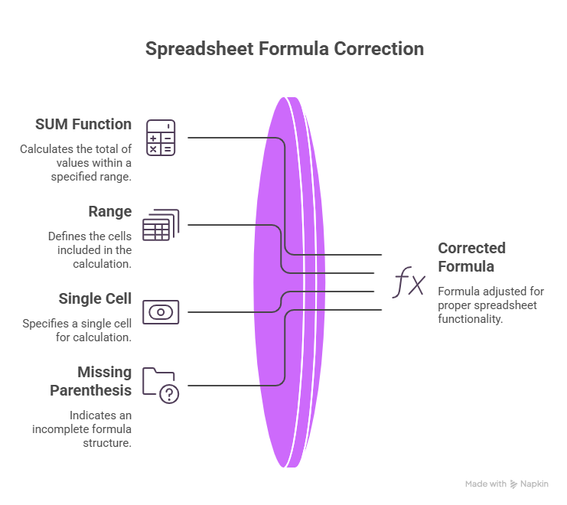
SECTION 3: Microsoft PowerPoint — The Presentation Application

3. Microsoft PowerPoint

3.1 Introduction to MS PowerPoint
Microsoft PowerPoint is a presentation software that allows users to create visual slideshows combining text, images, charts, animations, audio, and video. Used for business meetings, academic lectures, training, sales pitches, and public speeches.

3.2 The PowerPoint Interface
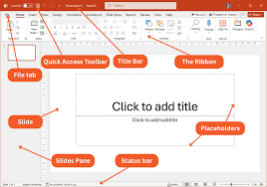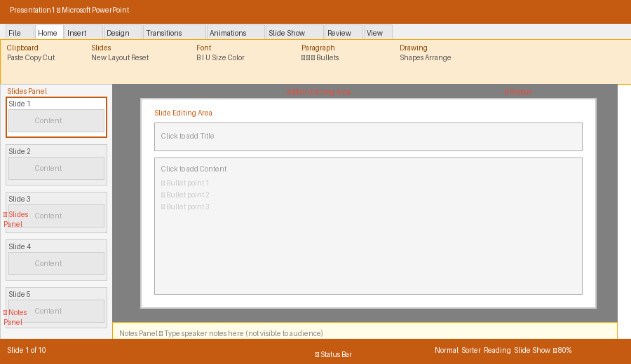
Figure 3.1 – Microsoft PowerPoint Interface Components

Component | Location | Purpose
Slides Panel | Left side | Thumbnail previews of all slides. Click to navigate; drag to rearrange.
Slide Editing Area | Center | Main area where you create and edit the current slide.
Notes Panel | Below slide | Speaker notes — not visible to audience during presentation.
Ribbon | Top | Tabs: Home, Insert, Design, Transitions, Animations, Slide Show, etc.
Status Bar | Bottom | Shows slide number/total, view buttons, zoom slider.

PowerPoint Ribbon Tabs
Tab | Key Functions
File | New, Open, Save, Export, Print, Share (Backstage View)
Home | Clipboard, Slides (New/Layout/Reset), Font, Paragraph, Drawing
Insert | Tables, Images, Icons, SmartArt, Charts, Media (Audio/Video), Hyperlinks, Text Boxes
Design | Themes, Variants, Slide Size, Format Background
Transitions | Slide Transition Effects and Timing
Animations | Object Animation Effects, Animation Pane, Timing
Slide Show | Start from Beginning/Current, Set Up Show, Record, Rehearse Timings
Review | Spell Check, Comments, Compare
View | Normal, Outline, Slide Sorter, Notes Page, Slide Master, Zoom

3.4 Adding and Managing Slides
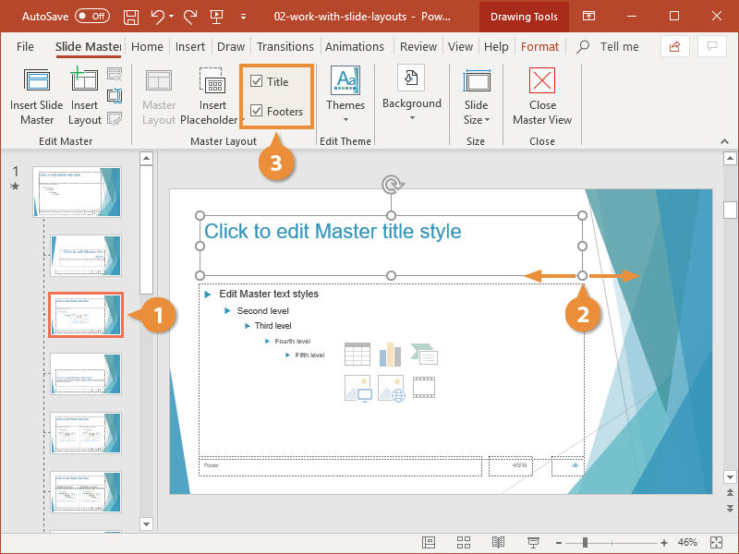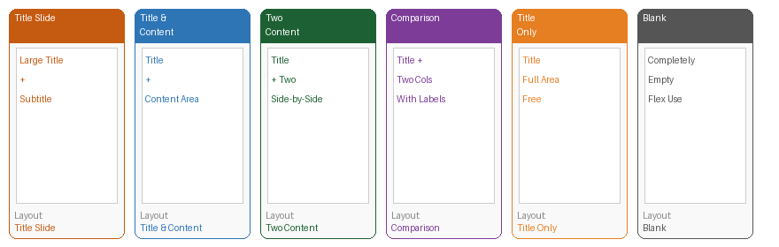
Figure 3.2 – PowerPoint Slide Layout Options

Layout Name | Description | Best Used For
Title Slide | Large title and subtitle | First (cover) slide of the presentation
Title and Content | Title at top + one content area below | Most common: text, bullet points, images
Two Content | Title + two side-by-side areas | Comparisons or parallel information
Comparison | Like Two Content but with column labels | Comparing two items with labels
Title Only | Only a title placeholder | Custom content fills the rest of slide
Blank | Completely empty | Maximum design flexibility
Picture with Caption | Image + caption below | Photo-focused slides with description

3.8 Animations
Animations are effects applied to individual objects on a slide — they control how objects appear, disappear, or move.

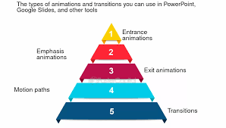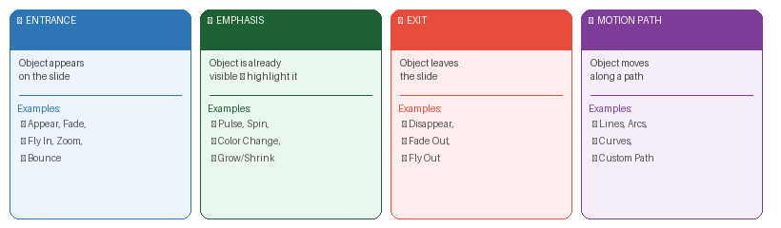
Figure 3.3 – Four Animation Categories in PowerPoint

Category | Effect Type | Examples
Entrance | Controls how an object APPEARS on the slide | Appear, Fade, Fly In, Zoom, Bounce
Emphasis | Highlights an object already VISIBLE | Pulse, Color Change, Spin, Grow/Shrink
Exit | Controls how an object DISAPPEARS from the slide | Disappear, Fade Out, Fly Out, Shrink
Motion Paths | MOVES the object along a drawn path | Lines, Arcs, Curves, Custom Path

Start Option | Meaning
On Click (default) | Animation plays when presenter clicks the mouse
With Previous | Plays simultaneously with the previous animation
After Previous | Plays automatically after the previous animation finishes

3.9 Transitions
Transitions are effects that occur when moving from one slide to the NEXT. They are applied at the slide level (not object level like animations).

Type | Examples | Recommended Use
Subtle | Cut, Fade, Push, Wipe | Professional presentations — minimal distraction
Exciting | Cube, Ripple, Honeycomb, Vortex | Eye-catching slides — use sparingly
Dynamic Content | Pan, Orbit, Fly Through | Impactful title or section slides

⚠ IMPORTANT
Avoid using too many different transitions. A consistent, simple transition (like Fade) creates a more professional look. Use 'Apply to All' for consistency.

3.10 Inserting Multimedia
Media | Insert Path | Playback Options
Audio | Insert → Media → Audio → Audio on My PC / Record Audio | Automatically / On Click, Loop, Hide icon during show
Video (Embedded) | Insert → Media → Video → This Device | Automatically / On Click, Loop, Fade in/out — stays in file
Online Video | Insert → Media → Video → Online Video | Requires internet connection during presentation

3.11 Setting Up and Delivering the Slide Show
Action | Shortcut / Method | Notes
Start from Slide 1 | F5 | Starts full-screen presentation from beginning
Start from Current Slide | Shift + F5 | Useful for testing a specific section
Next Slide / Animation | Click / Space / Right Arrow / Page Down | Advances presentation
Previous Slide | Backspace / Left Arrow / Page Up | Goes back
Jump to Slide N | Type number + Enter (e.g., 5 + Enter) | Jumps directly to slide 5
End Presentation | Esc | Exits slideshow and returns to editing
Blackout Screen | B | Turns screen black (press again to resume)
Whiteout Screen | W | Turns screen white (press again to resume)

💡 TIP
Presenter View shows your notes, the next slide, and a timer — only on your screen. The audience sees only the full-screen slide. Enable via: Slide Show → Use Presenter View.

3.13 MS PowerPoint Keyboard Shortcuts
Shortcut | Action | Shortcut | Action
Ctrl + N | New presentation | F5 | Start from slide 1
Ctrl + M | Insert new slide | Shift + F5 | Start from current slide
Ctrl + D | Duplicate slide/object | Esc | End slide show
Ctrl + G | Group selected objects | B | Blackout screen
Ctrl + Shift + G | Ungroup objects | W | Whiteout screen
Ctrl + B / I / U | Bold / Italic / Underline | Tab | Select next object on slide
Ctrl + E / L / R | Center / Left / Right align | Shift + Tab | Select previous object
Ctrl + F | Find text | Ctrl + P | Print presentation
Ctrl + Z / Y | Undo / Redo | Alt + Shift + D | Insert date on slide

3.14 Section Summary — MS PowerPoint
Topic | Key Points to Remember
Interface | Slides panel (left), Editing area (center), Notes panel (bottom), Ribbon (top).
Slides | Use layouts for consistent structure. Home → New Slide → choose layout.
Design | Design tab → Themes. Keep consistent. Use Slide Master for global changes.
Animations | Applied to individual OBJECTS. Four types: Entrance, Emphasis, Exit, Motion Path.
Transitions | Applied to entire SLIDES. Transitions tab. Use 'Apply to All' for consistency.
Slide Show | F5 = start from beginning. Shift+F5 = current slide. Esc = exit.
Presenter View | Slide Show tab → Use Presenter View. Shows notes, next slide, timer.

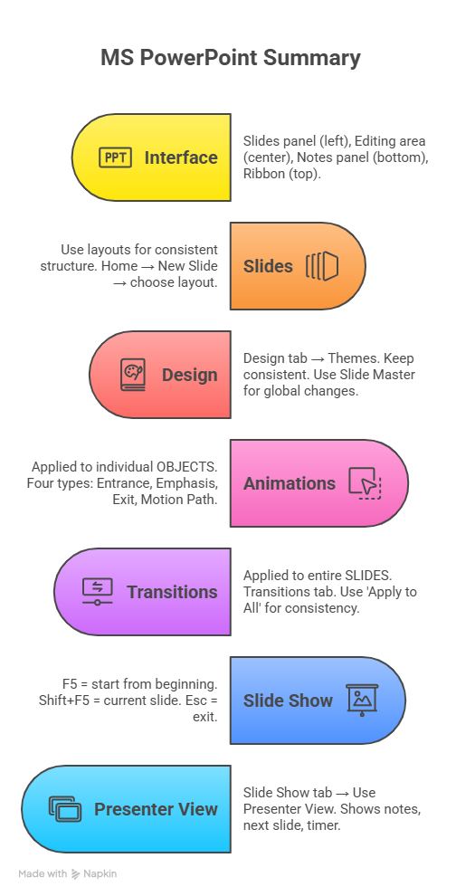

Appendix: Comparison of Word, Excel & PowerPoint
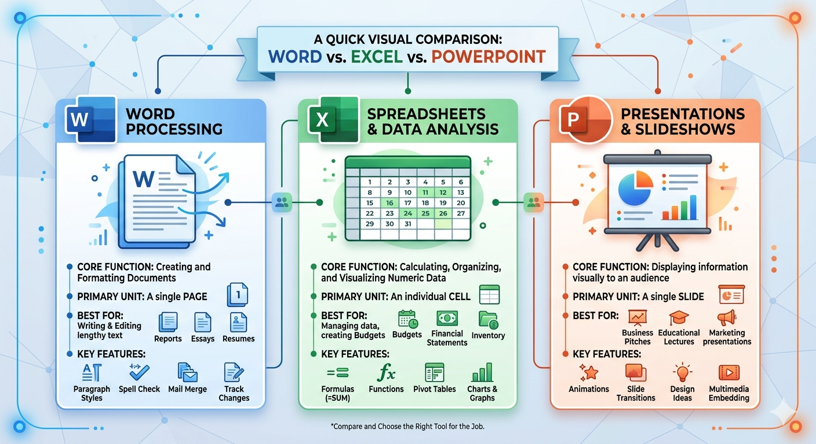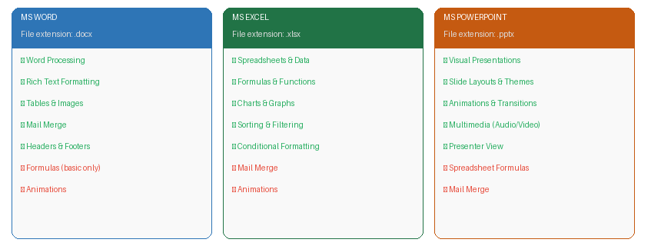
Figure A.1 – Quick Comparison: MS Word vs Excel vs PowerPoint

Feature / Aspect | MS Word | MS Excel | MS PowerPoint
Primary Purpose | Creating text documents | Data analysis & calculation | Visual presentations
File Extension | .docx | .xlsx | .pptx
Main Working Area | Scrollable pages | Grid of cells | Individual slides
Primary Content | Text, paragraphs, tables | Numbers, formulas, data | Text, images, animations
Key Strength | Formatting & word processing | Calculations & data analysis | Visual storytelling
Charts | Yes (via Insert) | Yes (core feature) | Yes (via Insert)
Tables | Yes (core feature) | Yes (via Format as Table) | Yes (via Insert)
SmartArt | Yes | No | Yes
Mail Merge | Yes (core feature) | No | No
Formulas | Basic only | Yes (core feature) | No
Animations | Limited | No | Yes (core feature)
Slide Show Mode | No | No | Yes (core feature)
Save as PDF | Yes | Yes | Yes

Final Tips for Exam Success

General Study Tips
- Practice each application hands-on — reading alone is not enough.
- Create sample documents: a letter in Word, a grade sheet in Excel, a 5-slide presentation in PowerPoint.
- Memorize the most common keyboard shortcuts — exams often include shortcut questions.
- Know the correct Tab and Group location for every major feature.
- For Excel: practice writing formulas from scratch without looking them up.
- For PowerPoint: understand the difference between Transitions (slide-level) and Animations (object-level).

Most Tested Topics
Application | High-Frequency Exam Topics
MS Word | Ribbon interface, formatting shortcuts, page setup, mail merge steps, table operations
MS Excel | Cell references (relative/absolute), SUM/AVERAGE/IF/VLOOKUP functions, sorting, chart types
MS PowerPoint | Slide layouts, adding animations, transition vs. animation, Presenter View, F5 shortcut

Conclusion
The comprehensive study of Microsoft Word, Excel, and PowerPoint presented in this document highlights the integral role these applications play in modern digital workflows. Each tool serves a distinct yet interconnected purpose—Word for structured documentation, Excel for intelligent data processing, and PowerPoint for impactful presentation—forming a complete ecosystem of productivity.
Through detailed explanations, structured content, and practical examples, this material successfully transforms complex functionalities into understandable and usable knowledge. The emphasis on keyboard shortcuts, real-life applications, and exam-focused topics ensures that learners can efficiently apply their skills in both academic and professional environments.
A key strength of this document lies in its balance between theory and practice. It not only explains “how” features work but also demonstrates “where” and “why” they are used. This approach enhances problem-solving ability and prepares learners to handle real-world tasks with confidence and efficiency.
Furthermore, the comparative analysis of the three applications provides a holistic understanding of their unique capabilities and appropriate use cases. The final tips and study strategies reinforce the importance of continuous practice, conceptual clarity, and practical implementation.

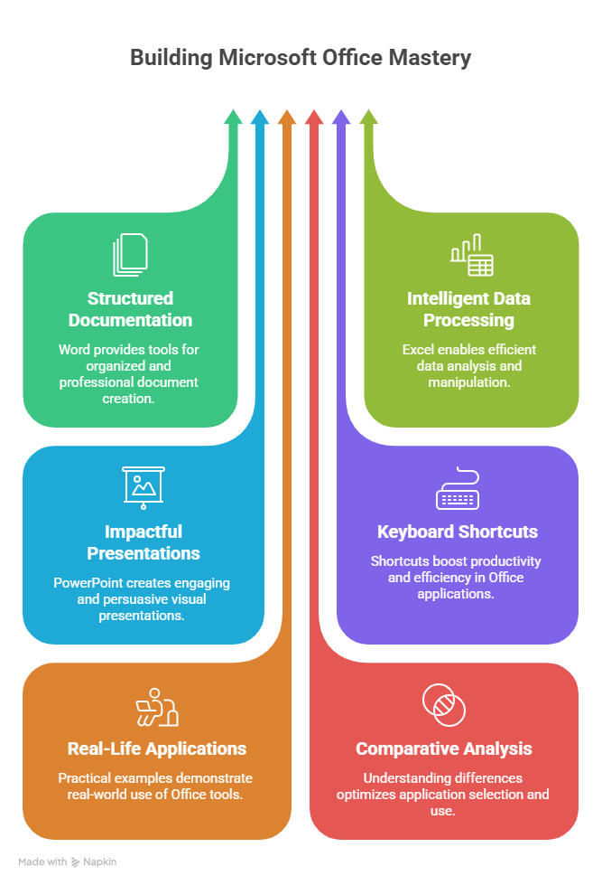
In conclusion, mastering Microsoft Office is a critical step toward digital literacy and professional competence. This study guide serves as a reliable and complete resource to achieve that goal, equipping learners with the knowledge, skills, and confidence needed to excel in exams and real-world applications alike.
Mohan Shahi
Thank You
— End of Study Notes —

