Democratizing self-driving labs through user-developed automation infrastructure
Contributions and learnings from the Democratizing Self Driving Labs workshop at Accelerate 2024
Brenden Pelkie¹, Sterling Baird², Eunice Aissi³, Kenzo Aspuru-Takata², Yang Cao², Jin Hyun Chang⁴, Kshitij Gambhir⁴, Wm Salt Hale¹, Lucy Hao⁵, Chance Hattrick², Jason E Hein^{2,5,6}, Danli Luo¹, Owen A. Melville², Monique Ngan², Louie Lucas Bisgaard Nyeland⁴, Nadya Peek¹, Maria Politi⁵, Ethan Rajkumar^{2,5,}, Alexander E. Siemenn³, Blair Subbaraman¹, Sonya Vasquez, Jeffrey Watchorn², Wenyu Zhang⁵, Rógvi Ziskason⁴, Lilo Pozzo¹, Tonio Buonassisi³, Tejs Vegge⁴

1 - University of Washington, 2 - Acceleration Consortium, University of Toronto, 3 - Massachusetts Institute of Technology, 4 - Technical University of Denmark, 5 - University of British Columbia, 6 - University of Bergen

Abstract
As self-driving labs become widely deployed in chemicals and materials research, interest in democratizing access to these platforms is growing. SDLs can be democratized by lowering their costs to increase accessibility and by creating systems that allow researchers to modify, extend, and share SDL tools to meet the needs of their science and contribute to the advancement of the SDL community. In particular, user-developed automation infrastructure is an important component of democratized SDL ecosystems. To advance community adoption of democratized SDL practices, we organized the “Democratizing Self-Driving Labs” workshop held at the 2024 Accelerate conference. As part of this workshop, the authors contributed to a demonstration of their user-developed automation infrastructure. 14 examples of custom built hardware, software, and workflows were shared. This workshop provided an opportunity for researchers to see user-developed infrastructure in action, learn about how they could integrate these projects into their work, and contribute to discussion about what is needed to advance the state of democratized SDLs. In this perspective, ten contributed examples of user-developed hardware and software from the workshop are highlighted. Despite a diverse array of projects, common motivations for pursuing user-developed infrastructure were cost savings and specification requirements that were unmet by commercially available products. Continuing to advance the state of user-developed automation infrastructure will require commitments to completing high-quality documentation for open-source hardware projects, pathways for materials researchers to learn hardware development skills, and more opportunities for researchers to share their infrastructure advancements, in addition to the scientific advancements that they enable.

Introduction
Self-driving labs (SDLs) are gaining broad adoption throughout chemicals and materials research.^{1–3} These systems—also referred to as autonomous experimentation platforms or materials acceleration platforms—combine automated experimentation workflows with machine learning-directed experimental design strategies to iteratively optimize material properties or perform materials discovery tasks. Successfully implementing a self-driving lab is a complex endeavor requiring careful integration of components for sample preparation, sample characterization, active learning, data management, and system orchestration. Automating sample preparation and characterization workflows accounts for a significant portion of this complexity,⁴ so many SDL implementations turn to commercial solutions to provide automation infrastructure.^{5,6} While such commercial SDLs have enabled important contributions to the development of the field, their expense and complexity puts them out of reach for many scientists. Their widespread acceptance may normalize SDLs as expensive, specialized equipment reserved for only the most promising science and well-resourced researchers. There is, however, an emergent alternative vision for a democratized future of SDLs. In this future, SDLs and automated experimentation more generally are everyday tools seen in research labs around the world, and are used by researchers with varied research aims, skill sets, and budgets. This broad adoption is achieved by shared hardware designs reproducible at lowered costs and a supportive community that values contributions which advance the usability and accessibility of SDLs. We believe that pursuing this vision for SDL deployment will lead to the largest impact from accelerated science. Laboratory automation hardware and software that is open source and can be self-produced by researchers will be critical to realizing this democratized future of SDLs. These user-developed tools can lower barriers to SDL implementation. Specifically, they bridge gaps between existing commercial solutions and the needs of researchers. They provide flexibility and extensibility that allow them to be reconfigured in new ways. They serve as lower-cost alternatives to commercially available products. They provide learning opportunities for new users by exposing them to low-level components that are abstracted away by pre-built systems. “User-developed automation infrastructure” is intentionally a loosely and inclusively defined class. We consider a project’s inclusion in this category to be determined by the developer’s motivation and empowerment to build tools that meet the needs of their research. This certainly includes projects that meet the licensing and documentation requirements of “open hardware” (such as those of the Open Source Hardware Association)⁷, and also those that do not.
Successful adoption of user-developed automation infrastructure will require strong community involvement. To support this, we organized the “Democratizing Self-Driving Labs” workshop held at the 2024 Accelerate Conference in Vancouver, BC. This workshop featured talks, discussions, and demonstrations with the goal of generating community alignment around democratized automation. At the core of the workshop was a showcase of user-developed automation infrastructure featuring 14 examples contributed by the community. These projects ranged in scope from niche enhancements for existing tools to complete end-to-end automation pipelines, in price point from hundreds to tens of thousands of dollars, and in reproducibility from one-off solutions to widely deployed open hardware initiatives. Despite the diversity of examples, many common motivations and challenges were shared by the presenters. This perspective discusses a selection of the projects presented at the showcase and provides common lessons learned and suggestions for the future of democratized SDLs.

Contributed projects
Out of 14 projects presented at the workshop, ten are included for discussion in this perspective. The tools presented fit into three general categories: stand-alone tools, complete automation platforms, and control or orchestration software. Each project addresses specific experimental automation needs in a democratized manner. Table 1 summarizes the projects and provides external resources for more information.

Table 1: Overview of featured contributed user-developed automation projects.

Project | Authors | Cost to reproduce (USD) | Time to reproduce | More information
Powder dispensing module | Jin Hyun Chang, Kshitij Gambhir, Rógvi Ziskason, Louie Lucas Bisgaard Nyeland | $300 | 10 hours | Manuscript In progress
LEDbyXample modular photoreactor | Owen Alfred Melville, Monique Ngan, Jeffrey Watchorn | $80-160 | 24 hours | https://github.com/owen-melville/photo-reactor
Rolling Ball viscometer | Jin Hyun Chang, Kshitij Gambhir, Rógvi Ziskason, Louie Lucas Bisgaard Nyeland | $300 | 10 hours | Manuscript In progress
“DiSCO” platform for photovoltaics synthesis and characterization | Alexander E. Siemenn, Eunice Aissi, Basita Das, Tonio Buonassisi | $30-$40K | 3 months | https://github.com/PV-Lab/Archerfish,  https://github.com/PV-Lab/SDCNN, and https://github.com/PV-Lab/Autocharacterization-Bandgap
Color mixing bot | Jin Hyun Chang, Kshitij Gambhir, Rógvi Ziskason, Louie Lucas Bisgaard Nyeland | $300 | 10 hours | https://gitlab.com/auto_lab/47332-student-excercises
“Science-jubilee” flexible automation platform | Brenden Pelkie, Maria Politi, Blair Subbaraman, Danli Luo, Nadya Peek, Sonya Vasquez, Wm Salt Hale | $2000 | 100 hours | https://science-jubilee.readthedocs.io/en/latest/
Electrochemical workflow on science-jubilee | Yang Cao, Ethan Rajkumar, Ilya Yakavets | $20K | 300 hours | Manuscript in progress
Digital pipette Jubilee integration | Chance Hattrick, Sterling Baird | $100 | 3 hours | https://accelerated-discovery.org/t/improvements-to-the-digital-pipette/236 and https://accelerated-discovery.org/t/science-jubilee-adapter-for-the-digital-pipette/255
Public control of Open Flexure microscope | Kenzo Aspuru-Takata, Sterling Baird | $300 (for microscope) | 30 hours (including microscope build) | https://ac-training-lab.readthedocs.io/en/latest/
“IvoryOS” GUI control software | Wenyu Zhang, Lucy Hao, Jason E Hein | $0 (free software) | 0-1 hour for new hardware integration | https://gitlab.com/heingroup/ivoryos

Stand-alone tools

Powder dispensing module
Solids handling, in particular powder dispensing, is a ubiquitous task, yet it is also extremely challenging to automate with the necessary precision and reliability. Commercial powder dispensing systems promise high accuracy and precision, but are expensive and lack the flexibility required to integrate with modular automation workflows. Existing open-hardware projects like the Open Trickler⁷ did not meet the developers’ material compatibility or modularity requirements. In particular, they required a powder dispensing module that integrated the capability to mix powders with an input liquid to produce a mixed substance. The developers decided that high accuracy was not their most important criterion for their use cases, especially given that the powder dispensing system would be used in an iterative optimization format where dispensed amounts can be adjusted and averaged over multiple experiments. To meet their needs, the developers designed their own powder dispensing system. It uses a stepper motor to drive a precision auger and an integrated balance for feedback control over the dispensed powder amount. This feedback ensures precision and repeatability across a range of powder types and quantities. The powder is dispensed into a disposable syringe body, where a peristaltic pump mixes it with a liquid. The modular design includes a low-cost interchangeable dispensing head that can be easily swapped, allowing for the use of dedicated components for each powder used. This tool provides affordable, modular powder-dispensing capability that can be integrated in line with other tools in the researcher’s workflow.

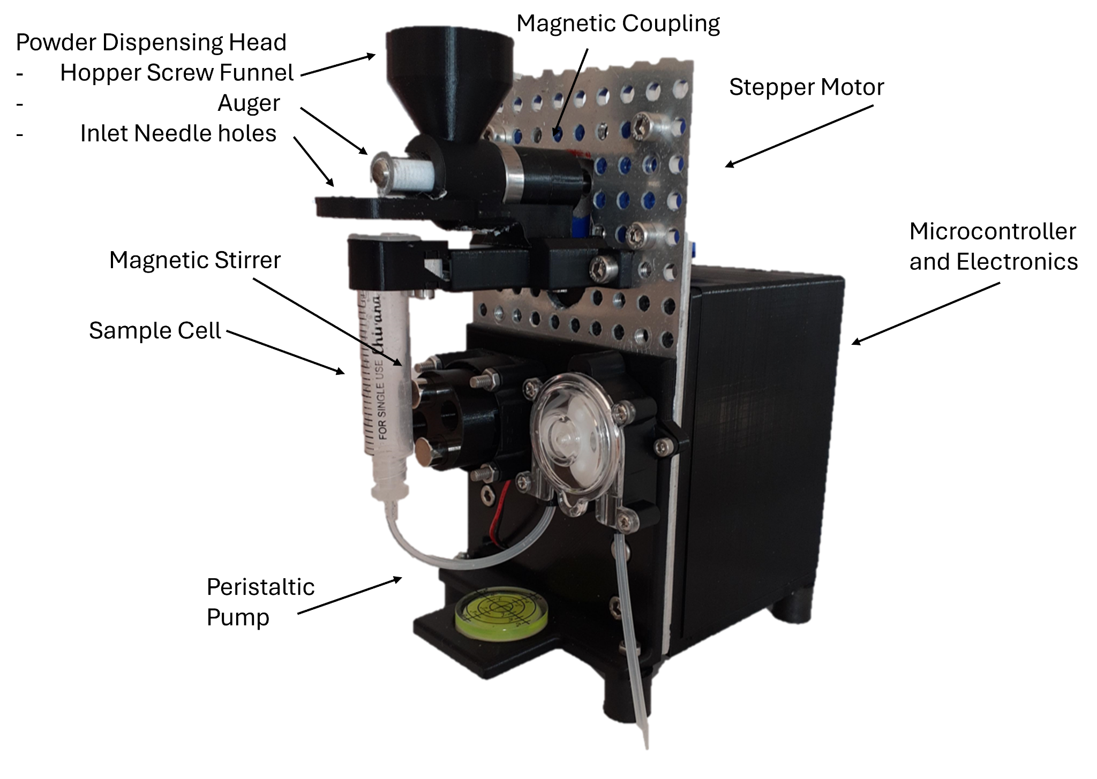
Figure 1: Stand-alone powder dispensing module

LEDbyXample modular photoreactor
Using intense light is common during experimental chemistry workflows including crosslinking, photopolymerization, and augmenting reaction pathways. The LEDbyXample photoreactor is an inexpensive and modular photoreactor designed for integration with automated chemistry setups including self-driving labs. It is designed modularly with simple parts and a 3D printed frame. Swappable light-emitting modules containing ~1W LEDs of specific wavelengths mounted to heat sinks are slotted onto the side of the reactor. A fan with mounted magnets is incorporated into the base of the reactor to allow for magnetic stirring of a small stir bar. An active cooling module can be mounted onto the side of the reactor. All modules are controlled using custom PCB boards in tandem with a Raspberry Pi Pico and simple Python code. Clear documentation of the build process and required parts is freely available (see Table 1). Most components are relatively easy to modify or scale for specific experimental requirements.
In designing LEDbyXample, the developers sought to build an automation-friendly system that was more flexible and lower cost than other options available, such as the open-hardware Wisconsin Photoreactor platform⁸ and the budget commercial Pioreactor.⁹ This project’s developers wanted a system that was lower-cost than Pioreactor while providing easy assembly and extensibility so researchers can modify the design and incorporate new capabilities. The relatively simple fabrication can also serve to reinforce builders’ skills with prototyping electronics, 3d printing and using a microcontroller.
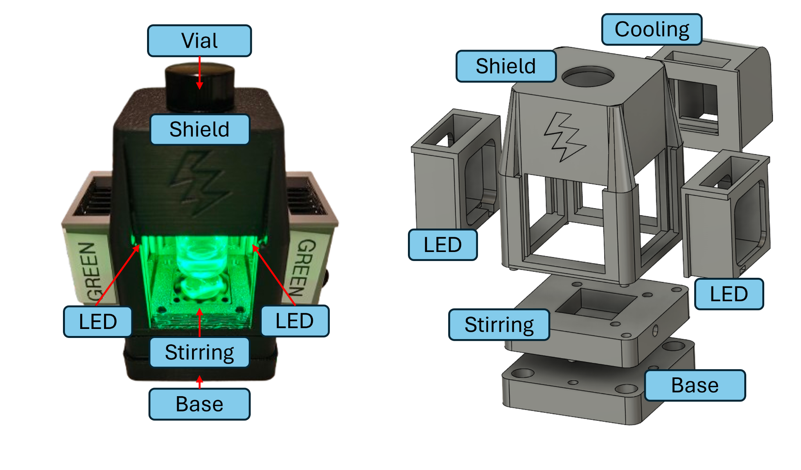
Figure 2: LEDbyXample photoreactor

Rolling ball viscometer
Rheology, in particular viscometry, is a common measurement in formulation applications. Complete rheological characterization of samples requires large, expensive equipment, is time-consuming, and is challenging to automate. Sample loading and equipment cleaning are particularly difficult to automate on traditional rheometers. Low-fidelity proxy methods are commonly used to estimate viscosity in end-use applications, such as the estimation of paint viscosities by timing drainage from a perforated cup¹⁰. Automated viscometry for Newtonian fluids has also been demonstrated on pipetting robots by comparing set dispense rates to actual liquid dispense rates¹¹. The developers of the rolling ball viscometer needed an affordable, repeatable, and automated method to measure the viscosity of Newtonian fluid samples. This project utilizes the rolling ball principle and Stoke’s law to measure fluid viscosity. A liquid sample is loaded into a clear tube, then the tube is rotated so that a small ball rolls through the fluid. The motion of the ball is captured with a high-speed camera, allowing the Newtonian viscosity of the fluid to be estimated with Stoke’s law. This design allows for automated sample loading and cleaning with peristaltic pumps. The developers decided to build their own tools for this application because they did not find any alternatives that met their requirements for cost, precision, and scalability that would integrate into their workflows.

End-to-end automation systems

Color mixing bot
Implementing a self-driving lab and using it effectively to accelerate research requires a diverse set of skills including hardware engineering, software development, data science and machine learning, background in the scientific application of interest, and system-wide debugging. No conventional degree program teaches the complete combination of prerequisites. Thus, significant opportunities for education and ‘on-the-job’ training are necessary to advance the adoption of SDLs. Color mixing experiments have become a standard entry point for new users^{12,13}. The objective of a color-matching experiment is to reproduce a target color by learning an appropriate ratio of primary colors to mix. Successful implementation requires automated sample preparation, characterization, machine learning-based experimental design, and workflow orchestration. Progress can be easily monitored visually with a digital camera or spectrometer, and it can be performed with safe chemicals (e.g., food coloring in water) or no chemicals (e.g., mixing LED light intensities). This color mixing bot project increases the complexity by adding a pH matching objective, extending the classic demonstration to a multi-objective context. The system integrates all the necessary components to run the experiment into a compact package. Peristaltic pumps are used to mix stock solutions in a measuring chamber. Stock solutions include colored solutions and clear solutions with acidic or basic pH (achieved with lemon juice or soap). An RGB sensor measures the resulting color, and a pH probe measures pH. A multi-objective Bayesian optimization algorithm learns the optimal ratio of stock solutions to make a solution with target color and pH. This platform is well suited for use in educational settings due to its low cost, portability, and lack of chemical or mechanical hazards.

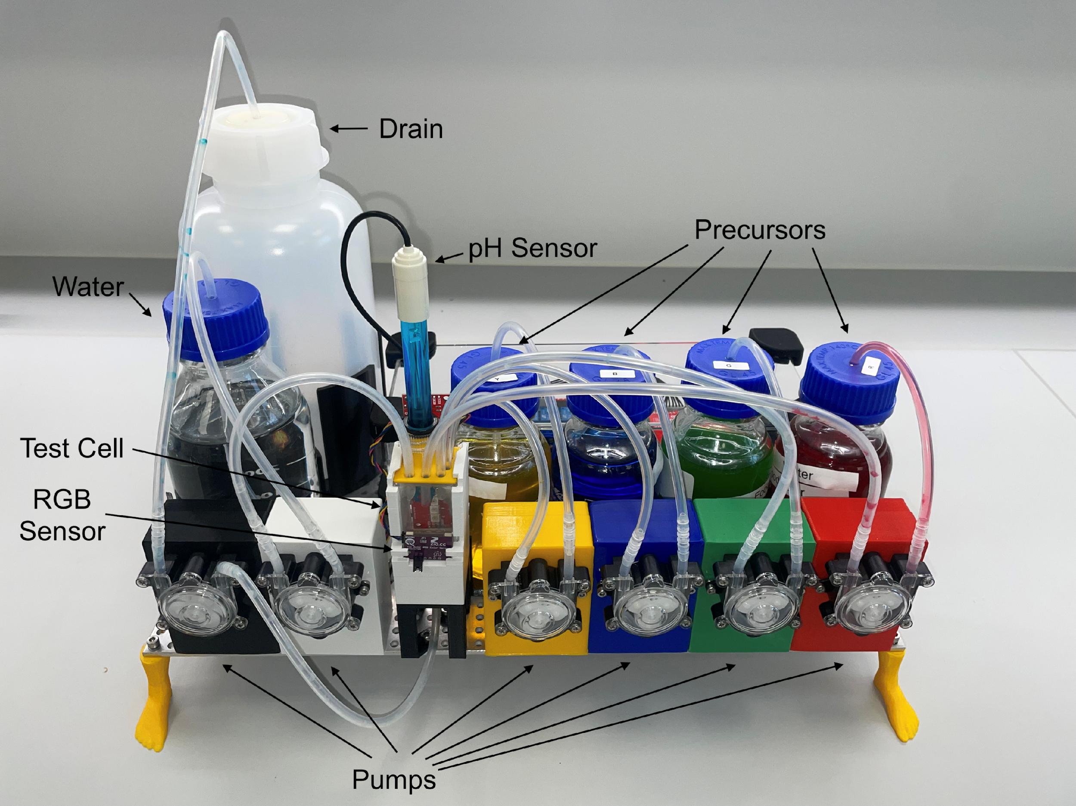
Figure 4: Color mixing bot

DiSCO materials synthesis and characterization system
To bring a self-driving lab to life, individual automation components must be strung together with sample transfer and control orchestration infrastructure. Many self-driving lab builders turn to robotic arms to shuttle samples between individual workstations in an SDL. While this approach can integrate stand-alone equipment for specific tasks and enables the re-use of human-centric experiment steps, throughput cannot be maximized and challenges arise due to the cost and complexity of reliable robotics. Pursuing a user-developed end-to-end automation hardware approach can provide an opportunity to reconsider and simplify how steps in a sample preparation workflow are physically integrated to maximize reliability and throughput for autonomous campaigns extending several weeks. The DiSCO (Discovery, Synthesis, Characterization, and Optimization) platform takes advantage of this opportunity to simplify the integration of synthesis and characterization for automated experimentation in high-dimensional materials search spaces such as perovskite semiconductor compositions. DiSCO is designed to screen these search spaces and identify regions of high-performing materials with high-throughput but low-fidelity methods. These proportions of these discovered regions can then be further considered with more expensive, higher-fidelity manual experiments. DiSCO integrates several modular components for the synthesis, characterization, and optimization of drop-cast materials. Modules include Archerfish combinatorial printing synthesis technology expanded for 10-dimensional rapid drop-cast synthesis of materials¹⁴, automated optical and contact-based characterization^{15,16}, and custom machine learning models for experimental control.¹⁷ To integrate the physical synthesis and characterization modules, DiSCO is built around a linear rail that moves samples from module to module. This reduces the sample positioning problem to reliable movement along one axis, improving positional accuracy and decreasing jerk and vibrations. In-house development of the integrated modules allows them to work with this sample positioning system. The modules are all open-source, aside from commercial components like hyperspectral imagers. This flexible platform could easily be modified or expanded to support different synthesis methods of characterization modules and enable use cases in diverse materials problems.

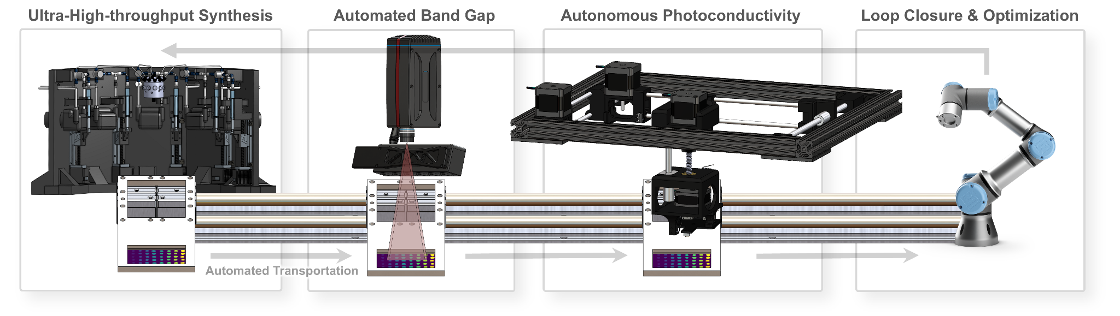

Figure 3: DiSCO

Science Jubilee
While the DiSCO project automates experiments by bringing samples to tools, the science-jubilee platform brings the tools to the samples. The science-jubilee project is an experiment automation ecosystem comprising 3 main elements: (1) open-hardware experimental automation tools, (2) software modules which provide flexible control of these tools, and (3) a community of users who contribute to the advancement of the project. It aims to provide flexible, application-agnostic automation infrastructure that researchers can use to explore possibilities for integrating automation into their work. Science-jubilee builds on the success of the Jubilee open-source tool-changing 3D printer¹⁸ by adding tools and capabilities that make it easy to use this motion platform for experimental automation. The Jubilee motion platform is built from a kit that consists of common off the shelf parts and a few commercially available custom components. The tool-changing capability of the platform allows researchers to run multi-step experimental workflows without moving samples to different locations on the same machine or to different machines altogether. A growing library of open-hardware tools enables common tasks like liquid handling, sample imaging, and sonication. A Python library provides a straightforward high-level interface for programming experiments. Documented tool and software interfaces make it possible to develop new tools that extend the platform's capability. Thorough documentation describes in step by step detail the process of building, provisioning, and using the science-jubilee system. The project has a strong focus on building community involvement and adoption. The developers host workshops, engage new users on a Discord server, and travel to showcase the platform. The flexibility of the platform makes it useful in many self-driving lab contexts. The above-mentioned color matching experiment can also be implemented on science-jubilee using a liquid handling tool and a camera tool, making it a useful platform for education and outreach. However, the extensibility and reliability of the motion platform also make it a powerful tool for enabling a wide range of automated scientific workflows, such as for the sonochemical synthesis of quantum dots or automated plant growth monitoring^{19,20}. Science-jubilee fills a large gap in capabilities and cost between truly low-cost automation, such as hacked 3D printers, and commercial automation solutions.
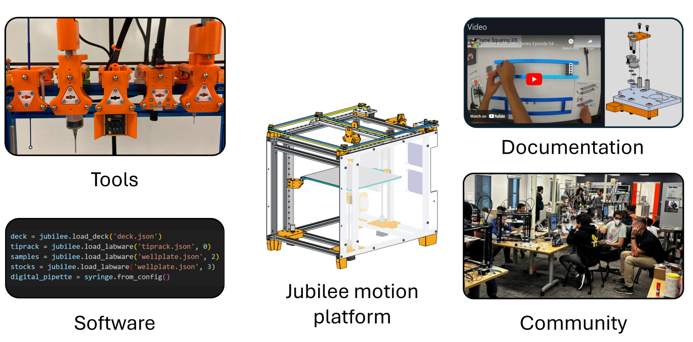
Figure 5: Science-Jubilee platform elements include the base Jubilee motion platform, science specific tools, control software, documentation, and support for a community of users. Jubilee drawing licensed under CC4.0, accessed from https://jubilee3d.com/index.php?title=Main_Page.

Multi-Platform Liquid Handling Tool
When building SDL platforms from existing equipment, integrating heterogeneous mounting, power supply, and control connections can be complicated. Tool developers can remove complexity from this process by building devices with stand-alone packaging, power supply, and controls. This can allow for easier adoption of their devices on new platforms. Liquid handling in particular is a task that is at the core of many automated experiments.This project modified the existing Digital Pipette tool’s design and control system so that it works as a stand-alone device, enabling it’s easy integration with many SDL platforms. The Digital Pipette is a low-cost and easily adaptable liquid handling device that can be integrated into flexible research setups²¹. The tool provides a liquid handling solution with a price of less than $100USD, replaceable fluid-contacting components, and easy fluidic integration via luer-lock tip syringes. The design is remarkably simple, involving a self-contained linear servo actuator, a syringe, and 3D printed frame components. This project modified the original Digital Pipette design with a 3D printed attachment that allows the tool to be mounted on motion platforms, such as science-jubilee or robotic arms. Additionally, MQTT communication capabilities were implemented which enable the pipette to work in tandem with other devices. The integration of the Digital Pipette tool has been successfully reproduced by several groups and science-jubilee users, where it is actively used in ongoing research.

Workflow for the development of redox-active compounds
Flexible open automation ecosystems like the science-jubilee platform promise to lower barriers to entry in SDLs by providing baseline infrastructure that can be used by researchers to automate specific tasks in their workflow. In this project, the developers take advantage of the capabilities of the science-jubilee platform to build a novel electrochemical workflow for the development of redox-active compounds. This workflow includes several tasks including the chemical synthesis, isolation and characterization of redox-active compounds. The science-jubilee Opentrons OT2 pipette adapter is used with an Opentrons OT2 P300 pipette to perform liquid handling tasks. The project developers are designing a custom science-jubilee tool to integrate a commercial BluRev rotating disk electrode (RDE). This will allow for the automation of electrochemical characterization steps. In addition, the science-jubilee python control software allows the developers to efficiently program and automate materials synthesis (such as metal-ligand coordination compounds) and characterization (including cyclic voltammetry and kinetic analysis of redox events). The developers chose to build this project on the science-jubilee platform due to its ease of extension to include new tools, programmability, and affordable cost. In particular, the flexibility of the science-jubilee software and friendly graphical user interface facilitated the integration of the rotating disk electrode and ultrasound cleaning tools. Similar workflows could be performed on commercially available automation platforms but at much higher cost.

Control and orchestration software

Public control of an Open Flexure microscope
Automated experimentation opens up new possibilities for how researchers use equipment and perform experiments. For example, distributed experiments have combined resources located around the world^{3,22}. Future SDLs that operate as user facilities will also likely require distributed access to equipment. This project explored use cases for remote equipment access systems by building a remote interface to the Open Flexure microscope. The Open Flexure microscope platform has gained popularity as a low-cost, programmable, open-source option²³. The programmable nature of the microscope is essential in automation, making tasks such as taking scans of larger areas much faster and more efficient. This project developed a software interface that enables public remote access to a programmable Open Flexure microscope. The interface uses the MQTT protocol to allow users to position the stage, focus, and capture images remotely via a python interface. The requesting credential system of this project allows unrelated individuals to take turns using the microscope. The Open Flexure microscope was chosen as the equipment to build this system due to its wide adoption and open source status. The microscope’s code is also open source, and the hardware is relatively inexpensive compared to other options. This project expands on existing open source microscope control software such as Micro Manager²⁴ by allowing remote, public control to the tools. This system has the potential to enable cloud experimentation tasks for education or research, broadening access to research equipment to anyone with an internet connection. While this project focused specifically on enabling microscope access, similar implementations could be developed to extend the accessibility of many tools in automated experimentation, including several other examples from this workshop.

IvoryOS
The projects described so far have focused on enabling autonomous experimentation through the advancement of hardware capabilities. While these advancements are important, they are not enough to realize democratized access to SDLs. Reliable and efficient orchestration and control software is a critical part of SDL infrastructure. Currently, it is common for SDL developers to create their own control software by stringing together scripts and notebooks. While this can get an effort off the ground, controlling SDLs programmatically requires a steep learning curve that turns away many researchers without coding experience. This status quo also leads to challenges in maintainability, extensibility, and reproducibility of automation systems. Many initiatives have sought to provide software frameworks for SDL control and orchestration including ChemIDE and $χ$DL^{25,26} , AlabOS²⁷, and ChemOS2.0²⁸. However, easy integration with existing software is challenging due to the heterogeneity of SDL components. SDL research objectives are also fluid, making rigidly configured control software difficult to maintain. The ivoryOS project aims to provide adaptable, easily integrated GUI interfaces to SDL platforms that will make programming and controlling SDLs easier for researchers²⁹. To achieve configuration-free GUI integration, the ivoryOS works as an extension to existing Python scripts to dynamically manage module states. During setup, the backend will capture the SDL features by iterating through instances and inspecting their available methods and parameter requirements (serialization). This captured snapshot summarizes the platform’s functionalities and updates the web GUI fields accordingly, where users can visualize the method and interact with SDLs. This permits flexibility in SDL developments, where there is no constraint in frameworks or layouts, meeting the continuous development requirement of SDLs. Additionally, the GUI also provides low-code programming for quick workflow design using available methods, allowing flexibility in building various experiments. The experiment execution has a self-driving centered design, featuring built-in iteration options including simple repeat, high-throughput or adaptive experimentations. When configuring optimization parameters, the GUI provides a code-free interface for users to configure parameters and objectives for their optimization campaign. This adaptability simplifies the initial setup and enhances the flexibility to incorporate a variety of devices, providing a ready-to-use GUI option when sharing SDLs to the broader audience.

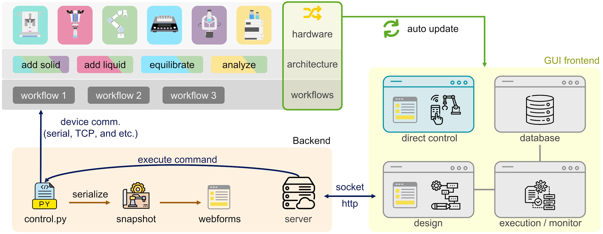

Figure 6: IvoryOS

Discussion

Common challenges and motivations
Many common experiences with the process of building user-developed automation infrastructure were shared by participants at the workshop. Most contributors were motivated to undertake their development projects, rather than purchase or use existing solutions, because they needed tools with specific capabilities that were not otherwise available. A strong spirit of community contribution and desire to improve the overall accessibility of SDLs was also expressed by all contributors. Cost was an important consideration in the build vs. buy decision. Many projects, such as the redox exploration workflow, would have been possible to custom build with commercial hardware providers, albeit at a steep increase in price. Most of the projects presented make cost vs. performance tradeoffs that prioritize lowering the sticker price of the tool, for example by using 3D printed parts in place of machined components and selecting commodity electronics components. However, user-developed automation does not necessarily imply low-cost, “frugal twin”³⁰ tools. Several examples, such as DiSCO and the electrochemical workflow integrate high performing components with large price tags.
Despite the diversity of projects, contributors repeatedly reported similar challenges in their development. The first group of issues relate to the technical hurdles in building new tools. Many of the presented projects (with notable exceptions) were built by chemists and materials scientists, not electrical and mechanical engineers. Building automation equipment requires fluency in many disciplines, including mechanical design and fabrication, electronics assembly, and software configuration. Contributors reported issues with all three of these tasks while developing their projects, expressing frustration that seemingly easy tasks held up their progress. Contributors who included external open-hardware projects in their work described challenges with inadequate documentation to reproduce existing tools. Developers also faced non-technical challenges. SDL development tends to be isolated to individual labs, or even individual projects within research groups, which limits opportunities to test out ideas on potential users, get feedback from colleagues, and trade ideas for improvements and best practices. Contributors also faced logistics issues related to automation adoption, such as lengthy processes for Environmental Health and Safety clearance of new systems.

Outlook
The potential impact of widespread adoption of democratized lab automation and SDLs is huge. User-developed automation will play an important role in providing flexible, accessible, and creative solutions that can make SDLs commonplace in future materials research.
This workshop provided an opportunity to understand the state of user-developed automation and assess needs for the future. During the workshop, a survey of attendees was performed to assess community needs for democratized SDL adoption. Survey respondents (n=58) ranked “Developing low-cost SDL equipment and shared blueprints” as a top priority in advancing democratized SDLs. Over 70% of respondents shared a willingness to publish hardware designs and related software. The strong engagement with this workshop demonstrates that the accelerated experimentation community is interested in and open to wider adoption of democratized automation solutions. This workshop and the contributed projects provide some important lessons to consider as the democratized SDL movement grows.
Most of the contributed projects describe lowered cost compared to commercially available options as a motivation. The notion that user-developed automation is cheaper is worth critically examining. Yes, the bill of materials for the contributed projects is an order of magnitude or two lower than what a commercial system may have cost. However, hundreds to thousands of hours have been invested in these projects. While commercial tools do require time investment for setup and onboarding, the time and opportunity costs of pursuing in-house automation development are significant. The time spent on these projects is not necessarily a “waste”, as researchers who invest in up-skilling in SDL design and build tasks will be better positioned to successfully and independently troubleshoot, modify, and extend their platforms. Nevertheless, these costs may negate any savings on capital expenses achieved by avoiding commercial equipment purchases. User-developed automation can lower costs, however, when it is replicated and widely adopted as an open hardware project. Initial development expenses are easier to accept if the project will be replicated and integrated by others in the community.
To be widely adopted by other researchers, automation infrastructure needs documentation that thoroughly describes the steps required to procure, build, configure, run, and troubleshoot the system. Simply sharing CAD files and a list of parts to buy is not sufficient to empower new users to successfully leverage a project in their own work. In her closing keynote at the Accelerate conference, Nadya Peek described how documentation is mandatory for open source hardware projects. For hardware, documentation is the source—it is how a new user transforms a box of screws and a spool of 3D printer filament into a productive component of their automation ecosystem. Without documentation, there is no open hardware. However, supporting projects with documentation is time-intensive. Significant up-front effort is required to prepare complete, high-quality documentation. Supported projects also have ongoing overhead to keep the documentation up to date and provide direct support to new users. While these contributions are critical to the success of a project, they are not highly valued or incentivized by traditional academic currencies. New initiatives that lower barriers to developing project documentation or provide incentives for doing so are needed to increase the availability and sustainability of open-source SDL infrastructure.
Education and knowledge sharing are important for empowering researchers to be effective in developing their own automation solutions. It is notable that contributors to this workshop did not widely describe challenges with complex, application-specific design challenges, but rather ‘small stuff’ like wire crimping and part design. While these are relatively straightforward tasks, researchers often are not formally trained in them and are left to figure them out on the fly when building automation tools for their work. Consider another potential challenge that was not widely reported: programming systems to perform desired tasks. We hypothesize that the lack of programming barriers is in part due to the widespread adoption of Python programming coursework in curriculum over the past 5-10 years. A similar coursework primer on electrical and mechanical design topics for students and researchers working on SDLs could greatly accelerate the development of automation tooling in research labs.
It is important to be realistic about the limits of user-developed automation and consider the benefits of working with commercial options. Automation involving hazardous conditions or components, such as high pressures or X-ray radiation, should not be built in an ad-hoc manner. Similarly, systems requiring fabrication or validation capabilities that are not widely available, such as specialized spectroscopy equipment, may be best supplied by commercial vendors. Opportunities exist to integrate commercial and user-developed equipment to gain the benefits of both. For example, the science-jubilee project integrates a commercial pipettor tool to provide low-cost, high-precision liquid handling, and the DiSCO project integrates an off-the-shelf hyperspectral imaging tool with a custom motion system to enable high-throughput characterization. As a community, we should engage with vendors and encourage them to develop products that complement user-developed automation through modular designs, accessible programming interfaces, and thorough documentation.
More than anything, this workshop demonstrated the importance of solving important problems in SDL development as a community. We often develop our platforms in isolation and focus on sharing abstract updates on our system’s capabilities and exciting scientific results they generate. While we should ultimately be focused on the science we are enabling, there is also significant knowledge generated in the development of user-developed automation that is valuable to the community. There is no ‘one right way’ to build an SDL, as demonstrated by the variety of approaches to managing automation in this workshop. However, many SDL builders face similar challenges. Online forums are providing nascent spaces for SDL builders to share advice and resources.^{31,32} More of these opportunities are needed. This workshop provided an in-person exchange where builders could see platforms in action, trade advice on solving problems, and share their work with an interested audience. Building SDLs is hard, and building them in a democratized fashion with user-developed automation only adds to the challenge. The contributions to this workshop show that the community is rising to the challenge, and suggest an exciting future for democratized access to self-driving labs.

References
(1) Rupnow, C. C.; MacLeod, B. P.; Mokhtari, M.; Ocean, K.; Dettelbach, K. E.; Lin, D.; Parlane, F. G. L.; Chiu, H. N.; Rooney, M. B.; Waizenegger, C. E. B.; Hoog, E. I. de; Soni, A.; Berlinguette, C. P. A Self-Driving Laboratory Optimizes a Scalable Process for Making Functional Coatings. Cell Rep. Phys. Sci. 2023, 4 (5). https://doi.org/10.1016/j.xcrp.2023.101411.
(2) Bennett, J. A.; Orouji, N.; Khan, M.; Sadeghi, S.; Rodgers, J.; Abolhasani, M. Autonomous Reaction Pareto-Front Mapping with a Self-Driving Catalysis Laboratory. Nat. Chem. Eng. 2024, 1 (3), 240–250. https://doi.org/10.1038/s44286-024-00033-5.
(3) Strieth-Kalthoff, F.; Hao, H.; Rathore, V.; Derasp, J.; Gaudin, T.; Angello, N. H.; Seifrid, M.; Trushina, E.; Guy, M.; Liu, J.; Tang, X.; Mamada, M.; Wang, W.; Tsagaantsooj, T.; Lavigne, C.; Pollice, R.; Wu, T. C.; Hotta, K.; Bodo, L.; Li, S.; Haddadnia, M.; Wołos, A.; Roszak, R.; Ser, C. T.; Bozal-Ginesta, C.; Hickman, R. J.; Vestfrid, J.; Aguilar-Granda, A.; Klimareva, E. L.; Sigerson, R. C.; Hou, W.; Gahler, D.; Lach, S.; Warzybok, A.; Borodin, O.; Rohrbach, S.; Sanchez-Lengeling, B.; Adachi, C.; Grzybowski, B. A.; Cronin, L.; Hein, J. E.; Burke, M. D.; Aspuru-Guzik, A. Delocalized, Asynchronous, Closed-Loop Discovery of Organic Laser Emitters. Science 2024, 384 (6697), eadk9227. https://doi.org/10.1126/science.adk9227.
(4) Christensen, M.; E. Yunker, L. P.; Shiri, P.; Zepel, T.; L. Prieto, P.; Grunert, S.; Bork, F.; E. Hein, J. Automation Isn’t Automatic. Chem. Sci. 2021, 12 (47), 15473–15490. https://doi.org/10.1039/D1SC04588A.
(5) Vescovi, R.; Ginsburg, T.; Hippe, K.; Ozgulbas, D.; Stone, C.; Stroka, A.; Butler, R.; Blaiszik, B.; Brettin, T.; Chard, K.; Hereld, M.; Ramanathan, A.; Stevens, R.; Vriza, A.; Xu, J.; Zhang, Q.; Foster, I. Towards a Modular Architecture for Science Factories. Digit. Discov. 2023, 2 (6), 1980–1998. https://doi.org/10.1039/D3DD00142C.
(6) Szymanski, N. J.; Rendy, B.; Fei, Y.; Kumar, R. E.; He, T.; Milsted, D.; McDermott, M. J.; Gallant, M.; Cubuk, E. D.; Merchant, A.; Kim, H.; Jain, A.; Bartel, C. J.; Persson, K.; Zeng, Y.; Ceder, G. An Autonomous Laboratory for the Accelerated Synthesis of Novel Materials. Nature 2023, 624 (7990), 86–91. https://doi.org/10.1038/s41586-023-06734-w.
(7) Bao, R. Eamars/OpenTrickler, 2024. https://github.com/eamars/OpenTrickler (accessed 2024-12-14).
(8) Lampkin, P. P.; Thompson, B. J.; Gellman, S. H. Versatile Open-Source Photoreactor Architecture for Photocatalysis Across the Visible Spectrum. Org. Lett. 2021, 23 (13), 5277–5281. https://doi.org/10.1021/acs.orglett.1c01910.
(9) Pioreactor. Pioreactor. https://pioreactor.com/ (accessed 2024-12-14).
(10) Standard Test Method for Viscosity by Ford Viscosity Cup. https://www.astm.org/d1200-10r18.html (accessed 2024-12-11).
(11) W. Soh, B.; Chitre, A.; Yang Lee, W.; Bash, D.; N. Kumar, J.; Hippalgaonkar, K. Automated Pipetting Robot for Proxy High-Throughput Viscometry of Newtonian Fluids. Digit. Discov. 2023, 2 (2), 481–488. https://doi.org/10.1039/D2DD00126H.
(12) Exploring Benchmarks for Self-Driving Labs using Color Matching | Proceedings of the SC ’23 Workshops of The International Conference on High Performance Computing, Network, Storage, and Analysis. https://dl.acm.org/doi/abs/10.1145/3624062.3624615?casa_token=XgPNy8AKiMcAAAAA:PTwEp3dwnTB9FSLXvhLBjgtY1omV4JqMD8B2u7aPrJbjJrGPFwhnjbHG_4946UQQwEGw9cznpUPJrQ (accessed 2024-11-29).
(13) Baird, S. G.; Sparks, T. D. Building a “Hello World” for Self-Driving Labs: The Closed-Loop Spectroscopy Lab Light-Mixing Demo. STAR Protoc. 2023, 4 (2), 102329.
(14) Siemenn, A. E.; Das, B.; Aissi, E.; Sheng, F.; Elliott, L.; Hudspeth, B.; Meyers, M.; Serdy, J.; Buonassisi, T. Archerfish: A Retrofitted 3D Printer for High-Throughput Combinatorial Experimentation via Continuous Printing. ChemRxiv August 22, 2024. https://doi.org/10.26434/chemrxiv-2024-fz16p.
(15) Siemenn, A. E.; Aissi, E.; Sheng, F.; Tiihonen, A.; Kavak, H.; Das, B.; Buonassisi, T. Using Scalable Computer Vision to Automate High-Throughput Semiconductor Characterization. Nat. Commun. 2024, 15 (1), 4654. https://doi.org/10.1038/s41467-024-48768-2.
(16) Siemenn, A. E.; Das, B.; Ji, K.; Sheng, F.; Buonassisi, T. Deep Learning Robotics Using Self-Supervised Spatial Differentiation Drive Autonomous Contact-Based Semiconductor Characterization. arXiv November 15, 2024. https://doi.org/10.48550/arXiv.2411.09892.
(17) Siemenn, A. E.; Ren, Z.; Li, Q.; Buonassisi, T. Fast Bayesian Optimization of Needle-in-a-Haystack Problems Using Zooming Memory-Based Initialization (ZoMBI). Npj Comput. Mater. 2023, 9 (1), 1–13. https://doi.org/10.1038/s41524-023-01048-x.
(18) Vasquez, S.; Twigg-Smith, H.; Tran O’Leary, J.; Peek, N. Jubilee: An Extensible Machine for Multi-Tool Fabrication. In Proceedings of the 2020 CHI Conference on Human Factors in Computing Systems; CHI ’20; Association for Computing Machinery: New York, NY, USA, 2020; pp 1–13. https://doi.org/10.1145/3313831.3376425.
(19) Subbaraman, B.; Lange, O. de; Ferguson, S.; Peek, N. The Duckbot: A System for Automated Imaging and Manipulation of Duckweed. PLOS ONE 2024, 19 (1), e0296717. https://doi.org/10.1371/journal.pone.0296717.
(20) Politi, M.; Baum, F.; Vaddi, K.; Antonio, E.; Vasquez, S.; Bishop, B. P.; Peek, N.; Holmberg, V. C.; Pozzo, L. D. A High-Throughput Workflow for the Synthesis of CdSe Nanocrystals Using a Sonochemical Materials Acceleration Platform. Digit. Discov. 2023.
(21) Yoshikawa, N.; Darvish, K.; Vakili, M. G.; Garg, A.; Aspuru-Guzik, A. Digital Pipette: Open Hardware for Liquid Transfer in Self-Driving Laboratories. Digit. Discov. 2023, 2 (6), 1745–1751. https://doi.org/10.1039/D3DD00115F.
(22) Orchestrating nimble experiments across interconnected labs - Digital Discovery (RSC Publishing) DOI:10.1039/D3DD00166K. https://pubs.rsc.org/en/content/articlehtml/2023/dd/d3dd00166k (accessed 2024-12-11).
(23) Collins, J. T.; Knapper, J.; Stirling, J.; Mduda, J.; Mkindi, C.; Mayagaya, V.; Mwakajinga, G. A.; Nyakyi, P. T.; Sanga, V. L.; Carbery, D.; White, L.; Dale, S.; Lim, Z. J.; Baumberg, J. J.; Cicuta, P.; McDermott, S.; Vodenicharski, B.; Bowman, R. Robotic Microscopy for Everyone: The OpenFlexure Microscope. bioRxiv December 3, 2019, p 861856. https://doi.org/10.1101/861856.
(24) Edelstein, A.; Amodaj, N.; Hoover, K.; Vale, R.; Stuurman, N. Computer Control of Microscopes Using µManager. Curr. Protoc. Mol. Biol. 2010, 92 (1), 14.20.1-14.20.17. https://doi.org/10.1002/0471142727.mb1420s92.
(25) Mehr, S. H. M.; Craven, M.; Leonov, A. I.; Keenan, G.; Cronin, L. A Universal System for Digitization and Automatic Execution of the Chemical Synthesis Literature. Science 2020, 370 (6512), 101–108. https://doi.org/10.1126/science.abc2986.
(26) Hammer, A. J. S.; Leonov, A. I.; Bell, N. L.; Cronin, L. Chemputation and the Standardization of Chemical Informatics. JACS Au 2021, 1 (10), 1572–1587. https://doi.org/10.1021/jacsau.1c00303.
(27) Fei, Y.; Rendy, B.; Kumar, R.; Dartsi, O.; Sahasrabuddhe, H. P.; McDermott, M. J.; Wang, Z.; Szymanski, N. J.; Walters, L. N.; Milsted, D.; Zeng, Y.; Jain, A.; Ceder, G. AlabOS: A Python-Based Reconfigurable Workflow Management Framework for Autonomous Laboratories. Digit. Discov. 2024, 3 (11), 2275–2288. https://doi.org/10.1039/D4DD00129J.
(28) Sim, M.; Vakili, M. G.; Strieth-Kalthoff, F.; Hao, H.; Hickman, R. J.; Miret, S.; Pablo-García, S.; Aspuru-Guzik, A. ChemOS 2.0: An Orchestration Architecture for Chemical Self-Driving Laboratories. Matter 2024, 7 (9), 2959–2977. https://doi.org/10.1016/j.matt.2024.04.022.
(29) Zhang, W.; Hao, L.; Reish, M.; Greenwood, R.; Depner, N.; Min, J.; El-khawldeh, R.; Prieto, P.; Trushina, E. Hein, J.E. ; IvoryOS: An Interoperable Operating System for Flexible Self-Driving Laboratories. Research Square November 4, 2024. https://doi.org/10.21203/rs.3.rs-5307798/v1.
(30) Lo, S.; G. Baird, S.; Schrier, J.; Blaiszik, B.; Carson, N.; Foster, I.; Aguilar-Granda, A.; V. Kalinin, S.; Maruyama, B.; Politi, M.; Tran, H.; D. Sparks, T.; Aspuru-Guzik, A. Review of Low-Cost Self-Driving Laboratories in Chemistry and Materials Science: The “Frugal Twin” Concept. Digit. Discov. 2024, 3 (5), 842–868. https://doi.org/10.1039/D3DD00223C.
(31) Lab Automation Forums. Lab Automation Forums. https://labautomation.io/ (accessed 2024-12-14).
(32) Accelerated Discovery - AI and automation to accelerate materials discovery. Accelerated Discovery. https://accelerated-discovery.org/ (accessed 2024-12-14).

Author Contributions
BP: Conceptualization, Compilation and organization of project contributions, writing – original draft, writing – review and editing. SGB, LDP, TV, TB: Conceptualization, Writing – review and editing. All other authors: Contribution of project descriptions, writing – review and editing.

Conflicts of Interest
There are no conflicts of interest to declare

Funding acknowledgements

- Wenyu Zhang, Lucy Hao, and Jason Hein acknowledge Canada Foundation for Innovation (CFI-35833) Natural Sciences and Engineering Research Council of Canada (RGPIN-2021–03168, Discovery Accelerator) the University of British Columbia.
- Jin Hyun Chang and Tejs Vegge acknowledge Pioneer Center for Accelerating P2X Materials Discovery (CAPeX), DNRF grant number P3.
- Tejs Vegge acknowledges support from European Union's Horizon 2020 research and innovation program under grant agreement no. 957189 (BIG-MAP)
- Owen A. Melville, Monique Ngan, Jeffrey Watchorn, Yang Cao, Jason Hein, Wenyu Zhang, and Lucy Hao acknowledge support provided to the University of Toronto’s Acceleration Consortium from the Canada First Research Excellence Fund (CFREF-2022–00042).
- Lilo Pozzo acknowledges support from NSF POSE grant TIP-2229018 and NSF PREM grant DMR-2424949

