Furnace start-up procedure
1. Arrange crucible on top of Teflon, alumina, and boron nitride tube in order shown in figure 1.

Teflon
Alumina
Boron Nitride
Crucible
Quartz tube
Figure 1 Diagram of crucible support structure.

2. Place YSZ specimen in crucible.
3. Adjust level of induction furnace stand to place induction coils around the crucible.
4. Place quartz tube over crucible support structure.
5. Check alignment of crucible and support structure through the peep hole. Components should be in the center of the quartz tube and should not touch the quartz wall. Reposition components if necessary.
6. Confirm the system is sealed, then turn on the roughing pump.
7. Allow the pressure to reach ______ Torr, then turn on the high vacuum pump
8. Allow system to reach a vacuum, about ____________ torr, then open argon valves. Turn the valve on the tank left, turn the next valve right, and then the next valve (Refer to figure 2)

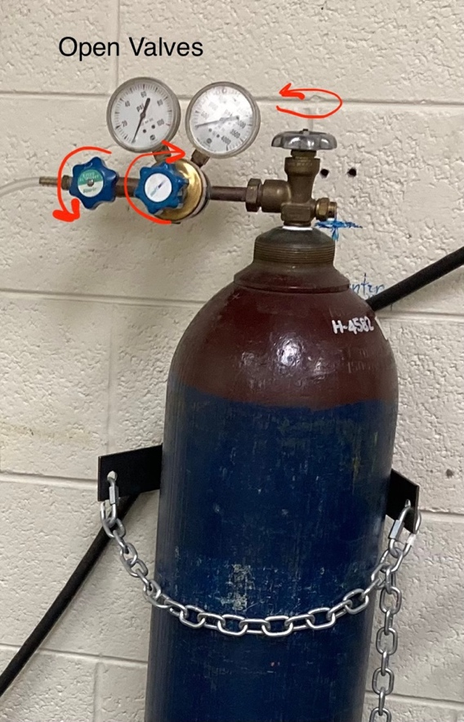
Figure 2 Open valves to argon gas.

9. Confirm the pyrometer is connected to power
10. Turn on cooler control box, power box, and EIA box.
11. Turn on fans
12. From LabVIEW, enter emergency notification email
13. Press start program, gradually increase power to begin heating the specimen (Keep heating rate to < 10 K/min)
14. Increase power until desired temperature has been reached. (Note that the pyrometer does not recognize temperatures < 700 deg C)

Image 1.
b. Change pressure set point so that the high vacuum pump stays on all the time
9. Begin to power on the furnace gradually from LabVIEW
- Get a screen shot of labVIEW screen to show where to input power

Shut Down Procedure

1. Close valves to argon gas
2. Turn off T-Station vacuum pump. Press button on the left and then middle button
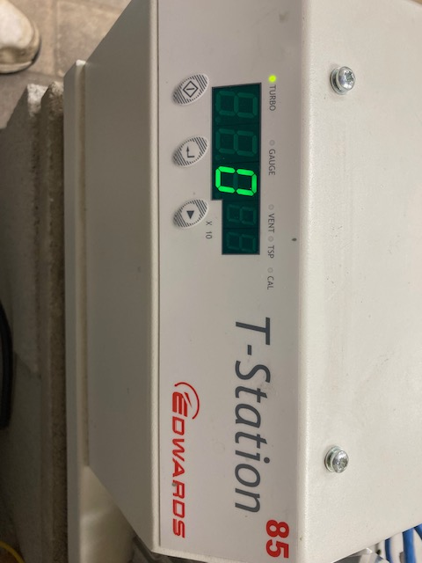

3. Turn off cooler control box, power box, and EIA box
4. Turn off fans
5. Turn off power to pyrometer and vacuum pump
6. In LabVIEW press E-Stop / End program

Furnace Operation

Check daily
- Coolant levels and any fluid leaks.
- Temperature of coolant should be below 45 deg C. It will automatically shut down at 50 deg C, but should not be run above 45 deg C for prolonged periods of time
- Pressure should be roughly 2 torr
- To get coolant temperature down, increase the water flow or decrease the furnace power.

(do not exceed 10 deg C per minute heating rate)

Check pyrometer power.

