Drop Tower Standard Operating Procedure
Lansmont Model 23 shock test system, Smash Lab (CB 152A), Brigham Young University

Status, 2026-10-29: DRAFT TEMPLATE, not approved for use. Drop tower use has been halted since 2026-10-19, when the cable of the 10,000 g single-axis accelerometer broke at its connector (issue #115; section 17.3). Testing resumes when [restart condition, for example: this SOP is approved and the corrective action for the cable failure is signed off by the supervisor].

Document control
Document | Drop tower SOP, [document number]
Revision | 0.1, template generated 2026-10-29 from the project repository
Equipment | Lansmont Model 23 (M23) shock test system, serial [number], with the Lansmont Test Partner 4 (TP4) data recorder (PR #28, issue #27)
Location | CB 152A (Smash Lab)
Prepared by | Marcus Madsen, Jinkwan [last name]
Reviewed by | [name, role, date]
Approved by | [supervisor name], [date] (signatures in section 19)
Next review | [date, for example one year after approval, or after any incident]

How to use this template (delete this box before approval):
- Each topic section has the same four parts: What this section must cover (the requirement from the SOP request), Procedure, How it is verified, and Stop the test if.
- Text in [gray brackets] is a placeholder. Replace it or delete it.
- Everything else was drafted from the project's repository records (linked under Sources in each section) and from general drop-test practice. Treat all of it as a draft: check each statement against the machine, the Lansmont manuals, and the supervisor before approval.
- Appendix A maps each required item to the section that covers it, so the reviewers can check that nothing is missing.
- After editing, update the table of contents: right-click it and choose Update Field (Word desktop), or use References, Update Table (Word for the web).

Contents
1. Checklists 3
1.1 Start of session (once per session) 3
1.2 Before every drop 3
1.3 After every drop 3
1.4 End of session, or before leaving the machine 4
2. Purpose, scope and current status 5
3. Definitions and roles 5
4. Scheduling, workspace and storage 6
5. Equipment and the prepared setup 8
5.1 Drop tower 8
5.2 Instrumentation 8
5.3 Fixture and absorber 9
5.4 The correctly prepared setup 9
6. Hazards, eye protection and personnel clearance 9
6.1 Hazards 9
6.2 Eye protection 10
6.3 Guarding and personnel clearance 10
7. Safety key and the raised mass 11
7.1 Safety key procedure 11
7.2 Supporting the raised mass 11
8. Approved operating limits 12
9. Specimen and sensor setup 12
9.1 Securing the block 12
9.2 Using proper shock accelerometers 13
9.3 Accelerometer installation and handling 14
9.4 Securing accelerometer cable slack 14
10. Pre-test inspection 15
11. DAQ readiness 16
12. Running a drop 17
12.1 Pre-drop checklist and communication 17
12.2 Rebound and secondary impacts 18
12.3 Increasing test severity 18
13. Stop-work conditions 19
14. Failed release, interrupted test and emergency stop 19
15. Post-test inspection 20
16. Leaving the machine 21
16.1 Leaving the machine during operation 21
16.2 Leaving the system pressurized 21
16.3 Leaving the system in a secure state 21
17. Test and incident log 22
17.1 What to record 22
17.2 Events that need immediate supervisor notification 22
17.3 Previous incidents and preventive steps 23
18. Training and authorization 23
19. Approval and revision history 24
Appendix A. Requirement coverage 25
Appendix B. Session test log 25
Appendix C. Incident report 26
Appendix D. Source records 26

1. Checklists
Print this section and keep it at the drop tower. The right-hand column gives the section with the full procedure for each item. The checkboxes can be clicked in Word.

1.1 Start of session (once per session)
Done | Check | Section
☐ | The drop tower is booked for today on the Smash Lab calendar, and any shared day is coordinated with the other booking. | 4
☐ | At least [two] authorized operators are present. One is named release controller and recorded in the log. | 12.1, 18
☐ | Everyone in the room is wearing eye protection. | 6.2
☐ | Safety key is out and held by the person setting up. Key interlock check done and recorded. | 7.1
☐ | Pre-test inspection done and recorded. | 10
☐ | Today's test plan is inside the approved operating limits. Any increase in height, mass or pressure has been reviewed. | 8, 12.3
☐ | Accelerometers suit the expected peak, are mounted, and their cables are routed with strain relief. Cable travel checked with a slow raise. | 9.2 to 9.4
☐ | TP4 settings match the reference screen. Session named after specimen and campaign. | 11
☐ | Exclusion zone marked and clear. [Guard or shield] in place. | 6.3
☐ | Test log opened for the session. | 17

1.2 Before every drop
Done | Check | Section
☐ | Block and specimen retained. Attachment checked by hand. | 9.1
☐ | Accelerometers tight. Cables clamped, slack loop clear of the carriage, guide rods, brakes and absorber over the full travel and rebound. | 9.3, 9.4
☐ | Drop height, mass and pressure match the test plan and the approved limits. | 8
☐ | TP4 armed with the right channels, trigger and session name. Camera recording, if used. | 11
☐ | Nobody inside the exclusion zone. Everyone wearing eye protection. | 6
☐ | Release controller asks "Ready?" and hears "Ready" from each person present. | 12.1
☐ | Release controller calls "All clear, dropping" and releases. | 12.1

1.3 After every drop
Done | Check | Section
☐ | Carriage is held by the brakes and all motion has stopped before anyone approaches. | 12.2
☐ | Capture checked in the TP4: impact in the record, no channel at full scale, no flat or stepping channel. | 11, 15
☐ | Specimen, sensors, cables and fixture inspected. Anything abnormal recorded. | 15
☐ | Drop recorded in the test log. | 17

1.4 End of session, or before leaving the machine
Done | Check | Section
☐ | Carriage lowered to [rest position]. [Mechanical restraint] in place. | 16.3
☐ | Air supply closed and vented. Gauge reads 0 psi. | 16.2
☐ | Controller and machine power off. | 16.3
☐ | Safety key removed and stored at [location]. | 7.1, 16.3
☐ | Accelerometers back in their cases, in the cabinet marked "Accelerometers". | 4
☐ | Acrylic plates on the team's shelf. Computer workbench and center tables cleared. | 4
☐ | Test log closed. Incidents reported. | 17

2. Purpose, scope and current status
Purpose
This SOP describes how to set up, run and shut down drop tests on the drop tower in CB 152A so that nobody is hurt, the machine and sensors are not damaged, and the data can be used.
Scope
It applies to everyone who operates the drop tower or works on it: setup, sensor installation, testing, troubleshooting and shutdown. At least four research teams use the tower (issue #115). [State whether this SOP covers all teams or only the tensegrity project, and who coordinates with the other teams.]
Current status
Drop tower use was halted on 2026-10-19, after the cable of the 10,000 g single-axis accelerometer (channel 5, CH5) broke at its connector (issue #115, Figure 5). The cable had been intermittent for an hour on 2026-10-17 before it failed (CH5 fault analysis). [Restart condition and who approves it.]

3. Definitions and roles
Definitions
Term | Meaning in this SOP
Drop tower | The Lansmont Model 23 shock test system in CB 152A: frame, guide rods, hoist, latch, carriage, brakes, absorber and controller.
Carriage (drop mass) | The table that is raised and dropped, with everything fastened to it. [Confirm the term used on the machine.]
Block | [Define: for example the fixture block fastened to the carriage table that the specimen and base plate sit on.]
Hoist (pulley) | Raises the carriage to the drop height. [Confirm: chain hoist on the top of the frame.]
Latch | Holds the carriage at the drop height until release. The release hook is part of it.
Brakes | The anti-rebound brakes that catch the carriage after it bounces off the absorber, so it does not strike a second time.
Absorber (programmer) | The material stack the carriage strikes, which shapes the shock pulse: felt, cardboard or polyurethane sheet in this project.
Bungee cords | Elastic cords that can be attached to the carriage to pull it down faster than free fall. They store energy while the carriage is raised.
Safety key | [Describe the key, where it goes in, and what it disables.]
Release controller | The one person who controls the release for a drop (section 12.1).
Exclusion zone | The area around the tower that must be clear of people during a drop (section 6.3).
Secure state | The state the machine is left in when unattended (section 16.3).
DAQ | Data acquisition system. Here, the Lansmont TP4 recorder and its software.
ICP (IEPE) | Accelerometers with built-in electronics, powered by a constant current from the DAQ (integrated electronics piezoelectric). ICP is PCB Piezotronics' name for it.
g | Acceleration in multiples of standard gravity, 9.81 m/s². The TP4 writes it as G.

Roles
Role | Who | Responsibilities
Supervisor | [name, for example Jeffrey Hill] | Approves this SOP, the operating limits, changes to either, and restarting after an incident. Receives incident notifications.
SOP owners | Marcus Madsen, Jinkwan [last name] | Keep this SOP, the test log and the incident register up to date.
Operator | Authorized people (section 18) | Set up, run and shut down tests by this SOP.
Release controller | One operator per session | Holds the safety key during the drop sequence, gives the calls, releases the carriage.
Observer | [optional or required] | Watches the exclusion zone and the cables during drops and calls "Stop" if needed.

4. Scheduling, workspace and storage
From the drop tower use protocol in issue #115 and the CB 152A workspace notes from 2026-10-13 (comment).
Booking the drop tower
- Get your BYU email added to the Smash Lab calendar before you book.
- Plan the tests for the day you want.
- Book the drop tower for the whole day, not a time slot. You may book several days in a row.
- If someone has already booked the date you need, contact that person and agree on times.
Workspace and storage in CB 152A
- Store items and work only in the areas marked in Figure 1 (a) and (b).
- The large wooden tables in the center of the room may be used during testing. Clear and clean them as soon as testing is done.
- When the scheduled testing is finished, put the whole setup away: accelerometers back in their cases (Figure 1 (c)) and on the shelf marked "Accelerometers" (Figure 1 (d)), acrylic plates on the team's shelf, and the computer workbench and center tables cleared of the team's items.
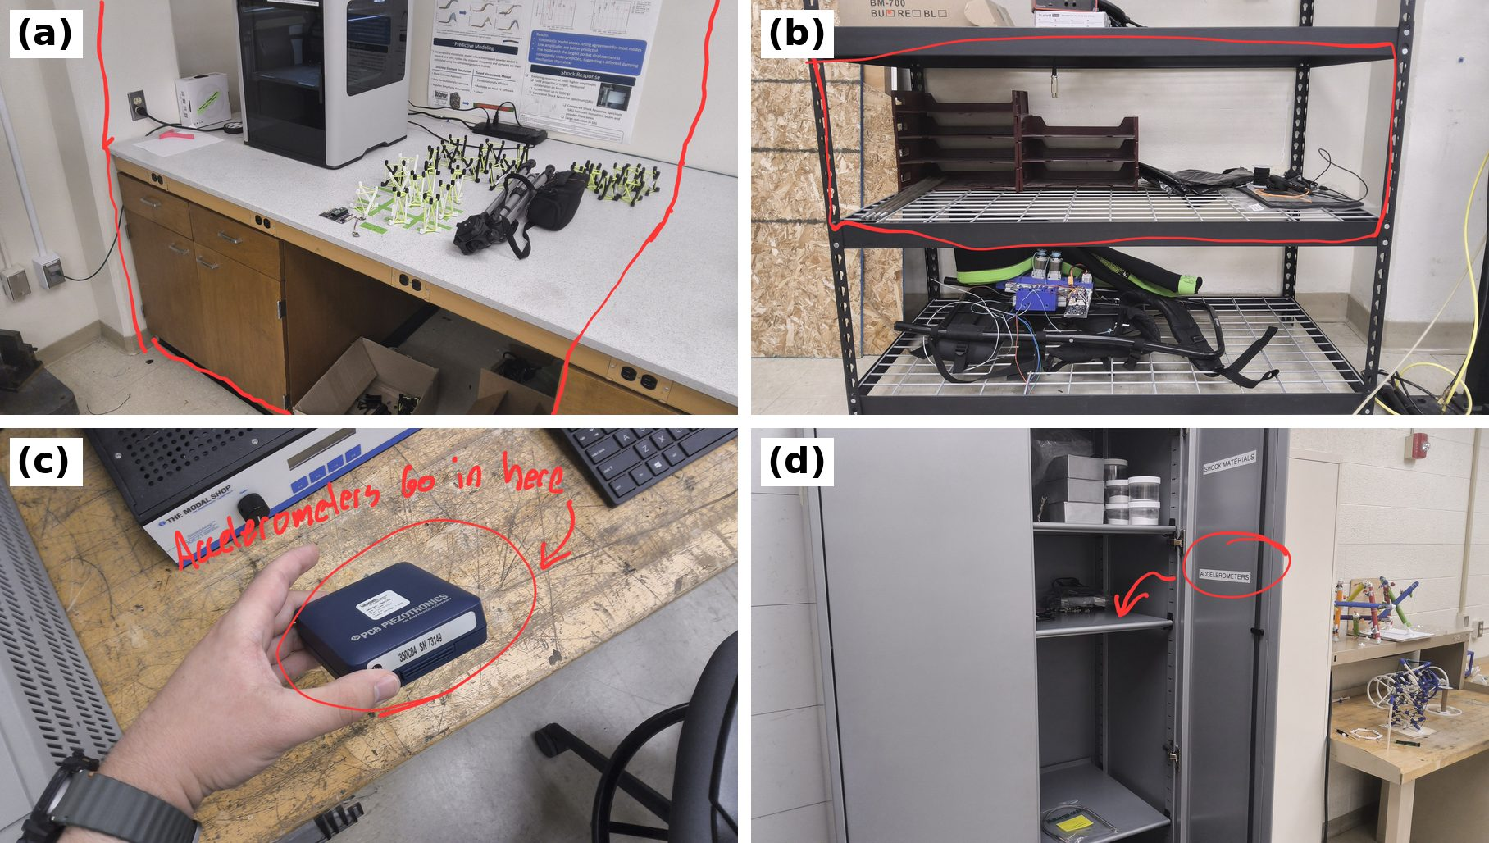
Figure 1. CB 152A workspace and storage, marked in red. (a) Bench area the team may use. (b) The team's shelf. (c) Accelerometer case (this one is labeled PCB Piezotronics 350C04, SN 73149). (d) Cabinet shelf marked "Accelerometers". Photos: Marcus Madsen, issue #115, 2026-10-13.

5. Equipment and the prepared setup

5.1 Drop tower
Values from the Lansmont M23 data sheet (October 2025 revision) as transcribed in the equipment notes. Confirm each one against the lab's machine and its manual, and fill in the blanks. | 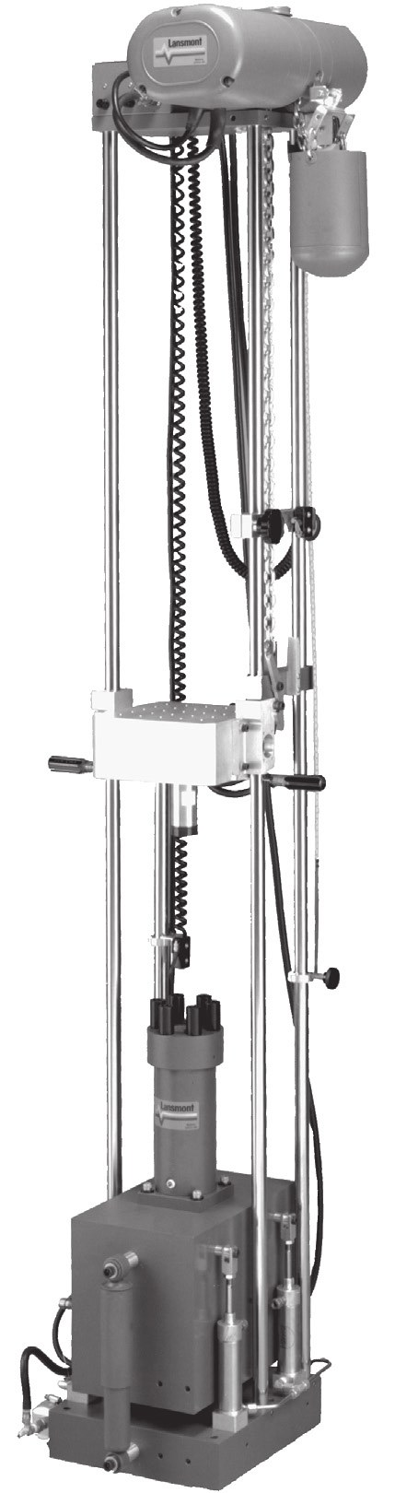  Figure 2. Lansmont Model 23: hoist at the top, carriage on the guide rods, brake and air components at the base. [Replace with a labeled photo of the lab's machine.] Vendor photo, M23 data sheet, October 2025.
  Item | Value
  Model and serial number | Lansmont Model 23, serial [number]
  Controller | TouchTest Shock II table top console [confirm]
  Maximum acceleration | 5,000 g
  Minimum pulse duration | 0.25 ms (half-sine)
  Maximum velocity change | 24 to 32 ft/s (7.3 to 9.7 m/s)
  Maximum payload | 80 lb (36 kg)
  Table size | 9.06 in by 9.06 in (23 cm by 23 cm)
  Air supply | Plant air at 90 psi (6.2 bar). [Regulator setting used in the lab.]
  Machine power | 200 to 240 VAC three-phase at 4 A or more, or 380 to 480 VAC three-phase. [Disconnect location.]
  Emergency stop | [Equipped? Location? See section 14.]
  Manuals | [Where the M23 and TP4 manuals are kept. The TP4 Quick Start Guide and User's Guide were attached to the GitHub issue that started the drop-test protocol.]

5.2 Instrumentation
Channel use in the 2026 campaigns, from the TP4 settings re-entered on 2026-08-18 (Figure 6) and the per-campaign records on PR #86. Sensor models, serial numbers and calibration sheets have not been recorded yet. Fill them in here and in table 9.2.
Channel | Sensor | Location and mounting used | TP4 full scale | Sensitivity | Role
CH2, CH3, CH4 | High-range tri-axis accelerometer [model, serial] | Top vertex of the specimen, in the printed key seat, held with wax; cable clamped to a rod | 14,492.8 / 14,992.5 / 13,624.0 G | 0.690 / 0.667 / 0.734 mV/G | Output ("TOP")
CH5 | Single-axis accelerometer, 10,000 g class [model, serial] | Base acrylic plate, taped (wax in earlier runs) | 9,442.9 G | 1.059 mV/G | Input and trigger
DAQ | Lansmont TP4 [serial] | [location of recorder and computer] |  |  | Records all channels

5.3 Fixture and absorber
- Specimens sit on an acrylic base plate on the carriage and are tied down to the plate bolts with cords (Figure 3).
- Absorber stacks used so far: 4 felt sheets plus 1 cardboard sheet (the standard 60 in campaign setup), 5 felt sheets, and a 1/2 in polyurethane sheet (print-defects setup, pre/post grease test).
- Bungee cords: attached in the first drops (issue #36), removed for the later campaigns.
- An earlier specimen cage used two acrylic plates on four 18 in threaded rods (drop-test protocol).

5.4 The correctly prepared setup
[Replace Figure 3 with a photo of the setup approved for this SOP, with the parts labeled. Take it after the corrective actions in section 17.3 are in place.]
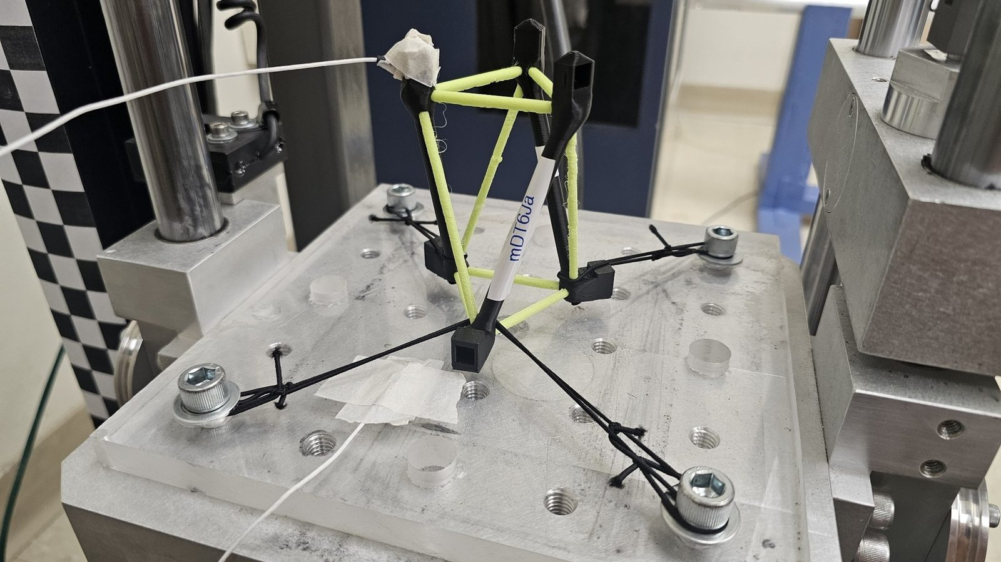
Figure 3. Example of a prepared setup (2026-08-06): specimen mdt6ja on the acrylic base plate, bottom vertices tied to the plate bolts with cords, the top-vertex accelerometer cable taped at the vertex, and the base-plate accelerometer under tape. The checkerboard is the scale reference for video. Photo: project IDETC 2026 slide deck, slide 23 (copy in the repository).

6. Hazards, eye protection and personnel clearance

6.1 Hazards
Hazard | Where | Controlled in
Falling carriage: crushing and pinching | Under and around the carriage, between carriage, absorber and base | 7.2, 6.3, 16
Stored energy: raised carriage, stretched bungee cords, compressed air | Hoist, latch, bungee attachment points, air lines and brakes | 7, 14, 16.2
Ejected parts: broken specimens, loose sensors, fixture pieces | Around the table | 6.2, 6.3, 9
Pinch points at the latch, hoist and brakes | Moving parts of the tower | 7.1
Cable snagging and whipping | Sensor cables between carriage and frame | 9.4
Compressed air (90 psi) | Hoses, fittings, brake cylinders | 10, 16.2
Electrical (three-phase machine power) | Machine and controller | 16.3
Noise from impacts | Room | [hearing protection: required or optional?]

6.2 Eye protection
What this section must cover: Specify required protection for operators and anyone near the test.

Procedure
- Everyone in CB 152A wears safety glasses with side shields marked Z87+ (impact rated to ANSI Z87.1) whenever [the safety key is in, the system is pressurized, or the carriage is raised].
- Prescription glasses count only if they are Z87+ rated. Otherwise wear goggles or over-glasses over them.
- [A face shield is required when: for example testing specimens that can shatter, or whenever the guard is open.]
- Spare safety glasses are kept at [location]. Visitors get a pair before entering.
How it is verified
- The release controller checks that everyone present has eye protection on before each "Ready?" call (checklist 1.2).
Stop the test if
- Anyone in the room is not wearing eye protection.
- Eye protection is cracked, scratched so that vision is impaired, or missing side shields.

6.3 Guarding and personnel clearance
What this section must cover: Define the exclusion zone, operator location, and protection from ejected parts or broken specimens.

Procedure
- Exclusion zone: [distance, for example 1 m] around the tower, marked with [floor tape or a barrier]. Nobody enters it from the "Ready?" call until the carriage is caught and all motion has stopped (section 12.2).
- Operator location during a drop: [at the controller, location], outside the zone, with a clear view of the tower and the cables.
- Guard: [describe the shield or enclosure and when it must be closed].
- Tie specimens to the base plate (Figure 3) and clamp sensor cables so a broken specimen or a loose sensor stays on the table.
- Tell everyone else in the room before each drop or run.
How it is verified
- The release controller looks over the zone before calling "All clear".
- [Optional: an observer watches the zone during automatic runs.]
Stop the test if
- Anyone enters the zone after the "Ready?" call.
- The guard is open or missing.
- Any part leaves the table. Re-assess the zone size and the retention before continuing.

7. Safety key and the raised mass

7.1 Safety key procedure
What this section must cover: Require removal of the safety key before working on the machine. Define how to verify that the system is configured correctly so removing the key prevents both the pulley from raising and the latch from releasing. Specify when the key may be reinserted.

Procedure
- Remove the safety key from [location on the controller] before any work on the machine: mounting a specimen or sensor, adjusting cables, changing the absorber, inspecting, cleaning or troubleshooting.
- The person working on the machine keeps the key [in a pocket or on a lanyard] until the work is done. Nobody else reinserts it.
- Reinsert the key only when everyone is out of the exclusion zone, tools and loose items are off the machine, checklist 1.2 is complete up to the "Ready?" call, and the person who held the key agrees.
- The spare key is kept by [supervisor] at [location].
How it is verified
- At the start of each session, and after any maintenance or wiring change, with the key out and the carriage resting on [its supports]: press the hoist raise control. The carriage must not move.
- With the key out, operate the release control [describe how to test this safely, for example with the latch empty]. The latch must not open.
- Record both results in the log.
Stop the test if
- The hoist raises or the latch releases with the key out. The interlock is not working: put the machine in the secure state, tag it out, and notify the supervisor.
- The key is missing, or a second key is in use.
Note: Removing the safety key does not hold up a raised carriage. Section 7.2 applies whenever anyone reaches under it.

7.2 Supporting the raised mass
What this section must cover: Define the mechanical restraint required before accessing beneath it. Removal of the safety key does not replace mechanical support of the raised mass.

Procedure
- Never put hands, tools or any part of the body under a raised carriage that is held only by the latch, the hoist or the brakes.
- Lower the carriage to [its rest position] before working under it whenever possible.
- If it must stay raised, install [the mechanical restraint: for example safety pins through the frame, or a rigid prop rated for the carriage weight] directly under it, then remove the safety key.
- If bungee cords are attached, [detach or relax them] before working near the carriage. They store energy while it is raised.
- Remove the restraint only after everyone's hands are out and everyone is clear.
How it is verified
- A second person checks that the restraint is in place before anyone reaches under.
- [Record use of the restraint in the log.]
Stop the test if
- No rated restraint is available.
- The restraint is damaged, or the carriage moves while it is being installed.

8. Approved operating limits
What this section must cover: Establish allowable mass, drop height, pressure, and test configurations, including who approves changes.

The "Used so far" column comes from the campaign records on PR #86. The approved limits are for the supervisor to set.
Parameter | Approved limit | Machine maximum (M23 data sheet) | Used so far in this project
Drop mass (carriage, fixture and specimen) | [ ] | 80 lb (36 kg) payload | [record the carriage mass]
Drop height | [ ] | [from the manual] | 5, 10, 13 and 60 in
Peak table acceleration | [ ] | 5,000 g | [ ]
Air pressure | [ ] | 90 psi (6.2 bar) supply | [ ]
Bungee cords | [allowed? how many?] |  | Attached in the first drops, removed since
Absorber stacks | [approved list] |  | 4 felt + 1 cardboard; 5 felt; 1/2 in polyurethane
Automatic repeat drops | [maximum drops per run] |  | About 40 s per drop, up to 500 drops per run
Peak reading vs. sensor range | Below [80 %] of the sensor's range and of the TP4 full scale |  | Some channels reached full scale in 2026 (section 17.3)

Who approves changes
- Operators may run any configuration inside the approved limits.
- A new limit, a new absorber, a new fixture or block, or bungee cords need [the supervisor's] approval, recorded in [the log or a revision of this SOP] before the first drop.

9. Specimen and sensor setup

9.1 Securing the block
What this section must cover: Specify how the block is retained and how its attachment is checked before every drop.

Procedure
- [Describe the block and how it is fastened: bolt size, number, torque, thread locker.]
- Fasten the acrylic base plate to the block with [fasteners].
- Tie the specimen's bottom vertices to the plate bolts with cords (Figure 3). [Or the approved method.]
- Mark each bolt with a paint-pen line across the head and the plate (witness mark).
How it is verified
- Before every drop: push and twist the block and plate by hand. Nothing moves, and the witness marks line up (checklist 1.2).
- [Torque check every N drops or each session.]
Stop the test if
- The block or plate moves, a fastener is missing, or a witness mark is broken.
- The plate is cracked or crazed.

9.2 Using proper shock accelerometers
What this section must cover: Verify measurement range, shock-survival rating, and suitability for the expected impact.

Procedure
- Estimate the peak acceleration for the planned test from earlier drops with the same height and absorber. Write the estimate in the test plan.
- Pick a sensor whose measurement range is at least [1.5] times the expected peak and whose shock-survival rating (from its data sheet) is well above the worst case, including the sensor coming loose and hitting the table.
- Set the TP4 so the expected peak stays below [80 %] of full scale. The TP4 "Full Scale" column is the recorder's input range (10 V) divided by the sensitivity: 10 V / 1.059 mV/G = 9,442.9 G for CH5. It is not the sensor's rated range or its shock survival.
- Record each sensor's model, serial number, sensitivity, range, shock survival and calibration date in the table below.
How it is verified
- A second operator checks the sensor data sheet against the expected peak before any new configuration.
- After each drop, the peak is below [80 %] of full scale (checklist 1.3).
Stop the test if
- Any channel reaches full scale (clipping).
- The peak exceeds the sensor's measurement range.
- A sensor was dropped or struck. Check its sensitivity before using it again.
Channel | Model | Serial | Sensitivity | Range (± g) | Shock survival (± g) | Calibration due
CH2 | [ ] | [ ] | 0.690 mV/G | [ ] | [ ] | [ ]
CH3 | [ ] | [ ] | 0.667 mV/G | [ ] | [ ] | [ ]
CH4 | [ ] | [ ] | 0.734 mV/G | [ ] | [ ] | [ ]
CH5 | [PCB 350C04? confirm] | [ ] | 1.059 mV/G | [ ] | [ ] | [ ]

9.3 Accelerometer installation and handling
What this section must cover: Specify mounting method, appropriate mounting torque, connector handling, and protection from direct impact.

Procedure
- Mounting method for each location: [stud mount to a tapped hole at the torque on the sensor's data sheet, for example ___ in-lb with a torque wrench; adhesive mount; or the approved method]. Bare wax and press fits have let sensors fall off (section 17.3).
- Top-vertex sensor: seat it flush in the printed key seat with wax inside the housing, and clamp its cable to a rod so cable pull cannot drag it out of the seat.
- Connectors: hand-tighten [10-32 coaxial] connectors. Never pull on the cable to disconnect, never let a connector carry the weight of the cable, and cap unused connectors.
- Place sensors and connectors where nothing can strike them during travel or rebound, and away from the absorber contact area.
- Carry sensors in their cases. At the end of the day, return them to their cases and the cabinet (Figure 1).
How it is verified
- After mounting: a light tug on the sensor body (not the cable) does not move it.
- First drop of the session: every channel shows an impact and returns to baseline.
Stop the test if
- A sensor is loose, tilted or out of its seat.
- A connector is loose or its strain relief is damaged.
- Readings are abnormal (section 13).
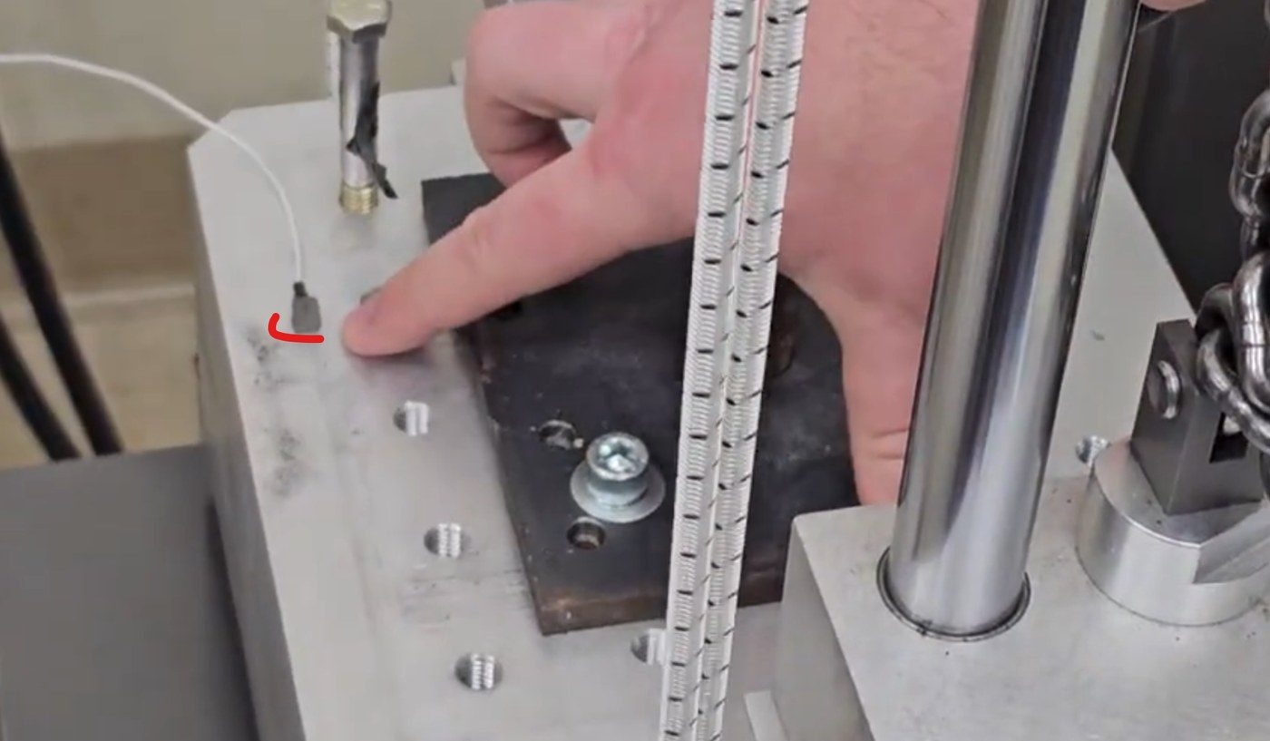
Figure 4. Carriage table during the first drop tests. The red mark shows a base accelerometer next to the absorber plate. The striped elastic cords are bungee cords. Photo: issue #36 (copy).

9.4 Securing accelerometer cable slack
What this section must cover: Define cable routing and strain relief throughout the full travel and rebound to prevent snagging, pinching, or pulling on connectors.

Procedure
- Route each cable from the sensor to a strain-relief clamp on the carriage within [100 mm] of the sensor, then in one loop to a fixed anchor on the frame at [location], then to the TP4.
- Strain relief at both ends: the clamp takes any pull before it reaches the connector. Use [cable clamps or P-clips]. Do not tape over the connector.
- Size the loop so it reaches the full drop height plus the rebound plus [margin] without going tight, and so it never hangs into the guide rods, brakes, latch, hoist or absorber.
- Before the first drop of a session, and after any change, raise the carriage slowly to the drop height while watching the cable along the whole travel.
- No sharp bends at the connectors. Minimum bend radius: [from the cable data sheet].
How it is verified
- Slow-raise check at the start of each session (checklist 1.1).
- Visual check before every drop (checklist 1.2).
- After every drop: no kinks, cuts or flattened sections, and no strain at the connectors.
- In the TP4 series table, every capture holds an impact. Missed impacts or baseline steps point to a cable fault.
Stop the test if
- A cable touches a moving part, or goes tight anywhere in the travel.
- A cable or connector is damaged.
- The signal is intermittent: missing impacts, steps in the baseline, false triggers.
Sources and related records
- CH5 cable fault: intermittent for an hour on 2026-10-17, then broken by 2026-10-19 (analysis). The recommendation at the time was to reseat or replace the cable and both connectors and give it strain relief clear of the carriage (lab actions).
- Sensor dragged out of the key seat by cable pull, fixed by clamping the cable to a rod (run 1, run 2).
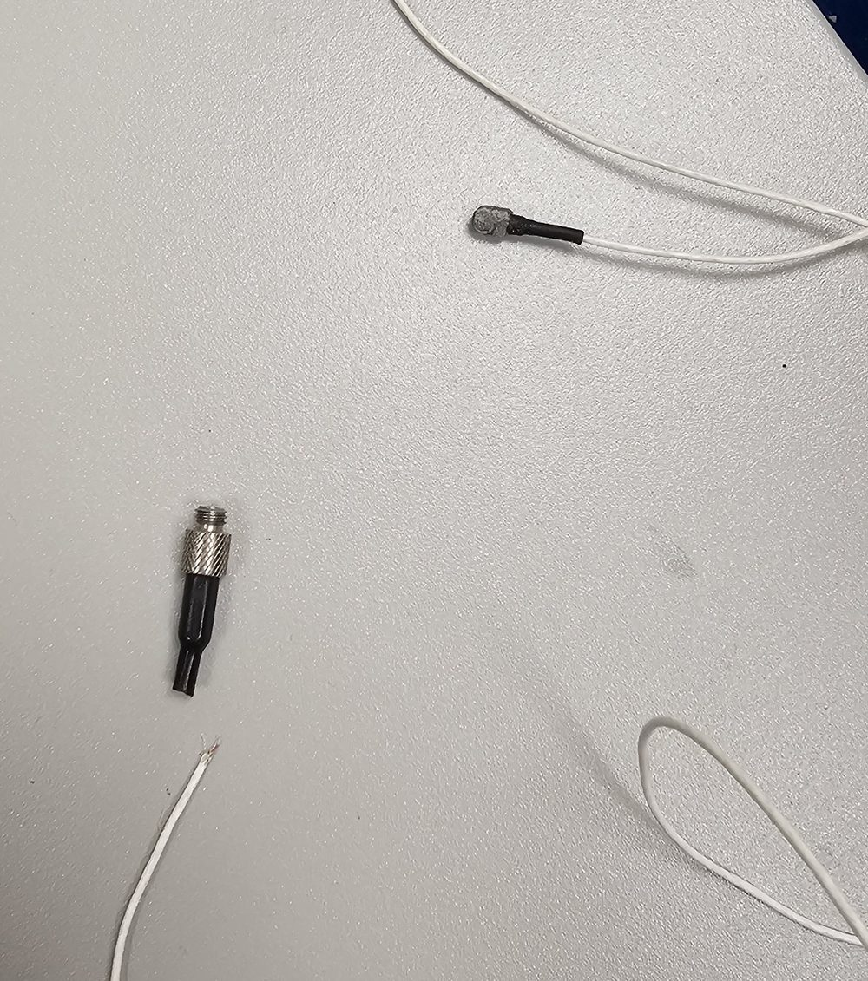
Figure 5. The CH5 (10,000 g single-axis) accelerometer cable after it broke at the connector, 2026-10-19. Drop tower use was halted after this failure. Photo: Marcus Madsen, issue #115.

10. Pre-test inspection
What this section must cover: Check fasteners, fixtures, guides, lifting and release components, hoses, fittings, cables, and sensors for damage or looseness.

Do this inspection with the safety key out and the carriage at rest, at the start of each session and after any incident. Initial each line in the log.
Done | Item | Check | Past problem
☐ | Fasteners | Block, plate and fixture bolts tight; witness marks line up
☐ | Fixture and acrylic plates | No cracks, crazing or chips
☐ | Guide rods and bearings | Clean, lubricated per [the manual], no scoring; carriage moves freely | Rail friction cut impact speed to 79 to 86 % of free fall; rods were cleaned and greased on 2026-08-10 (record)
☐ | Drop pins | Present and undamaged [confirm what they are] | A drop pin broke in the 2026-08-04 to 08-06 sessions (issue #92, analysis)
☐ | Hoist (pulley) and its chain | No damage; [check per manual]
☐ | Latch and release hook | Hook falls closed by itself and engages fully; release works | Hook stuck open after more than 1,500 drops, 2026-07-22 (note)
☐ | Brakes | [check per manual]
☐ | Air hoses and fittings | No hissing or cracks; hoses secured; regulator at [ ] psi
☐ | Absorber stack | Right stack for the plan; not worn past [limit]
☐ | Bungee cords (if used) | No fraying; right number and attachment
☐ | Sensor cables and connectors | No kinks, cuts or loose connectors; strain relief in place | CH5 cable broke, 2026-10-19
☐ | Sensors | Mounted firmly; no visible damage | Sensors fell off in four runs (section 17.3)
☐ | Safety key interlock | Check in section 7.1 done
☐ | Emergency stop | [test per manual, if equipped]

How it is verified
- Each line initialed in the log before the first drop of the session.
Stop the test if
- Any line fails. Fix it, or put the machine in the secure state and tell the supervisor.

11. DAQ readiness
What this section must cover: Verify sensor connections, excitation, input ranges, triggering, and recording before release.

Procedure
- Connections: each sensor cable goes to the TP4 channel in table 5.2, connectors hand tight.
- Excitation: ICP on for every channel with an ICP sensor (CH2 to CH5 in Figure 6). [Check the sensor bias or fault indicator, if the TP4 shows one.]
- Input ranges and sensitivities match table 9.2 and the calibration sheets. Compare the Recording Setup screen with the reference (Figure 6) and photograph it again after any change.
- Trigger: channel [CH5], level [150 G], pre-trigger [2 %], record time [100 ms], sample rate [1.25 MHz]. Trigger levels from 150 G to 1,000 G have been used.
- Recording: name the TP4 session after the specimen and campaign (for example RW5F61_100drops). Check that there is disk space.
- Camera (optional): recording, framed so the specimen and the release point are both in view.
How it is verified
- After the first drop: an impact is in the record, peaks are near the reference values for the configuration, and no channel is flat, clipped or stepping. Example from 2026-10-17: CH4 peak at least 150 G; CH5 pulse about 3 to 4 ms long with a velocity change of about 205 to 225 in/s (source).
Stop the test if
- Missed triggers, or captures with no impact.
- A channel is clipped, flat or stepping.
- Settings differ from the reference. On 2026-08-18 the TP4 settings were reset and had to be re-entered (check).
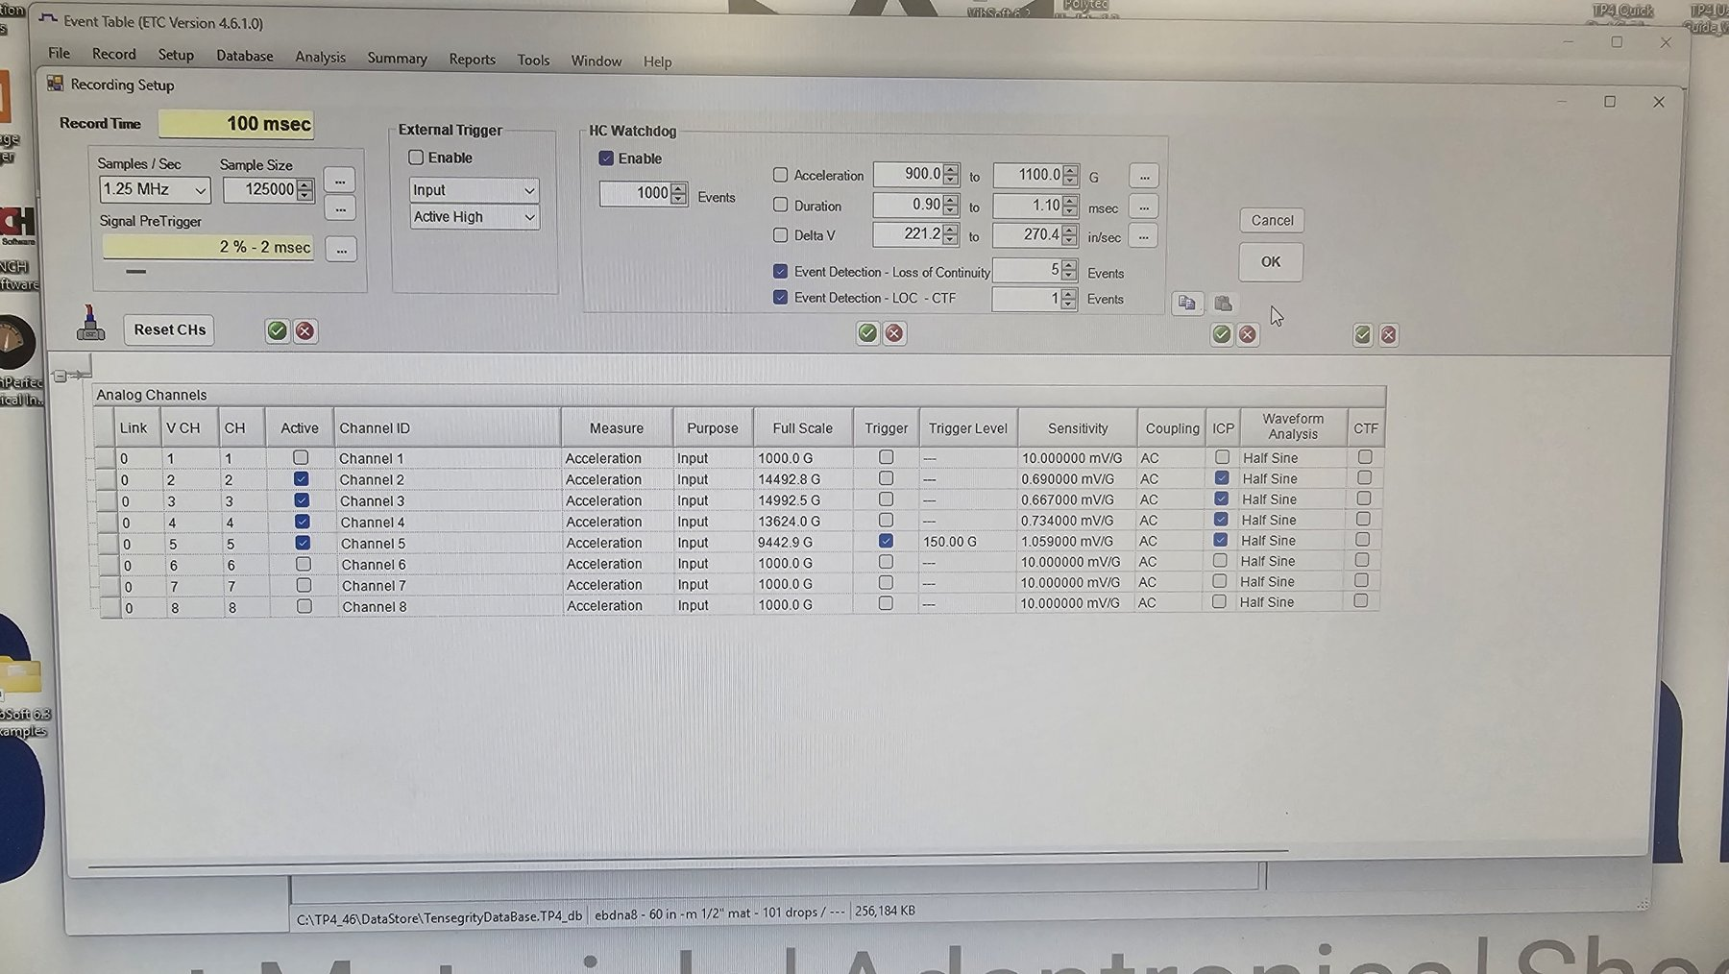
Figure 6. TP4 Recording Setup and Analog Channels screen as re-entered on 2026-08-18: 100 ms record at 1.25 MHz, 2 % pre-trigger, CH2 to CH5 active with ICP on, trigger on CH5 at 150 G. Photo: calibration-check record, PR #86.

12. Running a drop

12.1 Pre-drop checklist and communication
What this section must cover: Assign one person control of release and require explicit readiness confirmation and an "all clear."

Procedure
- At the start of the session, name one release controller and record the name in the log. Only that person inserts the safety key, raises the carriage and releases it. A handover is said out loud and logged.
- The release controller completes checklist 1.2 items 1 to 5.
- The release controller asks "Ready?". Each person present answers "Ready". The DAQ operator answers "Recording armed" and the camera operator "Camera rolling".
- The release controller looks over the exclusion zone, calls "All clear, dropping" and releases within [10 s]. If anything changes before the release, the call is void and starts again at step 3.
- Anyone may call "Stop" at any time. The release controller does not release after a "Stop".
- Automatic repeat runs (about 40 s per drop): [define how the calls work, for example one call at the start of the run, the release controller stays at the controller for the whole run, and anyone entering the zone stops the run].
How it is verified
- The log names the release controller for each session and each handover.
Stop the test if
- Someone does not answer "Ready".
- Anyone enters the zone.
- Anyone calls "Stop".

12.2 Rebound and secondary impacts
What this section must cover: Describe how these are controlled and when it is safe to approach.

In two 60 in drops onto five felt sheets filmed at 960 frames per second, the carriage bounced back at 0.35 to 0.43 times its impact speed, and the anti-rebound brakes stopped it 86 to 89 ms after impact, 130 to 150 mm above the absorber, with no second impact (Figure 7; analysis).
Procedure
- Keep the anti-rebound brakes [on, with air at ___ psi] for every drop.
- Approach only when the brakes hold the carriage, the specimen and cables have stopped moving, and [the controller shows ___]. Wait at least [5 s] after impact.
- If the brakes do not catch and the carriage strikes again, stop and inspect before the next drop.
How it is verified
- One impact per capture in the TP4 record; the brake catch shows in video or data.
Stop the test if
- A second impact.
- The brakes do not catch, or the carriage creeps down after the catch.
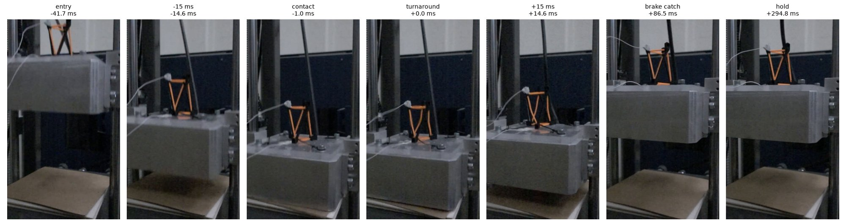
Figure 7. Frames from a 60 in drop filmed at 960 frames per second: entry, contact, turnaround, rebound, brake catch at 86.5 ms, and hold. Figure: 60 in, 5 felt video analysis, PR #86.

12.3 Increasing test severity
What this section must cover: Require inspection and review of the previous test before increasing height, mass, or pressure.

Procedure
- Increase severity in steps no larger than [for example 25 % of the drop height, or one absorber layer].
- Before each step up: inspect after the last drop at the current level (section 15), and review its data: peaks below [80 %] of sensor range and TP4 full scale, one impact, normal brake catch.
- Record the review in the log with the initials of [two people].
- A step beyond the approved limits needs the supervisor's approval first (section 8).
How it is verified
- A signed review in the log before each step up.
Stop the test if
- The review is not done, or the previous drop was abnormal.

13. Stop-work conditions
What this section must cover: Include loose components, damaged cables, leaks, unexpected motion, abnormal readings, and anyone entering the exclusion zone.

Anyone present may call "Stop". After a stop: do not release, end any automatic run [how], put the machine in the secure state (section 16.3) before investigating, and record the stop in the log. Events in section 17.2 also need the supervisor's approval to restart.
Condition | Examples | Before restarting
Loose component | Fastener, fixture, plate or sensor moves | Fix and re-inspect (section 10)
Damaged cable or connector | Cut, kink, crushed jacket, strained connector | Replace; slow-raise check (9.4)
Leak | Hissing, pressure falling | Vent (16.2), fix, leak check
Unexpected motion | Carriage creeps, latch will not close, hoist moves without a command | Secure state; supervisor (17.2)
Abnormal readings | Missing impacts, clipping, baseline steps, peaks far from reference | Check sensors, cables and settings (9, 11)
Someone in the exclusion zone | During the call, the drop or the rebound | Restart the call (12.1)
No eye protection | Anyone in the room | Glasses on (6.2)
Interlock failure | Hoist or latch works with the key out | Tag out; supervisor (7.1)
Noise, smell or smoke | From the hoist, controller or wiring | Power off; supervisor
[Add]

14. Failed release, interrupted test and emergency stop
What this section must cover: Define how to secure and unload the system before troubleshooting. Explain what the emergency stop does, if equipped, and what hazards remain afterward.

Procedure
- If the carriage does not release: do not reach under it, and do not keep retrying. Remove the safety key.
- Unload the latch: lower the carriage with the hoist [describe] onto [its rest position]. If it cannot be lowered, install the mechanical restraint (section 7.2) before anyone works near it.
- Vent the air (section 16.2) and switch off the power (section 16.3) before troubleshooting the latch, hoist or release.
- Interrupted test (power loss, air loss, DAQ crash, someone in the zone): treat the carriage as raised and latched until checked, and follow steps 1 to 3.
- Release hook that will not fall closed: follow the troubleshooting note, with power and air off and the carriage supported.
How it is verified
- The secure state is checked (section 16.3) before troubleshooting starts.
Stop the test if
- Any failed release or interrupted test. Restart needs the supervisor's approval (17.2).
Emergency stop
Question | Answer
Is the machine equipped with one? Where is it? | [ ]
What it does | [for example: cuts power to the hoist motor and controller]
What it does not do | [for example: it does not lower the carriage. A raised carriage stays raised and can still fall. Air stays in the lines and brakes. Bungee cords stay stretched.]
Hazards left after an emergency stop | [raised mass, stretched bungee cords, compressed air, broken specimen pieces, others]
How to reset it | [ ]
How often it is tested | [ ]

15. Post-test inspection
What this section must cover: Define what must be inspected after each drop and the conditions that must be met before continuing.

After every drop
Item | Condition to continue
Specimen | Still in position on the plate; tie-downs intact; damage recorded
Sensors | Still seated and flush; not moved
Cables | Intact, clamped, still clear of moving parts
Fixture and block | No movement, no cracks
Absorber | In place, not shifted
Data | Impact in the record; no clipping; baseline returns; peaks in the expected range

During automatic runs
- Check the TP4 series table every [N] drops, and stop the run if a capture fails the conditions above.
Every [N] drops, and at the end of the session
- Repeat the section 10 checks on the guide rods, latch, hoist, brakes and hoses.
- Check absorber wear and replace it at [limit].
Stop the test if
- Any condition above is not met (section 13).

16. Leaving the machine

16.1 Leaving the machine during operation
What this section must cover: Define required operator attendance and the steps required before stepping away.

Procedure
- An authorized operator stays in CB 152A, in sight of the tower, whenever the safety key is in, the system is pressurized or the carriage is raised. This includes automatic repeat runs.
- Before stepping away for any length of time: stop the run, lower the carriage to [its rest position], and take the safety key.
- Away for more than [10 min]: leave the machine in the secure state (section 16.3).
- Never leave a carriage held up by the latch alone.
- Hand over to another authorized operator in person, and say out loud who is now the release controller.
How it is verified
- Breaks and handovers are recorded in the log.
Stop the test if
- No authorized operator can stay with the machine.

16.2 Leaving the system pressurized
What this section must cover: Define when depressurization is required and how residual pressure is checked.

Procedure
- Depressurize at the end of each session, before leaving the machine unattended, before work on any air component (hoses, fittings, brakes, release), and after an emergency stop or a leak.
- Close the supply valve at [location] and vent through [valve]. Watch the gauge at [location] fall to zero.
- Check for residual pressure: the gauge reads 0 psi after [time], and [cycling the brake or release valve with the key out] releases no air.
- The system may stay pressurized only while an authorized operator is present.
How it is verified
- The end-of-session gauge reading is recorded in the log.
Stop the test if
- The gauge does not fall to zero, or the pressure rises again after venting (leaking valve).

16.3 Leaving the system in a secure state
What this section must cover: Define the required position of the drop mass, mechanical restraints, pressure state, power state, and safety key location.

Done | Item | Required state
☐ | Drop mass (carriage) | Lowered to [rest position]. Never left raised.
☐ | Mechanical restraints | [pins or blocks] in place
☐ | Bungee cords | [detached or relaxed]
☐ | Air | Supply closed and vented; gauge at 0 psi
☐ | Power | Controller off; machine [disconnect] off
☐ | Safety key | Removed and stored at [location]. Never left in the controller.
☐ | Sensors | Removed from the specimen, in their cases, in the cabinet (Figure 1)
☐ | Workspace | Cleared (section 4)

How it is verified
- The last person to leave initials checklist 1.4 in the log.

17. Test and incident log
What this section must cover: Maintain a log of test conditions and any anomalies, errors, equipment damage, near misses, or safety incidents. Record the date, operators, description, corrective action, and approval to resume testing when required. Define which events require immediate notification of the supervisor.

17.1 What to record
- The log is kept at [paper binder at the tower and/or file location]. Session data and campaign notes have also been posted on PR #86. [Say which one is the official log.]
- Every session: date, operators, release controller, specimen IDs, configuration (height, mass, absorber, bungee cords, pressure), TP4 session name, settings photo if changed, sensors and serial numbers, number of drops, start and end times, interlock check, inspections, anomalies.
- Every anomaly, error, damage, near miss or safety incident: date, operators, description, immediate action, corrective action, and approval to resume (name and date). Use the form in Appendix C.

17.2 Events that need immediate supervisor notification
Notify [supervisor name, phone] at once, and do not resume testing until the supervisor approves it in the log, for:
- Any injury, however small.
- Any near miss: someone in the exclusion zone during a drop, or under a raised carriage without the restraint.
- Damage to the tower (latch, pins, guide rods, brakes, hoist, air system) or to a sensor or cable.
- A failed release, an unexpected drop, or a carriage that moves without a command.
- A failed safety key interlock check.
- An air leak that tightening a fitting does not fix.
- A part thrown outside the exclusion zone.
- [Add or remove events.]

17.3 Previous incidents and preventive steps
Each previous incident is matched to a preventive step in this SOP. "Logged" is the date the run was recorded in the repository. [Review each line, add any incident not listed, and confirm the preventive step.]
Logged | What happened | Preventive step | Section
First drops (issue #36) | With bungee cords pulling the carriage faster than free fall, the specimen lifted off the base and landed out of line. The cage top plate could tilt about 25°. | Tie specimens to the base plate. Bungee cords only in approved configurations. | 5.3, 8, 9.1
2026-06-23 (record) | Vertex-mounted accelerometer not fully secured; it fell off on the drop. | Tug test after mounting; check before every drop. | 9.3, 1.2
2026-06-29 (record) | Top-vertex accelerometer fell out of the key seat; press fit alone was not enough. | Wax inside the key-seat housing (follow-up). | 9.3
2026-07-02 (run 1) | Tri-axis accelerometer fell out of the key seat at drop 26. | Clamp the cable to a rod so cable pull cannot reach the sensor; it then stayed on for all 50 drops (run 2). | 9.4
2026-07-03 (record) | CH5 base-plate accelerometer, held with bare wax, fell off mid-run. | Approved mounting method; stop if a sensor is loose. | 9.3, 13
2026-07-13 (record) | CH7 and CH8 exceeded full scale (clipping) on most captures at 10 in. | Choose sensors and TP4 ranges for the expected peak. | 9.2
2026-07-22 (note) | Release hook stuck open after more than 1,500 drops; the latch no longer re-engaged by itself. WD-40 did not help. | Latch check in the pre-test inspection; keep the latch dry; never free the hook with the carriage unsupported. | 10, 14
2026-08-06 (issue #92) | A drop pin broke. Rail friction cut impact speed to 79 to 86 % of free fall. | Inspect drop pins and guide rods; clean and grease the rods (follow-up). | 10
2026-08-18 (check) | TP4 settings were reset and had to be re-entered. | Compare settings with the reference screen every session. | 11
2026-10-17 to 2026-10-19 (analysis) | CH5 cable intermittent for an hour, then broke at the connector. Drop tower use halted. | Cable routing with strain relief at both ends; slow-raise check; cable inspection after every drop; stop on missing impacts. | 9.4, 15, 13
[date] | [Add any incident not listed.] | [ ] | [ ]

18. Training and authorization
What this section must cover: Define who may operate the system and who approves the SOP and subsequent modifications.

- Authorized operators have: [completed the required BYU lab safety training (name it)], read this SOP and signed the record below, been trained on the drop tower by [the supervisor or a named trainer], and run [N] sessions under supervision.
- Training walkthrough video: youtu.be/RNjpAmWWmkQ.
- [The supervisor] approves this SOP and every later change. Changes are listed in section 19 and announced to all operators [and to the other teams using the tower].
- Operators re-read the SOP and re-sign [every year, and after every revision].
Name | Trained by | Date | Supervised sessions | Authorized by | Date

19. Approval and revision history
Role | Name | Signature | Date
Supervisor | [ ]
SOP owner | Marcus Madsen
SOP owner | Jinkwan [last name]
[Lab or facility manager] | [ ]

Revision | Date | Description | By | Approved
0.1 | 2026-10-29 | Template drafted from the repository records (issue #115) | Claude Code, for M. Madsen and Jinkwan | Not approved

Appendix A. Requirement coverage
Each item from the SOP request and the section that covers it.
Required item | Section
Secure accelerometer slack | 9.4
Safety key procedure | 7.1
Eye protection | 6.2
Leaving the machine during operation | 16.1
Leaving the system pressurized | 16.2
Leaving the system in a secure state | 16.3, checklist 1.4
Securing the block | 9.1
Using proper shock accelerometers | 9.2
Accelerometer installation and handling | 9.3
Supporting the raised mass | 7.2
Pre-test inspection | 10
Approved operating limits | 8
Guarding and personnel clearance | 6.3
Rebound and secondary impacts | 12.2
Pre-drop checklist and communication | 1.2, 12.1
DAQ readiness | 11
Increasing test severity | 12.3
Stop-work conditions | 13
Failed release or interrupted test, emergency stop | 14
Post-test inspection | 15
Test and incident log, supervisor notification | 17
Training and authorization, SOP approval | 18, 19
Photo of the correctly prepared setup | 5.4 (Figure 3)
Short checklist before every drop | 1.2
A preventive step for each previous incident | 17.3

Appendix B. Session test log
Session
Date
Operators
Release controller (and handovers)
Specimen IDs
Configuration: height, mass, absorber, bungee cords, pressure
TP4 session name
Sensors and serial numbers
Interlock check (7.1) and pre-test inspection (10)
Start and end times
End-of-session gauge reading and secure state (16)

Drop or TP4 signal | Time | Height | Notes and anomalies | Initials

Appendix C. Incident report
Field | Entry
Date and time
Operators present
Type (anomaly, error, damage, near miss, safety incident)
What happened
Immediate action taken
Supervisor notified (name, time)
Cause
Corrective action
Preventive step added to this SOP (section)
Approval to resume testing (name, date)

Appendix D. Source records
- Drop tower use protocol and CB 152A workspace notes: issue #115.
- Drop-test protocol and troubleshooting: drop-test-protocol.md, drop-test-hook-troubleshooting.md.
- Lansmont M23 notes and data sheets: equipment/lansmont-m23, M23_Data_Sheet_official.pdf.
- Campaign records and analyses (per-run READMEs, incidents, settings): PR #86.
- TP4 settings check: drop-test-calibration-check-analysis.md.
- Rebound and brake catch: drop-test-60in-5felts-analysis.md.
- CH5 cable fault: ch5-fault-and-replicates.md.
- Photo provenance for Figure 3: figures/photos/overview/README.md.
- This template's source script and figures: docs/drop-tower-sop/ and scripts/build_drop_tower_sop.py in this repository.

