Marcus E. Madsen*  Department of Mechanical Engineering,  Brigham Young University,  Provo, UT 84602, USA  Audrey K. Christiansen*  Department of Mechanical Engineering,  Brigham Young University,  Provo, UT 84602, USA  Jinkwan Han*  Department of Mechanical Engineering,  Brigham Young University,  Provo, UT 84602, USA  Jeffrey R. Hill†‡  Department of Mechanical Engineering,  Brigham Young University,  Provo, UT 84602, USA  email: jeff.hill@byu.edu  Sterling G. Baird^{†‡1}  Department of Mechanical Engineering,  Brigham Young University,  Provo, UT 84602, USA  email: sterling.baird@byu.edu | Experiment-Driven Bayesian Optimization of the Impact Response of Multi-Material 3D-Printed Tensegrity-Inspired Structures  Tensegrity-inspired structures of rigid and soft members could cushion impacts, but the shock they transmit is hard to predict by simulation. We report a Bayesian optimization campaign, driven by drop tests, over three-strut prisms printed in one piece from polylactic acid and thermoplastic polyurethane. The search space begins with five geometry variables and, from the third batch, adds infill densities and filament settings. Each candidate is rescaled to a common mass, printed, and drop-tested repeatedly. The optimizer seeks low transmissibility (the top-to-base ratio of filtered peak accelerations) and a low velocity loss index (the fraction of impact velocity not returned at the top). Most printed articles amplify the peak shock. Over a quasi-random initial batch of experiments and three model-recommended batches (35 articles), the dominated hypervolume grew 65 percent and the model chose every design on the final Pareto front. The fourth batch's best-predicted design lowered transmissibility to 0.803, ten percent below the best seed article. After the conclusion of the campaign, several specimens were reprinted and tested multiple times to account for variability.  Keywords: tensegrity, multi-material 3D printing, Bayesian optimization, impact mitigation, design of experiments

Draft note (remove before submission): this draft is written at the intended final scope of the study, and any value printed in this violet color is a synthetic placeholder rather than a measurement. The Results contain no violet values. The four reported batches (35 articles) and the second and third prints of the batch-3 designs (18 articles, the third added 2026-10-11) are measured data from the committed campaign record. The Conclusions carry one violet placeholder for the outcome of the replicate study listed below. Still pending, and written as future work: the re-seat confirmations of the batch-4 record article and of the third-print outlier dran35, the entry of the third print into the surrogate fit, and any batches beyond the fourth. Also pending are the replicate rank-stability study (best-, mid-, and worst-predicted in-sample designs in nominal triplicate), the quasi-static crush campaign, the metal-analog comparison, and the archival (Zenodo) code release.

1 Introduction
Tensegrity structures are assemblies of rigid compression members suspended within a continuous network of tension members. Their defining property, that no two rigid bars touch, yields lightweight assemblies with high strength-to-weight ratios and tunable nonlinear mechanical responses [1, 2]. These properties have made tensegrity attractive across scales, from metamaterial unit cells [3–5] to compliant impact-absorbing robots developed for planetary landing [6–10]. Recent work has shown that tensegrity-inspired unit cells can be directly 3D-printed and exhibit load-limiting plateaus under drop-weight impact [11]. Throughout, we use tensegrity-inspired for printable cells that borrow the separated compression-member and tension-network geometry of tensegrity while relaxing defining mechanical conditions of classical tensegrity. In the present specimens, the printed soft tension elements are extensible, the rigid struts may share printed junctions, and no pretension is activated or measured. We therefore do not claim classical tensegrity, prestress-stabilized behavior, or equivalence to an ideal cable-strut prism.
Multi-material fused-deposition modeling (FDM) can pair a rigid polymer such as polylactic acid (PLA) with a soft, rate-dependent elastomer such as thermoplastic polyurethane (TPU) on a single platform. It has been used to fabricate rigid-soft architected energy absorbers, including thick-panel origami metamaterials with PLA panels and TPU hinges [12] and honeycombs of acrylonitrile butadiene styrene (ABS) and TPU with tunable stiff/flexible proportions [13]. The same rigid-soft co-printing capability makes it possible to fabricate diverse tensegrity-inspired geometries, which adopt a discrete-compression/continuous-tension topology rather than an origami or honeycomb one. Although extruded TPU does not behave as an idealized inextensible cable, its rate-dependent damping is a desirable property for impact-absorption applications and complements the elastic stiffness of the PLA compression members.
Designing such architected absorbers is a design-of-experiments problem. Strut geometry, tension-element cross-section, connectivity, and unit-cell tiling span a large configuration space. Each candidate must be physically printed and tested, and the relevant impact-performance metrics (the shock transmitted across the structure and the velocity it gives back to the protected payload) are noisy and partially correlated. Bayesian optimization (BO) suits this regime and has been applied to problems ranging from hyperparameter tuning of AlphaGo [14] to sustainable concrete [15], autonomous discovery of organic laser emitters [16], and architected materials [17, 18]. The gap this paper addresses is the combination of these two ideas. Pajunen et al. [11] printed tensegrity-inspired cells under a single fabrication condition with no optimization loop, and Mo et al. [17] closed a multifidelity BO loop entirely in simulation. Among the studies reviewed here, prior work separately demonstrates physical impact testing of printed tensegrity-inspired structures, rigid-flexible additive fabrication, and Bayesian optimization of architected materials. We found no prior report combining these elements in a BO campaign over co-printed multi-material tensegrity-inspired hardware with physical impact measurements as the optimization ground truth. In the campaign reported here, we close the recommend, fabricate, measure, and update cycle three times. We trained the surrogate on a seed batch drawn from a Sobol sequence, and each of three successive model-recommended batches was fabricated, tested under the identical protocol, and folded back into the refit that produced the next.
The printed PLA/TPU T₃ prism studied here is a testbed for developing and validating the closed-loop workflow, not flight hardware, and not the end of the design space we intend to search. The planetary-lander setting motivates the objectives (limit the shock delivered to a payload, limit the velocity returned to it) and the constant-mass fairness constraint. Our contribution is the loop itself, a stepping stone toward optimizing tensegrity-inspired structures generally, independent of the eventual application scale.
Contributions. This paper makes the following contributions:
- A parameterized family of multi-material 3D-printable tensegrity-inspired unit cells that uses TPU in place of the tension elements of the traditional tensegrity topology, with PLA members that carry compression most of the time. The cells are not prestressed, so neither member type acts as a pure tension or compression element. Under impact some tendons stretch while others buckle. The TPU tendons are anchored inside the ends of each PLA strut, the strut acting as a rigid cage in which the tendons meeting at a given end join before exiting through discrete outlets. We report the resulting printable joint geometry. Pull-out strength and fatigue life remain untested and are an area of planned follow-on work. We compare candidate designs fairly through a constant-mass projection that rescales every geometry to a common material budget before printing (Section 3.1).
- A characterized drop-tower protocol and objective stack for printed impact absorbers. We drop-test each article repeatedly (101 stabilized captures in the seed batch, about twenty recorded drops in later batches) with standardized SAE J211 filtering [19]. The measured within-session variance justifies the smaller count in later batches (Section 3.3). The two per-article objectives, the transmissibility after channel-frequency-class (CFC) 180 filtering and the velocity loss index (optimized in a mass-weighted form), are each characterized for repeatability before entering the optimizer.
- An experiment-driven BO loop, built on BoTorch/Ax [20, 21] with a fully Bayesian sparse axis-aligned subspace surrogate (SAASBO) [22], that ingests the physical drop measurements, models per-print mass explicitly, and recommends each next batch of designs to fabricate. We report all four measured batches (35 articles). The final Pareto front is entirely model-chosen, and the best-predicted design of the fourth batch had the lowest transmissibility measured in the campaign (Sections 3.4 and 4).
- A measured error budget for drop-tower ranking of printed articles. We printed and tested one full nine-design batch two more times (360 additional drops). Print-to-print and seating variation exceed the within-session scatter, a broadband seat gauge (Section 3.3) flags the largest single-print errors, and we adopted a between-seat replication rule in response (Section 4.2).
The completed evidence in this paper is restricted to single-cell, fixed-topology T₃-prism-inspired specimens under one axial drop condition. Quasi-static testing is planned as an extension for future work. Off-axis and combined loading, controlled fatigue and damage-accumulation testing, multi-cell behavior, and landing-attitude variability are likewise future work (Section 5). We limit the novelty and generality claims above to this restricted prototype design space.

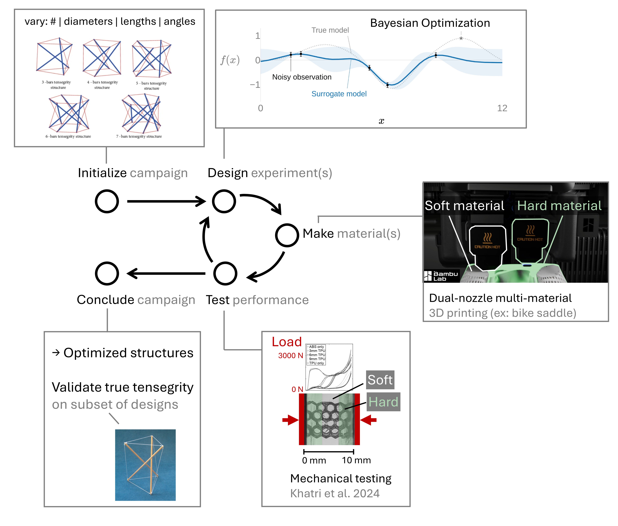
Fig. 1 Closed-loop, experiment-driven design framework. Parameterized PLA/TPU tensegrity-inspired unit cells are printed, characterized by repeated instrumented drop-weight impacts, and the resulting performance data drive a Gaussian-process surrogate that recommends the next batch of designs to fabricate.

The remainder of the paper is organized as follows. Section 2 reviews tensegrity mechanics, multi-material 3D printing for energy absorption, and Bayesian optimization with an emphasis on multi-objective and noise-robust acquisition functions. Section 3 introduces the design parameterization, fabrication workflow, drop-tower protocol and objectives, and BO loop, and states the planned metal-analog comparison. Section 4 reports all four measured batches, the surrogate audits, and the replication findings, and Section 5 discusses the implications and limitations of the approach. Section 6 concludes.

2 Background
2.1 Tensegrity-Inspired Architectures for Energy Absorption. Tensegrity prisms and their planar extensions exhibit a softening-stiffening response under compression [3–5], which is desirable for impact mitigation because the structure can absorb a large fraction of the input energy at a controlled force plateau. Santos [23] characterized a tensegrity energy-dissipation metamaterial with equivalent viscous damping of ∼23% and negligible residual strain per impact, which suggests that tensegrity-inspired architectures suit repeated-impact use. The space program literature documents large-scale tensegrity-inspired absorbers for planetary landing [6–10] and a long history of crushable energy-absorbing landing systems [24–26]. Pajunen et al. [11] directly 3D-printed truncated-tetrahedral tensegrity-inspired unit cells and measured load-limiting plateaus, which motivates the present focus on additively manufactured PLA/TPU composites. Davami et al. measured the dynamic energy absorption of additively manufactured, shape-recovering lattices [27], and Intrigila et al. fabricated and characterized a bistable tensegrity-like unit cell for lattice metamaterials [28], the closest published analog to the present cells. Neither study used multi-material FDM or closed-loop design optimization. Table 1 compares the present work with selected prior efforts spanning the three elements combined here (impact-tested printed tensegrity-inspired structures, rigid-flexible fabrication, and BO of architected materials). None of the studies we reviewed combines a multi-material FDM tensegrity-inspired architecture with an experiment-driven optimization loop.

Table 1 Positioning of this work against selected prior efforts spanning the elements combined here. The present campaign uses physical drop measurements of the transmissibility (t₁₈₀) and a mass-weighted form of the velocity loss index (E_{reb}, Eq. (1)) as its BO responses. It does not optimize specific energy absorption or crush energy.
Study | Architecture | Fabrication | Optimization | Response optimized | Ground truth
Pajunen et al. 2019 [11] | Truncated-tetrahedral | Single-material | None | n/a | Experiment
 | tensegrity-inspired | 3D print | (single condition) |  | (drop impact)
Intrigila et al. 2022 [28] | Bistable tensegrity-like | Single-material | None | n/a | Experiment
 | lattice unit cell | 3D print |  |  | (quasi-static compr.)
Mo et al. 2023 [17] | Architected lattices | n/a (simulation) | Multifidelity BO | Simulated response | Simulation
 |  |  |  | metric | (+ sparse high-fid.)
Almeida 2025 [29]; | Tensegrity-inspired | Additive | None reported | n/a | Experiment
Davami 2025 [30] | structures | manufacturing |  |  | (high-rate/dynamic)
Wang et al. 2026 [31] | Tensegrity-inspired | Integrated | None reported | n/a | Physical
 | rigid-flexible metamat. | dual-material |  |  | validation
This work | Tensegrity-inspired | Multi-material | Experiment-driven | t₁₈₀; provisional | Physical
 | T₃-prism cell (PLA/TPU) | FDM (PLA + TPU) | BO (SAASBO/qNEHVI) | E_{reb} | experiment

2.2 Multi-Material 3D Printing of PLA/TPU Composites. Multi-material rigid-soft FDM enables stiff/compliant combinations on a single platform with tunable energy absorption, demonstrated for thick-panel origami whose PLA panels are joined by TPU hinges [12] and for ABS/TPU honeycombs [13]. Neither study is itself a tensegrity, but both establish the rigid-soft co-printing route we adopt. Ye et al. [12] introduced a wrapping-based strategy in which rigid cores are encapsulated by continuous soft skins, reported to reduce interface delamination under cyclic loading, something we take inspiration from in our designs. Beyond these rigid-soft demonstrations, several studies show that tensegrity-inspired architectures can be additively manufactured with tunable mechanical response. Bauer et al. [32] showed that 3D-printed tensegrity metamaterials delocalize deformation to resist catastrophic failure, while Pajunen et al. [33] tuned acoustic bandgaps in 3D-printed tensegrity-inspired lattices through prestrain, and Sabouni-Zawadzka et al. [34] experimentally characterized 3D-printed tensegrity-inspired metamaterials built on the simplex module. More directly relevant to impact, Almeida et al. [29] and Davami et al. [30] characterized the high-strain-rate and dynamic response of additively manufactured tensegrity-inspired structures, and Wang et al. [31] reported an integrated fabrication-and-validation workflow for tensegrity-inspired rigid-flexible metamaterials. None of these studies combines multi-material FDM with an experiment-driven optimization loop. Work on multi-material PLA/TPU sandwich and layered composites [35] reports quantitative bounds on stiffness, strength, and energy absorption for the same PLA/TPU pair used here, while FDM PLA fatigue data [36, 37] can inform conservative design bounds for the rigid struts. Architected multi-material lattices with co-printed compliant skins have been designed for high specific energy absorption [38]. Recent surveys review additively manufactured polymeric energy absorbers [39, 40].
2.3 Bayesian Optimization for Architected-Material Design. Bayesian optimization is a sequential, model-based strategy for optimizing expensive black-box functions using a Gaussian-process surrogate [41, 42]. Modern implementations such as BoTorch [20] and the Ax platform built atop it [21] support parallel batched evaluations and many acquisition functions. Recent algorithmic advances include log expected improvement (log-EI) for numerical robustness [43], noisy expected hypervolume improvement (qNEHVI) for multi-objective settings [44], input-noise-robust acquisitions [45], and evolution-guided constrained multi-objective BO for self-driving labs [46]. Mixed/categorical search spaces, needed for the planned connectivity-topology extension rather than the continuous T₃-prism prototype studied here, have dedicated treatments in Bayesian optimization of combinatorial structures (BOCS) [47] and the one-hot-with-rounded-kernel construction of [48]. BO has been applied to architected-material design [17] and to additive manufacturing [18]. Mo et al. [17] in particular established a multifidelity BO framework for architected materials by fusing low-fidelity simulations with high-fidelity ground truth via nonlinear information-fusion priors [49]. We shift the emphasis from simulation surrogates to direct experimental data, which suits materials whose constitutive response is difficult to calibrate from first principles.

3 Materials and Methods
3.1 Design Parameterization. We parameterize a family of tensegrity-inspired unit cells via four groups of design variables. For the working T₃-prism prototype that defines the initial BO search space (Section 3.4), only the first two groups are active and all of their variables are continuous. We hold the connectivity-topology and tiling groups fixed for this prototype and list them here as planned extensions of the design family:
- PLA compression members. Strut diameter d_{s} and length ℓ_{s}, with the slenderness ratio ℓ_{s}/d_{s} bounded away from buckling-dominated regimes.
- TPU tension elements. Cross-sectional area A_{t} (or equivalent diameter d_{t} for circular cross-sections).
- Connectivity topology (future extension). Selected from a discrete set of candidate unit cells (e.g., truncated-tetrahedral, prism-based, and octahedral variants). When activated, the design vector would encode this as a categorical choice. It is held fixed at the T₃ prism for the present campaign.
- Unit-cell tiling (future extension). Number of cells N_{x} × N_{y} × N_{z} and the orientation of each cell relative to the impact direction. It is held fixed at a single cell here.
Working prototype and search-space evolution. We validated the fabrication and test pipeline on the first instance of this family, a three-strut, T₃-prism-inspired cell scaled to a ∼50 mm bounding box. In batches 1 and 2 the BO search space has five continuous design variables over the ranges listed in Table 2. They are the base radius R, cell height H, twist angle θ, a single strut diameter d_{s}, and a single cable (tendon) diameter d_{t}. We treat the cable diameter d_{t} as a continuous variable on [3.0, 5.5] mm. From batch 3 the space grows to include the print process: two per-article sparse-infill densities (strut and tendon, each 12 to 35%) chosen by the acquisition, and four filament settings (PLA and TPU nozzle temperature and maximum volumetric speed). The filament settings are physically one value per print job, so we draw them as one quasi-random point per batch, and they remain confounded with batch until a round varies them within a plate (Section 3.4). Under the prism’s D₃ symmetry all struts are equivalent, and we also give all cables one diameter. We therefore use a single strut-diameter axis and a single cable-diameter axis, leaving room to relax to per-orbit (saddle, top, bottom) or fully per-member diameters once the individual orbits have been characterized. We hold the joint diameter d_{j} fixed at 7.0 mm. It sets the printed strut-end cage that houses the internal cable anchors (Section 3.2), so it is constrained primarily by the TPU-tendon outlet count and the dual-nozzle clearance rather than by energy-absorption performance. Fixing it keeps the anchor geometry constant across specimens so that the optimized variables are not confounded by joint-strength changes. Relaxing d_{j} is deferred to a follow-on joint-design study. Figure 2 shows the parametric CAD model alongside an as-printed prototype of this working T₃ prism.
Constant-mass projection and printability screens. Because cell mass varies severalfold across the raw design box, an unconstrained search would partly reward designs for carrying more material rather than for their architecture. We therefore project every candidate onto a constant material budget before printing. Each design is uniformly rescaled (all dimensions except the twist angle) until its mass target is met, converged to within 0.15 g on rendered geometry. The target evolved with the campaign. Batches 1 and 2 held solid CAD mass ρ_{PLA}V_{PLA} + ρ_{TPU}V_{TPU} at m⋆ = 30.95 g, the solid mass of the reference prism. That budget does not hold printed grams constant, because PLA struts print at partial infill while thin TPU cables print near solid. As-printed masses spanned 18.50 to 22.04 g across the tested seed articles, a coefficient of variation (CV, the standard deviation divided by the mean) of 5.5%, and 17.91 to 23.47 g (CV 8.7%) across batch 2. For those batches printed mass is therefore only approximately constant, and the surrogate carries each article’s weighed mass explicitly (Section 3.4). From batch 3 the projection instead holds printed mass at 20.23 g, the mass of the printed reference article. A calibrated model predicts each design’s printed mass from its geometry, and the design is scaled until that prediction equals the target (Supplementary Information). The printed batches came in slightly light. Their mean masses were 0.2 to 0.6 g (1 to 3%) below the target, and the CV within a batch was 1.7% for batch 3 and 2.3% for batch 4.
We also checked each projected design against two printability limits. Both were recorded as warnings, and neither was used to reject or change a design. The first compares πR²H with 250 cm³, where R is the radius of the circle through the joint centers and H is the height between joint centers. The 250 cm³ value is a placeholder size limit carried over from an earlier simulation study. It is not the printer’s build volume, and because it is measured to the joint centers it undercounts the printed part. Seven printed articles (five designs) exceeded it. The second limit is a 3.0 mm minimum on the printed TPU cable diameter, adopted after the thin, unsupported top cables of early PETG test prints failed. Because the projection rescales the whole cell, a design at the 3.0 mm lower bound of the cable variable can print thinner. Nine articles printed with cables of 2.51 to 2.78 mm, including all four batch-4 articles that reduced the peak shock (Section 4.2). With hand-painted tendon supports (Section 3.2), all nine printed. One had stringing, one had a slight tendon indent, and seven had no logged defect. The most common tendon defect was a TPU strand that did not fuse to the tendon and came away from it. It was logged on five articles, all with cables of 3.28 to 4.23 mm. The 3.0 mm value is therefore a conservative rule for this workflow. Our prints do not show that thinner cables cause more defects.
Table 2 Design variables for the T₃-prism campaign, as implemented in the BO code. The seed batch is an n = 9 Sobol draw (fixed seed) over the five geometry variables, with each design then projected onto the constant-mass budget of the text. The process variables joined the space in batch 3. The two infill densities are acquisition-chosen per article, while the four filament settings admit one value per print job and are therefore drawn as a single quasi-random point per batch, confounded with batch until varied within a plate. The joint diameter is held fixed. All specimens print upright on a Bambu Lab H2D, with the prism axis normal to the build plate and the base triangle on the bed (Fig. 3, slicing panel). The seed batch used one specimen per named build plate, and each later batch used one nine-article plate.
Variable | Symbol | Range | Units | Active
Base radius | R | 25-40 | mm | batch 1 on
Cell height | H | 60-110 | mm | batch 1 on
Twist angle | θ | 40-80 | deg | batch 1 on
Strut (PLA) diameter | d_{s} | 6.0-12.0 | mm | batch 1 on
Cable (TPU) diameter | d_{t} | 3.0-5.5 | mm | batch 1 on
Strut infill density | - | 12-35 | % | batch 3 on
Tendon infill density | - | 12-35 | % | batch 3 on
PLA nozzle temperature | - | 212-228 | °C | batch 3 onª
PLA volumetric speed | - | 20-30 | mm³/s | batch 3 onª
TPU nozzle temperature | - | 235-245 | °C | batch 3 onª
TPU volumetric speed | - | 2.2-3.6 | mm³/s | batch 3 onª
Joint diameter (fixed) | d_{j} | 7.0 | mm | -
ªOne value per print job (a plate carries a single filament configuration), so per-batch rather than per-article.
As-built resolution of the continuous variables. Although we treat d_{s} and d_{t} as continuous, the nozzle diameter, the slicer line width, and support interaction discretize the as-built cross-sections, so the effective search granularity is coarser than the nominal continuous box. The realized member diameter changes in steps set by the slicer line width, and these steps determine the smallest CAD change that gives a distinguishable as-built member. The 3.0 mm lower bound on the TPU cable diameter is likewise a limit of this workflow. It is the printability minimum described above, set by printing unsupported cables and by the slicer’s auto-support detection on this H2D printer. We weigh every article on a 0.01 g scale, and mass is the only as-built quantity measured for every article. We have not yet measured the dimensions of the printed members, so the geometry attached to the surrogate is the commanded post-projection geometry. Two sets of repeated prints bound the fabrication scatter in mass. One seed design printed three times has a mass standard deviation of 0.457 g, the value used in the observation noise model (Section 3.4). The batch-3 plate, also printed three times, averaged 19.59, 19.86, and 20.07 g per print, so its second and third prints ran 0.27 g and 0.48 g heavier article for article. That is a per-print flow offset rather than random scatter.
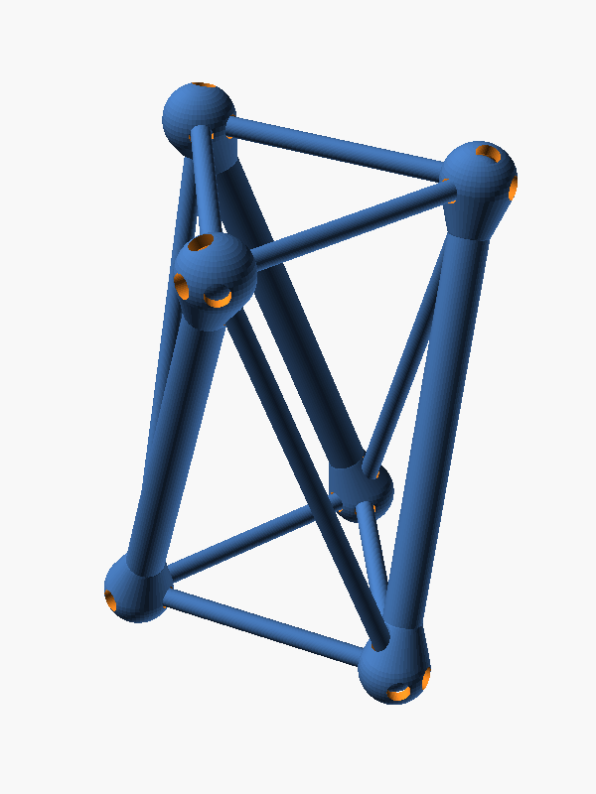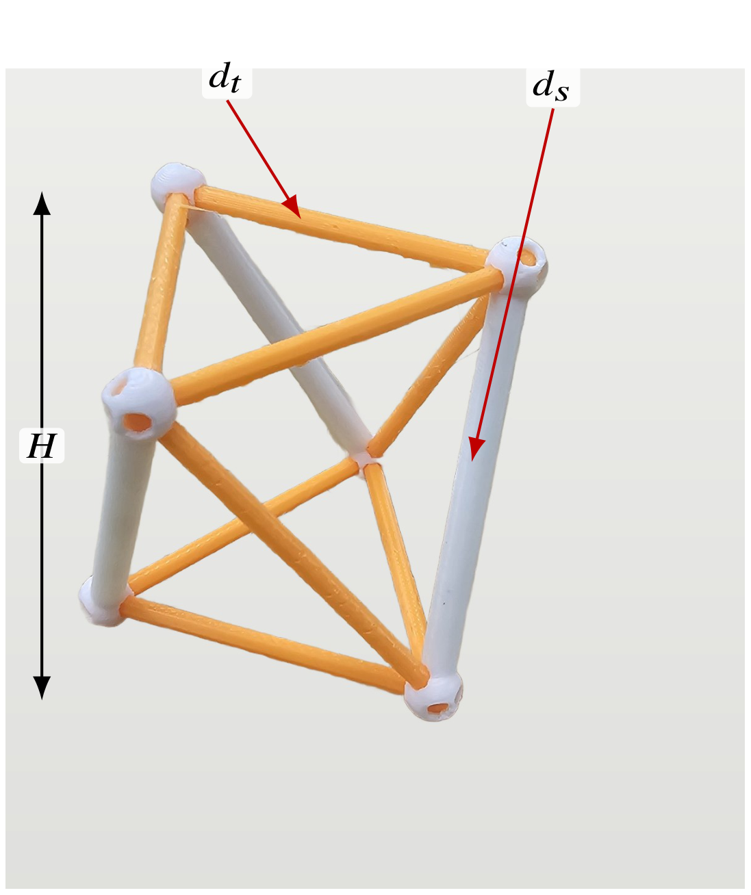
Fig. 2 Working T₃-prism prototype. (a) Parametric OpenSCAD model whose base radius R, cell height H, twist angle θ, strut diameter d_{s}, and cable diameter d_{t} are the design variables of Table 2. (b) A representative dual-material prototype print (rigid PLA struts in white, tendon members in orange), with callouts marking the strut diameter d_{s}, a tendon (cable) diameter d_{t}, and the cell height H. The twist angle θ is the relative rotation of the top and bottom node triangles, and the base radius R sets their circumradius. The photograph’s wooden background was digitally replaced with a plain light backdrop. The specimen itself is unedited.
3.2 Multi-Material Fabrication. We fabricate specimens on a multi-material FDM printer using PLA for the rigid struts and TPU for the soft tension elements. Figure 3 summarizes the fabrication and characterization workflow, from parametric CAD through multi-material slicing, dual-extrusion printing, post-processing, and mechanical testing. Rather than wrapping the struts in a continuous TPU skin, we anchor the TPU tension elements inside the ends of each PLA strut. The cables converging at a given strut end are joined within the strut, which acts as a rigid cage housing the junction, and the individual tendons then exit through discrete outlets. This keeps the soft-rigid interface in internal, compression-dominated pockets rather than at an exposed overmolded surface. This construction inverts the material roles of the wrapping strategy of Ye et al. [12], in which a soft skin covers a rigid core. Here a rigid PLA shell captures a soft TPU core, so that work is a precedent for multi-material co-printing but does not validate the present junction.
Print platform and joint geometry. The working platform is a Bambu Lab H2D printer, which permits a single rigid-soft build without filament swaps. Strut endpoints are tied to cables through parametric joint geometries developed and ranked in a five-design OpenSCAD study (anchor-bulb, dovetail, TPU-sleeve overmold, eyelet-loop, and TPU-rebar variants). The working prototype uses a dovetail joint (Design B) with an anchor-bulb backup (Design A) for sensitivity studies. A captive TPU core is routed inside the PLA shell to keep the soft tendon protected from layer-line failure at the strut-to-cable transition. The full five-design comparison and the selected junction are detailed in the Supplementary Information.
Supports for soft members. Because near-vertical TPU tendons are otherwise unsupported during printing, we disable automatic support generation and paint supports manually in the slicer. PLA edge supports run along each tendon, with the support-to-object clearance tightened from 0.35 mm to 0.2 mm during tuning on the reference prism. Support removal left two recurring defects in the seed batch, both logged per article in the print key (Supplementary Information). One is surface stringing. The other, on two articles, is an unfused TPU strand that came away from a bottom tendon during support removal. We developed an automated alternative (a lowered support-threshold angle plus mesh-ray-cast narrowing pillars) in parallel and document it in the Supplementary Information.
Moisture and nozzle management. TPU is hygroscopic, so we feed the soft filament from a heated dry box held near 8 % relative humidity, logged per print. Midway through the seed batch the TPU extruder developed a progressive drop in flow (a partial clog, compounded by a stray PLA fragment found inside the extruder). We resolved it by performing a cold pull and moving the TPU to a dedicated high-flow 0.6 mm nozzle, after which print quality was restored. We identify the affected and post-fix articles in the print key so that any nozzle-related covariate can be checked against the measured objectives.
Table 3 Multi-material print parameters on the Bambu Lab H2D, transcribed from the archived as-printed Bambu Studio project (t3-prism-bo-batch.H2D-MM-PLAstruts-TPUcables.as-printed.3mf, Bambu Studio 2.7.1). Filaments are Bambu Lab PLA Basic (struts, support material) and Bambu Lab TPU 85A (tendons). The print profile is “0.30 mm Standard @BBL H2D 0.6 nozzle.” The reporting structure follows the methods section of Ye et al. [12].
Parameter | PLA (struts) | TPU 85A (tendons)
Nozzle | 0.6 mm | 0.4 then 0.6 mm HFª
Nozzle temperature (C) | 220 | 220
Bed temperature, profile (C) | 55 | 35
Layer height / line width (mm) | 0.30 / 0.62
Infill | 15% grid, 2 walls | near-solid
Outer / inner wall speed (mm/s) | 200 / 300 (profile)
Filament drying | n/a | dry box, ∼8% RH
Build-plate type | Textured PEI
Build orientation | Upright (Fig. 3)
Supports | Manual painted tree supports, PLA
ªThe TPU side ran a standard 0.4 mm nozzle until the mid-batch clog, then a dedicated high-flow (HF) 0.6 mm nozzle. Affected articles are flagged in the print key.

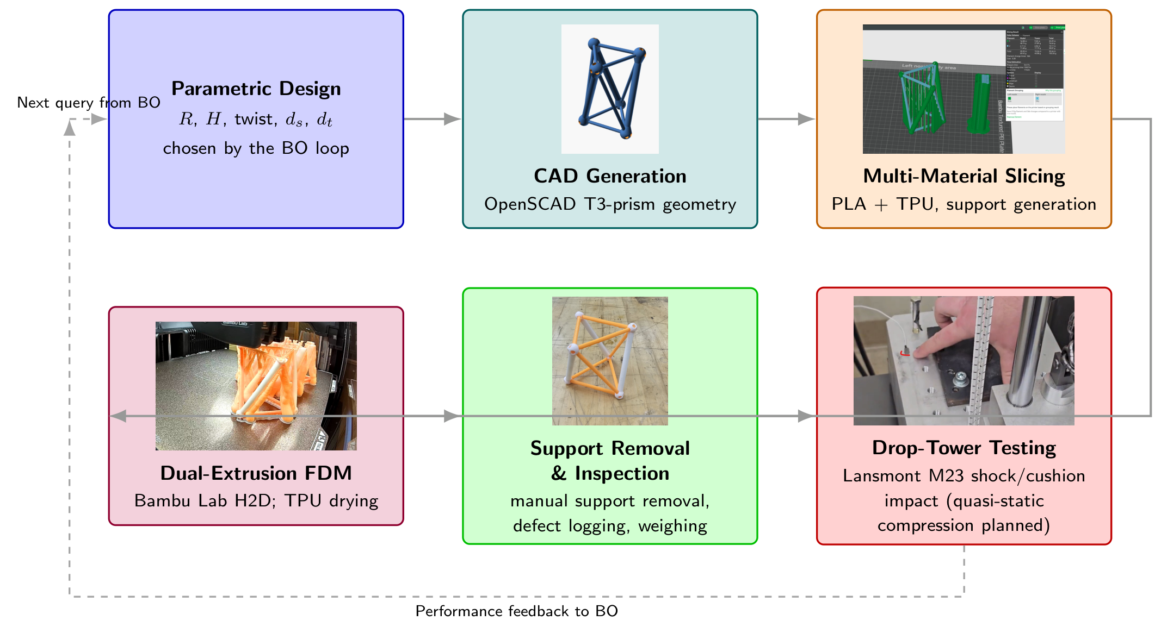
Fig. 3 Fabrication and characterization workflow for the multi-material tensegrity-inspired unit cells. The steps are parametric CAD from the design parameters, slicing with manually painted supports along the TPU tendons, a single multi-material print on the Bambu Lab H2D, post-processing and inspection, and mechanical testing. Node photographs are representative examples from the project’s build history. They show the OpenSCAD T₃-prism render (CAD), the dual-nozzle Bambu Studio slice with PLA on the left extruder and TPU on the right (slicing), an in-progress H2D print of the prism batch (FDM), an as-printed specimen (post-processing), and the bungee-assisted drop-tower base plate with accelerometer (testing).

3.3 Experimental Characterization.
Drop-tower fixture. We characterize the specimens primarily by repeated drop-weight impact on a Lansmont Model 23 shock test system. The printed specimen rides upright on the carriage plate, which is raised 60 in (1.524 m) along guide rails and released. The plate lands on a single 0.5 in Shore 60 OO polyurethane cushioning sheet, which shapes the landing into a single sharp base pulse of roughly 1.6 ms duration. We selected this impact surface in a blinded crossover experiment over three candidate mat arrangements. Unlike a felt stack, it does not measurably compact over hundred-drop sessions. We monitor rig health continuously through the impact velocity change Δv recovered from the base accelerometer. Over an uninterrupted 100-drop characterization session, the Δv coefficient of variation was 0.54% with no drift. We check every campaign session against the healthy tower baseline. Details, including the within-session mat warm-up and recovery pattern, are in the Supplementary Information. One drop takes roughly 42 s, so a seed-batch characterization completes in about ninety minutes per article and a later-batch session in about fifteen.
Instrumentation and signal processing. A single-axis piezoelectric accelerometer on the carriage plate records the base input and triggers the acquisition. A triaxial accelerometer (Dytran 3133A4) seated in a printed pocket at the specimen’s top vertex records the transmitted response. We cross-calibrated the two base-capable channels in place over fifteen co-located drops (ratio 0.953 ± 0.001 at matched filtering) and archived the transducer settings with the data. Signals are captured at 1.25 MHz over a 100 ms record with a 2 ms pre-trigger. We low-pass filter all channels with the SAE J211/1 channel-frequency-class (CFC) filters [19], implemented from the standard’s published coefficients with the two-pass corner frequency handled explicitly. A common implementation shortcut narrows the passband by roughly 20%, which we identified and corrected before the campaign. All reported numbers use the corrected filter. CFC-180 is the reporting class for peak metrics, with CFC-1000 retained as a higher-bandwidth diagnostic.
Per-article objectives and session protocol. Session length changed as our understanding of the measurement noise improved, so the drop counts differ by batch. Seed sessions recorded 103 drops per article and contribute 101 stabilized captures each (103 for one article, autv5r) after we discard the first two drops of each session as seating warm-up. A pre-campaign variance study on the commissioning datasets put the statistical minimum at five stabilized drops after two warm-ups. The seed sessions confirmed that the stabilized mean is insensitive to session length. Their within-session per-drop CVs were 0.17 to 0.48%, with flat post-warm-up trends. A replay of the seed sessions truncated to twenty drops leaves the transmissibility ranking of all eight tested articles unchanged. The worst-case mean shift is +0.008 against design-to-design gaps of 0.007 to 0.087, and the per-drop standard error is still an order of magnitude below those gaps. We therefore shortened later sessions to about twenty drops per article. The archived record lists 21 to 22 valid captures per batch-2 article and 20 recorded drops per article in batches 3 and 4, against 101 valid captures per seed article. As before, we discard the two warm-up drops of every session. Exact per-session counts are in the archived per-drop records. Shortening the sessions cuts tower time per article from about ninety minutes to about fifteen while retaining roughly four times the minimum stabilized-drop budget. A shorter session enters the surrogate with a proportionally larger standard error, which the model downweights. The three prints of batch 3 (Section 4.2) later showed that seating and print-to-print variation limit what one session can claim far more than session length does, so we spend the freed tower time on re-seats. Each session yields two objectives, each reported as a stabilized mean with the per-drop scatter quoted as one standard deviation, and the standard error of the mean enters the surrogate’s noise model (Section 3.4):
$$\begin{matrix}t_{180} & =\frac{\max_{t}∥a_{top}\left(t\right)∥_{CFC180}}{\max_{t}{\left|a_{base}\left(t\right)\right|}_{CFC180}}, \\ VLI & =1−e_{reb}, e_{reb}=\frac{gt_{second}}{2Δv}, \\ E_{reb} & =\left(1−VLI\right)mgh,\end{matrix}$$ | (1)
where t₁₈₀ is the CFC-180 filtered peak-acceleration ratio, which we call the transmissibility throughout. It is the peak magnitude of the triaxial top-vertex response over the peak base input within the impact window. We use the term in the shock-testing sense that is standard for cushioning and packaging drop tests, a ratio of filtered peak accelerations across the article under a single transient, not the steady-state frequency-response function of vibration isolation. The two peaks need not be simultaneous, and the filter class is part of the definition. We cite SAE J211/1 only for the impact-channel filtering. Values above unity indicate the structure amplifies the peak shock reaching its top vertex; values below unity indicate attenuation. The second objective is built on the velocity loss index (VLI), the fraction of the impact velocity change that the structure does not give back at its top vertex. Its complement is the rebound fraction e_{reb}, the speed at which the top vertex hops after impact divided by the measured base velocity change Δv. We estimate the hop speed from the time to the second contact, t_{second}, assuming the hop is ballistic [50]. The index is dimensionless, and higher is better, the opposite of the transmissibility. Across the 53 tested articles it ranges from 0.937 to 0.986. In all four batches the optimizer minimized a mass-weighted form of the index, E_{reb}, which multiplies 1 − VLI by the article’s weighed mass m, the gravitational acceleration g, and the drop height h to give millijoules per drop. The tables and figures report E_{reb}, since it is the quantity the optimizer used. Weighting by mass keeps grams in the objective, because equal indices on articles of different mass are not equivalent outcomes for a payload. The weighting matters most where printed mass varied. In batches 3 and 4, which held printed mass constant, ranking the articles by E_{reb} and by the index gives nearly the same order (Spearman rank correlation ρ = 0.995 over 27 articles). In batches 1 and 2 the two orders agree less well (ρ = 0.855 over 17). Two caveats apply. First, we have not yet checked the hop timing against synchronized video, and Δv is the base plate’s velocity change, which may differ from the relative velocity at impact. The index is therefore a timing-based measure, and 1 − VLI should not be read as a coefficient of restitution. Second, returned kinetic energy would scale with the square of a velocity ratio, so E_{reb} is a ranking score that penalizes designs, and grams, that send more motion back to the payload. It is not a measured energy. Once the hop timing is validated, the index could become a constraint rather than an objective (Section 5). We record ringdown descriptors per drop as print-health and prestress diagnostics [51], but they are not campaign objectives. They are the fitted natural frequency f_{n} (260 to 470 Hz for every article but one batch-4 design that rings at 764 Hz) and, where the exponential fit passes an r² ≥ 0.85 gate, a damping ratio ζ. The within-session per-drop CV of t₁₈₀ spans 0.06 to 2.0% across all 53 tested articles (0.17 to 0.48% in the seed batch). These values describe repeated drops of the same physical article in one seating and do not estimate print-to-print or seating-to-seating repeatability. Serial dependence among drops may also make $s/\sqrt{n_{drops}}$ optimistic. As an advisory screen, we compute a seat gauge for every session, the ratio of its CFC-1000 to its CFC-180 transmissibility. It reads 1.00 to 1.07 on most sessions, and we treat a reading of 1.15 or more as a re-seat candidate. Two replication measurements bound what a single session can claim. The seed attenuator, re-measured across a day and an independent re-seat, agreed to 0.13%. Three prints of the batch-3 designs put the standard deviation between articles and seatings at 0.0087 in t₁₈₀, once sessions that fail the seat gauge or carry a drift flag are set aside (Section 4.2). The two largest deviations, 10 and 20% above their design medians, both came with a failed gauge. We therefore adopted a between-seat replication rule: a single-seating value that would drive a decision (a batch extreme, a claimed attenuator, a front membership) requires confirmation on an independent re-seat before we treat it as a design property.
Planned quasi-static extension. The drop test loads the specimens in their elastic regime. The crush lasts 1 to 3 ms and the article recovers, so crush-energy metrics such as specific energy absorption (SEA) and compaction efficiency are not recoverable from these captures by any reprocessing. We plan a quasi-static compression campaign on a benchtop load frame (BYU CB 123 Instron, with a low-range load cell appropriate to the expected cell stiffness) to supply the complementary crush metrics
$$SEA=\frac{1}{m}\int_{0}^{δ_{d}}{F}\left(δ\right)dδ, η_{c}=\frac{\int_{0}^{δ_{d}}{F}\left(δ\right)dδ}{F_{max}δ_{d}},$$ | (2)
with the densification displacement δ_{d} taken at the maximum of the energy-absorption efficiency curve and $F_{max}$ the peak force within [0, δ_{d}]. We follow the standard cellular-solid treatments [52–55] and mirror the quasi-static protocol of Pajunen et al. [11]. These metrics will be reported as a complementary characterization of selected designs rather than as objectives of the drop-tower campaign. Slip resistance and traction at the specimen-to-floor interface, governed by the tip geometry rather than the internal architecture, follow ISO 11334-4 [56] for walking-aid tips and are out of scope for the present axial-impact study.
Complementary data streams. High-speed video (959 fps, three clips per specimen) supplements the accelerometer data. The camera cannot resolve the millisecond-scale impact pulse (one to two frames), so the accelerometer channels produce the objectives, and video documents the post-impact rebound and recovery. Synchronized laser-Doppler vibrometry is reserved for follow-up characterization of selected designs.
3.4 Experiment-Driven Bayesian Optimization Loop. The optimization loop maintains a Gaussian-process (GP) surrogate over the design space defined in Section 3.1. After each round of physical experiments, we refit the surrogate and maximize an acquisition function to recommend the next batch of designs to fabricate. We pose the campaign as a two-objective minimization of the transmissibility t₁₈₀ and the mass-weighted velocity-loss objective E_{reb} of Eq. (1), and minimizing the latter favors a high velocity loss index on a light article. Both objectives serve the same payload. The transmissibility t₁₈₀ bounds the peak shock the payload feels during the impact, and E_{reb} penalizes the motion thrown back into it afterward. The seed data showed an apparent trade-off, driven substantially by the single strongest attenuator and not statistically resolved at seven mapped articles (Spearman ρ = −0.39, p = 0.38; Section 5). After four batches, the measured front is nondegenerate (its members span both axes), and the velocity loss index remains a candidate to become a constraint once its ballistic reading is validated. Until then, the next batch keeps E_{reb} as its second objective, so that its results stay comparable with the existing front. We implement the loop in the Ax platform [21] over BoTorch [20], with noisy expected hypervolume improvement (qNEHVI) [44] as the multi-objective acquisition. The T₃-prism search space is fully continuous, including the process variables added in batch 3 (Table 2), so no categorical encoding is required. Mixed-search-space constructions [48] and the BOCS combinatorial baseline [47] are the route for adding connectivity topology as a categorical variable in a later campaign. The input-noise-robust acquisition of Daulton et al. [45] and the evolution-guided constrained variant of Low et al. [46] are held in reserve as contingencies.
Surrogate and noise model. The surrogate is the fully Bayesian sparse axis-aligned subspace model (SAASBO) [22]. It uses a Matérn-5/2 kernel with automatic relevance determination whose length scales carry strong sparsity-inducing priors and are marginalized by Markov-chain Monte Carlo with the No-U-Turn Sampler (NUTS) rather than point-estimated. Every refit in the campaign, through the batch-4 ingestion, uses this model with qNEHVI on top (Ax 0.4 for the early rounds, Ax 0.5.0 from the batch-3 refit). We retain SAASBO, even though the dimensionality is modest, because marginalizing the hyperparameters tends to improve uncertainty quantification at the very small sample sizes of physical campaigns. We audit the fitted model each round with cross-validation (leave-one-out, and leave-one-design-out once replicates entered the record) and length-scale-based sensitivity diagnostics (Section 4). Inputs are normalized to the unit cube and outputs standardized. We supply observation noise per observation as a fixed variance: for t₁₈₀ the squared standard error of the stabilized mean, σ_{t}² = s_{drop}²/n_{drops}, and for E_{reb} the drop-scatter term plus the propagated print-to-print mass scatter, σ_{E}² = σ_{E,drops}² + (∂E_{reb}/∂m)²σ_{m}² with σ_{m} = 0.457 g measured from the one design printed in triplicate. The estimand this noise model implies is the response of the tested article in its seating, not of a freshly printed article at the same design. An independent adversarial review (Section 5) argued that the decision-relevant target is the latter. To account for that target, we use the measured replication evidence of Section 4.2 (second and third prints of one batch) together with the between-seat replication rule, rather than an inflated per-article noise term. We ingested the nine second-print articles, re-prints of the same designs, as distinct completed trials at identical design coordinates, each with its own weighed mass and per-session standard error and with no pre-pooling. Later refits therefore observe measured design-level replicates directly. Because per-session variances are supplied as known, replicate disagreement is not absorbed by a separately inferred noise parameter. Instead, it widens the posterior through the fit itself. The third print was tested after the last refit reported here and has not yet entered the fit. SAASBO is the prespecified surrogate. We make no claim that it outperforms a standard single-task GP at this dimensionality and sample size, and the planned head-to-head calibration comparison against a point-estimated GP with the same kernel remains future work.
Mass treatment. Because the constant solid-mass projection of batches 1 and 2 does not hold printed grams constant (Section 3.1), printed mass correlates with the shape variables in the seed batch, and with t₁₈₀ (r = 0.83, n = 7, dominated by the lightest article). We therefore keep mass explicit in the loop. The second objective, E_{reb}, is in absolute millijoules computed with each article’s weighed mass, so added grams are penalized through the motion they send back to the payload. The transmissibility t₁₈₀ stays a ratio on purpose, because payload peak acceleration is a damage criterion that does not scale with specimen mass. The objective surrogates take the design coordinates of Table 2 as their inputs. We attach printed mass as a separately modeled tracking metric, so the model learns as-printed mass as a function of the design coordinates and every recommendation reports a predicted printed mass. In the diagnostic refit behind Fig. 9, we additionally include printed mass as an input to probe this confound. With the calibrated printed-mass model (Supplementary Information), we then held printed grams constant in batches 3 and 4. Across all 53 tested articles, printed mass explains about 1% of the variance in transmissibility (r = 0.12), so the seed batch’s mass confound was removed by the experimental design rather than adjusted away in the analysis (Section 4.3).
Budget and seeding. We drew the nine seed designs as the first points of a scrambled Sobol sequence [57, 58], the initialization step of the Ax platform, with a recorded seed (0). A Sobol sequence is a quasi-random sequence that covers the five-variable box more evenly than the same number of independent random draws. We printed the nine designs together with the fixed reference prism (S0). Optimization proceeds in sequential batches of q = 9 prints, sized to one build-plate generation cycle. Three model-recommended batches are reported here (Ax trials 10 to 18, 28 to 36, and 37 to 45). The numbering gap records a superseded draft batch that was regenerated, before printing, when the batch-level filament handling was simplified. From batch 3 the four filament settings take one quasi-random point per batch, formally the settings of that batch’s best-predicted article, so those axes are confounded with batch and are reported as unidentified rather than learned. We record all random seeds, the full experiment state, and the recommendation tables per round. Full computational reproducibility (the exact processing pipeline and model settings) is carried by the campaign code. We plan to escalate to trust-region BO (TuRBO) [59] only if per-member-diameter extensions push the design space well beyond the present regime. We retain a single-objective log-Expected-Improvement run [43] on t₁₈₀ as a baseline to quantify the benefit of the multi-objective formulation. We will archive the campaign code and recommended batches at a Zenodo-minted DOI mirroring the GitHub repository.
3.5 Replicate Rank-Stability Study. Repeated prints of the batch-3 designs (Section 4.2) showed that a single article’s measurement can move between seatings and prints by more than the design signal separating neighboring designs, which bounds any claim that one design outranks another. We plan a replicate study to quantify this bound by re-printing a deliberately spread subset of the already-measured designs. Among the campaign’s in-sample designs, ranked by the current posterior’s predictions, we will select the best-predicted design, the worst-predicted design, and one mid-pack (“run-of-the-mill”) design. We will then print three fresh articles of each and drop-test every article under the standard protocol of Section 3.3, including the between-seat replication rule. This repeat count is provisional and will be fixed when the print is scheduled. The question is whether the predicted ordering survives fabrication and seating variation. With three designs the exact permutation floor for a Spearman rank correlation is p = 1/6, so no significance claim is available at this size. Instead, the primary readout is the separation of the three designs’ repeat clusters relative to the within-design (print-to-print plus seat-to-seat) scatter, reported alongside ρ_{s} between the predicted and measured orderings of each repeat. Clean separation would support treating the campaign’s rankings as design properties. Overlapping clusters would measure the ranking noise floor that the three batch-3 prints could only bound. Table 4 gives the reporting format. We will add entries and design IDs once the repeat articles are printed and tested.
Table 4 Placeholder (data pending). Planned replicate rank-stability study: the best-, mid-, and worst-predicted in-sample designs, each re-printed as a nominal three fresh articles and drop-tested under the standard protocol. Entries will record each repeat’s stabilized t₁₈₀, the within-design scatter, and the measured rank of each design’s repeat cluster against its predicted rank.
Tier | Design | Pred. t₁₈₀ | t₁₈₀ (repeats 1 / 2 / 3)
Best | TBD | - | - | - | -
Mid | TBD | - | - | - | -
Worst | TBD | - | - | - | -
3.6 Metal-Analog Validation. In the future we plan a validation campaign that tests whether the rankings learned on the printed PLA/TPU specimens generalize beyond the as-printed polymer system. We will reproduce a subset of the T₃-prism designs as metal analogs built from hollow aluminum rods (compression members) and stainless-steel threaded cables (tension members), using the same R, H, θ, and member-diameter parameterization. Rather than fabricating only the top-ranked geometries, we will deliberately span the predicted performance range. A few designs the surrogate predicts to be worst-performing, a few mediocre, and a few best-performing will each be built in both material systems. Comparing the measured ordering of the PLA/TPU specimens against their hollow-aluminum/stainless-steel counterparts probes whether both systems preserve the same rank ordering of impact performance. We treat this as a planned, exploratory comparison rather than a preregistered validation. The deformation modes, joint compliance, friction, pretension behavior, and strain-rate sensitivity all differ between the PLA/TPU and aluminum/steel systems, so agreement is not expected a priori. The protocol details that would let the comparison distinguish geometric rank transfer from material-system and mass confounds remain to be fixed and will be tabulated before any metal article is built. They are the aluminum alloy and temper, tube wall thickness, cable construction, joint hardware and torque, article and payload masses, replicate count, and tie-handling rules. The intended rank statistic is the Spearman rank-correlation coefficient ρ_{s} between the two material systems’ orderings of the primary campaign metric (t₁₈₀ under the identical drop protocol), reported with an exact permutation test. We will report the velocity loss index and, once the quasi-static extension runs, SEA as secondary rankings. Rank agreement would be preliminary evidence consistent with transfer. Disagreement would not isolate which material or joint difference caused the change. Table 5 gives the planned reporting format. We will add the table entries and the specimen photographs of Fig. 4 after fabrication and testing.
Table 5 Placeholder (data pending). Planned rank-ordering validation: representative T₃-prism designs predicted to be worst-, mid-, and best-performing, each fabricated as a printed PLA/TPU specimen and as a hollow-aluminum-rod / stainless-steel-cable metal analog. Entries will record the measured performance metric (t₁₈₀ under the identical drop protocol, with the velocity loss index secondary) and the resulting rank within each material system.
Predicted tier | Design ID | PLA/TPU (rank) | Al/SS (rank)
Worst | D-w1 | - | -
Worst | D-w2 | - | -
Mediocre | D-m1 | - | -
Mediocre | D-m2 | - | -
Best | D-b1 | - | -
Best | D-b2 | - | -
Figure placeholder: Assembled validation specimens for each predicted performance tier (worst / mediocre / best), shown as printed PLA/TPU builds alongside their hollow-aluminum-rod and stainless-steel-threaded-cable metal analogs, with callouts marking the aluminum compression members, the threaded steel tension cables, and the strut-end cable anchors. Photographs to be added once the specimens are fabricated.
Fig. 4 Placeholder. Assembled validation specimens for each predicted performance tier (worst / mediocre / best), shown as printed PLA/TPU builds alongside their hollow-aluminum-rod and stainless-steel-threaded-cable metal analogs, with callouts marking the aluminum compression members, the threaded steel tension cables, and the strut-end cable anchors. Photographs to be added once the specimens are fabricated.

4 Results
4.1 Seed-Batch Measurements. We printed all nine Sobol specimens and the reference prism and declared them acceptable to test. Nine articles (seven mapped Sobol designs, the reference prism, and one article whose design mapping is unconfirmed) completed seed characterization sessions, totaling over 900 clean captures within a project-wide history of more than 4,000 instrumented drops. The two remaining seed designs (specs 03 and 06) were printed, but their drop sessions are absent from the campaign record and they do not enter any fit or figure. Table 6 reports the stabilized objectives. Three findings frame the batch. First, the measured t₁₈₀ spans 0.893 to 1.062. Six of nine tested articles amplify the peak shock reaching the top vertex (means above unity), and two sit marginally below unity (0.997 and 0.980). One tested article (the print of Sobol spec 01, the thick-strut, thin-cable, high-twist corner of the batch) had a mean t₁₈₀ of 0.893, indicating peak attenuation under the tested condition. This article later reproduced its attenuation within 0.13% across an independent re-seat. It is the campaign’s positive control for the replication rule of Section 3.3. Across the tested articles, t₁₈₀ spans 0.169 (18.9% of the observed minimum). This between-article range far exceeds the 0.17 to 0.48% within-session per-drop CV, but one mechanically tested article per geometry cannot separate geometry effects from print-to-print variation or other fabrication covariates. Second, the objectives show an apparent trade-off in this sample. The best attenuator has the lowest velocity loss index of the batch (0.950) and the largest E_{reb} (13.9 mJ per drop), so the observed front is nondegenerate. The trade-off rests largely on that single article, though, and is not statistically resolved at this sample size (Section 5). Third, among the eight mapped articles with weighed masses, printed mass and t₁₈₀ showed a large sample correlation (r = 0.82, n = 8). The association is confounded with the design coordinates and is highly sensitive to the lightest article (r = 0.26 when 6lhxfy is omitted), so it is not evidence of a causal mass effect. It nonetheless motivated the mass-aware objective formulation of Section 3.4, and the constant-printed-mass batches later removed the confound (Section 4.3). Figure 5 renders the seed geometries to a common scale, showing how widely the constant-mass box spans aspect ratio, member sizing, and twist.
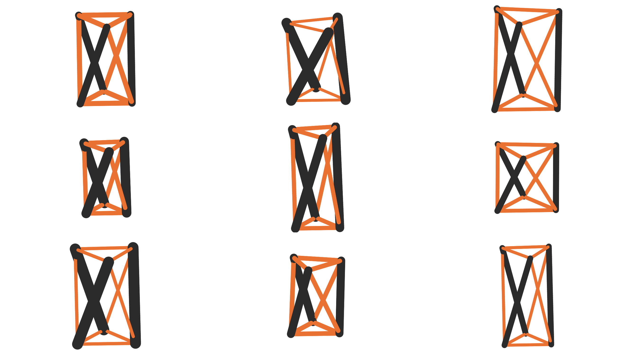
Fig. 5 The nine seed geometries rendered to a common millimeter scale (rigid PLA struts in black, TPU tendons in orange). Every rendering corresponds to a physically printed article in the seed campaign.

Table 6 Seed-batch drop-tower results: 101 stabilized captures per article (103 for autv5r) at 60 in onto the standardized polyurethane surface, CFC-180 filtering, counted after the first two warm-up drops of each session were discarded. Means ± one standard deviation over the stabilized drops. Rows are ordered by t₁₈₀. E_{reb} uses each article’s weighed mass per Eq. (1). The ringdown frequency f_{n} is a print-health descriptor, not an objective. A dash denotes a quantity that cannot be computed from the available record. Article amdjwm, which lacks a weighed mass and a confirmed design mapping, is excluded from the surrogate fit and from all mass-dependent quantities. No accepted f_{n} estimate is available for bag26v or ajhby6. Specs 03 and 06 were printed but have no drop sessions in the campaign record.
Design | Article | Mass (g) | t₁₈₀ | E_{reb} (mJ) | f_{n} (Hz)
Spec 01 | 6lhxfy | 18.50 | 0.8931 ± 0.0042 | 13.9 | 368
(unmapped) | amdjwm | - | 0.9805 ± 0.0025 | - | 455
Spec 05 | 6nheas | 21.73 | 0.9970 ± 0.0032 | 13.1 | 322
S0 ref. | bpx68c | 20.23 | 1.0111 ± 0.0024 | 6.2 | 468
Spec 07 | ajhby6 | 20.53 | 1.0127 ± 0.0038 | 6.1 | -
Spec 00 | 9hhbkp | 21.62 | 1.0183 ± 0.0017 | 6.9 | 364
Spec 04 | nvxsrv | 20.66 | 1.0275 ± 0.0044 | 8.2 | 294
Spec 02 | autv5r | 22.04 | 1.0404 ± 0.0035 | 8.8 | 386
Spec 08 | bag26v | 21.42 | 1.0616 ± 0.0051 | 7.7 | -

4.2 Model-Recommended Batches and Replication. Table 7 reports the stabilized objectives for the three model-recommended batches, and Fig. 6 overlays every measured article with the non-dominated front after each batch. We evaluate Pareto membership over articles with both objectives and omit the unmapped seed article amdjwm, whose E_{reb} cannot be computed without a weighed mass. Dominated hypervolume, evaluated at the fixed reference point (t₁₈₀, E_{reb}) = (1.35, 15 mJ), grew from 3.155 after the seed batch to 3.969 after batch 2 (+25.8%), 4.007 after batch 3 (+0.9%), and 5.195 after batch 4 (+29.7%), a 65% total gain over the seed front. We have not run a budget-matched physical baseline of Sobol designs, so the comparison the data support is against the campaign’s own Sobol seed. After batch 4, every member of the combined front (corny7, corny6, drran5, drran3, r2d2c6) is a model-recommended design, and the last seed article left the front when the batch-4 record dominated it. These fronts score every article as measured, with each repeated batch-3 design at its first print. Scoring each batch-3 design instead at the mean of its screened prints (Table 8) removes drran5 and drran3 from the final front. The design-mean front is corny7, corny6, r2d2c2, corny4, and r2d2c6, still entirely model-recommended, with r2d2c2’s membership provisional on its drift flag. Scored the same way, batch 3 added 0.1% to the hypervolume instead of 0.9%, so most of its apparent gain came from favorable first prints.
Batch 2 (Ax trials 10 to 18). We generated the first recommended batch from the seed fit and printed it under the constant-solid-mass projection, so its printed masses still spread widely (17.91 to 23.47 g). A regenerated constant-printed-mass recommendation set is archived alongside the as-printed one, and every result reported here is for the as-printed set. The batch grew the front almost entirely on the velocity-loss axis, and four batch-2 articles joined the front. Article r2d2c6 still holds the lowest E_{reb} on record, 4.1 mJ per drop, and its velocity loss index of 0.986 ties two later articles (drran3 and corny4) for the highest. On the transmissibility axis, the archived posterior predictions sat below the measurements for nine of nine articles, with a mean absolute percentage error (MAPE) of 14.4%. The worst case was r2d2c3 (predicted 0.910, measured 1.334), the strongest amplifier in the campaign record. That nine-of-nine optimism probably widened the refit posterior for every batch that followed.
Batch 3 (Ax trials 28 to 36). Batch 3 was the first batch at constant printed mass (19.24 to 20.06 g, CV 1.7%) and the first with the infill and filament axes active (Section 3.1). Its first prints filled the knee of the front without extending it (+0.9% hypervolume, three articles joined). Eight of nine articles measured within 0.3 posterior standard deviations of their predictions (MAPE 3.8%). Two first-print results stood out. The best-predicted design (trial 32, predicted 1.020) measured 1.251, then the strongest amplification on record, and the batch’s only attenuator (drran8, 0.980, drift-flagged) was its only twisted design. Neither result held up on the later prints described below.
Batch 4 (Ax trials 37 to 45). The acquisition split the batch between the wide, high-twist, thin-cable family it had been steering toward since batch 2 and a previously unvisited tall, low-twist corner. Four of nine articles attenuate, all of them from the wide family. Article corny7, the batch’s best-predicted design (trial 37, predicted 0.934 ± 0.13), measured t₁₈₀ = 0.8031 ± 0.0025, the strongest attenuation in the program, 10% below the best seed article and 21% below the reference prism. Its velocity loss index, 0.968 (E_{reb} = 9.4 mJ per drop), is mid-pack, and it dominates the seed attenuator on both objectives (Fig. 7). Within the attenuating family, the archived predictions ranked the four measurements perfectly (Spearman ρ = +1.0). Across all nine articles the rank correlation is 0.82, although the five amplifier predictions span only 0.9% and so carry no ordering signal. The batch MAPE was 6.0%, and no article left its predictive band by more than one standard deviation. The record itself beat its band by 1.0 standard deviation in the good direction. Per the between-seat replication rule, the batch-4 attenuation values, including the record, are single-seating measurements whose re-seat confirmations are scheduled. One session (corny5) carries a drift flag, so its mean is provisional. Another (corny6) was erratic, with a per-drop CV of 2.0%, but attenuates under any reading of its record.
Replication: three prints of batch 3. We printed the batch-3 plate three times and drop-tested every article under the identical protocol, 540 drops in all. In the later prints, articles 2dranN and dran3N re-print drranN at the same Ax trial (round-3 print key). Each of the nine designs therefore has three articles (Table 8 and Fig. 8). The three prints averaged 19.59, 19.86, and 20.07 g. Neither extreme of the first print recurred. Trial 32, whose first print (drran7) measured 1.2513, then the strongest amplification on record, measured 1.0286 and 1.0448 on its later prints, close to its prediction of 1.020. The drift-flagged 0.9804 attenuator of trial 35 (drran8) measured 1.0109 and 0.9958. Trial 35 is the lowest-transmissibility design in every print, but its screened mean is 1.003, so batch 3 contains no reproducibly attenuating design.
We screen each session with the seat gauge of Section 3.3, and every large same-design deviation came with a failed gauge. The four sessions that read 1.15 or more were each their design’s highest value, 4.5 to 19.8% above the design’s median over the three prints. The 23 sessions below that threshold sat a median 0.2% from their design medians (at most 3.7%, on a drift-flagged session), and the gauge correlates with the deviation (Spearman ρ = 0.52, p = 0.006). The third print supplied one new gross outlier, dran35 (trial 28), at 1.168 with a gauge of 2.43, against 1.037 and 1.060 for its earlier prints. Its re-seat is pending, and the screened means leave it out.
Setting aside the four gauge failures and the two drift-flagged sessions leaves 21 of the 27. Fitting those 21 with one mean per design plus one offset per print leaves a residual standard deviation of 0.0087 in t₁₈₀ (10 degrees of freedom). That is below the 0.013 estimated from the first two prints alone, and still an order of magnitude above the within-session standard errors (median 0.0006) that the surrogate ingests. The second print’s offset is +0.008 and the third’s −0.003, so the upward shift of the second print did not recur. The third print was also the heaviest, so that shift was probably not a mass effect. Over the screened sessions the intraclass correlation of t₁₈₀ (the share of its variance that lies between designs) is 0.58, against 0.06 when every session is included. Most of the design signal in batch 3 comes from trial 35. Without it, the other eight design means span 1.028 to 1.045 (standard deviation 0.006), less than the scatter of a single article. Single articles therefore cannot rank those eight, and the orderings from different prints agree poorly (Spearman ρ of 0.08, 0.67, and 0.20 between pairs of prints). The frozen batch-3 predictions rank the nine design means with ρ = 0.75 (p = 0.02) when each mean is adjusted for the print offsets, and with ρ = 0.55 (p = 0.13) without that adjustment. Against single prints they reach 0.20, 0.72, and 0.30.
E_{reb} repeats far less well than transmissibility. For each design the largest of its three values is 1.35 to 2.9 times the smallest (5.2 against 15.1 mJ at trial 30). The rank correlations between prints are −0.18, 0.25, and 0.33, and the scatter between prints (standard deviation 3.4 mJ) exceeds the spread of the design means (2.3 mJ).
The 1.2513 session had passed every within-session stability check (per-drop CV 0.77%, no drift), so a stable session is not enough to show that its value reflects the design. We adopted the between-seat replication rule of Section 3.3 in response. Across an independent re-seat, the seed attenuator agreed to within 0.13%, so genuine attenuation can reproduce. The seat gauge accompanies the rule as an advisory screen, and all four batch-4 attenuators pass the gauge (0.98 to 1.06). The nine second-print articles joined the surrogate’s training set as distinct observations at identical design coordinates (Section 3.4). None of the third-print articles enters the fits, the cross-validation, or Fig. 6. Their sessions (2026-09-28 to 2026-10-02) postdate the most recent refit.

Table 7 Model-recommended batch results under the protocol and reporting conventions of Table 6 (CFC-180, stabilized means ± one standard deviation, rows ordered by t₁₈₀ within each batch). Each article received about twenty drops against the seed batch’s 101, and the archived per-drop records give the exact per-session counts. E_{reb} uses each article’s weighed mass per Eq. (1). “Pred.” is the posterior-mean t₁₈₀ archived when the batch was recommended, before any of its articles were tested. Batch-2 articles were projected to constant solid mass, and batches 3 and 4 to constant printed mass (20.23 g). Flags follow the session record: † marks a transmissibility-drift-flagged session whose mean is provisional, and ‡ marks the erratic corny6 session (per-drop CV 2.0%).
Batch | Article | Trial | Mass (g) | t₁₈₀ | E_{reb} (mJ) | Pred. t₁₈₀
2 | r2d2c7 | 15 | 18.51 | 0.9484 ± 0.0008 | 12.2 | 0.905
2 | r2d2c1 | 13 | 19.38 | 0.9942 ± 0.0021 | 6.0 | 0.948
2 | r2d2c2† | 12 | 17.96 | 1.0411 ± 0.0154 | 5.6 | 0.926
2 | r2d2c9 | 10 | 17.91 | 1.0530 ± 0.0035 | 5.8 | 0.873
2 | r2d2c6 | 14 | 19.11 | 1.0548 ± 0.0042 | 4.1 | 0.953
2 | r2d2c8 | 17 | 19.98 | 1.0704 ± 0.0116 | 7.9 | 0.955
2 | r2d2c5 | 18 | 23.47 | 1.1516 ± 0.0040 | 6.7 | 0.987
2 | r2d2c4 | 11 | 19.33 | 1.1847 ± 0.0076 | 6.4 | 0.885
2 | r2d2c3 | 16 | 18.63 | 1.3337 ± 0.0117 | 5.6 | 0.910
3 | drran8† | 35 | 19.32 | 0.9804 ± 0.0051 | 11.2 | 1.039
3 | drran1 | 36 | 19.31 | 1.0326 ± 0.0016 | 18.1 | 1.051
3 | drran4 | 29 | 19.92 | 1.0344 ± 0.0017 | 9.1 | 1.032
3 | drran2 | 33 | 19.33 | 1.0345 ± 0.0006 | 11.8 | 1.056
3 | drran5 | 28 | 19.88 | 1.0373 ± 0.0024 | 5.0 | 1.059
3 | drran3 | 31 | 19.92 | 1.0389 ± 0.0012 | 4.2 | 1.043
3 | drran9 | 30 | 19.34 | 1.0425 ± 0.0009 | 5.2 | 1.058
3 | drran6 | 34 | 19.24 | 1.0471 ± 0.0040 | 4.8 | 1.065
3 | drran7 | 32 | 20.06 | 1.2513 ± 0.0096 | 8.2 | 1.020
4 | corny7 | 37 | 19.62 | 0.8031 ± 0.0025 | 9.4 | 0.934
4 | corny9 | 43 | 19.46 | 0.8766 ± 0.0036 | 18.1 | 0.942
4 | corny6‡ | 41 | 19.45 | 0.9106 ± 0.0181 | 5.7 | 0.943
4 | corny8 | 39 | 19.64 | 0.9535 ± 0.0025 | 17.5 | 0.954
4 | corny1 | 42 | 20.20 | 1.0459 ± 0.0029 | 8.7 | 1.010
4 | corny4 | 44 | 20.56 | 1.0475 ± 0.0025 | 4.3 | 1.013
4 | corny3 | 45 | 20.15 | 1.0705 ± 0.0013 | 8.8 | 1.004
4 | corny2 | 38 | 20.21 | 1.0846 ± 0.0030 | 9.2 | 1.008
4 | corny5† | 40 | 20.58 | 1.0876 ± 0.0099 | 8.5 | 1.012
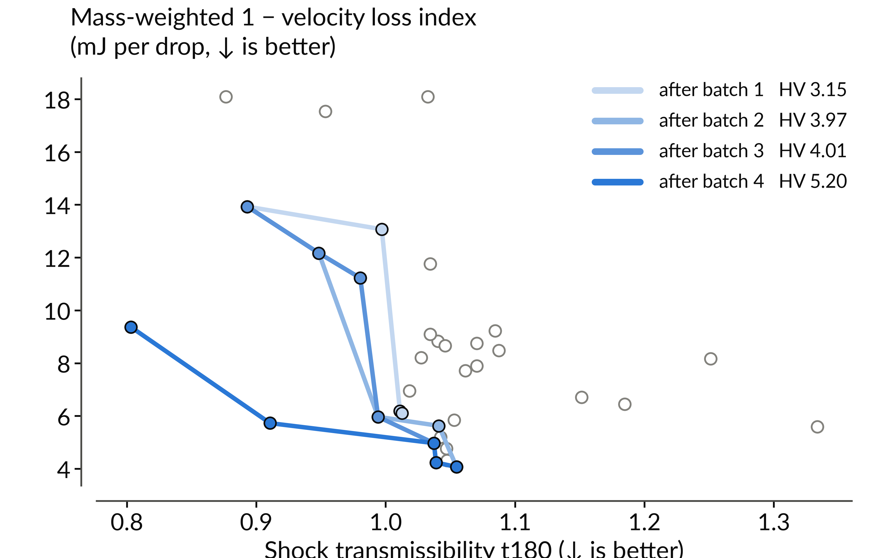
Fig. 6 Measured objective space and front evolution across the four batches. The vertical axis is the mass-weighted velocity-loss objective E_{reb} = (1 − VLI) mgh of Eq. (1). Gray circles are all measured articles at their stabilized means. The blue lines are the non-dominated fronts after each batch, with the dominated hypervolume at the (1.35, 15 mJ) reference in the legend. Batch 2 grew the front on the velocity-loss axis, batch 3 filled the knee, and batch 4 extended it to lower transmissibility. Repeated batch-3 designs are drawn at their first-print values. The design-mean front is given in the text. Lower is better on both axes.
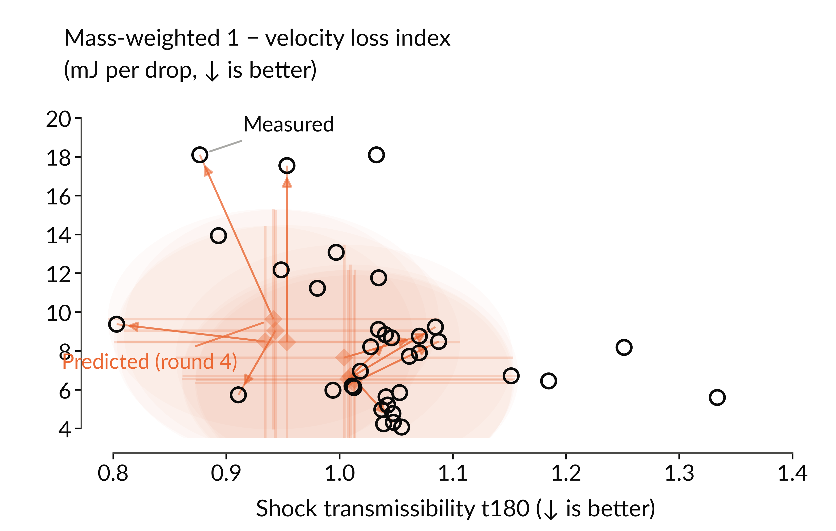
Fig. 7 Batch-4 predictions against outcomes. Orange diamonds with bars are the archived posterior predictions (mean ± one standard deviation) for trials 37 to 45 at recommendation time. Arrows connect each prediction to its article’s measured value. Black circles are measured values, and all previously measured articles are shown for context. The vertical axis is E_{reb}, as in Fig. 6. The record attenuator corny7 (measured 0.803) is the left-most measured point. Lower is better on both axes.
Table 8 Batch-3 repeatability as stabilized t₁₈₀ over three prints of the same nine designs, under the protocol of Table 6. Articles drranN, 2dranN, and dran3N are prints 1, 2, and 3. “Pred.” is the posterior-mean t₁₈₀ archived before any batch-3 article was tested. “Mean” averages the prints that pass the health screen, a seat gauge (the ratio of CFC-1000 to CFC-180 transmissibility) below 1.15 and no drift flag. § marks a failed seat gauge and † a transmissibility-drift flag. E_{reb} is listed for prints 1, 2, and 3.
Trial | N | Pred. | Print 1 | Print 2 | Print 3 | Mean | E_{reb} (mJ)
28 | 5 | 1.059 | 1.0373 | 1.0604 | 1.1679§ | 1.0489 | 5.0 / 5.0 / 7.2
29 | 4 | 1.032 | 1.0344 | 1.0433 | 1.0201 | 1.0326 | 9.1 / 11.2 / 15.5
30 | 9 | 1.058 | 1.0425 | 1.0451 | 1.0438 | 1.0438 | 5.2 / 15.1 / 6.7
31 | 3 | 1.043 | 1.0389 | 1.0533 | 1.0366 | 1.0429 | 4.2 / 9.4 / 7.0
32 | 7 | 1.020 | 1.2513§ | 1.0286 | 1.0448 | 1.0367 | 8.2 / 11.6 / 10.8
33 | 2 | 1.056 | 1.0345 | 1.0900§ | 1.0386 | 1.0366 | 11.8 / 4.5 / 4.5
34 | 6 | 1.065 | 1.0471 | 1.0859† | 1.0353 | 1.0412 | 4.8 / 7.7 / 6.8
35 | 8 | 1.039 | 0.9804† | 1.0109 | 0.9958 | 1.0033 | 11.2 / 9.9 / 8.3
36 | 1 | 1.051 | 1.0326 | 1.0791§ | 1.0209 | 1.0267 | 18.1 / 7.3 / 9.6
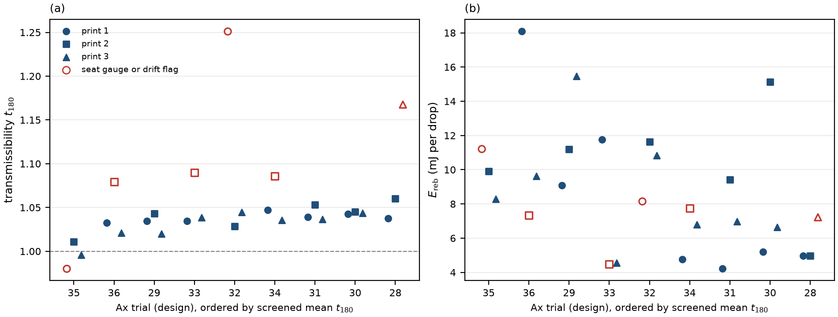
Fig. 8 Three prints of each batch-3 design. (a) Transmissibility and (b) E_{reb} for print 1 (circles), print 2 (squares), and print 3 (triangles), with the designs ordered by their screened mean transmissibility. Open red markers are sessions with a failed seat gauge or a drift flag, which the screened means leave out. The dashed line marks t₁₈₀ = 1.

4.3 Surrogate Audits Across the Campaign. We audit each refit with leave-one-out cross-validation (LOOCV), using one full NUTS refit per held-out article, and with length-scale diagnostics. Figure 9 reports the seed-state SAASBO length-scale diagnostics. At seven observations for six correlated inputs, these are prior-sensitive model diagnostics only, and they support no claim of variable relevance or ranking.
Held-out point accuracy declined as the campaign grew. The t₁₈₀ LOOCV MAPE was 2.9% with rank correlation +0.76 on the seed state (8 articles, 6 model inputs), 5.4% and +0.60 after batch 2 (17 articles), and 6.2% and +0.19 after batch 3 (26 articles, 12 inputs). The E_{reb} MAPE was 29.3%, 23.6%, and 32.2% at the same states. The fold-level records are archived with the campaign data. Three changes coincided and are confounded: the input space doubled from 6 to 12 while the data grew only from 17 to 26, four of the six added axes carry a single value per batch and are therefore perfectly confounded with batch, and batch 3 itself added the campaign’s largest outliers. The held-out posterior shrinks predictions toward the pooled mean, so it misses the campaign’s extremes. We therefore read the predicted columns as a record of what the model expected when it chose each design, rather than as forecasts. Batch 4’s value was the design family it selected and the record it found, not its point accuracy, and its best-predicted article was the record.
Plain LOOCV also leaks once replicates exist. When one print of a repeated design is held out, its twin remains in training at nearly identical coordinates, so the fold tests interpolation rather than prediction. We re-audited the full record with leave-one-design-out folds (35 folds over 44 articles, each drran/2dran pair held out together, one full NUTS refit per fold). The t₁₈₀ MAPE is 5.0% with rank correlation +0.08. While the measurements span 0.80 to 1.33, the held-out posterior stays near the pooled mean (Fig. 10). The E_{reb} MAPE is 39.4% with rank correlation −0.38. Held-out design-level t₁₈₀ skill is therefore near zero. Part of the apparent E_{reb} skill of the earlier states came from the model fitting chance differences between prints, which matches the poor print-to-print repeatability of E_{reb} in Table 8. The comparison to the LOOCV trajectory is descriptive rather than a controlled ablation. The states differ in article count, fold structure, and the presence of the repeat data itself.
The correlation between printed mass and transmissibility fell from r = 0.82 over the eight seed articles to 0.12 over all 53 tested articles (r² = 0.01), which suggests that the constant-printed-mass projection removed the seed batch’s main confound. Within batch 4 alone the two correlate strongly (r = 0.85). There, however, the wide, high-twist family printed at 19.45 to 19.64 g and the tall, low-twist family at 20.15 to 20.58 g, so printed mass follows the design family. The correlation within the batch therefore cannot be read as a mass effect. We have not yet run the planned head-to-head calibration comparison against a point-estimated single-task GP with the same kernel, so we make no claim that SAASBO outperforms it here.
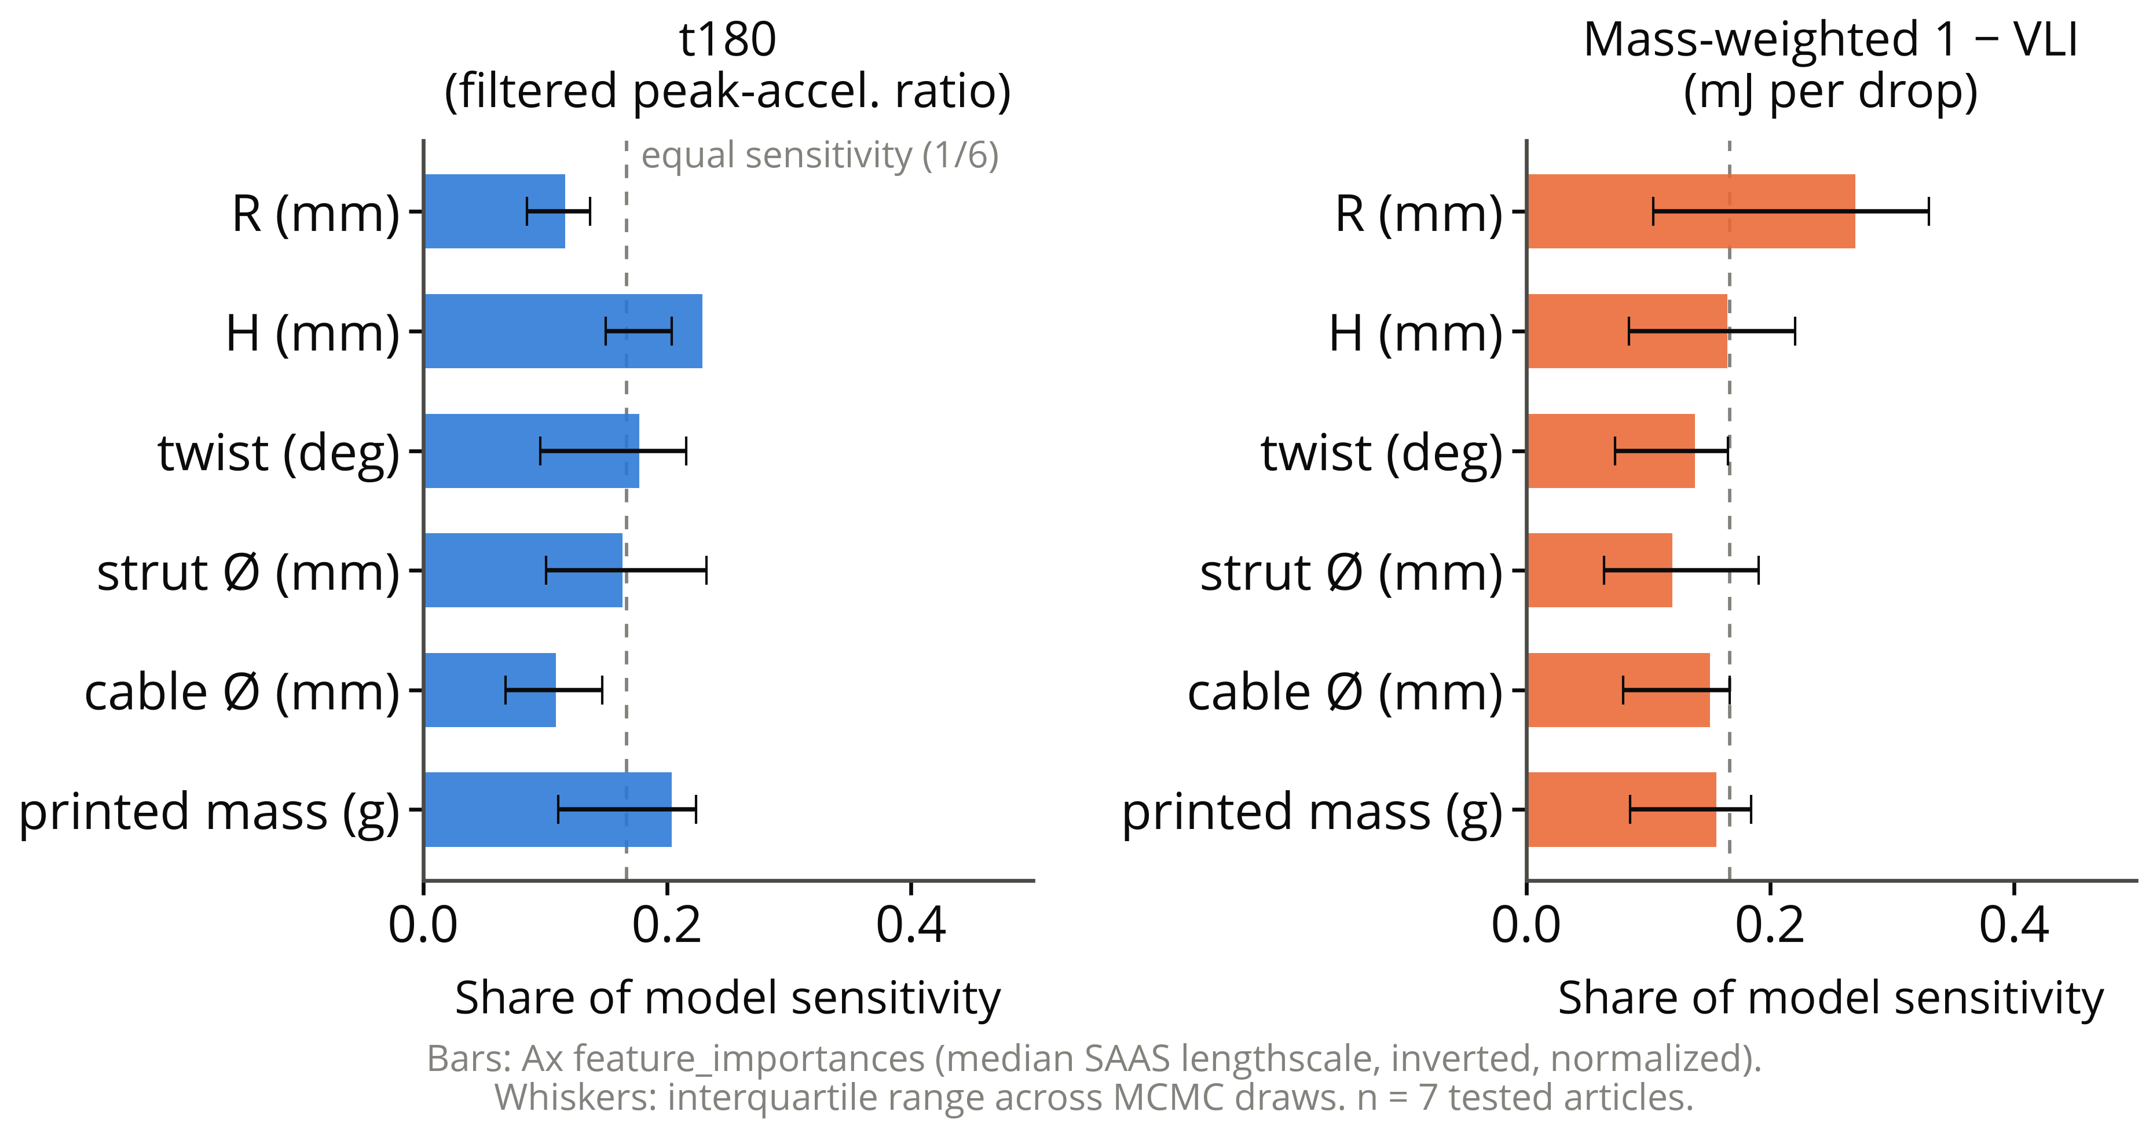
Fig. 9 Seed-state SAASBO length-scale diagnostics per objective for the five design variables plus printed mass. Bars are median normalized inverse length scales over MCMC draws, and whiskers are interquartile ranges. The horizontal axis, labeled “share of model sensitivity” in the plot, is this normalized inverse-length-scale diagnostic. No input separates decisively from the equal-share line (dashed) at seven mapped articles, and these prior-sensitive model diagnostics are not evidence of variable relevance.
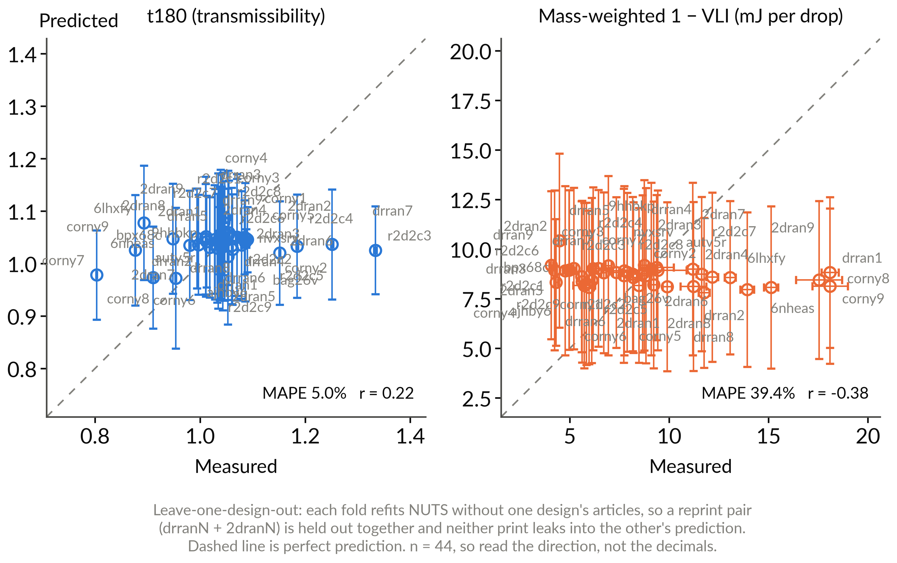
Fig. 10 Leave-one-design-out cross-validation of the SAASBO surrogate over the full 44-article record (35 design folds, one full NUTS refit per fold). Each batch-3 reprint pair is held out together so neither print leaks into the other’s prediction. Vertical bars are one posterior standard deviation of the held-out prediction, horizontal bars are the ingested standard error, and the dashed line is parity. Held-out t₁₈₀ predictions stay close to the pooled mean (MAPE 5.0%, rank correlation +0.08), and the E_{reb} ordering is anti-correlated (−0.38). Design-level held-out skill is near zero on transmissibility and absent on the mass-weighted velocity-loss objective.
Studies pending. The following remain future work, and none of their values appear in this section. The batch-4 attenuators (the record article first) and the third-print outlier dran35 await re-seats. The third print of the batch-3 designs has not yet entered the surrogate fit or its cross-validation. A fifth batch has been generated, regenerated once the second print entered the fit, and staged for printing, but nothing from it appears here. The replicate rank-stability study of Section 3.5 (best-, mid-, and worst-predicted in-sample designs re-printed in nominal triplicate), the quasi-static crush campaign, and the metal-analog comparison (Table 5) have not yet run.

5 Discussion
What the campaign establishes. Across the four measured batches, the end-to-end loop closed repeatedly: printed articles, instrumented characterizations, a fitted fully Bayesian surrogate, and three successive model-recommended batches whose own measurements fed the next refit. The measurement distinguishes the tested articles. The campaign t₁₈₀ means span 0.803 to 1.334, far beyond within-session drop scatter. The three prints of batch 3 locate the resolution floor for a single article. Clean seatings of different prints differ by a standard deviation of about 0.009, and a broadband gauge flags occasional seating failures of 10 to 20%. The physics is less favorable than the cushioning intuition suggests. At this scale and rate, most printed prisms amplify the peak shock reaching their top vertex (26 of 35 articles measured above unity). We therefore sharpened the campaign question from “how much does the architecture cushion” to “which corner of the design space crosses into attenuation, and at what cost to the velocity loss index.” The batches answered that question, though not on the first try. Batch 2’s forecasts were optimistic on nine of nine articles, and batch 3’s best-predicted design measured as its worst amplifier on its first print, a seating artifact that its two later prints did not repeat. Batch 4 then delivered four attenuators from the wide, high-twist, thin-cable family, led by its best-predicted design at t₁₈₀ = 0.803. The strongest attenuators still tend to have low velocity loss indices (0.938 and 0.940 for corny9 and corny8), and the record article is mid-pack at 0.968. The tall batch-4 family reaches an index as high as 0.986 at a transmissibility near unity, so the front remains two-dimensional.
Review of the objective stack. We pre-registered an adversarial, data-first review of the objective choices with an external AI referee that was required to commit to its own objective set from the raw campaign files before reading ours. Its findings temper the round-1 formulation and set the round-3 revision. First, the rebound fraction e_{reb} rests on a ballistic interpretation of the second contact event that has not yet been validated against synchronized video (a restrained-versus-unrestrained check is scheduled). Second, the apparent t₁₈₀-versus-E_{reb} trade-off is driven substantially by the single strongest attenuator (Spearman ρ = −0.39, p = 0.38 across the reliable articles). Third, per-drop standard errors are much smaller than the between-article variation, and therefore understate design-level uncertainty. In response, we printed and tested the batch-3 plate three times, which measured the print-to-print scatter directly (Section 4.2) and confirmed the understatement at an order of magnitude in t₁₈₀. The between-seat replication rule now gates every extreme, the velocity loss index stays a candidate constraint pending its ballistic validation, and the constant-printed-mass projection removed the mass channel the review flagged. We report this trajectory because the loop is the contribution, and revising objectives mid-campaign, with the revision criteria stated in advance, is probably how such loops behave in practice.
Mass as a confound and as a design variable. Holding solid CAD mass constant did not hold printed grams constant. PLA prints at partial infill while thin TPU cables print near solid, so the seed articles span 18.50 to 22.29 g, and among the mapped seed articles mass and t₁₈₀ are correlated (r = 0.82). Printed mass is itself induced by the geometry and is strongly collinear with member dimensions (light articles are the thick-strut, thin-cable corner by construction), so the seed observations cannot identify separate geometry and mass effects. A post hoc mass-adjusted regression would be unstable and would estimate a different, direct-effect quantity. We addressed the confound by experimental design rather than adjustment. We used the calibrated printed-mass model (Supplementary Information) to compare geometries at fixed printed grams in batches 3 and 4, where the batch mass CVs were 1.7 and 2.3%. Over all 53 tested articles, mass and transmissibility are nearly uncorrelated (r = 0.12). The confound was broken by construction, and E_{reb} keeps grams penalized where they matter physically, in the motion returned to the payload.
Relation to prior art, and why simulation sits outside the loop. Relative to Pajunen et al. [11], we vary the geometry under an optimization loop rather than characterizing a single fabrication condition. Relative to Mo et al. [17], the loop’s ground truth is physical measurement, and no simulated number enters the objectives, the acquisition, or candidate priority. We based that exclusion on an exploratory multi-engine simulation study conducted alongside the campaign (rigid-body through finite-element fidelities, archived in the project repository). The study could not reproduce the amplification that dominates the measured record, predicted design-invariant rebound where the measurement discriminates strongly, and correlated only weakly with the measured transmissibility. Its rigid-strut models cap the transmissibility near unity, while most printed articles exceed it. Its constant-mass fairness constraints and its diagnosis of the seed batch’s mass confound did shape the campaign design, which is the screening role we consider simulation to have earned here. Before simulation takes on a larger role, it must demonstrate prospective predictive skill on articles it has not seen. The measured near-unity transmission of most seed articles also cautions against reading the printed-tensegrity literature’s attenuation results as generic. The as-printed cells here are not pretensioned, and activating genuine pretension in additively manufactured tensegrity (for example through shrink-on-treatment routes) is an open direction we deliberately scope out of the present campaign.
Practical considerations and path forward. PLA/TPU interface durability under repeated impact remains open. No joint failed during the repeated-drop measurement sessions, which covered more than 1,400 stabilized captures across 35 articles, plus the second and third prints of batch 3. Because those sessions were not designed as controlled fatigue tests, the observation does not establish interface durability. Pull-out and fatigue characterization of the internal-anchor joint is planned follow-on work. Sensitivity to print-process covariates (the print key logs defects, humidity, and the mid-batch nozzle change for this purpose) and transfer to other material pairs likewise remain open. In the future we plan the re-seat confirmations of the batch-4 attenuators, the replicate rank-stability study of Section 3.5, the metal-analog rank-transfer comparison of Section 3.6, quasi-static testing as an extension of the characterization (Section 3.3), pretension activation, tiled multi-cell absorbers and lattices [34], and miniaturization to crutch-tip envelopes. Long-term crutch use is associated with substantial upper-extremity overuse injury and ground-reaction-force impulses [60–64]. Existing spring-loaded [65, 66] and polymer-damped [67] tip designs reduce loading rate but not peak transmitted force. Recent tensegrity crutch concepts [68] and open-source 3D-printed crutch work [69] suggest a plausible translation path, with adjacent footwear and orthotic lattice studies [70–72] providing transferable design heuristics.
Limitations. The measured evidence base is 53 articles: 35 across the four batches and 18 re-prints of the nine batch-3 designs, which are the only designs tested more than once. The surrogate fit includes the nine second prints but not yet the nine third prints. That replication exposed the sensitivity to seating and printing, so every single-article extreme, including the batch-4 record, is provisional until its re-seat. The drop protocol probes one height, one impact surface, and axial loading only. The specimens never leave the elastic regime, so crush-energy metrics await the quasi-static campaign. Per-specimen energy absorption in joules is also not recoverable from the current rig, because the falling-mass and displacement channels required for a force integral are not instrumented. The four filament axes carry one value per batch, so their effects are not identifiable. The held-out prediction skill of the surrogate declined as the input space grew (Section 4.3). One tested seed article lacks a design mapping, one seed design’s official article assignment carries a recorded discrepancy, and two seed designs have no session record. All results come from a single printer, material pair, and cell topology. We plan to address these limits with the replication rule, the re-seat confirmations, the replicate rank-stability study (Section 3.5), and the metal-analog protocol (Section 3.6).

6 Conclusions
We have presented an experiment-driven Bayesian-optimization framework for designing multi-material 3D-printed tensegrity-inspired energy absorbers, with TPU used in place of the traditional tension elements and PLA members carrying compression most of the time. We have run it through the recommend, fabricate, measure, and update cycle three times on physical hardware. The framework parameterizes a T₃-prism family (five geometry variables, joined in batch 3 by infill and filament process variables) under a constant-mass fairness projection. It fabricates each candidate in a single multi-material FDM build with TPU tendons anchored inside the PLA strut ends and characterizes every article with repeated instrumented drops (101 stabilized captures in the seed batch, about twenty thereafter). A fully Bayesian Gaussian-process surrogate [20, 22] fitted to those measurements recommends the next batch. Across the four measured batches (35 articles), the transmissibility spanned 0.803 to 1.334, and most articles amplified the peak shock. The model-recommended batches grew the dominated hypervolume 65% over the Sobol seed front, ending with a front whose five members are all model-chosen. The batch-4 best-predicted design set the program record at t₁₈₀ = 0.803, ten percent below the best seed article, and awaits its re-seat confirmation under the campaign’s replication rule. Printing one batch’s nine designs three times put the print-to-print standard deviation of the transmissibility at 0.009, an order of magnitude above the standard error of a session mean. A broadband seat gauge flagged both of the largest single-print errors, so a single-print extreme needs a replicate, or at least a clean re-seat, before it counts. [Placeholder: what the replicate study shows about rank stability.] The workflow is a candidate for other experimentally evaluated architected structures whose constitutive response is difficult to calibrate from first principles, but transfer beyond this printer, material pair, topology, and axial impact condition remains untested.

Acknowledgment
This work was supported by the Brigham Young University Mentored Research Grant program. The authors thank the undergraduate researchers who carried out the multi-material printing and impact testing, and the graduate co-mentor who supported day-to-day operations.

Funding Data
- Brigham Young University Mentored Research Grant.

Conflict of Interest
The authors declare no conflict of interest.

References
[1] Skelton, R. E. and de Oliveira, M. C., 2009, Tensegrity Systems, Springer, New York.
[2] Sultan, C., 2009, “Tensegrity: 60 Years of Art, Science, and Engineering,” Advances in Applied Mechanics, 43, pp. 69–145.
[3] Amendola, A., Carpentieri, G., de Oliveira, M. C., Skelton, R. E., and Fraternali, F., 2014, “Experimental Investigation of the Softening–Stiffening Response of Tensegrity Prisms under Compressive Loading,” Composite Structures, 117, pp. 234–243.
[4] Zhang, Q., Zhang, D., Dobah, Y., Scarpa, F., Fraternali, F., and Skelton, R. E., 2018, “Tensegrity Cell Mechanical Metamaterial with Metal Rubber,” Applied Physics Letters, 113(3), p. 031906.
[5] Fraternali, F., Carpentieri, G., and Amendola, A., 2015, “Tensegrity Ring Structures for Impact Protection,” International Journal of Solids and Structures, 65–66, pp. 232–243.
[6] Agogino, A. K., SunSpiral, V., and Atkinson, D., 2018, “Super Ball Bot — Structures for Planetary Landing and Exploration,” NASA Ames Research Center, https://www.nasa.gov/general/super-ball-bot/
[7] Caluwaerts, K., Agogino, A. M., and SunSpiral, V., 2014, “SUPERball: Exploring Tensegrities for Planetary Probes,” Proceedings of the 12th International Symposium on Artificial Intelligence, Robotics and Automation in Space (i-SAIRAS).
[8] Sabelhaus, A. P., Bruce, J., Caluwaerts, K., Manovi, P., Firoozi, R. F., Dobi, S., Agogino, A. M., and SunSpiral, V., 2015, “System Design and Locomotion of SUPERball, an Untethered Tensegrity Robot,” 2015 IEEE International Conference on Robotics and Automation (ICRA), pp. 2867–2873, .
[9] Vespignani, M., Friesen, J. M., SunSpiral, V., and Bruce, J., 2018, “Design of SUPERball v2, a Compliant Tensegrity Robot for Absorbing Large Impacts,” 2018 IEEE/RSJ International Conference on Intelligent Robots and Systems (IROS), pp. 2865–2871, .
[10] Deitrich, N., Baldonado, K. M., Khan, A., Cook, J., and Rizzo, L., 2022, “A Rideshare Tensegrity Rover Concept to Explore Titan’s Lands and Oceans,” AIAA SciTech Forum, NASA Langley Research Center / Ames Research Center.
[11] Pajunen, K., Johanns, P., Pal, R. K., Rimoli, J. J., and Daraio, C., 2019, “Design and Impact Response of 3D-Printable Tensegrity-Inspired Structures,” Materials & Design, 182, p. 107966.
[12] Ye, H., Liu, Q., Cheng, J., Li, H., Jian, B., Wang, R., Sun, Z., Lu, Y., and Ge, Q., 2023, “Multimaterial 3D Printed Self-Locking Thick-Panel Origami Metamaterials,” Nature Communications, 14, p. 1607.
[13] Khatri, N. R. and Egan, P. F., 2024, “Energy Absorption of 3D Printed ABS and TPU Multimaterial Honeycomb Structures,” 3D Printing and Additive Manufacturing, 11, pp. e840–e850.
[14] Chen, Y., Huang, A., Wang, Z., Antonoglou, I., Schrittwieser, J., Silver, D., and de Freitas, N., 2018, “Bayesian Optimization in AlphaGo,” arXiv preprint arXiv:1812.06855.
[15] Ament, S., Witte, A., Garg, N., and Kusuma, J., 2023, “Sustainable Concrete via Bayesian Optimization,” arXiv preprint arXiv:2310.18288, NeurIPS 2023 Workshop on Adaptive Experimental Design and Active Learning in the Real World.
[16] Strieth-Kalthoff, F., Hao, H., Rathore, V., Derasp, J., Gaudin, T., Angello, N. H., Seifrid, M., Trushina, E., Guy, M., Liu, J., et al., 2024, “Delocalized, Asynchronous, Closed-Loop Discovery of Organic Laser Emitters,” Science, 384(6697), p. eadk9227.
[17] Mo, C., Perdikaris, P., and Raney, J. R., 2023, “Accelerated Design of Architected Materials with Multifidelity Bayesian Optimization,” Journal of Engineering Mechanics, 149(6), p. 04023028.
[18] Zhang, M., Parnell, A., Brabazon, A., and Benavoli, A., 2021, “Bayesian Optimisation for Sequential Experimental Design with Applications in Additive Manufacturing,” arXiv preprint arXiv:2107.12809.
[19] SAE International, 2022, “Instrumentation for Impact Test—Part 1: Electronic Instrumentation,” Surface Vehicle Recommended Practice J211/1_202208, .
[20] Balandat, M., Karrer, B., Jiang, D. R., Daulton, S., Letham, B., Wilson, A. G., and Bakshy, E., 2020, “BoTorch: A Framework for Efficient Monte-Carlo Bayesian Optimization,” Advances in Neural Information Processing Systems 33 (NeurIPS 2020), https://arxiv.org/abs/1910.06403
[21] Olson, M., Santorella, E., Tiao, L. C., Cakmak, S., Garrard, M., Daulton, S., Lin, Z. J., Ament, S., Beckerman, B., Onofrey, E., Igusti, P., Lara, C., Letham, B., Cardoso, C., Shen, S. S., Lin, A. C., Grange, M., Kashtelyan, E., Eriksson, D., Balandat, M., and Bakshy, E., 2025, “Ax: A Platform for Adaptive Experimentation,” Proceedings of the Fourth International Conference on Automated Machine Learning, L. Akoglu, C. Doerr, J. N. van Rijn, R. Garnett, and J. R. Gardner, eds., Proceedings of Machine Learning Research, Vol. 293, PMLR, pp. 21/1–25, https://proceedings.mlr.press/v293/olson25a.html
[22] Eriksson, D. and Jankowiak, M., 2021, “High-Dimensional Bayesian Optimization with Sparse Axis-Aligned Subspaces,” Proceedings of the Thirty-Seventh Conference on Uncertainty in Artificial Intelligence (UAI), Proceedings of Machine Learning Research, Vol. 161, pp. 493–503, https://proceedings.mlr.press/v161/eriksson21a.html
[23] Santos, F. A., 2023, “Toward a novel energy‐dissipation metamaterial with tensegrity architecture,” Advanced Materials, May 2023.
[24] Cloutier, G. J., 1966, “Landing Impact Energy Absorption Using Anisotropic Crushable Materials,” Journal of Spacecraft and Rockets, 3(12), pp. 1755–1761.
[25] Adams, D. S., 2004, “Mars Exploration Rover Airbag Landing Loads Testing and Analysis,” 45th AIAA/ASME/ASCE/AHS/ASC Structures, Structural Dynamics and Materials Conference, .
[26] Jackson, K. E., Fasanella, E. L., and Polanco, M. A., 2014, “Simulating the Response of a Composite Honeycomb Energy Absorber: I. Dynamic Crushing of Components and Multiterrain Impacts,” Journal of Aerospace Engineering, 27(3), pp. 424–436.
[27] Davami, K., Mohsenizadeh, M., Munther, M., Palma, T., Beheshti, A., and Momeni, K., 2019, “Dynamic energy absorption characteristics of additively-manufactured shape-recovering lattice structures,” Materials Research Express, 6(4), p. 045302.
[28] Intrigila, C., Micheletti, A., Nodargi, N. A., Artioli, E., and Bisegna, P., 2022, “Fabrication and experimental characterisation of a bistable tensegrity-like unit for lattice metamaterials,” Additive Manufacturing, 57, p. 102946.
[29] Almeida, N., Gulledge, B., Park, J., Momeni, K., Tajyar, A., Davami, K., and Beck, S., 2025, “High strain rate response of 3D-printable tensegrity-inspired structures,” International Journal of Solids and Structures, 322, p. 113590.
[30] Davami, K., Rowe, R., Gulledge, B., Park, J., Beheshti, A., Palazotto, A., Tavangarian, F., and Beck, S., 2025, “Dynamic analysis of additively manufactured tensegrity structures,” International Journal of Impact Engineering, 198, p. 105208.
[31] Wang, Z., Zhang, M., Sun, J., Wen, Q., and Chu, J., 2026, “Integrated fabrication and validation of tensegrity-inspired rigid-flexible mechanical metamaterials,” Additive Manufacturing, 118, p. 105107.
[32] Bauer, J., Kraus, J. A., Crook, C., Rimoli, J. J., and Valdevit, L., 2021, “Tensegrity Metamaterials: Toward Failure-Resistant Engineering Systems through Delocalized Deformation,” Advanced Materials, 33(10), p. 2005647.
[33] Pajunen, K., Celli, P., and Daraio, C., 2021, “Prestrain-induced bandgap tuning in 3D-printed tensegrity-inspired lattice structures,” Extreme Mechanics Letters, 44, p. 101236.
[34] Sabouni-Zawadzka, A. A., Gilewski, W., and Zawadzki, A., 2024, “Experimental investigations on mechanical properties of 3D-printed tensegrity-inspired metamaterials based on 4-strut simplex module,” Archives of Civil Engineering, 70(2), pp. 343–357.
[35] Arifvianto, B., Satiti, B. E., Salim, U. A., Suyitno, Nuryanti, A., and Mahardika, M., 2022, “Mechanical properties of the fff sandwich-structured parts made of pla/tpu multi-material,” Progress in Additive Manufacturing, 7:1213-1223, Apr 2022.
[36] Ezeh, O. H. and Susmel, L., 2018, “On the fatigue strength of 3d-printed polylactide (pla),” Procedia structural integrity, 9:29-36, Jan 2018.
[37] Vanaei, H. R., Shirinbayan, M., Vanaei, S., Fitoussi, J., Khelladi, S., and Tcharkhtchi, A., 2021, “Multi-scale damage analysis and fatigue behavior of pla manufactured by fused deposition modeling (fdm),” Rapid Prototyping Journal, 27:371-378, Jan 2021.
[38] Yavas, D., Liu, Q., Zhang, Z., and Wu, D., 2022, “Design and fabrication of architected multi-material lattices with tunable stiffness, strength, and energy absorption,” Materials & Design, 217:110613, May 2022.
[39] Bustihan, A. and Botiz, I., 2026, “Recent advances in additively manufactured polymeric structures for mechanical energy absorption,” Polymers, 18:1019, Apr 2026.
[40] Liu, J., Seidu, R., Hu, L., Cheng, C., Yan, S., Yang, L., and xiang Jiang, S., 2026, “Three-dimensional printed lattice structures for next generation of wearable technology,” Fashion and Textiles, Mar 2026.
[41] Shahriari, B., Swersky, K., Wang, Z., Adams, R. P., and de Freitas, N., 2016, “Taking the Human Out of the Loop: A Review of Bayesian Optimization,” Proceedings of the IEEE, 104(1), pp. 148–175.
[42] Frazier, P. I., 2018, “A Tutorial on Bayesian Optimization,” arXiv preprint arXiv:1807.02811.
[43] Ament, S., Daulton, S., Eriksson, D., Balandat, M., and Bakshy, E., 2023, “Unexpected Improvements to Expected Improvement for Bayesian Optimization,” Advances in Neural Information Processing Systems, Vol. 36, .
[44] Daulton, S., Balandat, M., and Bakshy, E., 2021, “Parallel Bayesian Optimization of Multiple Noisy Objectives with Expected Hypervolume Improvement,” Advances in Neural Information Processing Systems, Vol. 34, pp. 2187–2200, https://arxiv.org/abs/2105.08195
[45] Daulton, S., Cakmak, S., Balandat, M., Osborne, M. A., Zhou, E., and Bakshy, E., 2022, “Robust Multi-Objective Bayesian Optimization Under Input Noise,” Proceedings of the 39th International Conference on Machine Learning, Proceedings of Machine Learning Research, Vol. 162, pp. 4831–4866, https://arxiv.org/abs/2202.07549
[46] Low, A. K. Y., Mekki-Berrada, F., Ostudin, A., Xie, J., Vissol-Gaudin, E., Lim, Y.-F., Gupta, A., Li, Q., Ong, Y. S., Khan, S. A., and Hippalgaonkar, K., 2024, “Evolution-guided Bayesian Optimization for Constrained Multi-Objective Optimization in Self-Driving Labs,” npj Computational Materials, 10, pp. 1–11.
[47] Baptista, R. and Poloczek, M., 2018, “Bayesian Optimization of Combinatorial Structures,” Proceedings of the 35th International Conference on Machine Learning (ICML), pp. 462–471, https://proceedings.mlr.press/v80/baptista18a.html
[48] Garrido-Merchán, E. C. and Hernández-Lobato, D., 2020, “Dealing with Categorical and Integer-Valued Variables in Bayesian Optimization with Gaussian Processes,” Neurocomputing, 380, pp. 20–35.
[49] Perdikaris, P., Raissi, M., Damianou, A., Lawrence, N. D., and Karniadakis, G. E., 2017, “Nonlinear Information Fusion Algorithms for Data-Efficient Multi-Fidelity Modelling,” Proceedings of the Royal Society A, 473(2198), p. 20160751.
[50] Bernstein, A. D., 1977, “Listening to the coefficient of restitution,” American Journal of Physics, 45(1), pp. 41–44.
[51] Ashwear, N. and Eriksson, A., 2014, “Natural frequencies describe the pre-stress in tensegrity structures,” Computers & Structures, 138, pp. 162–171.
[52] Gibson, L. J. and Ashby, M. F., 1997, Cellular Solids: Structure and Properties, 2nd ed., Cambridge Solid State Science Series, Cambridge University Press.
[53] Avalle, M., Belingardi, G., and Montanini, R., 2001, “Characterization of polymeric structural foams under compressive impact loading by means of energy-absorption diagram,” International Journal of Impact Engineering, 25(5), pp. 455–472.
[54] Tan, P. J., Reid, S. R., Harrigan, J. J., Zou, Z., and Li, S., 2005, “Dynamic compressive strength properties of aluminium foams. Part I—experimental data and observations,” Journal of the Mechanics and Physics of Solids, 53(10), pp. 2174–2205.
[55] Michailidis, N., Stergioudi, F., Tsouknidas, A., and Pavlidou, E., 2011, “Establishment of process parameter optimization for the manufacturing of aluminium foams and the determination of their mechanical properties,” Materials Science and Engineering: B, 176(1), pp. 19–25.
[56] International Organization for Standardization, 1999, “ISO 11334-4:1999 Assistive products for walking manipulated by one arm — Requirements and test methods — Part 4: Walking sticks with three or more legs,” Standard, International Organization for Standardization, https://www.iso.org/standard/27298.html
[57] Sobol’, I. M., 1967, “On the Distribution of Points in a Cube and the Approximate Evaluation of Integrals,” USSR Computational Mathematics and Mathematical Physics, 7(4), pp. 86–112.
[58] Owen, A. B., 1998, “Scrambling Sobol’ and Niederreiter-Xing Points,” Journal of Complexity, 14(4), pp. 466–489.
[59] Eriksson, D., Pearce, M., Gardner, J. R., Turner, R. D., and Poloczek, M., 2019, “Scalable Global Optimization via Local Bayesian Optimization,” Advances in Neural Information Processing Systems 32 (NeurIPS 2019), pp. 5496–5507, https://arxiv.org/abs/1910.01739
[60] Requejo, P. S., Wahl, D. P., Bontrager, E. L., Newsam, C. J., Gronley, J. K., Mulroy, S. J., and Perry, J., 2005, “Upper extremity kinetics during lofstrand crutch-assisted gait,” Medical engineering & physics, 27 1:19-29, Jan 2005.
[61] Rasouli, F. and Reed, K. B., 2020, “Walking assistance using crutches: a state of the art review,” Journal of Biomechanics, 98:109489, Jan 2020.
[62] Manocha, R. H. K., MacGillivray, M. K., Eshraghi, M., and Sawatzky, B. J., 2021, “Injuries associated with crutch use: a narrative review,” PM&R, 13:1176-1192, Dec 2021.
[63] da Silva, D. B.-B. and Fachin-Martins, E., 2022, “Pain mapping and health-related conditions in relation to forearm crutch usage: a cross-sectional study,” Assistive Technology, 34:334-340, Oct 2022.
[64] Dozono, K., Hachisuka, A., Wada, F., and Hachisuka, K., 2015, “Peripheral neuropathies in nonparetic upper extremities of stroke patients induced by excessive use of a walking device,” Journal of stroke and cerebrovascular diseases : the official journal of National Stroke Association, 24 8:1841-7, Aug 2015.
[65] Segura, A. and Piazza, S. J., 2007, “Mechanics of ambulation with standard and spring-loaded crutches,” Archives of physical medicine and rehabilitation, 88 9:1159-63, Sep 2007.
[66] Zhang, Y., Liu, G., Xie, S., and Liger, A., 2011, “Biomechanical evaluation of an innovative spring-loaded axillary crutch design,” Assistive Technology, 23:225-231, Dec 2011.
[67] MacGillivray, M. K., Manocha, R. H., and Sawatzky, B., 2016, “The influence of a polymer damper on swing-through crutch gait biomechanics,” Medical engineering & physics, 38 3:275-9, Mar 2016.
[68] Gu, J., Spyra, J., Walski, A., Elsaesser, L., Bierner, S., and Dotov, D., 2026, “Tensegrity crutches with compliance from a pre-stressed self-tensile module improve ground reaction force profiles, speed, effort, comfort, and perceived stability,” arXiv preprint arXiv:2605.02710, Preprint.
[69] Mottaghi, M., Woods, M. C., Danier, L., So, A., Reeves, J. M., and Pearce, J. M., 2025, “Open-source 3d printable forearm crutch,” PLOS ONE, Nov 2025.
[70] Wang, H.-Y., Wu, L., Qi, J., Ding, J.-T., and Wang, Y., 2025, “Porous lattice structure optimization in 3d printed insole design,” Journal of Fiber Bioengineering and Informatics, 18, pp. 29–39.
[71] Zhang, J., Lu, S., Lin, Y., Wang, Y., Yi, X., and Fang, W., 2024, “Pressure-reducing design of 3d-printed diabetic shoe midsole utilizing auxetic lattice structure,” Applied Sciences, 14:5291, Jun 2024.
[72] Janarthanan, A. K. K. and Vaidhyanathan, B., 2024, “Additive manufacturing of smart footwear components for healthcare applications,” Micromachines, 16:30, Dec 2024.

List of Figures
1 Closed-loop, experiment-driven design framework. Parameterized PLA/TPU tensegrity-inspired unit cells are printed, characterized by repeated instrumented drop-weight impacts, and the resulting performance data drive a Gaussian-process surrogate that recommends the next batch of designs to fabricate. 3
2 Working T₃-prism prototype. (a) Parametric OpenSCAD model whose base radius R, cell height H, twist angle θ, strut diameter d_{s}, and cable diameter d_{t} are the design variables of Table 2. (b) A representative dual-material prototype print (rigid PLA struts in white, tendon members in orange), with callouts marking the strut diameter d_{s}, a tendon (cable) diameter d_{t}, and the cell height H. The twist angle θ is the relative rotation of the top and bottom node triangles, and the base radius R sets their circumradius. The photograph’s wooden background was digitally replaced with a plain light backdrop. The specimen itself is unedited. 6
3 Fabrication and characterization workflow for the multi-material tensegrity-inspired unit cells. The steps are parametric CAD from the design parameters, slicing with manually painted supports along the TPU tendons, a single multi-material print on the Bambu Lab H2D, post-processing and inspection, and mechanical testing. Node photographs are representative examples from the project’s build history. They show the OpenSCAD T₃-prism render (CAD), the dual-nozzle Bambu Studio slice with PLA on the left extruder and TPU on the right (slicing), an in-progress H2D print of the prism batch (FDM), an as-printed specimen (post-processing), and the bungee-assisted drop-tower base plate with accelerometer (testing). 7
4 Placeholder. Assembled validation specimens for each predicted performance tier (worst / mediocre / best), shown as printed PLA/TPU builds alongside their hollow-aluminum-rod and stainless-steel-threaded-cable metal analogs, with callouts marking the aluminum compression members, the threaded steel tension cables, and the strut-end cable anchors. Photographs to be added once the specimens are fabricated. 10
5 The nine seed geometries rendered to a common millimeter scale (rigid PLA struts in black, TPU tendons in orange). Every rendering corresponds to a physically printed article in the seed campaign. 10
6 Measured objective space and front evolution across the four batches. The vertical axis is the mass-weighted velocity-loss objective E_{reb} = (1 − VLI) mgh of Eq. (1). Gray circles are all measured articles at their stabilized means. The blue lines are the non-dominated fronts after each batch, with the dominated hypervolume at the (1.35, 15 mJ) reference in the legend. Batch 2 grew the front on the velocity-loss axis, batch 3 filled the knee, and batch 4 extended it to lower transmissibility. Repeated batch-3 designs are drawn at their first-print values. The design-mean front is given in the text. Lower is better on both axes. 13
7 Batch-4 predictions against outcomes. Orange diamonds with bars are the archived posterior predictions (mean ± one standard deviation) for trials 37 to 45 at recommendation time. Arrows connect each prediction to its article’s measured value. Black circles are measured values, and all previously measured articles are shown for context. The vertical axis is E_{reb}, as in Fig. 6. The record attenuator corny7 (measured 0.803) is the left-most measured point. Lower is better on both axes. 13
8 Three prints of each batch-3 design. (a) Transmissibility and (b) E_{reb} for print 1 (circles), print 2 (squares), and print 3 (triangles), with the designs ordered by their screened mean transmissibility. Open red markers are sessions with a failed seat gauge or a drift flag, which the screened means leave out. The dashed line marks t₁₈₀ = 1. 14
9 Seed-state SAASBO length-scale diagnostics per objective for the five design variables plus printed mass. Bars are median normalized inverse length scales over MCMC draws, and whiskers are interquartile ranges. The horizontal axis, labeled “share of model sensitivity” in the plot, is this normalized inverse-length-scale diagnostic. No input separates decisively from the equal-share line (dashed) at seven mapped articles, and these prior-sensitive model diagnostics are not evidence of variable relevance. 15
10 Leave-one-design-out cross-validation of the SAASBO surrogate over the full 44-article record (35 design folds, one full NUTS refit per fold). Each batch-3 reprint pair is held out together so neither print leaks into the other’s prediction. Vertical bars are one posterior standard deviation of the held-out prediction, horizontal bars are the ingested standard error, and the dashed line is parity. Held-out t₁₈₀ predictions stay close to the pooled mean (MAPE 5.0%, rank correlation +0.08), and the E_{reb} ordering is anti-correlated (−0.38). Design-level held-out skill is near zero on transmissibility and absent on the mass-weighted velocity-loss objective. 15
List of Tables
1 Positioning of this work against selected prior efforts spanning the elements combined here. The present campaign uses physical drop measurements of the transmissibility (t₁₈₀) and a mass-weighted form of the velocity loss index (E_{reb}, Eq. (1)) as its BO responses. It does not optimize specific energy absorption or crush energy. 3
2 Design variables for the T₃-prism campaign, as implemented in the BO code. The seed batch is an n = 9 Sobol draw (fixed seed) over the five geometry variables, with each design then projected onto the constant-mass budget of the text. The process variables joined the space in batch 3. The two infill densities are acquisition-chosen per article, while the four filament settings admit one value per print job and are therefore drawn as a single quasi-random point per batch, confounded with batch until varied within a plate. The joint diameter is held fixed. All specimens print upright on a Bambu Lab H2D, with the prism axis normal to the build plate and the base triangle on the bed (Fig. 3, slicing panel). The seed batch used one specimen per named build plate, and each later batch used one nine-article plate. 5
3 Multi-material print parameters on the Bambu Lab H2D, transcribed from the archived as-printed Bambu Studio project (t3-prism-bo-batch.H2D-MM-PLAstruts-TPUcables.as-printed.3mf, Bambu Studio 2.7.1). Filaments are Bambu Lab PLA Basic (struts, support material) and Bambu Lab TPU 85A (tendons). The print profile is “0.30 mm Standard @BBL H2D 0.6 nozzle.” The reporting structure follows the methods section of Ye et al. [12]. 6
4 Placeholder (data pending). Planned replicate rank-stability study: the best-, mid-, and worst-predicted in-sample designs, each re-printed as a nominal three fresh articles and drop-tested under the standard protocol. Entries will record each repeat’s stabilized t₁₈₀, the within-design scatter, and the measured rank of each design’s repeat cluster against its predicted rank. 9
5 Placeholder (data pending). Planned rank-ordering validation: representative T₃-prism designs predicted to be worst-, mid-, and best-performing, each fabricated as a printed PLA/TPU specimen and as a hollow-aluminum-rod / stainless-steel-cable metal analog. Entries will record the measured performance metric (t₁₈₀ under the identical drop protocol, with the velocity loss index secondary) and the resulting rank within each material system. 10
6 Seed-batch drop-tower results: 101 stabilized captures per article (103 for autv5r) at 60 in onto the standardized polyurethane surface, CFC-180 filtering, counted after the first two warm-up drops of each session were discarded. Means ± one standard deviation over the stabilized drops. Rows are ordered by t₁₈₀. E_{reb} uses each article’s weighed mass per Eq. (1). The ringdown frequency f_{n} is a print-health descriptor, not an objective. A dash denotes a quantity that cannot be computed from the available record. Article amdjwm, which lacks a weighed mass and a confirmed design mapping, is excluded from the surrogate fit and from all mass-dependent quantities. No accepted f_{n} estimate is available for bag26v or ajhby6. Specs 03 and 06 were printed but have no drop sessions in the campaign record. 11
7 Model-recommended batch results under the protocol and reporting conventions of Table 6 (CFC-180, stabilized means ± one standard deviation, rows ordered by t₁₈₀ within each batch). Each article received about twenty drops against the seed batch’s 101, and the archived per-drop records give the exact per-session counts. E_{reb} uses each article’s weighed mass per Eq. (1). “Pred.” is the posterior-mean t₁₈₀ archived when the batch was recommended, before any of its articles were tested. Batch-2 articles were projected to constant solid mass, and batches 3 and 4 to constant printed mass (20.23 g). Flags follow the session record: † marks a transmissibility-drift-flagged session whose mean is provisional, and ‡ marks the erratic corny6 session (per-drop CV 2.0%). 12
8 Batch-3 repeatability as stabilized t₁₈₀ over three prints of the same nine designs, under the protocol of Table 6. Articles drranN, 2dranN, and dran3N are prints 1, 2, and 3. “Pred.” is the posterior-mean t₁₈₀ archived before any batch-3 article was tested. “Mean” averages the prints that pass the health screen, a seat gauge (the ratio of CFC-1000 to CFC-180 transmissibility) below 1.15 and no drift flag. § marks a failed seat gauge and † a transmissibility-drift flag. E_{reb} is listed for prints 1, 2, and 3. 14

Corresponding Author. October 11, 2026

