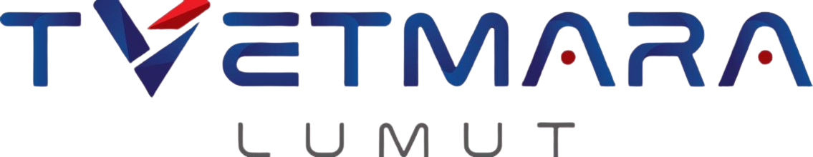
INSTITUT KEMAHIRAN MARA LUMUT
DIPLOMA IN COMPUTER TECHNOLOGY (BIG DATA)
DFD40143 – MOBILE APPLICATION DEVELOPMENT
PROJECT PROPOSAL
HYRA: AI-POWERED CAREER HUB

A Progressive Web Application for Students and Fresh Graduates

PREPARED BY: FAKHRULLAH BIN RASSUL
MATRIC NO: 2501083
LECTURER: MOHD SHUKRI BIN MUHAMAD HUSIN
SESSION: JULY – DECEMBER 2026

Table of Contents
Table of Contents 2
1. Introduction 4
2. Problem Identification 5
2.1 Background of the Problem 5
2.2 Current Issues Faced by Users 5
2.3 Why the Problem Needs to Be Solved 6
2.4 Project Objectives 6
3. Problem-Solving Process 7
3.1 Identify the Problem Factors 7
3.2 Data Analysis (Planned) 7
3.3 Application of Knowledge and Ideas 7
3.4 Information Collection 8
4. Decision Making 9
4.1 Alternative Solutions Considered 9
4.2 Comparison of Alternatives 9
4.3 Justification for the Proposed Solution 10
5. Concept Development 11
5.1 Brainstorming Process 11
5.2 System Concept 11
5.3 Proposed Workflow 11
5.4 Proposed System Architecture 12
6. Proposed Solution Design 13
6.1 System Design 13
6.2 Proposed User Interface Design 13
6.3 Proposed Database Design 14
6.4 Proposed Algorithms and Program Logic 15
7. Proposed Development Plan 16
7.1 Proposed Tools and Technologies 16
7.2 Proposed Development Timeline 16
7.3 Anticipated Challenges and Mitigation 17
8. Expected Outcome and Significance 18
8.1 Expected Outcome 18
8.2 Innovation and Originality 18
8.3 Expected Benefits to Users 18
9. Survey and User Feedback 19
9.1 Respondent Information (Section A) 19
9.2 Survey Question Results (Section B) 21
9.3 Analysis and Interpretation (Pending Survey Completion) 26
10. Conclusion 27
References 28
Appendices 29
Appendix A: Proposed Survey Questionnaire 29

1. Introduction
This proposal presents Hyra, an AI-powered career hub proposed for development as a Progressive Web Application (PWA) under the DFD40143 Mobile Application Development course. The name Hyra is derived from the word "hire", reflecting the application's mission, captured in its tagline: "Get Hired, Smarter." Hyra is designed to consolidate several career-preparation tools that currently exist as fragmented, separate services into one seamless, mobile-friendly workflow: an AI resume analyzer, a smart job-matching engine, an AI cover letter generator, and an AI mock interview simulator.
The project is motivated by the increasingly competitive nature of the graduate job market. Recruitment today is heavily automated, with most companies relying on Applicant Tracking Systems (ATS) to filter resumes before a human recruiter reviews them. Fresh graduates, who typically lack experience in resume optimization and interview preparation, are disproportionately screened out by these systems. Meanwhile, the tools that could help them exist as separate, often expensive subscription services priced beyond the reach of a typical Malaysian student.
This proposal outlines the background of the problem, the objectives of the project, the proposed solution and its underlying concept, the technologies to be applied, and the planned approach to developing and evaluating the system. The PWA platform was selected specifically because it allows the project to be built and deployed without the cost of publishing to the Google Play Store or Apple App Store, in accordance with the project's resource constraints.

2. Problem Identification

2.1 Background of the Problem
The process of applying for jobs has changed significantly over the past decade. Employers increasingly rely on automation to manage large volumes of applications, and ATS platforms have become the standard first gatekeeper in recruitment. A resume that is not formatted or keyworded appropriately is often rejected automatically, regardless of the candidate's actual ability. At the same time, the barrier to submitting applications has dropped, since candidates can apply to dozens of jobs quickly, which forces employers to filter even more aggressively. The result is a paradox in which applying has never been easier, but getting shortlisted has never been harder.

2.2 Current Issues Faced by Users
- Students and fresh graduates do not know whether their resumes can pass ATS screening, and receive no feedback when their applications are rejected.
- Writing an effective, tailored cover letter for every job application is time-consuming, so many candidates either skip it or submit a generic letter.
- Career tools are fragmented: job listings are on one platform, resume checking on another, and interview preparation on yet another, forcing users to juggle multiple websites and accounts.
- Existing AI career tools are mostly subscription services priced in US dollars, making them unaffordable for a typical Malaysian student.
- Fresh graduates struggle to identify which jobs actually match their skills, leading to poorly targeted applications and low success rates.
- Many graduates face interviews without any structured practice, resulting in anxiety and underperformance.

2.3 Why the Problem Needs to Be Solved
Graduate employability is a matter of national importance, and the transition from study to work is a critical period in which the right support has an outsized impact. If capable graduates are filtered out by automated hiring systems simply because they lack access to optimization tools, the underlying problem is one of access rather than ability. Solving it helps level the playing field, shortens the job-search period, and enables graduates to present their true potential to employers.

2.4 Project Objectives
- To design and develop a Progressive Web Application that combines resume analysis, job matching, cover letter generation, and interview preparation in a single platform.
- To integrate a Large Language Model (LLM) API to provide automated, actionable feedback on user resumes.
- To design a skill-based job matching algorithm that ranks job listings according to their relevance to the user's profile.
- To evaluate user acceptance and requirements for the proposed application through a user requirement survey prior to full development.

3. Problem-Solving Process

3.1 Identify the Problem Factors
The main contributing factors of the identified problem were analysed as follows:
- Automation gap: recruitment is automated (ATS, AI screening) but most candidates prepare their applications manually without any feedback loop.
- Knowledge gap: fresh graduates are rarely taught resume optimization, keyword targeting, or interview technique as part of their formal studies.
- Fragmentation: the tools that address each part of the problem exist in isolation, with no integrated workflow connecting resume, job, letter, and interview preparation.
- Cost barrier: established platforms charge premium subscription fees targeted at working professionals in Western markets, not students.

3.2 Data Analysis (Planned)
To validate the problem and gather user requirements, a user requirement survey will be conducted via Google Forms prior to development. The questionnaire will consist of two sections: Section A will collect respondent demographic information (country of origin, age, gender, occupation, app topic of interest, and app intent), while Section B will contain ten questions measuring respondents' current job-seeking behaviour, their confidence in their resumes and interview readiness, and their interest in the proposed features of Hyra. A minimum of 70 responses will be collected and analysed to confirm the demand for each proposed feature before development proceeds.

3.3 Application of Knowledge and Ideas
The development of Hyra will apply the following concepts, technologies, and techniques learned throughout the programme:
- Progressive Web Application (PWA) concepts: web app manifest, service workers, and responsive mobile-first design, allowing the app to be installed on a mobile device without an app store.
- Client-server architecture and RESTful API design: the frontend will communicate with the backend exclusively through structured JSON endpoints.
- Large Language Model integration and prompt engineering: prompts will be designed to instruct the LLM to return structured feedback (scores, strengths, weaknesses, and keyword suggestions) that the application can parse and display.
- Text processing and information retrieval: resume text will be extracted from PDF files, cleaned, and compared against job descriptions using keyword extraction and similarity scoring to produce a match percentage.
- Relational database design: user profiles, resumes, job listings, and subscription status will be stored in normalised relational tables with defined relationships.

3.4 Information Collection
Information to support this proposal was collected through several methods. First, a case study review of an existing mobile application, JobStreet by SEEK, was conducted to understand the strengths and weaknesses of the current market-leading platform in Malaysia. Second, preliminary research into existing AI career tools and official technical documentation (React, FastAPI, PostgreSQL, and the Gemini API) informed the selection of technologies proposed in this document. The planned user requirement survey (Section 3.2) will supplement this with direct, quantitative evidence from the target user group.

4. Decision Making
Several alternative solutions were considered before arriving at the proposed solution. The alternatives were evaluated in two areas: the application platform and the AI service provider.

4.1 Alternative Solutions Considered
- Alternative 1: A native Android application developed in Kotlin.
- Alternative 2: A cross-platform mobile application developed in Flutter.
- Alternative 3: A Progressive Web Application developed in React (proposed).

4.2 Comparison of Alternatives
Table 4.1: Comparison of application platform alternatives
Criteria | Native Android (Kotlin) | Flutter | React PWA (Proposed)
Cross-platform support | Android only | Android, iOS, Web | Any device with a browser
Installation | Play Store required | App store required | Installable directly from browser
Development speed | Slow | Moderate | Fast
Deployment cost | Google Play fee + review | App store fees + review | No publishing fee, instant deployment
Suitability for a one-semester project | Moderate | Moderate | High

Table 4.2: Comparison of AI service alternatives
Criteria | OpenAI API | Google Gemini API (Proposed)
Free tier availability | Limited / trial credit | Generous free tier
Cost for student project | Paid per token | Free within quota
Text quality for resume tasks | Excellent | Excellent
Ease of integration (Python) | Simple SDK | Simple SDK

4.3 Justification for the Proposed Solution
The React Progressive Web Application is proposed because it satisfies the project's mobile application requirement while offering the fastest development cycle, no app store publishing cost, and compatibility with any device. This is particularly important given the project's one-semester timeline and lack of budget for Google Play or Apple Developer Program fees. FastAPI (Python) is proposed for the backend because Python provides mature libraries for PDF text extraction and natural language processing, and FastAPI offers high performance with automatic API documentation. PostgreSQL is proposed as the database for its reliability and strong support for relational data. The Google Gemini API is proposed as the AI provider primarily because its free tier is expected to fully cover the development and demonstration needs of this project at zero cost.

5. Concept Development

5.1 Brainstorming Process
The concept for Hyra began with an analysis of the job application journey of a typical fresh graduate. The journey was broken down into four stages: preparing a resume, finding suitable jobs, applying with a cover letter, and attending interviews. During brainstorming, each stage was examined for its pain points, and existing tools that address each pain point were studied. The key insight from this process was that the value of the application lies not in any single feature, since each feature already exists separately in the market, but in connecting them into one continuous workflow driven by a single source of truth: the user's resume.

5.2 System Concept
Hyra is designed around a "resume-first funnel". The user uploads their resume once. The AI analyses it and extracts the user's skill profile. That skill profile then powers every other module: the job matching engine ranks listings against it, the cover letter generator combines it with a selected job description, and the mock interview simulator generates questions relevant to the target role. This concept ensures that every output of the application is personalised to the individual user without requiring repeated data entry.

5.3 Proposed Workflow
The proposed overall workflow of the application is illustrated in the flowchart below.
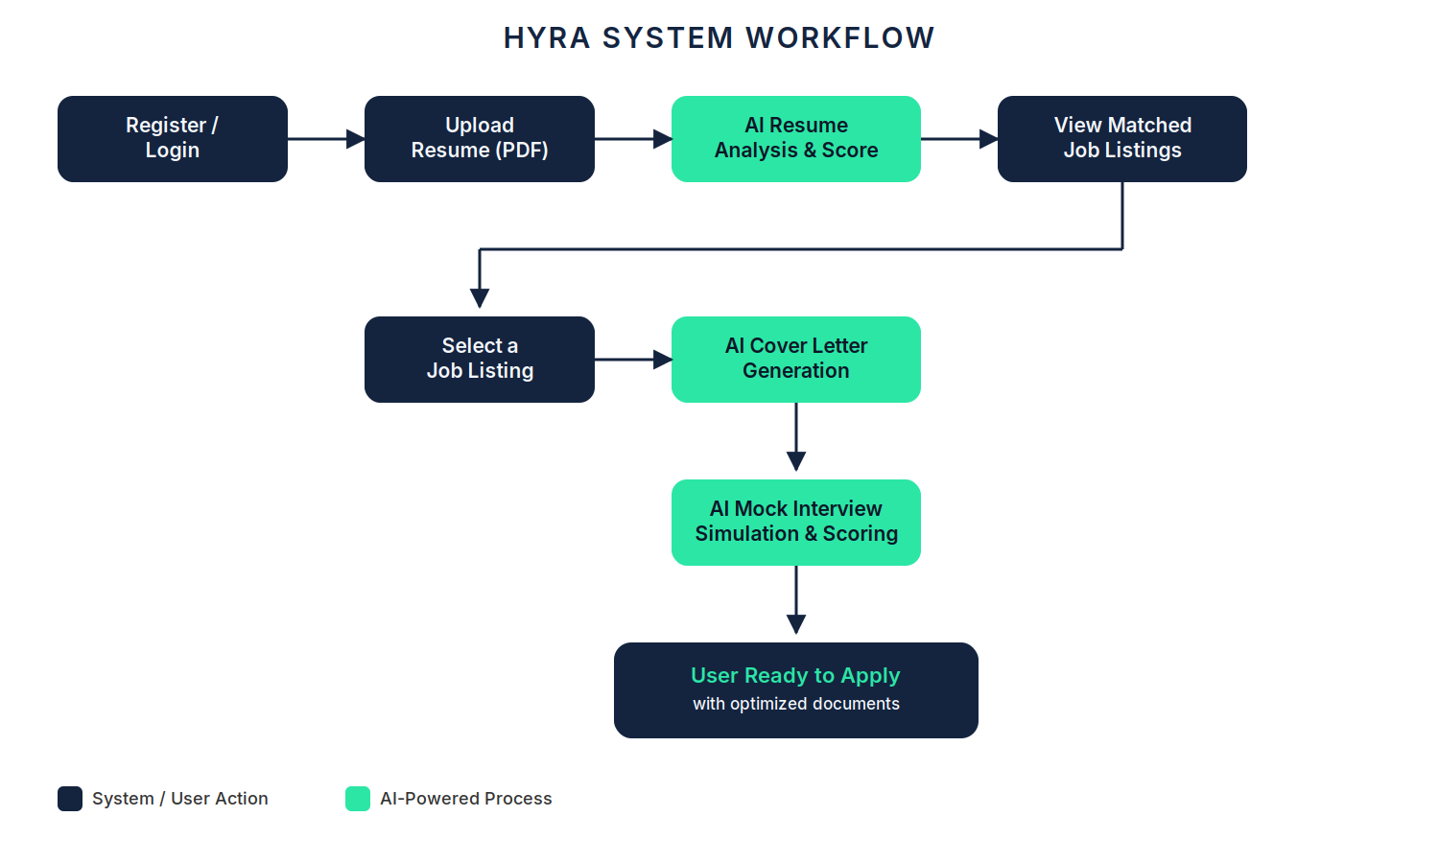
Figure 5.1: Proposed Hyra system flowchart

5.4 Proposed System Architecture
Hyra is proposed to follow a three-tier client-server architecture. The presentation tier is the React Progressive Web Application running in the user's browser. The application tier is the FastAPI backend, which will contain all business logic, including the resume processing pipeline, the matching engine, and the integration layer that communicates with the external Gemini API. The data tier is the PostgreSQL database, which will store user accounts, resumes and extracted skill profiles, job listings, and subscription status. The proposed architecture is illustrated below.
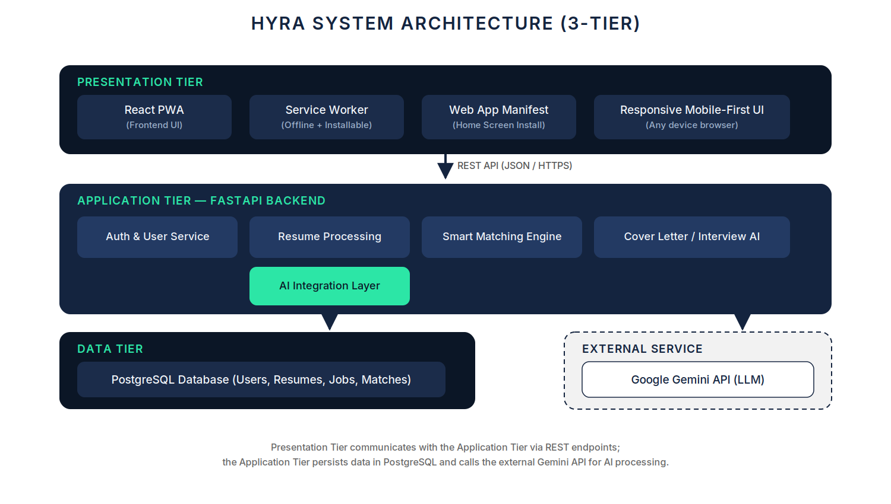
Figure 5.2: Proposed Hyra three-tier system architecture

6. Proposed Solution Design

6.1 System Design
The system is proposed to be organised into six functional modules:
- User Management Module – registration, login, authentication, and profile management.
- Resume Analyzer Module – PDF upload, text extraction, AI analysis, scoring, and feedback display.
- Job Listing Module – storage and display of job postings with search and filter functions.
- Smart Matching Module – computation of a match percentage between the user's skill profile and each job listing.
- Cover Letter Generator Module – AI generation of a tailored cover letter from the user's resume and a selected job description.
- Mock Interview Module – AI-driven, text-based interview simulation with scoring and feedback.
A subscription tier component is also proposed to control feature limits, distinguishing Free users (limited number of AI analyses per day) from Premium users (unlimited AI features).

6.2 Proposed User Interface Design
The user interface is proposed to follow a mobile-first design language consistent with the Hyra brand identity: a dark navy base colour, mint green accents for actions and success states, and the Space Grotesk typeface for headings. Screens are planned to keep each task to a single focused view with minimal input required from the user. Wireframes and screen mock-ups for the main screens will be placed below once designed.
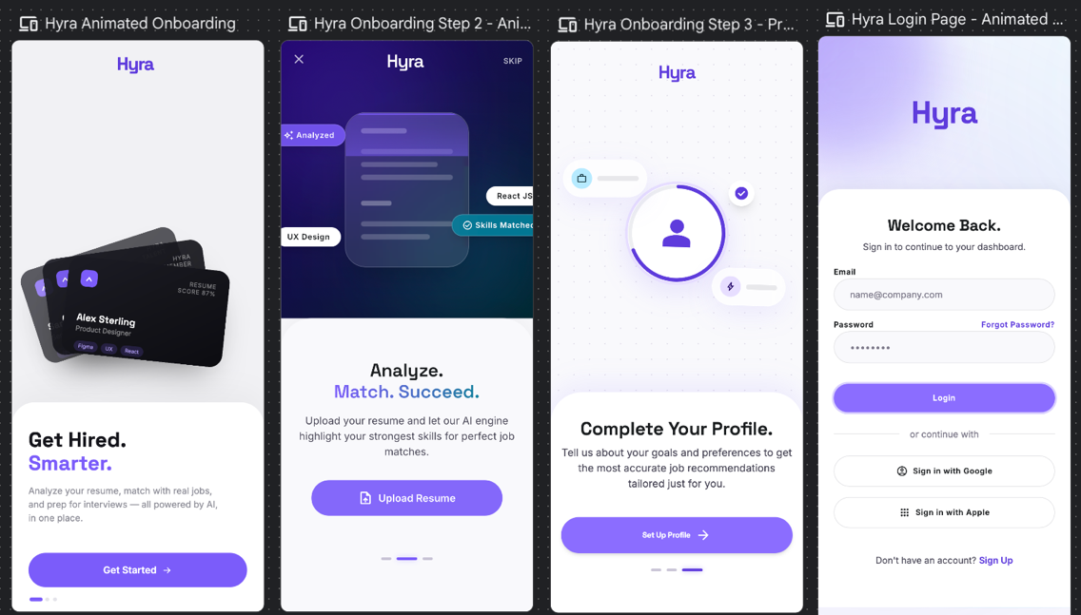
Figure 6.1: Proposed user interface wireframes (to be finalised during design phase)

6.3 Proposed Database Design
The database is proposed to consist of five main entities. The users table will store account credentials and subscription status. The resumes table will store each uploaded resume, its extracted text, its AI score, and the extracted skill profile. The job_listings table will store job postings with their titles, companies, descriptions, and required skills. The match_results table will store the computed match percentage between a resume and a job listing. The interview_sessions table will store mock interview transcripts and scores. The proposed relationships between these entities are shown in the conceptual Entity Relationship Diagram below.
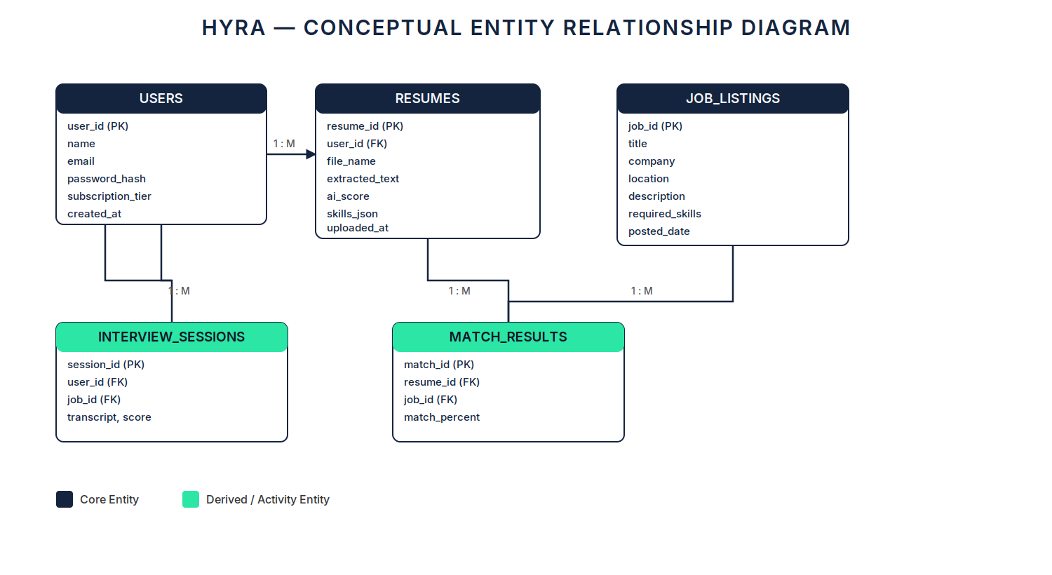
Figure 6.2: Proposed conceptual Entity Relationship Diagram (ERD) of the Hyra database
Table 6.1: Summary of proposed database tables
Table | Key Fields | Relationship
users | user_id (PK), name, email, password_hash, tier, created_at | 1 user : many resumes
resumes | resume_id (PK), user_id (FK), file_name, extracted_text, ai_score, skills_json | 1 resume : many match_results
job_listings | job_id (PK), title, company, location, description, required_skills, posted_date | 1 job : many match_results
match_results | match_id (PK), resume_id (FK), job_id (FK), match_percent, computed_at | Bridge table
interview_sessions | session_id (PK), user_id (FK), job_id (FK), transcript, score, created_at | 1 user : many sessions

6.4 Proposed Algorithms and Program Logic
Resume analysis pipeline: when a resume is uploaded, the backend will extract the raw text from the PDF file, clean it, and send it to the Gemini API together with a structured prompt requesting a JSON response containing an overall score, identified strengths, identified weaknesses, and suggested keywords. The parsed response will be stored in the database and rendered in the user interface.
Smart matching algorithm: the skills extracted from the user's resume and the required skills of each job listing will be converted into normalised keyword sets and vector representations. The similarity between the two will be computed using cosine similarity, and the result scaled to a percentage. Jobs will then be presented to the user ranked from highest to lowest match. This module represents the application of Big Data text-processing techniques within the project.
Cover letter generation: the user's extracted resume profile and the selected job description will be combined into a single prompt instructing the LLM to produce a concise, personalised cover letter referencing the user's actual skills and the specific job requirements, avoiding generic template phrasing.
Mock interview logic: the system will prompt the LLM to act as an interviewer for the selected job, asking five questions one at a time. After the final answer, the full transcript will be sent for evaluation, and the LLM will return a score with feedback for each answer, to be stored in the interview_sessions table.

7. Proposed Development Plan

7.1 Proposed Tools and Technologies
Table 7.1: Proposed development tools and technologies
Category | Details
Programming languages | JavaScript (React frontend), Python (FastAPI backend), SQL (database)
Frontend | React with Vite, PWA manifest and service worker, CSS
Backend | FastAPI, pdfplumber (PDF text extraction), Google Gemini API SDK
Database | PostgreSQL (SQLite for early development)
Software tools | Visual Studio Code, Google Chrome DevTools, Postman, Git and GitHub
Hardware | MacBook Air (Apple M4) development machine; standard Android/iOS smartphones for PWA testing

7.2 Proposed Development Timeline
The project is planned to be completed within a three-month semester timeline, structured into three development phases as summarised below.
Table 7.2: Proposed project timeline (Gantt-style overview)
Phase | Key Activities | Month 1 | Month 2 | Month 3
Phase 1 | Proposal, survey, project foundation: database schema, authentication, PWA shell | ✓
Phase 2 | Core AI pipeline: resume upload, analysis, smart matching, cover letter generator |  | ✓
Phase 3 | Mock interview module, subscription tiers, UI refinement, testing, report & presentation |  |  | ✓

7.3 Anticipated Challenges and Mitigation
- Inconsistent PDF resume formats may cause text extraction errors. Mitigation: clean extracted text and use the LLM itself as a fallback extractor for complex layouts.
- The AI may occasionally return inconsistently formatted responses. Mitigation: strict prompt engineering requiring a JSON-only response with a fixed schema, validated by the backend.
- API free-tier rate limits could be exceeded during testing. Mitigation: implement a daily usage limit per user, which will also form the technical basis of the Free versus Premium subscription tiers.
- Live job data aggregation from platforms such as LinkedIn is restricted by their terms of service. Mitigation: seed the database with real job postings collected manually to ensure a stable, dependency-free demonstration.

8. Expected Outcome and Significance

8.1 Expected Outcome
Upon completion, Hyra is expected to be a fully functional Progressive Web Application demonstrating an integrated career-preparation workflow: a working AI resume analyzer, a seeded job-listing database with skill-based match scoring, an AI cover letter generator, and a text-based AI mock interview simulator, supported by a working Free/Premium tier distinction.

8.2 Innovation and Originality
The originality of Hyra lies not in inventing a new individual tool, but in the integration, localisation, and accessibility of its solution.
- Integrated resume-first workflow: unlike existing platforms where resume checking, job searching, cover letters, and interview practice are separate products, Hyra connects them into one pipeline powered by a single resume upload.
- Match-aware content generation: cover letters and interview questions are intended to be generated with awareness of both the user's actual resume and the specific selected job, producing personalised output rather than generic templates.
- Localisation for Malaysian students: existing AI career tools are priced in US dollars for Western professionals. Hyra is designed for the Malaysian student market, with an affordable RM-denominated freemium model to be validated by survey data.

8.3 Expected Benefits to Users
- Improved resume quality and higher likelihood of passing ATS screening.
- Reduced time and effort spent on job applications through automated, personalised document generation.
- Increased interview confidence through structured, repeatable practice.
- Access to AI-assisted career tools at an affordable price point suited to students.

9. Survey and User Feedback
A user requirement survey will be conducted using Google Forms to gather feedback from potential users and validate the proposed features of Hyra prior to full development. The questionnaire consists of Section A (respondent information) and Section B (ten survey questions), as detailed in Appendix A. A minimum of 70 responses will be collected. This section reserves the space for the survey results, charts, and analysis that will be completed once data collection is finished.

9.1 Respondent Information (Section A)
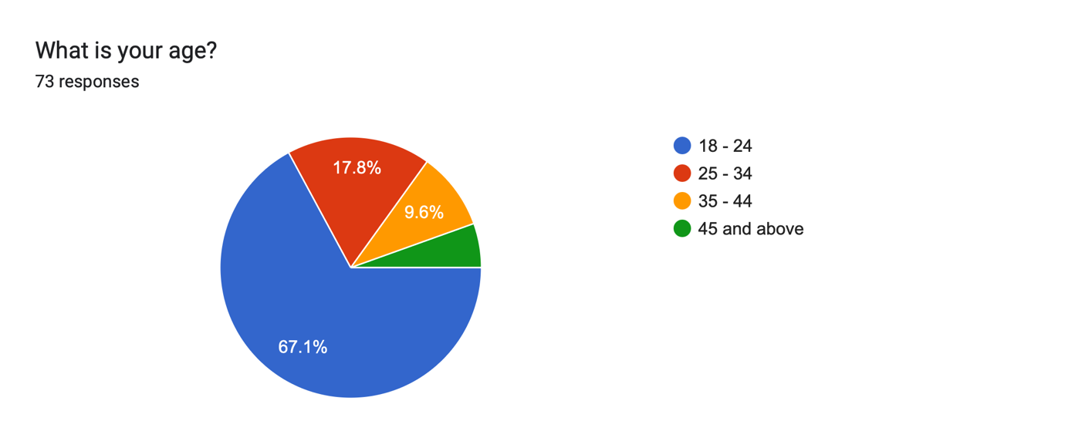
Figure 9.2: Respondents' age
Most respondents (67.1%) are expected to be aged between 18 and 24, representing the student and fresh graduate demographic that Hyra targets.
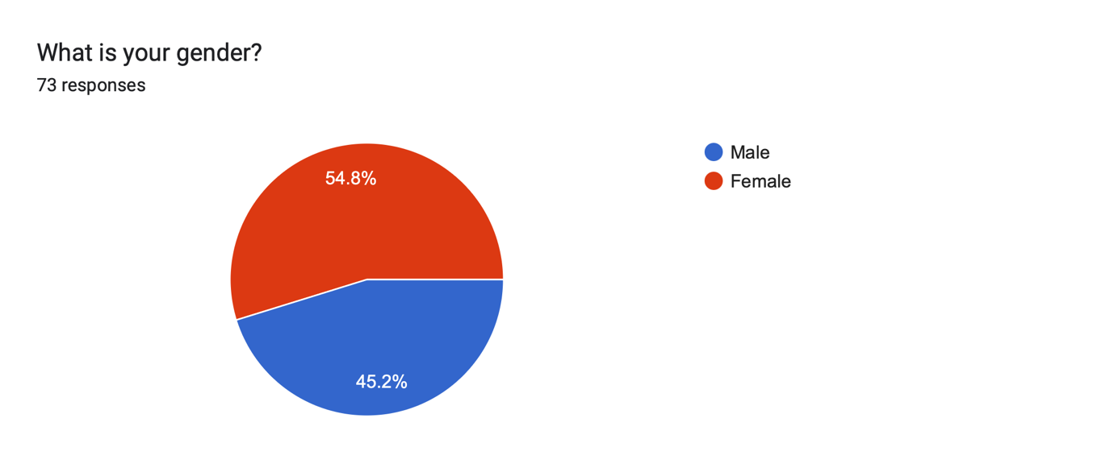
Figure 9.3: Respondents' gender
The respondents are expected to consist of approximately 45.2% male and 54.8% female participants.
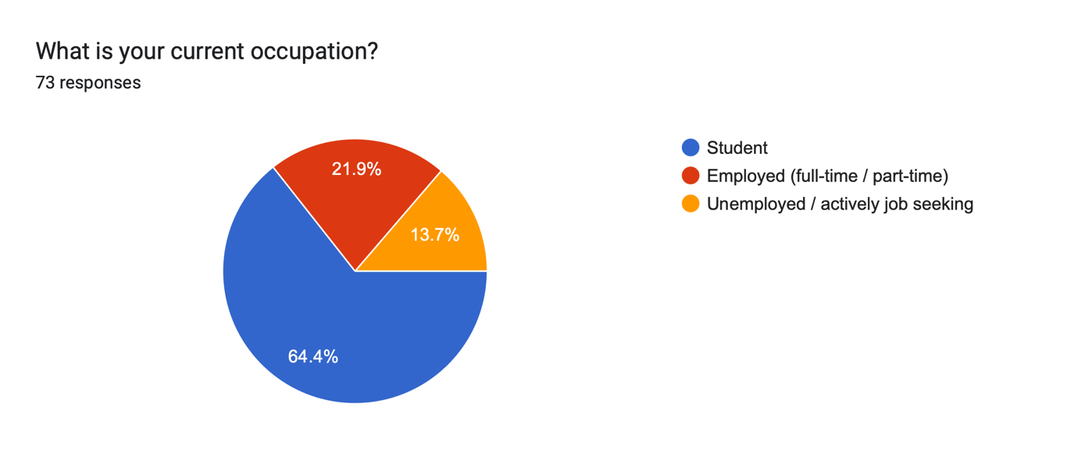
Figure 9.4: Respondents' occupation
64.4% of respondents are expected to be students, confirming that the survey reaches the intended target user group.
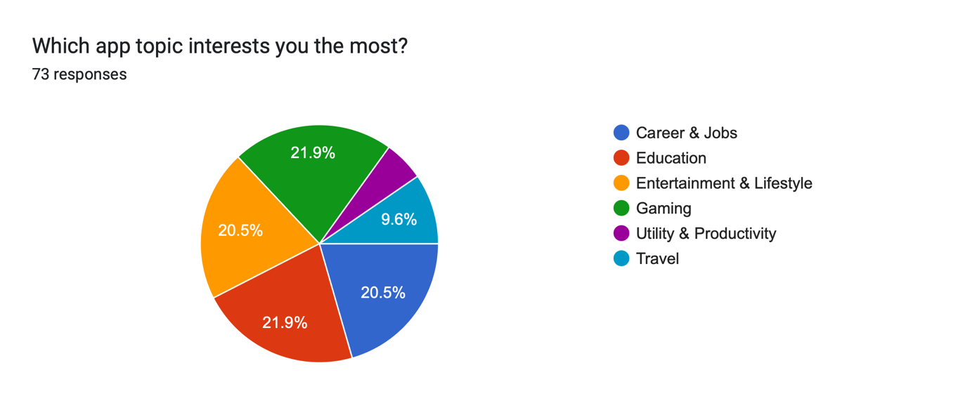
Figure 9.5: Respondents' app topic of interest
Career and jobs are expected to emerge as a highly selected topic of interest at 20.5%, indicating natural demand for a career-focused application within this demographic.
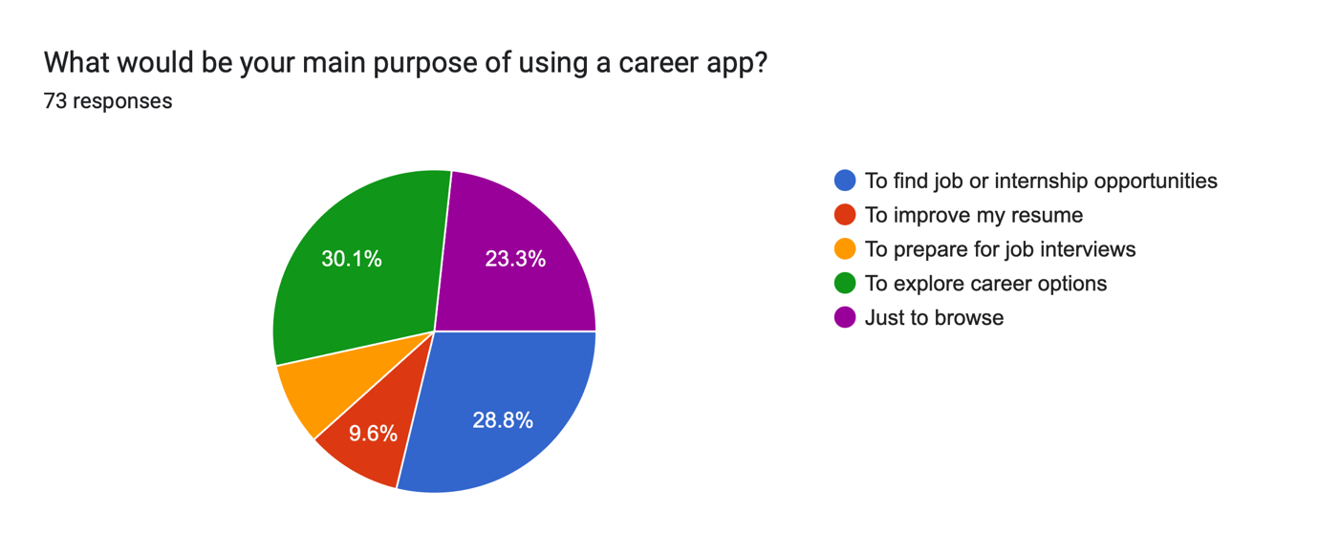
Figure 9.6: Respondents' app intent (purpose of using the app)
The most common intent is expected to be [finding job or internship opportunities] at 28.8%, followed by [improving my resume] at 9.6%.

9.2 Survey Question Results (Section B)
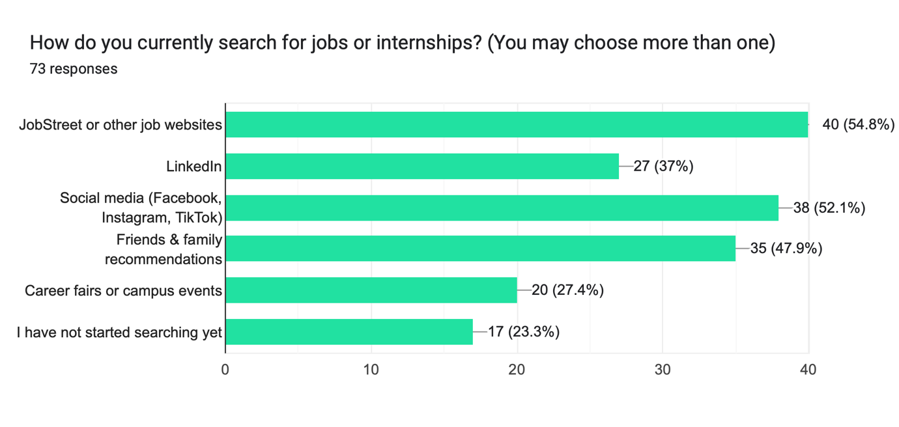
Figure 9.7: How do you currently search for jobs or internships?
The results are expected to show that [JobStreet / social media / LinkedIn] is the most common channel at 54.8%, while 23.3% have not started searching yet, confirming that respondents rely on fragmented channels with no preparation support.
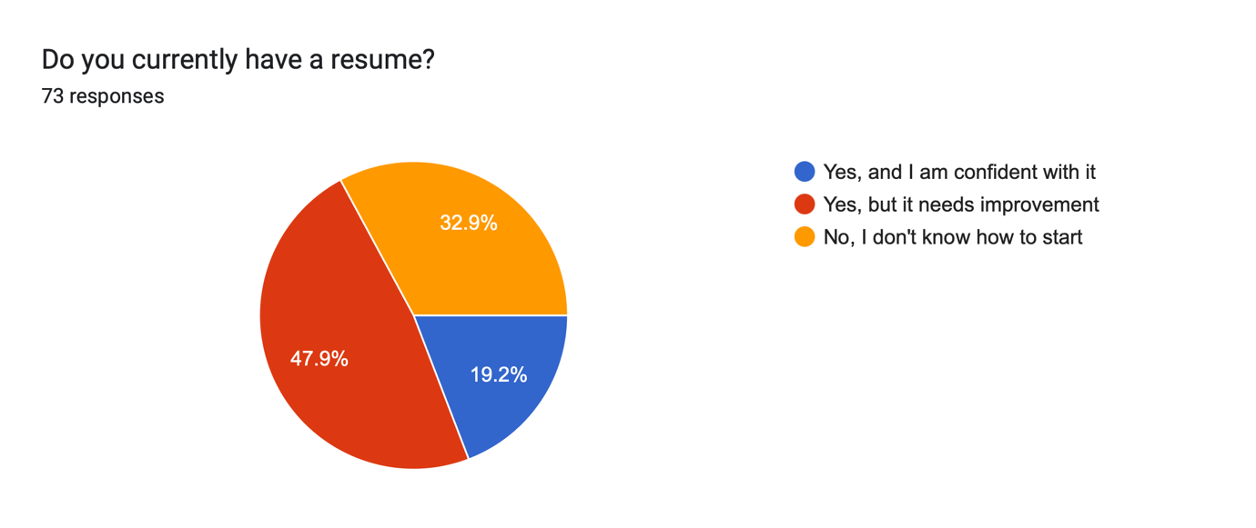
Figure 9.8: Do you currently have a resume?
It is expected that only 19.2% of respondents will be confident with their current resume, while 47.9% state it needs improvement and 32.9% do not know how to start — directly validating the need for the AI Resume Analyzer module.
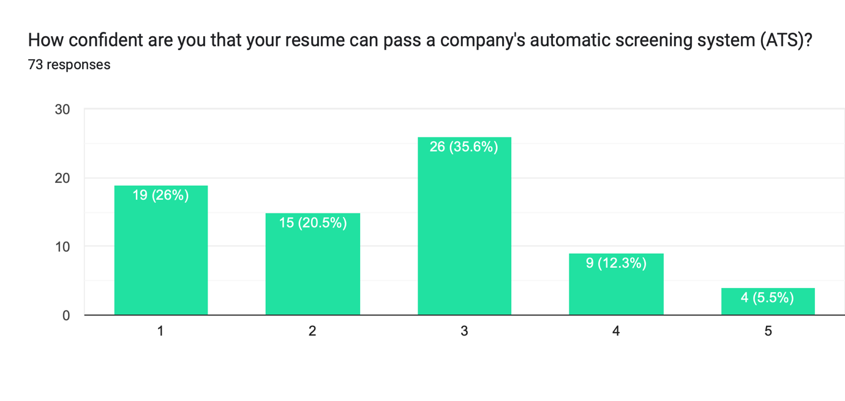
Figure 9.9: How confident are you that your resume can pass ATS screening?
A majority of respondents (46.5%) are expected to rate their confidence at only 1-2 out of 5, showing widespread awareness that their resumes may not survive automated screening.
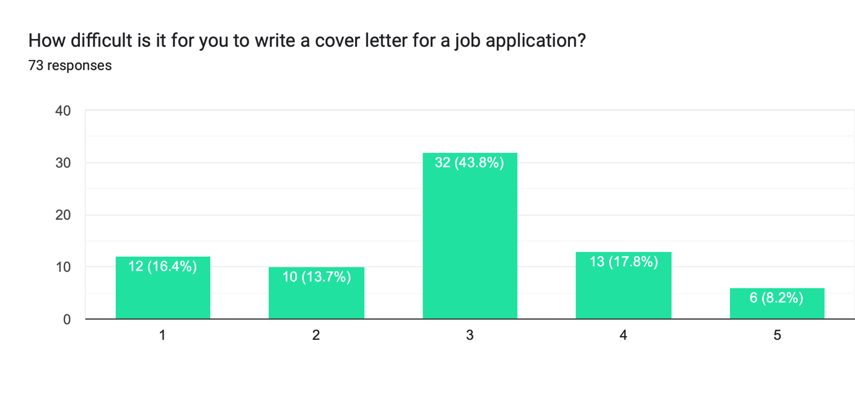
Figure 9.10: How difficult is it for you to write a cover letter?
26% of respondents are expected to rate cover letter writing as difficult (4-5 out of 5), supporting the inclusion of the AI Cover Letter Generator.
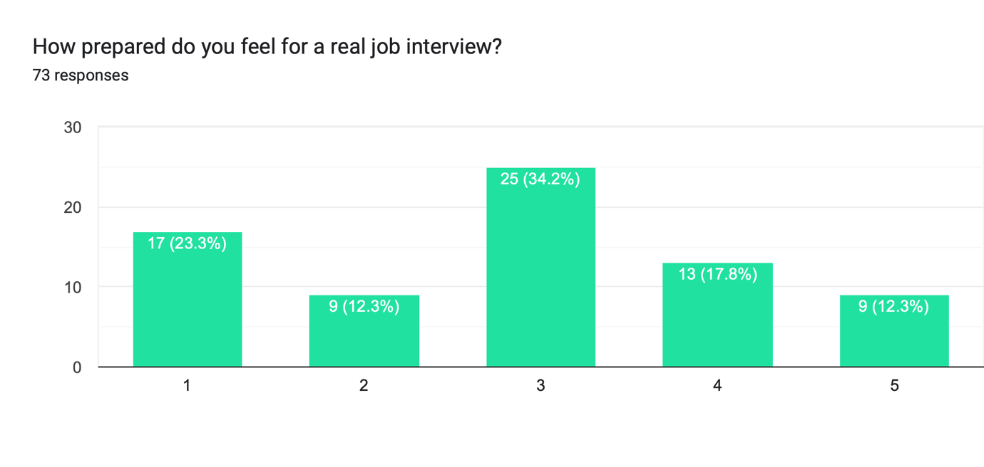
Figure 9.11: How prepared do you feel for a real job interview?
Only 30.1% of respondents are expected to feel prepared for a real job interview (4-5 out of 5), demonstrating the need for structured interview practice.
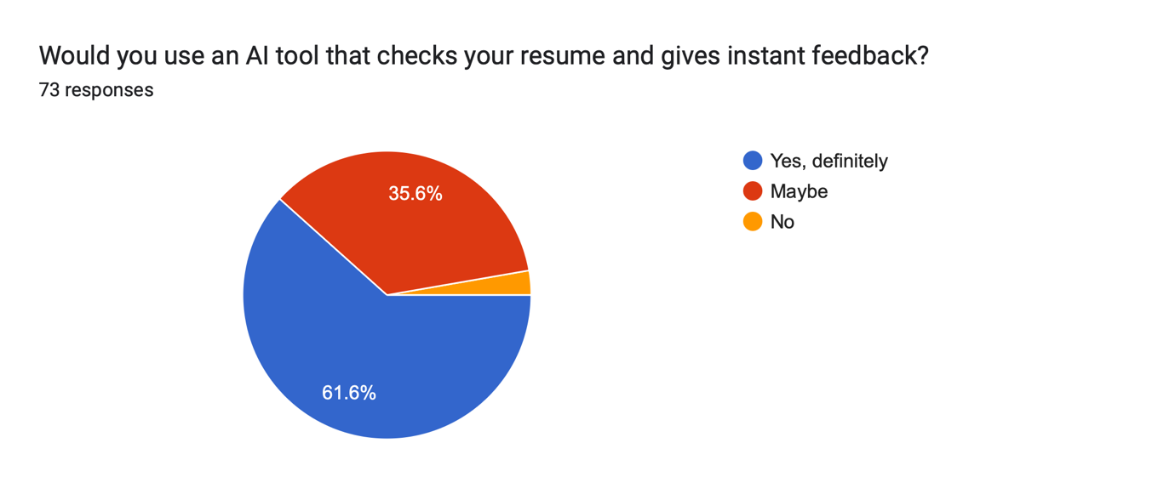
Figure 9.12: Would you use an AI tool that checks your resume and gives instant feedback?
61.6% are expected to answer "Yes, definitely" and a further 35.6% "Maybe", indicating strong anticipated acceptance of the application's core feature.
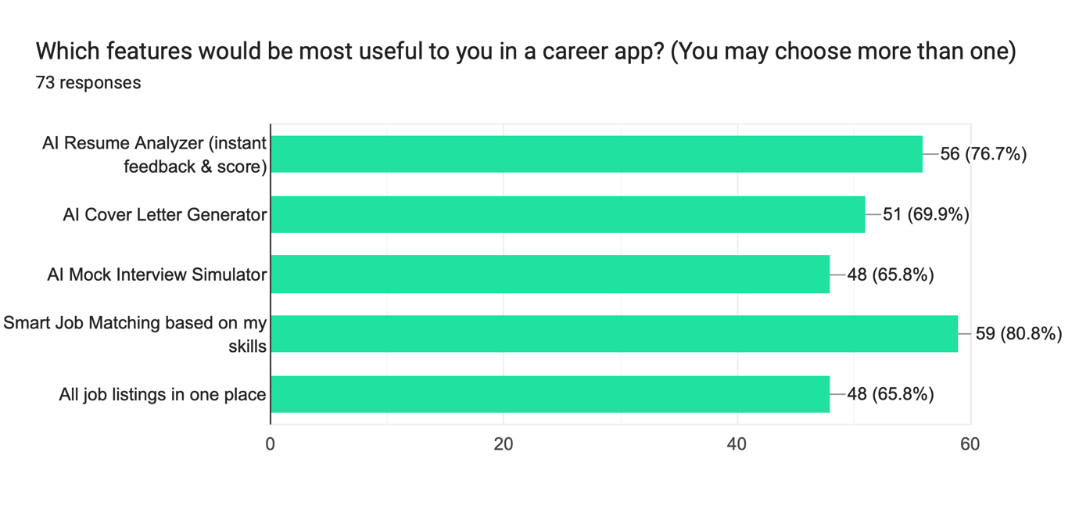
Figure 9.13: Which features would be most useful to you in a career app?
The most requested feature is expected to be Smart Job Matching based on skill at 80.8%, followed by AI Resume Analyzer at 76.7%, with all five proposed features expected to receive meaningful demand.
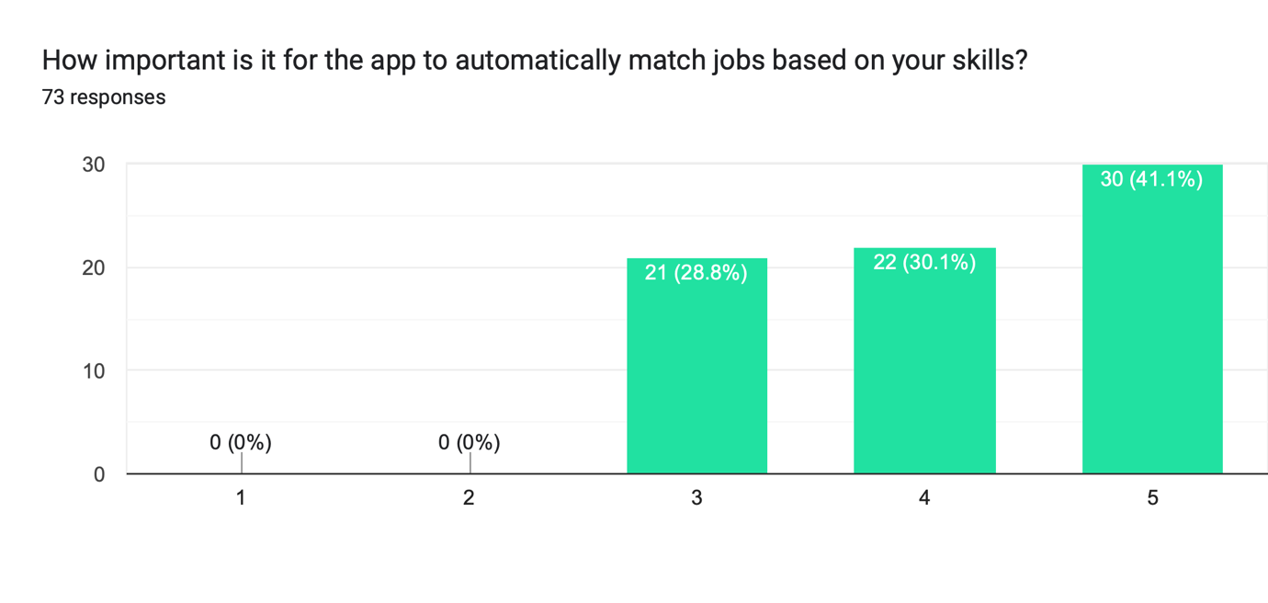
Figure 9.14: How important is it for the app to automatically match jobs based on your skills?
71.2% of respondents are expected to rate automatic skill-based matching as important (4-5 out of 5), validating the Smart Matching module as a priority feature.
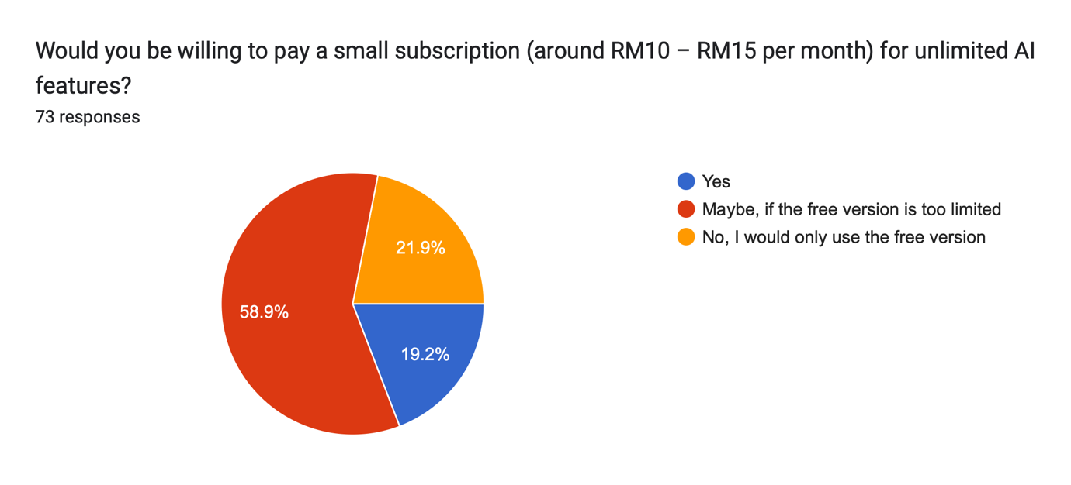
Figure 9.15: Would you be willing to pay a small subscription (RM10-RM15/month) for unlimited AI features?
19.2% of respondents are expected to be willing to pay RM10-RM15 monthly, and 58.9% would consider it if the free version is limited, supporting the viability of the freemium subscription model.
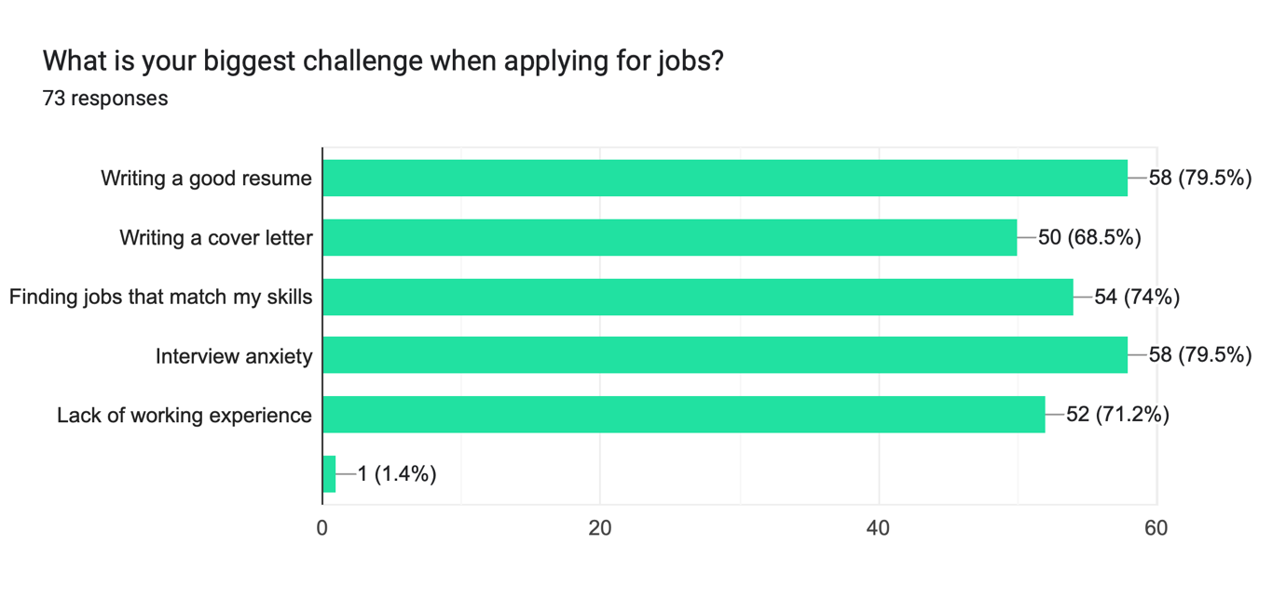
Figure 9.16: What is your biggest challenge when applying for jobs?
The most cited challenge is expected to be Interview Anxiety & Writing a Good Resume at 79.5%. Every major challenge identified is anticipated to correspond directly to a module implemented in Hyra.

9.3 Analysis and Interpretation (Pending Survey Completion)
Once the survey results above are populated, this subsection will summarise the key patterns across respondent demographics and feature demand, and explain how the findings validate the problem statement and the proposed feature set described in Sections 2 and 6 of this proposal. Overall user acceptance and willingness to adopt the freemium subscription model will also be reported here.

10. Conclusion
This proposal has presented Hyra, an AI-powered career hub to be developed as a Progressive Web Application, addressing a real and growing problem: capable students and fresh graduates are being filtered out of the modern, automated hiring process because they lack access to the tools needed to compete in it.
The proposed solution unifies resume analysis, skill-based job matching, cover letter generation, and mock interview practice into a single seamless workflow, built using React, FastAPI, PostgreSQL, and the Google Gemini API. A user requirement survey will be conducted to validate the problem and the proposed feature set prior to full development. If approved, the project will proceed according to the three-phase development plan outlined in Section 7, culminating in a functional demonstration and a complete project report documenting the implementation, testing, and survey findings.

References
- FastAPI. (n.d.). FastAPI documentation. Retrieved July 18, 2026, from https://fastapi.tiangolo.com/
- Google. (n.d.). Gemini API documentation. Google AI for Developers. Retrieved July 18, 2026, from https://ai.google.dev/gemini-api/docs
- Meta Open Source. (n.d.). React documentation. Retrieved July 18, 2026, from https://react.dev/
- Mozilla. (n.d.). Progressive web apps. MDN Web Docs. Retrieved July 18, 2026, from https://developer.mozilla.org/en-US/docs/Web/Progressive_web_apps
- PostgreSQL Global Development Group. (n.d.). PostgreSQL documentation. Retrieved July 18, 2026, from https://www.postgresql.org/docs/
- SEEK. (n.d.). JobStreet Malaysia. Retrieved July 18, 2026, from https://www.jobstreet.com.my/
- Jobscan. (n.d.). What is an applicant tracking system (ATS)? Retrieved July 18, 2026, from https://www.jobscan.co/applicant-tracking-systems

Appendices

Appendix A: Proposed Survey Questionnaire
Section A: Respondent Information
- Country of origin
- Age
- Gender
- Occupation
- App topic of interest
- App intent (purpose of using the app)

Section B: Survey Questions (10 items)
- How do you currently search for jobs or internships?
- Do you currently have a resume?
- How confident are you that your resume can pass a company's automatic screening system (ATS)?
- How difficult is it for you to write a cover letter for a job application?
- How prepared do you feel for a real job interview?
- Would you use an AI tool that checks your resume and gives instant feedback?
- Which features would be most useful to you in a career app?
- How important is it for the app to automatically match jobs based on your skills?
- Would you be willing to pay a small subscription (around RM10–RM15 per month) for unlimited AI features?
- What is your biggest challenge when applying for jobs?

