Greg S.  
5/30/21  
Foundations of Programming: Python  
Assignment 08

https://github.com/verttiig0/IntroToProg-Python-Mod08

Python Classes

# Introduction

For assignment 08, I will be using the provided Python starter script for that demostrates the uses of classes. I will be updating that script with additional functions and code to ask the user for a new product and price and then save the data to a file. Once the script completed, I will upload it to a Github repository using Github Desktop.

## Classes

Python classes are used to group together functions. Using functions and classes helps make your code more re-usable. The functions in the classes are called methods and the variables are called fields. If your method is not going to be reinstansciated multiple times, then it is called a Static Method and a “@staticmethod” is placed before the function definition (see Figure 1).

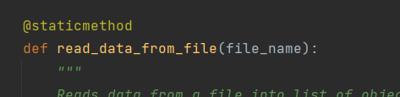

Figure 1 Static Method in a Class

Objects  
When you load a class into memory, you can call that class multiple times by creating an object instance. These objects are all in different memory locations but are all defined by that original class, so they look and feel the same.

### DocStrings

DocStrings are the header in a function that gives the user more information about the script/class/function (See Figure 2). You can also view the docstring by using the builtin property “__doc__”.

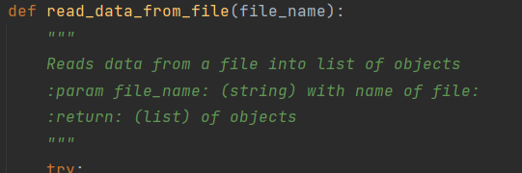

Figure 2 Function DocString

#### Script

I used PyCharm to create a new project and saved the location to C:\_PythonClass\Assingment08. After creating the project, I copied the starter script to the same folder as well as the products.txt to hold the data. The script loads the data from the file, prints a menu, and then asks the user to choose an option. One option is to show what data is currently being held and another for adding a new product and price to that data. Finally, there is a third option to save the data to a file and exit. After completing the file I executed the script within PyCharm (see Figure 3).

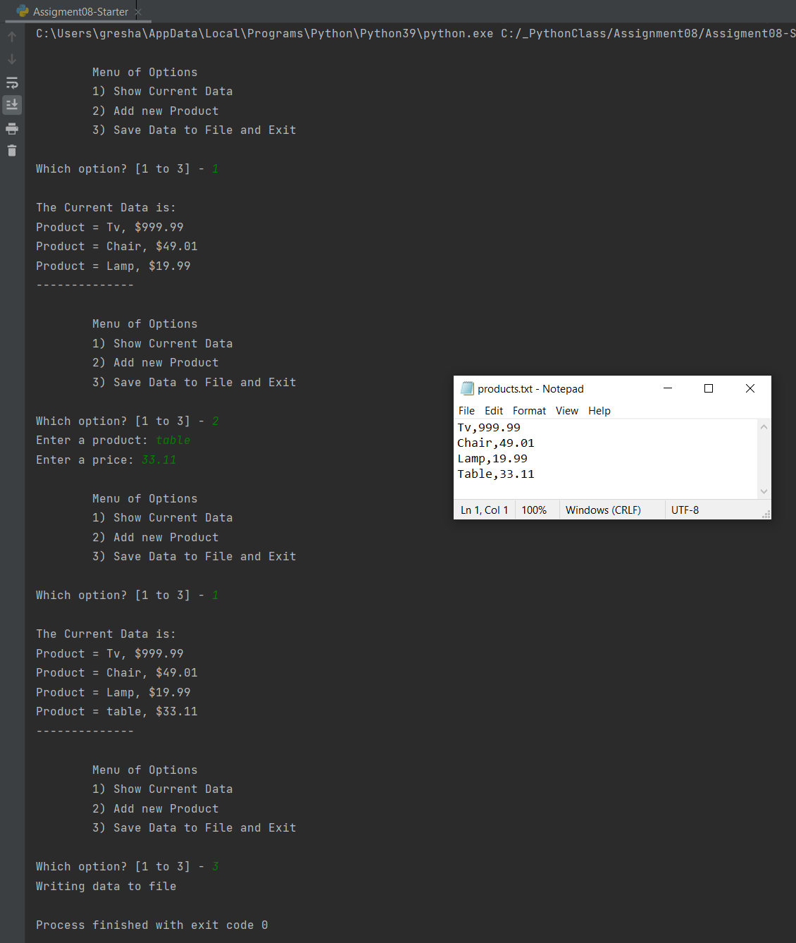

Figure 3 PyCharm Script Results

I also ran the script from the command line (see Figure 4).

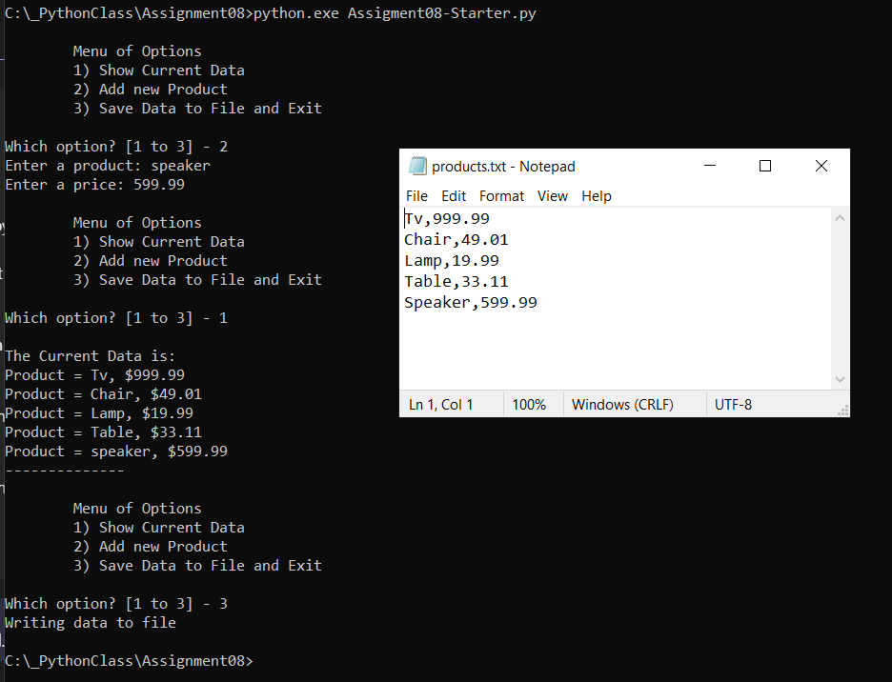

Figure 4 Command Line Results

### Github Desktop

For this assignment we were tasked with using Github Desktop to work with our Github repository. After downloading and installing the GitHub Desktop program, I created a new repository called “IntroToProg-Python-Mod08” and added a local path of “C:\_PythonClass\Github (see Figure 5).

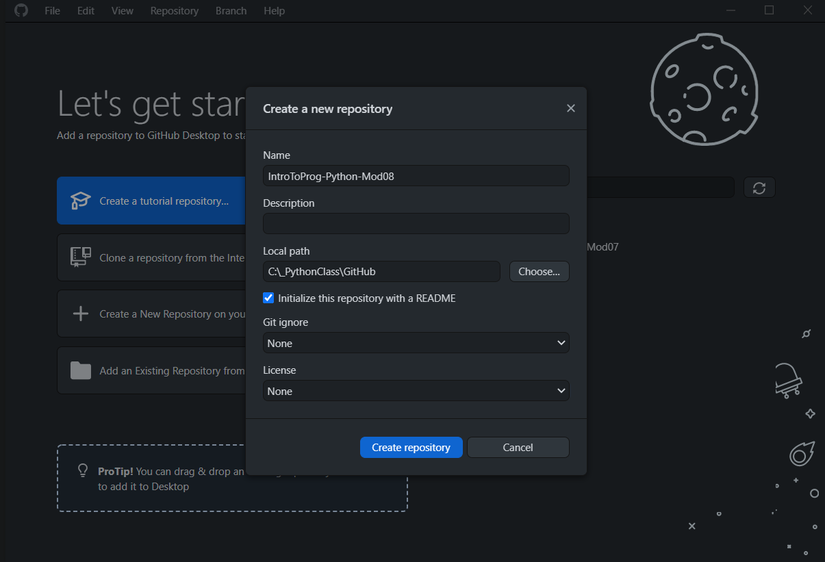

Figure 5 Github Desktop Repository

Once the repository was created need to publish it to Github inorder for the repository to change from a local to a Github repository (see Figure 6).

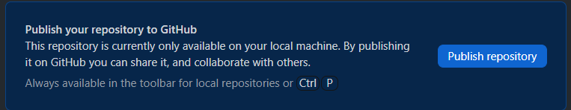

Figure 6 Publishing Repository in Github Desktop

After publising the repository, I copied the script and data file into the local Github folder. I used the referesh to make Github Desktop aware of the new changes and then added a comment before commiting the files to the repository (see Figure 7). Once the files were commited they needed to be pushed up to the Github repository.

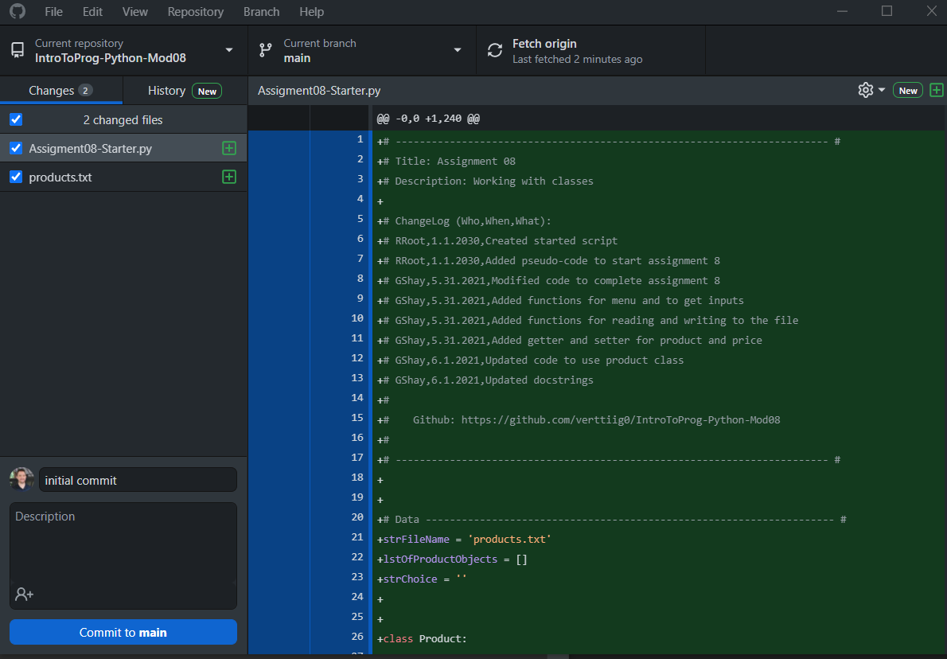

Figure 7 Commiting Changes in Github Desktop

After commiting the files to the main branh and pushing the changes, I verified the files were accessable on the main Github webpage (see Figure 8)

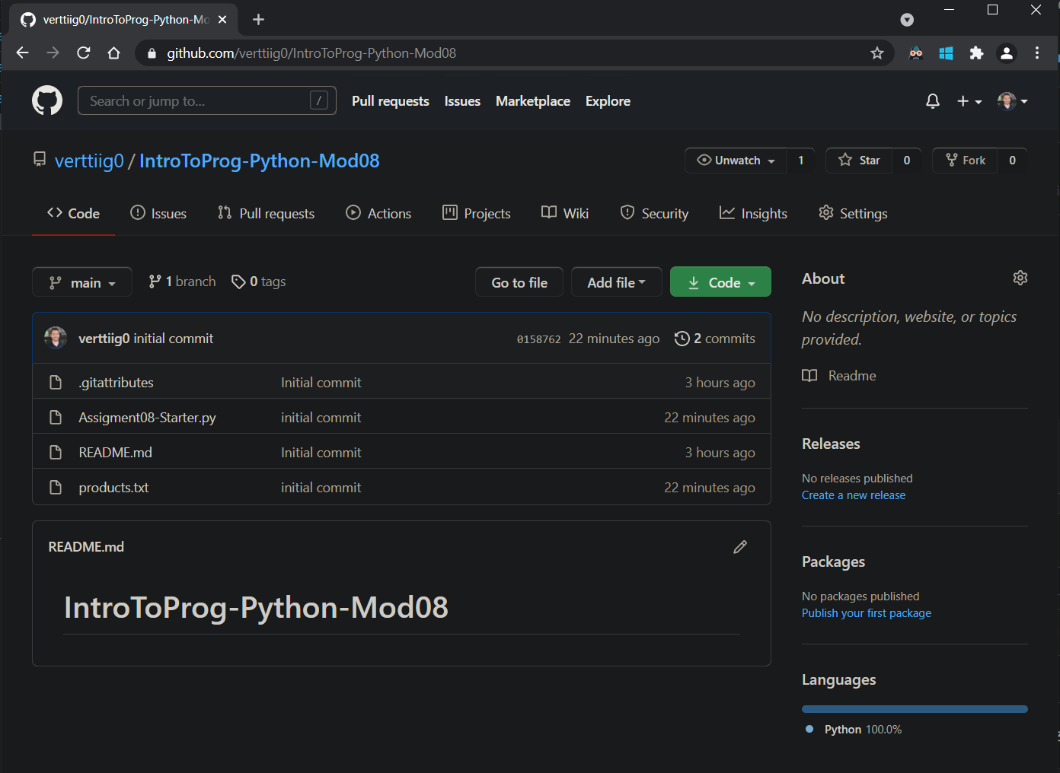

Figure 8 Github Repository

#### Summary

In this assignment we learned more about classes and how they are used to group function. Classes can also be used to create objects, like having a bluprint. We also learned how to work with a repository using Github Desktop.