Operating expense review
Fictional evaluation document with a table and an embedded inspection label.

Current period summary
Record identifier: TEST-DOCX-03
Issue date: 2026-09-13
Current reporting period: 2026-Q3
Currency: USD
Net total for current period: 1516
Approved total for current period: 1591

Allocation schedule
Description | Period | Amount
Service allocation | 2026-Q3 | 1316
Materials allocation | 2026-Q3 | 200
Inspection label
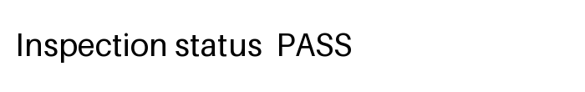
Historical comparison: 2025-Q3; total 8900 JPY. Excluded from current totals.

