H-eduware — End-to-End Simulation Test Report
10 student queries, captured live through the local app (agent + simulation).
Each section: (1) agent trace, (2) spec document, (3) completed simulation image.

Query: "아두이노와 LED로 LED 켜는 회로 만들어줘" (01-led)

1. Agent trace
Response kind: circuit
Assistant: 아두이노 D13으로 LED를 켜는 기본 회로를 만들었어요. LED는 220Ω 저항과 직렬로 연결했고, GND로 돌아가는 닫힌 경로도 포함했습니다.
Events:
- [coordinator] deepagents-coordinator — completed: Created structured circuit draft through Deepagents.
- [coordinator] requirement-analysis-agent — completed: synthesize_circuit: 아두이노 디지털 출력으로 5mm LED를 220Ω 저항과 직렬로 연결해 켜는 초보자용 저전압 회로 요청입니다.
- [tool] validate_circuit_spec — completed: Recovered completed validate_circuit_spec tool call from Deepagents message history.
- [validation] context-coverage-gate — completed: sufficient
- [validation] server-validator — completed: valid
- [validation] build-runnable-gate — completed: runnable
Context trace (sources):
- memory:agent-operating-memory
- policy:safety-policy
- policy:simulation-truthfulness-policy
- bundle:digital-light-output
- sources:support-bundle:digital-light-output
- data:capability-graph:digital-light-output
- registry:part-capabilities:arduino-uno
- registry:part-capabilities:breadboard-half
- registry:part-capabilities:led-5mm
- registry:part-capabilities:resistor-220

2. Spec document (simulation spec)
Title: 아두이노 LED 켜기 회로
Goal: 아두이노로 LED를 켜는 교육용 회로를 만든다
Components:
- arduino-uno — Arduino Uno
- breadboard-half — Half Breadboard
- led-5mm — LED
- resistor-220 — 220Ω Resistor
Connections: 4
Build runnable: yes (runnable)
Requirement document:
# Project Requirement: 아두이노 LED 켜기 회로

_Status: valid_

_Simulation: valid_

_Build runnable: runnable_

## Goal

아두이노로 LED를 켜는 교육용 회로를 만든다

## Parts Needed

- Arduino Uno (arduino-uno)
- Half Breadboard (breadboard-half)
- LED (led-5mm)
- 220Ω Resistor (resistor-220)

## What It Should Do

아두이노 D13을 HIGH로 두면 220Ω 저항을 거쳐 LED가 켜지고, LOW로 두면 꺼진다.

## Connections

- **c1**: u1:D13 -> r1:1
- **c2**: r1:2 -> led1:A
- **c3**: led1:K -> u1:GND
- **c4**: u1:GND -> bb1:- rail

## Current Flow

- LED forward current: about 13.6 mA from u1:D13 to u1:GND

## Safety And Validation Notes

- None

## Assumptions

- Arduino Uno의 5V 로직을 사용한다
- LED는 일반 5mm LED 한 개를 사용한다
- 220Ω 저항은 LED와 직렬로 연결한다
- 브레드보드는 배선 정리용으로 사용한다

3. Completed simulation
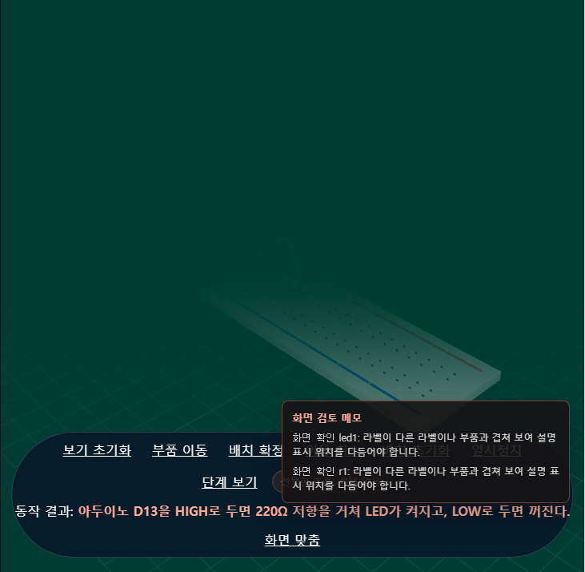

Query: "버튼으로 LED 켜는 회로 만들어줘" (02-button-led)

1. Agent trace
Response kind: circuit
Assistant: 버튼을 누를 때 LED가 켜지는 회로로 만들 수 있어요. Arduino Uno, 버튼, LED, 220Ω 저항, 브레드보드로 구성했습니다.
Events:
- [coordinator] deepagents-coordinator — completed: Created structured circuit draft through Deepagents.
- [coordinator] requirement-analysis-agent — completed: synthesize_circuit: 버튼을 누르면 LED가 켜지는 Arduino 기반 저전압 회로 요청으로 해석됨.
- [tool] validate_circuit_spec — completed: Recovered completed validate_circuit_spec tool call from Deepagents message history.
- [tool] assess_request_scope — completed: Recovered completed assess_request_scope tool call from Deepagents message history.
- [validation] context-coverage-gate — completed: sufficient
- [validation] server-validator — completed: valid
- [validation] build-runnable-gate — completed: runnable
Context trace (sources):
- memory:agent-operating-memory
- policy:safety-policy
- policy:simulation-truthfulness-policy
- registry:part-capabilities
- simulation:primitives
- rendering:render-footprints
- bundle:button-controlled-light-output
- sources:support-bundle:digital-light-output
- sources:support-bundle:button-controlled-light-output
- data:capability-graph:digital-light-output
- data:capability-graph:button-controlled-light-output
- data:simulation-primitives:digital_on_off
- data:simulation-primitives:current_flow_animation
- rendering:render-footprint:arduino
- rendering:render-footprint:breadboard
- rendering:render-footprint:button
- rendering:render-footprint:led
- rendering:render-footprint:resistor
- rendering:render-footprint:wire
- registry:part-capabilities:arduino-uno
- registry:part-capabilities:breadboard-half
- registry:part-capabilities:led-5mm
- registry:part-capabilities:button-tactile
- registry:part-capabilities:resistor-220

2. Spec document (simulation spec)
Title: 버튼으로 LED 켜기
Goal: 버튼을 누를 때 LED를 켜는 교육용 회로를 만든다
Components:
- arduino-uno — Arduino Uno
- breadboard-half — Breadboard
- button-tactile — Tactile Button
- led-5mm — LED
- resistor-220 — 220 Ohm Resistor
Connections: 7
Build runnable: yes (runnable)
Requirement document:
# Project Requirement: 버튼으로 LED 켜기

_Status: valid_

_Simulation: valid_

_Build runnable: runnable_

## Goal

버튼을 누를 때 LED를 켜는 교육용 회로를 만든다

## Parts Needed

- Arduino Uno (arduino-uno)
- Breadboard (breadboard-half)
- Tactile Button (button-tactile)
- LED (led-5mm)
- 220 Ohm Resistor (resistor-220)

## What It Should Do

Arduino는 버튼 입력(D2)을 읽어 버튼이 눌리면 D13 출력을 HIGH로 올려 LED를 켜고, 버튼이 떼지면 LOW로 내려 LED를 끕니다.

## Connections

- **c1**: arduino1:5V -> breadboard1:+ rail
- **c2**: arduino1:GND -> breadboard1:- rail
- **c3**: arduino1:D2 -> button1:A
- **c4**: button1:B -> arduino1:GND
- **c5**: arduino1:D13 -> res1:1
- **c6**: res1:2 -> led1:A
- **c7**: led1:K -> arduino1:GND

## Current Flow

- LED forward current: about 13.6 mA from arduino1:D13 to arduino1:GND

## Safety And Validation Notes

- None

## Assumptions

- Arduino Uno는 5V 로직을 사용한다.
- 버튼 입력은 내부 풀업/풀다운을 쓰지 않고 외부 기준 연결이 필요하므로, 버튼 한쪽을 GND에 연결하는 기본 예제로 구성한다.
- LED에는 220Ω 직렬 저항을 사용한다.

3. Completed simulation
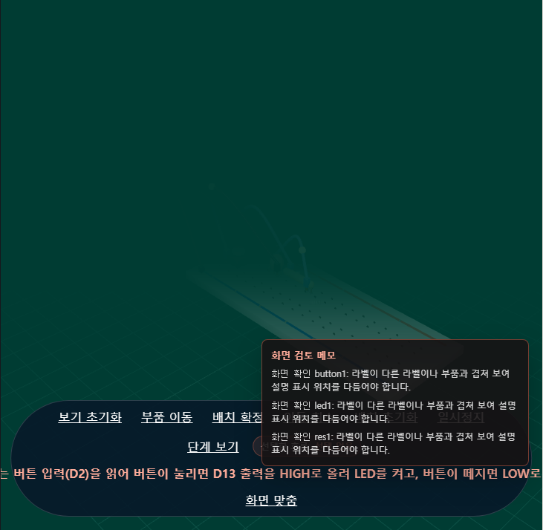

Query: "조도센서로 어두우면 LED 켜는 회로 만들어줘" (03-light-sensor)

1. Agent trace
Response kind: circuit
Assistant: 조도센서로 어두우면 LED가 켜지는 회로로 만들 수 있어요. Arduino Uno 기준으로, 조도센서의 AO를 A0에 연결하고 D9로 LED를 제어하는 구성입니다. 원하시면 제가 이어서 이 회로의 아두이노 코드까지 같이 적어드릴게요.
Events:
- [coordinator] deepagents-coordinator — completed: Created structured circuit draft through Deepagents.
- [coordinator] requirement-analysis-agent — completed: synthesize_circuit: 조도센서(LDR)로 주변이 어두워지면 LED가 켜지는 아두이노 기반 저전압 회로를 요청함.
- [tool] validate_circuit_spec — completed: Recovered completed validate_circuit_spec tool call from Deepagents message history.
- [validation] context-coverage-gate — completed: sufficient
- [validation] server-validator — completed: valid
- [validation] build-runnable-gate — completed: runnable
Context trace (sources):
- memory:agent-operating-memory
- policy:safety-policy
- policy:simulation-truthfulness-policy
- registry:part-capabilities
- simulation:primitives
- rendering:render-footprints
- bundle:light-sensor-triggered-output
- sources:support-bundle:digital-light-output
- sources:support-bundle:light-sensor-triggered-output
- data:capability-graph:digital-light-output
- data:capability-graph:light-sensor-triggered-output
- data:simulation-primitives:analog_threshold
- data:simulation-primitives:digital_on_off
- data:simulation-primitives:current_flow_animation
- rendering:render-footprint:arduino
- rendering:render-footprint:breadboard
- rendering:render-footprint:ldr-module
- rendering:render-footprint:led
- rendering:render-footprint:resistor
- rendering:render-footprint:wire
- registry:part-capabilities:arduino-uno
- registry:part-capabilities:breadboard-half
- registry:part-capabilities:led-5mm
- registry:part-capabilities:resistor-220
- registry:part-capabilities:photoresistor-ldr

2. Spec document (simulation spec)
Title: 어두우면 LED 켜지는 조도센서 회로
Goal: 주변이 어두워지면 LED를 켠다
Components:
- arduino-uno — Arduino Uno
- breadboard-half — Breadboard
- photoresistor-ldr — LDR 조도센서 모듈
- resistor-220 — 220Ω 저항
- led-5mm — LED
Connections: 6
Build runnable: yes (runnable)
Requirement document:
# Project Requirement: 어두우면 LED 켜지는 조도센서 회로

_Status: valid_

_Simulation: valid_

_Build runnable: runnable_

## Goal

주변이 어두워지면 LED를 켠다

## Parts Needed

- Arduino Uno (arduino-uno)
- Breadboard (breadboard-half)
- LDR 조도센서 모듈 (photoresistor-ldr)
- 220Ω 저항 (resistor-220)
- LED (led-5mm)

## What It Should Do

아두이노가 A0에서 조도센서 값을 읽어 어두움이 감지되면 D9를 HIGH로 바꿔 LED를 켜고, 밝아지면 LED를 끈다.

## Connections

- **c1**: u1:5V -> ldr1:VCC
- **c2**: u1:GND -> ldr1:GND
- **c3**: u1:A0 -> ldr1:AO
- **c4**: u1:D9 -> r1:1
- **c5**: r1:2 -> led1:A
- **c6**: led1:K -> u1:GND

## Current Flow

- LDR light sensor module sensing divider: sensing divider from u1:5V to u1:GND
- LDR light sensor module analog signal: signal activity from ldr1:AO to u1:A0
- LED forward current: about 13.6 mA from u1:D9 to u1:GND

## Safety And Validation Notes

- None

## Assumptions

- Arduino Uno 5V 저전압 교육용 회로로 구성한다.
- 조도센서 모듈의 AO 출력은 A0에 연결한다.
- 어두움 판정은 간단한 임계값 비교로 구현한다.

3. Completed simulation
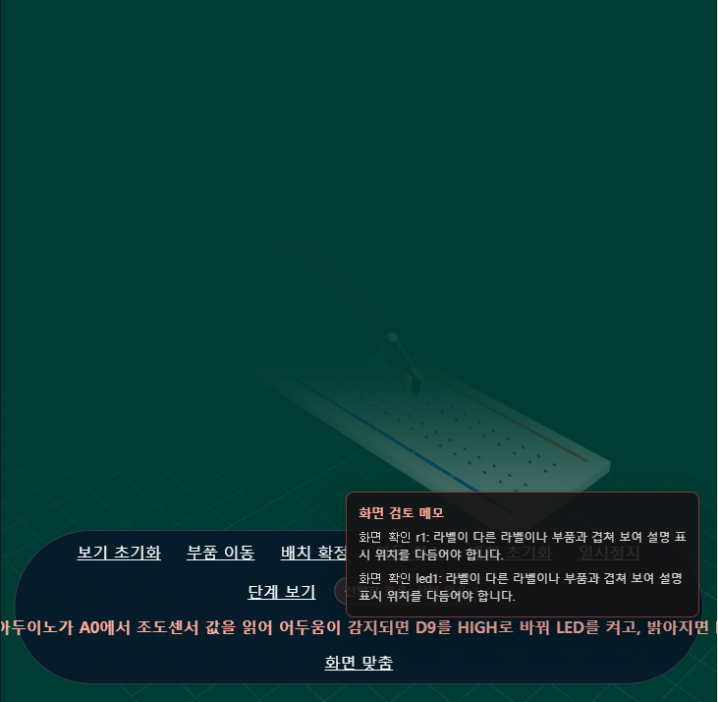

Query: "초음파센서로 거리를 OLED에 표시하는 회로 만들어줘" (04-ultrasonic)

1. Agent trace
Response kind: circuit
Assistant: 아직 이 회로를 안전하게 확정할 수 없어요. 회로 검증에서 현재 요청 범위에 포함되지 않은 부품이 초안에 들어간 문제가 확인됐습니다. 다음 단계: 회로를 안전하게 확정하려면 입력, 출력, 전원 조건을 조금 더 알려주세요.
Events:
- [coordinator] deepagents-coordinator — completed: Created structured circuit draft through Deepagents.
- [coordinator] requirement-analysis-agent — completed: synthesize_circuit: Context coverage is sufficient for circuit synthesis.
- [tool] assess_request_scope — completed: Recovered completed assess_request_scope tool call from Deepagents message history.
- [tool] search_part_capabilities — completed: Recovered completed search_part_capabilities tool call from Deepagents message history.
- [tool] validate_circuit_spec — completed: Recovered completed validate_circuit_spec tool call from Deepagents message history.
- [validation] context-coverage-gate — completed: sufficient
- [validation] server-validator — warning: invalid
- [validation] build-runnable-gate — warning: blocked
Context trace (sources):
- memory:agent-operating-memory
- policy:safety-policy
- policy:simulation-truthfulness-policy
- registry:part-capabilities
- simulation:primitives
- rendering:render-footprints
- bundle:digital-input-display-readout
- sources:support-bundle:analog-sensor-display-readout
- sources:support-bundle:display-text-output
- sources:support-bundle:digital-input-display-readout
- sources:support-bundle:distance-sensor-display
- data:capability-graph:analog-sensor-display-readout
- data:capability-graph:display-text-output
- data:capability-graph:digital-input-display-readout
- data:capability-graph:distance-sensor-display
- data:simulation-primitives:digital_input_state
- data:simulation-primitives:display_static_text
- data:simulation-primitives:current_flow_animation
- rendering:render-footprint:arduino
- rendering:render-footprint:breadboard
- rendering:render-footprint:oled
- rendering:render-footprint:wire
- registry:part-capabilities:arduino-uno
- registry:part-capabilities:breadboard-half
- registry:part-capabilities:oled-i2c-096

2. Spec document (simulation spec)
Title: 초음파 센서 거리 OLED 표시
Goal: 초음파센서의 거리 값을 아두이노가 읽어 OLED에 표시한다
Components:
- arduino-uno — Arduino Uno
- breadboard-half — Half-size breadboard
- oled-i2c-096 — 0.96 inch I2C OLED
- ultrasonic-hc-sr04 — HC-SR04 Ultrasonic Sensor
Connections: 10
Build runnable: no (blocked)
Requirement document:
# Project Requirement: 초음파 센서 거리 OLED 표시

_Status: invalid_

_Simulation: invalid_

_Build runnable: blocked_

## Goal

초음파센서의 거리 값을 아두이노가 읽어 OLED에 표시한다

## Parts Needed

- No build-ready parts. Resolve validation status `invalid`, simulation status `invalid`, and runnable gate status `blocked` before treating this as a parts list. Build runnable gate blocked this draft: validation status is invalid DISTANCE_SENSOR_ECHO_MISSING: HC-SR04 Ultrasonic Sensor ECHO must connect to an Arduino digital input such as D2. CONTEXT_CANDIDATE_PART_NOT_ALLOWED: ultrasonic-hc-sr04 was not selected by the current context route and cannot be used in this circuit draft. simulation status is invalid CONTEXT_CANDIDATE_PART_WARNING: Circuit drafts may only use parts selected by the current ContextPacket candidateParts.

## What It Should Do

아두이노가 HC-SR04의 TRIG를 짧게 펄스하고 ECHO 시간을 읽어 거리를 계산한 뒤, OLED에 cm 단위로 표시한다.

## Connections

- No build-ready wiring. Resolve validation status `invalid`, simulation status `invalid`, and runnable gate status `blocked` before treating this as a wiring guide. Build runnable gate blocked this draft: validation status is invalid DISTANCE_SENSOR_ECHO_MISSING: HC-SR04 Ultrasonic Sensor ECHO must connect to an Arduino digital input such as D2. CONTEXT_CANDIDATE_PART_NOT_ALLOWED: ultrasonic-hc-sr04 was not selected by the current context route and cannot be used in this circuit draft. simulation status is invalid CONTEXT_CANDIDATE_PART_WARNING: Circuit drafts may only use parts selected by the current ContextPacket candidateParts.

## Current Flow

- Current-flow details are hidden until the runnable gate passes. Current runnable gate status: `blocked`. Build runnable gate blocked this draft: validation status is invalid DISTANCE_SENSOR_ECHO_MISSING: HC-SR04 Ultrasonic Sensor ECHO must connect to an Arduino digital input such as D2. CONTEXT_CANDIDATE_PART_NOT_ALLOWED: ultrasonic-hc-sr04 was not selected by the current context route and cannot be used in this circuit draft. simulation status is invalid CONTEXT_CANDIDATE_PART_WARNING: Circuit drafts may only use parts selected by the current ContextPacket candidateParts.

## Safety And Validation Notes

- DISTANCE_SENSOR_ECHO_MISSING: HC-SR04 Ultrasonic Sensor ECHO must connect to an Arduino digital input such as D2.
- CONTEXT_CANDIDATE_PART_NOT_ALLOWED: ultrasonic-hc-sr04 was not selected by the current context route and cannot be used in this circuit draft.
- CONTEXT_CANDIDATE_PART_WARNING: Circuit drafts may only use parts selected by the current ContextPacket candidateParts.
- CONTEXT_CANDIDATE_PART_WARNING: Circuit drafts may only use parts selected by the current ContextPacket candidateParts.
- validation status is invalid
- DISTANCE_SENSOR_ECHO_MISSING: HC-SR04 Ultrasonic Sensor ECHO must connect to an Arduino digital input such as D2.
- CONTEXT_CANDIDATE_PART_NOT_ALLOWED: ultrasonic-hc-sr04 was not selected by the current context route and cannot be used in this circuit draft.
- simulation status is invalid
- CONTEXT_CANDIDATE_PART_WARNING: Circuit drafts may only use parts selected by the current ContextPacket candidateParts.

## Assumptions

- HC-SR04는 5V로 동작하는 초음파 거리 센서로 가정한다.
- 센서와 OLED는 아두이노와 공통 GND를 사용한다.
- OLED는 I2C 주소가 일반적인 SSD1306 계열로 가정한다.

3. Completed simulation
(no simulation image — this turn did not build a runnable circuit)

Query: "온습도센서로 온도와 습도를 OLED에 표시하는 회로 만들어줘" (05-dht11)

1. Agent trace
Response kind: chat
Assistant: 온습도센서 종류를 하나 정해 주세요.
예: **DHT11로 OLED에 온도/습도를 표시하는 회로**로 만들까요?
Events:
- [coordinator] deepagents-coordinator — completed: Answered conversationally — no circuit synthesis this turn.
Context trace (sources):
- memory:agent-operating-memory
- policy:safety-policy
- policy:clarification-policy
- policy:simulation-truthfulness-policy
- sources:support-bundle:analog-sensor-display-readout
- sources:support-bundle:display-text-output
- sources:support-bundle:digital-input-display-readout
- data:capability-graph:analog-sensor-display-readout
- data:capability-graph:display-text-output
- data:capability-graph:digital-input-display-readout

2. Spec document (simulation spec)
Title: 일반 대화
Goal: 온습도센서로 온도와 습도를 OLED에 표시하는 회로 만들어줘
Components:
- arduino-uno — Arduino Uno
Connections: 0
Build runnable: no (blocked)

3. Completed simulation
(no simulation image — this turn did not build a runnable circuit)

Query: "부저로 소리내는 회로 만들어줘" (06-buzzer)

1. Agent trace
Response kind: circuit
Assistant: 부저가 소리 나도록 회로를 구성했어요. Arduino Uno의 D9로 부저를 구동하고, GND는 공통 접지로 연결하면 됩니다.
Events:
- [coordinator] deepagents-coordinator — completed: Created structured circuit draft through Deepagents.
- [coordinator] requirement-analysis-agent — completed: synthesize_circuit: Context coverage is sufficient for circuit synthesis.
- [tool] validate_circuit_spec — completed: Recovered completed validate_circuit_spec tool call from Deepagents message history.
- [validation] context-coverage-gate — completed: sufficient
- [validation] server-validator — completed: valid
- [validation] build-runnable-gate — completed: runnable
Context trace (sources):
- memory:agent-operating-memory
- policy:safety-policy
- policy:simulation-truthfulness-policy
- registry:part-capabilities
- simulation:primitives
- rendering:render-footprints
- bundle:sound-alert-output
- sources:support-bundle:sound-alert-output
- data:capability-graph:sound-alert-output
- data:simulation-primitives:buzzer_pulse
- data:simulation-primitives:digital_on_off
- data:simulation-primitives:current_flow_animation
- rendering:render-footprint:arduino
- rendering:render-footprint:breadboard
- rendering:render-footprint:buzzer
- rendering:render-footprint:wire
- registry:part-capabilities:arduino-uno
- registry:part-capabilities:breadboard-half
- registry:part-capabilities:piezo-buzzer

2. Spec document (simulation spec)
Title: Arduino 부저 소리 회로
Goal: Arduino로 부저에서 소리를 내기
Components:
- arduino-uno — Arduino Uno
- breadboard-half — Breadboard
- piezo-buzzer — Buzzer
Connections: 4
Build runnable: yes (runnable)
Requirement document:
# Project Requirement: Arduino 부저 소리 회로

_Status: valid_

_Simulation: valid_

_Build runnable: runnable_

## Goal

Arduino로 부저에서 소리를 내기

## Parts Needed

- Arduino Uno (arduino-uno)
- Breadboard (breadboard-half)
- Buzzer (piezo-buzzer)

## What It Should Do

Arduino Uno의 D9 출력으로 부저를 구동하면 부저가 소리를 냅니다. GND는 공통 접지로 연결합니다.

## Connections

- **c1**: u1:D9 -> bz1:+
- **c2**: u1:GND -> bz1:-
- **c3**: u1:5V -> b1:+ rail
- **c4**: u1:GND -> b1:- rail

## Current Flow

- Buzzer current: about 15 mA from u1:D9 to u1:GND

## Safety And Validation Notes

- None

## Assumptions

- 학생은 Arduino Uno와 저전압 실습용 부저를 사용한다.
- 부저는 지원되는 piezo-buzzer로 가정한다.
- 브레드보드는 배선 정리를 위한 선택 요소다.

3. Completed simulation
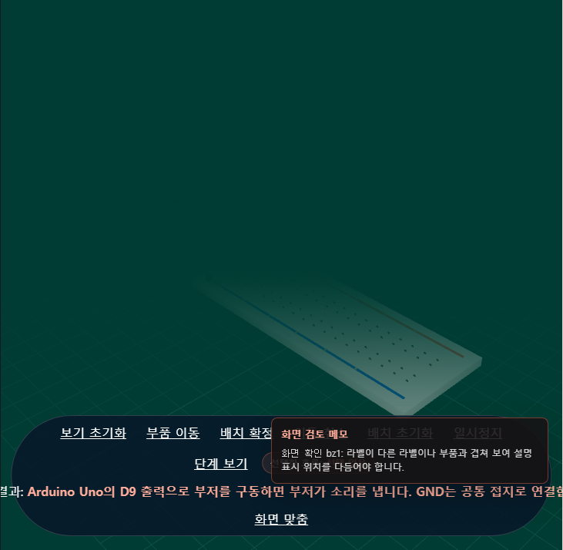

Query: "서보모터를 움직이는 회로 만들어줘" (07-servo)

1. Agent trace
Response kind: circuit
Assistant: { "assistantMessage": "아두이노 Uno로 서보모터를 움직이는 회로를 만들었습니다. D9 PWM 신호로 각도를 제어하고, 공통 GND를 연결합니다. 실제 서보는 전류가 많이 필요할 수 있어 전원 경고도 함께 표시됩니다.", "clarification": null, "circuitSpec": { "id": "servo-motion-output-basic", "title": "Arduino로 서보모터 움직이기", "intent": { "primaryGoal": "Arduino PWM 신호로 서보모터를 움직인다", "output": "서보모터 각도 모션", "controller": "Arduino Uno", "input": "PWM", "behavior": "PWM 신호에 따라 서보가 각도로 회전
Events:
- [coordinator] deepagents-coordinator — completed: Created structured circuit draft through Deepagents.
- [coordinator] requirement-analysis-agent — completed: synthesize_circuit: 서보모터를 Arduino PWM 신호로 움직이는 기본 회로 요청으로 해석됨. 5V 전원, 공통 GND, PWM 핀 연결이 핵심인 지원 범위 내 요청이다.
- [tool] assess_request_scope — completed: Recovered completed assess_request_scope tool call from Deepagents message history.
- [tool] validate_circuit_spec — completed: Recovered completed validate_circuit_spec tool call from Deepagents message history.
- [validation] context-coverage-gate — completed: sufficient
- [validation] server-validator — completed: valid
- [validation] build-runnable-gate — completed: runnable
Context trace (sources):
- memory:agent-operating-memory
- policy:safety-policy
- policy:simulation-truthfulness-policy
- registry:part-capabilities
- simulation:primitives
- rendering:render-footprints
- bundle:servo-motion-output
- sources:support-bundle:servo-motion-output
- data:capability-graph:servo-motion-output
- data:simulation-primitives:servo_angle
- data:simulation-primitives:current_flow_animation
- rendering:render-footprint:arduino
- rendering:render-footprint:breadboard
- rendering:render-footprint:servo
- rendering:render-footprint:wire
- registry:part-capabilities:arduino-uno
- registry:part-capabilities:breadboard-half
- registry:part-capabilities:micro-servo

2. Spec document (simulation spec)
Title: Arduino로 서보모터 움직이기
Goal: Arduino PWM 신호로 서보모터를 움직인다
Components:
- arduino-uno — Arduino Uno
- breadboard-half — Half-size breadboard
- micro-servo — Micro servo
Connections: 5
Build runnable: yes (runnable)
Requirement document:
# Project Requirement: Arduino로 서보모터 움직이기

_Status: valid_

_Simulation: valid_

_Build runnable: runnable_

## Goal

Arduino PWM 신호로 서보모터를 움직인다

## Parts Needed

- Arduino Uno (arduino-uno)
- Half-size breadboard (breadboard-half)
- Micro servo (micro-servo)

## What It Should Do

아두이노 D9에서 PWM 신호를 출력하면 서보모터가 해당 각도로 움직인다. 공통 GND를 공유하며, 교육용 시뮬레이션에서는 서보 각도 상태와 전류 경고가 함께 표시된다.

## Connections

- **c1**: u1:5V -> s1:VCC
- **c2**: u1:GND -> s1:GND
- **c3**: u1:D9 -> s1:SIG
- **c4**: u1:GND -> b1:- rail
- **c5**: u1:5V -> b1:+ rail

## Current Flow

- Servo supply current: about 120 mA from u1:5V to u1:GND
- Servo PWM signal activity: signal activity from u1:D9 to s1:SIG

## Safety And Validation Notes

- SERVO_CURRENT_WARNING: Real servos may need a separate 5V supply.
- SERVO_CURRENT_WARNING: Real servos may need a separate 5V supply.

## Assumptions

- 교육용 SG90급 마이크로 서보를 사용한다
- 아두이노 Uno 5V로 구동하는 저전압 교실 회로로 가정한다
- 빵판은 배선 시각화를 위한 선택 요소다

3. Completed simulation
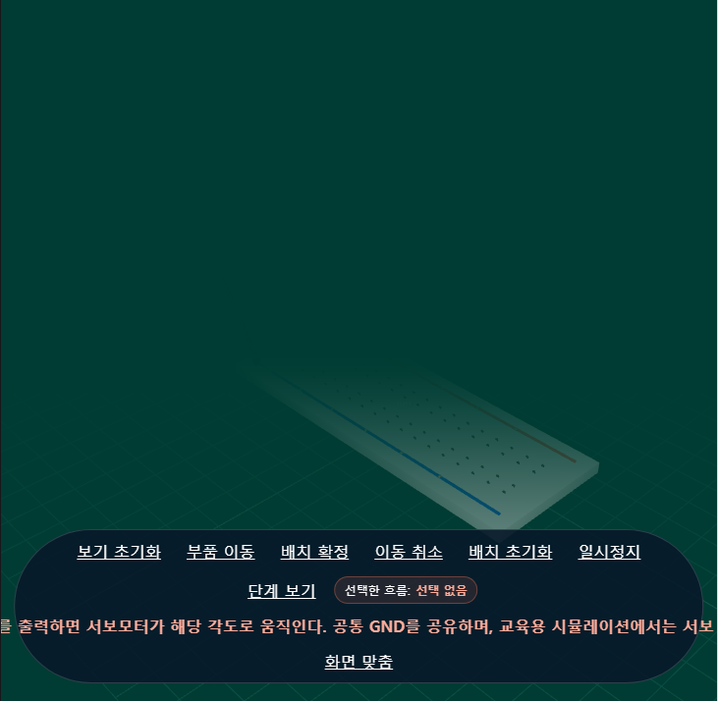

Query: "가변저항으로 LED 밝기를 조절하는 회로 만들어줘" (08-dimmer)

1. Agent trace
Response kind: circuit
Assistant: 완성했어요. 가변저항을 돌리면 Arduino가 값을 읽어서 LED 밝기를 PWM으로 조절하는 회로입니다. 원하면 다음 단계로 이어서 해드릴 수 있어요: - Arduino 코드까지 같이 작성 - LED를 RGB LED로 바꾸기 - 밝기 범위를 더 부드럽게 조정하기
Events:
- [coordinator] deepagents-coordinator — completed: Created structured circuit draft through Deepagents.
- [coordinator] requirement-analysis-agent — completed: synthesize_circuit: 가변저항으로 Arduino UNO의 아날로그 입력을 읽고, PWM으로 LED 밝기를 조절하는 회로 요청입니다. 지원되는 아날로그 LED 디머 패턴에 해당합니다.
- [tool] validate_circuit_spec — completed: Recovered completed validate_circuit_spec tool call from Deepagents message history.
- [tool] compile_render_plan — completed: Recovered completed compile_render_plan tool call from Deepagents message history.
- [tool] build_netlist — completed: Recovered completed build_netlist tool call from Deepagents message history.
- [tool] estimate_current_paths — completed: Recovered completed estimate_current_paths tool call from Deepagents message history.
- [validation] context-coverage-gate — completed: sufficient
- [validation] server-validator — completed: valid
- [validation] build-runnable-gate — completed: runnable
Context trace (sources):
- memory:agent-operating-memory
- policy:safety-policy
- policy:simulation-truthfulness-policy
- registry:part-capabilities
- simulation:primitives
- rendering:render-footprints
- bundle:analog-led-dimmer
- sources:support-bundle:digital-light-output
- sources:support-bundle:analog-led-dimmer
- data:capability-graph:digital-light-output
- data:capability-graph:analog-led-dimmer
- data:simulation-primitives:analog_pwm_dimmer
- data:simulation-primitives:digital_on_off
- data:simulation-primitives:current_flow_animation
- rendering:render-footprint:arduino
- rendering:render-footprint:breadboard
- rendering:render-footprint:potentiometer
- rendering:render-footprint:led
- rendering:render-footprint:resistor
- rendering:render-footprint:wire
- registry:part-capabilities:arduino-uno
- registry:part-capabilities:breadboard-half
- registry:part-capabilities:led-5mm
- registry:part-capabilities:resistor-220
- registry:part-capabilities:potentiometer-10k

2. Spec document (simulation spec)
Title: 가변저항으로 LED 밝기 조절
Goal: 가변저항으로 LED 밝기를 조절한다
Components:
- arduino-uno — Arduino Uno
- breadboard-half — Breadboard
- potentiometer-10k — 10K Potentiometer
- resistor-220 — 220Ω Resistor
- led-5mm — LED
Connections: 6
Build runnable: yes (runnable)
Requirement document:
# Project Requirement: 가변저항으로 LED 밝기 조절

_Status: valid_

_Simulation: valid_

_Build runnable: runnable_

## Goal

가변저항으로 LED 밝기를 조절한다

## Parts Needed

- Arduino Uno (arduino-uno)
- Breadboard (breadboard-half)
- 10K Potentiometer (potentiometer-10k)
- 220Ω Resistor (resistor-220)
- LED (led-5mm)

## What It Should Do

가변저항을 돌리면 A0에서 읽는 값이 변하고, Arduino가 이를 PWM 값으로 바꿔 D9 LED 밝기를 어둡게/밝게 조절한다.

## Connections

- **c1**: u1:5V -> rv1:VCC
- **c2**: u1:GND -> rv1:GND
- **c3**: rv1:OUT -> u1:A0
- **c4**: u1:D9 -> r1:1
- **c5**: r1:2 -> d1:A
- **c6**: d1:K -> u1:GND

## Current Flow

- 10K potentiometer sensing divider: sensing divider from u1:5V to u1:GND
- 10K potentiometer analog signal: signal activity from rv1:OUT to u1:A0
- LED forward current: about 13.6 mA from u1:D9 to u1:GND

## Safety And Validation Notes

- None

## Assumptions

- Arduino Uno 5V 저전압 교육용 회로로 구성한다.
- 가변저항은 10K 포텐셔미터를 사용한다.
- LED는 220Ω 저항과 직렬로 연결한다.

3. Completed simulation
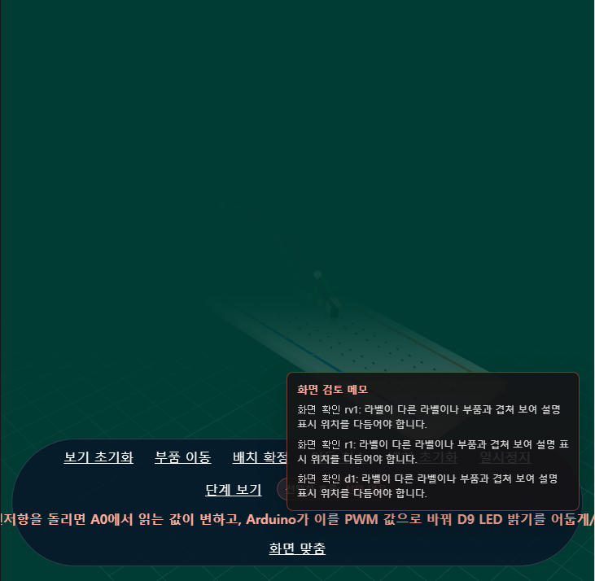

Query: "OLED에 HELLO 글자를 표시하는 회로 만들어줘" (09-oled-text)

1. Agent trace
Response kind: circuit
Assistant: 아직 이 회로를 안전하게 확정할 수 없어요. 회로 검증에서 수정이 필요한 배선 또는 부품 문제가 확인됐습니다. 다음 단계: 회로를 안전하게 확정하려면 입력, 출력, 전원 조건을 조금 더 알려주세요.
Events:
- [coordinator] deepagents-coordinator — completed: Created structured circuit draft through Deepagents.
- [coordinator] requirement-analysis-agent — completed: synthesize_circuit: Context coverage is sufficient for circuit synthesis.
- [validation] validation-repair — warning: Attempt 1/2 failed deterministic quality gates: INTENT_INPUT_NOT_FULFILLED: The student requested analog-sensor, but the final circuit draft does not include a matching input part. | INTENT_INPUT_NOT_FULFILLED: The student requested analog, but the final circuit draft does not include a matching input part. | INTENT_INPUT_NOT_FULFILLED: The student requested digital-input, but the final circuit draft does not include a matching input part. | INTENT_INPUT_NOT_FULFILLED: The student requested digital-sensor, but the final circuit draft does not include a matching input part.
- [tool] assess_request_scope — completed: Recovered completed assess_request_scope tool call from Deepagents message history.
- [tool] validate_circuit_spec — completed: Recovered completed validate_circuit_spec tool call from Deepagents message history.
- [validation] context-coverage-gate — completed: sufficient
- [validation] server-validator — warning: invalid
- [validation] build-runnable-gate — warning: blocked
- [validation] validation-repair-exhausted — warning: Stopped after 2 bounded quality-gate attempts: INTENT_INPUT_NOT_FULFILLED: The student requested analog-sensor, but the final circuit draft does not include a matching input part. | INTENT_INPUT_NOT_FULFILLED: The student requested analog, but the final circuit draft does not include a matching input part. | INTENT_INPUT_NOT_FULFILLED: The student requested digital-input, but the final circuit draft does not include a matching input part. | INTENT_INPUT_NOT_FULFILLED: The student requested digital-sensor, but the final circuit draft does not include a matching input part.
Context trace (sources):
- memory:agent-operating-memory
- policy:safety-policy
- policy:simulation-truthfulness-policy
- registry:part-capabilities
- simulation:primitives
- rendering:render-footprints
- bundle:digital-input-display-readout
- sources:support-bundle:analog-sensor-display-readout
- sources:support-bundle:display-text-output
- sources:support-bundle:digital-input-display-readout
- data:capability-graph:analog-sensor-display-readout
- data:capability-graph:display-text-output
- data:capability-graph:digital-input-display-readout
- data:simulation-primitives:digital_input_state
- data:simulation-primitives:display_static_text
- data:simulation-primitives:current_flow_animation
- rendering:render-footprint:arduino
- rendering:render-footprint:breadboard
- rendering:render-footprint:oled
- rendering:render-footprint:wire
- registry:part-capabilities:arduino-uno
- registry:part-capabilities:breadboard-half
- registry:part-capabilities:oled-i2c-096

2. Spec document (simulation spec)
Title: OLED에 HELLO 표시
Goal: OLED에 HELLO 글자를 표시한다
Components:
- arduino-uno — Arduino Uno
- breadboard-half — Half-size breadboard
- oled-i2c-096 — 0.96 inch I2C OLED
Connections: 4
Build runnable: no (blocked)
Requirement document:
# Project Requirement: OLED에 HELLO 표시

_Status: invalid_

_Simulation: invalid_

_Build runnable: blocked_

## Goal

OLED에 HELLO 글자를 표시한다

## Parts Needed

- No build-ready parts. Resolve validation status `invalid`, simulation status `invalid`, and runnable gate status `blocked` before treating this as a parts list. Build runnable gate blocked this draft: validation status is invalid INTENT_INPUT_NOT_FULFILLED: The student requested analog-sensor, but the final circuit draft does not include a matching input part. INTENT_INPUT_NOT_FULFILLED: The student requested analog, but the final circuit draft does not include a matching input part. INTENT_INPUT_NOT_FULFILLED: The student requested digital-input, but the final circuit draft does not include a matching input part. INTENT_INPUT_NOT_FULFILLED: The student requested digital-sensor, but the final circuit draft does not include a matching input part. simulation status is invalid INTENT_FULFILLMENT_WARNING: Runnable simulations must preserve the student requested input/output modality instead of silently substituting a simpler circuit.

## What It Should Do

아두이노가 OLED와 I2C로 통신해 화면에 HELLO를 표시한다.

## Connections

- No build-ready wiring. Resolve validation status `invalid`, simulation status `invalid`, and runnable gate status `blocked` before treating this as a wiring guide. Build runnable gate blocked this draft: validation status is invalid INTENT_INPUT_NOT_FULFILLED: The student requested analog-sensor, but the final circuit draft does not include a matching input part. INTENT_INPUT_NOT_FULFILLED: The student requested analog, but the final circuit draft does not include a matching input part. INTENT_INPUT_NOT_FULFILLED: The student requested digital-input, but the final circuit draft does not include a matching input part. INTENT_INPUT_NOT_FULFILLED: The student requested digital-sensor, but the final circuit draft does not include a matching input part. simulation status is invalid INTENT_FULFILLMENT_WARNING: Runnable simulations must preserve the student requested input/output modality instead of silently substituting a simpler circuit.

## Current Flow

- Current-flow details are hidden until the runnable gate passes. Current runnable gate status: `blocked`. Build runnable gate blocked this draft: validation status is invalid INTENT_INPUT_NOT_FULFILLED: The student requested analog-sensor, but the final circuit draft does not include a matching input part. INTENT_INPUT_NOT_FULFILLED: The student requested analog, but the final circuit draft does not include a matching input part. INTENT_INPUT_NOT_FULFILLED: The student requested digital-input, but the final circuit draft does not include a matching input part. INTENT_INPUT_NOT_FULFILLED: The student requested digital-sensor, but the final circuit draft does not include a matching input part. simulation status is invalid INTENT_FULFILLMENT_WARNING: Runnable simulations must preserve the student requested input/output modality instead of silently substituting a simpler circuit.

## Safety And Validation Notes

- INTENT_INPUT_NOT_FULFILLED: The student requested analog-sensor, but the final circuit draft does not include a matching input part.
- INTENT_INPUT_NOT_FULFILLED: The student requested analog, but the final circuit draft does not include a matching input part.
- INTENT_INPUT_NOT_FULFILLED: The student requested digital-input, but the final circuit draft does not include a matching input part.
- INTENT_INPUT_NOT_FULFILLED: The student requested digital-sensor, but the final circuit draft does not include a matching input part.
- INTENT_FULFILLMENT_WARNING: Runnable simulations must preserve the student requested input/output modality instead of silently substituting a simpler circuit.
- INTENT_FULFILLMENT_WARNING: Runnable simulations must preserve the student requested input/output modality instead of silently substituting a simpler circuit.
- validation status is invalid
- INTENT_INPUT_NOT_FULFILLED: The student requested analog-sensor, but the final circuit draft does not include a matching input part.
- INTENT_INPUT_NOT_FULFILLED: The student requested analog, but the final circuit draft does not include a matching input part.
- INTENT_INPUT_NOT_FULFILLED: The student requested digital-input, but the final circuit draft does not include a matching input part.
- INTENT_INPUT_NOT_FULFILLED: The student requested digital-sensor, but the final circuit draft does not include a matching input part.
- simulation status is invalid
- INTENT_FULFILLMENT_WARNING: Runnable simulations must preserve the student requested input/output modality instead of silently substituting a simpler circuit.

## Assumptions

- OLED 모듈은 5V 전원과 I2C(SDA/SCL)를 사용하는 0.96인치 I2C OLED이다.
- Arduino Uno의 A4는 SDA, A5는 SCL로 사용한다.

3. Completed simulation
(no simulation image — this turn did not build a runnable circuit)

Query: "뭔가 만들어줘" (10-vague)

1. Agent trace
Response kind: chat
Assistant: 좋아요. 어떤 회로를 만들지 한 가지만 정해 주세요: **LED 깜빡이기**, **버튼 누르면 부저 울리기**, **온도/빛 센서 읽기** 중에서 고르면 바로 만들어드릴게요.
Events:
- [coordinator] deepagents-coordinator — completed: Answered conversationally — no circuit synthesis this turn.
Context trace (sources):
- memory:agent-operating-memory
- policy:safety-policy
- policy:clarification-policy
- policy:simulation-truthfulness-policy

2. Spec document (simulation spec)
Title: 일반 대화
Goal: 뭔가 만들어줘
Components:
- arduino-uno — Arduino Uno
Connections: 0
Build runnable: no (blocked)

3. Completed simulation
(no simulation image — this turn did not build a runnable circuit)

