Deepagents E2E 12개 회로 시뮬레이션 테스트
학생의 탐색 대화부터 최종 입력, 내부 context/deepagents trace, deterministic validation/render/simulation 결과와 최종 회로 이미지를 한 문서에 묶은 E2E 실행 가이드입니다.
생성 시각 | 2026-06-02T02:48:53.476Z
증거 생성 | buildContextPacket -> validateCircuitSpec -> compileRenderPlan -> compileSimulationPlan -> buildRunnableReport -> buildSolverGateResult
범위 | WP-01부터 WP-12까지 각 1개 대표 학생 흐름, 총 12개 runnable simulation 케이스

1. 전체 케이스 요약
Case | 학생 목표 | Route | Capability | Gate | Paths
01  WP-01 | 조도 센서로 어두우면 LED 켜기 | v2-light-sensor-triggered-output | digital-light-output, light-sensor-triggered-output | valid / valid / runnable | 3
02  WP-02 | 버튼을 누르면 LED 켜기 | v2-button-controlled-light-output | digital-light-output, button-controlled-light-output | valid / valid / runnable | 1
03  WP-03 | 조이스틱 X/Y 값을 OLED에 표시 | v2-digital-input-display-readout | analog-sensor-display-readout, display-text-output, digital-input-display-readout | valid / valid / runnable | 6
04  WP-04 | 16x2 I2C LCD에 문구 표시 | v2-display-text-output | display-text-output | valid / valid / runnable | 1
05  WP-05 | RGB LED 색상 믹스 | v2-digital-light-output | digital-light-output | valid / valid / runnable | 3
06  WP-06 | IRF520으로 DC 모터 구동 | v2-low-side-switched-load-output | low-side-switched-load-output | valid / valid / runnable | 4
07  WP-07 | 9V 배터리와 7805로 5V 전원 레일 만들기 | v2-low-voltage-power-rail | low-voltage-power-rail, prototyping-surface-context | valid / valid / runnable | 0
08  WP-08 | Arduino Nano 핀맵과 전압 도메인 보기 | v2-controller-board-substitution | controller-board-substitution | valid / valid / runnable | 0
09  WP-09 | Perfboard 배치 컨텍스트 보기 | v2-prototyping-surface-context | prototyping-surface-context | valid / valid / runnable | 0
10  WP-10 | BMP280 값을 OLED에 표시 | v2-i2c-sensor-display-readout | i2c-sensor-display-readout | valid / valid / runnable | 4
11  WP-11 | HC-05 로컬 UART 상태를 OLED에 표시 | v2-uart-communication-module-readout | uart-communication-module-readout | valid / valid / runnable | 4
12  WP-12 | 74HC595 인터페이스 상태를 OLED에 표시 | v2-logic-interface-context | logic-interface-context | valid / valid / runnable | 4

2. 케이스별 E2E 흐름
각 케이스는 학생이 회로 목표를 탐색하고, 마지막 입력으로 회로를 확정한 뒤, 내부 context/deepagents tool chain이 어떤 판정을 내렸는지 보여줍니다.

Case 01. 조도 센서로 어두우면 LED 켜기
WP-01 목적: 학생이 센서 기반 LED 동작을 탐색한 뒤 지원되는 photoresistor threshold 회로로 확정하는지 확인한다.

학생 탐색 흐름
1. 학생: 뭐 만들까? 한번 제안해줘.
2. 학생: 센서가 들어간 회로가 좋아.
3. 학생: 조도 센서로 어두우면 LED 켜지는 걸로 하자.
4. 학생: 좋아, 그 회로로 진행해줘.
최종 입력 | 조도 센서로 어두우면 LED 켜지는 회로를 만들어줘
기대 판정 | light-sensor-triggered-output route, LED resistor path, analog threshold signal, runnable simulation
Route | v2-light-sensor-triggered-output
Capability | digital-light-output, light-sensor-triggered-output
Prompt budget | 7166/13000

내부 Deepagents Trace
[coordinator] request-analysis completed: route=v2-light-sensor-triggered-output; capabilities=digital-light-output, light-sensor-triggered-output
[retriever] context-packet completed: bundles=bundle:light-sensor-triggered-output; candidates=arduino-uno, breadboard-half, led-5mm, resistor-220, photoresistor-ldr; promptBudget=7166/13000
[planner] draft-grounding completed: topology=controller-analog-threshold-output; components=breadboard-half, arduino-uno, photoresistor-ldr, resistor-220, led-5mm
[tool:validate_circuit_spec] valid: errors=0; warnings=0; validatedPaths=analog-threshold-sensing-divider:ldr-1, analog-threshold-analog-signal:ldr-1, led-forward-current
[tool:compile_render_plan] completed: parts=5; wires=6; renderWarnings=2
[tool:compile_simulation_plan] valid: paths=analog-threshold-sensing-divider:ldr-1, analog-threshold-analog-signal:ldr-1, led-forward-current; expectedStates=2
[runnable-gate] runnable: runnable=true; reasons=none
[solver-gate] mode=verified_build_simulation; visible=true; buildReady=true; activity=verified_current; repair=none

Gate Summary
Validation | valid | errors=0 | warnings=0
Render | parts=5 | wires=6 | warnings=2
Simulation | valid | paths=analog-threshold-sensing-divider:ldr-1, analog-threshold-analog-signal:ldr-1, led-forward-current
Runnable | runnable | runnable=True
Solver Gate | verified_build_simulation | visible=True | buildReady=True | activity=verified_current
주요 warning | none

최종 Simulation 회로
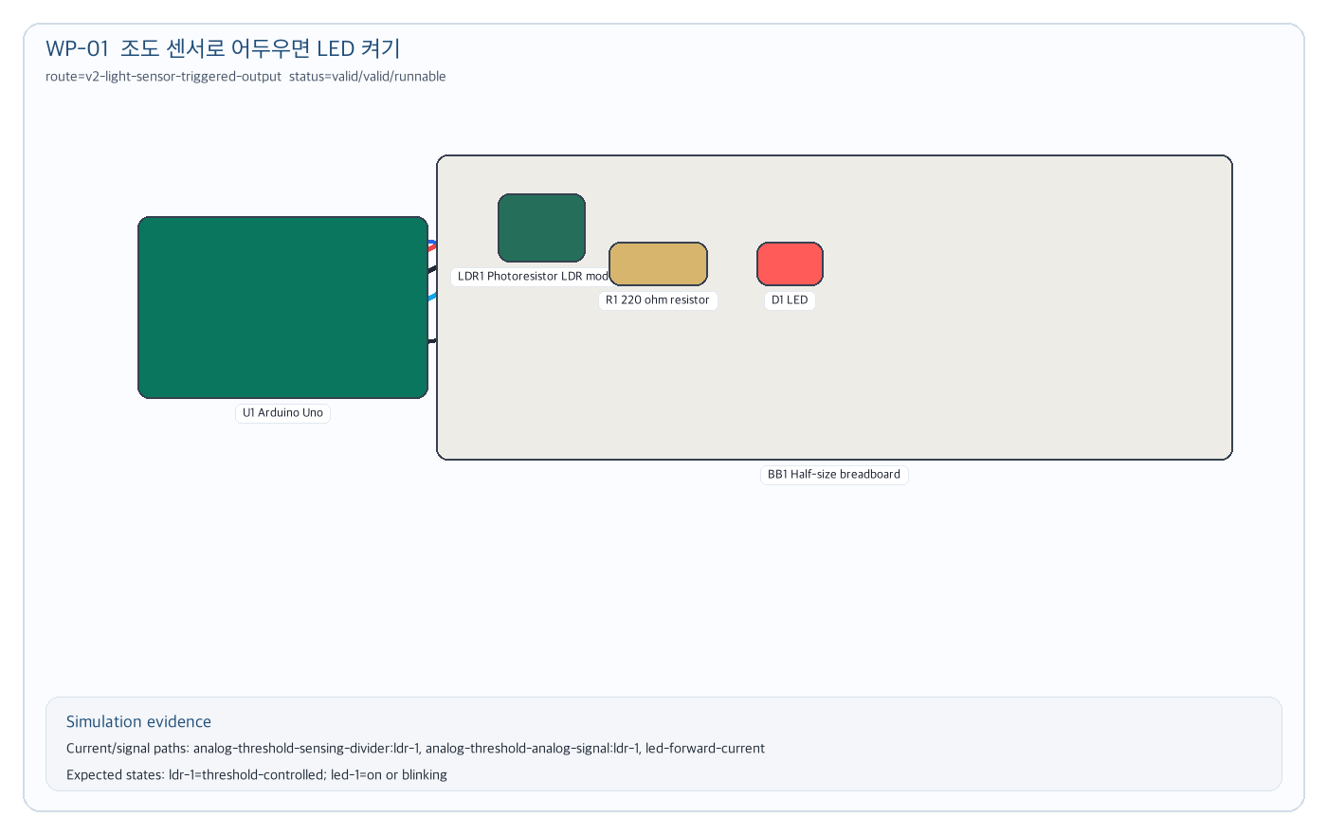
Figure 01. 조도 센서로 어두우면 LED 켜기 simulation circuit evidence

Case 02. 버튼을 누르면 LED 켜기
WP-02 목적: 간단한 디지털 입력-출력 요구가 반복 확인 없이 button-controlled-light-output으로 진행되는지 확인한다.

학생 탐색 흐름
1. 학생: 처음 해볼 회로 추천해줘.
2. 학생: 버튼으로 LED 켜는 건 어때?
3. 학생: 그걸로 진행하자.
4. 학생: 버튼을 누르면 LED가 켜지는 회로로 확정해줘.
최종 입력 | 버튼을 누르면 LED가 켜지는 회로로 진행해줘
기대 판정 | button input, protected LED load, current path, runnable simulation
Route | v2-button-controlled-light-output
Capability | digital-light-output, button-controlled-light-output
Prompt budget | 6645/12000

내부 Deepagents Trace
[coordinator] request-analysis completed: route=v2-button-controlled-light-output; capabilities=digital-light-output, button-controlled-light-output
[retriever] context-packet completed: bundles=bundle:button-controlled-light-output; candidates=arduino-uno, breadboard-half, led-5mm, button-tactile, resistor-220; promptBudget=6645/12000
[planner] draft-grounding completed: topology=controller-digital-input-switch-plus-output; components=breadboard-half, arduino-uno, resistor-220, led-5mm, button-tactile
[tool:validate_circuit_spec] valid: errors=0; warnings=0; validatedPaths=led-forward-current
[tool:compile_render_plan] completed: parts=5; wires=5; renderWarnings=3
[tool:compile_simulation_plan] valid: paths=led-forward-current; expectedStates=1
[runnable-gate] runnable: runnable=true; reasons=none
[solver-gate] mode=verified_build_simulation; visible=true; buildReady=true; activity=verified_current; repair=none

Gate Summary
Validation | valid | errors=0 | warnings=0
Render | parts=5 | wires=5 | warnings=3
Simulation | valid | paths=led-forward-current
Runnable | runnable | runnable=True
Solver Gate | verified_build_simulation | visible=True | buildReady=True | activity=verified_current
주요 warning | none

최종 Simulation 회로
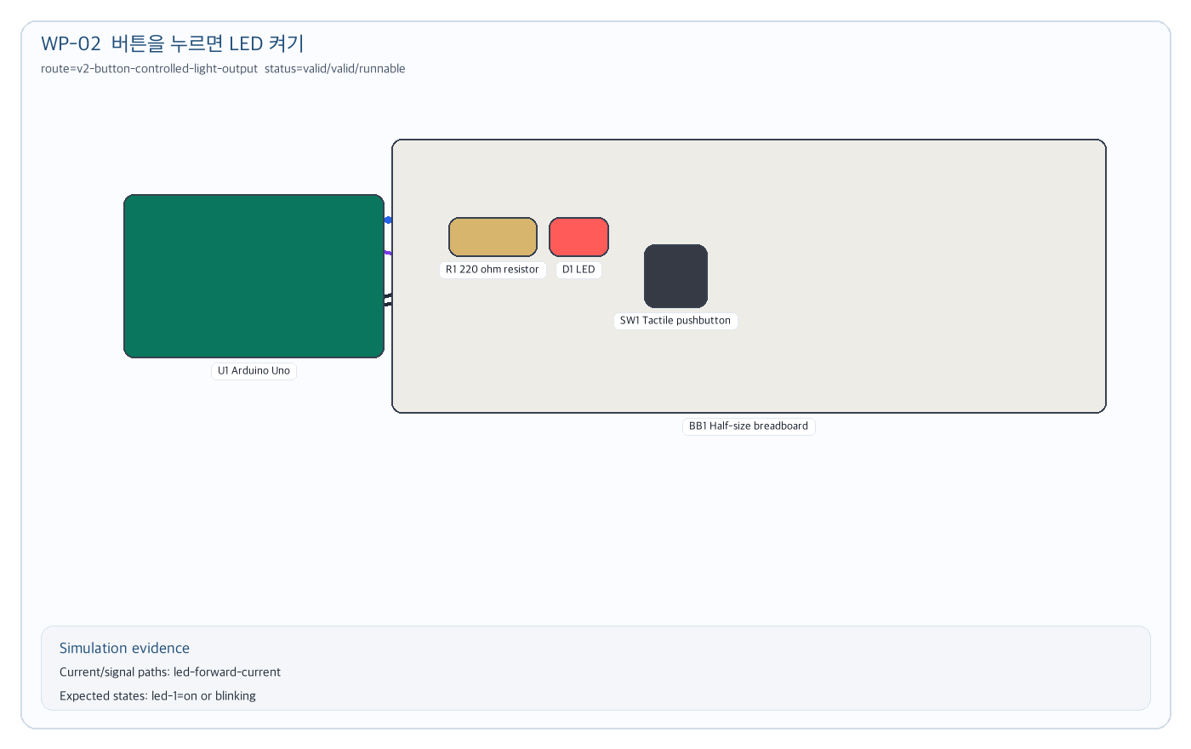
Figure 02. 버튼을 누르면 LED 켜기 simulation circuit evidence

Case 03. 조이스틱 X/Y 값을 OLED에 표시
WP-03 목적: multi-input analog/digital module이 joystick-display-readout으로 라우팅되고 X/Y/SW 신호가 분리되는지 확인한다.

학생 탐색 흐름
1. 학생: 입력 장치가 있는 회로를 만들어보고 싶어.
2. 학생: 방향을 움직이는 입력이면 좋겠어.
3. 학생: 조이스틱 값을 화면에 보여주자.
4. 학생: 조이스틱 X/Y 값을 OLED에 표시해줘.
최종 입력 | 조이스틱 X/Y 값을 OLED에 표시해줘
기대 판정 | joystick-display-readout route, dual analog paths, switch signal, OLED bus, runnable simulation
Route | v2-digital-input-display-readout
Capability | analog-sensor-display-readout, display-text-output, digital-input-display-readout
Prompt budget | 8726/17000

내부 Deepagents Trace
[coordinator] request-analysis completed: route=v2-digital-input-display-readout; capabilities=analog-sensor-display-readout, display-text-output, digital-input-display-readout
[retriever] context-packet completed: bundles=bundle:digital-input-display-readout; candidates=arduino-uno, breadboard-half, oled-i2c-096; promptBudget=8726/17000
[planner] draft-grounding completed: topology=controller-dual-analog-input-display; components=breadboard-half, arduino-uno, joystick-module, oled-i2c-096
[tool:validate_circuit_spec] valid: errors=0; warnings=1; validatedPaths=joystick-supply-current:joystick-1, joystick-x-analog-signal:joystick-1, joystick-y-analog-signal:joystick-1, joystick-switch-signal:joystick-1, joystick-display-bus-activity:oled-display, oled-module-current
[tool:compile_render_plan] completed: parts=4; wires=9; renderWarnings=1
[tool:compile_simulation_plan] valid: paths=joystick-supply-current:joystick-1, joystick-x-analog-signal:joystick-1, joystick-y-analog-signal:joystick-1, joystick-switch-signal:joystick-1, joystick-display-bus-activity:oled-display, oled-module-current; expectedStates=2
[runnable-gate] runnable: runnable=true; reasons=none
[solver-gate] mode=verified_build_simulation; visible=true; buildReady=true; activity=verified_current; repair=none

Gate Summary
Validation | valid | errors=0 | warnings=1
Render | parts=4 | wires=9 | warnings=1
Simulation | valid | paths=joystick-supply-current:joystick-1, joystick-x-analog-signal:joystick-1, joystick-y-analog-signal:joystick-1, joystick-switch-signal:joystick-1, joystick-display-bus-activity:oled-display, oled-module-current
Runnable | runnable | runnable=True
Solver Gate | verified_build_simulation | visible=True | buildReady=True | activity=verified_current
주요 warning | JOYSTICK_QUALITATIVE_ONLY: Analog joystick module is modeled as qualitative X/Y position and switch state, not calibrated force or HID behavior. / JOYSTICK_QUALITATIVE_ONLY: Analog joystick module is modeled as qualitative X/Y position and switch state, not calibrated force or HID behavior.

최종 Simulation 회로
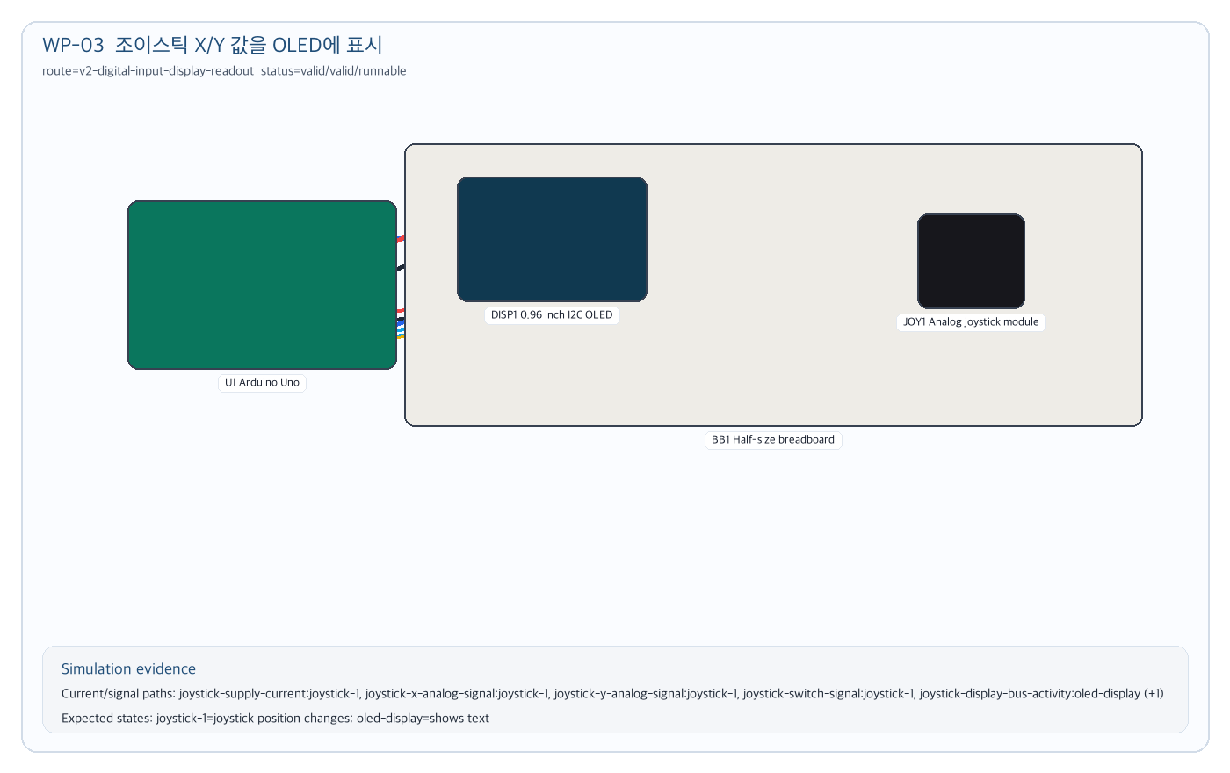
Figure 03. 조이스틱 X/Y 값을 OLED에 표시 simulation circuit evidence

Case 04. 16x2 I2C LCD에 문구 표시
WP-04 목적: display expansion 부품이 OLED fallback으로 섞이지 않고 LCD footprint와 I2C display contract를 쓰는지 확인한다.

학생 탐색 흐름
1. 학생: 화면에 글자를 띄우는 회로를 해보자.
2. 학생: OLED 말고 LCD도 가능해?
3. 학생: 16x2 LCD에 간단한 문구를 띄우고 싶어.
4. 학생: 16x2 I2C LCD에 HELLO LCD를 표시해줘.
최종 입력 | 16x2 I2C LCD에 HELLO LCD를 표시해줘
기대 판정 | display-text-output route, lcd-16x2 candidate, I2C display current/bus paths, runnable simulation
Route | v2-display-text-output
Capability | display-text-output
Prompt budget | 4225/9000

내부 Deepagents Trace
[coordinator] request-analysis completed: route=v2-display-text-output; capabilities=display-text-output
[retriever] context-packet completed: bundles=bundle:display-text-output; candidates=arduino-uno, breadboard-half, lcd-16x2; promptBudget=4225/9000
[planner] draft-grounding completed: topology=controller-i2c-character-display; components=breadboard-half, arduino-uno, lcd-16x2
[tool:validate_circuit_spec] valid: errors=0; warnings=0; validatedPaths=oled-module-current
[tool:compile_render_plan] completed: parts=3; wires=4; renderWarnings=0
[tool:compile_simulation_plan] valid: paths=oled-module-current; expectedStates=1
[runnable-gate] runnable: runnable=true; reasons=none
[solver-gate] mode=auto_repaired_simulation; visible=true; buildReady=true; activity=verified_current; repair=layout

Gate Summary
Validation | valid | errors=0 | warnings=0
Render | parts=3 | wires=4 | warnings=0
Simulation | valid | paths=oled-module-current
Runnable | runnable | runnable=True
Solver Gate | auto_repaired_simulation | visible=True | buildReady=True | activity=verified_current
주요 warning | none

최종 Simulation 회로
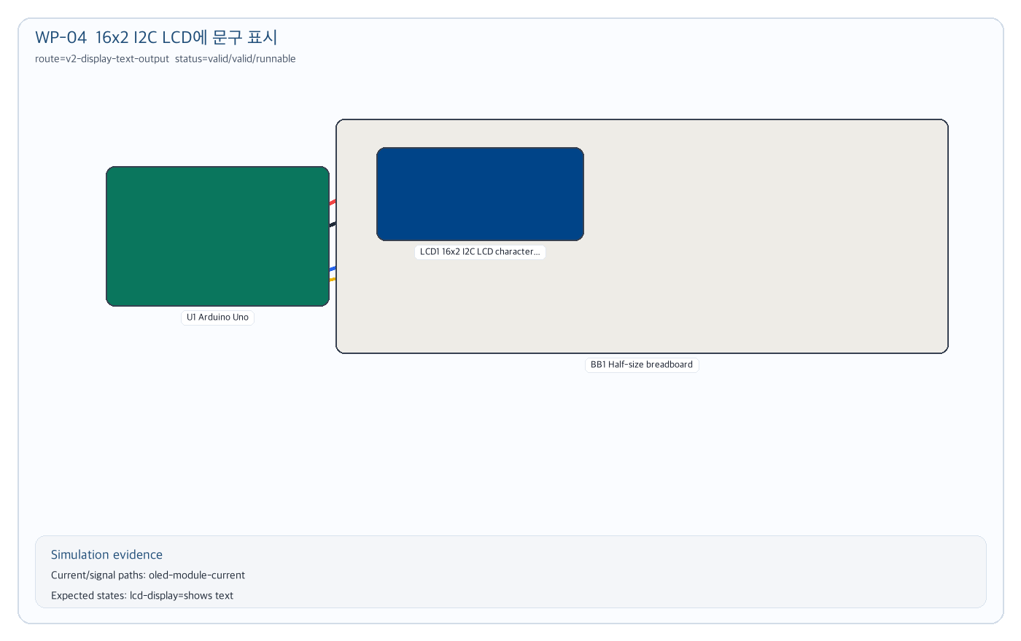
Figure 04. 16x2 I2C LCD에 문구 표시 simulation circuit evidence

Case 05. RGB LED 색상 믹스
WP-05 목적: WP-05 light output 부품이 각 채널 저항과 PWM 경로를 요구하는지 확인한다.

학생 탐색 흐름
1. 학생: LED보다 조금 더 화려한 출력이 있을까?
2. 학생: 색이 바뀌는 LED를 써보고 싶어.
3. 학생: RGB LED로 색을 섞어보자.
4. 학생: 공통 캐소드 RGB LED 색상 믹스 회로를 만들어줘.
최종 입력 | 공통 캐소드 RGB LED 색상 믹스 회로를 만들어줘
기대 판정 | explicit RGB LED, three current-limited channels, PWM activity, runnable simulation
Route | v2-digital-light-output
Capability | digital-light-output
Prompt budget | 5402/9000

내부 Deepagents Trace
[coordinator] request-analysis completed: route=v2-digital-light-output; capabilities=digital-light-output
[retriever] context-packet completed: bundles=bundle:digital-light-output; candidates=arduino-uno, breadboard-half, rgb-led-common-cathode, resistor-220, jumper-wire; promptBudget=5402/9000
[planner] draft-grounding completed: topology=controller-rgb-led-current-limited-output; components=breadboard-half, arduino-uno, rgb-led-common-cathode, resistor-220, resistor-220, resistor-220
[tool:validate_circuit_spec] valid: errors=0; warnings=0; validatedPaths=rgb-led-channel-current:rgb-led:R, rgb-led-channel-current:rgb-led:G, rgb-led-channel-current:rgb-led:B
[tool:compile_render_plan] completed: parts=6; wires=7; renderWarnings=3
[tool:compile_simulation_plan] valid: paths=rgb-led-channel-current:rgb-led:R, rgb-led-channel-current:rgb-led:G, rgb-led-channel-current:rgb-led:B; expectedStates=1
[runnable-gate] runnable: runnable=true; reasons=none
[solver-gate] mode=verified_build_simulation; visible=true; buildReady=true; activity=verified_current; repair=none

Gate Summary
Validation | valid | errors=0 | warnings=0
Render | parts=6 | wires=7 | warnings=3
Simulation | valid | paths=rgb-led-channel-current:rgb-led:R, rgb-led-channel-current:rgb-led:G, rgb-led-channel-current:rgb-led:B
Runnable | runnable | runnable=True
Solver Gate | verified_build_simulation | visible=True | buildReady=True | activity=verified_current
주요 warning | none

최종 Simulation 회로
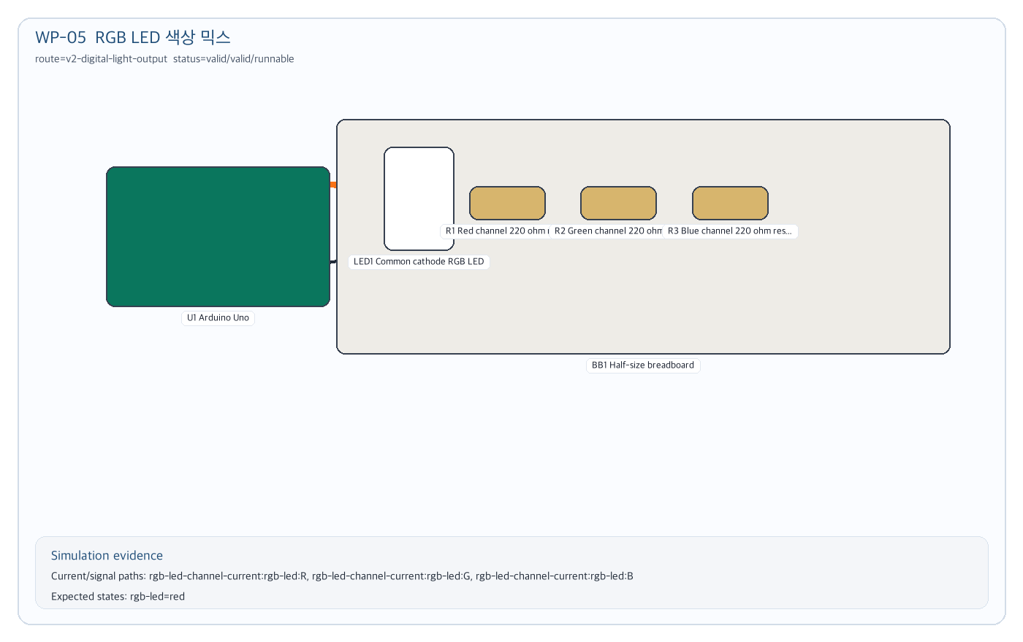
Figure 05. RGB LED 색상 믹스 simulation circuit evidence

Case 06. IRF520으로 DC 모터 구동
WP-06 목적: 모터를 GPIO에 직접 연결하지 않고 low-side driver contract와 high-current warning을 적용하는지 확인한다.

학생 탐색 흐름
1. 학생: 움직이는 회로를 만들 수 있어?
2. 학생: 작은 DC 모터를 돌리고 싶어.
3. 학생: 아두이노에서 바로 연결하지 말고 드라이버를 써보자.
4. 학생: IRF520 MOSFET 모듈로 DC 모터를 켜는 회로를 만들어줘.
최종 입력 | IRF520 MOSFET 모듈로 DC 모터를 켜는 회로를 만들어줘
기대 판정 | low-side-switched-load-output route, driver control path, motor load path, safety warning, runnable simulation
Route | v2-low-side-switched-load-output
Capability | low-side-switched-load-output
Prompt budget | 7736/15000

내부 Deepagents Trace
[coordinator] request-analysis completed: route=v2-low-side-switched-load-output; capabilities=low-side-switched-load-output
[retriever] context-packet completed: bundles=bundle:low-side-switched-load-output; candidates=arduino-uno, breadboard-half, dc-motor-130, irf520-mosfet; promptBudget=7736/15000
[planner] draft-grounding completed: topology=controller-mosfet-module-load; components=breadboard-half, arduino-uno, irf520-mosfet, dc-motor-130
[tool:validate_circuit_spec] valid: errors=0; warnings=3; validatedPaths=hbridge-motor-current, hbridge-control-signals, low-side-load-supply-current:motor-1, low-side-load-control-signal:motor-1
[tool:compile_render_plan] completed: parts=4; wires=5; renderWarnings=0
[tool:compile_simulation_plan] valid: paths=hbridge-motor-current, hbridge-control-signals, low-side-load-supply-current:motor-1, low-side-load-control-signal:motor-1; expectedStates=2
[runnable-gate] runnable: runnable=true; reasons=none
[solver-gate] mode=verified_build_simulation; visible=true; buildReady=true; activity=verified_current; repair=none

Gate Summary
Validation | valid | errors=0 | warnings=3
Render | parts=4 | wires=5 | warnings=0
Simulation | valid | paths=hbridge-motor-current, hbridge-control-signals, low-side-load-supply-current:motor-1, low-side-load-control-signal:motor-1
Runnable | runnable | runnable=True
Solver Gate | verified_build_simulation | visible=True | buildReady=True | activity=verified_current
주요 warning | LOW_SIDE_LOAD_POWER_WARNING: DC motor 130 is simulated qualitatively; real motor-like loads need current budgeting, suitable power, and common ground. / INDUCTIVE_LOAD_FLYBACK_WARNING: DC motor 130 requires real flyback/protection design outside this educational simulation.

최종 Simulation 회로
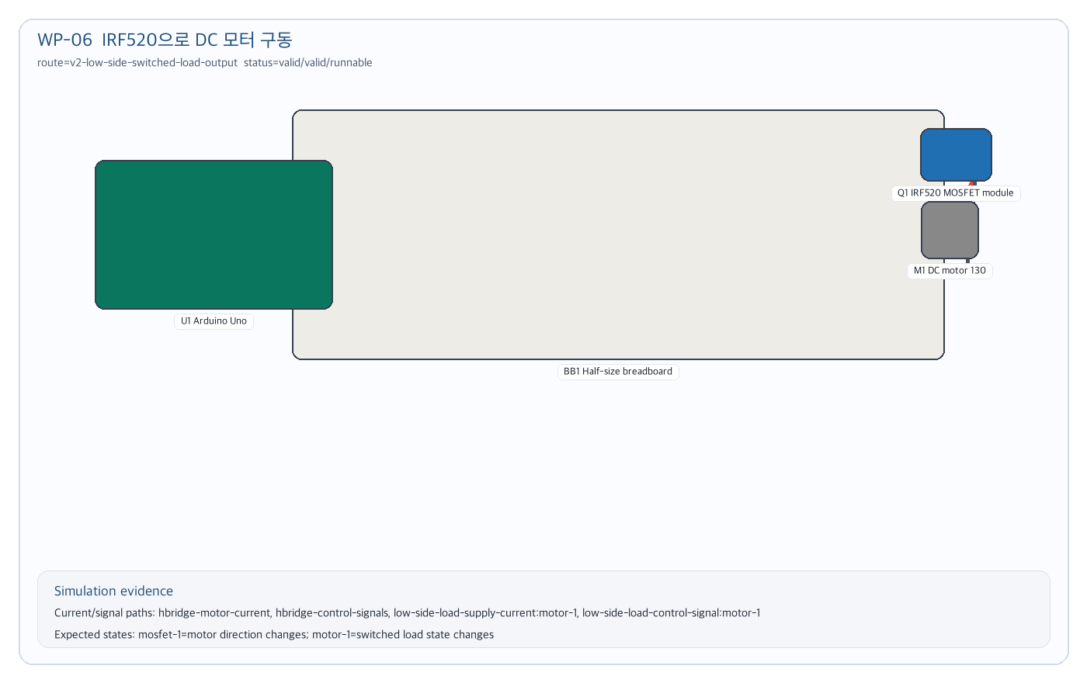
Figure 06. IRF520으로 DC 모터 구동 simulation circuit evidence

Case 07. 9V 배터리와 7805로 5V 전원 레일 만들기
WP-07 목적: 전원/레귤레이터 context가 부하 용량을 과장하지 않고 rail state simulation으로 처리되는지 확인한다.

학생 탐색 흐름
1. 학생: 전원 회로도 테스트해보자.
2. 학생: 9V 배터리를 5V로 낮출 수 있어?
3. 학생: 7805 레귤레이터로 브레드보드 5V 레일을 만들자.
4. 학생: 9V 배터리와 7805로 5V 브레드보드 전원 레일을 만들어줘.
최종 입력 | 9V 배터리와 7805로 5V 브레드보드 전원 레일을 만들어줘
기대 판정 | low-voltage-power-rail route, regulator IN/OUT/GND paths, qualitative rail state, runnable simulation
Route | v2-low-voltage-power-rail
Capability | low-voltage-power-rail, prototyping-surface-context
Prompt budget | 7620/13000

내부 Deepagents Trace
[coordinator] request-analysis completed: route=v2-low-voltage-power-rail; capabilities=low-voltage-power-rail, prototyping-surface-context
[retriever] context-packet completed: bundles=bundle:low-voltage-power-rail; candidates=breadboard-half, breadboard-psu, 9v-battery-clip, 7805-regulator; promptBudget=7620/13000
[planner] draft-grounding completed: topology=regulated-5v-rail; components=breadboard-half, arduino-uno, 9v-battery-clip, 7805-regulator
[tool:validate_circuit_spec] valid: errors=0; warnings=3; validatedPaths=none
[tool:compile_render_plan] completed: parts=4; wires=4; renderWarnings=1
[tool:compile_simulation_plan] valid: paths=none; expectedStates=2
[runnable-gate] runnable: runnable=true; reasons=none
[solver-gate] mode=verified_build_simulation; visible=true; buildReady=true; activity=state_only; repair=none

Gate Summary
Validation | valid | errors=0 | warnings=3
Render | parts=4 | wires=4 | warnings=1
Simulation | valid | paths=state-only
Runnable | runnable | runnable=True
Solver Gate | verified_build_simulation | visible=True | buildReady=True | activity=state_only
주요 warning | LOW_VOLTAGE_POWER_RAIL_QUALITATIVE_ONLY: 9V battery clip is modeled as a qualitative educational rail state, not a real current budget or power supply rating. / LOW_VOLTAGE_POWER_RAIL_QUALITATIVE_ONLY: 7805 5V regulator is modeled as a qualitative educational rail state, not a real current budget or power supply rating.

최종 Simulation 회로
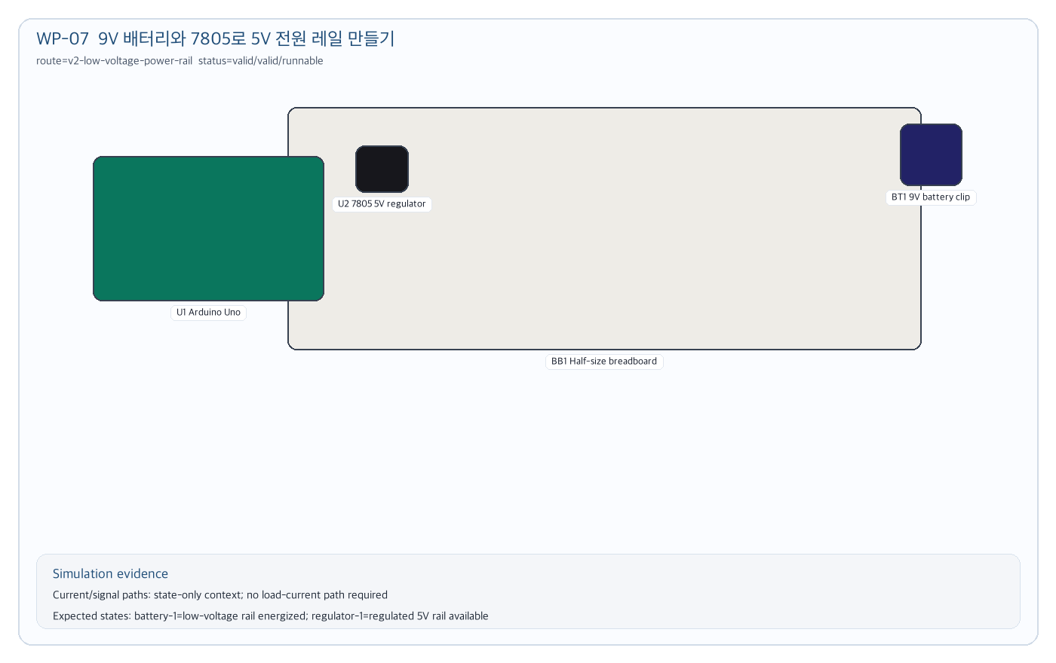
Figure 07. 9V 배터리와 7805로 5V 전원 레일 만들기 simulation circuit evidence

Case 08. Arduino Nano 핀맵과 전압 도메인 보기
WP-08 목적: controller board 요청이 회로 대체를 추론하지 않고 pin-map context로만 표시되는지 확인한다.

학생 탐색 흐름
1. 학생: 보드를 Uno 말고 다른 걸로 볼 수 있어?
2. 학생: Arduino Nano가 궁금해.
3. 학생: 일단 핀맵이랑 전압 도메인부터 보여줘.
4. 학생: Arduino Nano 핀맵과 전압 도메인을 보여줘.
최종 입력 | Arduino Nano 핀맵과 전압 도메인을 보여줘
기대 판정 | controller-board-substitution route, state-only render, no inferred circuit substitution, runnable context simulation
Route | v2-controller-board-substitution
Capability | controller-board-substitution
Prompt budget | 5713/10000

내부 Deepagents Trace
[coordinator] request-analysis completed: route=v2-controller-board-substitution; capabilities=controller-board-substitution
[retriever] context-packet completed: bundles=bundle:controller-board-substitution; candidates=arduino-nano; promptBudget=5713/10000
[planner] draft-grounding completed: topology=controller-board-pin-map-substitution; components=arduino-nano
[tool:validate_circuit_spec] valid: errors=0; warnings=1; validatedPaths=none
[tool:compile_render_plan] completed: parts=1; wires=0; renderWarnings=0
[tool:compile_simulation_plan] valid: paths=none; expectedStates=1
[runnable-gate] runnable: runnable=true; reasons=none
[solver-gate] mode=verified_build_simulation; visible=true; buildReady=true; activity=state_only; repair=none

Gate Summary
Validation | valid | errors=0 | warnings=1
Render | parts=1 | wires=0 | warnings=0
Simulation | valid | paths=state-only
Runnable | runnable | runnable=True
Solver Gate | verified_build_simulation | visible=True | buildReady=True | activity=state_only
주요 warning | CONTROLLER_BOARD_CONTEXT_STATE_ONLY: Arduino Nano is rendered as board-specific pin-map and voltage-domain context only; validated circuit substitution requires a circuit bundle that explicitly allows this controller. / CONTROLLER_BOARD_CONTEXT_STATE_ONLY: Arduino Nano is rendered as board-specific pin-map and voltage-domain context only; validated circuit substitution requires a circuit bundle that explicitly allows this controller.

최종 Simulation 회로
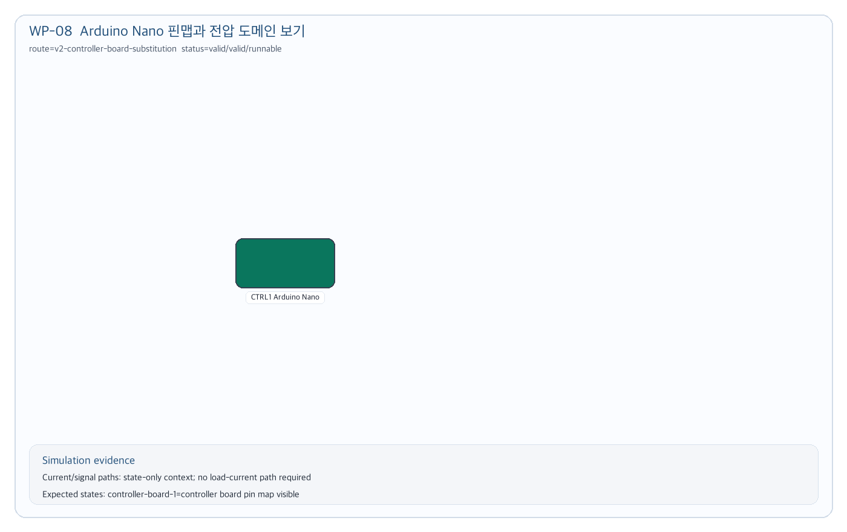
Figure 08. Arduino Nano 핀맵과 전압 도메인 보기 simulation circuit evidence

Case 09. Perfboard 배치 컨텍스트 보기
WP-09 목적: prototyping surface가 숨은 net/current를 만들지 않고 placement context로만 렌더되는지 확인한다.

학생 탐색 흐름
1. 학생: 브레드보드 말고 납땜 보드도 볼 수 있어?
2. 학생: 5x7 perfboard를 써보고 싶어.
3. 학생: 실제 배선 전에 배치만 확인하자.
4. 학생: 5x7 perfboard를 low-voltage 배치 컨텍스트로 보여줘.
최종 입력 | 5x7 perfboard를 low-voltage 배치 컨텍스트로 보여줘
기대 판정 | prototyping-surface-context route, no hidden current path, state-only runnable context
Route | v2-prototyping-surface-context
Capability | prototyping-surface-context
Prompt budget | 5376/11000

내부 Deepagents Trace
[coordinator] request-analysis completed: route=v2-prototyping-surface-context; capabilities=prototyping-surface-context
[retriever] context-packet completed: bundles=bundle:prototyping-surface-context; candidates=breadboard-half, perfboard-5x7; promptBudget=5376/11000
[planner] draft-grounding completed: topology=prototyping-surface-context-only; components=breadboard-half, arduino-uno, perfboard-5x7
[tool:validate_circuit_spec] valid: errors=0; warnings=1; validatedPaths=none
[tool:compile_render_plan] completed: parts=3; wires=0; renderWarnings=0
[tool:compile_simulation_plan] valid: paths=none; expectedStates=1
[runnable-gate] runnable: runnable=true; reasons=none
[solver-gate] mode=verified_build_simulation; visible=true; buildReady=true; activity=state_only; repair=none

Gate Summary
Validation | valid | errors=0 | warnings=1
Render | parts=3 | wires=0 | warnings=0
Simulation | valid | paths=state-only
Runnable | runnable | runnable=True
Solver Gate | verified_build_simulation | visible=True | buildReady=True | activity=state_only
주요 warning | PROTOTYPING_SURFACE_STATE_ONLY: 5x7 perfboard is rendered as placement/build context only; it does not energize rails, create hidden nets, or imply solder bridges. / PROTOTYPING_SURFACE_STATE_ONLY: 5x7 perfboard is rendered as placement/build context only; it does not energize rails, create hidden nets, or imply solder bridges.

최종 Simulation 회로
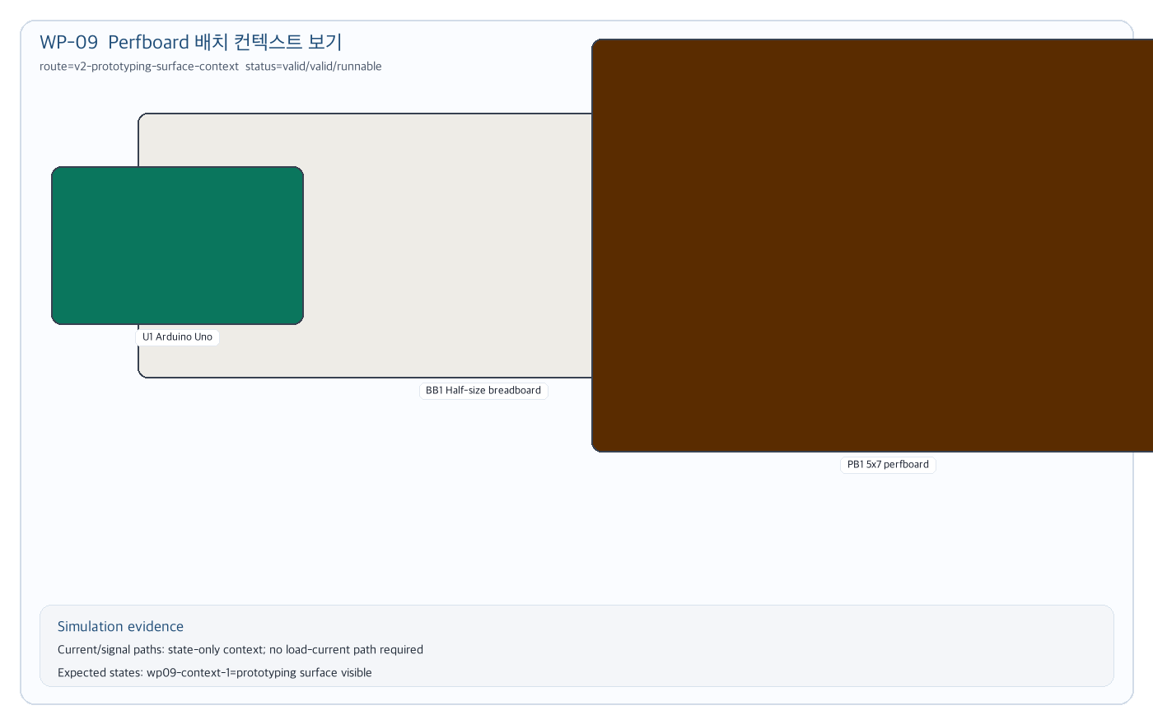
Figure 09. Perfboard 배치 컨텍스트 보기 simulation circuit evidence

Case 10. BMP280 값을 OLED에 표시
WP-10 목적: I2C protocol sensor와 OLED가 같은 bus를 공유하고 calibrated measurement overclaim 없이 정성 readout으로 실행되는지 확인한다.

학생 탐색 흐름
1. 학생: 센서 모듈 중에 기압 센서도 있어?
2. 학생: BMP280으로 온도랑 기압을 보고 싶어.
3. 학생: OLED에 값을 표시하자.
4. 학생: BMP280 기압/온도 값을 OLED에 표시해줘.
최종 입력 | BMP280 기압/온도 값을 OLED에 표시해줘
기대 판정 | i2c-sensor-display-readout route, sensor/OLED shared I2C bus, qualitative readout, runnable simulation
Route | v2-i2c-sensor-display-readout
Capability | i2c-sensor-display-readout
Prompt budget | 6686/15000

내부 Deepagents Trace
[coordinator] request-analysis completed: route=v2-i2c-sensor-display-readout; capabilities=i2c-sensor-display-readout
[retriever] context-packet completed: bundles=bundle:i2c-sensor-display-readout; candidates=arduino-uno, breadboard-half, oled-i2c-096, bmp280; promptBudget=6686/15000
[planner] draft-grounding completed: topology=controller-i2c-sensor-display; components=breadboard-half, arduino-uno, bmp280, oled-i2c-096
[tool:validate_circuit_spec] valid: errors=0; warnings=1; validatedPaths=protocol-sensor-supply-current:bmp280-1, protocol-sensor-bus-activity:bmp280-1, protocol-sensor-display-bus-activity:oled-display, oled-module-current
[tool:compile_render_plan] completed: parts=4; wires=8; renderWarnings=1
[tool:compile_simulation_plan] valid: paths=protocol-sensor-supply-current:bmp280-1, protocol-sensor-bus-activity:bmp280-1, protocol-sensor-display-bus-activity:oled-display, oled-module-current; expectedStates=2
[runnable-gate] runnable: runnable=true; reasons=none
[solver-gate] mode=verified_build_simulation; visible=true; buildReady=true; activity=verified_current; repair=none

Gate Summary
Validation | valid | errors=0 | warnings=1
Render | parts=4 | wires=8 | warnings=1
Simulation | valid | paths=protocol-sensor-supply-current:bmp280-1, protocol-sensor-bus-activity:bmp280-1, protocol-sensor-display-bus-activity:oled-display, oled-module-current
Runnable | runnable | runnable=True
Solver Gate | verified_build_simulation | visible=True | buildReady=True | activity=verified_current
주요 warning | PROTOCOL_SENSOR_QUALITATIVE_ONLY: BMP280 pressure and temperature sensor is modeled as a qualitative classroom readout; it is not a calibrated, certified, medical, navigation, tracking, payment, or security instrument. / PROTOCOL_SENSOR_QUALITATIVE_ONLY: BMP280 pressure and temperature sensor is modeled as a qualitative classroom readout; it is not a calibrated, certified, medical, navigation, tracking, payment, or security instrument.

최종 Simulation 회로
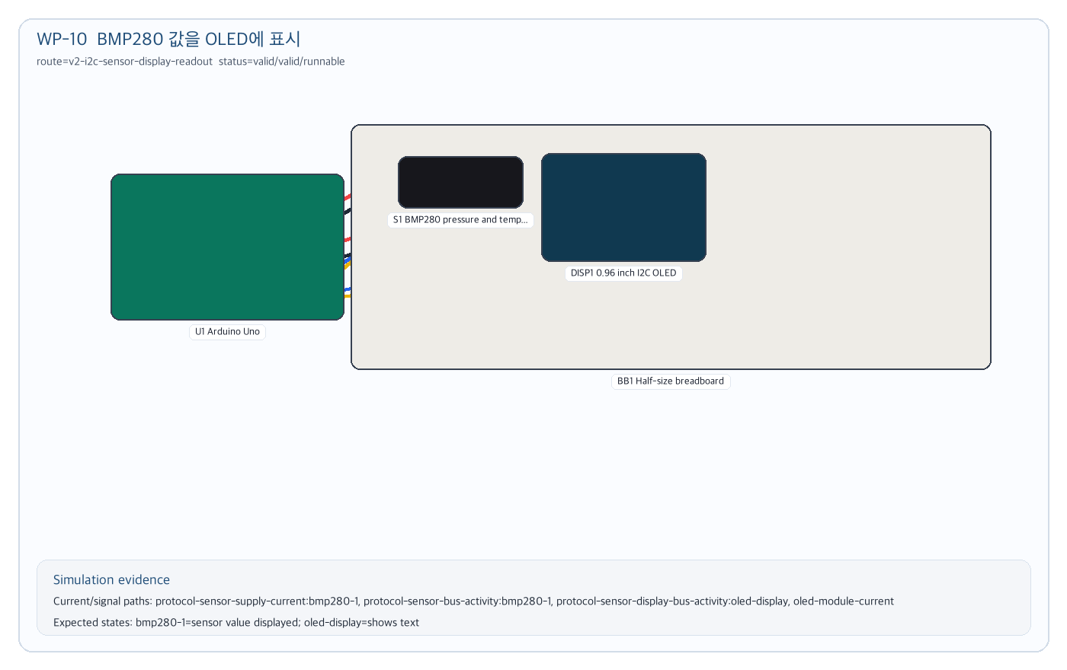
Figure 10. BMP280 값을 OLED에 표시 simulation circuit evidence

Case 11. HC-05 로컬 UART 상태를 OLED에 표시
WP-11 목적: 통신 모듈이 실제 페어링/네트워크를 주장하지 않고 local command-state simulation으로 제한되는지 확인한다.

학생 탐색 흐름
1. 학생: 블루투스 모듈도 테스트 가능해?
2. 학생: 폰 연결까지는 말고 모듈 상태만 보고 싶어.
3. 학생: HC-05 UART 상태를 화면에 표시하자.
4. 학생: HC-05 블루투스 모듈의 로컬 UART 상태를 OLED에 표시해줘.
최종 입력 | HC-05 블루투스 모듈의 로컬 UART 상태를 OLED에 표시해줘
기대 판정 | uart-communication-module route, TX/RX direction, OLED bus, network overclaim blocked, runnable qualitative simulation
Route | v2-uart-communication-module-readout
Capability | uart-communication-module-readout
Prompt budget | 7004/12000

내부 Deepagents Trace
[coordinator] request-analysis completed: route=v2-uart-communication-module-readout; capabilities=uart-communication-module-readout
[retriever] context-packet completed: bundles=bundle:uart-communication-module-readout; candidates=arduino-uno, breadboard-half, oled-i2c-096, hc05-bluetooth, jumper-wire; promptBudget=7004/12000
[planner] draft-grounding completed: topology=controller-uart-communication-module; components=breadboard-half, arduino-uno, hc05-bluetooth, oled-i2c-096
[tool:validate_circuit_spec] valid: errors=0; warnings=1; validatedPaths=communication-module-supply-current:hc05-1, communication-module-bus-activity:hc05-1, communication-module-display-bus-activity:oled-display, oled-module-current
[tool:compile_render_plan] completed: parts=4; wires=8; renderWarnings=1
[tool:compile_simulation_plan] valid: paths=communication-module-supply-current:hc05-1, communication-module-bus-activity:hc05-1, communication-module-display-bus-activity:oled-display, oled-module-current; expectedStates=2
[runnable-gate] runnable: runnable=true; reasons=none
[solver-gate] mode=verified_build_simulation; visible=true; buildReady=true; activity=verified_current; repair=none

Gate Summary
Validation | valid | errors=0 | warnings=1
Render | parts=4 | wires=8 | warnings=1
Simulation | valid | paths=communication-module-supply-current:hc05-1, communication-module-bus-activity:hc05-1, communication-module-display-bus-activity:oled-display, oled-module-current
Runnable | runnable | runnable=True
Solver Gate | verified_build_simulation | visible=True | buildReady=True | activity=verified_current
주요 warning | COMMUNICATION_MODULE_QUALITATIVE_ONLY: HC-05 Bluetooth module is modeled as local command/bus state only; real networking, pairing, RF range, SMS/calls, USB devices, vehicle networks, and backend services are outside this simulation. / COMMUNICATION_MODULE_QUALITATIVE_ONLY: HC-05 Bluetooth module is modeled as local command/bus state only; real networking, pairing, RF range, SMS/calls, USB devices, vehicle networks, and backend services are outside this simulation.

최종 Simulation 회로
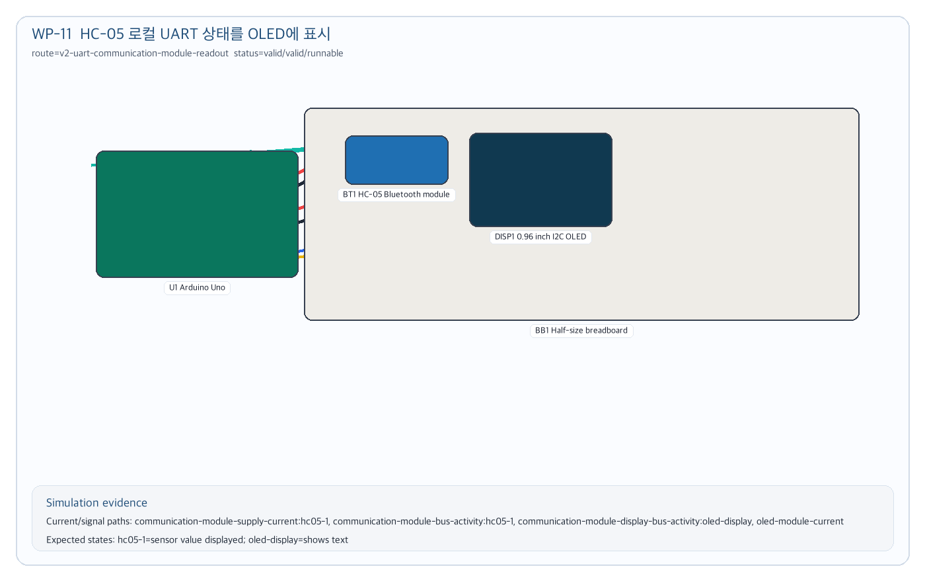
Figure 11. HC-05 로컬 UART 상태를 OLED에 표시 simulation circuit evidence

Case 12. 74HC595 인터페이스 상태를 OLED에 표시
WP-12 목적: logic/interface IC가 hidden output load나 chip-level simulation을 추론하지 않고 qualitative interface state로 처리되는지 확인한다.

학생 탐색 흐름
1. 학생: IC도 다룰 수 있는지 보자.
2. 학생: 시프트 레지스터가 궁금해.
3. 학생: 출력 LED 여러 개까지는 말고 상태를 OLED에 보여줘.
4. 학생: 74HC595 시프트 레지스터 상태를 OLED에 표시해줘.
최종 입력 | 74HC595 시프트 레지스터 상태를 OLED에 표시해줘
기대 판정 | logic-interface-context route, SER/SRCLK/RCLK signals, qualitative interface warning, runnable simulation
Route | v2-logic-interface-context
Capability | logic-interface-context
Prompt budget | 7495/12000

내부 Deepagents Trace
[coordinator] request-analysis completed: route=v2-logic-interface-context; capabilities=logic-interface-context
[retriever] context-packet completed: bundles=bundle:logic-interface-context; candidates=arduino-uno, breadboard-half, oled-i2c-096, 74hc595-shift, jumper-wire; promptBudget=7495/12000
[planner] draft-grounding completed: topology=controller-logic-interface-context; components=breadboard-half, arduino-uno, 74hc595-shift, oled-i2c-096
[tool:validate_circuit_spec] valid: errors=0; warnings=1; validatedPaths=logic-interface-supply-current:logic-1, logic-interface-signal-activity:logic-1, logic-interface-display-bus-activity:oled-display, oled-module-current
[tool:compile_render_plan] completed: parts=4; wires=9; renderWarnings=0
[tool:compile_simulation_plan] valid: paths=logic-interface-supply-current:logic-1, logic-interface-signal-activity:logic-1, logic-interface-display-bus-activity:oled-display, oled-module-current; expectedStates=2
[runnable-gate] runnable: runnable=true; reasons=none
[solver-gate] mode=auto_repaired_simulation; visible=true; buildReady=true; activity=verified_current; repair=layout

Gate Summary
Validation | valid | errors=0 | warnings=1
Render | parts=4 | wires=9 | warnings=0
Simulation | valid | paths=logic-interface-supply-current:logic-1, logic-interface-signal-activity:logic-1, logic-interface-display-bus-activity:oled-display, oled-module-current
Runnable | runnable | runnable=True
Solver Gate | auto_repaired_simulation | visible=True | buildReady=True | activity=verified_current
주요 warning | LOGIC_INTERFACE_QUALITATIVE_ONLY: 74HC595 shift register is modeled as qualitative interface state, not precision analog, exact timing, hidden output-load, or chip-level electrical simulation. / LOGIC_INTERFACE_QUALITATIVE_ONLY: 74HC595 shift register is modeled as qualitative interface state, not precision analog, exact timing, hidden output-load, or chip-level electrical simulation.

최종 Simulation 회로
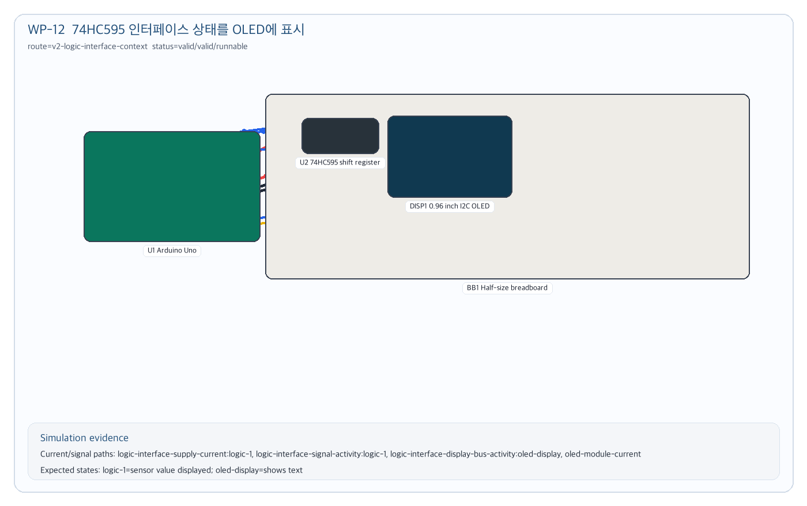
Figure 12. 74HC595 인터페이스 상태를 OLED에 표시 simulation circuit evidence

3. 실행 전 Acceptance Checklist
□ 각 케이스에서 학생의 마지막 입력이 기존 blocked artifact가 아니라 새 synthesis request로 처리된다.
□ Deepagents trace에 route, selected bundle, candidate parts, validation, render, simulation, runnable gate, solver gate가 모두 남는다.
□ Validation이 valid이고 simulation이 valid일 때만 최종 simulation 회로 이미지를 승인한다.
□ 통신/logic/interface 케이스는 실제 네트워크, 페어링, 정밀 측정, exact timing을 주장하지 않는다.
□ 지원되는 저전압 회로는 build confirmation 이후 render canvas와 current/signal overlay로 이어져야 한다.
□ 문서에 기재된 prompt budget은 maxPromptChars 이하로 유지되어야 한다.

4. 12개 케이스 최종 판정
Case | 목표 | Validation | Simulation | Runnable
01  WP-01 | 조도 센서로 어두우면 LED 켜기 | valid | valid | runnable
02  WP-02 | 버튼을 누르면 LED 켜기 | valid | valid | runnable
03  WP-03 | 조이스틱 X/Y 값을 OLED에 표시 | valid | valid | runnable
04  WP-04 | 16x2 I2C LCD에 문구 표시 | valid | valid | runnable
05  WP-05 | RGB LED 색상 믹스 | valid | valid | runnable
06  WP-06 | IRF520으로 DC 모터 구동 | valid | valid | runnable
07  WP-07 | 9V 배터리와 7805로 5V 전원 레일 만들기 | valid | valid | runnable
08  WP-08 | Arduino Nano 핀맵과 전압 도메인 보기 | valid | valid | runnable
09  WP-09 | Perfboard 배치 컨텍스트 보기 | valid | valid | runnable
10  WP-10 | BMP280 값을 OLED에 표시 | valid | valid | runnable
11  WP-11 | HC-05 로컬 UART 상태를 OLED에 표시 | valid | valid | runnable
12  WP-12 | 74HC595 인터페이스 상태를 OLED에 표시 | valid | valid | runnable

