Hardware Object Drag and Adjustment Evidence
Generated 2026-06-02 13:38 KST
Gate interpretation correction. The visual-move screenshot is not proof that a hardware placement gate accepted the moved layout. It is a dirty visual preview: canonical CircuitSpec and verified wire routes remain unchanged, and Run/current controls stay disabled until reset or hardware placement resolution. Gate-pass evidence is the hardware-move resolver output plus the adjustment-mode E2E matrix.

Implementation Evidence
Scope | What Changed | Evidence | Status
Phase 1 | Rule gate as automatic presentation adjustment | Four E2E adjustment-mode cases remain visible without unsupported controls. | Passed
Phase 2 | Scene graph and debug snapshot | Part, wire, label, and preview-wire groups expose deterministic debug metadata. | Passed
Phase 3 | Visual-only movement | Visual transforms move rendered objects and dashed preview wires without mutating CircuitSpec. | Passed
Phase 4 | Hardware movement resolver | Dragged component is sent to placement API, snapped, rerouted, and returned as canonical artifacts. | Passed
QA fix | Library-only parts excluded from default PCB stage | Demo circuit no longer shows non-circuit library parts as if they were verified hardware. | Passed

Adjustment Mode Matrix
Mode | Visible Adjustment | Control Policy | Proof
Diagnostic | Safe 3D diagnostic scene remains visible while build/current claims stay scoped. | Run/current disabled unless verified paths exist. | Phase 1 E2E
Placeholder | Generic registered placeholder may render when exact footprint evidence is missing. | Exact geometry and pin claims disabled. | Phase 1 E2E
Safe Equivalent | Unsafe original is replaced with a safe displayed equivalent. | Original never build-ready; equivalent controls follow its own validation. | Phase 1 E2E
State Only | Pin-map, layout, and static state context can render without fake current flow. | Current animation off; static inspection on. | Phase 1 E2E

Browser Evidence Screenshots
Baseline verified OLED demo scene. Library-only preview parts are no longer rendered in the PCB stage.
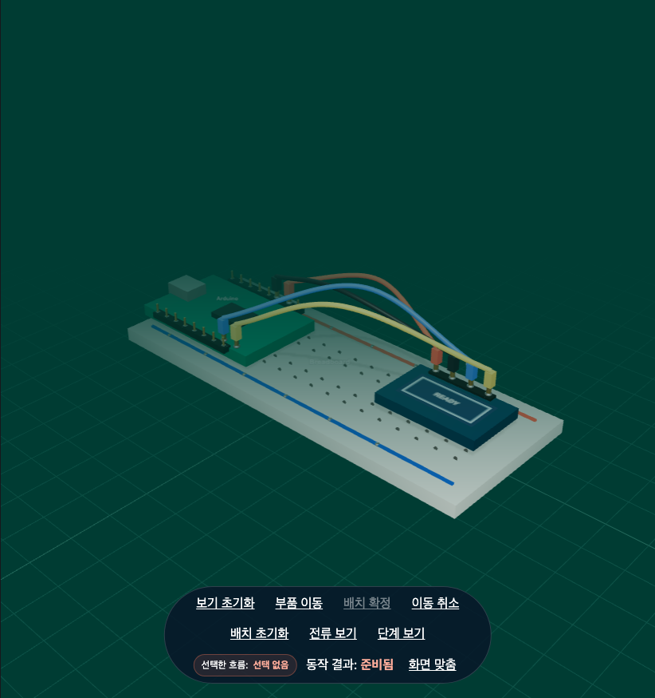

Visual-only movement preview. This is intentionally not a hardware gate pass; the scene is marked as visual arrangement and Run/current controls are disabled.
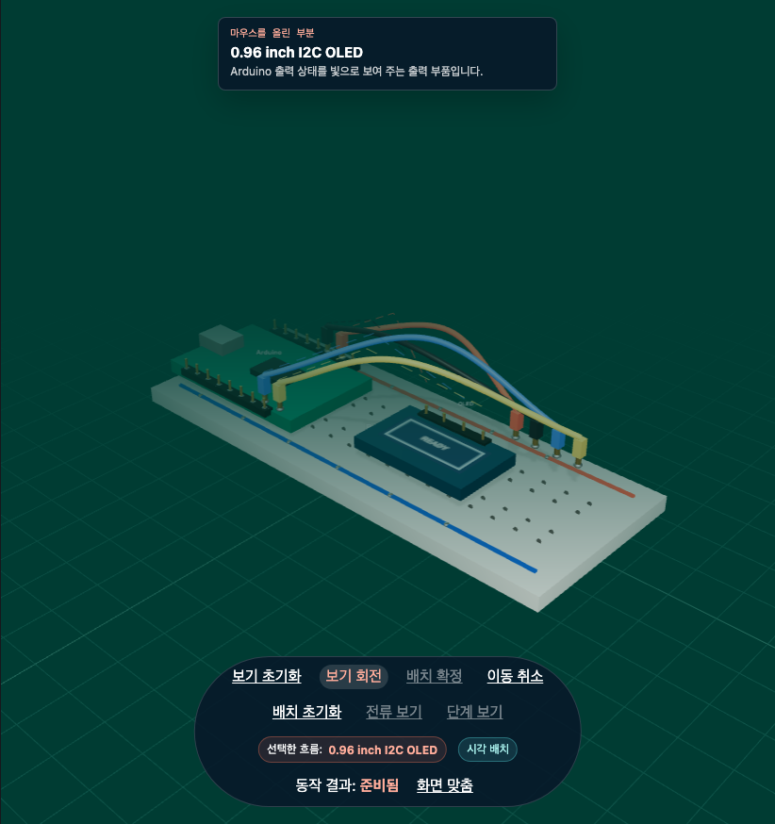

Hardware placement resolution. The dragged LED layout is returned through the placement API as a canonical adjusted render plan.
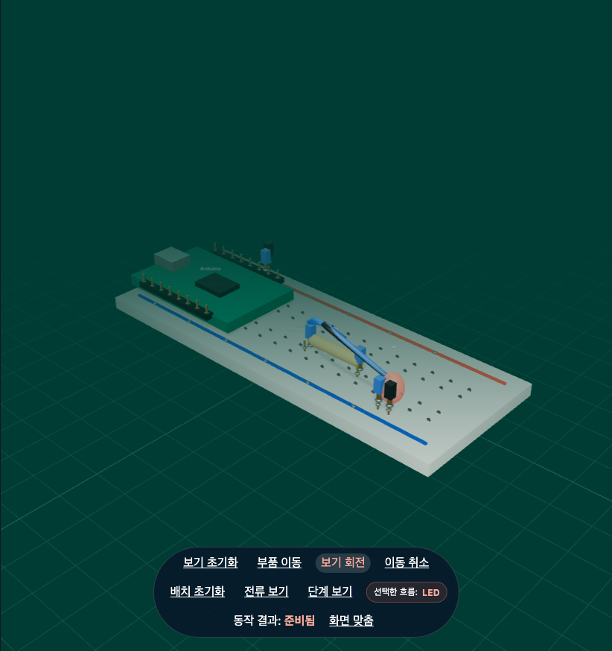

Verification Commands
Gate | Command or Case | Result
Syntax | node --check src/main.js && node --check src/stageScene.js | Passed
Typecheck | npm run typecheck | Passed
Unit | npm run test:unit | 318 passed
Build | npm run build | Passed; existing Vite large chunk warning only
Targeted E2E | Phase 1 adjustment matrix, 3D render, visual move, hardware move | 7 passed
Focused post-QA E2E | 3D render, visual move, hardware move after libraryOnly fix | 3 passed
Evidence capture | node scripts/generate_hardware_evidence.mjs | Passed

QA Notes
- The image that showed an off-board blue part was not a hardware gate-pass result; it was a visual preview and also exposed a libraryOnly rendering problem.
- Default PCB rendering now excludes libraryOnly parts so the visible stage matches the verified circuit under inspection.
- Visual movement is still allowed for inspection, but it stays dirty and disables Run/current controls until reset.
- Hardware movement is the canonical path: pointer-up sends a deterministic placement intent, then the server returns adjusted artifacts.
- The post-QA E2E test now asserts that hardware move changes wireRouteHash and remains buildReady after resolver output.

