LAPPEENRANTA-LAHTI UNIVERSITY OF TECHNOLOGY LUT   
School of Energy Systems

Electrical Engineering

FEASIBILITY EVALUATION OF LPWAN TECHNOLOGIES – CASE STUDY FOR A WEATHER STATION

Examiners: Associate Professor (tenure-track) Pedro Juliano Nardelli

Junior Researcher Dick Carrillo Melgarejo

Supervisors: Hannu Valo (Vaisala Oyj)

Panu Kilponen (Vaisala Oyj)

**TIIVISTELMÄ**

Lappeenrannan-Lahden teknillinen yliopisto LUT

School of Energy Systems

Sähkötekniikan koulutusohjelma

Vesa Mäki

**Feasibility Evaluation of LPWAN Technologies – Case Study for a Weather Station**

Diplomityö 2021

16 sivua (lasketaan sivujen lukumäärä nimiölehdestä viimeiseen sivuun), 1 kuva, 1 taulukko, 1 liite

Työn tarkastajat: Apulaisprofessori (tenure-track) Pedro Juliano Nardelli

Nuorempi tutkija Dick Carrillo Melgarejo

Hakusanat: NB-IoT, LoRaWAN, TS-UNB, Telegram Splitting, LPWAN

Tähän kirjoitetaan ytimekäs tiivistelmä: tausta, tavoite, tulokset ja johtopäätökset. Tiivistelmässä kannattaa käyttää lyhyen nasevia lauseita. Itse tekstissä voi käyttää monimutkaisempia lauseita. Tiivistelmä-sivu on yksi sivu ja tiivistelmäteksti on yksi kappale, ei useita kappaleita. On hyvä kertoa työn tavoitteet. Mikäli työ sisältää oleellisia aiheen rajauksia, ne kannattaa mainita jo tiivistelmässä. Työn tulokset ja johtopäätökset luetellaan lukijan mielenkiinnon lisäämiseksi. Opinnäytetyö kirjoitetaan passiivissa tyyliin ”tässä työssä tutkitaan” aktiivin sijaan ”minä tutkin” ja marginaalit tasataan aina sekä vasemmalle että oikealle. Työn sivunumerointi aloitetaan kansilehdeltä, mutta tätä roomalaista numeroa ei merkitä näkyviin.

**ABSTRACT**

Lappeenranta-Lahti University of Technology

School of Energy Systems

Electrical Engineering

Vesa Mäki

**Feasibility Evaluation of LPWAN Technologies – Case Study for a Weather Station**

Master’s Thesis 2021

16 pages, 1 figure, 1 table, 1 appendix

Examiners: Associate Professor (tenure-track) Pedro Juliano Nardelli

Junior Researcher Dick Carrillo Melgarejo

Keywords: NB-IoT, LoRaWAN, TS-UNB, Telegram Splitting, LPWAN

Read the instructions in Final thesis instructions” in the study guide. Here is the same text as in the Finnish abstract. Do not change the content. Present the core items of your thesis, background, goal(s), results, and the main conclusions. Favor short sentences. The text in the thesis may have sentences and structures of various styles. There is one abstract page and the abstract text is one paragraph, not two or many. Present the goal(s) of your work, present also the main constraints and delimitations, if some profound constraints are present. Main results and main conclusions are given such that the reader gets highly interested in the work done. Use passive form instead of active in the presentation, such as “this study concentrates on digital communications systems”, not as “I studied communications”. Alignment is justified (both left and right). Page numbering starts from the cover page but the page number in Roman is not printed. Page numbering with Arabic numbers start from the page with the table of contents.

**PREFACE**

This work was commissioned by Vaisala Oyj and was conducted during the second half of 2020 and the first half of 2021, the two years marked in history with the Covid-19 pandemic. For me, this was the “remote Thesis”, a heavy mental burden I was to face mostly in the solitary confines of social distancing imposed by the pandemic.

I want to thank everyone who supported me through all the small video frames and chat box windows on my screen, as well as through the audio of my headphones. Particularly thanks to my thesis supervisor Ass. Professor Pedro Nardelli at LUT University, technical supervisor Panu Kilponen at Vaisala, and especially to Junior Researcher Dick Carrillo Melgarejo at LUT University. Many thanks to all other colleagues at Vaisala, who contributed their time and keyboards in answering my questions.

Special thanks to my line managers Sabit Nasretdin and Hannu Valo at Vaisala for allowing me this thesis opportunity and your flexibility when I overshot the deadline.

Lastly, I want to thank my wife Piia for the unwavering support and patience throughout this effort and all my studies. Without you I would not be on this road.

**TABLE OF CONTENTS**

[1 Introduction 10](#_Toc65759329)

[1.1 Background 11](#_Toc65759330)

[1.2 Regarding Terminology 13](#_Toc65759331)

[1.3 Research Questions, Goals and Delimitations 13](#_Toc65759332)

[1.4 Methodology and Structure of the Thesis 15](#_Toc65759333)

[2 Weather Station as a Use-Case 17](#_Toc65759334)

[2.1 Message Size and Format 18](#_Toc65759335)

[2.2 Transmission Intervals 19](#_Toc65759336)

[2.3 Data Rate 20](#_Toc65759337)

[2.4 Reliability 21](#_Toc65759338)

[2.5 Communication Range 22](#_Toc65759339)

[2.6 Battery Capacity 22](#_Toc65759340)

[3 Wireless LPWAN Technologies 24](#_Toc65759341)

[3.1 NB-IoT 26](#_Toc65759342)

[3.1.1 Protocol Stack 31](#_Toc65759343)

[3.1.2 Link Adaptation 32](#_Toc65759344)

[3.1.3 Power Saving Features 36](#_Toc65759345)

[3.2 LoRaWAN 40](#_Toc65759346)

[3.2.1 Link Adaptation 42](#_Toc65759347)

[3.2.2 Frame Structure 44](#_Toc65759348)

[3.3 Telegram Splitting 45](#_Toc65759349)

[3.3.1 Frame Structure 46](#_Toc65759350)

[3.3.2 TSMA 47](#_Toc65759351)

[4 Feasibility Studies 51](#_Toc65759352)

[4.1 Coverage 53](#_Toc65759353)

[4.1.1 Regarding Propagation Models 59](#_Toc65759354)

[4.1.2 Free Space Model 60](#_Toc65759355)

[4.1.3 Hata/COST 231 Model 61](#_Toc65759356)

[4.1.4 Link Budgets 63](#_Toc65759357)

[4.1.4.1 NB-IoT 66](#_Toc65759358)

[4.1.4.2 LoRaWAN 70](#_Toc65759359)

[4.1.4.3 TS-UNB 71](#_Toc65759360)

[4.2 Duration of Activity States 72](#_Toc65759361)

[4.2.1 NB-IoT 73](#_Toc65759362)

[4.2.2 LoRaWAN 75](#_Toc65759363)

[4.2.3 TS-UNB 77](#_Toc65759364)

[4.3 Duty Cycle 78](#_Toc65759365)

[4.3.1 LoRaWAN 80](#_Toc65759366)

[4.3.2 TS-UNB 81](#_Toc65759367)

[4.4 Data Rate 81](#_Toc65759368)

[4.4.1 NB-IoT 82](#_Toc65759369)

[4.4.2 LoRaWAN 84](#_Toc65759370)

[4.4.3 TS-UNB 84](#_Toc65759371)

[4.5 Energy Consumption 85](#_Toc65759372)

[4.6 Battery Lifetime Estimation 88](#_Toc65759373)

[4.7 Costs 89](#_Toc65759374)

[4.7.1 LCC Cost Calculation 91](#_Toc65759375)

[5 Results and Discussion 95](#_Toc65759376)

[5.1 Coverage 95](#_Toc65759377)

[5.2 Duration of Activity States 97](#_Toc65759378)

[5.3 Duty Cycle 100](#_Toc65759379)

[5.4 Data Rate 101](#_Toc65759380)

[5.5 Energy Consumption and Battery Lifetime 102](#_Toc65759381)

[5.6 Costs 107](#_Toc65759382)

[6 Conclusions 110](#_Toc65759383)

[6.1 NB-IoT 110](#_Toc65759384)

[6.2 LoRaWAN 111](#_Toc65759385)

[6.3 TS-UNB 111](#_Toc65759386)

[6.4 Future Work 112](#_Toc65759387)

[7 Summary 113](#_Toc65759388)

[References 114](#_Toc65759389)

**APPENDIX 1 Comparison table of wireless technologies**

**APPENDIX 2 Link to original calculations and simulations**

**LIST OF FIGURES**

|  |  |  |
| --- | --- | --- |
| Figure 1 | Example weather station use-case setup. | 12 |
| Figure 2 | Wireless connectivity use-case representations. | 17 |
| Figure 3 | Various configurations of the weather station. [55] | 18 |
| Figure 4 | Various wireless access technologies presented with relation to maximum range, adapted from [11]. | 24 |
| Figure 5 | NB-IoT subcarrier spacing [29]. | 28 |
| Figure 6 | NB-IoT UL Resource Unit assignment combinations [36]. | 28 |
| Figure 7 | NB-IoT physical signals and channels [29]. | 29 |
| Figure 8 | Generalization of NB-IoT DL and UL frame structure with 15 kHz subcarrier spacing [36]. | 30 |
| Figure 9 | NB-IoT user data protocol stack. | 32 |
| Figure 10 | End-device behavior between transmission events [38]. | 38 |
| Figure 11 | RRC\_IDLE state eDRX example as given by [47]. | 39 |
| Figure 12 | Examples of LoRa up-“chirps” for different spreading factors. [16]. | 41 |
| Figure 13 | LoRa Class A downlink slots [39]. | 42 |
| Figure 14 | LoRa frame structure [35]. | 44 |
| Figure 15 | TSMA benefit against interference, as expressed by [7]. | 46 |
| Figure 16 | TSMA operation. [19] | 48 |
| Figure 17 | Determining time between radio bursts for TS-UNB uplink [19]. | 49 |
| Figure 18 | Communication system model [46]. | 51 |
| Figure 19 | Gains and losses affecting signal level of a transmission. | 53 |
| Figure 20 | MCL and MPL. | 58 |
| Figure 21 | Path-loss and effects of large-scale and small-scale variations as a function of distance to signal power [14]. | 60 |
| Figure 22 | Path loss curves for different environment categories with Hata/COST 321 model with BS height at 40 meters and UE at 2 meters, and carrier frequency 880.09 MHz (NB-IoT). Range up-to: a) 15 km and b) 2 km. | 65 |
| Figure 23 | NB-IoT simulation result for NPUSCH for TBS=1544. | 67 |
| Figure 24 | Indicative NB-IoT uplink SNR thresholds for each level, while achieving BLER of 10 %. | 69 |
| Figure 25 | MSK modulation BER to . | 72 |
| Figure 29 | LCC breakdown for NB-IoT. | 107 |
| Figure 30 | LCC breakdown for LoRaWAN and TS-UNB. | 108 |

**LIST OF TABLES**

|  |  |  |
| --- | --- | --- |
| Table 1 | LwM2M protocol stack overhead down to network-layer. | 19 |
| Table 2 | Uplink data rate requirements. | 20 |
| Table 3 | Generated monthly cumulative data in MB per month. | 21 |
| Table 4 | 3GPP Standardized QCI characteristics, level 6. | 22 |
| Table 5 | Profile current consumption and battery capacity. | 23 |
| Table 6 | List of IoT aimed wireless technologies. | 25 |
| Table 7 | Combined tables for NB-IoT DL DCI information [21]. | 33 |
| Table 8 | Supported combinations of , , and , for frame structure type 1 used to carry uplink user data [20]. | 34 |
| Table 9 | Combined tables for NB-IoT UL DCI information [22]. | 35 |
| Table 10 | EU863-870 Data Rate and end-device output power [34]. | 43 |
| Table 11 | TS-UNB radio frame transmission times [19]. | 50 |
| Table 12 | Uplink link budget parameters. | 64 |
| Table 13 | NB-IoT uplink TBS values with corresponding SNR requirement values (in dB). | 68 |
| Table 14 | NB-IoT uplink TBS values with corresponding APL values (in dB). | 70 |
| Table 15 | LoRa sensitivity and SNR requirement values for corresponding SF for bandwidth of 125 kHz [52]. | 71 |
| Table 16 | Parameter values chosen for NB-IoT power saving features. | 75 |
| Table 17 | Uplink OaT parameters per message. | 78 |
| Table 18 | Summary of Duty Cycle regulation of license-exempt spectrum in Europe and the US [10]. | 79 |
| Table 19 | OaT per subcarrier. | 81 |
| Table 20 | Power (P) in | 88 |
| Table 28 | Battery lifetime estimation in days for each technology and message interval. | 104 |
| Table 21 | LCC cost items. | 93 |
| Table 22 | Calculated LoRa APL and corresponding Hata/COST 231 rural/open PL model distance values for each SF for bandwidth of 125 kHz. | 96 |
| Table 23 | State durations for NB-IoT | 97 |
| Table 24 | State durations for LoRaWAN and TS-UNB. | 99 |
| Table 25 | LoRaWAN SF7 uplink message interval feasibility against duty-cycle limits. | 100 |
| Table 26 | Uplink duty cycle results. | 101 |
| Table 27 | L2 data rates. | 102 |
| Table 29 | LCC results for 100 weather stations. | 108 |
| Table 30 | LCC results for 2 weather stations (and 1 BS). | 109 |
| Table 31 | Full list of comparison factors. | 123 |

**LIST OF SYMBOLS AND ABBREVIATIONS**

|  |  |
| --- | --- |
|  |  |
|  |  |
| 3GPP | 3rd Generation Partnership Project |
| 5G NR | 5G New Radio |
| BER | Bit Error Rate |
| BLE | Bluetooth Low Energy |
| BLER | Block Error Rate |
| BPSK | Binary Phase Shift Keying |
| BTS | Base Transceiver Station |
| CE | Coverage Extension |
| CIMO | Commission for Instruments and Methods of Observation |
| CoAP | Constrained Application Protocol |
| DMU | Data Management Unit |
| DRX | Discontinuous Reception |
| DSSS | Direct Sequence Spread Spectrum |
| DTLS | Datagram Transport Layer Security |
| eNB | Evolved Node B |
| ETSI | European Telecommunications Standards Institute |
| E-UTRAN | Evolved Universal Terrestrial Radio Access Network |
| FDD | Frequency-division duplexing |
| GSM | Global System for Mobile |
| IEEE | Institute of Electrical and Electronics Engineers |
| IoT | Internet of Things |
| IPv4 | Internet Protocol version 4 |
| IPv6 | Internet Protocol version 6 |
| ISM | Industrial Scientific Medical |
| LAN | Local Area Network |
| LBT | Listen-Before-Talk |
| LPWA(N) | Low-power Wide Area (Network) |
| LTE | Long Term Evolution |
| M2M | Machine-to-Machine |
| MAC | Media Access |
| MCL | Maximum Coupling Loss |
| MNO | Mobile Network Operator |
| MPL | Maximum Path Loss |
| MTC | Machine-Type-Communications |
| NB-IoT | Narrow Band Internet of Things |
| OFDMA | Orthogonal Frequency Division Multiple Access |
| PAN | Personal Area Network |
| PDCP | Packet Data Convergence Protocol |
| PER | Packet Error Rate |
| PHY | Physical |
| PSM | Power Saving Mode |
| QoS | Quality of Service |
| QPSK | Quadrature Phase Shift Keying |
| RAN | Radio Access Network |
| RF | Radio Frequency |
| RLC | Radio Link Control |
| SC-FDMA | Single Carrier – Frequency Division Multiple Access |
| SF | Spreading Factor |
| SIG | Special Interest Group |
| TDD | Time-division duplexing |
| TLS | Transport Layer Security |
| TS-UNB | Telegram Splitting Ultra-Narrowband |
| UE | User Equipment |
| UNB | Ultra-Narrowband |
| wM-Bus | Wireless Meter Bus |

# Introduction

Vaisala has a long history in designing weather stations and in utilization of wireless access technologies. Installation locations are sometimes exotic or otherwise out of reach of telecommunication lines, which means that a wireless link may be the only option. In addition to satellite-based systems, for the choice wireless link technology, two categories are available which differ in their use of radio spectrum. The first is cellular technologies, standardized by 3GPP, which operate on licensed spectrum. The second is the many radio technologies operating on unlicensed spectrum, which come based to either an open standard or proprietary technology.

Particularly for the latter category, the last decade has sprung up a multitude of choices along with the rise (or the expectation) of concepts such as Internet of Things (IoT) and Industry 4.0. In the IoT, sensory devices and connectivity is embedded to all the “things” around us in our homes, city streets, cars and even clothing, bringing about an internet where machines talk to machines (M2M). This in a sense is nothing new. M2M communication has existed for decades. The difference is in the volume of information which arises from connecting massive amounts of devices to the internet. With the use management platforms, big data analysis, machine learning and smart algorithms IoT then promises to enable a “smart world”.

During the first half of 2010s, it became apparent, that 3GPP and progression of cellular technologies was late to the game of IoT, so to say. At that time, cellular technologies of 2G, 3G and LTE (4G) where mainly focused to provide connectivity and capability to Human-to-Machine (H2M) type of communications, as in video calls and smartphone web surfing, and not well suitable for the resource constrained small sensors as characterized by the IoT. As a consequence, many new technologies were developed to fill-in that niece, such as Zig-Bee, LoRaWAN, SigFox, TS-UNB and Weightless to name a few. Generally, these were designed from the ground up to cater IoT devices and aim to favor low energy consumption and simple and low-cost hardware design with the expense of data rate and reliability or coverage.

However, IoT covers a wide range of use-cases, and here lies an issue. Due to laws of nature, some use-case requirements are contrary to others. For example, achieving minimal energy consumption with very long communication range and high data rate. Emphasis for one side of a coin means a sacrifice for the other. Because of this fact, most of the current IoT focused wireless technologies are aimed at specific use-cases that come with a set of specific requirements. To add to the mix, 3GPP also eventually noticed the IoT, and has since developed new IoT specific cellular technologies under the umbrella of 5G, of which LTE-M and NB-IoT are currently in adoption. The question thus is: “Which wireless technology is best suited for my use-case?”

## Background

Traditionally, Vaisala’s customers for weather stations are national meteorological organizations, research centers, airports, militaries and other publicly funded entities, as well as larger corporations. A common factor is the requirement of top tier measurement accuracy, quality and reliability. On the other hand, another common trait for these customers is that they traditionally are not very avid in hopping on with the latest technology trends, but tend to stick to established ones (even until forced to move on due to components reaching end-of-life -status).

Thereof, it is not surprising to find the many weather stations and instruments of this field equipped with serial line output telemetry based on TIA-485/422/232 standards. They are still considered as industry standard output telemetry options, and many customers request support of these “legacy” interfaces. The landscape is changing however, and perhaps due to the media hype around 5G and the IoT during the past decade, a growing voice in the market is asking for modern communication options. The fact that many people increasingly have cheap wirelessly connected smart sensors at their homes may also play a role in shifting attitudes on a personal level.

Wirelessly connected sensors have the advantage of providing options for greater diversity of installation location, since the location is not bound by the availability of wired communication medium. A weather station commonly includes sensor elements, but can additionally act as a base station, to which other sensors connect to from further afield. This is illustrated in the example of Figure 1. Generally, there is more freedom to choose the installation location to get the most accurate and representative measurement. Material and labor costs may be reduced due as no cabling work is required.

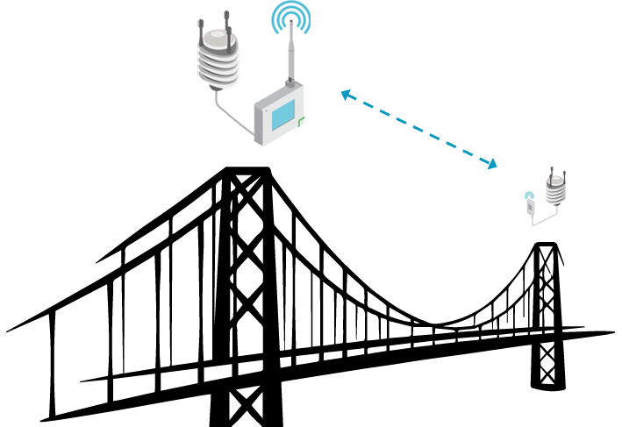

**Figure 1.** Example weather station use-case setup.

The aspiration is that the weather station would be simple to deploy with freedom to choose a location that is not bound by access to wired communications and mains-power. However, lack of mains power necessitates reliance on batteries and energy harvesting, commonly with solar panels, and imposes a requirement to focus on minimizing energy consumption. Wireless communication, due to the nature of the transmission, is generally more power hungry, which furthermore demands emphasis on the communication technology choice and weather station and its module design to minimize energy consumption to prevent or at least minimize any down time

This background provides the motivation for this work. The purpose of this work is to research the feasibility of a few chosen wireless technologies in the context of a weather station and its specific requirements.

## Regarding Terminology

There are a multitude of different terms used in literature, whilst discussing the area of wireless IoT. Cellular terminology largely comes from 3GPP nomenclature and specifications, which are riddled with abbreviations. Some terms have also changed over the course of specification evolution, such as NB-IoT and LTE-M, which have changed between different 3GPP releases. Commonly, specifications may use different terms, than what industry and marketing use, as is the case with IEEE 802.11 / WiFi. Then there are industry use-case terms, which are sometimes used as umbrellas for multiple technologies. An example being massive Machine-Type-Connections (mMTC). As a reaction to this and in an attempt to introduce clarity, this report aims to mention the many terms used for each technology, but use the term most commonly given in academia.

In telecommunications, different functions and behavior of data transactions are commonly arranged and defined as protocols, which can be thought of as software modules with each performing some specific function. This may be, in example, internet addressing or data encryption. Each protocol has an input interface and an output product, and they are arranged as layers in what is called a protocol stack. At the top is what is called an application layer, and at the bottom is the physical layer where data actually takes the form of ones and zeros on the wire / radio waves. When discussing protocol layers, the layer in question is often referred to as, where is the layer number starting from one at the physical layer. In layer numbering, this work refers to the TCP/IP protocol layer model.

## Research Questions, Goals and Delimitations

This work sets out to answer the question “*What is the most feasible wireless technology for the use-case of a weather station?*” To get to the bottom of this topic there are many prior questions to answer. Since there are a multitude of different technologies introduced in the industry, both proprietary and open standard, as well established and newly emerging, to keep this report at reasonable length, it is necessary to define which technologies to include in our more detailed analysis. More specifically, the wireless technologies in question here are categorized as Low-Power Wide Area Network (LPWAN) technologies. The choice of technologies in this work is further discussed in Chapter 3.

Generally, this work mainly relies on information and works available in industry and academia. Most analyses presented here base on theory and any derived information through calculation or simulation. No empirical analyses were conducted for any technology by the author, but references to empirical results of analyses conducted by others may be given.

It is very difficult or possibly even impossible to do general comparisons between technologies. This is because each tech has their unique behavior (which may be dynamic and beyond user’s control), which is heavily affected by the specific use-case. Technologies may also face operational restrictions such as duty cycle and packet size limits.

For example, LoRaWAN has maximum supported packet sizes of 51, 112 and 251 Bytes depending on the spreading factor (SF) used. SF is dynamically adjusted based on observed signal conditions. NB-IoT has a similar concept of coverage extension (CE) level, but no restrictions on packet size or duty cycle. Is it fair to make the comparison with a payload the size of 512 Bytes, which would cause fragmentation with LoRaWAN, but not with NB-IoT? But selecting a smaller payload may not reflect the optimal situation for NB-IoT.

While it may be technically possible to perform direct simulation based analysis and comparison by fixing enough of the variables involved according to a specific use-case, how confident can one be on the representativeness of the results to real deployments, because of the highly dynamic behavior and environment? How useful will any information gained for this sort of analysis ultimately be?

Of course, the feasibility of the entire weather station including the communication module is subject to meeting many other requirements, of which one of the greatest is the overall energy consumption. This work limits the focus to the aspects of the communication technology, and purposely does not consider of the device as a complete system, its measurement interval, processing, or other such points. Transmission interval is included in the analysis, being an integral component to communication. In addition, to limit the scope, this work will mainly focus on uplink.

Finally, IoT connectivity is a very broad subject, and the choice wireless communication technology is only a small part of getting data from the IoT device to the end user. This work will concentrate mainly on the physical and data link layers of data communication. Aspects regarding higher layers will only be addressed where appropriate for the reader’s convenience, like, in example, for the subject of packet sizes and amount of traffic generated.

## Methodology and Structure of the Thesis

Feasibility can be determined through an evaluation of capabilities versus requirements. Factors to be used in the evaluation must be defined, such as upstream/downstream data rate, range, transmission interval etc. from the use-case requirements. A key sub-topic of interest for this work in conjunction with other capabilities, is the energy consumption characteristics of each wireless technology. Consequently, the work flows on towards an analysis of energy consumption, while defining and setting prerequisite factors along the way. The factors used in this evaluation can mainly be straightforwardly derived numerical values.

The analysis starts with Chapter 2, where the specific use-case at the focus of this study – Vaisala weather station – is defined along with its requirements as factors of feasibility in discrete measureable values.

Chapter 3 covers the wireless technologies analyzed in this work, which identify themselves as IoT specific and low-power/energy. Because of the fact that the array of technologies in the LPWAN category is relatively large, the author conducted a prior pre-study and compared technologies by their “data sheet figures” against the use-case requirements. The purpose was to narrow down candidates to three most potential ones for a more detailed analysis in this work. Focus is to give an overview of each technology and details of lower layers of the protocol stack, mainly physical (PHY) and media-access (MAC) layers, L1 and L2.

After presenting the technologies, Chapter 4 proceed with the feasibility analysis. Each factor is analyzed consecutively and in a chain-like order, which results from relationships the factors have to each other. Each factor analysis requires making assumptions on values to input parameter and produce results based on those assumptions. Subsequent factors in the relationship chain then use the results for their input parameters, as applicable. This chapter also covers the basic understanding and theoretical basis of each factor, and presents calculations or simulations used to derive results. Any further presumptions or other limitations are also given.

Chapter 5 presents results of each factor’s feasibility analysis and discusses the implications of findings individually. Chapter 6 then draws up the findings together to as final conclusions on feasibility of each technology for the use-case. Topics of potential and interesting future work are also presented. Lastly, Chapter 7 summarizes the work.

# Weather Station as a Use-Case

This chapter introduces three weather station IoT use-case profiles. Use-case for **Profile 1** (P1a) is for an end-device, which has direct connectivity to a cloud-service. Generally, the message transmitted over the wireless link includes the application payload and full stack protocol overhead, such as IP-addressing, as applicable to the technology. **Profile 2** (P2) represents a device, which connects to a local gateway. In example, an auxiliary sensor element connected wirelessly to a larger station. Here the application layer payload is smaller and the wireless link is burdened only with its inherent protocol overhead. Figure 2 illustrates both use-cases.

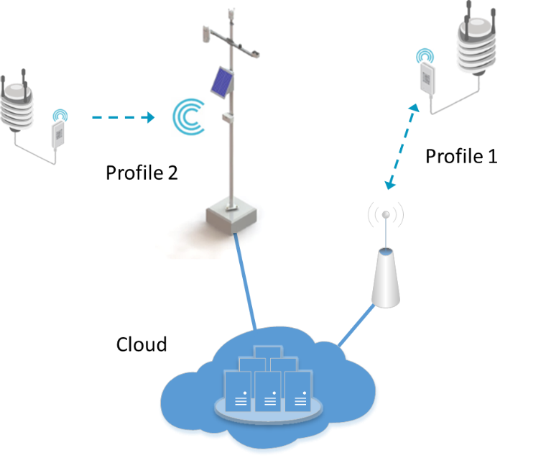

**Figure 2.** Wireless connectivity use-case representations.

The two profiles feature their own set of requirements, which are presented in more detail in the following chapters. For each, the weather station only assumes the role of end-device.

The same hardware is assumed in both profiles. As given in the datasheet [55] of the weather station, it is a compact instrument, which provides measurement of multiple weather related parameters: temperature, humidity, air pressure, rainfall, wind speed and direction. Various different configurations of the station are offered as shown in Figure 3, but this case-study will focus on the configuration with broadest set of measurements.

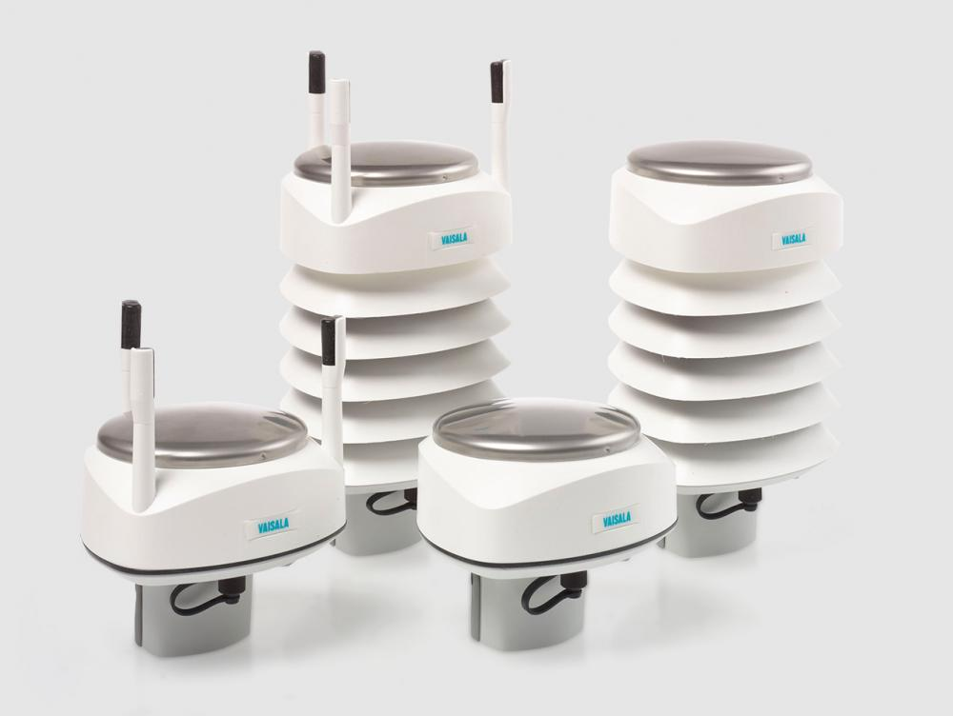

**Figure 3.** Various configurations of the weather station. [55]

The following chapters present the weather station use-case further and define its requirements and evaluation factors. For energy consumption and cost factors there is no requirement, but are still ranked.

## Message Size and Format

The weather station is highly configurable, and has many types of output messages available. In this work we consider two types of messaging. The message type used with P1 is an LwM2M application framework implementation.

In short, LwM2M (abbreviated from lightweight machine-to-machine) defines a framework with a protocol stack to enable communication between client and server. As a framework, it also includes various supporting services (interfaces), such as device bootstrapping, client registration, device management and information reporting. It is optimized to be used with resource constrained IoT devices and minimizes overhead data through the use of a protocol called Constrained Application Protocol (CoAP). CoAP may be described as a simplified version of Hypertext Protocol (HTTP). A CoAP header is only 4 bytes and it is usually used over User Datagram Protocol (UDP), while supporting Datagram Transport Layer Security (DTLS). [32]

The LwM2M-message amounts to about 1 KB in size for the weather station. In this work LwM2M application framework is assumed to use CoAP with UDP and DTLS encryption. Further, technology specific lower layer headering (from L1 to L3) must be added to get the total figure for frame size. For LwM2M they are approximated in Table 1 down to the network layer.

Table 1. LwM2M protocol stack overhead down to network-layer.

|  |  |  |
| --- | --- | --- |
| **Layer** | | **LwM2M**  **Size [Byte]** |
| Application | L5 | 1000 |
| Transfer | CoAP: 4 |
| Transport | L4 | DTLS: 13 |
| UDP: 8 |
| Network | L3 | IPv4/-6: 20/40 |
| Total |  | 1045 |

For P2 the message is based on a commonly used lightweight ASCII string message, called *composite message*. For example:

*1R0,Dm=169D,Sm=0.9M,Ta=16.0C,Ua=81.3P,Pa=1005.5H,Rc=40.15M,Ri=0.0M,Hc=0.0M,Hi=0.0M,Th=16.3C,Vh=25.6N<CR><LF>*

The composite message amounts to 102 characters (and 102 Bytes), where both carriage-return *<CR>* and linefeed *<LF>* signify one character each. For P2, it is assumed that L4 headering is included (without DTLS), amounting to at least 110 Bytes. Whether L3 headering is included with either profile message depends on the technology.

## Transmission Intervals

The weather station can be individually configured for different measurement and transmission intervals. The configuration options are presented in detail in the User’s Guide [56]. This case-study uses four different transmission intervals: 3 seconds, 15 seconds, 1 minute and 10 minute. These figures are selected to reflect the most common reporting intervals among customers by Vaisala’s experience as a manufacturer of weather stations. The interval of 3 seconds is used to support wind gust reporting.

## Data Rate

According to measurements at Vaisala, an end-device for Profile 1 transmits approximately 743374 Bytes and receives 10602 Bytes over a period of 2717 seconds for observation transmission interval of 60 seconds. This consists of about 45 observation data packets plus general network overhead of NTP and DNS-queries, broadcasts and the like. These values provide approximations of the generated data volumes and may be used as requirements for the MAC-layer data rate. Extrapolated rate requirements for both profiles are recorded in Table 2. Similarly, Table 3 gives the monthly cumulative amount of data generated. With P2, MAC-layer data rate requirement are taken directly from the payload size defined in the previous chapter and transmit intervals.

Table 2. Uplink data rate requirements.

|  |  |  |
| --- | --- | --- |
| **Interval** | **Data rate (bps)** | |
| **P1** | **P2** |
| 3 seconds | 1555.4 | 293.3 |
| 15 seconds | 311.1 | 58.7 |
| 60 seconds | 77.8 | 14.7 |
| 600 seconds | 7.8 | 1.5 |

It should be noted, that the derived values for 3, 15 and 600 second intervals are biased due to linear scaling of network overhead included in the measurement. For 3 and 15 second intervals the portion of overhead is overemphasized, while for 600 second interval the portion is underemphasized. Unfortunately the ratio between payload data and overhead is not known for the measurements to allow estimation of compensation factor. For technologies, which include no L3 headering in their message, the values are also further slightly overemphasized.

Table 3. Generated monthly cumulative data in MB per month.

|  |  |  |  |
| --- | --- | --- | --- |
| **Interval** |  | **P1** | **P2** |
| 3 seconds | UL | 504.0 | 95.0 |
|  | DL | 202.3 |  |
| 15 seconds | UL | 100.8 | 19.0 |
|  | DL | 40.5 |  |
| 60 seconds | UL | 25.2 | 4.8 |
|  | DL | 10.1 |  |
| 600 seconds | UL | 2.5 | 0.5 |
|  | DL | 1.0 | 95.0 |

## Reliability

Most of Vaisala’s customers for weather stations are industrial or enterprise customers. High reliability and availability is of great importance to these sectors, since the weather station data is used as part of many customers’ business processes. Reliable packet delivery is essential.

The fastest transmission interval of 3 seconds results in messages per day. Missing one message per day requires a Packet Error Rate (PER) of 10-5 or better. The reliability requirement can also be defined through industry standards and a good representation is given by the 3GPP Quality Class Indicator (QCI) level as expressed in TS 23.203 Ch. 6.1.7, here applicably abbreviated to Table 4. With cellular technologies reliability is commonly given as Block Error Rate (BLER) and here the requirement is set to 10% BLER. [33]

Table 4. 3GPP Standardized QCI characteristics, level 6.

|  |  |  |
| --- | --- | --- |
| **QCI level** | **PER** | **Example Services** |
| 6 | 10-6 | TCP-based (e.g., www, e-mail, chat, ftp, p2p file sharing, progressive video, etc.) |

Additionally, for both profiles, bidirectional data transmission capability is required in order for the higher layers to acknowledge transmissions and to request retransmissions.

Longevity is also defined as a requirement of reliability. General expectation in many industries for technology-lifetime is 10 to 15 years. Therefore, required life-time of used wireless technology is set to 10 years. Any technology involved should be expected to still exist and have support well into the 2030s.

## Communication Range

There is a broad range of application areas where localized weather observation data is utilized. This translates directly as a very broad range of installation locations and from the connectivity perspective, encompasses the dense connectivity of cities to sparser in rural areas, or even “remote islands” on offshore platforms and ships. This work specifies 1000 meters as the minimum required communication distance between weather station transmitter and gateway / base station, at which the required reliability and transmission intervals can be maintained.

## Battery Capacity

The weather station is expected to use include batteries, but we may expect some differences between use-case profiles. The battery capacity and current consumption for the minimum operation of the weather station as presented in Table 5.

Table 5. Profile current consumption and battery capacity.

|  |  |  |  |  |
| --- | --- | --- | --- | --- |
|  | **P1a** | | **P2** | |
| Battery capacity | 8000.0 | mAh | 3600.0 | mAh |
| Self-discharge | 0.03 | mA | 0.01 | mA |
| Weather station | 16.06 | | mA | |

The weather station power consumption comprises of base consumption of 1.5 mA and measurements for wind (4.5 mA), pressure-temperature-humidity (0.9 mA) and continuous precipitation (0.4 mA) for a 12 V supply. The total is adjusted to 3.6 V with a factor of 2.2. In general, the overall power consumption is highly dependent on the wind measurement, as much as 61%. According to the WXT User’s Guide [56], for wind the default is a sampling rate of 4 Hz and continuous measurement, but much lower consumption may be achieved by selecting a lower sampling rate and including measurement averaging.

# Wireless LPWAN Technologies

This chapter presents the technology options evaluated by this work. As explained in Chapter 1, the expected boom of the IoT market has sprung up a multitude wireless technologies, all aiming for different niches, while striving to gain popularity and market share. This presents a challenge for a designer to figure out the most suitable for their use-case. The available technologies include short-range radio protocols (such as ZigBee, Bluetooth and IEEE 802.11 Wi-Fi); longer-range radio protocols (such as LoRaWAN, SigFox and TS-UNB); or mobile networks with LTE-M, NB-IoT, legacy 2G and 3G, LTE 4G and 5G. There are also many others, mostly proprietary in nature at least in part. An indicative presentation of different technologies capability with respect to range is given in Figure 4 below.



**Figure 4.** Various wireless access technologies presented with relation to maximum range, adapted from [11].

To reduce complexity of this work, technologies were filtered by a pre-selection step based on qualitative high-level evaluation of technology capability against use-case requirements. The original list of technologies considered for the evaluation is given in Table 6, while arguments for the filtering of different technologies are given in the following paragraphs.

Table 6. List of IoT aimed wireless technologies.

|  |  |
| --- | --- |
| **WPANs** | Bluetooth Low Energy, Z-Wave (ITU G.9959), IEEE 802.15.4 (ZigBee, Thread, WirelessHart) |
| **WLANs** | IEEE 802.11ah (WiFi HaLow) |
| **LPWANs** | LoRaWAN, SigFox, TS-UNB, Telensa, Ingenu, Weightless standards, DASH7, Wireless M-Bus |
| **Cellular** | LTE-M, NB-IoT, EC-GSM-IoT, Legacy 2G, 3G and LTE |

A capability with a high limiting effect is communication range, for which, in this work, a minimum limit is defined in Chapter 2.5. This prunes many of the WPAN-labeled technologies such as Bluetooth Low Energy, Z-Wave, and IEEE 802.15.4 based ZigBee, Thread and WirelessHART, which are mainly rated for range of max. 100 meters. As stated by [48], utilization of the 2.4 GHz unlicensed band is in practice only applicable in short range communication of some tens of meters at best.

In the face of the argument of lack of range, advocates of WPAN-technologies will mention that many feature mesh-networking capability to reach greater coverage. In a mesh-topology, a node may communicate with any other node in the network either directly or by routing through other nodes. A mesh-network is also at best self-organizing and self-healing [5]. However, meshing requires well planned networks and high node density to achieve adequate levels of reliability and low outage probability. The node density needed for a mesh-network to cover our required range may be available cities, but it is not conceivable to expect such in rural or even suburban areas. Yet, authors in [4] also note, that real-life deployments, such as the ZigBee enabled smart meter example of Barcelona, can experience unforeseen problems with reliability. That system commonly experienced outages and high latency in the order of minutes at the worst due to the dynamically changing environment’s effect on channel conditions of the multi-hop natured network. A weather station with the ability to connect to a meshing network in itself is an attractive concept from a sales point-of-view. However, there are again multiple technologies to choose from and the reliability concerns alone are worth their own dedicated investigation.

SigFox is widely promoted by industry and has also been the subject of much academic work. All in all, it provides an easily approachable service for a narrow range of use-cases. However, our use-case does not fit in to this range simply due to SigFox’s limits in maximum payload size of 12 Bytes and amount of allowed daily packets, 140 on the uplink. [47]

This work will not consider any legacy cellular technologies (2G/3G/4G), even though they have been widely used in the past for similar use-cases – by Vaisala as well. They offer great coverage and adequate data rates, as well as being standardized and mature technologies with world-wide network deployments. Still, their greatest short coming is energy consumption, of which improvement aspirations have led to the development todays NB-IoT, LTE-M and EC-GSM-IoT standards in the first place.

Neither EC-GSM-IoT nor IEEE 802.11ah will be considered as both lack in popularity by the industry. Lastly, technologies such as Telensa, Ingenu, Weightless, DASH7 etc. will not be considered due to not having enough information available regarding their inner workings. Further feasibility study will conducted for **NB-IoT**, **LoRaWAN** and **TS-UNB**.

For reference, Appendix 1 presents a comparison table of above mention technologies. Data was sourced from various standards and academic and industry literary sources such as [10; 15; 19; 26; 29; 33; 34; 39; 40; 43; 44; 53].

## NB-IoT

The second technology proposed in 3GPP Release 13 for M2M communications is Narrowband-IoT (NB-IoT). It is sometimes also referred to as Cat-NB1, and was originally proposed as a clean-slate approach called NB-CIoT by Huawei [28]. Release 14, introduced a second device category, referenced as Cat-NB2, which introduced performance improvements and higher peak data rates. In Release 15, 3GPP performed an evaluation of NB-IoT against a set performance requirements, which were agreed and defined for the *Fifth Generation* (5G) *massive machine-type communications* (mMTC) use-case concept. According to [33], NB-IoT qualifies as a member under the 5G mMTC umbrella by meeting those requirements in all fronts with margins to spare. This work specifically refers to Cat-NB2, when discussing about NB-IoT.

Bandwidth-wise NB-IoT requires 180 kHz of spectrum for both up- and downlink, respectively. It’s designed to be relatively simple to deploy as a direct replacement of an LTE or Global System for Mobile (GSM) sub carrier. Alternatively an LTE guard-band may be used for deployment. NB-IoT deployments are referred to as *stand-alone*, *in-band* or *guard-band* deployments in 3GPP nomenclature. Also, any new hardware is not required by the network operator as deployment requires only a software update to existing equipment. [33]

NB-IoT builds upon the same radio frame structure as LTE. For uplink, Single Carrier – Frequency Division Multiple Access (SC-FDMA) is used, while Orthogonal Frequency Division Multiple Access (OFDMA) is for downlink. For the uplink, the 180 kHz bandwidth is divided to either 12 or 48 subcarriers (SCs) with correspondingly 15 kHz or 3.75 kHz spacing. The downlink always uses 15 kHz spacing. In the downlink a cycle of 1024 time domain hyper frames is repeated, where each hyper frame contains 1024 frames. One frame is made of 10 subframes, each lasting 1 ms. A subframe is further divided to two 0.5 ms slots, both carrying seven OFDM symbols. If 3.75 kHz spacing is used on the uplink, then slot duration expands to 2 ms. This is illustrated in in Figure 5 and Figure 8. The uplink can be further chosen to use either single or multi-carrier transmissions, which in NB-IoT are referred to as tones. For multi-tone transmission, subcarrier spacing (SCS) is always 15 kHz and 3, 6 or 12 subcarriers can be used. [29; 33; 36]

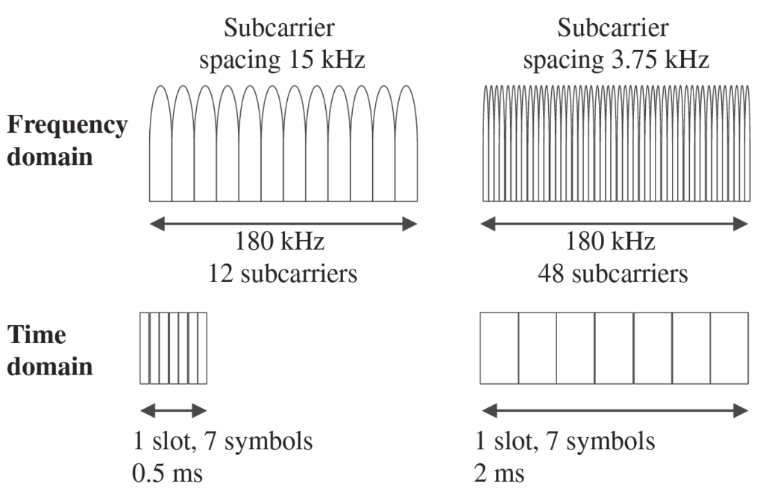

**Figure 5.** NB-IoT subcarrier spacing [29].

NB-IoT brings along a new type of resource mapping scheme in the uplink, called the Resource Unit (RU). The RU, illustrated in Figure 6, results from the combination of the number of subcarriers and the number of timeslots. The way the RU is used is explained in the following chapter. [36]



**Figure 6.** NB-IoT UL Resource Unit assignment combinations [36].

Similar to LTE, the up- and downlink carry information over a number of different signals and channels, which are listed in Figure 7.

Downlink

Uplink

Narrowband Physical Random Access Channel

Narrowband Physical Uplink Shared Channel

Demodulation Reference Signal

Narrowband Physical Downlink Shared Channel

Narrowband Physical Downlink Control Channel

Narrowband Physical Broadcast Channel

Narrowband Reference Signal

Narrowband Secondary Synchronization Signal

**NPSS**

**NSSS**

Narrowband Primary Synchronization Signal

**NRS**

**NPBCH**

**NPDCCH**

**NPDSCH**

**NPRACH**

**DMRS**

**NPUSCH**

**Figure 7.** NB-IoT physical signals and channels [29].

NPRACH channel has three main uses. Over this channel, UEs performs the initial connection procedure to the network, request radio resources when they wish to transmit, and reconnect to the network in case of link failure. During initial network access, UEs acquire the network’s information by listening for the Master Information Block (MIB) and System Information Blocks (SIBs), which are transmitted periodically by the eNB, from channels NPBCH and NPDCCH, respectively. The NRS channel’s purpose is with cell search and initial system acquisition, where as NPSS and NSSS handle frequency and timing synchronization for the UE with the eNB. Actual user data is transmitted over the NPDSCH and NPUSCH channels. It should also be noted, that in contrast with LTE, NB-IoT utilizes no control channel for uplink, and any control data is transmitted over NPUSCH. [29]



**Figure 8.** Generalization of NB-IoT DL and UL frame structure with 15 kHz subcarrier spacing [36].

When the end-device has data to send upstream, it first makes a request for scheduled resources. The request is made over the NPARCH procedure, and the eNB responds with DCI report, with the scheduling and resource info. According to this information, the end-device sets its parameters and transmits the data. Similar procedure happens on the downlink. However, this time there is no request, but instead the UE tunes-in to the downlink data on the NPDSCH according to the DCI information received on the NPDCCH. The contents of DCIs are and resourcing is explained in Chapter 3.1.2 in more detail. Chapter 3.1.3 also shed further light on how the end-device is informed to expect downlink data. [29; 38]

3GPP defines three levels of coverage extension (CE) for NB-IoT operation: normal, robust and extreme, through which dynamic service is provided for devices in varying levels of network coverage. The extreme CE is expected for devices located indoors or underground. The coverage level is dynamically adjusted through control signaling and it dictates the type of channel coding, modulation, amount of repetitions, and such measures used. Data rates are poorer with robust and extreme CE levels, but perceived receiver sensitivity is increased. Repetitions can be applied individually per channel and count up to 2048. NB-IoT incorporates MAC-layer reliability mechanisms, which do ensure message delivery. However, in the worst case, latencies potentially measured in the order of seconds may be experienced. [29; 38]

On paper, NB-IoT is capable of an instantaneous peak physical data rate of 250 kbps on the uplink and 170 kbps on the downlink. The instantaneous peak physical data rate is often the performance metric included in data sheets. However, it does not account for signaling and data scheduling overhead present overall for a transmission. Actual sustained rates are much lower and highly dependent on the channel conditions and determined CE level. NB-IoT offers no Quality of Service (QoS) concept and thus cannot guarantee any minimum bit rate. Peak MAC-layer data rates, which include all the physical layer overhead of signaling and data scheduling may be in the range of 26 kbps (depends on deployment type) for downlink and 62 kbps for uplink [29; 33; 40].

NB-IoT is secured with LTE type encryption on the link. However, TCP/UDP payloads crossing over to the Internet should be further encrypted at the Transport layer with Transport Layer Security (TLS) or Datagram Transport Layer Security (DTLS). Essentially, NB-IoT exposes devices with direct TCP/IP connectivity to the Internet, and therefore should be secured with appropriate measures.

UEs transmission power is set by an open-loop power control as defined in [33], when the number of used repetitions is less than three. Furthermore, three power classes are given in Release 13 and 14 specifications: 14, 20 or 23 dBm for the maximum transmit power level. Lastly, NB-IoT employs power saving features, which affect UEs behavior in the network, as further explained in Chapter 3.1.3. [38]

### Protocol Stack

The maximum payload size for each transmission is 1600 bytes. In other words, this is the maximum supported size of the Packet Data Convergence Protocol (PDCP) Service Data Unit (SDU) payload, which is the protocol just below the Network-layer on the protocol stack. PDCP-protocol is responsible of functions such as transfer of user data, sequence numbering, Robust Header Compression (ROHC) function, ciphering and integrity protection. It adds a header to the data before it is passed down to the Radio Link Control (RLC) protocol as an RLC SDU. The NB-IoT protocol stack for user data is given in Figure 9 for reference. [24]

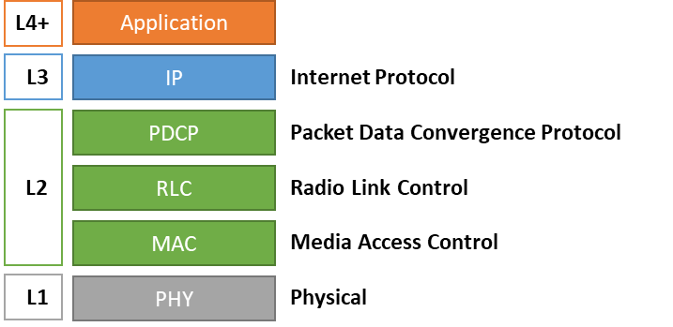

**Figure 9.** NB-IoT user data protocol stack.

The RLC protocol is a complex layer, and its main duty is to frame higher layer payloads into lower layer segments (RLC PDUs) of a size indicated by the MAC layer as the chosen Transport Block Size (TBS) for the transmission. The RLC is also responsible for functions such as error correction through automatic repeat requests (ARQs), duplicate detection, protocol error detection and recover, and more. [23]

### Link Adaptation

In NB-IoT, the end-device and the eNB determine the link parameters based on a derived estimation of the channel state. Essentially, the idea is to choose the appropriate number of Resource Units (RU), the modulation, code rate, transport block size and repetitions to accommodate a minimum BLER of 10 %. The eNB informs the UE over the NPDCCH with a Downlink Control Indicator (DCI) report on what resources the UE can use, what modulation and coding scheme is to be utilized for the transmission and demodulation of received data, and the number of repetitions to use. There are different formats of the DCI for various circumstances. Generally, format 0 is used to define parameters for UL and formats 1A-D and 2A-C are for DL. [21]

On the downlink NPDSCH, for user data the DCI informs the UE of the number of subframes () in the resource assignment index field (). Repetition count () is given in the DCI repetition number indication field (). Modulation order for downlink is always. To determine the MCS, the UE must read the 4-bit MCS indication field () on the DCI. The transport block size (TBS) in bits is then given by associatingfor the assigned number of subframes. This is summarized in Table 7. The downlink is always modulated with QPSK and uses Tail Biting Convolutional Coding (TBCC) with a code rate of 1/3 [20; 21].

Table 7. Combined tables for NB-IoT DL DCI information [21].

|  |  |  |  |  |  |  |  |  |  |  |  |  |
| --- | --- | --- | --- | --- | --- | --- | --- | --- | --- | --- | --- | --- |
|  |  |  |  |  |  | | | | | | | |
| 0 | 1 | 0 | 1 | 0 | 1 | 2 | 3 | 4 | 5 | 6 | 7 |
| 1 | 2 | 1 | 2 | 0 | 16 | 32 | 56 | 88 | 120 | 152 | 208 | 256 |
| 2 | 4 | 2 | 3 | 1 | 24 | 56 | 88 | 144 | 176 | 208 | 256 | 344 |
| 3 | 8 | 3 | 4 | 2 | 32 | 72 | 144 | 176 | 208 | 256 | 328 | 424 |
| 4 | 16 | 4 | 5 | 3 | 40 | 104 | 176 | 208 | 256 | 328 | 440 | 568 |
| 5 | 32 | 5 | 6 | 4 | 56 | 120 | 208 | 256 | 328 | 408 | 552 | 680 |
| 6 | 64 | 6 | 8 | 5 | 72 | 144 | 224 | 328 | 424 | 504 | 680 | 872 |
| 7 | 128 | 7 | 10 | 6 | 88 | 176 | 256 | 392 | 504 | 600 | 808 | 1032 |
| 8 | 192 |  |  | 7 | 104 | 224 | 328 | 472 | 584 | 680 | 968 | 1224 |
| 9 | 256 |  |  | 8 | 120 | 256 | 392 | 536 | 680 | 808 | 1096 | 1352 |
| 10 | 384 |  |  | 9 | 136 | 296 | 456 | 616 | 776 | 936 | 1256 | 1544 |
| 11 | 512 |  |  | 10 | 144 | 328 | 504 | 680 | 872 | 1032 | 1384 | 1736 |
| 12 | 768 |  |  | 11 | 176 | 376 | 584 | 776 | 1000 | 1192 | 1608 | 2024 |
| 13 | 1024 |  |  | 12 | 208 | 440 | 680 | 904 | 1128 | 1352 | 1800 | 2280 |
| 14 | 1536 |  |  | 13 | 224 | 488 | 744 | 1032 | 1256 | 1544 | 2024 | 2536 |
| 15 | 2048 |  |  |  |  |  |  |  |  |  |  |  |

On the uplink, for NPUSCH channel, the DCI includes similar information. First there is the subcarrier indication field (), which determines how many subcarriers, and on which frequencies, are allocated for a resource unit. Then, in the DCI, the resource assignment indication field () gives the number of resource units (), and the repetition count () is given by the repetition number indication field (). MCS is determined by the MCS indication field () in the DCI. Modulation order (the modulation technique) is dependent on the used subcarrier spacing and number of allocated subcarriers for the RU.

* If, the modulation order and TBS indication are given by table 16.5.1.2-1 of [22] and as given in Table 9.
* If, then modulation order and.

Allowed values for are listed in Table 8. [20; 22]

Table 8. Supported combinations of , , and , for frame structure type 1 used to carry uplink user data [20].

|  |  |  |  |  |
| --- | --- | --- | --- | --- |
| **NPUSCH format** |  |  |  |  |
| 1 | 3.75 kHz | 1 | 16 | 7 |
| 15 kHz | 1 | 16 |
| 3 | 8 |
| 6 | 4 |
| 12 | 2 |
| 2 | 3.75 kHz | 1 | 4 |
| 15 kHz | 12 | 4 |

Finally, TBS is derived according to and. The above details are summarized below in

Table 9. The uplink is modulated with either Binary Phase Shift Keying (BPSK) or Quadrature Phase Shift Keying (QPSK), and uses Turbo coding with a code rate of 1/3. Lower coding redundancy is achieved on higher MCS levels, which means greater TB sizes for equal number of RUs. [20; 21; 39]

Table 9. Combined tables for NB-IoT UL DCI information [22].

|  |  |  |  |  |  |  |  |  |
| --- | --- | --- | --- | --- | --- | --- | --- | --- |
|  |  |  |  |  | | | | |
|  |  |  |  |  |  |  | **Modulation** | |
| 0 | 1 | 0 | 1 | 0 | 1 | 0 | BPSK | |
| 1 | 2 | 1 | 2 | 1 | 1 | 2 | BPSK | |
| 2 | 4 | 2 | 3 | 2 | 2 | 1 | QPSK | |
| 3 | 8 | 3 | 4 | 3 | 2 | 3 | QPSK | |
| 4 | 16 | 4 | 5 | 4 | 2 | 4 | QPSK | |
| 5 | 32 | 5 | 6 | 5 | 2 | 5 | QPSK | |
| 6 | 64 | 6 | 8 | 6 | 2 | 6 | QPSK | |
| 7 | 128 | 7 | 10 | 7 | 2 | 7 | QPSK | |
|  |  |  |  | 8 | 2 | 8 | QPSK | |
|  |  |  |  | 9 | 2 | 9 | QPSK | |
|  |  |  |  | 10 | 2 | 10 | QPSK | |
|  |  |  |  |  |  |  |  |  |
|  |  | | | | | | | |
| 0 | 1 | 2 | 3 | 4 | 5 | 6 | 7 |
| 0 | 16 | 32 | 56 | 88 | 120 | 152 | 208 | 256 |
| 1 | 24 | 56 | 88 | 144 | 176 | 208 | 256 | 344 |
| 2 | 32 | 72 | 144 | 176 | 208 | 256 | 328 | 424 |
| 3 | 40 | 104 | 176 | 208 | 256 | 328 | 440 | 568 |
| 4 | 56 | 120 | 208 | 256 | 328 | 408 | 552 | 680 |
| 5 | 72 | 144 | 224 | 328 | 424 | 504 | 680 | 872 |
| 6 | 88 | 176 | 256 | 392 | 504 | 600 | 808 | 1032 |
| 7 | 104 | 224 | 328 | 472 | 584 | 680 | 968 | 1224 |
| 8 | 120 | 256 | 392 | 536 | 680 | 808 | 1096 | 1352 |
| 9 | 136 | 296 | 456 | 616 | 776 | 936 | 1256 | 1544 |
| 10 | 144 | 328 | 504 | 680 | 872 | 1032 | 1384 | 1736 |
| 11 | 176 | 376 | 584 | 776 | 1000 | 1192 | 1608 | 2024 |
| 12 | 208 | 440 | 680 | 904 | 1128 | 1352 | 1800 | 2280 |
| 13 | 224 | 488 | 744 | 1032 | 1256 | 1544 | 2024 | 2536 |

NB-IoT is designed to be usable also in fringe areas of coverage (such as basements) and the main tool to achieve this is use of transmission repetitions. For NPRACH and NPUSCH, the number of repetitions can be chosen from the range defined by, where. For NPDSCH the number of repetition reaches up to 2048. Repetitions increase the probability of successful decoding by increasing the perceived SNR at the receiver. In general, repeated copies of the transmission at the receiver can be combined, and the resulting SNR () can be thought as the sum of SNRs of each transmission copy. This can be expressed as

|  |  |
| --- | --- |
|  | (1) |

This assumes that the channel conditions do not change between transmissions of each repetition. [5; 33]

### Power Saving Features

Add here about power headroom and dynamic power control!!!!

In NB-IoT, the Radio Resource Control (RRC) is the function, similar to LTE, which handles many of the logical connectivity procedures. RRC has two states: Idle and Connected. These include connection establishment and release, broadcast of control information, paging notifications and such. A UE starts in RRC\_IDLE state, and transits to RRC\_CONNECTED after it has established connection. In RRC\_CONNECTED, the UE may request communication resources from the network. [38; 42]

Discontinuous reception (DRX) is a feature specified in 3GPP cellular technologies, which allows IoT devices to conserve energy. In general, to receive downlink data, the UE needs to know of pending transmission, and thus when to turn on its receiver. The information of pending downlink data is informed by the network through a paging procedure similar to LTE, in specific sub frames called Paging Occasions (POs). The procedure specifies which sub frame, within specific radio frames called Paging Frames (PFs), to listen to. What results is cycles of alternating periods of active reception and idling. Hence it’s called discontinuous reception, and the feature is available for both RRC\_CONNECTED and RRC\_IDLE -modes. Some UEs may also transfer into a sleep-mode during this idle period for further energy conservation. Energy saving are further optimized by the fact that during idling or sleep-mode both the network and the UE maintain device context. This reduces signaling needs as well as need to renegotiate security in the case that the UE transitions back to RRC\_CONNECTED state for new up- or downlink data. [33; 38; 47; 51]

When the UE transitions to RRC\_CONNECTED state, the UE communicates any up- and downlink data with the network, and two timers, referred to as the DRX Inactivity Timerand the RRC Inactivity Timer, are started. Overall, the time the UE spends in RRC Connected state depends on the RRC Inactivity Timer, which length is determined by the network. DRX Inactivity Timer on the other hand is a duration while the UE is actively receiving. It can have values in ms, where, and value 0 disables the timer. If any downlink scheduling or an uplink grant is received in the NPDCCH, both timers are restarted. [33; 38; 47; 51]

There are some differences in how DRX functions in both RRC states. Below are the definitions and naming used in this work:

* Connected-DRX (C-DRX) cycle. In RRC\_CONNECTED state.
* I-DRX cycle. In RRC\_IDLE state.
* I-eDRX cycle. Alternative to DRX cycle in RRC\_IDLE state.
* Idle-DRX (I-DRX) cycle. Executed within a DRX/eDRX cycle.

After DRX Inactivity Timer expires, the UE can start with C-DRX cycles until RRC Release. After RRC Inactivity Timer expires, the UE takes action for the RRC Release and transitions to RRC\_IDLE state. If no further data is to be sent or is received, then the length of RRC\_IDLE state is determined by the Tracking Area Update (TAU) timer. A TAU may be thought of as an ultimate “Hello, I’m still here” message to the network, if no other communication is performed by the UE. [33; 38; 51]

In LTE, C-DRX has to types: a short or a long cycle. For IoT-applications, based on [47], the short cycle is optional and hardly used. Thus, the long cycle is only discussed here. The long C-DRX cycle can range from 10 to 2560 ms and consists of two periods: a period of continuous active listening for notification of pending downlink data through NPDCCH, called OnDuration; and an opportunity for a period of idle/sleep through the rest of the cycle. The OnDuration may range from 1 to 100 SFs (1 - 100 ms).

Alternatively, the UE may request use of extended DRX cycle in RRC\_CONNECTED state, but it is only applicable for the long cycle. Essentially, C-eDRX modifies the parameter values to specific to NB-IoT, while the functionality is the same as C-DRX. DRX Inactivity Timer and OnDuration can range up to 32 SFs, while DRX-cycle is extended to 9216 SFs. Figure 10 presents the behavior a UE goes through and the different DRX cycles while transitioning between RRC states, including DRX Inactivity Timer. [47]

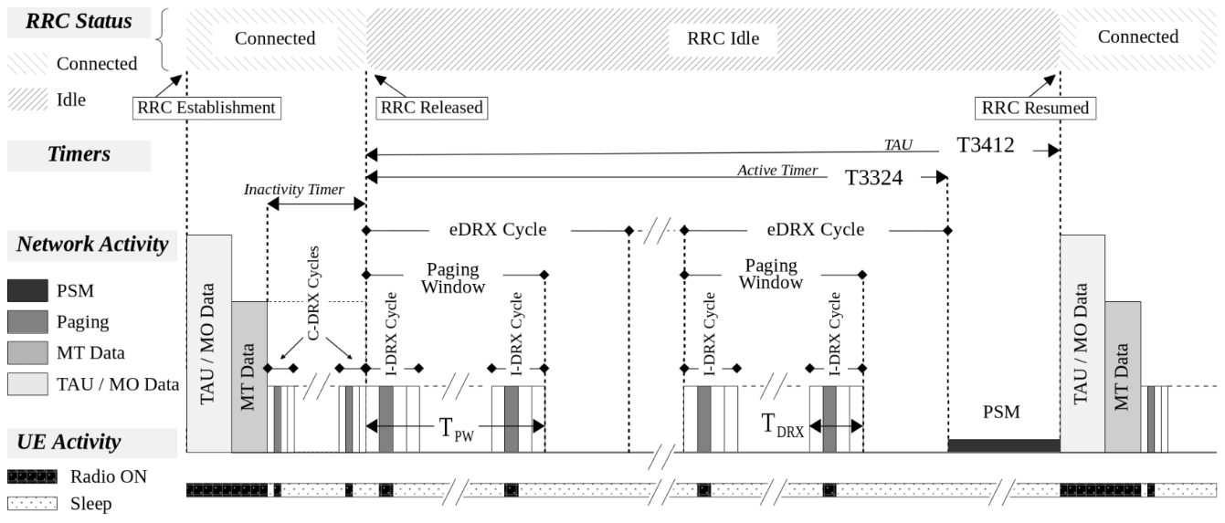

**Figure 10.** End-device behavior between transmission events [38].

If C-DRX/-eDRX is used, an UE may also set a flag called Release Assistance Indicator (RAI), while communicating with the network before an uplink data transmission. The RAI flag indicates to the eNB that the UE expects to: send another uplink transmission; receive a downlink transmission; or neither. Based on the flag information, the eNB has the opportunity to perform RRC Release ahead of time of the RRC Inactivity Timer, which allows the UE to reduce time spent in C-DRX. [41]

As mentioned, within RRC\_IDLE, the UE may employ the I-DRX paging procedure to check for any downlink data. The paging is controlled by several timers. In general, the time during which the UE is reachable from the network is determined by the Active Timer T3324. The timer’s length is determined by the number of I-DRX/-eDRX cycles performed by the UE and is in the range of 0 s to 11160 seconds. I-DRX paging cycle is similar to LTE, as explained in a previous paragraph. PFs occur at periods of either 128, 256, 512 or 1024 RFs. Within a PF, up to 4 specific SFs may be assigned as POs. The UE needs to only listen to only one PO. Which PO the UE listens to is controlled by the network through a calculation process. [47]

Alternatively, the UE may request use of eDRX cycle in RRC\_IDLE state, which adds an extra layer to the process. An eDRX cycle is counted in Paging Hyper Radio Frames (PHs) with one hyper RF equaling 1024 radio frames. Valid values between PHs follow the formula, where, which allows for the maximum period of a little less than three hours. Within a PH, there is a further Paging Time Window (PTW,), during which I-DRX cycles performed (PFs observed). Valid values for PTW start from 256 RFs and go up to 4096. Figure 11 presents the above functionality. [33; 38; 47; 51]

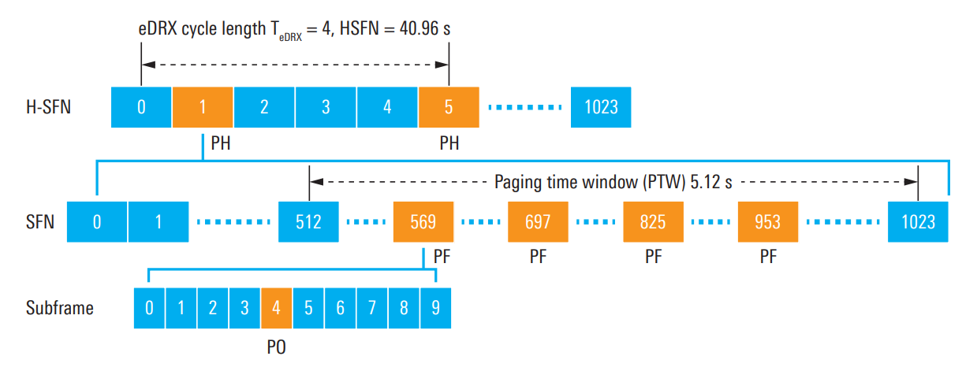

**Figure 11.** RRC\_IDLE state eDRX example as given by [47].

Power Saving Mode (PSM) is specifically named as a concept by 3GPP in Release 12/13 to decrease device power consumption. Generally, in PSM, an end-device or its communication module assumes a sleep-mode, where various hardware components are powered down. UE is waken from sleep-mode either when the TAU timer expires or when it has data to send. The maximum value for the TAU timer is 1 year. Overall, as mentioned, some of the timers, such as RRC Inactivity Timer or PTW, are mandatory and set by the network. Others may be controlled by the UE to the limits set by the network operator, if any. [31; 33; 38]

## LoRaWAN

LoRaWAN is a wireless technology (MAC-layer protocol) most commonly using the license-exempt spectrum. At its heart is LoRa, short for “Long Range”, a patented proprietary physical layer technology from Semtech. While the physical layer is proprietary, the higher layers are part of the open standard LoRaWAN, managed by The LoRa Alliance™.

LoRaWAN utilized in different deployments. There are free and public networks, which may be used freely for non-commercial activities, such as The Things Network. Additionally, many telecom operators have deployed their own networks and offer subscription based connectivity. Finally, users may acquire their own LoRaWAN gateways to deploy private networks. [10]

The physical layer part, LoRa, works on the sub-1 GHz industrial, scientific and medical (ISM) bands. LoRa is commonly distinguished and remembered by its use of the chirped spread spectrum (CSS) modulation technique. In CSS, a narrow-band signal is spread to a wider bandwidth in pulses of finite length of increasing or decreasing frequency. These are called up or down “chirps”. The waterfall graph of Figure 13 gives examples of these chirps in domains of frequency and time. CSS is also called as a wideband linear frequency modulation technique. As common with spread spectrum techniques, the resulting modulated signal has high resilience against interference and is difficult to detect or jam. Alternatively, specifically in Europe, LoRa may also utilize Gaussian Frequency-Shift Keying (GFSK) modulation. [11; 16; 32; 37; 39]

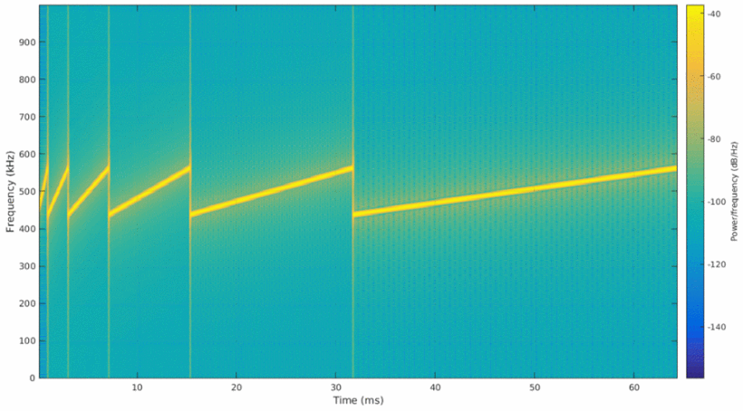

**Figure 12.** Examples of LoRa up-“chirps” for different spreading factors. [16].

Channel access of LoRa is based on purely on ALOHA principle. This means, that LoRa end-devices do not follow any channel access protocol, but always immediately transmit any new data. LoRaWAN networks are star of star topologies, where LoRa gateways act as hubs, and listen-in for messages. The gateways are then responsible of further relaying of the messages to a central-server, often through a higher capacity wired medium. In LoRaWAN, end-devices are not tied to any specific gateway, and the same message may be received (and relayed) by multiple gateways. In this situation, it is up to the central server to filter out the duplicates. [11; 16; 39]

LoRaWAN employs three different device classes regarding downlink data transmissions. Class-A is for power-constrained end-devices and applications, which require no, or only minimal, downlink communications (i.e. acknowledgements). End-devices in this class often utilize sleep-modes extensively between transmission events, and thus the downlink communication is only possible during windows after uplink transmissions. After each uplink transmission, the end-device will listen for short periods for any incoming downlink messages as shown in Figure 13. If a downlink transmission is initiated during either periods, the end-device will continue to receive until the end of the transmission. [39]

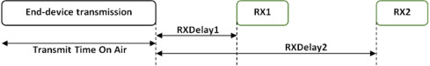

**Figure 13.** LoRa Class A downlink slots [39].

Class-B builds on top of Class-A uplink receive slots by opening an additional receive window at scheduled times regardless of uplink events. Scheduling on the other hand requires the end-device to synchronize with a gateway beacon so that the gateway knows when the end-device is in receive state. Finally, Class-C is for devices, essentially gateways, which are connected to a constant power source. In Class-C, the device is listening for incoming messages at all times except while transmitting. [39]

### Link Adaptation

LoRa transmissions employ a concept named spreading factor (SF) to combat varying channel conditions. SF is the ratio between symbol rate and chip rate. In spread spectrum techniques, such as CSS, DSS or CDMA, data bits are added with pseudorandom sequences, which result in pulses known as chips. The chip rate is always greater than the data rate. An increased SNR may be achieved with a higher SF, but with the expense of greater On-air Time (OaT) of the message. Indeed, each step in SF results with double the OaT for the same message payload size. This is illustrated in Figure 13. There are six levels for the spreading factor, and the value of SF configuration parameter ranges from 7 to 12. SFs are orthogonal with respect to each other, which thus allows separation between networks utilizing different SFs. [8]

LoRa can operate on different channel bandwidths ranging from 7.8 kHz to 500 kHz. Still, many commercial implementations use only three different bandwidths: 500, 250 or 125 kHz. Additionally, the specification [34] of LoRaWAN lists region specific sets of channels, which end-devices may use. In example, in Europe there are six 125 kHz channels listed in the 864.10 – 864.50 and 868.10 – 868.50 MHz frequency ranges.

LoRa is reported to be able to provide bitrates from 250 bps to 50 kbps. The actual rate much depends on SF, CR, channel bandwidth configuration and country/region specific ISM band uses. The bitrate achievable with LoRa follows the equation

|  |  |
| --- | --- |
|  | (2) |

where is the spreading factor, the used bandwidth and the coding rate. [3; 11; 39]

In actuality, the LoRaWAN specification [34] specifies pre-calculated bitrates (DR) for various regions, such as Europe, US, China, etc. Not all are covered here, and instead the DRs for region of Europe are given in Table 10 as reference.

Table 10. EU863-870 Data Rate and end-device output power [34].

|  |  |  |  |  |  |  |
| --- | --- | --- | --- | --- | --- | --- |
| **DR** | **Configuration** | **Indicative PHY bitrate (bit/s)** | **CR** |  | **level** | **Configuration** |
| 0 | LoRa: SF12 / 125 kHz | 250 | 4/6 |  | 0 | 20 dBm (if sup.) |
| 1 | LoRa: SF11 / 125 kHz | 440 | 4/6 |  | 1 | 14 dBm |
| 2 | LoRa: SF10 / 125 kHz | 980 | 4/5 |  | 2 | 11 dBm |
| 3 | LoRa: SF9 / 125 kHz | 1 760 | 4/5 |  | 3 | 8 dBm |
| 4 | LoRa: SF8 / 125 kHz | 3 125 | 4/5 |  | 4 | 5 dBm |
| 5 | LoRa: SF7 / 125 kHz | 5 470 | 4/5 |  | 5 | 2 dBm |
| 6 | LoRa: SF7 / 250 kHz | 11 000 | 4/5 |  |  |  |
| 7 | FSK: 50 kbps | 50 000 |  |  |  |  |

LoRa also employs a feature called Adaptive Data Rate (ADR), which allows it to adapt and optimize data rate and of end-device according changing channel conditions.

To increase sensitivity, LoRa employs Forward Error Coding (FEC). The code rate (CR) used to encode the message payload may be set to either 4/5, 4/6, 4/7 or 4/8 ratios. With regard to LoRa, the CR is often expressed as a parameter in literature, and the coding rate is given by , where . [8]

### Frame Structure

LoRaWAN end-devices can be connected to the internet via the gateway. More specifically, the LoRa message does not include L3-headering, but relies on an assigned device-address, which allows gateways to identify each device. Upon receiving a message, the gateway then appends L3 and other headers in order to forward the message to a data collection platform.

The frame structure with header fields and sizes are depicted in Figure 14. The fields indicating values starting from zero are optional, and may be omitted if the frame is only used to transmit commands to the receiver with no FRM Payload. Acknowledgements are transmitted as a bit in the Frame header’s (FHDR) Frame Control (FCtrl) byte. [35]



**Figure 14.** LoRa frame structure [35].

The physical LoRa frame transmission always starts with a preamble, which is by default 12 symbols long. The preamble is used for synchronization, but also is encoded with a sync word to be used to differentiate LoRa networks from each other if they utilize the same frequency band. The preamble length, denoted by , is configurable up-to 65535 symbols. The LoRa frame may optionally include a physical header (PHDR) and a header Cyclic Redundancy Check (CRC) field. The PHDR and PHDR CRC are always coded with and the CR used for the payload is stored in the header. This allows communication between radios using different CR, such is the case for a gateway receiving messages from end-devices operating in various noise and interference environments. The PHDR also includes information such as payload length (1 byte) and if a payload CRC is included. It can be noted, that setting the payload length field to just 1 byte restricts the maximum payload size per frame to 255 bytes. [5; 35; 52]

## Telegram Splitting

Telegram Splitting Ultra Narrow Band (TS-UNB) is the name given for the ETSI TS 103 357 standard, which is to supersede the older Wireless M-Bus standard. TS-UNB was originally developed by the Fraunhofer Institute for Integrate Circuits (IIS) and currently the most prominent implementation is the MIoTy® protocol by the Canadian company BerhTech.

The main idea of the technology is to split higher layer data packets into small sub-packets (radio bursts) at the physical layer, which are transmitted pseudo-randomly over frequency and time. The receiver (base station) listens to the whole spectrum and reassembles the sub-packets to a coherent packet. The main idea is to give each radio burst (RB) a short on-air period, and thus avoid one interfering transmission from corrupting the entire message. The name given to this method is Telegram Splitting Multiple Access (TSMA) in the specification and illustrated in Figure 15. [19]

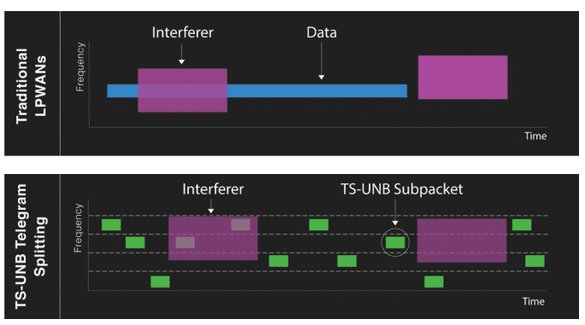

**Figure 15.** TSMA benefit against interference, as expressed by [7].

TS-UNB communication is asynchronous and initiated by the end-device. The protocol supports two communication classes, A and Z. Class A is for uplink data only and class Z is for bidirectional transmissions, which are supported with downlink having a defined transmission period after any uplink transmissions. Acknowledgements may be used in both links as a bit-flag in the MAC header. Channel coding is used in the RBs to increase receiver sensitivity (down to -139 dBm) and, as advertised by BehrTech, up-to 50% of RBs may be lost while still allowing for successful reassembly. Transmission are modulated with coherent Minimum Shift Keying (MSK) or Gaussian MSK (GMSK) modulation. TS-UNB may be operated on license-exempt bands with channel bandwidths of 25, 100 or 725 kHz. These are respectively referred to as Narrow, Standard and Wide TSMA modes in the specification. [19]

### Frame Structure

TS-UNB end-devices can be connected to the internet via the gateway. More specifically, the sent message does not include L3-headering, but relies on an assigned device-address, which allows a gateway to identify each end-device. Upon receiving a message, the gateway then appends L3 and other headers in order to forward the message to a data collection platform.

Higher layer data payload size may be up to 245 bytes in uplink and 250 bytes in downlink. The payload is first encrypted with AES128 before arriving to the MAC-layer. On the uplink the MAC-layer protocol data unit (MPDU) includes the application payload and max. 15 bytes of headering including the fields: header, address, packet counter, MAC-payload format indicator (MPF) and a cipher-based message authentication code (CMAC). At the physical layer, the MPDU is taken as input for the physical payload data unit (PSDU), which may be minimum 20 and maximum 255 bytes in size. If the MPDU is less than 20 bytes, then zero padding is to fill the PSDU to 20 bytes. Then a further 26 bits are added including a Cyclic Redundancy Check (CRC) and MAC-mode fields.

The radio transmission of the packet, called the radio frame, consists of a core-frame and an optional extension frame. On the uplink, the technology is optimized for payload size of 10 bytes, which builds the core-frame. The extension frame is used in addition to the core frame with payloads larger than 8 bytes. The uplink core frame consists of 24 RBs.

Finally, before sub-packetizing, the physical layer payload is whitened and encoded with 1/3 FEC of convolutional code. Each RB, or also called Burst Data Unit (BDU) at this point, make up from two data parts (A and B) of 12 symbols. During the sub-packetizing process a 12 bit pilot sequence is placed between the data parts. After modulation with MSK, the symbol rate given for both uplink (UL-ULP mode) and downlink is 2 380.371 sym/s. [19]

### TSMA

The TSMA procedure is where the radio frame is split into RBs, which are then spread over 24 subcarriers and different transmission times pseudo-randomly in what is called a TSMA pattern, as illustrated in Figure 16.

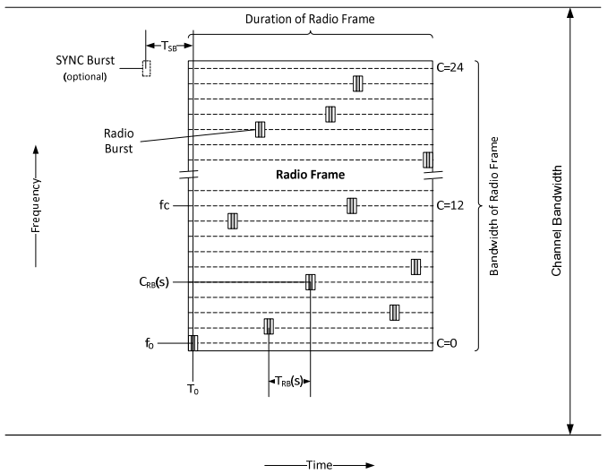

**Figure 16.** TSMA operation. [19]

For uplink, there are three groups specified for the patterns (UPG1-3), and one for downlink (DPG). UPG1 is used for single transmission, UPG2 when the radio frame is repeated and UPG3 is only used for frames with low latency requirements. The time between RBs is the Radio-burst Time,, measured between the middle points of pilot sequences of consecutive RBs in the number of symbols with duration . The tables 6-50, 6-52 and 6-54 of [19] give for each combination of pattern number and RBs index in the uplink. Table 6-57 gives the same for downlink.

As mentioned previously, the 12 symbol pilot sequence is placed between the two 12 symbol data sections. As such, between middle points of two RBs lie the equivalent of two data sections and one pilot section in the amount of symbols. Thereof the actual separation between two RBs, denoted as , is

|  |  |
| --- | --- |
|  | (3) |
|  |  |
|  | (4) |

This is illustrated in Figure 17. [19]



**Figure 17.** Determining time between radio bursts for TS-UNB uplink [19].

Given the previously mentioned symbol rate, the symbol duration. The average for the number of symbols, for each pattern group are as follows:

* UPG1: 379
* UPG2: 378
* UPG3: 82
* DPG: 507

The radio frame transmission times are in Table 6-59 of [19], and show below in Table 11.

Table 11. TS-UNB radio frame transmission times [19].

|  |  |  |  |
| --- | --- | --- | --- |
|  | **RB duration** | **Core Frame on-air time** | **Ext. frame on-air time** |
| UL-ULP | 15.14 ms | 362.97 ms | 15.14 ms per add. Byte in MPDU |
| UL-ER | 90.74 ms | 2 177.81 ms | 90.74 ms per add. Byte in MPDU |
| DL-TS | 11.76 … 21.43 ms | 105.57 ms | 211.73 … 383.13 ms  per add. ext. frame block |

# Feasibility Studies

This chapter presents all factors evaluated for feasibility. First, relevant background information and theory is given for each factor and what values are used for relevant parameters. Any assumptions made and limitations are acknowledged. Further details all calculations and simulations used to evaluate each factor are provided in APPENDIX XX.

As mentioned in Chapter 1, a wireless link is always compromise between spatial coverage, data rate and reliability. This chapter will explore the relationships between each of them. Claude Shannon described, that all electronic communication can be described by a system, which comprises of three basic parts, a transmitter, a receiver and a communications channel, as shown in Figure 18. A modulated signal is emitted by the transmitter and the receiver attempts to receive and decode it. It may not always succeed, since the communication channel imparts detrimental effects upon the signal’s reception.

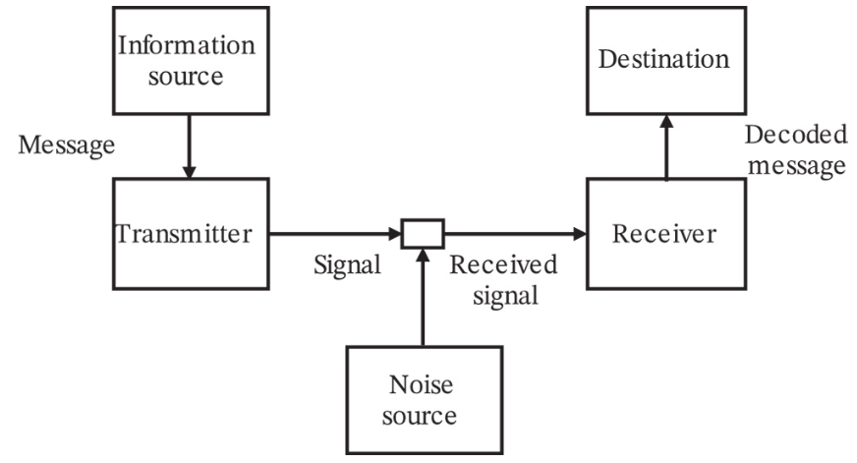

**Figure 18.** Communication system model [46].

The signal loses intensity over distance and, especially in the case of wireless transmission, there may be absorption and other signals or reflections, which cause interference at the receiver. The mechanic is combined in the Signal-to-Noise Ratio (SNR), which is the ratio of received average signal power and average noise power. The higher the value of SNR, the more likely is a successful reception. [12, 46, 50]

Radio frequency (RF) band usage is a limited resource and subsequently heavily regulated by laws of nation states around the world, as well by laws of nature. Without regulation, we risk everyone being lazy and polluting the airways with overpowered transmitters just to get their message “heard” over others more easily. To avoid utter cacophony, the power of transmissions is limited in most parts of the world.

Since transmission power is being capped, to achieve greater spatial coverage, the industry has turned to narrowing bandwidth. This is why we see many “narrow-band” technologies being developed. A good intuition can be gained from the Shannon-Hartley theorem in an Additive White Gaussian Noise (AWGN) channel

|  |  |
| --- | --- |
|  | (5) |

where is capacity in bits per second (bps) of the channel, is the bandwidth in hertz, and accounts for the average signal and noise power over the bandwidth in watts as a linear power ratio. The theorem dictates, that for a fixed SNR, narrowing/decreasing bandwidth has a decreasing effect to capacity. On the other hand, if bit rate requirement is fixed low, better SNR can be achieved by lowering the bandwidth.

Data rate is related to modulation technique. If transmission power is fixed, usage of low modulation rate techniques such as BPSK, QPSK or GMSK means putting more energy for each transmitted bit, which increases the perceived SNR at the receiver and increases the probability of successful decoding. In other words, communication range can be increased. Or if the range is fixed, then transmission power may be decreased, resulting in lower energy consumption. Using lower modulation rate techniques also commonly means simpler hardware design, which potentially lowers costs and provides further energy savings. [11]

## Coverage

The communication between a transmitter and receiver is possible only if the receiver is able to successfully decode the transmitted signal. More specifically, *coverage area* is defined as all spatial positions around the transmitter where the SNR of the received signal is larger than a threshold for successful decoding. This point is also called the receiver sensitivity. At which physical distance this threshold is crossed depends on the degrading effects of loss and interference (noise and fading) imposed on the channel. [46]

A basic tool of wireless communication engineering is link budgeting. It is used to estimate the propagation loss and signal power level at the receiver of a link. It is required in estimating achievable user data rates in both up- and downlink, and the ultimate communication range, where this rate is still achievable. The link budget is indeed called a budget, because it is much like a book-keeping of the gains and losses related to the transmitter, communication medium (wireless channel) and the receiver, as illustrated in Figure 19.



**Figure 19.** Gains and losses affecting signal level of a transmission.

Since link budget involves characterization of the link, it relies on a propagation model. The model’s purpose is to estimate link characteristics as close to real life conditions as possible. It typically may account for distance-dependent path loss and spatio-temporal random effects caused by shadowing and Doppler-effect, as well as interfere from multipath propagation of the signal and other transmissions. [54]

In the budget, gains come from transmission power and antenna directivity, while losses are caused by the radio environment, attenuation and inefficiencies in cables and circuitry, and noise level at the receiver. The end result of the link budget is the allowed path-loss () in the link, which is an indication of communication range. The general link budget formula is

|  |  |
| --- | --- |
|  | (6) |

These parameters can be further broken down to a finer grained set of items contributing to the overall budget. The following paragraphs explain some of these parameters. [30]

The equivalent isotropically radiated power (**EIRP**) is an often used figure in link budgets, which combines the transmit power with transmit antenna’s equivalent isotropic gain. This is expressed as

|  |  |
| --- | --- |
|  | (7) |

The receiver side antenna also has a gain, denoted as. Gain is a coefficient, which describes the physical directional ability of the antenna to induce current with response electromagnetic radiation, mostly for the frequency the antenna is tuned for.

As explained in [50], the net effect of both loss and noise contribute to the degradation of average Signal power to average Noise power Ratio (, or), as losses decreased the perceived signal power, while interference sources accumulate the perceived noise power. For digital communications, may be substituted by, which is a bit-normalized version of. Bit energy is denoted by in joules and it equals to, where is signal power in watts and is bit time in seconds. denotes noise power spectral density in watts per Hz (thermal noise), which equals to, where is noise power and is bandwidth. Because bit time is reciprocal with data rate in bits/s, we can instead write. Finally, relation to can be expressed as

|  |  |
| --- | --- |
|  | (8) |

**Receiver sensitivity**, expressed as and often given in dBm, is the minimum required power level at the receiver, which allows successful identification and processing of the transmitted signal. It may be improved by narrowing the channel bandwidth or reducing the noise level at the receiver. Sensitivity can expressed as

|  |  |
| --- | --- |
|  | (9) |

where is the bandwidth, the Noise Figure, and the SNR required to reach a predefined reliability in decoding of information. [14]

Reliability is an important angle in modeling communication links. Generally, this may be thought of as the probability of successfully transmitting one bit over the communication channel. On the flip-side, a common parameter is Bit-Error Rate (BER), which defines that how many transmitted bits may be expected to be erroneously decoded at the receiver. BER is a simple metric, but often times not enough, since information is commonly transmitted in terms of packets. In cellular communication transmitted information is referred to as blocks. Packet Error Rate (PER) and Block Error Rate (BLER) are a much more complex topics than BER, because in addition to the communication channel characteristics, they are subject to protocol mechanics and other techniques, which aspire to enhance successful decoding of blocks and packets. For example, in modern communications, the transmitted information is usually coded with error-correcting code (ECC). As stated in [26], this allows detection or correction of bit errors by the receiver’s decoder, which were introduced to the modulated signal as it was transmitted through the channel.

Link budgets are always conducted with a target reliability in mind, which links back to. It sets the threshold of, at which one may expect to reach the reliability target. The value of depends on characteristics of the technology in question and the desired data rate. It is commonly derived through various methods such as analytical calculation or statistical analysis from simulations or empirical measurements.

Thermal noise is ever present noise perceived by the receiver circuits, which is the cause of thermal vibrations of atoms. It is commonly tied to temperature via the Boltzmann’s constant:

|  |  |
| --- | --- |
|  | (10) |

The temperature used in calculations for terrestrial systems is commonly. [45]

Noise Figure is the decibel equivalent of the absolute valued *noise factor*, which in turn is the ratio of SNR measured at the input of a system (i.e. a receiver component) to the SNR measured at the output. Any amplification (gain) by the component will affect both the input signal and noise, which will introduce additional noise at the output. The Noise Figure is a value commonly included in link budgeting, which is meant to account for various imperfections in the receiver circuitry. [45]

The transmitted signal can experience absorption, scattering, diversion, or reflection on its path to the receiver, which are also considered losses – part of the signal energy is lost. and are the sums of all margins and losses, respectively. The margins include parameters such as, small scale fading (), shadow fading () and interference () margin, so that

|  |  |
| --- | --- |
|  | (11) |

Interference on the other hand is perceived at the receiver. It is like another conversation at the neighboring table making it harder for you to understand what your friend is talking to you. Noise and interference consist of mechanisms and sources such as thermal noise, atmospheric noise, galaxy noise, intermodulation noise, switching transients, and other interfering signal transmissions. Link budgeting commonly uses margins to counter these degrading effects to the signal. [30; 50]

Parameters marked explicitly as losses, which are more statistical in nature, are clumped in the parameter. These include, for example, feeder cable loss (), antenna pointing loss (), wall penetration loss (), body loss (), etc. Generally, the sum of all applicable loss components, as in

|  |  |
| --- | --- |
|  | (12) |

Maximum Coupling Loss (MCL) is another common way the industry and literature refers to when discussing about coverage. MCL is defined as the difference in the conducted power level, when measuring at the antenna ports of the transmitter and receiver. The gains of transmitting or receiving antennas are not included, because the antenna connector is used as the reference point. MCL is essentially the maximum loss in the conducted power level required for operation. Figure 20 shows a visualization of the concept. [33]

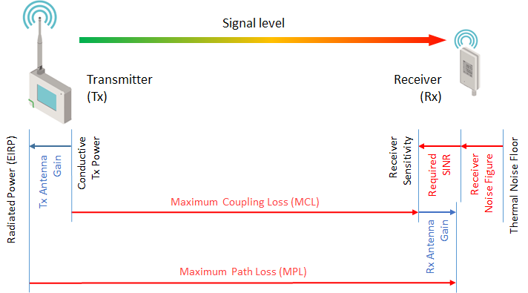

**Figure 20.** MCL and MPL.

In terms of the link budget, for a given, MCL is expressed as:

|  |  |
| --- | --- |
|  | (13) |

On the other hand, can also be calculated as a function of MCL:

|  |  |
| --- | --- |
|  | (14) |

Furthermore, the term Maximum Path Loss (MPL) is also sometimes used as a measure of coverage, which can be thought of as the maximum APL in terms of link budget that a technology can support. As also depicted in Figure 20, MPL is measured as the difference in radiated power levels at the transmitting and receiving antennas, and as such incorporates the gains of the transmitting and receiving antennas. [33]

MPL may be expressed as

|  |  |
| --- | --- |
|  | (15) |

### Regarding Propagation Models

The link budget will provided the APL for the link in question, or how much signal power (in dBs) drop may occur between transmitter and receiver. However, to find out how much this drop is in distance over the land (or space), we must turn to propagation models.

The purpose of propagation models is to serve as tools in predicting the detrimental effects to the signal on its path to a receiver. The major component in models of path loss over a distance is *Free Space Path Loss* (FSPL), which is covered in the next chapter. Also, as previously mentioned, a signal is affected by a number of variables, which come from the physical environment such as the atmosphere and physical objects, as well as the signal itself and other signals. Part of these effects are categorized as small scale fading, which accounts for short time variations in signal level due to Doppler shifts and constructive or destructive multipath propagation. Fading due to multipath propagation can also be frequency specific, which means that in a multichannel system, such as cellular systems, subcarriers are not evenly affected. Another part for effects is from large scale fading, also called shadowing, which refers to attenuation of signal level from obstacles in the direct transmission path. Common values for shadowing range of 6 to 10 dB [30]. Shadowing affects the signal in longer time scales. FSPL is sometimes also included, when discussing about large scale fading. Figure 21 gives an illustration on signal attenuation over distance along with small and large scale variations. [12; 14; 50]

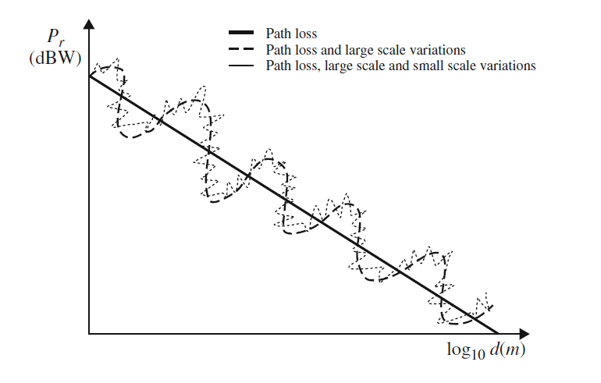

**Figure 21.** Path-loss and effects of large-scale and small-scale variations as a function of distance to signal power [14].

Propagation models cannot accurately provide predictions of the nature of any particular link, but instead provide in most cases a statistical average of the path loss. Also, no one model can provide accuracy in all environments and situation, and thus multiple models have been created to account for the many situations (i.e. urban or rural, flat or mountainous) where wireless links are used. In the following chapter, two models are presented, and of which the Hata/COST 213 is used in this work. [54]

### Free Space Model

The Free Space Path Loss (FSPL) model sets the theoretical lower bounds for signal propagation based geometric properties and distance. It is often used as a benchmark for wireless channel model performance studies. The intensity of electromagnetic waves propagating from a single point in ideal free space decreases by the inverse-square of the distance from the source. FSPL does not take into account any attenuations, atmospheric effects, obstructions, reflections or intrusions to the radio path. Thus, of course, in practice the closest scenario where this model could apply is deep space communications. FSPL is still a component of the total path loss in all wireless communication and can be combined with other path loss models developed for practical purposes. [54]

FSPL is expressed as

|  |  |
| --- | --- |
|  | (16) |

where is the distance between the receiver and transmitter in meters and the wave length. Since where is the speed of light and the carrier frequency in Hz, we can write

|  |  |
| --- | --- |
|  | (17) |

In decibels (dB) this is

|  |  |
| --- | --- |
|  | (18) |

which is commonly expressed in form

|  |  |
| --- | --- |
|  | (19) |

### Hata/COST 231 Model

Hata/COST 231 model has its roots in the empirical measurements performed by Okumura *et. al.* in city of Tokyo, Japan, published in 1968. These measurements where further defined as a series of empirical relationships by Hata *et. al.*, which are more commonly known as the Okumura-Hata model. Since then, the model has undergone further refining development steps and the latest iteration was introduced in the European Conference of Postal and Telecommunications Administrations (CEPT) and European Radiocommunications Committee (ERC) Report 68. [45]

The Hata/COST 213 model is based on curve matching to measurements of path loss done in environments categorized as urban, suburban or open/rural. It’s defined for frequencies between 30 MHz and 3 GHz and between 1 and 100 km. Antenna heights are expected within range of 1 to 200 meters. The model accounts for fading as shadowing, which follows a Gaussian distribution with a mean of 0 dB and σ 2 = 5 dB. The model is best used for generic studies with an interest in average path loss over distance. [45]

According to [45; 30], the urban environment specifies the core of the Hata/COST 213 model, and is expressed as

|  |  |
| --- | --- |
|  | (20) |

where is the carrier frequency in megahertz, and are the effective heights of the transmitting and receiving antennas and the distance between TX and RX antennas in kilometers. The parameters is used to fit the model for distance between 20 and 100 km, and is defined as

|  |  |
| --- | --- |
|  | (21) |

The effective antenna height is the height of the antenna with respect to the average terrain height between link end-points. The model can be adapted with regards to city size and carrier frequency through the term. For small and medium sized cities it is expressed as

|  |  |
| --- | --- |
|  | (22) |

For a large city and carrier frequencies below 300 MHz, it is

|  |  |
| --- | --- |
|  | (23) |

while for frequencies above 300 MHz, it is

|  |  |
| --- | --- |
|  | (24) |

The path loss for suburban and rural/open areas are based on the urban model, so that

|  |  |
| --- | --- |
|  | (25) |

and for rural/open it is

|  |  |
| --- | --- |
|  | (26) |

### Link Budgets

The values assumed for link budgeting are given in Table 12. These represent the author’s choice and view of what are common values used in industry, as well as what is given in specifications and described in previous chapters.

Table 12. Uplink link budget parameters.

|  |  |  |  |  |  |
| --- | --- | --- | --- | --- | --- |
|  |  |  | **NB-IoT** | **LoRaWAN** | **TS-UNB** |
| Carrier (center) freq. |  |  | 880.09 MHz | 868.10 MHz | 868.10 MHz |
| Carrier BW |  |  | 180 kHz | 125 kHz | 100 kHz |
| Subcarrier BW |  |  | 15 kHz | 125 kHz | 60.223 kHz |
| No. subcarriers |  |  | 12 | 1 | 24 |
| Channel BW |  |  |  | |  |
| UE ant. elevation |  |  | 2 m | | |
| BS ant. elevation |  |  | 40 m | | |
| TX Power |  |  | 23 dBm | 14 dBm | 14 dBm |
| TX Antenna Gain |  |  | 0 dBi | | |
|  |  |  |  | | |
| RX Antenna Gain |  |  | 17 dBi | 6 dBi | 6 dBi |
| Thermal Noise |  |  |  | | |
| Noise Power |  |  |  | | |
| Noise Figure |  |  | 3 dB (eNodeB) | 6 dB | 6 dB |
|  |  |  | Table 13 | Table 15 | 1 dB |
| RX sensitivity |  |  |  | | |
| Shadowing Margin |  |  | 7 dB | | |
| Interference Margin |  |  | 4 dB | | |
| Total Margin |  |  |  | | |
| Cable Loss |  |  | 0 dB | | |
| Cable Loss |  |  | 3 dB | | |
| Total Loss |  |  |  | | |

Path loss by Hata/COST 231 model were calculated using equations from (20) to (26) with values given in Table 12 and the result is presented for all environments in Figure 22.

|  |  |
| --- | --- |
| C:\Users\vtm\OneDrive - Vaisala Oyj\Diplomityö\Report\Figures\Hata-COST231_PL_15km_2.png | (a) |
| C:\Users\vtm\AppData\Local\Microsoft\Windows\INetCache\Content.Word\Hata-COST231_PL_2km&info.png | (b) |

**Figure 22.** Path loss curves for different environment categories with Hata/COST 321 model with BS height at 40 meters and UE at 2 meters, and carrier frequency 880.09 MHz (NB-IoT). Range up-to: a) 15 km and b) 2 km.

The difference in Hata/COST 231 model path loss between the carrier frequencies of NB-IoT and LoRa/TS-UNB is only about 0.1% (~ 10 meters) in favor of LoRa/TS-UNB. This analysis thus applies Figure 22 for all technologies.

#### NB-IoT

As described in chapter 3.1.2, NB-IoT employs an adaptive resource allocation scheme, which optimizes the combination of MCS, repetitions, TBS and number of RUs. The target SNR, which corresponds to a target minimum BLER (as stated in [33]) of 10% was derived using MatLab simulations. The simulation code were provided as part of the MathWorks MatLab LTE Toolbox. Simulation was only performed for uplink using the code in the NB-IoT NPUSCH Block Error Rate Simulation.

The simulations allow to insert values for parameters corresponding to the items in Table 9 and Table 7, and graph BLER result over a range of SNR. Multi-tone operation with allocation of subcarriers was assumed, but otherwise default parameters were used. Each run was performed with minimum of 200 simulated blocks. After setting the parameters, the simulation models the transmission channel effects through the following steps when run:

* Baseband waveform creation with random data by SC-FDMA modulation
* Passing the resulting passband waveform through channel of Additive White Gaussian Noise (AWGN) and frequency-selective fading
* Performing receiver operations, including block CRC checking
* Calculation of BLER against block CRC results.

Figure 23 provides an example of the resulting graph. [43]

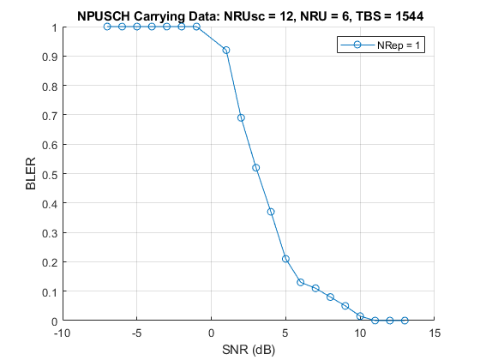

**Figure 23.** NB-IoT simulation result for NPUSCH for TBS=1544.

Table 13 represents the results of running the simulation for each and combination against each  for a value of correspondingto achieve a BLER of less than 10%. In other words, this value signifies the SNR required to be able to transmit using the associated TBS at target reliability.

Table 13. NB-IoT uplink TBS values with corresponding SNR requirement values (in dB).

|  |  |  |  |  |  |  |  |  |  |
| --- | --- | --- | --- | --- | --- | --- | --- | --- | --- |
|  |  | | | | | | | |  |
|  | 0 | 1 | 2 | 3 | 4 | 5 | 6 | 7 |  |
| 0 | -3.3 | -6.3 | -7.2 | -7.5 | -5.9 | -6.5 | -7.0 | -7.6 | -7.6 |
| 1 | -2.5 | -3.2 | -4.1 | -3.8 | -4.3 | -4.0 | -6.0 | -6.4 | -6.4 |
| 2 | -0.9 | -2.2 | -2.1 | -2.9 | -4.0 | -4.0 | -5.2 | -5.4 | -5.4 |
| 3 | 0.0 | -0.5 | -1.2 | -2.2 | -3.1 | -3.2 | -4.2 | -4.0 | -4.2 |
| 4 | 0.9 | -0.1 | -0.5 | -1.2 | -1.7 | -1.8 | -3.2 | -3.7 | -3.7 |
| 5 | 1.6 | 0.5 | -0.1 | -0.4 | -0.9 | -1.4 | -2.0 | -2.6 | -2.6 |
| 6 | 2.7 | 1.6 | 0.6 | 0.6 | 0.0 | -0.6 | -1.3 | -2.0 | -2.0 |
| 7 | 3.7 | 2.7 | 1.7 | 1.8 | 0.6 | 0.4 | -0.1 | -0.8 | -0.8 |
| 8 | 4.2 | 3.6 | 2.8 | 2.4 | 2.1 | 1.2 | 0.7 | -0.1 | -0.1 |
| 9 | 5.1 | 4.5 | 3.7 | 3.3 | 2.8 | 2.2 | 1.6 | 0.7 | 0.7 |
| 10 | 5.5 | 5.2 | 4.6 | 4.0 | 4.0 | 2.9 | 2.1 | 1.7 | 1.7 |
| 11 | 6.8 | 6.5 | 6.0 | 5.5 | 4.9 | 3.9 | 3.4 | 2.8 | 3.4 |
| 12 | 8.4 | 7.8 | 7.2 | 8.0 | 5.7 | 5.3 | 4.4 | 3.8 | 3.8 |
| 13 | 9.5 | 9.3 | 8.5 | 8.8 | 7.0 | 6.9 | 5.8 | 5.2 | 5.2 |

For reference, the minimum value of were also extracted for each MCS and these are further shown in Figure 24. As may be observed, in more favorable channel conditions, greater amounts of data may be transmitted without errors.

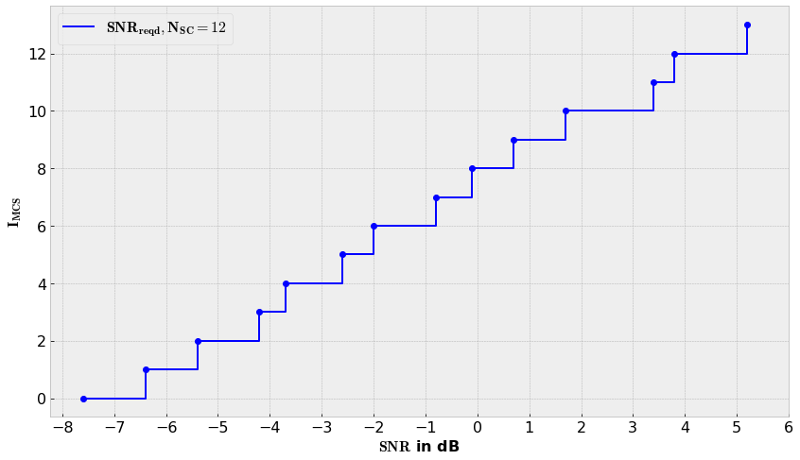

**Figure 24.** Indicative NB-IoT uplink SNR thresholds for each level, while achieving BLER of 10 %.

Using equations (6), (7), (9) and link budget parameter values from Table 12, the APL can be calculated for each TBS index. These results are presented in Table 14.

Table 14. NB-IoT uplink TBS values with corresponding APL values (in dB).

|  |  |  |  |  |  |  |  |  |
| --- | --- | --- | --- | --- | --- | --- | --- | --- |
|  |  | | | | | | | |
|  | 0 | 1 | 2 | 3 | 4 | 5 | 6 | 7 |
| 0 | 147.7 | 150.7 | 151.6 | 151.9 | 150.3 | 150.9 | 151.4 | 152.0 |
| 1 | 146.9 | 147.6 | 148.5 | 148.2 | 148.7 | 148.4 | 150.4 | 150.8 |
| 2 | 145.3 | 146.6 | 146.5 | 147.3 | 148.4 | 148.4 | 149.6 | 149.8 |
| 3 | 144.4 | 144.9 | 145.6 | 146.6 | 147.5 | 147.6 | 148.6 | 148.4 |
| 4 | 143.5 | 144.5 | 144.9 | 145.6 | 146.1 | 146.2 | 147.6 | 148.1 |
| 5 | 142.8 | 143.9 | 144.5 | 144.8 | 145.3 | 145.8 | 146.4 | 147.0 |
| 6 | 141.7 | 142.8 | 143.8 | 143.8 | 144.4 | 145.0 | 145.7 | 146.4 |
| 7 | 140.7 | 141.7 | 142.7 | 142.6 | 143.8 | 144.0 | 144.5 | 145.2 |
| 8 | 140.2 | 140.8 | 141.6 | 142.0 | 142.3 | 143.2 | 143.7 | 144.5 |
| 9 | 139.3 | 139.9 | 140.7 | 141.1 | 141.6 | 142.2 | 142.8 | 143.7 |
| 10 | 138.9 | 139.2 | 139.8 | 140.4 | 140.4 | 141.5 | 142.3 | 142.7 |
| 11 | 137.6 | 137.9 | 138.4 | 138.9 | 139.5 | 140.5 | 141.0 | 141.6 |
| 12 | 136.0 | 136.6 | 137.2 | 136.4 | 138.7 | 139.1 | 140.0 | 140.6 |
| 13 | 134.9 | 135.1 | 135.9 | 135.6 | 137.4 | 137.5 | 138.6 | 139.2 |

Cross-referencing between APL values of Table 14 and the path-loss curves in Figure 22 gives an indication of the TBS index and distance. This information may be used to evaluate, which and combinations are available for a given distance between transmitter and receiver.

#### LoRaWAN

LoRa receiver sensitivity is commonly between -116 to -137 dBm depending on the bandwidth used. Greater BW will increase throughput, but weaken sensitivity. The sensitivity value also depends on the SF used through the set requirement for level of SNR. Semtech specifies this in the datasheets of modules, i.e. in [52]. Table 15 gives an example listing for the SX1272 model, while sensitivity is calculated with equation (9). Similar results for BER 10-6 were also produced by authors in [18].

Table 15. LoRa sensitivity and SNR requirement values for corresponding SF for bandwidth of 125 kHz [52].

|  |  |  |  |
| --- | --- | --- | --- |
| Config | Chips / symbol | LoRa Demod.  (dB) | Sensitivity  (dB) |
| 6 | 64 | -5 | -122 |
| 7 | 128 | -7.5 | -124.5 |
| 8 | 256 | -10 | -127 |
| 9 | 512 | -12.5 | -129.5 |
| 10 | 1024 | -15 | -132 |
| 11 | 2048 | -17.5 | -134.5 |
| 12 | 4096 | -20 | -137 |

Using equations (6), (7), (9) and link budget parameter values from Table 12, the APL can be calculated for each SF index. The APL was further compared with the Hata/COST231 rural/open PL curve of Figure 22. These results are presented in Table 22.

#### TS-UNB

According to specification [19], TS-UNB shall use MSK modulation in the uplink. For MSK, there exists a well-established statistical formula in evaluating BER for an AWGN channel, as described in [50], which is

|  |  |
| --- | --- |
|  | (27) |

Here efrc is the complementary error function and the energy per bit per noise power spectral density, as defined by eq. (8). In Figure 25, BER is graphed as a function of .

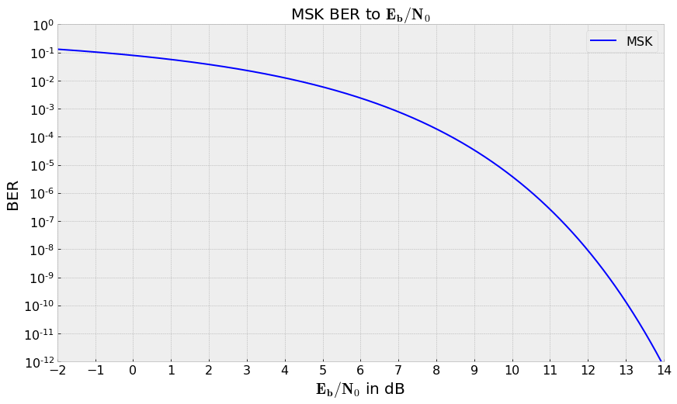

**Figure 25.** MSK modulation BER to.

It may be observed, that for our BER requirement of,. As given in the specification [19], TS-UNB has a symbol rate of. Furthermore, [19] states that, for TS-UNB, MSK modulation bit rate. Bandwidth, if the “Standard” bandwidth is used. The given in Table 12 is derived with this information and equation (8). Using equations (6), (7), (9) and link budget parameter values from Table 12, the APL for TS-UNB may be calculated.

## Duration of Activity States

**This chapter will analyze the durations, which an end-device spends on four different states during message transmission event. These states are: TX, RX, Idle, Sleep and PSM. Time spent in each state is a required component in any further analysis of energy consumption. It can also be used for calculating data rate. For NB-IoT, this analysis is only relevant with P1a and P1b.**

**In general, a device is**

* **in TX-state when transmitting, for duration .**
* **in RX-state when receiving, for duration .**
* **in Sleep-state when it has suspended its operation. Generally after all other activity has ceased and before the next transmission event, for duration.**
* **in PSM-state when, similar to Sleep-state, it has powered down all internal components to the bare minimum, for duration .**
* **in Idle-state at all other times, such as while waiting for a receive window, for duration .**

**In real life, state transfers take a small amount of time, particularly in the case of returning to an active-state from Sleep- or PSM-state. The time taken to resume depends much on the hardware platform and operating system (OS). Generally, a lightweight OS or a Real Time OS (RTOS) takes a few milliseconds. However, using a general purpose embedded OS, i.e. Linux-based, resume process may take more than 10 seconds, even if the boot/resume process is optimized for the application. These transition times are generally not accounted for in the following analysis.**

### NB-IoT

**As explained under Chapter 3.1, NB-IoT includes continuous information exchange between the end-device and eNB regarding the connection parameters, such as for resourcing and link adaption. The control information exchanges of SIBs and DCIs cause a highly complex scenario. Yet, for stationary end-devices, this information is not expected to change very often. Therefore, this analysis will simply focus on state durations of an uplink message transmission event.** It is assumed, that the end-device has completed cell search and has received all the SIBs and DCIs from the eNB required for communication, including an uplink scheduling grant.

With NB-IoT, transmission and reception is measured in RUs and SFs, which correspond to a defined duration, as explained under Chapter 3.1. In short, for uplink, the duration was a result of the combination of subcarrier allocation and spacing, MCS and number of RUs and repetitions. TBS also plays a role in determining how many transmission events are required for the higher layer data payload. This analysis bases on the SCS (15 kHz) and subcarrier allocation () that were defined in Table 12 for link budget calculation. The MCS is given by the coverage analysis of Chapter 4.1. Based on the results recorded in Chapter 5.1, this analysis sets. Furthermore, we note that since, as given by Chapter 3.1.2. Then, according to Table 9, at the defined MCS level we get the TBS by selecting the minimum TBS able to accommodate the segment size handed down from RLC-protocol. The segmentation by RLC protocol with respect to the use-case profiles is further detailed under Chapter 4.4.1.

Finally, the number of RUs, denoted as, required to transmit the transport block may be obtained again from Table 9. The number of repetitions are set to 1 for this analysis (no repetitions). For NPUSCH, the minimum time needed for transmission of a TB, denoted asis determined as

|  |  |
| --- | --- |
|  | (28) |

depends on SCS (3.75 or 15 kHz) and subcarrier allocation , which dictate the time to transmit one RU. This relation was shown in Figure 6. Finally, the value is multiplied for the amount of repetitions chosen.

On the downlink, this analysis only considers reception duration for the transmission acknowledgments as. Given the same SCS and subcarrier allocation, this amounts to one subframe (1 ms). In addition to the and there are two time gaps specified between states, which is counted as time in Idle-state. After receiving the DCI with scheduling info (minimum one sub-frame without repetitions, 1 ms), a time gap of 8 ms is required so that the UE has time to decode the DCI and prepare the uplink transmission. After transmission is completed, another gap of minimum 3 ms is specified to allow the UE to switch from transmission to receiving mode. [39]

A further segment in the analysis of duration of activity states for NB-IoT is the behavior inflicted by the, rather complex, power saving features, which were discussed in Chapter 3.1.3. Table 16 lists the assumed values for parameters such as timers set by the network or the end-device, along with other relevant information. **The analysis is based on a simplified model of the end-device’s behavior. RRC Inactivity Timer is set to Immediate Release, thus disabling C-DRX. I-eDRX is used in RRC\_IDLE state. It is assumed, that the PO is an SF of index 9 (the last SF within an RF).**

Table 16. Parameter values chosen for NB-IoT power saving features.

|  |  |  |  |
| --- | --- | --- | --- |
|  |  | Designation | Value |
| Radio Frame |  |  |  |
| Radio Subframe |  |  |  |
| **RRC\_Connected** | | | |
| RRC Inactivity Timer | 1. |  |  |
| **RRC\_Idle** | | | |
| PO Subframe index | 2. |  |  |
| Number of I-DRX cycles | 3. |  |  |
| I-DRX cycle | 4. |  |  |
| Paging Window Timer | 5. |  |  |
| Number of I-eDRX cycles | 6. |  |  |
| e-DRX cycle | 7. |  |  |
| Active Timer | 8. |  |  |
| TAU Timer | 9. |  |  |

**Time before expiry of Active timer T3324 is recorded to, while time in after T3324 and before TAU timer expiry is recorded to. TAU timer is expected to be set at 600 seconds or more, which has the effect that sole TAU transmissions are not expected and thus will not accumulate any time to and in this analysis.**

### LoRaWAN

Semtech provides the following equations in its LoRa chip datasheet [52] to calculate the number of payload symbols per transmission:

|  |  |
| --- | --- |
|  | (29) |

PLD is the number of bytes in PHY Payload field (includes L2 headering) and SF the spreading factor. CRC is one, if payload CRC is enabled, and zero otherwise. H is one, if PHDR is included, and zero otherwise. DE is one, if a function called “low data rate optimization” is enabled, and zero otherwise. This function is mandatory for SFs 11 and 12 at 125 kHz bandwidth, but no further detail is provided of its effect. [5; 52]

**TX-state duration is calculated as**

|  |  |
| --- | --- |
|  | (30) |

**where**

|  |  |
| --- | --- |
|  | (31) |

This work expects the default settings, as given by Semtech in [52], regarding preamble length (12 symbols) and use of PHDR and CRCs (included). Additionally, a MAC overhead of 29 Bytes is expected, which allows for maximum FRM Payload size of 255 – 29 = 226.

As explained in Chapter 3.2.2, LoRa messages omit L3-headering, but here we expect it to otherwise include other higher layers. Thus for P1, an application layer payload of 1025 is expected to be passed to the MAC layer, and as result it needs to be sent over several transmissions. After segmenting and adding the MAC overhead, the total PHY Payloads then result to:

* P1: 4 x 255 & 1 x 150 Bytes
* P2: 139 Bytes

**All uplink messages are expected to be confirmed. An acknowledgement packet is a packet without payload and amounts to simply the overhead. Here the size of 29 bytes is assumed. The time intervals between TX- and RX-states is in LoRaWAN defined as** RECEIVE\_DELAY1, RECEIVE\_DELAY2 etc. In this work only the first receive window with a delay of 1 second will be used, which the device spends in Idle-state. Also, a LoRaWAN device is expected to exclusively utilize PSM-state instead of Sleep-state.

### TS-UNB

The total duration in TX-state can be obtained by applying the durations of core and extension frame radio bursts, as given in [19], with the total number of radio bursts for a transmission event. Repetitions are not considered in this analysis. The core frame in the uplink always consists of 24 radio-bursts. The extension frame adds up to this by one radio burst per each additional byte in the physical payload. The number of extension frame radio bursts may be calculated by deducting the minimum PSDU size of 20 bytes from the total application layer payload size. In short, as

|  |  |
| --- | --- |
|  | (32) |

The duration in TX-state is then calculated as

|  |  |
| --- | --- |
|  | (33) |

where and are the transmission times for the whole core frame and individual extension frame radio bursts, respectively.

As explained in Chapter 3.3.1, TS-UNB messages omit L3-headering, but here we expect it to otherwise include other higher layers. Given the payload sizes defined in Chapter 2.1 for P1, and the TS-UNB protocol details of Chapter 3.3, it can be concluded, that P1 requires more than one transmissions event (radio frame) and P2 manages with just one. Adding up the MAC- and physical layer overheads gives the size of the physical payload. Then through rules of the core- and extension frame formulation, the number radio frames and the number of RBs for each extension frame may be obtained. The values used in the calculations are summarized in Table 17.

Table 17. Uplink OaT parameters per message.

|  |  |  |
| --- | --- | --- |
| Application layer payload | Profile 1  1045 Bytes | Profile 2  110 Bytes |
| Radio frame max. payload | 245 Bytes | |
| Min. PSDU size | 20 Bytes | |
| No. core frames | 5 | 1 |
| No. ext. RBs, | 4 \* 225 + 45 | 90 |
| Core frame time, | 362.97 ms | |
| Ext. frame time, | 15.14 ms per additional byte | |
| Full radio frame time, | 3769.5 ms | |

As mentioned in Chapter 3.3, acknowledgements are sent as a bit in the MAC-headering, and thus require only the core-frame. Device is in Idle-state between radio bursts and while waiting for ACK in receive window. The time gap between UL and DL is given in [19] as 16384 symbol durations by default, or . Also, a TS-UNB device is expected to exclusively utilize PSM-state instead of Sleep-state between ACK and time of next message.

## Duty Cycle

This chapter will look into capability with regards duty cycle regulation. For wireless links, duty cycle is defined as the ratio of the cumulated sum of time from all transmissions during an observation period, this is expressed as:

|  |  |
| --- | --- |
|  | (34) |

Different regions in the world have their own regulations for the utilization of radio frequency resources. For most regions, duty cycle of transmission is one of the regulated parameters. Looking widely at the regulation, it may be observed that the rules are most strict in Europe and the US, and that many other regions follow their example or have more relaxed regulation. Authors in [10] gathered a good summary on technical constraints by regulations from top ten GDP countries worldwide, partly presented below in Table 18.

In Europe the regulation is dictated by the European commission and is laid out by the commission decision in document 2006/771/EC [1]. In the US, the regulatory responsibility is with the Federal Communications Commission (FCC) and the relevant regulations are available in [17].

Table 18. Summary of Duty Cycle regulation of license-exempt spectrum in Europe and the US [10].

|  |  |  |
| --- | --- | --- |
|  | **US** | **Europe** |
| **General parameters** | | |
| Frequency Range (MHz) | 902 - 928 | 863 - 875.6 |
| **Parameters for Medium Access based on Duty Cycle** | | |
| Band Duty Cycle (%) | - | 0.1 (863-868)  1 (865-868)  0.1 (868.7-869.2)  10 (869.4-869.6)  1 (870-875.6) |
| Band Duty Cycle Period(s) | - | 3600 |
| Channel Duty Cycle (%) | 2 (BW < 250 kHz)  4 (250 kHz < BW < 500 kHz) | - |
| Channel Duty Cycle Period(s) | 20 (BW < 250 kHz)  10 (250 Hz < BW < 500 kHz) | - |

Formally the **Band Duty Cycle**, applied in European regions means the percentage of time a device actively emits in the whole frequency band. Band Duty Cycle Period specifies the observation period of one hour. To address frequency hopping access schemes, the US regulations specify Channel Duty Cycle, which specifies different duty cycles for each sub-channel. [10]

The following analysis is only valid for license-exempt technologies. It should also be noted, that individual countries may have their own regulation, which may differ from the regional norm. Particularly this is the case within the EU.

### LoRaWAN

In LoRaWAN, each packet is sent continuously over a channel, although there are several channels to available, region specifically. The channelization is given in the LoRaWAN specification [34], and for Europe there are six channels of 125 kHz of bandwidth, and for US, 64 channels of 125 kHz and 8 channels of 400 kHz. LoRaWAN has been designed to take into account duty-cycle regulations by going even as far as encoding it to its specification. For example, it employs a scheme, where record is kept for each channels transmission time and duty cycle, which results in a time-off timer. A channel is blocked from further transmissions until its time-off timer has passed. [34]

Since P1 requires multiple transmission events or packets, this allows each packet to be sent over different channel. As result a faster interval may be used, than would be possible with just one channel. However, it makes the duty cycle calculation more complex, since it requires bookkeeping of timer per channel.

For the analysis with LoRaWAN, a bookkeeping simulation was developed to derive the usability of each interval for each use-case profile. As explained above, the simulation enforces the duty cycle limit per channel by blocking used channels from further transmissions until each channel’s timer expires. The result is a Boolean determination whether the analyzed transmission interval is OK or NOK. Interval period is determined unfeasible, if there is an event, where no channels are available () at start of packet transmission.

### TS-UNB

As explained in Chapter 3.3.2, TS-UNB splits each message to RBs, which are transmitted over 24 sub-channels by way of a pseudo-random pattern. Using equation (34) the band DC may be calculated from the total OaT of the message given in Table 23. Channel DC may be calculated by dividing the message OaT with the amount of subcarriers, 24 as given in Chapter 3.3.2. The OaT per sub-channel for each profile is given in Table 17.

Table 19. OaT per subcarrier.

|  |  |  |
| --- | --- | --- |
|  | **P1** | **P2** |
| OaT per subcarrier | 659.1 ms | 71.9 ms |

According to UPG1 carrier set table 6-49 in [19], the TSMA scheme frequency hops in a pseudo-random pattern and all subcarriers are treated with equal degree and of approximately 4.2% utilization per SC for the core-frame. With the extension frame, for which the standard specifies a deterministic formula to select an SC for each consecutive RB, this analysis generalizes and expects, that the above mentioned SC utilization conforms to each pattern set of 24 RBs of the extension frame. Although this is not clearly stated in the specification and thus not confirmed to be accurate, it is assumed.

## Data Rate

This chapter presents data rate evaluation for both use-case profiles. At its basics, data rate is defined as the amount of physical bits transferred over a communications channel in a unit of time given in seconds. This is commonly called the “raw” physical layer bitrate, and is expressed as:

|  |  |
| --- | --- |
|  | (35) |

However, the raw bitrate is not a good measure for most applications from the designer’s point of view, because it often times abstract any extra information or functions added to the transmission by each layer in the protocol stack, such as packet headers, acknowledgement responses or retransmissions, all of which are generally referred to as “overhead”. In practice, information bits are modulated to symbols, and only then transmitted. Depending on the modulation rate, a symbol can incorporates one or more data bits, making symbol rate less than or equal to raw bitrate. Furthermore, before modulation, information bits are commonly encoded with redundant bits for FEC, still reducing the actual information rate.

Thereof, for the same transmission, data rate gets different values depending on which protocol stack layer is under observation. As such, when discussing about data rate, it should be generally always also mentioned, that at which layer of the protocol stack it is “measured” at. When moving up the protocol stack, i.e. starting from the PHY-layer, the data rate of the next-above layer may generally be obtained with the following formula

|  |  |
| --- | --- |
|  | (36) |

Here represents the protocol layer of index, while is the data payload and the layer specific overhead. It may be observed, that data rate at (current layer) is simply data rate at (layer below) multiplied with the ratio of data payload and total payload (of the current layer). [39]

Regardless of which protocol layer is under examination, the layer specific data rate may be obtained also directly with equation (35) with assigning as the sum of all data (payload + overhead) from the current and lower layers, and as the total time it takes to transmit the data and perform all the necessary functions up to the current layer (i.e. reception acknowledgements and related waiting times, retransmissions). This method is used in this work, for example in Chapter 4.4.1 and equation (38).

### NB-IoT

With NB-IoT, in literature it is common to read about data rate expressed as peak physical data rate,. This is the raw bitrate derived from TBS and minimum transmission time as given by equation (28) from chapter 4.2.1. In short, the peak physical rate is calculated as

|  |  |
| --- | --- |
|  | (37) |

A 24 bit Cyclic Redundancy Check (CRC) is added to the TBS.

The peak physical data rate is not useful in evaluation of feasibility. For that, the MAC-layer data rate is better suited, which also acknowledges the signaling overhead of scheduling grant over the NPDCCH channel in the extra time required is also considered. Essentially, the time taken to receive or transmit control signaling, such as DCI or HARQ-ACK. The payloads defined in Chapter 2.1 down to the Network-layer are further assumed to be included with the following protocol overheads when passed down to the Physical-layer for transmission, as given by [32]:

* PCDP: 1 Byte
* RLC: 2 Byte
* MAC: 2 Byte

The RLC headering depends on the payload, and is included in every segmented part of the payload, while it may also be omitted if no segmentation is required (the whole payload fits to a single transport block) [29]. The ROHC function utilized by PCDP layer can compress the IP (v4) and UDP headers (20 and 8 Bytes) for the transmission between end-device and the eNB to a minimum size of 2 Bytes. MAC-headering is added once for each TB. [24; 39]

Following these rules, P1 with a L3 payload of 1045 B is less than the maximum SDU size defined for the PCDP layer as given in Chapter 3.1.1. PCDP performs ROHC function and headering, resulting with a PCDP PDU of 1020 Bytes. This is too large to fit to any one transport block as given in Table 9 (max. is 317 B). Therefore, the PCDP PDU will get segmented by RLC to fit to a set of appropriately sized TBs.

P2 with 130 Bytes of payload results in a PCDP PDU of 105 Bytes after ROHC and headering, which can fit fully to a TB given high enough link quality. In a real life situation, segmentation by RLC may occur if link quality results with a combination of and corresponding to a smaller TBS. Also, the selected transport block is dynamically fitted with segments from one or more payloads from higher layers, so that “wasted space” in the TB is kept at minimum. Segmentation and the amount of transmission events also affect control channel signaling. Every NPUSCH transmission requires receiving a DCI with scheduling info and/or (N)ACK signals from the eNB through NPDCCH. For this analysis, segmentation is minimized by fitting the PDCP PDU to the closest matching TBS.

As already mentioned in Chapter 4.2.1, there are two time gaps to also include in the L2 data rate analysis: 8 ms from the reception of the DCI and before uplink transmission, and 3 ms after end of uplink transmission. Based on values used in Chapter 4.2.1 for SCS, number of SCs and no repetitions, the L2-data rate may be calculated with the following formula

|  |  |
| --- | --- |
|  | (38) |

### LoRaWAN

Physical layer bitrate calculation is clearly defined by equation (2) from Chapter 4.4. The LoRaWAN specification in [34] additionally specifies transmission parameter configurations for different regions. These configuration specify the frequency, bandwidth and coding rate for each spreading factor. The values given in Table 10 are used here.

MAC-layer data rate is calculated by adapting equation (35) for L2 with OaT times from Table 23 and the derived total L2-payload from Chapter 4.2.2 calculations.

### TS-UNB

**The raw data rate may be calculated based on physical payload in bits and transmission time, as given by equation** (35) **in Chapter 4.4. For TS-UNB, the transmission time consists of periods of OaT of the radio bursts, followed by pseudo-random periods of idle-time between consecutive RBs, as explained in Chapter 3.3.2. The number of radio bursts and the OaT required for each Profile transmissions are in provided by** Table 17 **along with the payload sizes. The specification [19] tells that depends on the pattern from set UPG1 used for each transmission event, which changes cyclically. For generality, the average value of 379 symbols given in chapter 3.3.2 for UPG1 is used here as.**

**The total duration of one transmission event in seconds is given by**

|  |  |
| --- | --- |
|  | (39) |

**The total idle-time between RBs, was described in chapter 3.3.2 and equations** (3) **and** (4)**.** MAC-layer data rates for each profile are calculated adapting equation (35) so that:

|  |  |
| --- | --- |
|  | (40) |

Here is the total payload on L2 in bytes, which is divided by the total time in seconds of the transmission event ending in the reception of BS acknowledgement.

In the case of Profile 1, the data rate is calculated for one full radio frame (24 + 249 RBs) and max. higher layer payload of 245 Bytes. Results for P1 and P2 are given in Chapter 5.4. For reference, the physical layer bitrate is also calculated for the maximum sized radio frame and core-frame only. According to the specification [19] the maximum core-frame size is 576 bits and maximum total radio frame size is 6 216 bits.

## Energy Consumption

As has been a trend of this work, the overall energy consumption of a wireless module is a complex task to evaluate, because of the dynamic workings of each technology. Despite this, it is possible to find statements of energy consumption or battery lifetime in datasheets of devices. Such statements don’t however hold much value, if the exact circumstances, device/connection configuration and use-case are not known.

In an attempt to abstract this analysis, a relatively simple model is used with a static scenario of a single transmission event. Its foundation is on the analysis of Chapter 4.2 and its results, including all assumptions made, and the definitions of activity states and their division. Furthermore, estimates of reasonable power consumption at each activity state are assumed to be common (except for) between technologies analyzed here, and they are generally founded on information found in hardware module datasheets. By using common power consumption values with all technologies, we can still evaluate the differences between technologies in energy consumption, even if the original power consumption does not exactly reflect reality. An exception is made with transmit power, since different values for were used with previous link budget analysis, as given in Table 12. Any intermittent activities by the end-device, which take place before, after or between the four states are not included by the analysis. These could include activities such as wake-up, radio circuit powering, state-transfers, context-storing for suspend/sleep, and they may be distinguishable in actual power consumption measurements, as is mentioned by authors in [9].

Two terms appear in industry and academic literature, when discussing topics related to energy: power consumption and energy consumption. The first thing is to understand is what the difference between the two is. In short, power consumption is the power drawn by a device, commonly in watts or milliwatts, at any given moment. This is expressed as the relation of voltage in volts and current in amperes, so that

|  |  |
| --- | --- |
|  | (41) |

From power, energy consumption, can be obtained by defining what period of time the device draws power, so that

|  |  |
| --- | --- |
|  | (42) |

Energy consumption is generally expressed in joules, which is defined as one watt of power per one second. Other common way to express energy is in different units of watt-hours. Energy consumption may also be expressed as consumption of current over time. This form is often used when making current measurements of a device’s operation, and is given in an appropriate unit of amperes per hour (Ah). Energy consumption from this form may be obtained with equations (41) and (42), when voltage is known.

In order to get a full picture of the energy consumption of one transmission event (time between two message transmissions) for a hardware module, the time component of equation (42) needs to be split apart to reflect the different activity states. The overall energy consumption becomes a sum of parts, so that

|  |  |
| --- | --- |
|  | (43) |

Average power consumption can be obtained by dividing with total time.

|  |  |
| --- | --- |
|  | (44) |

Another unit of measure sometimes given in literature, regarding energy consumption of different technologies, is the average energy consumption per data byte in the transmission event. This may be obtained by dividing the total energy consumption with the amount of data transmitted, so that

|  |  |
| --- | --- |
|  | (45) |

The specific protocol layer, to which refers to as payload should be mentioned, as was the case in Chapter 4.4.

Table 20 summarizes the power consumption for each activity state. To get an idea of approximate power consumption, the values used here are derived from hardware module datasheets as worst-case averages and assumptions. With this information, as well as the results of analysis of Chapter 4.2 given in Table 23 and Table 24, the energy consumption may be calculated with equation (43).

Table 20. Power (P) in milliwatts for each activity state.

|  |  |  |  |  |  |
| --- | --- | --- | --- | --- | --- |
|  |  |  |  |  |  |
| NB-IoT | 2747.000 | 47.454 | 51.870 | 6.365 | 0.017 |
| LoRaWAN TS-UNB | 121.704 |

## Battery Lifetime Estimation

The most common types of markings on batteries is their capacity and nominal voltage. A battery’s capacity is given in ampere-hours, which is measured by draining it at a known current load until the voltage drops to a minimum acceptable level and recording the time it took [6]. However, the load current on the battery is not always the same when the battery connected to different devices and is subject to change depending on the voltage. Therefore, a better unit of capacity is in watt-hours, which can be used directly to determine the life time of the battery, when power consumption is known. Capacity in watt-hours can be obtained with equation (41), while replacing current with capacity in ampere-hours. Battery lifetime in hours can then be calculated by dividing the capacity with power consumption, as in the following formula

|  |  |
| --- | --- |
|  | (46) |

Here is the battery capacity reported in milliwatt-hours, a safety factor, the average power consumption of the weather station, and the average self-discharge power of the battery. The safety factor can be used to set the lifetime against a minimum remaining capacity instead of zero and is optional. In case the system has some form of energy harvesting feature, then in general any charging power may be discounted from denominator.

For this analysis, is obtained from results the analysis in Chapter 4.5, while the other values are given by Chapter 2.6. The average device power consumption and the battery self-discharge rate are calculated with a nominal voltage of 3.6 V. Safety factor is not used.

## Costs

Costs are a major factor in deciding the choice of wireless technology. This chapter attempts to evaluate the costs involved with our use-case profiles when utilizing various technologies through a Life-Cycle Cost (LCC) –analysis. LLC includes all costs associated with the system through-out its lifetime. These are costs of purchase, deployment, operation, maintenance and eventual decommissioning at the end-of-life. LCC is expressed as:

|  |  |
| --- | --- |
|  | (47) |

Costs divide differently depending on technology. In the case of license-exempt technologies, the end-user/organization is also responsible for building the infrastructure, whereas with cellular technologies the infrastructure costs are embedded as part of the subscription with the cellular service operator.

**Purchase cost** consists of the cost of hardware and software and include items such as the cost of the communication modules, base station units, cost of additional hardware for fastenings and cabling. Any information property licenses would also fall under this category which may be charged at per unit basis. Purchase costs are given as

|  |  |
| --- | --- |
|  | (48) |

where is the number of end-devices and the number of base stations.

**Deployment costs** encompass all labor costs of HW installation, software setup and configuration work. In case of license-exempt technologies, these costs are multiplied by the number of base stations. Base stations may be installed to an existing mast. For example, many telecom companies rent device space from their mobile masts. Purchase and deployment costs are generally thought of as one-time investments. Deployment costs are given as

|  |  |
| --- | --- |
|  | (49) |

**Operational costs** on the other hand accumulate over time. Cellular subscription data plans are clearly of this category and have potential to amount to the greatest share of lifetime costs. Still, license-exempt technologies are not without either, since the same costs bundled under the cellular data plan may exist individually for the base stations. Namely these include items such as mast/site rent, electricity and back-haul data connection costs. Costs from data subscriptions are often priced as megabyte per month. Operational costs are given as

|  |  |
| --- | --- |
|  | (50) |

**Maintenance costs** consist of replacement of faulty units over time. The items included here are cost of a new unit and the work cost of device replacement. The overall maintenance lifetime costs are dictated by the number of failed units over time, which can be derived from the failure rate. The number of expected failures per end-device within a set of end-devices in the interval from to can be calculated using the renewal function, while expecting a constant failure rate of. [49]

|  |  |
| --- | --- |
|  | (51) |

The renewal function assumes, that failed devices are repaired or replaced to become good-as-new versions of the device. Then expected number of failed devices for units is then given by

|  |  |
| --- | --- |
|  | (52) |

The overall maintenance costs are given as

|  |  |
| --- | --- |
|  | (53) |

Lastly, one must remember to include **decommissioning costs** relating to system, as electronic devices must be properly disposed of. These equal the deployment costs given by eq. (49).

### LCC Cost Calculation

The purpose of this calculation is not to be all-encompassing, but to provide insight of the cost differences between technologies. Costs unrelated to technology choice, such as the LCC of the weather station itself, are omitted except for the communication module. Maintenance costs are calculated over number of modules and BSs, if applicable, and failed devices are replaced with new ones. Two scenarios are covered. In the first scenario (S1), the weather station is connected to a base station, which is installed to space rented from mobile mast operator. In the second scenario (S2), BS is installed to a private mast, and any data plan costs are not counted.

Table 21 presents the chosen cost items of the LCC calculation. The values are derived from various sources and aim to reflect the current market prices for the business customer. Some example prices are recorded in APPENDIX XXX from which averages are taken. The following is assumed:

* System life-time aimed at hours (120 months or 10 years).
* A setup of weather stations.
* base stations are used with the license-exempt technologies to avoid a single point of failure.
* hours.
* Only one device expected to fail per day (regarding work cost calculation).
* The technician manages to install / replace / dismantle two BS per day with minimum of ½ day labor cost.
* Combined UL and DL monthly cumulative data amounts as given by Table 3 of Chapter 2.3.
* Only dismantling work costs are applied for decommissioning.

Table 21. LCC cost items.

|  |  |  |  |  |
| --- | --- | --- | --- | --- |
| Cost Item | No. | LoRaWAN | TS-UNB | NB-IoT |
| **Purchase** | | | | |
| Module | 100 | 12 € | 14 € | 14 € |
| Outdoor BS | 2 | 800 € | | - |
| BS Installation HW & Cabling Kit | 2 | 150 € / BS | | - |
| **Deployment** | | | | |
| Installation work |  | 550 € / day | | - |
| **Operative** | | | | |
| Data Subscription | 100 | - | - | 0.2 €/MB |
| Mast Device Space Rent + Electricity | 2 | ~120 € / Mast / Month | | - |
| BS Data Subscription | 2 | ~70 € / Month | | - |
| **Maintenance** | No. given by eq. (52) | | | |
| Module / BS |  | As above | | |
| Replacement work |  | 550 € / day | | |
| **Decommission** | | | | |
| Dismantling work |  | 550 € / day | |  |

For overall clarification, below is a summary of all calculated items. For NB-IoT, the base station infrastructure is handled by the cellular operator, which means only S1 is applicable. Thus, in the calculation, deployment and decommissioning costs are not included. The formula, where NB-IoT is used with P1 and P2, is given as:

|  |  |
| --- | --- |
|  | (54) |

S1 for LoRaWAN and TS-UNB includes all cost items. A note here that the BS data subscription is a fixed monthly cost. The formula, where LoRaWAN and TS-UNB are used with P1 and P2, is given as:

|  |  |
| --- | --- |
|  | (55) |

Finally, S2 for LoRaWAN and TS-UNB includes no operational costs. The formula, where LoRaWAN and TS-UNB are used only with P2, is given as:

|  |  |
| --- | --- |
|  | (56) |

# Results and Discussion

This chapter presents the results of each topic of the feasibility evaluation along with discussion of their implications. Further notes and considerations are also provided as support and reference.

## Coverage

The communication range requirement set in Chapter 2.5 was 1000 meters, and for a Hata/COST 231 rural/open environment model this translates to a PL of 94.7 dB, as can be observed from Figure 22. For NB-IoT, given the information in Table 14, all TBS indexes ( and combinations) may be expected to be suitable for uplink transmission at BLER of less than 10% for this PL. In other words, NB-IoT may be expected to transmit at the highest data rate. If every TBS index in Table 14 is compared with Figure 22, and the distances are derived, we can observe that the maximum communication range is between 14.7 and 37.6 km.

As seen from Table 22, LoRaWAN is well within capability to operate at required range with SF config 6. The same is true for TS-UNB, given the APL of 129.7 dB, which in comparison with the path loss curve of Figure 22 results in an approximate coverage of 10.41 kilometers. This is also confirmed by measurements with a third party source in [32].

This is comparable with results of a study done by BehrTech in [32], which presents -126 dBm as the signal power at the receiver at which close to zero messages were lost during transmission. Their test setup consisted of a laboratory environment, where a transmitter was connected to a base station over wire. PL was simulated with a step attenuator, while the background noise was also expected as 10 dB higher than thermal noise floor. Using the signal power they provide, we can extend their study with an estimate of communication range by applying it to our link budget. The noise power given in Table 12 is -124 dB. If we then set. Using this in our link budget results in an APL of 119 dB. As to distance, in the Hata/COST 231 rural/open model, it represents approximately 5.1 kilometers.

Table 22. Calculated LoRa APL and corresponding Hata/COST 231 rural/open PL model distance values for each SF for bandwidth of 125 kHz.

|  |  |  |
| --- | --- | --- |
| **config** | **APL (dB)** |  |
| 6 | -122 | 19.4 |
| 7 | -124.5 | 22.3 |
| 8 | -127 | 25.4 |
| 9 | -129.5 | 28.9 |
| 10 | -132 | 32.6 |
| 11 | -134.5 | 36.7 |
| 12 | -137 | 41.1 |

It should be noted, that these analyses do not take into account the presence of interference, which has a degrading effect on coverage. Interference is caused by other transmitting devices around the receiver. For NB-IoT, in most studies on the matter, interference is mainly caused by transmissions from neighboring cells (in-band/guard-band deployment). Authors in [2] present, that the effect of inter-carrier interference is negligible.

With LoRa, much research has been done to understand the interfering effect of other LoRa transmissions with equal or different spreading factors to the decoding of received messages. I.e. studies by [13] and [38] have shown, that despite claims of orthogonality between SFs and that transmissions using different SF would not interfere with each other, this is not necessarily the case. A threshold for signal to interference ratio (SIR) exists, where the decoding of a message is likely to fail due to errors caused by interfering transmissions. In real life, this may happen, when a transmitter using a high SF is placed far away from the receiver while the interfering transmitter is much closer. Performance of LoRa in multipath environments such as Raleigh and Rician fading channels is studied by authors in [25]. They point out significant range decrease in a heavily fading environments such as urban city centers.

TS-UNB, and its TSMA operation, is advertised by BehrTech to be resilient against interference. The study in [32], which was presented earlier, also includes PER evaluation under “dense” interference environment, and claims nearly zero lost packets at.

## Duration of Activity States

The analysis results for time spent in different activity states through the course of one message transmission event are presented in Table 23 for NB-IoT and Table 24 for LoRaWAN and TS-UNB. It should be noted, that in the case of Profile 1, one message is spread over several transmission events.

Table 23. State durations for NB-IoT.

|  |  |  |  |
| --- | --- | --- | --- |
| **NB-IoT** | | | |
| **State** | **Interval** | **P1** | **P2** |
| TX | | 40 ms | 4 ms |
| RX (ACK) | 3 s | 7 ms | 4 ms |
| 15 s | 6 ms | 3 ms |
| 60 s | 8 ms | 5 ms |
| 600 s | 8 ms | 5 ms |
| Idle | | 3 ms | 3 ms |
| Sleep | 3 s | 2950 ms | 2989 ms |
| 15 s | 12391 ms | 12430 ms |
| 60 s | 40956 ms | 40956 ms |
| 600 s | 40956 ms | 40956 ms |
| PSM | 3 s | 0 ms | 0 ms |
| 15 s | 0 ms | 0 ms |
| 60 s | 18993 ms | 19032 ms |
| 600 s | 558993 ms | 559032 ms |

As explained in Chapter 3.1.3, the behavior of the UE during and after a transmission event is dependent on the configuration imposed by the mobile network regarding the paging procedure and various timers. To add to the complexity, the different parameters and timers influencing the behavior are also commonly configurable through an API for most hardware modules, as explained by [38]. **It is also a choice between optimizing energy consumption and minimum latency downlink access. For very long transmission intervals, it should be kept in mind, that once the T3324 timer expires, the UE is not reachable until the next UL event or TAU. If the network allows, the Active Timer T3324 may fine-tuned to desired UE reachability. Essentially, in combination with the TAU timer T3412 and message interval, the chosen value has an effect to the maximum delay that exists when trying to reach the UE.**

**Of course, the downlink traffic imposed by higher layers plays a major role in the UE’s behavior. As described in Chapter 3.1, if any new DL data is received during paging in RRC\_IDLE state, the UE is transferred again back to RCC\_CONNECTED state and the Active Timer T3324 is reset. If this happens, and depending on message transmission interval, the device may not reach PSM-state for the message cycle. This should be kept in mind, when designing any data collection systems to which the weather station connects to.**

Results in Table 23 base solely on the author’s choice of parameter values and the choice has an effect on the results. Further optimization, if possible, with for example the Active Timer T3324, TAU timer T3412, whether use DRX/eDRX in Connected, Idle or both RRC states and finally whether to use DRX or eDRX paging cycles, is highly recommended according to the use-case requirements. **Given the choice by the network, the values of the timers may be adjusted to accommodate the use-case and transmission patterns.**

Furthermore, it must be mentioned, that in practice hardware modules and chipsets functionality regarding their state transfers may not strictly follow to the expected behavior conveyed by the specification. In other words, one should verify through testing, that a chosen hardware module does in fact, in example, power down unnecessary processes and components of its radio stack when entering to Sleep-state. In addition, as previously mentioned in Chapter 4.2, the time required for state transitions must be taken to account in real-life.

Table 24. State durations for LoRaWAN and TS-UNB.

|  |  |  |  |  |  |
| --- | --- | --- | --- | --- | --- |
|  | **State** | | | **P1** | **P2** |
| **LoRaWAN**  **SF 6** | TX | | | 1502 ms  (4 \* 324.9 + 226.6) | 190 ms |
| RX (ACK) | | | 314 ms  (4 \* 62.7 + 62.7) | 63 ms |
| Idle | | | 1000 ms | |
| PSM | | 3s | 0 ms | 1748 ms |
| 15s | 8185 ms | 13748 ms |
| 60s | 53185 ms | 58748 ms |
| 600s | 593185 ms | 598748 ms |
| **TS-UNB** | TX | | | 15819 ms  (4 \* 3769.5 + 1 044.3) | 1726 ms |
| RX (ACK) | | | 529 ms  (4 \* 105.8 + 105.8) | 105 ms |
| Idle | | | 158490 ms | 23356 ms |
| PSM | 3s | | 0 ms | 0 ms |
| 15s | | 0 ms | 0 ms |
| 60s | | 0 ms | 41802 ms |
| 600s | | 432574 ms | 581802 ms |

At SF6 LoRaWAN is at the high line of performance, but could cope with all message intervals. If each transmission is expected to be acknowledged by the BS, a further 1314 ms for P1 and 1063 ms for P2 are required. For P1 this extends the total transaction time for one message close to three seconds, essentially making PSM-state unusable for that interval.

The operation of TS-UNB results with a too low data rate to be suitable to transmit such large payloads in short enough amount of time. The problem is, that there are relatively large amount of time spent in Idle-state between transmissions of radio bursts, as well as between transmission and RX-window. Combining that Idle-time with TX- and RX-time, it can be seen that for both profiles three and 15 second intervals are too fast and will result in congestion. Profile 1 is only conceivable with 10 minute interval.

## Duty Cycle

LoRaWAN duty cycle results, which base on derived SF6 in Chapter 5.1 and OaT times derived in Chapter 5.2, are given in Table 25. In theory, from duty cycle point of view, P1 and P2 may be used at any transmission interval. For Profile 1a, intervals 3s and 15s are not achievable in the European region, but may be achieved in the US.

Table 25. LoRaWAN SF7 uplink message interval feasibility against duty-cycle limits.

|  |  |  |
| --- | --- | --- |
|  | **P1** | **P2** |
| 8 Channels, BW 125 kHz, EU865-868 & EU870-875.6 MHz – DC 1 % | | |
| 3 s | NOK | OK |
| 15 s | NOK | OK |
| 60 s | OK | OK |
| 600 s | OK | OK |
| 64 Channels, BW 125 kHz, US902-928 MHz – DC 2 % | | |
| 3 s | OK | OK |
| 15 s | OK | OK |
| 60 s | OK | OK |
| 600 s | OK | OK |

It needs to be noted, as given in Chapter 3.2.1, that choosing a higher spreading factor has an increasing impact on OaT. Therefore, feasible interval periods increase at higher SFs. Additionally, this simulation looks at the best case from duty cycle regulatory perspective and naively assumes, that all channels were always free from other transmissions. In real life, collisions with other transmission can cause retransmission requests, and force a dynamically changing environment for the bookkeeping of timers. In other words, delays occur in the transmissions and the strict message intervals may not be achieved.

For **TS-UNB**, Table 26 presents the result of the duty-cycle analysis. It can be clearly seen, that reaching the European regulatory limit for band duty cycle of 1 % is only achievable for P2 at 10 minute transmission interval. The faster 60 second interval could be used for the frequency band 869.4 - 869.6 MHz, which allows for 10% band duty cycle. At this band, P11 at 10 minute interval may also be usable.

Table 26. Uplink duty cycle results.

|  |  |  |  |  |
| --- | --- | --- | --- | --- |
|  | P1 | | P2 | |
| Interval | Band DC | Ch. DC | Band DC | Ch. DC |
| 3 s | 527.3 % | 22.0 % | 57.5 % | 2.4 % |
| 15 s | 105.5 % | 4.4 % | 11.5 % | 0.5 % |
| 60 s | 26.4 % | 1.1 % | 2.9 % | 0.1 % |
| 600 s | 2.6 % | 0.1 % | 0.3 % | 0.0 % |

The US regulations are more allowing for a large portion of spectrum. Since duty cycle is per subcarrier, the limit is 2% if Standard TS-UNB bandwidth of 100 kHz is used. At best, this allows the use of 15 second interval for P2, while for P1 intervals down-to 60 seconds are possible.

## Data Rate

Table 27 gives the results for the calculated L2 data rates for each technology and use-case profile. These are very much theoretical values and only indicate capability in ideal circumstances, and are subject to choices and assumptions made by the author. As previously explained, in NB-IoT the achieved rate is dependent on the channel conditions and resource assigned by the BS, therefore the relevant parameters of and are given. The MCS is based on results in Chapter 5.1 and was determined based on and the minimum TBS to accommodate the RLC segment.

Table 27. L2 data rates.

|  |  |  |  |  |
| --- | --- | --- | --- | --- |
|  | **Rate** | **Max.** | **P1** | **P2** |
| NB-IoT |  | 13 | 13 | 13 |
|  | 10 | 10 | 4 |
| L2 | 114.5 kbps | 114.5 kbps | 63.5 kbps |
| LoRaWAN | L2 | 695.7 bps | 695.7 bps | 562.0 bps |
| TS-UNB | L2 | 40.6 bps | 40.6 bps | 32.3 bps |

With LoRaWAN and TS-UNB, channel and interference conditions ultimately dictate the realized rate.

## Energy Consumption and Battery Lifetime

Authors in [4] put it succinctly on how it comes to wireless transmission: power gives you range and energy drains your battery. In short, if you can have high transmit power, while keeping transmission time very short, then you are on the right track in terms of battery energy efficiency.

**Figure 26.** Average power consumption for each message interval.

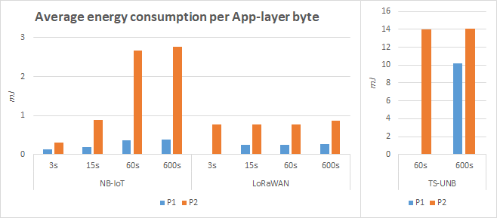

**Figure 27.** Average energy consumption of one byte of App-layer payload from Chapter 2.1.

Table 28. Battery lifetime estimation in days for each technology and message interval.

|  |  |  |  |  |  |  |  |
| --- | --- | --- | --- | --- | --- | --- | --- |
|  | **Int.** | **P1** | | | **P2** | | |
| Weather Station base |  | 20.7 | | | 9.3 | | |
|  |  | Module portion | Total | Module portion | | Total |
| With NB-IoT | 3 s | 8.8 | 11.9 | 1.4 | | 7.9 |
| 15 s | 4.3 | 16.4 | 1.0 | | 8.3 |
| 60 s | 2.0 | 18.7 | 0.7 | | 8.7 |
| 600 s | 0.2 | 20.5 | 0.1 | | 9.3 |
| With LoRaWAN | 3 s | NA | 0.0 | 2.9 | | 6.4 |
| 15 s | 5.8 | 14.9 | 0.8 | | 8.6 |
| 60 s | 1.5 | 19.2 | 0.2 | | 9.1 |
| 600 s | 0.2 | 20.6 | 0.0 | | 9.3 |
| With TS-UNB | 3 s | NA | 0.0 | NA | | 0.0 |
| 15 s | NA | 0.0 | NA | | 0.0 |
| 60 s | NA | 0.0 | 2.5 | | 6.8 |
| 600 s | 4.6 | 16.1 | 0.4 | | 9.0 |

**Figure 28.** Average energy consumption of one byte of App-layer payload from Chapter 2.1.

Some energy savings may be gained with LoRaWAN and TS-UNB, if the end-device is able to sleep between TX- and RX-states instead of just being on Idle.

This analysis should be considered mainly applicable only to the communication module. It does not account for the consumption of the parent system, such as a SoC to which the module is attached to.

Devices in bad coverage conditions, will utilize multiple repetitions with maximum transmit power, to ensure the data is received by the base station, and thus high power amplifier efficiency (PAE) is important.

Unlicensed spectrum regulations force restrictions on effective radiated power (ERP), duty cycles and listen-before-talk requirements. This in turn inherently weakens the energy efficiency of technologies utilizing the unlicensed bands. [2].

As stated by authors in [31], significant variations are observed in the transmission power depending on channel conditions. This is due to power control mechanism explained in Chapter 3.1.3, and the end-device has no control over it. This to account for this, this analysis was conducted with maximum transmission power in mind.

Additionally, considerable differences in consumption may also be witnessed between modules from different hardware manufacturers. Thus, measurements are needed. [31]

## Costs

The results of the LCC calculations are shown in Figure 29 and Figure 30, while Table 29 gives the totals. Noting that Figure 29 is in logarithmic scale, it can be clearly seen that the most significant factor is the operational costs. These costs are highly dependent on how much data is transmitted and the price per megabyte of the data subscription with the cellular operator.

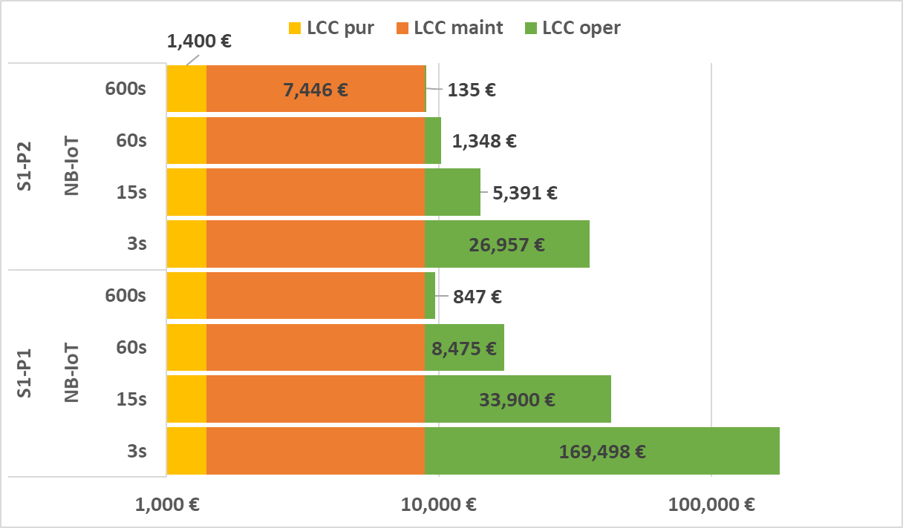

**Figure 29.** LCC breakdown for NB-IoT.

Given a system of 100 weather stations, already with the 0.02 € per MB price is an NB-IoT based solution cheaper than the unlicensed alternatives for all intervals except for P1 at the most frequent 3 second interval. The costs of operating the BS with device space rented from a telecom mast adds the most significant costs for LoRaWAN and TS-UNB. Furthermore, with respect to costs related to data transfer between the weather station and BS, the transmission interval plays no role with unlicensed technologies.

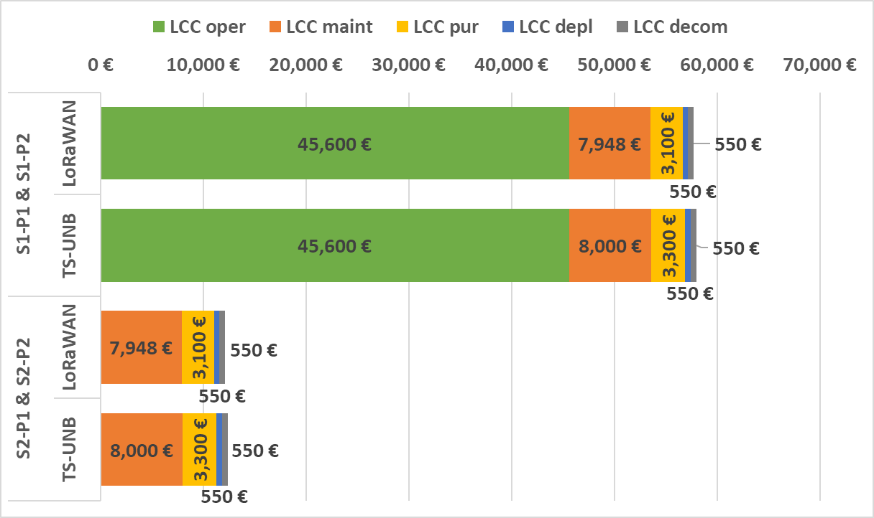

**Figure 30.** LCC breakdown for LoRaWAN and TS-UNB.

S2 represents the case, where the cost of operating the base stations is entirely local, and thus the costs device space rent, electricity or backhaul data subscription are not considered. In this situation, there is not much difference in costs between technologies. It is mainly a matter of module price, which in also affects expected maintenance costs.

Table 29. LCC results for 100 weather stations.

|  |  |  |  |  |  |  |
| --- | --- | --- | --- | --- | --- | --- |
|  | **Total LCC cost** | | | | | |
|  | S1-P1 | S1-P2 | S1-P1 & S1-P2 | | S2-P1 & S2-P2 | |
|  | NB-IoT | NB-IoT | LoRaWAN | TS-UNB | LoRaWAN | TS-UNB |
| 3s | 178344 € | 35803 € | 57748 € | 58000 € | 12148 € | 12400 € |
| 15s | 42746 € | 14237 € |
| 60s | 17321 € | 10194 € |
| 600s | 9693 € | 8981 € |

It should be noted that prices may vary significantly for a real life case and direct business-to-business sales and large bulk. For example, as explained by sales representative of Telia Towers Oy, renting space from a mobile mast is a sum of three components: antenna component (height and wind load), equipment space component (floor space in m2), and electricity. With a large number of end-devices, even small changes in price per unit of measure can have major impact in total LCCs. As in this example calculation, getting a better deal with the cellular operator (i.e. 0.01 € per MB) may even result in the reduction of one third from original costs. Generally, the most significant factors for cost optimization is with data plans and BS operating costs. Selecting the proper data plan according to measured cumulative transmitted data amount can give significant reductions in costs. In this calculation the BS backhaul data plan price was based on accumulation by 3 second interval as given in Table 3.

Based on Table 29, cost-wise for a large system the choice is clear. For Profile 1a-b NB-IoT is the cheapest choice, except for the 3 second interval with Profile 1a. For Profile 2, LoRaWAN takes first place. Giving the analysis another angle, NB-IoT’s rule becomes even more pronounced if the considered number of modules is set to two and with just one BS. In this situation, as shown by Table 30, NB-IoT is cheapest of all for S1 by an order of magnitude.

Table 30. LCC results for 2 weather stations (and 1 BS).

|  |  |  |  |  |  |  |
| --- | --- | --- | --- | --- | --- | --- |
|  | **Total LCC cost** | | | | | |
|  | S1-P1 | S1-P2 | S1-P1 & S1-P2 | | S2-P1 & S2-P2 | |
|  | NB-IoT | NB-IoT | LoRaWAN | TS-UNB | LoRaWAN | TS-UNB |
| 3s | 3,567 € | 716 € | 24,749 € | 24,754 € | 1,949 € | 1,954 € |
| 15s | 855 € | 285 € |
| 60s | 346 € | 204 € |
| 600s | 194 € | 180 € |

# Conclusions

fafasf

Wind gust reporting capability

Jhfghfgj

## NB-IoT

NB-IoT is preferred for applications that require guaranteed quality of service, whereas applications that do not have this constraint should choose LoRa or Sigfox. [39]

## LoRaWAN

## TS-UNB

## Future Work

This work provided only a literary view and theoretical analysis on feasibility of selected wireless technologies in this specific use-case. However, if making business decisions, these generalizations may only point the reader towards the right direction. A thorough prototype testing with hardware would be the obvious next step. As indicated by [31], the choice of hardware platform has impact on the behavior of the wireless module and thus performance of energy consumption. Therefore, it is imperative to perform trials on different modules before committing to a choice.

Another angle in minimizing energy consumption is to research the effect of using a method called event-based sampling. For human time scales, weather appears to be in constant shift. However, machines regard time differently. Looking at the data sent by the weather station, most measurements may not change even by one digit from message to message, except for wind measurements. This observation may present an opportunity to decrease transmission time, because one may argue that it brings no informational value to transmit the same values in multiple consecutive messages. The sensor could instead transmit a message only when the measured values change, for example over a specified threshold, leaving it up to the receiver side to fill in the time series based on previously received data. It may allow savings in consumed energy and subscription based data transmission costs, but this would need to be verified for example with time series of real life data.

# Summary

Gdfsgsdf

The last section of the work is the summary. This section summarizes the results and the conclusions from the results. This section gives answers for the promises given in the abstract and in the introduction. Items are only listed, the presentation becomes short in this sense, since everything is proved, shown, motivated, and presented in earlier sections of the thesis. There is nothing new given in this section, no new conclusions, and no new proposals for the future work. Maybe the only new thing is the criticism directed at the work performed by the author. In the thesis this section occupies only one page, the presentation becomes short and assertive.

# References

1. 2006/771/EC: Commission Decision of 9 November 2006 on harmonisation of the radio spectrum for use by short-range devices, *Official Journal of the European Union*. Available: https://eur-lex.europa.eu/legal-content/EN/TXT/?uri=CELEX%3A02006D0771%2801%29-20190813.
2. Adhikary A., Lin X., Wang Y.-P. E., Performance Evaluation of NB-IoT Coverage, *2016 IEEE 84th Vehicular Technology Conference (VTC-Fall)*, September 2016. Available: https://ieeexplore.ieee.org/document/7881160
3. AN1200.22 LoRa Modulation Basics, Revision 2, *Semtech*, May 2015.
4. Andreev S., Galinina O., Pyattaev A., Gerasimenko M., Tirronen T., Torsner J., Sachs J., Dohler M., Koucheravy Y., Understanding the IoT connectivity landscape: a contemporary M2M radio technology roadmap, *IEEE Communications Magazine*, Vol. 53, No. 9, September 2015. Available: <https://ieeexplore.ieee.org/document/7263370>.
5. Andres-Maldonado P., Ameigeiras P., Prados-Garzon J., Ramoz-Munoz J. J., Navarro-Ortiz J., Lopez-Soler J., Analytic Analysis of Narrowband IoT Coverage Enhancement Approaches, 2018 Global IoT Summit (GIoTS) Conference, March 2019. Available: https://arxiv.org/abs/1804.11118.
6. Barsukov Y., Jinrong Q., Battery Power Management for Portable Devices, *Artech House*, 2013.
7. Blackman J., What is MIOTY? All about telegram splitting and LoRaWAN bashing, *Enterprise IoT Insights*, September 2019. Available: <https://enterpriseiotinsights.com/20190926/channels/fundamentals/all-about-mioty-telegram-splitting-for-iiot>. Retrieved: 27.10.2020.
8. Bor M., Roedig U., LoRa Transmission Parameter Selection, *2017 13th International Conference on Distributed Computing in Sensor Systems (DCOSS)*, June 2017. Available: https://ieeexplore.ieee.org/document/8271941.
9. Casals L., Mir B., Vidal R., Gomes C., Modeling the Energy Performance of LoRaWAN, *MDPI Sensors*, Vol. 17, No. 10, October 2017. Available: <https://www.mdpi.com/1424-8220/17/10/2364>.
10. Castells-Rufas D., Galin-Pons A., Carrabina J., The Regulation of Unlicensed Sub-GHz bands: Are Stronger Restrictions Required for LPWAN-based IoT Success?, *arXiv.org*, November 2018. Available: <https://arxiv.org/abs/1812.00031>. Retrieved: 19.8.2020.
11. Chaudhari B. S., Zennaro M., Borkar S., LPWAN Technologies: Emerging Application Characteristics, Requirements, and Design Considerations, *MDPI Future Internet*, Vol. 12, No. 3, March 2020. Available: <https://www.mdpi.com/1999-5903/12/3/46/pdf>.
12. Chew D., The Wireless Internet of Things: A Guide to the Lower Layers, *Wiley-IEEE Standards Association*, 2019.
13. Croce D., Gucciardo M., Mangione S., Santaromita G., Tinnirello I., Impact of LoRa Imperfect Orthogonality: Analysis of Link-Level Performance, *IEEE Communications Letters*, Vol. 22, No. 4, April 2018. Available: https://ieeexplore.ieee.org/document/8267219
14. De la Roche G., Glazunov A. A., Allen B., LTE-Advanced and Next Generation Wireless Networks – Channel Modelling and Propagation, *John Wiley & Sons*, 2013.
15. Deloitte, The Future of Connectivity in IoT Deployments, March 2018. Available: <https://www2.deloitte.com/content/dam/Deloitte/de/Documents/technology/Connectivity-in-IoT-deployments-Deloitte.pdf>. Retrieved 14.8.2020
16. El-Aasser M., Gasser A., Ashour M., Elshabrawy T., Performance Analysis Comparison between LoRa and Frequency Hopping-based LPWAN, *2019 IEEE Global Conference on Internet of Things (GCIoT)*, December 2019. Available: https://ieeexplore-ieee-org.ezproxy.cc.lut.fi/document/9058411.
17. Electronic Code of Federal Regulations, Title 47, Chapter I, Subchapter A, Part 15 – Radio Frequency Devices, February 2021. Available: https://www.ecfr.gov/cgi-bin/text-idx?SID=7abc89590df38dc1442edd5e4369519f&mc=true&node=pt47.1.15&rgn=div5.
18. Elshabrawy T., Robert J., Closed-Form Approximation of LoRa Modulation BER Performance, IEEE Communications Letters, Vol. 22, No. 9, September 2018. Available: <https://ieeexplore.ieee.org/document/8392707>.
19. ETSI TS 103 357 V1.1.1, Short Range Devices; Low Throughput Networks (LTN); Protocols for radio interface A. European Telecommunications Standards Institute, June 2018. Available: https://www.etsi.org/deliver/etsi\_ts/103300\_103399/103357/01.01.01\_60/ts\_103357v010101p.pdf.
20. ETSI TS 136 211 V16.2.0, Technical Specification, E-UTRA - Physical channels and modulation, 3GPP Release 16, *European Telecommunications Standards Institute*. September 2020. Available: https://www.etsi.org/deliver/etsi\_ts/136200\_136299/136211/16.02.00\_60/ts\_136211v160200p.pdf.
21. ETSI TS 136 212 V16.2.0, Technical Specification, E-UTRA – Multiplexing and channel coding, 3GPP Release 16, Europea*n Telecommunications Standards Institute*. July 2020 Available: https://www.etsi.org/deliver/etsi\_ts/136200\_136299/136212/16.02.00\_60/ts\_136212v160200p.pdf.
22. ETSI TS 136 213 V14.16.0, Technical Specification, E-UTRA – Physical layer procedures, 3GPP Release 16, *European Telecommunications Standards Institute*. September 2020. Available: https://www.etsi.org/deliver/etsi\_ts/136200\_136299/136213/16.02.00\_60/ts\_136213v160200p.pdf.
23. ETSI TS 136 322 V16.0.0, Technical Specification, E-UTRA – Radio Link Control (RLC) protocol specification, 3GPP Release 16, *European Telecommunications Standards Institute*, July 2020. Available: <https://www.etsi.org/deliver/etsi_ts/136300_136399/136322/16.00.00_60/ts_136322v160000p.pdf>.
24. ETSI TS 136 323 V16.1.0, Technical Specification, E-UTRA – Packet Data Convergence Protocol (PDCP) specification, 3GPP Release 16, *European Telecommunications Standards Institute*, September 2020. Available: <https://www.etsi.org/deliver/etsi_ts/136300_136399/136323/16.01.00_60/ts_136323v160100p.pdf>.
25. Ferreira Dias C., Rodrigues de Lima E., Fraidenraich G., Bit Error Rate Closed-Form Expressions for LoRa Systems under Nakagami and Rice Fading Channels, *MDPI Sensors*, Vol. 19, No. 20, October 2019. Available: https://www.mdpi.com/1424-8220/19/20/4412.
26. Foubert B., Mitton N., Long-Range Wireless Radio Technologies: A Survey, *MDPI Future Internet*, Vol. 12, No. 1, January 2020. Available: https://www.mdpi.com/1999-5903/12/1/13/pdf.
27. Goldsmith A., Wireless Communications, *Cambridge University Press*, 2005.
28. Gravina R., Palau C.E., Manso M., Liotta A., Fortino G., Integration, Interconnection, and Interoperability of IoT Systems, *Springer International Publishing*, 2018.
29. Holma H., Toskala A., Nakamura T., 5G Technology – 3GPP New Radio, 1st edition, *John Wiley & Sons Ltd.*, 2020.
30. Hämäläinen J., Course Material, Long Term Evolution – Part 5: Radio Link Budget, ELEC-E7230 – Mobile Communication Systems, *Aalto University*, 2016.
31. Khan S., Alam M. M., LeMoullec Y., Kussik A., Parand S., Verikoukis C., An Empirical Modelling for the Baseline Energy Consumption of an NB-IoT Radio Transceiver., *TechRxiv*, Aug 2020. Available: <https://www.techrxiv.org/articles/preprint/An_Empirical_Modelling_for_the_Baseline_Energy_Consumption_of_an_NB-IoT_Radio_Transceiver/12738725>.
32. Lauterbach T., MYTHINGSTM vs. LoRa – A Comparative Study of Quality-of-Service Under External Interference, BehrTech Inc. Available: <https://behrtech.com/resources/lora-vs-mythings/>. Retrieved: 29.11.2020.
33. Liberg O., Sundberg M., Wang Y.-P. E., Bergman J., Sachs J., Wikström G., Cellular Internet of Things – From Massive Deployments to Critical 5G Applications, 2nd edition, *Academic Press*, 2020.
34. LoRaWAN Specification v.1.0, *LoRa Alliance*, January 2015. Available: https://lora-alliance.org/resource\_hub/lorawan-specification-v1-0/.
35. LoRaWAN Specification v1.1, *LoRa Alliance*, October 2017. Available: <https://lora-alliance.org/resource-hub/lorawanr-specification-v11>.
36. Malik H., Pervaiz H., Alam M. M., Le Moullec Y., Kuusik A., Radio Resource Management Scheme for NB-IoT Systems, *IEEE Access*, Vol. 6, Mach 2018. Available: <https://ieeexplore.ieee.org/document/8306882>.
37. Margelis G., Piechocki R., Kaleshi D., Thomas P., Low Throughput Networks for the IoT: Lessons learned from industrial implementations, *2015 IEEE 2nd World Forum on Internet of Things (WF-IoT)*, December 2015. Available: https://ieeexplore.ieee.org/document/7389049.
38. Markkula J., Mikhaylov K., Haapola J., Simulating LoRaWAN: On Importance of Inter Spreading Factor Interference and Collision Effect, *CC 2019 - 2019 IEEE International Conference on Communications (ICC)*, May 2019. Available: https://ieeexplore.ieee.org/document/8761055.
39. Matz A. P., Fernandez-Prieto J-A., Cañada-Bago J., Birkel U., A systematic Analysis of Narrowband IoT Quality of Service. *MDPI Sensors*, Vol. 20, No. 6, March 2020. Available: <https://www.mdpi.com/1424-8220/20/6/1636>.
40. Mesh Profile v1.0.1, Bluetooth Specification, *Bluetooth Special Interest Group*, January 2019. Available: https://www.bluetooth.com/specifications/mesh-specifications/ Retrieved: 15.7.2020.
41. Michelinakis F., Al-selvi A. S., Capuzzo M., Zanella A., Mahmood K., Elmokashfi A., Dissecting Energy Consumption of NB-IoT Devices Empirically., *IEEE*, Early Access, Aug 2020. Available: <https://ieeexplore-ieee-org.ezproxy.cc.lut.fi/document/9159902>.
42. Narrowband Internet of Things, Whitepaper, *Rohde & Schwarz*. Available: <https://cdn.rohde-schwarz.com/pws/dl_downloads/dl_application/application_notes/1ma266/1MA266_0e_NB_IoT.pdf>. Retrieved: 4.9.2020.
43. NB-IoT Channels – Examples, MathWorks LTE Toolbox R2020b, *The MathWorks Inc.* 2020. Available: <https://se.mathworks.com/help/lte/examples.html?category=nb-iot-channels&s_tid=CRUX_topnav>.
44. Oliveira L., Rodrigues J. J. P. C., Kozlov S. A., Rabêlo R. L., de Albuquerque V. H. C., MAC Layer Protocols for Internet of Things: A Survey, *MDPI Future Internet 2019*, Vol. 11, No. 1, January 2019. Available: <https://www.mdpi.com/1999-5903/11/1/16>.
45. Pahl J., Interference Analysis – Modelling Radio Systems for Spectrum Management, *John Wiley & Sons Ltd*., 2016.
46. Popovski P., Wireless Connectivity: An Intuitive and Fundamental Guide, *John Wiley & Sons*, May 2020.
47. Power saving methods for LTE-M and NB-IoT devices, White Paper, v.01.00, *Rohde & Schwarz*. Available: <https://www.rohde-schwarz.com/fi/solutions/test-and-measurement/wireless-communication/iot-m2m/whitepaper-power-saving-lte-m-nb-iot-register_251417.html>. Retrieved: 10.12.2020.
48. Rzepecki W., Ryba P., IoTSP: Thread Mesh vs Other Widely used Wireless Protocols – Comparison and use Cases Study, 2019 7th International Conference on Future Internet of Things and Cloud (FiCloud), *IEEE*, January 2020. Available: <https://ieeexplore.ieee.org/document/8972835>.
49. Saelens M., Hoebeke J., Shahid A., De Poorter E., Impact of EU duty cycle and transmission power limitations for sub-GHz LPWAN SRDs: an overview and future challenges, *EURASIP Journal on Wireless Communications and Networking*, Art. 219, September 2019. Available: https://jwcn-eurasipjournals.springeropen.com/articles/10.1186/s13638-019-1502-5
50. Sheikh A. U. H., Wireless Communications – Theory and Techniques, 1st edition, *Springer Scrience+Business Media LLC*, New York, 2004.
51. Specification TR 21.916 version 0.5.0, Release 16, *3GPP*, July 2020. Available: <https://portal.3gpp.org/desktopmodules/Specifications/SpecificationDetails.aspx?specificationId=3493>. Retrieved 20.8.2020.
52. SX1272/73, Datasheet, Semtech Corporation, January 2019. Available: <https://www.semtech.com/products/wireless-rf/lora-transceivers/sx1272#download-resources>. Retrieved: 19.11.2020.
53. Tikhvinskiy, V., Bochechka, G., Gryazev, A. and Aitmagambetov, A., Comparative analysis of QoS management and technical requirements in 3GPP standards for cellular IoT technologies, *Journal of Telecommunications and Information Technology*, Vol. 2, 2018. Available: <http://yadda.icm.edu.pl/baztech/element/bwmeta1.element.baztech-874dd3e5-34f2-45a7-9da9-ebb96ecadf08/c/JTIT_2_2018_Tikhvinskiy.pdf>.
54. Wang W., Capitaneanu S. L., Marinca D., Lohan E.-L., Comparative Analysis of Channel Models for Industrial IoT Wireless Communication, *IEEE Access*, Vol. 7, July 2019. Available: <https://ieeexplore.ieee.org/document/8756193>.
55. Weather Transmitter WXT530 Series Datasheet. Vaisala Available: <https://www.vaisala.com/sites/default/files/documents/WXT530-Datasheet-%20B211500EN.pdf>. Retrieved 10.6.2020.
56. Weather Transmitter WXT530 Series User’s Guide. Vaisala Available: [https://www.vaisala.com/sites/default/files/documents/WXT530-Users-Guide-M211840EN.pdf. Retrieved 10.6.2020](https://www.vaisala.com/sites/default/files/documents/WXT530-Users-Guide-M211840EN.pdf.%20Retrieved%2010.6.2020)
57. **Comparison table of wireless technologies**

This table summarizes the comparison factors with typical values for each technology including use-case requirements from Chapter 2.

**Table 31.** Full list of comparison factors.

|  |  |  |  |  |  |  |  |  |  |
| --- | --- | --- | --- | --- | --- | --- | --- | --- | --- |
| **Variable** | **SigFox** | **LoRaWAN** | **BLE** | **IEEE 802.15.4**  **(ZigBee, Thread)** | **IEEE 802.11ah** | **TS-UNB** | **LTE-M** | **NB-IoT** | **EC-GSM-IoT** |
| Typical Max Range | < 50 km | < 15 km | < 150 m | < 150 m | < 1 km | < 20 km | < 11 km | < 15 km | < 15 km |
| Max MAC-layer  Data Rate | 100 bps | < 50 kbps | 236.7 Kbps | < 250 kbps | 100 kbps – 7.8 Mbps | < 50 bps | < 1 Mbps | < 200 kbps | < 70 kbps |
| Max Payload | 12 B | 243 B | 23 B | 102 B | 511 B @ 1 MHz | 245 B (U)  250 B (D) | 8188 B | 1600 B | unknown |
| Modulation | DBPSK | GFSK  CSS | GFSK | DSSS  BPSK  O-QPSK | M-PSK M-QAM | MSK,  GMSK | QPSK, 16QAM | BPSK,  QPSK | GMSK  8PSK |
| Channelization / Media Access | UNB/FHSS (ALOHA) | ALOHA | TDMA | CSMA/CA | RAW | TSMA | OFDMA | OFDMA (D) SC-FDMA (U) | TDMA |
| Directionality | Limited Bi | Bi | Bi | Bi | Bi | Bi | Bi | Bi | Bi |
| Duplicity & Mode | Half | Half | Half | Half | Half | Half | Full or Half FDD / TDD | Half  FDD / TDD | Half |
| Energy Consumption | Very Low | Very Low | Low | Low | Low | Very Low | Low | Low | Medium |

(continues)

**APPENDIX 2.** **(continues)**

|  |  |  |  |  |  |  |  |  |  |
| --- | --- | --- | --- | --- | --- | --- | --- | --- | --- |
| **Variable** | **SigFox** | **LoRaWAN** | **BLE** | **IEEE 802.15.4** | **IEEE 802.11ah** | **TS-UNB** | **LTE-M** | **NB-IoT** | **EC-GSM-IoT** |
| RF Band | Unlicensed  Sub-1 GHz  900 MHz | Unlicensed  Sub-1 GHz | Unlicensed  2.4 GHz | Unlicensed  Sub-1 GHz,  2.4 GHz | Unlicensed  Sub-1 GHz | Unlicensed  Sub-1 GHz | Licensed LTE | Licensed LTE | Licensed GSM |
| Standardization | SigFox Proprietary | LoRa-Alliance  Proprietary | Bluetooth SIG  Bluetooth 5.0 | IEEE  Std 802.15.4-2020 | IEEE  Std 802.11ah-2016 | ETSI TS 103 357 | 3GPP  Rel. 13 | 3GPP  Rel. 13 | 3GPP  Rel. 13 |

1. Bluetooth and IEEE 802.15.4 may reach over greater coverage are through meshing.
2. Meshing-topologies may experience higher latencies
3. **Link to original calculations and simulations**

The many different calculations and simulations used in this work are available on the Author’s GitHub –page:

<https://github.com/vesamaki/MastersThesisSupplementaries>