Write a program that finds the ***longest adjacent sequence*** of colors in a matrix(2D grid). Colors are represented by ‘R’, ‘G’, ‘B’ characters (respectively Red, Green and Blue).

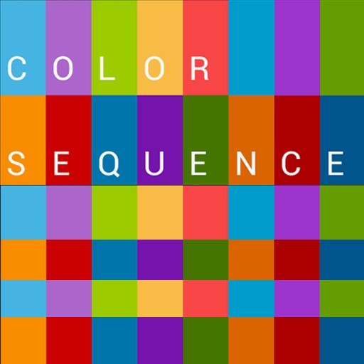

You will be provided with 4 individual test cases, which must also be included in your solution.

An example of your solution root directory should look like this:

solutionRootDir

| - (my solution files and folders)

| - tests/

| - test_1

| - test_2

| - test_3

| - test_4

1) Individual test case input format:

- First you should read two whitespace separated **32-bit integers** from the provided test case  
- that represents the size (**rows** and **cols**) of the matrix.  
- Next you should read **rows** number of **newline** separated lines of **8-bit characters**.

Your program should find and print the longest adjacent sequence (diagonals are not counted as adjacent fields), and **print** to the standard output the number.

NOTE: in case of several sequences with the same length – simply print their equal length.

|  |  |
| --- | --- |
| **Provided input** | **Expected Output** |
| 3 3 R R B G G R R B G | 2 |
| 4 4 R R R G G B R G R G G G G G B B | 7 |
| 6 6 R R B B B B B R B B G B B G G B R B B B R B G B R B R B R B R B B B G B | 22 |
| 1000 1000 1000 rows of 1000 R’s | 1000000 |

2) Your program entry point should accept from one to four additional parameters.  
Those parameters will indicate the names of the test cases that your program should run.  
• Example 1: ./myprogram test_1 test_3  
• Example 2: ./myprogram test_1 test_2 test_3 test_4  
• you can assume that the input from the user will be correct (no validation is required)