# MyWell: Crowdsourcing Citizen science for Groundwater Intervention

## Abstract

In rural India, over 60% of agriculture relies on groundwater. Groundwater is often over-exploited, and groundwater depletion threatens many livelihoods. Existing interventions have been insufficient, and often fail to engage farmers at the lowest level. MyWell sets out to build a participatory, bottom-up approach to groundwater management. MyWell is an application for data-driven insights of groundwater at the village level. MyWell crowdsources groundwater indicators from a group of connected farmers using SMS or a smartphone application. In this paper, we show how MyWell has the potential to impact the lives of farmers by (1) empowering them to participate in science, and finding solutions to groundwater scarcity, and (2) assist them in building communities which work together to conserve groundwater. Then, we assess MyWell’s application across two watersheds in rural India. We show how farmers are using MyWell to gain visibility into the groundwater situation, and examine the limitations of MyWell’s approach.

## Introduction

In this paper, we outline the challenges faced by rural communities that rely on groundwater in rural India. We introduce the MARVI project, a project which aims to promote participatory approaches to groundwater management. We show how MyWell can be used as a tool for facilitating PGWM and empowering villagers. We outline the MyWell system and talk through its implementation, and compare it to other similar approaches to citizen science. We then evaluate MyWell in two watersheds in rural west India, outlining its benefits, limitations, and the potential MyWell and of the MyWell approach to facilitate people to share water and stuff.

India uses the largest amount of groundwater in the world, estimated at 230 cubic kilometers per year (World Bank, 2010). Groundwater is a relatively cheap and accessible resource, which contributes to its over exploitation. As it is shared among a watershed, the property rights of groundwater are difficult to manage, as whoever pumps first owns the water (Maheshwari et al, 2014; Chinnasamy, Maheshwari and Prathapar, 2015). Groundwater is often overexploited for food production, with rainfall insufficient to recharge the groundwater levels (Rathore, 2004)

Groundwater is fundamental to the livelihoods of many farmers across India. In rural India, over 60 percent of agriculture is dependent on groundwater irrigation (World Bank, 2010). It allows farmers to grow crops in the dry season, as well as manage deficiencies in monsoonal rainfall, contributing to improved livelihoods and poverty alleviation (Maheshwari et al, 2014).

In order to better manage groundwater usage, intervention is required; both technological and social. Infrastructure is required to better facilitate aquifer recharge, and social frameworks are required to better manage groundwater use and sharing. The MARVI project, Managing Aquifer Recharge and Sustaining Groundwater Use through Village-level Intervention, aims to address this situation around groundwater management, by developing a participatory approach and methodology with tools to assist in groundwater management (Maheshwari et al, 2014).

The goal of the MARVI project is to give the ownership of groundwater situation to the villagers, and assist them in developing their own solutions. We foster this process through engagement with the community; helping them to understand and own the groundwater issues, and technology, namely in the collection and dissemination of information, allowing for a greater understanding and ownership of groundwater management.

In order to develop frameworks for improving the groundwater situation, accurate well data and sociological data are required. While the Indian Central Groundwater Board (CGWB) data are useful for groundwater monitoring on a national level, they are limited when applied to groundwater management at a village level. MARVI aims to collect more granular data, to better understand and apply to the issues directly to villages. Along with data collection, MARVI also conducted studies on the socio-economic aspects of groundwater management. Understanding the attitudes towards groundwater management for each village allows for MARVI to better apply solutions.

MARVI engages the community through water table monitoring, crop demonstrations, workshops, education in schools (Maheshwari, 2014). The goal of this is to foster community awareness around groundwater usage and depletion, and to create a platform for further discussion on improving groundwater management. Community engagement is also achieved through the Bhujal Jankaar program. Within each village, a volunteer known as a Bhujal Jankaar (BJ) - a hindi word for groundwater informed volunteer- has been trained to monitor wells, and act as a connection between MARVI and each village. They are able to disseminate information on rainfall and groundwater conditions, based on their water table monitoring work. They also play an important part in gathering together village communities for meetings, workshops and demonstrations.

India has experienced exponential growth of mobile phones and almost every household has at least one mobile handset for communication (**TODO: REF**). With the availability of mobile phones brings their application to help village community to monitor the local resource such as groundwater and develop longer term strategies for village level water security.

## Citizen Science in Action

Crowdsourcing is the approach of collecting data from a large number of distributed people. The growth of information technology has simplified crowdsourcing, and allowed for more novel applications, such as in citizen science. Citizen science is when amateurs are actively involved in science; through their contributions, a certain field of science can progress. Crowdsourcing for citizen science is being used to go beyond the boundaries of traditional scientific study, such as budget or time constraints, and is opening up new ways for everyday citizens to be involved.

While citizen science has been around for many years, technology is allowing for new applications and approaches. One of the oldest and longest running examples of citizen science is the Audobon Society’s Christmas Bird Count, started in 1900 (Audobon, 2015). The United States Geological Survey (USGS) has used citizen science for geological surveys for over 100 years (Quinn, press).

An example of using mobile applications for crowdsourcing citizen science is IBM’s Creekwatch. Creekwatch is a crowdsourcing tool which collects qualitative data; text and images about waterways across 25 countries (IBM Research, 2012).

Social.Water was a project for collecting stream data from 9 different locations in New York (Lowry and Fienen, 2013). Over a 10-month period, the system used text messages and emails to receive and process 150 measurements from citizen scientists in New York. The creators of this project write how the readings can be used to supplement readings where “telemetry or continuous recording are infeasible” (Fienen and Lowry, 2013). They also note that a secondary purpose to their project is community engagement.

Crowdsourcing citizen science is also being used to solve problems in low-income countries. Agro-Met is a tool for providing farmers in rural Maharashtra localized weather predictions over SMS, helping them become more resilient in the face of climate change (Singh, press). This project uses 75 weather stations, and also involves a training component. It overcomes a number of challenges unique to crowdsourcing approaches in low income countries, such as a lack of 3G/4G mobile infrastructure, language barriers, and community training. Another example is from the National Environmental Engineering Research Institute (NEERI) in India, which uses crowdsourcing to monitor water quality. Volunteers are given kits to test a number of water quality measures, and then use text messages to submit these readings. These messages are processed, aggregated and analysed, to calculate the water quality for individual villages (Toon, 2016).

## The citizen science and groundwater management

Decisions regarding the sustainable management of groundwater should be based on objective science. By connecting farmers and local community members with hands-on monitoring opportunities, we can begin village level movements for groundwater security by producing and empowering local groundwater champions. Crowdsourcing is suitable for groundwater monitoring since data are to be collected frequently (weekly or fortnightly) from wells, checkdams and rainfall stations spread across the country. Further, the data collection process is simple; anyone can learn how to monitor a well, checkdam or rainfall station.

Since 2012, the MARVI team has worked in Rajasthan and Gujarat with farmers, schools and others in the village community to develop village level groundwater monitoring approach. The idea of Bhujal Jankaar was developed to assist in monitoring of groundwater levels around villages, collecting local data and developing scientific understanding of groundwater dynamics. The data collected by BJs can inform sound decision making about the sustainable management of groundwater. MARVI helped to empower BJs, schoolchildren and ordinary citizens to collect valid and valuable scientific data related to their local groundwater situation, while providing those individuals with unique experiences, insights and access to leading groundwater researchers.

Our aim is to demystify groundwater science at the village level, making it accessible to villagers, government agencies and NGOs, while ensuring that it is cost-effective, evidence based and helps to groundwater situation at village level and beyond. The MARVI approach provides villagers the opportunity to work alongside researchers and government agencies.

The data collected by BJs are critical to build an understanding of how the groundwater levels fluctuate during the monsoon and other times of the year when pumping is in full swing. Also, local data collected this way can help us understand how we are impacting the groundwater situation at the village and inform sound decision-making about the management of groundwater.

Involving villagers for groundwater monitoring enables them to make a direct contribution to scientific research in their village, gain new insights based on sound data, and learn new ways to cope with groundwater scarcity. Also, involving villagers in groundwater monitoring provide immersive experiences that can help challenge current groundwater management practices.

## Study Area

MyWell has been piloted in two watersheds, the Dharta watershed in Rajasthan and the Meghraj watershed in Gujarat (Figure 1). In both watersheds, groundwater is the main source of irrigation water supply and plays an important role in agriculture and the livelihood of people. Both districts are in hard rock aquifer areas and groundwater levels have dropped significantly due to excessive pumping. MyWell is designed to be used in any part of India or in other parts of the world with minor modifications.

### Rajasthan

The study area of this project, the Dharta watershed, in Rajasthan is located in the Udaipur district, one of the 33 districts of the state. This district has about 2500 villages with population of 3 million and some parts of the district are predominantly tribal. The district is drained by the Sabarmati River in the west, the Banas River in the north and east and the Mahi River in the south and central parts. Agriculture plays a major role in the livelihoods of villagers but farmers often face Kharif **define** crop failure due to the lack of rain at a critical stage of the crop growth.

The soil type in the district is sandy loam to clay loam and the topography is often undulating. The average rainfall of the district is 650 mm, and about 128,000 ha of land is under irrigation with 89,000 ha mainly dependent on groundwater. The Dharta watershed is about 55 km east of Udaipur city. The main Kharif crops in the Dharta Watershed are maize, pulses, sorghum, guar, soybeans and the Rabi crops are wheat, barley, chick pea and mustard. For irrigation they mainly depend on open wells or tubewells but a large proportion of open wells have dried up or they are not reliable as source of water supply. Many farmers have dug tubewells to a depth of up to 150 metres, but they can also dry up during summer months or drought years.

Irrigation is widely performed using the surface method, however some farmers are rolling out sprinkler and drip systems as there is a government subsidy on the installation cost of these systems. Drinking water in these villages is solely from groundwater and is accessed through hand pumps, open wells or tubewells. Hinta village has piped water supply to most homes from a village overhead water tank constructed by the Government. Recently, a village overhead tank was constructed in Dharta village but most homes do not have piped water supply yet. Families in Sunderpura rely on hand pumps for their domestic water supply.

### Gujarat

The study area in Gujarat is located in the Aravali district, the 29th district created in 2013 and lies north of Ahmedabad. It has about 650 villages with a total population over 1 million. The district is drained by the Sabarmati River in the west, the Banas river in the north and east and the Mahi River in the south and central parts. The Aravalli district has a large tribal population with approximately 30% of the population coming from socially and economically disadvantaged groups.

The soil in the district is loamy type with an undulating topography. This distruct does not have many industries or urban centres, and unlike other districts in the state, about 80% of rural livelihoods are dependent mainly on agriculture and dairying. The average rainfall of the district is 750 mm, and there are 444,000 ha under irrigation with 170,000 ha dependent on groundwater through dug and tube wells.

The Meghraj watershed is located about 25 km west of Modasa town and 100 km from the state capital Gandhinagar. In this watershed also, agriculture is quite important in the livelihoods of villagers and the threat of Kharif crop failure is always there if there is insufficient rainfall at some stage during the monsoon season. The main crops grown in the district are maize, cotton, wheat, pigeon pea and castor. The soil type in the district is sandy loam to clay loam and the topography is often undulating. The average rainfall of the district is 750 mm, and about 444,000 ha of land is under irrigation with 170,000 ha mainly dependent on groundwater.

## MyWell

MyWell is a smartphone and SMS application for crowdsourcing groundwater, rainfall, water quality and checkdam water levels in project MARVI. BJs armed with a smartphone or feature phone can participate in a network of connected farmers who collect information, and glean insights into the groundwater situation.

In the MyWell system, a groundwater metric is known as a “Resource”, which can be a Well, Check dam or Rainfall Station. Every resource, village and collection of villages in the MyWell system is uniquely identifiable, using a combination of pincode, village ids and resource ids.

### Features

MyWell is available as an app on Android and iOS smartphones (MyWell Mobile), and also on any web browser as a web app (MyWelll web). For users with feature phones, MyWell’s basic tools and analysis are also available over SMS (MyWell SMS). When a BJ takes a well, they can record it directly with MyWell - submitting the date, Well Id, and the depth to water level of the well.

With MARVI’s network of BJs collecting data, MyWell is able to provide valuable insights to villagers. MyWell displays simple graphs; snapshots of the readings from a Well, Raingauge or Checkdam over the last 3 years. MyWell also calculates village level statistics. These tools allow villagers to easily compare and benchmark their wells against each other, and previous years.

#### MyWell SMS

Users interact with MyWell by sending and receiving SMS messages, a part of the application called MyWell SMS. MyWell users submit resource readings, as well as query MyWell for some basic groundwater statistics.

Data submission is performed over a single SMS message to MyWell’s phone number. The most common case is submitting a well reading. The message takes the format: “MYWL S PINCODE/RESOURCE_ID/READING”, where reading is the depth to water level in centimetres.

Users can also query MyWell over SMS, for some basic basic groundwater statistics. To query the groundwater level of a well, most recent rainfall amount in a rainfall station, or water column height in a checkdam, users send a text message of the format “MYWL Q PINCODE/RESOURCE_ID”. This query will return the current value, the value from last month, and the value one year ago.

To get the average for a village, a user can send a query with the format “MYWL Q PINCODE/VILLAGE_ID”. This query will return the current average depth to water level and the average monthly rainfall amount for this village.

Users can also request for groundwater statistics for all resources within a pincode, which will aggregate the data from resources across multiple villages. This is done using a query with format “MYWEL Q PINCODE”.

#### MyWell Mobile

The process for submitting readings on MyWell mobile is simpler than over SMS, but requires the user to have an Android or iOS smartphone and access to the internet, either over mobile data or Wifi.

To submit a reading, the user must first login using a one time code sent to either an email address or mobile number. The user then fills out a form, specifying the type of resource - well, rainfall station or checkdam- pincode, resource id, date of the reading (used for backdating readings) and the value of the reading - either depth to water level, rainfall amount or water column height for a well, rainfall station and checkdam accordingly. (Figure 2)

The user then presses the “submit” button, and MyWell mobile performs some validation and submits the reading. If the user doesn’t have access to the internet, they can choose to save the reading locally onto the device, and submit the reading later.

Groundwater statistics are also available for users of MyWell mobile. The map screen displays a map containing all the resources registered in MyWell, along with village names (Figure 2.).

When the user clicks a resource, users get a popup with the Village name of the well, the resource id, and the last recorded reading of the resource. Clicking the “more” button takes the user to a page that shows more information about that resource, including a graph that displays data for the last 3 years. (Figure 3)

MyWell also has a host of tools for BJs to manage the MyWell system. BJs can register a new Well, Rainfall Station or Checkdam - using their device’s inbuilt GPS to pinpoint the location. Each well also has a unique Banner Image - usually of the well and well’s owner - allowing for greater personalisation and buy-in from BJs.

Finally, MyWell allows MARVI project administrators and groundwater researchers to upload a large number of readings at a time. This allows an import of large amounts of historical data; increasing the immediate value of MyWell to the farmers.

### MyWell Architecture

MyWell can be seen as a collection of a number of smaller services. Figure 4 shows an overview of each service, and how they work together.

The core of the MyWell System is a service called MyWell Server. MyWell server is a web service written in Javascript, running on node js. All users, whether it be those using MyWell Web, Android or SMS ultimately end up interacting with MyWell Server.

MyWell’s database is a MariaDB database running in RDS, Amazon’s managed database service. RDS is responsible for securing and backing up data of the MyWell system. MyWell Server interacts with the database in order to save and retrieve data.

The SMS gateway provider is responsible for receiving and sending SMS messages for MyWell. It converts SMS messages into http calls that call MyWell Server. It also converts http calls from MyWell Server into SMS messages that get delivered to MyWell’s users.

The MyWell Mobile application is available on iOS and Android devices. It interacts directly with MyWell server, and also has some offline functionality to save readings and reduce the data usage for end users.

Finally, MyWell Web is MyWell’s website, which can be found at https://mywell.vessels.tech this site is hosted on Amazon’s Cloudfront, a content delivery network (CDN) that improves the load time of the web application.

### Implementation Journey

MyWell has been under development since 2015. It originally started as a project run by graduate students at Carnegie Mellon University. Since the developers have graduated, the continued development of MyWell has been taken over by Vessels Tech, a Social Enterprise based in Adelaide, Australia.

MyWell has gone through four major iterations, starting as as a small web server receiving SMS messages from an SMS gateway provider, through to it’s current architecture, running as a collection of services hosted on Amazon Web Services (AWS).

#### Version 1:

The first version of MyWell was a prototype that supported SMS only. This prototype was developed by Romin Parek, Constantin Baumgartner and James Laney at Carnegie Mellon University. They wrote a web server that received SMS messages containing well readings, and displayed them using a heatmap on a website.

#### Version 2:

After this initial prototype, Lewis Daly came on board to start building MyWell mobile, the mobile app component of MyWell. MyWell was also migrated from running on university infrastructure to a managed hosting service, using Azure Mobile backend as a service.

After this prototype was released, we conducted some field trials. We were able to observe benefits and limitations of the current approach, and incorporate this feedback into the next development stages.

#### Version 3:

The third iteration of MyWell added new features, allowing the application to handle new resource types - Checkdams and Rainfall Stations. We also added more features to help manage the MyWell system, allowing users to upload large amounts of past readings at once, and allowing for new resources to be registered from within the app . We also migrated the web components of MyWell to a self-managed environment, in order to reduce costs and prevent vendor lock-in.

#### Version 4:

In the fourth - and latest - version of MyWell, we moved the hosting to Amazon Web Services, to allow for a greater level of security and maintainability. We also redesigned the SMS queries to make MyWell SMS easier to use.

## Testing & Evaluation

### Workshops and Field Trials

We ran MyWell workshops with BJs in both the Dharta and Megraj watersheds. These workshops involved demonstrating to BJs both MyWell on Android and MyWell over SMS, and observing as BJs used MyWell without instruction.

We also conducted field trials where BJs uploaded well readings in real time, and we were able to see them on other devices.

After the workshops and field trials, we conducted a survey (n=10) of BJs and researchers in attendance. The survey focused on feedback on the areas of MyWell they thought worked, didn’t work, and areas where they think MyWell could expand and grow.

### Results:

One key learning from the surveys was that the BJs saw how using MyWell would lead to less errors, reduces the need for using paper, and makes recording well readings easier. From observing BJs using MyWell, we saw them quickly learning the features through simple navigation and trial and error.

Understandably, the MyWell SMS interface was harder for BJs to understand, and they all favoured using MyWell on an Android device over simple SMS.

BJs also noted that they saw how MyWell can be used to help with crop planning, and understanding their household and farm water needs. Finally, BJs and researchers alike liked that the data stored in MyWell is secure and isn’t going to get lost very easily, and it’s now shareable with just about anyone.

One area MyWell needs improvement is in its language selection, which is currently only English. Every survey mentioned the need for a Hindi version of MyWell. Some users also found it difficult to see and understand the graphs, and asked for changes to be made to make the graphs more easily read on devices with small screens.

The field trials demonstrated MyWell Mobile to work as expected when recording new readings. In areas of low connectivity, users were able to save readings locally on the device, and submit them when they later regained connectivity.

Due to issues with the MyWell SMS gateway provider, we were unable to test the MyWell SMS functionality completely from the field.

## MyWell and Other Crowdsourcing Projects

MyWell is an example of crowdsourcing citizen science, made to address the needs of farmers in rural India and project MARVI. It builds on previous applications of crowdsourcing citizen science, to fit the requirements of MARVI. It also has potential as a data collection and processing platform, with a focus on data collection in low income countries.

Similar to IBM’s Creekwatch, MyWell uses a mobile app for data collection, with a map-based visualisation on the web. However, Creekwatch collects qualitative data such as images and text, while MyWell focuses on quantitative data.

MyWell’s SMS features are similar to those of Social.Water. Fienen notes that in the US, using SMS lowers the barriers to entry for the platform (Lowry and Fienen, 2012). In India, where data coverage is low, and smartphones are not as popular (GSMA, 2016) this is even more the case. Using both SMS and mobile app, MyWell can have the advantage of providing advanced features to those users with smartphones, while keeping the platform accessible for all. MyWell SMS also focuses information dissemination, while Social.Water is purely a means for data collection.

Unlike the above examples, MyWell deals with a number of challenges that are unique to rolling out technology in low income countries. Like Agro-Met and NEERI’s water monitoring project, MyWell must work within the technology constraints, such as limited access to mobile data and language constraints. Mobile coverage, especially 3G/4G data is still limited in many parts of rural India, with 3G coverage reaching 75% of the population (GMSA, 2015). Also, smartphone uptake in these communities is small. In 2015, only 29.8% of all Indian mobile phone users had a smartphone (Statista, 2016). In order for MyWell as a platform to have the reach required, it needs to exist as a smartphone application and SMS application.

One of the key values of MyWell is its ability to remove the need for paper-based data collection and allow a distributed, network of data collection; lowering the barriers of entry into citizen science. MyWell can minimise the manual data entry requirements of MARVI, and reduce the time demand and errors associated with manual data entry. Additionally, the data stored in MyWell is saved instantly and backed up on an hourly basis, making it much more secure.

## Conclusion

Groundwater scarcity is a serious issue faced by many communities in rural India, and around the world. In this paper we looked at project MARVI, and introduced MyWell, an application for crowdsourcing groundwater levels and engage everyday citizens in groundwater science.

Project MARVI looks at the issues of groundwater management in rural India, aiming to give ownership of groundwater monitoring to the villagers, and assist them in developing their own solutions to the issues they face.

In this paper, we looked at the potential MyWell has to impact the lives of farmers by (1) empowering them to participate in science, and finding solutions to groundwater scarcity, and (2) assisting them in building communities which work together to conserve groundwater. We also outlined the design, architecture and development process of MyWell, and compared it to other approaches in crowdsourcing citizen science.

From our workshops and field trials, we show how farmers can use MyWell to gain visibility into the groundwater situation, and examine the limitations of this technology, along with areas for improvement.

Addressing these shortcomings is crucial to scaling up MyWell to more communities and application in larger groundwater management projects. We are actively working on features to improve MyWell for both researchers and BJs, as well as looking for partnerships with ther NGOs and governments to share water data together, this will foster new opportunities in groundwater management and further contribute to improving the groundwater situation.

## Definitions

* **WaterShed:** **TODO**
* **Aquifer Recharge:** Aquifer recharge is when surface water moves through the ground into an aquifer.
* **Depth to Water Level:** Depth to water level is a method for measuring well depths. Instead of measuring from the bottom of the well, the well is measured from the well opening. This gives an accurate way for well depths to be compared.
* **Bhujal Jankaar (BJ):** Bhujal Jankaar is a Hindi word meaning “Groundwater informed”. Within MARVI, BJ’s are trained, and then train farmers and villagers in effective groundwater management practices.
* **Autoscaling:** In computing, autoscaling is when the supply of computing resources (e.g., Number of servers) is increased and decreased to match the demand placed on the resources.
* **Continuous Integration:** Continuous Integration is a development practice that allows code to be tested and deployed automatically whenever a change is made. Within the context of MyWell, whenever code changes are submitted, MyWell will update automatically to reflect these changes.

## Figures

Figure 1 - Project MARVI study areas. 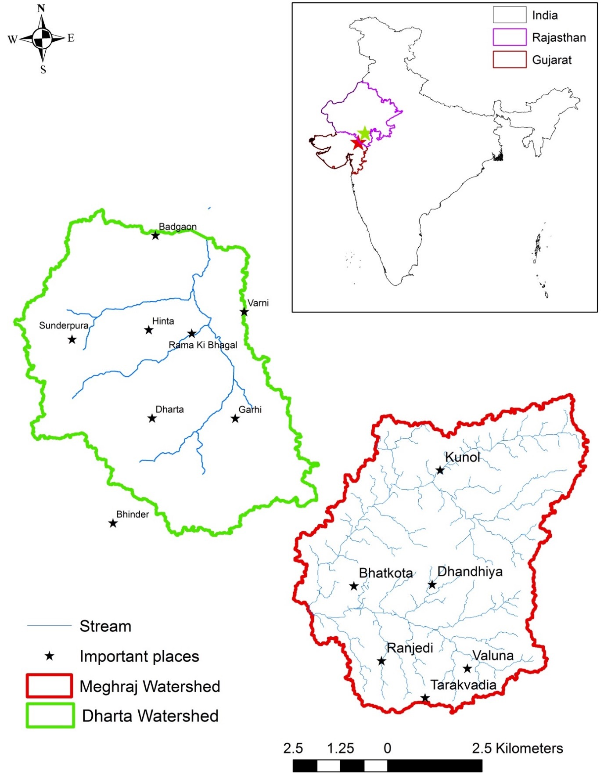

Figure 2 - Submitting a reading using MyWell Mobile. 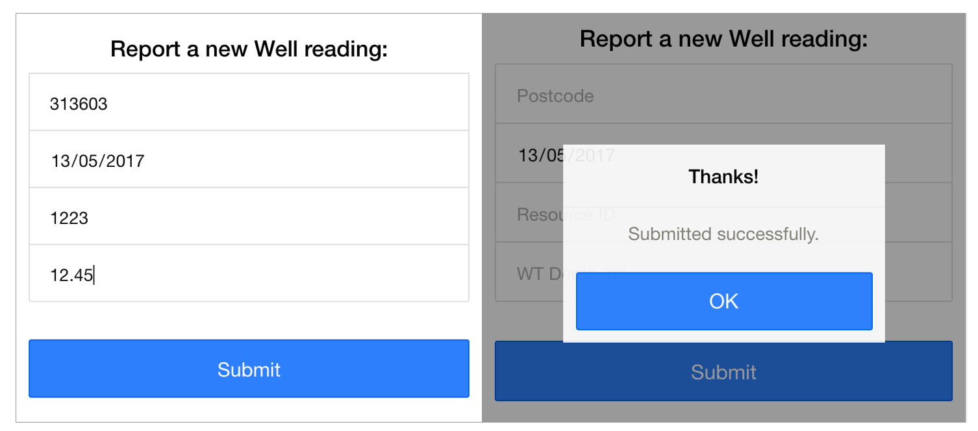

Figure 3: - MyWell Mobile Map Screen. 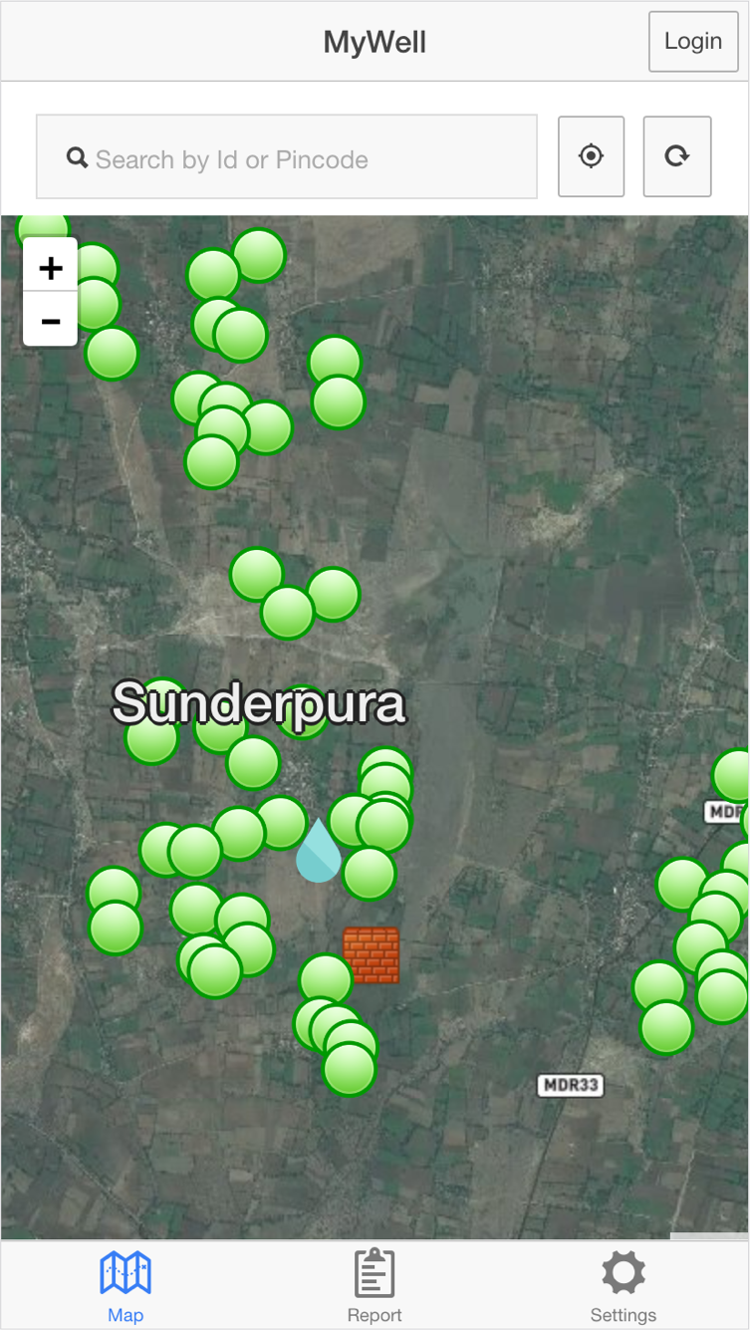

Figure 4: - MyWell Mobile Popup and Detail screens. 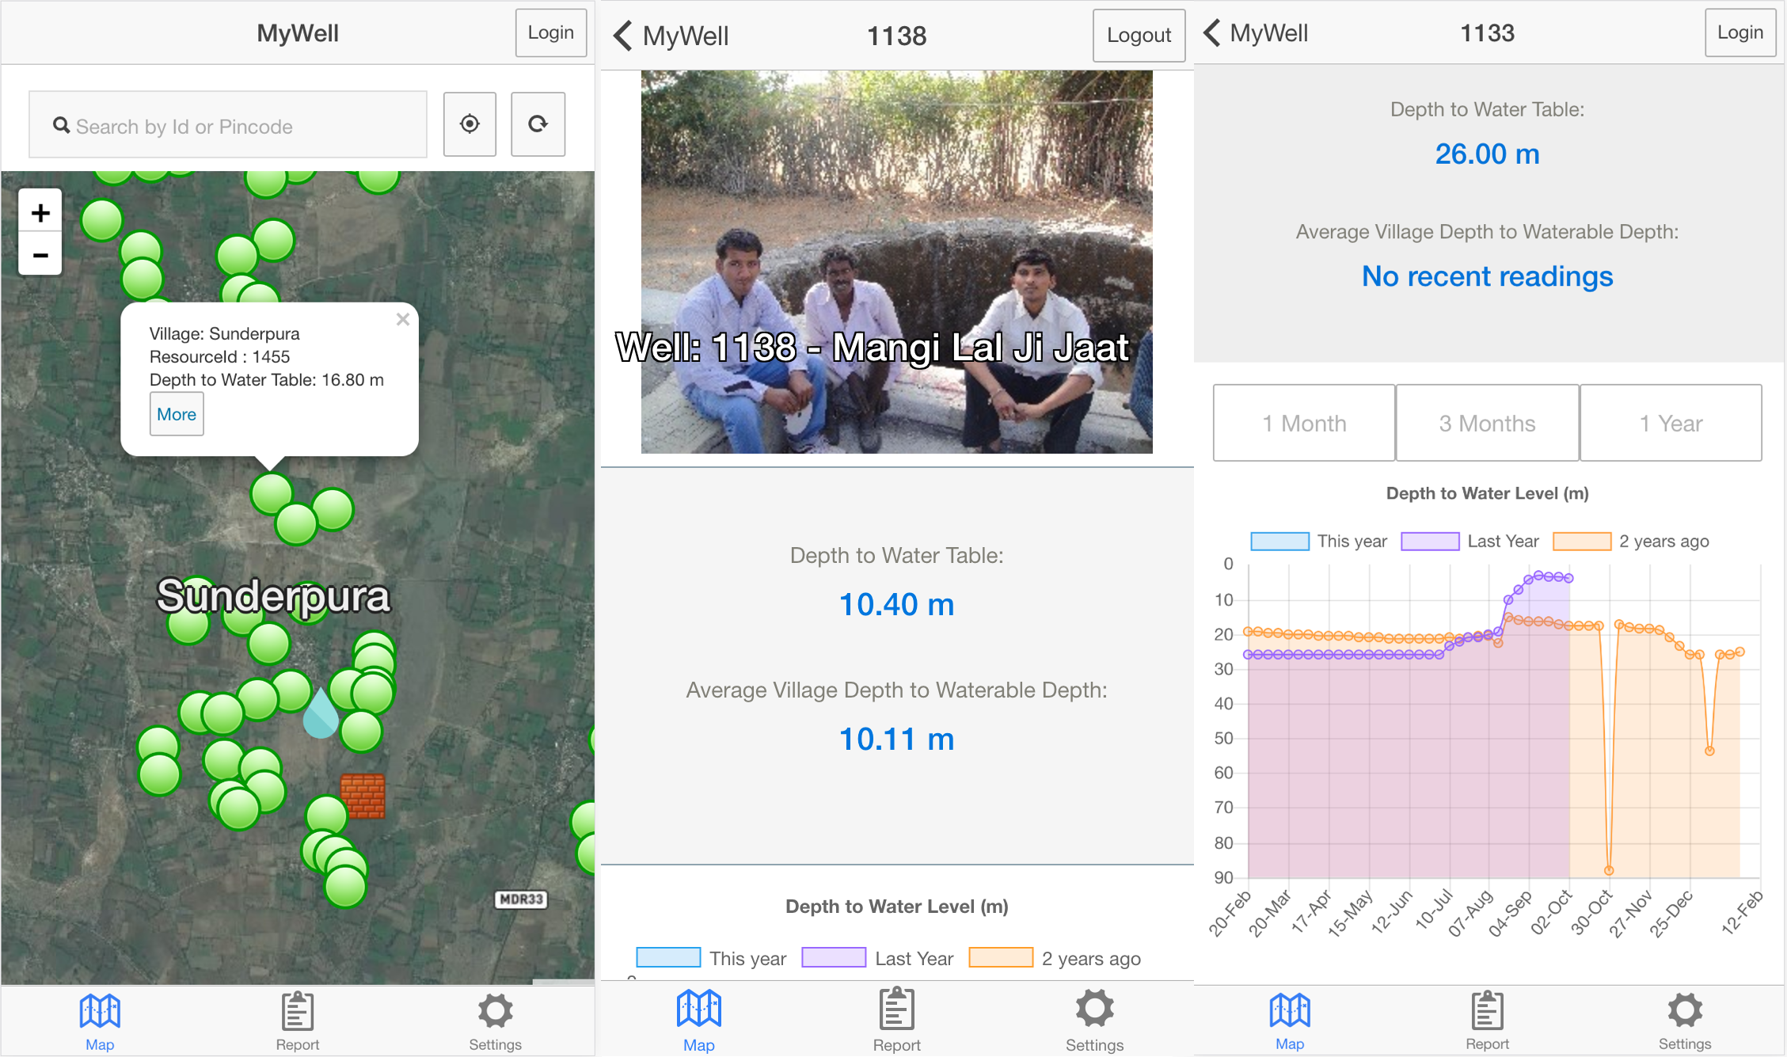

Figure 5: - MyWell System Architecture. 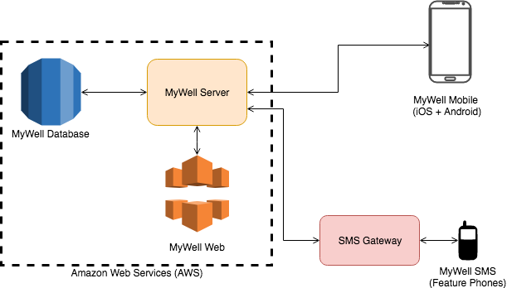

## References

* Chinnasamy, Pennan, Basant Maheshwari, and Sanmugam Prathapar. “Understanding Groundwater Storage Changes and Recharge in Rajasthan, India Through Remote Sensing”. Water 7.10 (2015): 5547-5565. Web.
* Deep Wells and Prudence. Washington D.C.: World Bank, 2010. Print.
* “Pew, 2014”, “Emerging Nations Embrace Internet, Mobile Technology”. Pew Research Center’s Global Attitudes Project. N.p., 2014. Web. 9 Apr. 2016.
* Fienen, Michael N., and Christopher S. Lowry. “Social.Water—A Crowdsourcing Tool for Environmental Data Acquisition”. Computers & Geosciences 49 (2012): 164-169. Web.
* “IBM Research, 2012”, IBM Research: Creek Watch IPhone App Goes Social“.
* Ibmresearchnews.blogspot.com.au. N.p., 2012. Web. 9 Apr. 2016.
* Lowry, Christopher S., and Michael N. Fienen. “Crowdhydrology: Crowdsourcing Hydrologic Data and Engaging Citizen Scientists”. Ground Water 51.1 (2012): 151-156. Web.
* Maheshwari, Basant et al. “The Role of Transdisciplinary Approach and Community Participation in Village Scale Groundwater Management: Insights from Gujarat and Rajasthan, India”. Water 6.11 (2014): 3386-3408. Web.
* Rathore, M. S. State Level Analysis of Drought Policies and Impacts in Rajasthan, India. Colombo, Sri Lanka: International Water Management Institute, 2004. Print.
* Rural Coverage: Strategies for Sustainability. GSMA Intelligence, 2015. Web. 1 Apr. 2016. Country Case Studies.
* “Service Level Agreements Summary Microsoft Azure”. Azure.microsoft.com. N.p., 2016. Web. 9 Apr. 2016.
* “Smartphone User Penetration in India 2014-2019”. Statista. N.p., 2016. Web. 9 Apr. 2016.
* “The Geological Society of London - Crowdsourcing Science”. Geolsoc.org.uk. N.p., 2016. Web. 9 Apr. 2016.
* “The History of Audubon”. Audubon. N.p., 2015. Web. 9 Apr. 2016.
* Toon, John. “Crowdsourcing Could Lead to Better Water in Rural India”. News.gatech.edu. N.p., 2016. Web. 9 Apr. 2016.
* Singh, Tanaya. “Farmers in Rural Maharashtra Are Fighting Climate Change. With Just a Mobile Phone.”. The Better India. N.p., 2016. Web. 10 Apr. 2016.