# Monitoring Groundwater at Village Level through Citizen Science Approach in India: Application of Mobile Phone Technology

## Abstract

Citizen science is when everyday citizens are involved in scientific study. Citizen science allows professionals to harness a large of resources, and amateurs the opportunity to contribute to science. Crowdsourcing, or obtaining information from the general public can be a method of citizen science [1]. The growth of mobile networks and the ubiquity of mobile phones in low income countries [2] has created an opportunity for innovation around crowdsourced citizen science to solve practical problems.

MyWell is a smartphone and SMS application for crowdsourcing groundwater, rainfall, water quality and checkdam water levels in rural India. Groundwater depletion is a serious issue for farmers and villagers who rely on groundwater for their livelihoods. MyWell crowdsources well information from villagers, and aims to improve the situation, both through information collection, and building community involvement and citizen ‘buy-in’.

## Introduction

The aim of this paper is to outline the process of developing and implementing mobile phone technology for villages in rural India and evaluate its potential for assisting sustainable groundwater management.

India uses the largest amount of groundwater in the world, estimated at per year [3]. Groundwater is a relatively cheap and accessible resource, which contributes to its over exploitation. As it is shared among a watershed, the property rights of groundwater are difficult to manage, as whoever pumps first owns the water [4][5]. Groundwater is often overexploited for food production, with rainfall insufficient to recharge the groundwater levels 6

Groundwater is fundamental to the livelihoods of many farmers across India. In rural India, over 60 percent of agriculture is dependent on groundwater irrigation 3. It allows farmers to grow crops in the dry season, as well as manage deficiencies in monsoonal rainfall, contributing to improved livelihoods and poverty alleviation 4.

In order to better manage groundwater usage, intervention is required; both technological and social. Infrastructure is required to better facilitate aquifer recharge, and social frameworks are required to better manage groundwater use and sharing. The MARVI project, Managing Aquifer Recharge and Sustaining Groundwater Use through Village-level Intervention, aims to address this situation around groundwater management, by developing a participatory approach and methodology with tools to assist in groundwater management 4.

The goal of the MARVI project is to give the ownership of groundwater situation to the villagers, and assist them in developing their own solutions to the issues they face. This process is being fostered through engagement with the community; helping them to understand and own the groundwater issues, and technology, namely in the collection and dissemination of information, allowing for a greater understanding of this invisible resource.

In order to develop frameworks for improving the groundwater situation, accurate well data and sociological data are required. While the Central Groundwater Board (CGWB) data are useful for groundwater monitoring on a national level, they are limited when applied to groundwater management at a village level. MARVI aims to collect more granular data, to better understand and apply to the issues directly to villages. MARVI also conducted studies on the socio-economic aspects of groundwater management. Collecting accurate groundwater data is important, but understanding the attitudes towards groundwater management for each village will allow for MARVI to better apply solutions.

MARVI engages the community through water table monitoring, crop demonstrations, workshops, education in schools 4. The goal of this is to foster community awareness around groundwater usage and depletion, and to create a platform for further discussion on improving groundwater management. Community engagement is also achieved through the Bhujal Jankaar program. Within each village, a volunteer known as a Bhujal Jankaar (BJ) has been trained to monitor wells, and act as a connection between MARVI and each village. They are able to disseminate information on rainfall and groundwater conditions, based on their water table monitoring work. They also play an important part in gathering together village communities for meetings, workshops and demonstrations.

India has experienced exponential growth of mobile phones and almost every household has at least one mobile handset for communication 7. With the availability of mobile phones brings their application to help village community to monitor the local resource such as groundwater and develop longer term strategies for village level water security.

## Citizen Science in Action

Crowdsourcing is the approach of collecting data from a large number of distributed people. The growth of information technology has simplified crowdsourcing, and allowed for more novel applications, such as in citizen science. Citizen science is when amateurs are actively involved in science; through their contributions, a certain field of science can progress. Crowdsourcing for citizen science is being used to go beyond the boundaries of traditional scientific study, such as budget or time constraints, and is opening up new ways for everyday citizens to be involved.

Citizen science is not a new practice; it has been performed for many years. Technology is opening up new approaches for citizen science to take place. One of the oldest and longest running examples of citizen science is the Audobon Society’s Christmas Bird Count, started in 1900 8. The United States Geological Survey (USGS) has used citizen science for geological surveys for over 100 years 9.

An example of using mobile applications for crowdsourcing citizen science is IBM’s Creekwatch. Creekwatch is a crowdsourcing tool which collects qualitative data; text and images about waterways across 25 countries 10.

Social.Water was a project for collecting stream data from 9 different locations in New York (Lowry and Fienen, 2013). Over a 10-month period, the system used text messages and emails to receive and process 150 measurements from citizen scientists in New York. The creators of this project write how the readings can be used to supplement readings where “telemetry or continuous recording are infeasible” 11. They also note that a secondary purpose to their project is community engagement.

Crowdsourcing citizen science is also being used to solve problems in developing countries. Agro-Met is a tool for providing farmers in rural Maharashtra localized weather predictions over SMS, helping them become more resilient in the face of climate change (Singh, press). This project uses 75 weather stations, and also involves a training component. It overcomes a number of challenges unique to crowdsourcing approaches in Low Income countries, such as a lack of 3G mobile infrastructure, language barriers, and community training. The National Environmental Engineering Research Institute (NEERI) in India is using crowdsourcing to monitor water quality. Volunteers are given kits to test a number of water quality measures, and then use text messages to submit these readings. They are then processed and analysed, to calculate the water quality for individual villages 12.

## The role of citizen science in groundwater management

Decisions regarding the sustainable management of groundwater should be based on objective science. By connecting farmers and local community members with hands-on monitoring opportunities, we can begin a village level movement for groundwater security through producing and empowering local groundwater champions. Crowdsourcing is suitable for groundwater monitoring since data are to be collected frequently (weekly or fortnightly) from wells, checkdams and rainfall stations spread across the country. Further, the data collection process is simple; anyone can learn how to monitor a well, checkdam or rainfall station.

Since 2012, the MARVI team has worked in Rajasthan and Gujarat with farmers, schools and others in the village community to develop village level groundwater monitoring approach. The idea of Bhujal Jankaar (BJ), a Hindi word meaning ‘groundwater informed’, was developed to assist in monitoring of groundwater levels around villages, collecting local data and developing scientific understanding of groundwater dynamics. The data collected by BJs can inform sound decision-making about the sustainable management of groundwater. MARVI helped to empower BJs, schoolchildren and ordinary citizens to collect valid and valuable scientific data related to their local groundwater situation, while providing those individuals with unique experiences, insights and access to leading groundwater researchers.

Our aim is to demystify groundwater science at the village level, making it accessible to villagers, government agencies and NGOs, while ensuring that it is cost-effective, evidence based and helps to groundwater situation at village level and beyond. The MARVI approach provides villagers the opportunity to work alongside researchers and government agencies.

The data collected by BJs are critical to build an understanding of how the groundwater levels fluctuate during the monsoon and other times of the year when pumping is in full swing. Also, local data collected this way can help us understand how we are impacting the groundwater situation at the village and inform sound decision-making about the management of groundwater.

Involving villagers for groundwater monitoring enables them to make a direct contribution to scientific research in their village, gain new insights based on sound data, and learn new ways to cope with groundwater scarcity. Also, involving villagers in groundwater monitoring provide immersive experiences that can help challenge current groundwater management practices. Ultimately, citizen science allows for more research to be accomplished globally and connects people in a worldwide environmental movement.

## Study Area

The development of MyWell is piloted in two watersheds, the Dharta watershed in Rajasthan and the Meghraj watershed in Gujarat (Figure 2). In both watersheds, groundwater is the main source of irrigation water supply and plays an important role in agriculture and the livelihood of people. Both districts are in hard rock aquifer areas and groundwater levels have dropped significantly due to excessive pumping. MyWell is designed to be used in any part of India or in other parts of the world with a slight modification.

### Rajasthan

The study area of this project, the Dharta watershed, in Rajasthan is located in the Udaipur district, one of the 33 districts of the state. This district has about 2500 villages with population of 3 million and some parts of the district are predominantly tribal. The district is drained by the Sabarmati River in the west, the Banas River in the north and east and the Mahi River in the south and central parts. Agriculture plays a major role in the livelihoods of villagers but farmers often face Kharif crop failure due to the lack of rain at a critical stage of the crop growth.

The soil type in the district is sandy loam to clay loam and the topography is often undulating. The average rainfall of the district is 650 mm, and about 128,000 ha of land is under irrigation with 89,000 ha mainly dependent on groundwater. The Dharta watershed is about 55 km east of Udaipur city. The main Kharif crops in the Dharta Watershed are maize, pulses, sorghum, guar, soybeans and the Rabi crops are wheat, barley, chick pea and mustard. For irrigation they mainly depend on open wells or tubewells but a large proportion of open wells have dried up or they are not reliable as source of water supply. Many farmers have gone for tubewell to a depth up to 150 m but they are also not so reliable these days as they can also dry up during summer months or during drought years.

The surface method of irrigation is widely used but some farmers are going for sprinkler and drip systems as there is a government subsidy on the cost of installation of these systems. The source of drinking water in all the villages is groundwater and it accessed through hand pumps, open wells or tubewells. Hinta village has piped water supply to most homes from a village overhead water tank constructed by the Government. Recently, a village overhead tank was constructed in Dharta village but most homes do not have piped water supply yet. Families in Sunderpura rely on hand pumps for their domestic water supply.

### Gujarat

The study area in Gujarat is located in the Aravali district, the 29th district created in 2013 and lies north of Ahmedabad. It has about 650 villages with a total population over 1 million. The district is drained by the Sabarmati River in the west, the Banas river in the north and east and the Mahi River in the south and central parts. The Aravalli district has a large tribal population with approximately 30% of the population coming from socially and economically disadvantaged groups.

The soil in the district is loamy type with topography undulating. Unlike other districts in the state, about 80% of rural livelihoods are dependent mainly on agriculture and dairying and the district does not have many industries or urban centres. Average rainfall of the district is 750 mm, and there are 444,000 ha under irrigation with 170,000 ha dependent on groundwater through dug and tube wells.

The Meghraj watershed is located about 25 km west of Modasa town and 100 km from the state capital Gandhinagar. In this watershed also, agriculture is quite important in the livelihoods of villagers and the threat of Kharif crop failure is always there if there is insufficient rainfall at some stage during the monsoon season. The main crops grown in the district are maize, cotton, wheat, pigeon pea and castor. The soil type in the district is sandy loam to clay loam and the topography is often undulating. The average rainfall of the district is 750 mm, and about 444,000 ha of land is under irrigation with 170,000 ha mainly dependent on groundwater.

## MyWell

MyWell is a Smartphone and SMS application for recording and tracking data in project MARVI. The app crowdsources Well, Checkdam and Rainfall readings from BJs, and displays the current status of each Well, Rainfall Station and Checkdam, as well as historical and village level data for simple comparison and analysis.

### Features

MyWell is available on Android and iOS smartphones in the form of an app, and also to browsers as a web application. For users with feature phones, MyWell’s basic tools and analysis are also available over SMS. When a BJ takes a well reading, they can record it directly using the MyWell app - submitting the date, Well Id, and the depth to water level of the well.

With MARVI’s network of BJs collecting data, MyWell is able to provide valuable insights to villagers. MyWell displays simple graphs; snapshots of the readings from a Well, Raingauge or Checkdam over the last 3 years. MyWell also calculates village level statistics. These tools allow villagers to easily compare and benchmark their wells against each other, and previous years.

MyWell also has a host of tools for BJs to manage the MyWell system. BJs can register a new Well, Rainfall Station or Checkdam - using their device’s inbuilt GPS to pinpoint the location. Each well also has a unique Banner Image - usually of the well and well’s owner - allowing for greater personalisation and buy-in at the village level.

Finally, MyWell allows MARVI project administrators to upload a large number of readings at a time. This allows an import of large amounts of historical data; increasing the immediate value of MyWell to the farmers.

### How it works

MyWell also deals with a number of constraints that are unique to the areas of low income countries, such as technology. Mobile coverage, especially mobile data coverage is still limited in many parts of rural India, with 3G coverage reaching 75% of the population (GMSA, 2015). Also, smartphone uptake in these communities is small. In 2015, only 29.8% of all Indian mobile phone users had a smartphone 7. In order for MyWell as a platform to have the reach required, it needs to exist as a smartphone application and SMS application.

#### MyWell Mobile

Using MyWell on an iOS or Android device, a BJ can record a reading directly into the MyWell system. First, the user selects the type of resource they are submitting data for; Well, Rainfall Station (a.k.a. Rain Gauge) or a Checkdam. Next, they enter the pincode and resourceId of the resource they are recording the reading of. They can also enter the date if they are backdating readings that they previously recorded, or leave it unchanged to record the reading on the current date. Finally, they enter the reading in the units specified by the app. For wells, this is the Depth to Water Level in metres, for Rainfall Stations, this is the amount of rainfall in mm, and for checkdams, this is the water column height in m.

After entering these values, the BJ hits ‘Submit’, and the reading is validated and saved to the MyWell system. If there are errors in processing the recording, the user is alerted, otherwise the user is informed that the recording was succesfully saved. This reading will then be available to be viewed on the map, and will be displayed in the ‘Last Reading’ value on the map, and the reading graphs in the resource detail screen.

#### MyWell SMS

Using SMS messages, users can submit readings and query MyWell for basic data analysis.

As with MyWell Mobile, the same fields are required to record a reading, only they are submitted in a single text message in a required order, along with some keywords. To submit a reading, a BJ sends a text message to the mobile number in the format MYWELL 000 PINCODE DATE RESOURCE_ID READING(cm). For example, to update a resource in pincode 313603 with id 1115 with a depth to water level of 15m, a BJ would send the text message: MYWELL 000 313603 170729 1115 1500.

Users can also send SMS messages to MyWell for some basic analysis. The format of a query is: MYWELL 999 PINCODE RESOURCE_ID, or MYWELL 999 PINCODE VILLAGE_ID. A query containing a resourceId will return the name of the village the resource is in, the type of resource and it’s owner, as well as the current reading, along with the reading 1 month ago and 1 year ago. A query contining a 2 digit village_id will return the current average watertable depth of the village, and the average from 1 year ago.

## MyWell Architecture

MyWell’s architecture is broken down into two parts, the client, and server. The client is the application running on the users device. In the case of MyWell, that could be the iOS or Android app, Web browser or SMS application. The server is the collection of services that handle the data processing, storage and delivery. These services are the MyWell Database, SMS Gateway, MyWell UI and MyWell Server.

### Client

#### MyWell Mobile & Web Applications

MyWell Mobile is a cross platform mobile application. It was built using Ionic, a framework for building mobile applications for iOS and Android using web technology. This enabled development of both iOS and Android simultaneously, simplifying the development and testing process. Ionic combines the AngularJS web framework with Apache Cordova, an open source tool for integrating web apps with mobile devices. MyWell also uses Leaflet and OpenStreetMap for displaying the wells, checkdams and rainfall stations on a map. It integrates with the MyWell server to display resources, process readings and allow users to register new resources.

#### MyWell SMS

When a BJ sends a message to MyWell’s mobile number, this message is received by SMS gateway provider, SMSHorizon. SMSHorizon forwards this message onto the MyWell server using a HTTP request. The message is then processed, and a reply is generated by MyWell server. MyWell Server will then send this reply to SMSHorizon over a HTTP request, which is then forwarded over SMS back to the user.

### Backend

MyWell’s backend was built with a Microservices approach. The microservice approach is to divide the system into smaller parts which perform 1 job each. The goal of a microservices approach is to ensure reliable, scaleable and overall maintainable system. We used Docker, a containerization platform in order to manage each service in the backend.

#### MyWell Server

MyWell Server is a server written in Javascript, based on the popuplar Node.js Express web framework. The primary function of MyWell server is to recieve and process HTTP requests from both the MyWell mobile and web applications, and the SMS gateway. MyWell server connects with the database to create, read, update and delete readings, resources and the like based on these requests.

#### MyWell UI

The MyWell UI service is also written in node.js and MyWell web application. When a user navigates to mywell.marvi.org.in, the server responds with the static webpage, which then communicates with MyWell server to the resource and reading data.

### MyWell Database

The MyWell Database is a MySQL database, hosted and managed by Amazon’s RDS. MyWell database is responsible for storing all of the MyWell data, such as readings, resources and user accounts. Amazon’s RDS is a managed database service which garuntees 99.95% uptime, and performs daily backups of all of MyWell’s data.

## Approach

### Implementation

MyWell has been in ongoing development since mid 2015. Work on the project has been completed in multiple stages, working from the basic MyWell SMS concept, and adding more features incrementally. This section covers the broad accomplishments of each development stage.

### MyWell 0.1:

Version 0.1 MyWell was designed and built by Romin Parek, Constantin Baumgartner and James Laney, Masters students at Carnegie Mellon University. This version focused on the SMS component, and implemented in Node.js. MyWell 0.1 received HTTP requests forwarded from the SMS gateway. These HTTP requests were parsed and saved to a database. MyWell 0.1 also featured a small website which displayed a map of all of the wells in the MyWell system, along with a heat indicator showing the depth to water level in each.

### MyWell 1.0:

Version 1.0 of MyWell included the development of MyWell Mobile, a mobile application for recording and tracking well readings. The server was migrated from running as a Node.js server to use Microsoft’s Azure Mobile Backend as a Service (MBaas). At this stage, the goal of the mobile app was for administrators to be able to see the system as a whole. Features from MyWell SMS, such as being able to submit well readings, were then transferred into MyWell mobile.

### MyWell 1.2:

Version 1.2 of MyWell saw another rearchitecture and reimplementation of MyWell Server. In addition, MyWell mobile was ported to a website to allow users web as well as mobile access to MyWell. MyWell 1.2 was implemented using a Microservices approach using a Docker, a tool for building applications as isolated, contained services.

The core features of MyWell were also expanded, adding the ability to handle Checkdams and Rainfall Stations. Aditionally, we improved the managment and admin tools of MyWell, allowing users to upload large numbers of readings at once, and register new resoures. A new “details” page was also added, displaying key statistics for a resource, personalised images of the resources and historical charts showing comparisons in readings over the last three years.

### Testing & Evaluation

#### TODO:We will include feedback from the workshop evaluation of the MyWell.

While there have been some limited field tests, MyWell is yet to receive full scale testing. Our initial results look promising, with MyWell SMS and Mobile fully operational. A full scale test is currently in progress, with users across India, Sri Lanka and Australia testing the rainfall recording features of MyWell.

#### Initial Results

Field tests revealed that MyWell worked successfully, with areas for improvement. One key area is in the the translation of MyWell. Currently, MyWell exists in English, which will decrease the utility of the app, as most BJ’s and the MARVI farmers speak mainly Hindi or Gujarati. This is also something that will need to be addressed in the future.

MyWell SMS started with a small set of text-based queries. As features have been added to MyWell, the complexity of the queries has also grown. MyWell SMS will need a more robust system for handling errors. This system could reply to a user if their query doesn’t make sense, or even attempt to auto-correct the query before processing.

Despite some minor issues, the initial results show MyWell to be functional; MyWell is ready for public release on SMS, Mobile and Web, and will continue to be improved in the coming months.

#### Full Scale Testing

Larger scale tests for MyWell are currently being conducted. These tests involve volunteers who are monitoring rainfall across India, Sri Lanka and Australia.

## MyWell Benefits

MyWell is an example of crowdsourcing citizen science, made to address the needs of farmers in rural India and project MARVI. It builds on previous applications of crowdsourcing citizen science, to fit the requirements of MARVI. It also has potential as a data collection and processing platform, with a focus on data collection in low income countries.

Similar to IBM’s Creekwatch, MyWell uses a mobile app for data collection, with a map-based visualisation on the web. However, Creekwatch collects qualitative data such as images and text, while MyWell focuses on quantitative data.

The SMS based aspect to MyWell is also similar to Social.Water. Fienen notes that in the US, using SMS lowers the barriers to entry for the platform 13. In India, where data coverage is low, and smartphones are not as popular 7, 14 this is even more the case. Using both SMS and mobile app, MyWell can have the advantage of providing advanced features to those users with smartphones, while keeping the platform accessible for all. MyWell SMS also allows for information dissemination, while Social.Water is purely a means for data collection.

MyWell is unique from the above examples, as it was built with an application for data collection in a low income country. Like Agro-Met and NEERI’s water monitoring project, MyWell must work within the technology constraints, such as limited access to mobile data and language constraints (an area of improvement for MyWell. For this reason, MyWell was built with a focus on both SMS data collection, and data collection from a smartphone app.

One of the key values of MyWell is its ability to remove the need for paper-based data collection and allow a self-organised team of citizen scientists. MyWell can minimise the time demand and errors associated with manual data entry. Additionally, MyWell is highly scaleable, and can work for thousands or even millions of wells.

MyWell is currently being used for groundwater data collection and information dissemination, but also has potential for other applications, especially in low income countries. The three main components; (1) data collection and processing, (2) basic analytics and (3), user verification are common to many different data collection applications, and could easily be adapted and extended for other purposes. The combination of SMS and mobile app allow it to reach a wide audience, especially in countries or situations where mobile data is limited. MyWell also has robust authentication and administration tools to protect the integrity of the data being collected, while still allowing public access.

## Conclusion

Citizen science is where citizens are actively involved in a field of study. Once such approach is crowdsourcing for citizen science, where data are collected from a large number of citizens. MyWell is an application of crowdsourced citizen science, within the context of MARVI.

MARVI looks at the issues of groundwater management in rural India, aiming to give the ownership of groundwater monitoring to the villagers while assisting them in developing their own solutions. MyWell is a part of this solution, allowing villagers to be engaged as citizen scientists in the data collection process.

This report looked at how MyWell supports the goals of MARVI, namely through improving data collection, and supporting community involvement around the issue of groundwater depletion. We looked at how MyWell works, the technology behind MyWell, and an example of MyWell being used in the field.

Within the scope of MARVI, a desirable future of MyWell is to increase the usage and utility of the application. New features such as an administration system, SMS reminders and translations will allow for the system to be maintained and scale.

Outside of MARVI, MyWell could also have future applications as an agnostic data collection platform for low income countries. It could be adapted for collection of many other types of information – and is not limited to water measurements. The combination of SMS and mobile app allow it to reach a wide audience, and improvements to the tools and utilites could make it compelling for other researchers.

## Definitions

* **Aquifer Recharge:** Aquifer recharge is when surface water moves through the ground into an aquifer.
* **Depth to Water Level:** Depth to water level is a method for measuring well depths. Instead of measuring from the bottom of the well, the well is measured from the well opening. This gives an accurate way for well depths to be compared.
* **Bhujal Jankaar**: Bhujal Jankaar (BJ) is a Hindi word meaning “Groundwater informed”. Within MARVI, BJ’s are trained, and then train farmers and villagers in effective groundwater management practices.

## Appendix

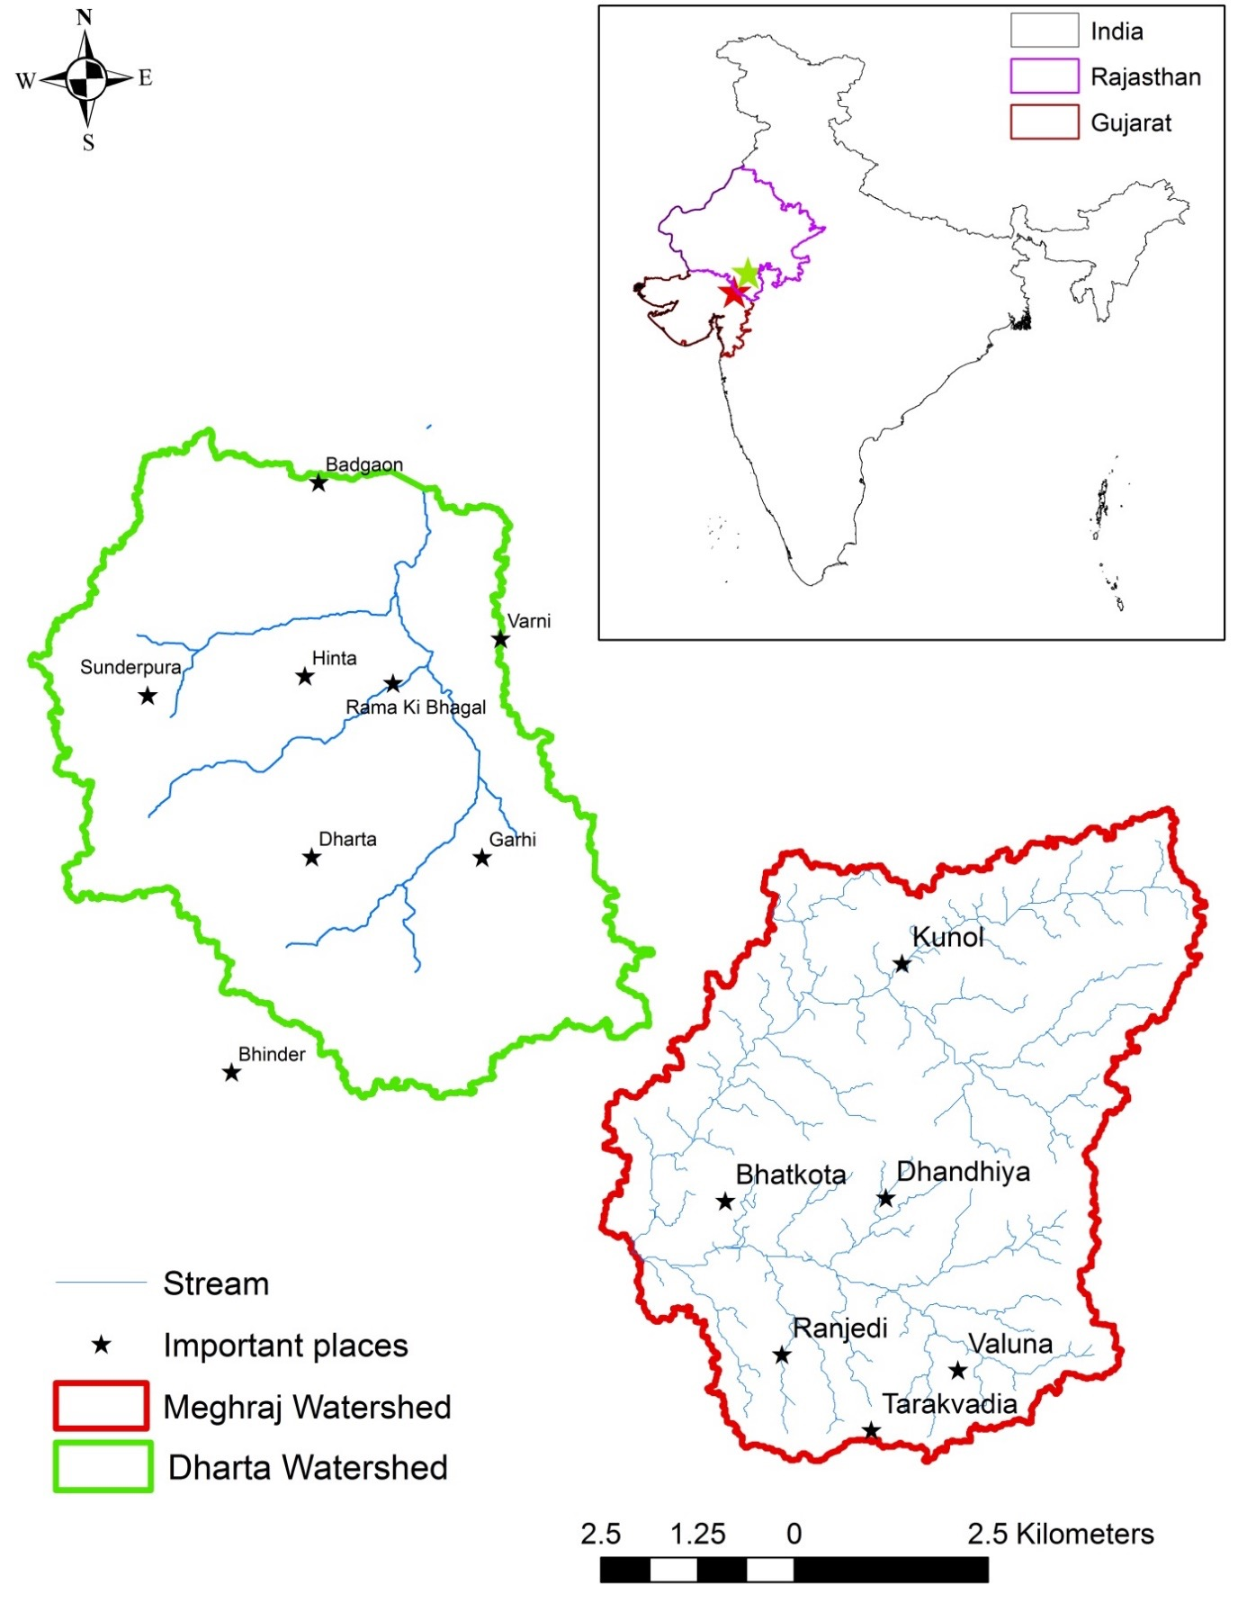

The MARVI study area

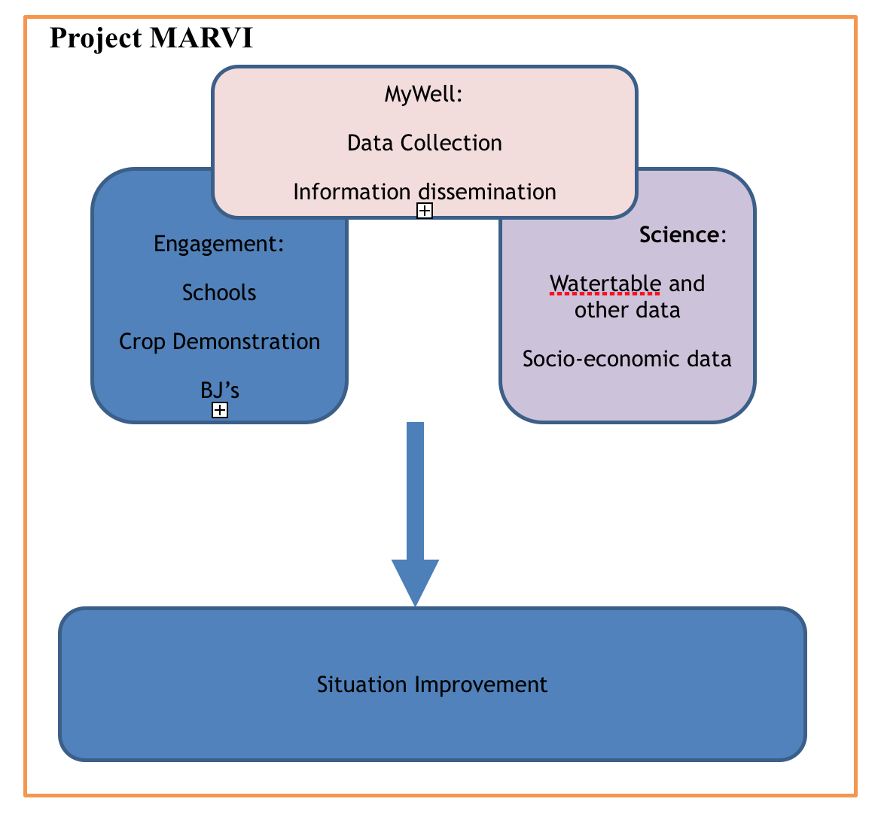

An overview of MARVI

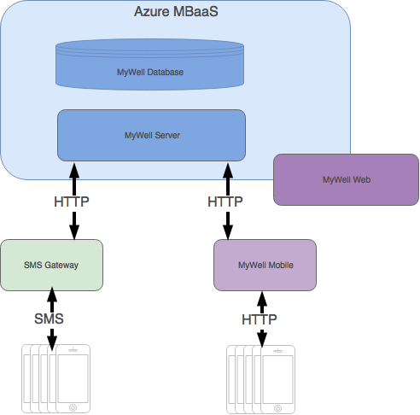

The MyWell system architecture

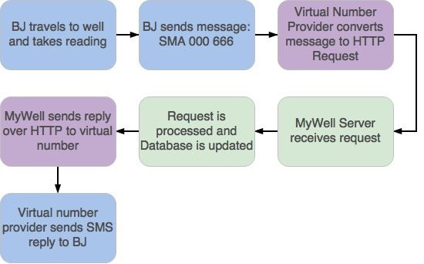

Steps to submit a reading.

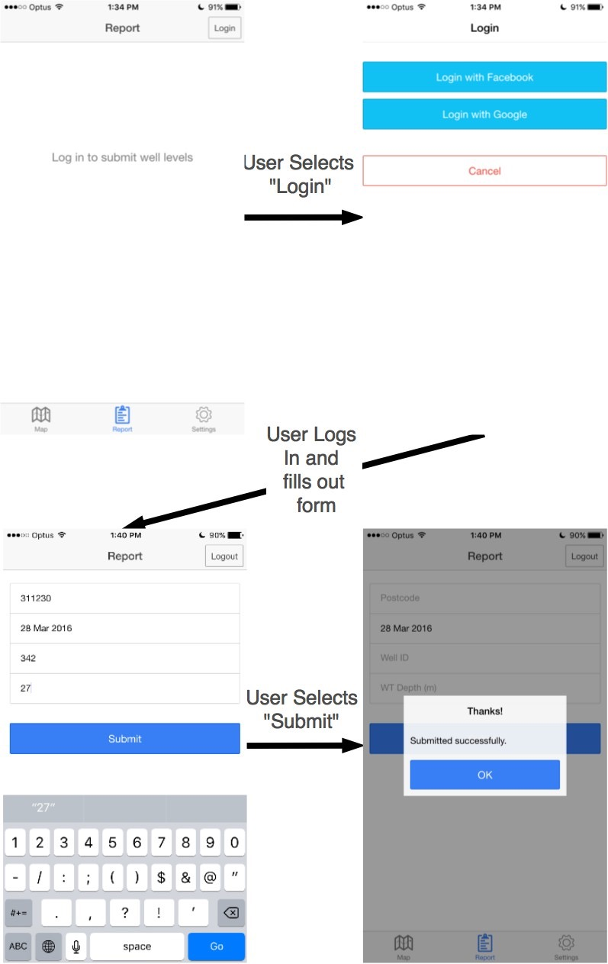

How to use MyWell Mobile to submit a reading.

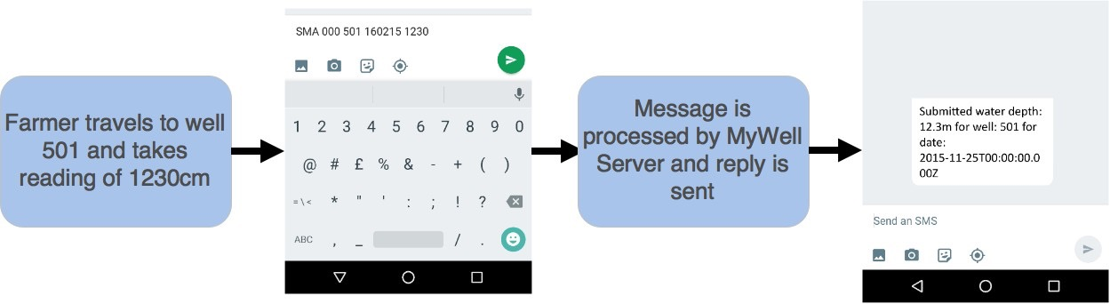

Submitting a reading using MyWell SMS.

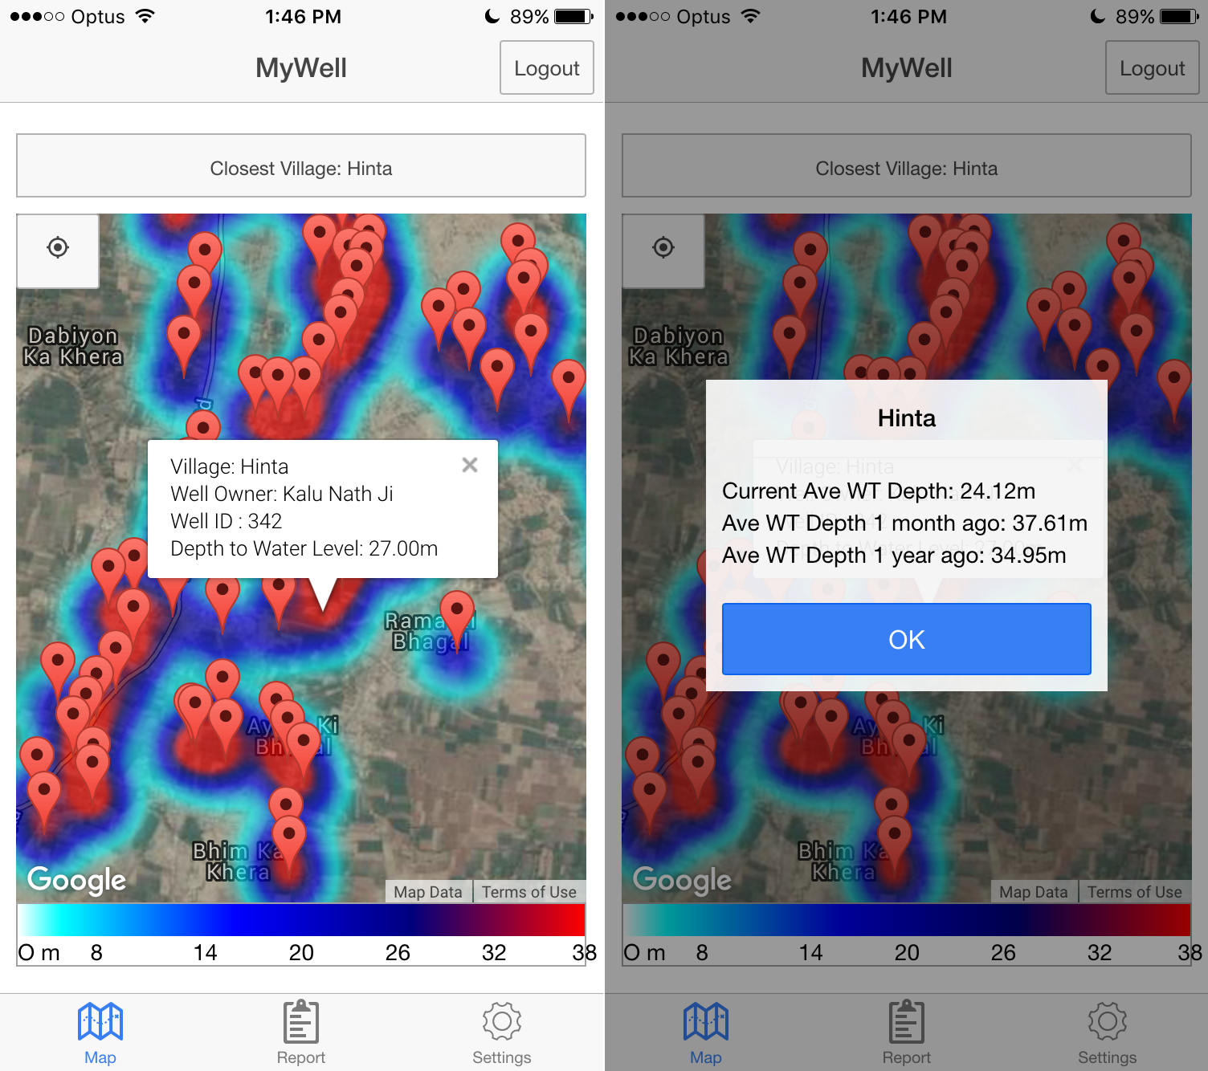

Screenshot from MyWell Mobile.

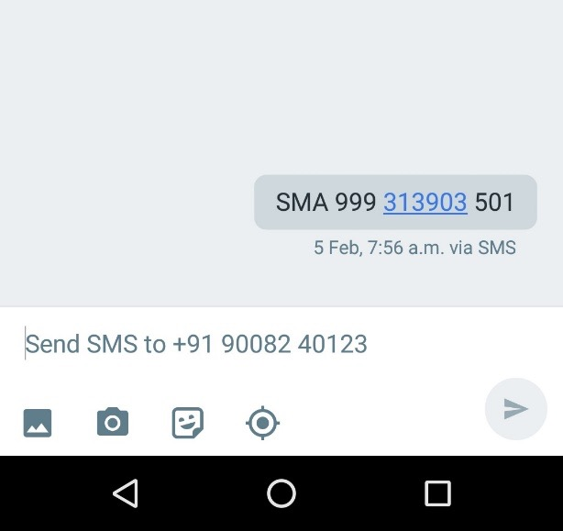

An example message to MyWell SMS.

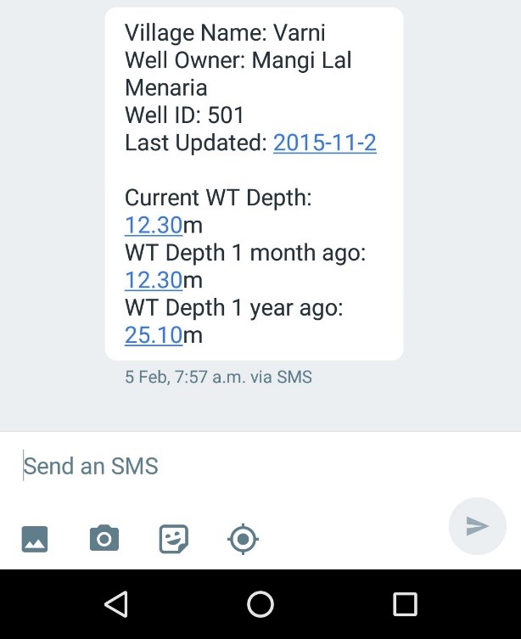

An example response from MyWell SMS.

**TODO: mywell_sms_query_resource** **TODO: mywell_sms_query_village**

## References

[1] J. Howe, “The Rise of Crowdsourcing,” *Wired*, vol. 14.06, Jun. 2006.

[2] “Emerging Nations Embrace Internet, Mobile Technology,” *Pew Research Center’s Global Attitudes Project*, 2014.

[3] “Deep Wells and Prudence,” *World Bank*, vol. 6, 2010.

[4] B. Maheshwari and S. Prathapar, “The Role of Transdisciplinary Approach and Community Participation in Village Scale Groundwater Management - Insights from Gujarat and Rajasthan, India,” *Water*, vol. 6.11, pp. 3386–3408, 2014.

[5] P. Chinnasamy, B. Maheshwari, and S. Prathapar, “Understanding Groundwater Storage Changes and Recharge in Rajasthan, India Through Remote Sensing,” *Water*, vol. 7.10, pp. 5547–5565, 2015.

[6] M. S. Rathore, “State Level Analysis of Drought Policies and Impacts in Rajasthan, India,” 2004.

[7] “Smartphone User Penetration in India 2014-2019,” *Statista*, 2016.

[8] “The History of Audubon,” 2015.

[9] H. Quinn, “Crowdsourcing Science,” *Geoscientist Online*. The Geological Society.

[10] “Creek Watch IPhone App Goes Social,” *IBM Research*, 2012.

[11] M. N. Fienen and C. S. Lowry, “Computers & Geosciences,” *Computers & Geosciences*, vol. 49, pp. 164–169, 2012.

[12] J. Toon, “Crowdsourcing Could Lead to Better Water in Rural India,” 2016.

[13] C. S. Lowry and M. N. Fienen, “Crowdsourcing Hydrologic Data and Engaging Citizen Scientists,” *Crowdhydrology*, vol. 51.1, pp. 151–156, 2012.

[14] “Rural Coverage-Strategies for Sustainability,” *Country Case Studies*, 2015.