**Extended Abstract Template (Second Round)**

**Please indicate ONLY ONE of the Session Topic themes to which you wish to submit your paper for consideration by TICKING the BOX in front of the session title.**

**Sessions are sub-divided by Core Thematic Area.**

**1. Technologies for Humanitarian Action**

Data science and machine learning for development and humanitarian action

**2. Medical Technologies**

Technologies for Non-Communicable Diseases in Developing Countries

Technologies for mother and child health

**3. Science and Technology for Disaster Risk Reduction**

Disaster Risk Reduction: the Elusiveness of Resilience

People-centered Early Warning Systems for Natural Hazards

High-Tech and/or Low-Tech for DRR in the Global South. What works, what doesn’t?

Low-cost ICTs for flood and drought risk management and development

Adapted Technologies for Early Warning Systems: Playing with Uncertainty

**4. Technologies for Sustainable Access to Energy**

Access to energy for all: measuring impact beyond kWh

Collaborating for Cleaner Technologies and Transitioning to Sustainable Energy Access

How can clean energy-based innovations boost incomes in Global South?

Gender And Renewable Energy Rural Electrification Programs

**5. Information and Communication Technologies for Development**

ICTs for Environment: challenges and opportunities of transdisciplinary research for development

Can MOOCs and OER transform Higher Education in the developing world?

Connecting Research to Practice: ICT4D Project Results Follow-Up

Data-Driven Farming For everyone

Designing for Inclusion: Why Adaptive and participatory methods are necessary

From data buckets to living platforms: Pitfalls and opportunities in designing spatial tools and data platforms for sustainable development

GovTech in the Global South: Harnessing ICT to transform governments and markets

**6. Technologies for Sustainable Development of Habitat and Cities**

Data management and appropriate geospatial technologies for cities of the Global South

Sustainable habitat and cities: Learning from the slum

Planning Smart City Technology in the Global South

International Cooperation And Construction: The Relationship Between Bureaucracy And Innovation.

Co-producing basic services: alternative socio-technological arrangements towards urban sustainability

**7. Crosscutting Themes**

Strengthening the research-policy nexus in the implementation of the SDGs

Opportunities and Challenges in Quality (Rigorous) Impact Evaluations: Lessons from the academia and the field

Development Engineering: Training Global Engineers

Open science: an opportunity for the Global South?

Heart Money - the role of venture capitalism in enabling social outcomes

Building bridges among global high-tech hubs in the African context

Development Engineering in the Private Sector

Blockchain and the BoP: a disruptive technology for economic inclusion?

**MyWell: Crowdsourcing Water Data for Sustainable Farming (Extended Abstract)**

**Lewis Daly 1,** Basant Maheshwari**2**

1 Vessels Tech, Adelaide, Australia

2 Western Sydney University, Syndey, Australia

**Presenting author’s email address:** lewis@vesselstech.com

***Biography of Presenting Author* (80 words):**

Lewis Daly is the Founder and CTO of Vessels Tech in Australia. He has a background in IT and Business, with a Masters degree from Carnegie Mellon University in Adelaide. He has also worked as an IT Systems research intern at Hitachi in Japan.

**Abstract:**

Across India, over 60% of agriculture relies on groundwater. Groundwater is often over-exploited, and groundwater depletion threatens many livelihoods. Existing interventions have been insufficient, and often fail to engage farmers at the lowest level. MyWell sets out to build a participatory, bottom-up approach to groundwater management. MyWell is an application for data-driven insights of groundwater at the village level. MyWell crowdsources groundwater indicators from a group of connected farmers using SMS or a smartphone application. In this paper, we show how MyWell has the potential to impact the lives of farmers by (1) empowering them to participate in science, and finding solutions to groundwater scarcity, and (2) assist them in building communities which work together to conserve groundwater. Then, we assess MyWell's application across two watersheds in rural India. We show how farmers are using MyWell to gain visibility into the groundwater situation, and examine the limitations of MyWell's approach.

**Keywords:**

Data Collection, Crowdsourcing, Groundwater

**Extended Abstract**

**Background**

India uses the largest amount of groundwater in the world, estimated at 230 cubic kilometers per year, more than 25% of the global total (World Bank, 2010). A cheap and accessible resource, groundwater is often over exploited for food production, with rainfall insufficient to recharge the groundwater levels (Rathore, 2004).

Groundwater is fundamental to the livelihoods of many farmers across India. In rural India, over 60 percent of agriculture is dependent on groundwater irrigation (World Bank, 2010). Groundwater allows farmers to grow crops in the dry season and manage deficiencies in monsoonal rainfall, contributing to improved livelihoods and poverty alleviation (Maheshwari and Prathapar, 2014).

To ensure the future livelihoods of these farmers, intervention is required. Many existing intervention approaches are top-down; policy makers and researchers with a clear view of watershed-level issues instruct farmers to use less water. With these approaches, farmers are often left out of the conversation, and aren't able to engage in groundwater management. MyWell, within the scope of a larger project MARVI - Managed Aquifer Recharge for Village level Intervention - set out to build participatory approaches for groundwater management from the bottom, the farmers and villages themselves.

**MyWell**

MyWell is a smartphone and SMS application for crowdsourcing groundwater, rainfall, water quality and check dam water levels in rural India. Farmers armed with a smartphone or feature phone can participate in a network of connected farmers who collect information, and glean insights into the groundwater situation. Fig. 1 has an example of MyWell running on a smartphone.

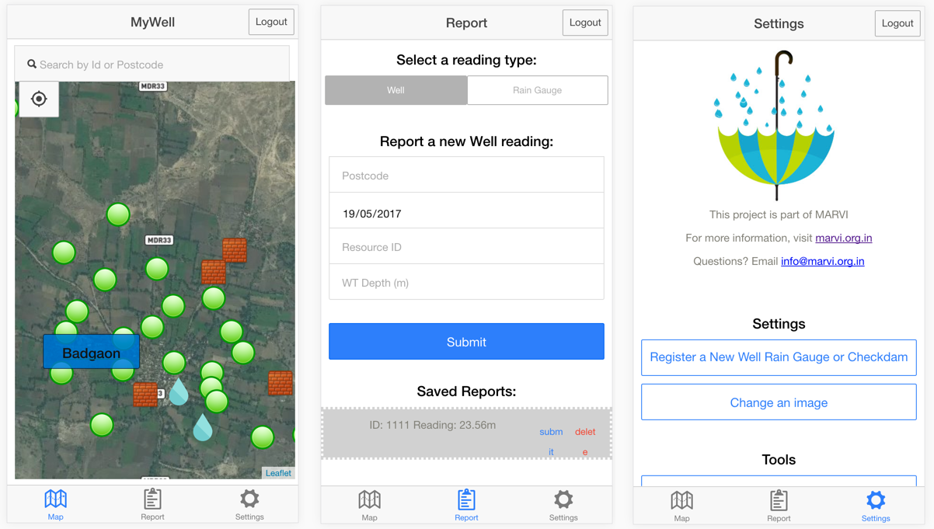

Fig. 1 MyWell running on a smartphone

Farmers record readings on Android or iOS devices using the MyWell app, or over SMS for those without smartphones or in poor coverage areas.

MyWell is able to provide valuable data-driven insights into the groundwater situation. MyWell displays simple graphs; snapshots of the readings from a well, rain gauge or check dam over the last 3 years. MyWell also calculates village level statistics. These tools allow farmers to compare and benchmark their own well and groundwater usage against each other, and against previous years.

MyWell also has a host of tools for farmers to manage the MyWell system. Farmers can register a new well, rain gauge or check dam, using their device's inbuilt GPS to pinpoint the location. Each well also has a unique Banner Image - usually of the well and well's owner - allowing for greater personalization and buy-in.

**Impact**

MyWell has the potential to impact the livelihoods of farmers across a variety of areas. We see the greatest potential for MyWell to empower smallholder farmers to be actively involved in science through data collection, and take part in the solution to groundwater scarcity.

MyWell also allows communities of farmers to make data-driven decisions about using groundwater. In the short term, these communities will allow for more efficient allocation of water, helping to prevent crop failure. Long term, MyWell provides a platform for taking steps towards ensuring the future of water security.

MyWell is a tool for helping build communities around the need to share groundwater. While not a solution in and of itself, we see MyWell as an instrument that can be used to facilitate conversations about groundwater.

**Results**

We evaluate MyWell's implementation in the Meghraj and Dharta watersheds in two Indian states, Gujarat and Rajasthan, as shown in Fig. 2.

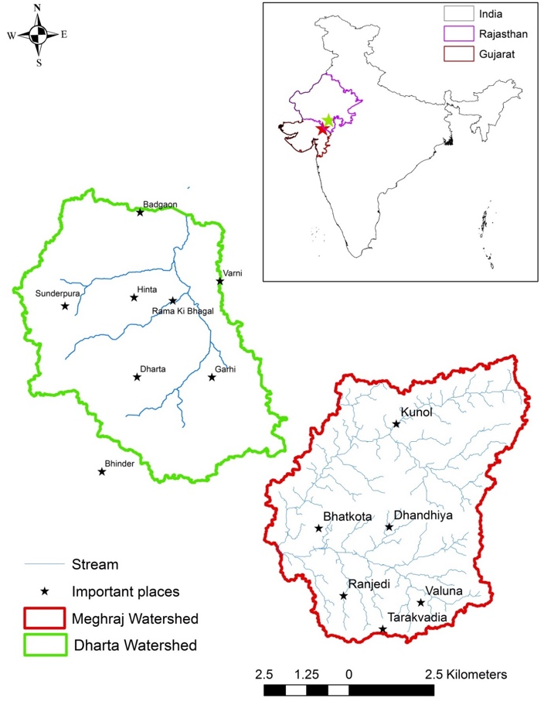

Fig. 2 MyWell study areas in West India.

We show that MyWell can be used from both feature and smartphones, and allow farmers to crowdsource well, rainfall and check dam readings, as well as access data-driven insights into the groundwater situation. We also show the potential for MyWell to empower smallholder farmers and villages to contribute to science, and be actively involved seeking village-led solutions to groundwater scarcity.

We see limitations in what MyWell - as a technological tool - can do alone, and show how technology facilitating groundwater intervention must exist within a larger program targeting social and economic aspects of groundwater management.

**Future**

While this study evaluates MyWell's use in 2 watersheds in rural India, MyWell is not limited to these areas, or even India. Future research and applications of MyWell will translate this approach to other countries with differing groundwater situations.

The value of data collected by MyWell also has considerable network effects. Increasing the number of wells and watersheds monitored by MyWell will increase the value of information delivered by MyWell. The more insights to be gained from MyWell, the more valuable the information gathered is, driving greater usage and value to its users.

MyWell's primary target is smallholder farmers, but the insights it delivers can be applied across many levels of groundwater management, from researchers to policy makers. We would see MyWell expand its features and integrations with other platforms, to allow for groundwater stakeholders at multiple levels to glean insights from MyWell.

**References**

World Bank (2010). Deep wells and prudence. Washington D.C.: World Bank

Rathore, M. S. (2004). State level analysis of drought policies and impacts in Rajasthan, India. Colombo, Sri Lanka: IMWI.

Maheshwari, B., Prathapar, S. (2014). The role of transdisciplinary approach and community participation in village scale groundwater management - insights from Gujarat and Rajasthan, India. Water 6(11), 3386-3408.