Completed by fourth-year student
"Computing and Digital Technologies"
Sofiya Serbina
Laboratory Work No. 3
Section A (Implementation and Results)
I containerized the Flask REST API from Lab 2 using Docker and Python 3.12. The service listens on 0.0.0.0:5000; port 5001 on macOS was mapped to container port 5000. GET /time returned server_time and served_by, while POST /echo returned the submitted message or HTTP 400 when the required field was missing.
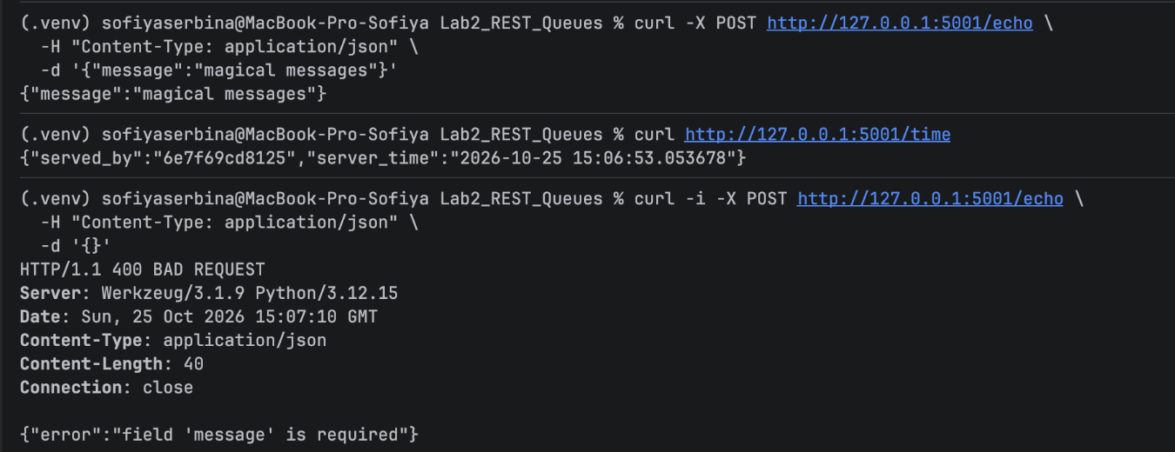
Figure 1. Successful REST API requests and input validation in Docker.
The image my-api:lab3 was built with dependencies installed before the application code. Docker Compose started the API successfully, and docker compose ps confirmed that the container was Up.
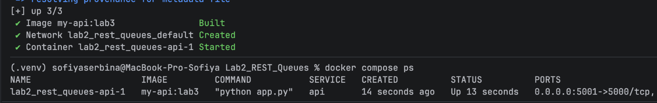
Figure 2. Docker Compose startup and active port mapping.
I deployed three replicas to Minikube behind a Kubernetes Service. All pods reached Running state. Across 30 requests, the three pods served 12, 10, and 8 responses, showing that traffic reached multiple instances.
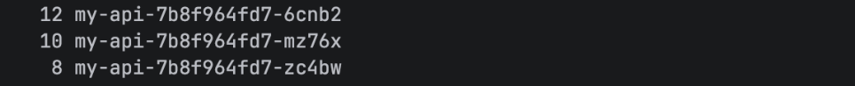
Figure 3. Request distribution between three Kubernetes pods (30 requests).

Section B (Self-Healing and Scaling)
After a pod was deleted, Kubernetes created a replacement automatically. During the availability check, all 100 requests returned HTTP 200. I then scaled the Deployment from 3 to 5 replicas and back to 3; the final Deployment status was 3/3 Ready.
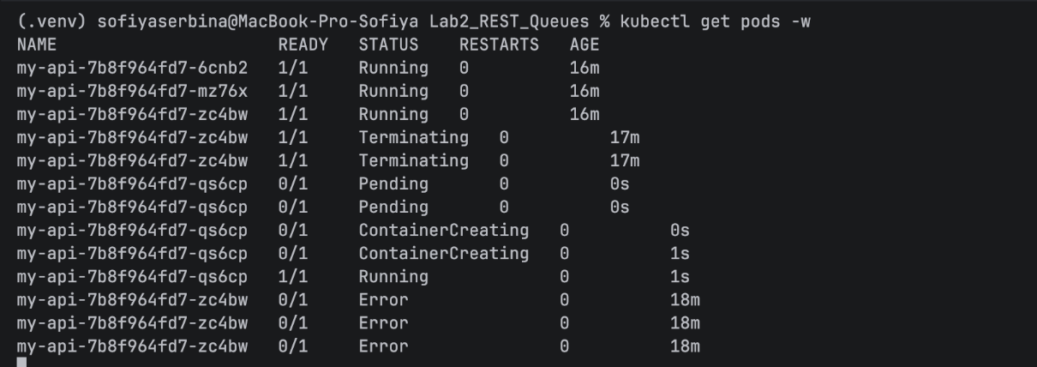
Figure 4. Kubernetes replacing a deleted pod during self-healing.
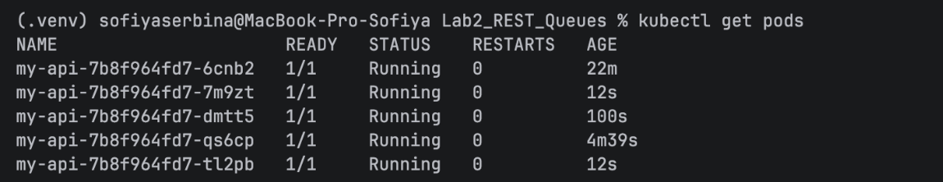
Figure 5. Deployment scaled to five running pods.
Reflection Questions
1. What is the fundamental difference between a container and a virtual machine?
- A virtual machine has its own guest operating system, while a container shares the host OS kernel and isolates application processes. Containers are usually lighter and start faster.
2. Why does a Dockerfile install dependencies before copying the application code?
- Docker caches build layers. When only the application code changes, the dependency layer can be reused, making later image builds faster.
3. Why use a Deployment instead of a bare pod? What happened after deletion?
- A Deployment maintains the desired number of replicas. When I deleted one pod, Kubernetes started a new pod and restored the three-replica state automatically.
4. How does a Service find pods, and why is statelessness important?
- A Service selects pods using matching labels and routes requests to their endpoints. A stateless API does not depend on local request history, so any replica can handle the next request.

